DYNAMIC ROUTE OPTIMIZATION FOR AUTONOMOUS VEHICLES IN REAL TIME ENVIRONMENTS

19CSE495 PROJECT PHASE 1 REVIEW 2 REPORT

Submitted by

| Roll number | Name |
| --- | --- |
| CB.EN.U4CSE20305 | AMRITESH P.J. |
| CB.EN.U4CSE20339 | NAKSHATRA SREE SREEDHAR |
| CB.EN.U4CSE20343 | NOUDURI SREENIVAS |
| CB.EN.U4CSE20367 | Y. TINA CHOUDARY |

BACHELOR OF TECHNOLOGY

IN

COMPUTER SCIENCE AND ENGINEERING



DEPARTMENT OF COMPUTER SCIENCE AND ENGINEERING

AMRITA SCHOOL OF COMPUTING

AMRITA VISHWA VIDYAPEETHAM

COIMBATORE - 641112

SEPTEMBER 2023

AMRITA VISHWA VIDYAPEETHAM

*TABLE OF CONTENTS*

| Sl No | Title | Page No |
| --- | --- | --- |
| 1. | Abstract |  |
| 2. | Introduction  2.1 Need for the project  2.2 Problem description  2.3 Problem Use case  2.4 Problem statement/ Research Objectives |  |
| 3. | Literature Survey  3.1 subtopics (if required)  3.2 subtopics (if required) |  |
| 4. | Proposed Methodology  4.1 V2V Communication:  4.2 Algorithm  4.3Architecture diagram  4.4 Implementation  4.4.1 Pseudo code  4.4.2 Output |  |
| 5. | References |  |

1.ABSTRACT

Autonomous vehicles, also known as self-driving cars, represent a revolutionary shift in transportation. These vehicles leverage advanced sensors, cameras, and algorithms to operate without human intervention, promising numerous benefits including improved road safety, efficient traffic management, and enhanced mobility for all. In the context of dynamic routing, autonomous vehicles adapt to real-time conditions using algorithms such as reinforcement learning, real-time traffic analysis, and genetic algorithms. These approaches optimize routes, consider traffic congestion, and adapt to changing scenarios. Furthermore, blockchain technology is emerging as a powerful tool in the autonomous vehicle ecosystem, providing secure data sharing, identity verification, and smart contract applications. However, challenges related to privacy and integration persist, but as blockchain continues to evolve, they are poised to shape the future of transportation by ensuring safe, efficient, and trustworthy autonomous mobility.

2.INTRODUCTION

The advancement of autonomous vehicle technology has revolutionized the transportation industry by offering the promise of safer, more efficient, and convenient mobility solutions. Autonomous vehicles, equipped with sensors, cameras, and advanced algorithms, have the potential to navigate complex urban environments without human intervention. However, to fully realize their potential, dynamic route optimization becomes paramount. This project focuses on the implementation of real-time dynamic route optimization for autonomous vehicles, addressing the pressing need for adaptive navigation in constantly changing environments.

2.1 NEED FOR THE PROJECT

The need for dynamic route optimization in autonomous vehicles arises from several factors:

Traffic Congestion: Urban areas are often plagued by traffic congestion, leading to increased travel times, fuel consumption, and pollution. Dynamic route optimization can help alleviate congestion by intelligently rerouting vehicles based on real-time traffic data.

Safety: Ensuring the safety of autonomous vehicles and their passengers is a primary concern. Real-time route optimization can help vehicles avoid accidents, road closures, and adverse weather conditions, enhancing overall safety.

Efficiency: Dynamic route optimization can lead to more fuel-efficient and environmentally friendly transportation systems. Optimized routes can reduce fuel consumption and emissions, contributing to sustainability goals.

Adaptability: Urban environments are dynamic, with road closures, accidents, and special events constantly altering traffic patterns. Autonomous vehicles must adapt to these changes in real-time to provide reliable transportation services.

2.2 PROBLEM DESCRIPTION

The problem at hand involves developing a system that enables autonomous vehicles to continuously assess their surroundings, process real-time data, and make informed decisions to optimize their routes dynamically. Storing this data in blockchain will also ensure security .This system should seamlessly integrate into the existing infrastructure and be capable of handling complex urban environments with multiple variables affecting route selection.

2.3 PROBLEM USE CASE:

Consider an autonomous ride-sharing service operating in a bustling city. A passenger requests a ride, and the autonomous vehicle is dispatched to pick them up. During the journey, unforeseen circumstances, such as a sudden road closure due to construction or a traffic accident, obstruct the original route. To ensure the passenger reaches their destination efficiently and safely, the autonomous vehicle must reevaluate its route in real-time, taking into account these obstacles, traffic conditions, and the passenger's preferences.

PROBLEM STATEMENT/RESEARCH OBJECTIVES

* Developing an algorithm that uses blockchain stored data for dynamically optimized routes for Autonomous vehicles considering factors like traffic, road conditions and other live events.
* Designing an efficient blockchain architecture for real time transport scenarios and implement mechanisms to verify the accuracy of traffic and routing data while ensuring the privacy and security of users.
* Integrating the blockchain and optimization solution with existing Autonomous vehicle systems and conduct simulated pilot tests to validate the system’s efficiency, reliability and scalability.

| **PAPER TITLE** | **YEAR AND PUBLISHER** | **JOURNAL/CONFERENCE** | **CONTENT** |
| --- | --- | --- | --- |
| Proof-of-event recording system for autonomous vehicles: A blockchain-based solution | 2020  IEEE | Journal | •The paper presents a blockchain-inspired event recording system for autonomous vehicle accident forensics.    •It proposes a "Proof-of-Event" mechanism with a dynamic federation consensus to create and verify accident records.    •The system involves accident, witness, and verifier vehicles, ensuring data integrity and trustworthiness. |
| Solutions to the routing problem: towards trustworthy autonomous vehicles | 2022  Springer Nature | Journal | •The paper discusses different traffic flow models and the importance of intention-awareness in developing effective routing solutions for autonomous vehicles. |
| Trust-based route planning for automated vehicles | 2021  Association for Computing Machinery | Conference | •The paper presents a trust-based route planning approach for automated vehicles    •It incorporates human trust as a factor in determining optimal routes. |
| An Automated Machine Learning (AutoML) Method of Risk Prediction for Decision-Making of Autonomous Vehicles | 2020  IEEE | Journal | •This study introduces a specialized AutoML system for risk prediction and behavior assessment in AV.  •  •It helps optimize features and provides insights for AV design.  •  •The study discusses its potential applications in improving AV safety and decision-making. |
| Efficient real-time routing for autonomous vehicles through Bayes correlated equilibrium: An information design framework | 2019  Elsevier B.V. | Journal | •This paper suggests using information-based methods to enhance traffic efficiency.    •It applies Bayesian persuasion and unified information design frameworks for traffic management efficiency. |
| A Route Reservation Approach for an Autonomous Vehicles Routing Problem | 2019  EDP Sciences | Conference(Gold-open Access) | •The paper proposes a route reservation approach  •  •It manages road traffic and improve the routing of autonomous vehicles. |
| Situation Awareness for Autonomous Vehicles Using Blockchain-based Service Cooperation. | 2022  Springer Science | Conference(Green Open Access) | •This paper discusses the need for efficient cooperation among autonomous vehicles    •It proposes a decentralized blockchain-based framework to address trust and latency issues. |
| Last mile delivery routing problem using autonomous electric vehicles. | 2023  Elsevier | Journal(Green Open Access) | •This paper focuses on using Autonomous Delivery Vehicles (ADVs) for urban last-mile logistics.    •It aims to minimize costs while meeting load, battery, route duration, and customer walking distance constraints.    •The paper proposes a two-phase metaheuristic approach to solve ADVRP efficiently. |
| LaneScanNET: A deep-learning approach for simultaneous detection of obstacle-lane states for autonomous driving systems | 2023  Elsevier | Journal | •This paper introduces LaneScanNET, a smart system that helps self-driving cars navigate tricky roads.  •  •It's great at spotting obstacles, finding lanes, and figuring out the road conditions.  •  •LaneScanNET is trained using real Indian road data and works really well, even in tough situations like fog or shadows. |
| Blockchain-based Secure and Intelligent Sensing Scheme for Autonomous Vehicles Activity Tracking Beyond 5G Networks | 2021  Springer | Journal | •The paper proposes a blockchain-based secure and intelligent sensing scheme for autonomous vehicles.  •  •It's key objective is to address critical challenges and enhance the safety and security of AVs. |
| An analysis of the value of optimal routing and signal timing control strategy with connected autonomous vehicles | 2022  Taylor and Francis | Journal | •The paper investigates the impacts of additional information from connected AVs. on routing and signal timing efficiency.    •It proposes an optimal control strategy that can reduce total travel time. |
| A reinforcement learning approach for global navigation satellite system spoofing attack detection in autonomous vehicles | 2022 | Journal | •The paper presents a deep reinforcement learning (RL) model for turn-by-turn spoofing attack detection in autonomous vehicles, using low-cost in-vehicle sensor data.  •The model exhibits high accuracy (99.99% to 100%) and 100% recall in detecting GNSS spoofing attacks, emphasizing its effectiveness in providing real-time protection for AVs during navigation. |
| An Automated Machine Learning (AutoML) Method of Risk Prediction for Decision-Making of Autonomous Vehicles | 2020 | Journal | •The study introduces a domain-specific AutoML system for AVs, enabling end-to-end machine learning for risk prediction and behavior assessment.  •AutoML achieves high accuracy (91.7%) in predicting four risk levels and demonstrates effectiveness in distinguishing safe-risk scenarios (95%), offering valuable insights for AV design through optimal feature subsets and hyperparameter values. |
| **BELIEVE: Privacy-Aware Secure Multi-Party Computation for Real-Time Connected and Autonomous Vehicles and Micro-Mobility Data Validation Using Blockchain—A Study on New York City Data** | 2023 | Journal | •The paper presents BELIEVE, a novel blockchain-based framework utilizing secure multi-party computation for real-time validation of mobility data without constant sharing of raw trajectories, addressing privacy concerns. Evaluation on simulated New York City data demonstrates efficiency in network communication and resource conservation. |

Proposed Methodology:

Designing an efficient blockchain architecture.

1. Identifying Specific transport scenarios(real time response)

2. Choosing blockchain type.(Public/private/consortiol blockchain)

3. Consensus mechanism identification.

Algorithm development for dynamic route optimization.

Data collection

Algorithm design

Integration with blockchain

Testing and simulating environment

3.Literature Survey

1. LaneScanNET:

In order to overcome the difficulties in creating reliable lane-keeping or lane-changing decision systems for autonomous driving systems (ADS), a novel deep learning technique called LaneScanNET was developed. This work provides an extensive analysis of the requirement for concurrent obstacle-lane state detection, the suggested LaneScanNET architecture, an assessment of its performance, and future directions for development.

An overview of the difficulties in creating autonomous driving systems, particularly in underdeveloped nations with inadequate transportation infrastructure. The effectiveness and safety of ADS depend on reliable lane-keeping and lane-changing decision systems. An explanation of LaneScanNET as a potential remedy for these problems.

Examining current frameworks for lane segment and obstacle recognition from RGB frames.Determining whether irregular engagement geometry between the ego vehicle (EGV) and other cars at various RGB frames is the cause of errors in lane-keeping or lane-changing decision systems. Outlining the suggested LaneScanNET network as a means of guaranteeing uniform participation and efficient decision-making.

A thorough explanation of the multi-task learning neural network with parallel architecture that is suggested for concurrent lane line recognition, object detection, and lane-change decision-making. three sensors—light detection and ranging (LiDAR), radio detection and ranging (RADAR), and global positioning system (GPS)—are integrated with hardware and software.A comparison of tracking position, performance, range, and distance results.

An analysis of LaneScanNET's accuracy and efficiency that emphasizes the excellence of the whale optimization algorithm.Comparing different deep learning and non-deep learning methods for operating self-driving cars under difficult road conditions. A suggestion for combining deep learning techniques with conventional computer vision techniques to provide a trustworthy benchmarking framework for lane detection.

Future Scope: LaneScanNET will be integrated into an end-to-end system to remove constraints and enhance the synchronization of decision-making. Possible reductions in the inference time by using multi-headed feature map extraction architectures.Adding new features to the framework, like three-dimensional reconstruction for improved environmental comprehension, global and local path planners, and vehicle speed calculation.

A summary of LaneScanNET's importance in overcoming the difficulties in creating reliable lane-keeping or lane-changing decision systems for ADS. The connections and members of the study team are acknowledged.A statement that there are no known conflicting financial interests or personal ties that could have influenced the research described in the publication.

2. Last mile delivery routing problem using autonomous electric vehicles:

The Last Mile Delivery Routing Problem with Autonomous Electric Vehicles (ADVs) in Urban Logistics is discussed in the study. The goal is to minimize vehicle utilization and route expenses while meeting a variety of requirements. Formulated as the Autonomous Delivery Vehicle Routing issue (ADVRP), the study offers a two-phase heuristic strategy and a mixed-integer linear programming (MILP) model to tackle this NP-hard issue.

A summary of combinatorial optimization routing issues is given in the literature review, with a distinction made between incomplete tours, or pathways, and complete tours, or cycles. Cycle construction problems (CCPs) are covered in the paper, along with Hamiltonian CCPs (HCCPs) and non-Hamiltonian CCPs (nHCCPs). Well-known instances of CCPs are highlighted, including the Vehicle Routing Problem (VRP) and the Traveling Salesman Problem (TSP).

The ADVRP is introduced, and the MILP model is developed, in this study. The challenge is determining the best routes for ADVs while taking into account limitations like maximum coverage distance, load capacity, battery capacity, and time-constrained routes. In addition to addressing vehicle route costs and assignment costs, the model offers a thorough framework for handling the intricacies of last mile delivery routing.

The paper offers a productive two-phase heuristic method for solving the NP-hard ADVRP. Improvement-and-repair operators tailored to the situation are introduced in the first phase, and a hybrid metaheuristic incorporating numerous neighborhood motions is employed in the second. The goal of this strategy is to offer a reliable and efficient way to solve the ADVRP while taking into account freshly created datasets and covering-routing.

Computational Results: A comparison between the suggested algorithm and the most advanced techniques found in the literature is provided in Section 5's report on the computational results. The study assesses the suggested method's efficacy over a range of datasets, proving how well it works to handle the challenges associated with last-mile delivery routing using ADVs.

A case study drawn from data from a big supermarket in Istanbul, Turkey, is included in the paper. This real-world application offers insightful information about the usefulness of using autonomous delivery trucks for last-mile delivery in urban logistics. The case study illustrates the possible advantages and difficulties of incorporating ADVs into current delivery processes.

3. Situation Awareness for Autonomous Vehicles Using Blockchain-based Service Cooperation:

The system outlined in this proposal introduces a cutting-edge blockchain-based solution designed to facilitate secure cooperation among autonomous vehicles. This innovative approach leverages edge servers to enable transparent data sharing while serving as a collaborative platform for a diverse array of organizations, including transport service providers. A proof-of-concept is presented, illustrating real-time data sharing and its practical application in providing adaptive guidance to drivers, particularly in scenarios involving multiple taxi companies. To address privacy concerns, robust measures such as pseudonymization, encryption, and authentication have been implemented, further fortified by the use of smart contracts and zero-knowledge arguments to safeguard sensitive data. The system's feasibility and performance are rigorously evaluated through a simulation utilizing Hyperledger Fabric, with the ultimate goal of enhancing situational awareness and promoting effective data sharing within the realm of autonomous vehicles.

4. Solutions to the routing problem: towards trustworthy autonomous vehicles:

In the first section of the review, the importance of the routing problem is discussed in relation to road traffic as an open, large-scale multi-agent system. It highlights how important it is to design routing that takes traffic flow into account and how it affects journey times. The writers present the idea of undesirable behavior in transportation systems and emphasize the significance of creating models to prevent such behavior.

This study explores how computer science models can be used to solve routing issues and how this could affect the advancement of autonomous vehicle technology. It highlights the necessity for models with higher abstraction to research and show qualities for enhancing social welfare as it addresses the applicability of these models for software engineers and traffic engineers.

This study explores how computer science models can be used to solve routing issues and how this could affect the advancement of autonomous vehicle technology. It highlights the necessity for models with higher abstraction to research and show qualities for enhancing social welfare as it addresses the applicability of these models for software engineers and traffic engineers.

The review also looks at the difficulties in creating computer science models for autonomous car routing. It talks about the basic problems with the routing problem and emphasizes the necessity of adding traffic engineering elements to the models. The authors stress that before adding traffic engineering elements to the models, it is imperative to address the fundamental concerns.

The writers also go over the various computer science models that are employed to solve the routing problem. The queuing model, the repeated routing game approach, and the routing game model are compared and evaluated. Every model is examined based on how well it can represent autonomous car behavior and how well it can direct perception autonomous agents' cycles of decision-action.

Intention-awareness approaches' significance for enhancing autonomous vehicle coordination is also covered in the paper. The authors stress that in order to prevent undesirable behavior, autonomous cars must be able to communicate clearly and understand each other's intentions. They talk about how intention-awareness approaches can save travel times and increase safety, among other possible advantages.

The paper concludes by highlighting the significance of creating reliable autonomous vehicles and the part computer science models play in accomplishing this. The writers emphasize the necessity of using more abstract models in order to look into and validate certain aspects of enhancing societal wellbeing. They also draw attention to the difficulties in creating computer science models for autonomous car routing and the significance of intention-awareness methods for enhancing inter-autonomous vehicle cooperation.

5. An analysis of the value of optimal routing and signal timing control strategy with connected autonomous vehicles:

Outlining the rise of automated and connected technologies that allow CAVs to interact and communicate with signal controllers and other vehicles.A discussion of how using CAVs could increase travel efficiency and lessen traffic.

Review of the Literature: - Investigation of the relationship between signal timing and routing, with an emphasis on the potential applications of traffic control to modify user equilibrium (UE) and influence route selection.A review of the theoretical frameworks and equilibrium conditions pertaining to the control of traffic signals and route selection, including talks about Wardrop's second equilibrium (WP2) and system optimal equilibrium.

Network information, flow information, and signal timing information are the three categories into which driver information levels are divided.A discussion of how important it is for travellers to estimate their travel expenses to have knowledge of the network topological structure, link length, number of lanes, and traffic flow.

The introduction of the four current routing and signal timing strategies—the shortest route, stochastic routing, partially adaptive policy (PAP), and PAP combined with P0 policy—under varying driver information levels. A comparison of these tactics depending on the amount of traffic data available.

The ORST control strategy for CAVs is presented, with the goal of using extra data from CAVs to shorten the overall travel time. Emphasising ORST's ability to beat current tactics in reducing the overall time needed to reach Wardrop's second equilibrium.

Using Simulation of Urban Mobility (SUMO) to compare five different routing and signal timing strategies in a symmetrical network in order to investigate the effects of information levels on routing and signal timing efficiency. Sensitivity analysis of ORST under various conditions and CAV penetration rates, indicating the possibility of increasing system efficiency.

An overview of the paper's contributions, such as the sensitivity analysis of ORST under various circumstances, the suggestion of the ORST control strategy, and the quantitative examination of information levels on routing and signal timing efficiency. emphasis on ORST's potential to increase system efficiency, particularly at high CAV penetration rates and low levels of congestion.

Overall, the study offers a thorough examination of the importance of signal timing control and optimal routing strategies with connected autonomous cars, providing information about the possible advantages and ramifications for next-generation transportation networks.

6. Trust-based route planning for automated vehicles

This paper presents the idea of automation trust and discusses its significance for automated vehicles. It draws attention to the necessity of a trust-based approach to route planning in order to enhance user experience and safety.

Research on vehicle route planning and automation trust is covered in the related work section. It highlights the need for a route planning strategy that takes human trust into account and points out shortcomings in the state-of-the-art at this time.

This section offers a thorough scenario of automated vehicle route planning that takes into account a variety of traffic incidents, including pedestrians, obstacles, and approaching trucks. The talks on trust-based route planning that follow are set up by this example.

The study outlines the planning and implementation of an online user survey aimed at gathering information on human confidence in automated cars. It describes how trust dynamics are measured and what influences the evolution of trust in the context of various traffic incidents.

The innovative trust-based route planning strategy, which incorporates the gathered trust dynamics data into the route planning framework, is presented in this section. It goes over how human trust influences automated cars' decision-making and how this knowledge is applied to optimise routes.

The procedure for conducting driving simulator experiments, including participant recruitment, study design, and data collection, is described in this paper. Additionally, it displays the outcomes of the experiments, including the impact of trust-based route planning on cumulative rewards and user experiences.

In this section, the research findings are discussed, the importance of trust-based route planning for automated vehicles is emphasised, and possible directions for future research in this area are suggested.

With the goal of improving knowledge and application of trust-based route planning for automated vehicles, the paper offers an extensive examination of trust dynamics, user studies, route planning techniques, and experimental findings.

7. Comparative Study on Supervised versus Semi-supervised Machine Learning for Anomaly Detection of In-vehicle CAN Network

An overview of the significance of in-vehicle CAN bus network security and the requirement for efficient anomaly detection techniques is given in the introduction. The study's comparison of supervised and semi-supervised machine learning techniques for anomaly detection in CAN network traffic data is framed by this.

The section on machine learning for in-vehicle CAN-Bus network data anomaly detection explores the use of supervised machine learning models, such as deep neural network-based DL models and conventional ML techniques, for anomaly identification in in-vehicle CAN bus networks. The models that were selected for the study include decision trees, the K-Nearest Neighbor (KNN) method, Random Forest (RF), and Extreme Gradient Boosting (XGBoost).

A deep autoencoder (DAE) based semi-supervised learning model for anomaly detection in CAN network traffic data is presented in this paper. It draws attention to how much better the suggested DAE method performs than alternative semi-supervised learning techniques. The part also covers the ablation study that was carried out to confirm the efficacy of the feature engineering technique and the useful features that were extracted. Emphasis is placed on the significance of the recently computed time interval feature and the effects of various XGBoost model variations on anomaly detection performance.

The research demonstrates the superiority of supervised methods over semi-supervised methods by providing a thorough comparison of the quantitative performance of the chosen models. It explores the causes of the discrepancies in performance and highlights the role that genuine labels play in the better performance of supervised techniques. The section also emphasizes how the built XGBoost-based model exhibited state-of-the-art performance in terms of accuracy, precision, and ROC AUC, outperforming all other approaches described in published works.

The study's conclusion highlights how important the suggested semi-supervised learning approach based on DAE is for accomplishing efficient anomaly detection in CAN bus networks in automobiles. It also emphasizes the significance of feature engineering, the extraction of useful features, and the possibility of more investigation into the characteristics of the data in order to enhance anomaly detection. The importance of in-vehicle CAN network security in the age of automated cars and Advanced Driver Assistance Systems (ADAS) is highlighted in the paper's conclusion, along with the necessity of ongoing research in anomaly detection for improved network security.

8. An Anomaly Detector for CAN Bus Networks in Autonomous Cars based on Neural Networks

This paper presents an intrusion detection system (IDS) based on a Multi-Layer Perceptron (MLP) neural network for securing in-vehicle communication networks, particularly the Controller Area Networks (CAN) bus. The authors use the K-means clustering algorithm to partition data based on the ID field of CAN packets and extract relevant features for training and validation. The IDS's performance is evaluated using Receiver Operating Characteristic (ROC) curves for specific IDs, with the number of nodes in the hidden layer of the neural network adjusted to balance detection rate and false positive rate. The study highlights the system's ability to detect simultaneous frequency-appearance and data-content modifications, making it suitable for implementation in a single Electronic Control Unit (ECU) to reduce complexity and cost. The paper emphasizes the importance of defining autonomous reactions for vehicular network security. Overall, this research offers a promising approach to enhance in-vehicle network security, and its results showcase the potential of the proposed IDS.

9.Anomaly detection in autonomous driving: A survey

This comprehensive literature survey explores anomaly detection for autonomous vehicles across various sensor modalities and scenario levels. It categorizes approaches into lidar data, radar data, multimodal sensor data, and abstract object data. In the lidar data section, it discusses the importance of lidar for depth perception and introduces the DeepSAD method for quantifying lidar degradation due to weather conditions. The survey then covers radar data, emphasizing the challenge of detecting "ghost targets" caused by multipath propagation. Various deep learning techniques are highlighted for radar anomaly detection. In the multimodal sensor data section, the paper showcases methods that fuse data from different sensors, such as transformers for radar ghost target detection. Lastly, the survey explores abstract object data, focusing on scenario-level anomaly detection. It discusses prediction-based and reconstructive methods for identifying risky and anomalous driving scenarios. Overall, this survey offers a comprehensive overview of the current state of anomaly detection in autonomous vehicles, making it a valuable resource for researchers and practitioners in the field of autonomous vehicle safety.

10. Time Series Anomaly Detection Based on GAN

This paper introduces a novel approach to time series anomaly detection for predictive maintenance in vehicles using Generative Adversarial Networks (GANs). It mimics the two-step process followed by engineers, employing GANs to establish dynamic thresholds for detecting abnormal behavior. The method is validated using actual vehicle sensor data collected over several years. Additionally, the paper provides a comprehensive literature review encompassing the development of GANs, the role of the Internet of Things (IoT) in predictive maintenance, various time series analysis methods, and the significance of perception systems in onboard diagnostics. The paper demonstrates that this GAN-based technique offers a robust solution for anomaly detection, making it a valuable asset for predictive maintenance in the automotive sector.

11. Blockchain-based cooperative autonomous detection of suspicious vehicles

This paper presents a proactive blockchain-based system to detect, verify, and track suspicious vehicles, particularly those that may be stolen and involved in criminal activities. It utilizes existing surveillance equipment, including dash cameras and CCTV cameras, to independently scan surrounding vehicles in real-time. Deep learning techniques are used to identify vehicle make and model and extract license plate data. The blockchain is employed to securely record inspection notices, ensuring transparency and data integrity. The system allows for distributed participation and aims to offload resource-intensive processes to local processing units. The paper's contributions include designing an IoT-based blockchain network for stolen car detection and enabling lightweight machine learning for real-time cooperative surveillance.

12. Blockchain Enabled Intelligent Digital Forensics System for Autonomous Connected Vehicles

The paper discusses the impact of autonomous connected vehicles (ACVs) on various industries and the need for security and privacy in this era of digitalization. It proposes a blockchain-based intelligent digital forensics system for ACVs, incorporating artificial intelligence. This system securely records incidents involving ACVs and leverages AI and machine learning for data analysis. The paper presents simulation results, emphasizing the importance of digital forensics in ensuring trust and security in a network of ACVs. It also highlights opportunities and challenges in the emerging field of ACV security.

13. Blockchain-based Secure and Intelligent Sensing Scheme for Autonomous Vehicles Activity Tracking Beyond:

This research paper focuses on the integration of Blockchain (BC), Artificial Intelligence (AI), and beyond 5G communication networks to create a secure and intelligent system for sensing and tracking Autonomous Vehicles (AVs). The proposed system aims to address security and privacy issues in AVs' communication, such as accidents, emergency responses, and real-time tracking, by using BC for data security and integrity. The system is divided into four layers: real-time infrastructure deployment, mobile edge servers, blockchain, and cloud computing. This approach enhances AVs' decision-making capabilities and enables rapid, reliable, and secure communication in scenarios like accidents, healthcare emergencies, and logistics tracking. The paper also discusses the motivations, contributions, and the potential of BC in securing AVs.

14. Autonomous vehicles and blockchain technology are shaping the future of transportation:

The paper explores the synergistic potential of integrating Blockchain technology with Autonomous Vehicles (AVs) to create a publicly owned transportation system. It proposes a service-driven network of AVs managed through a specialized mobile application utilizing Blockchain for secure, direct transactions between the user and the vehicle. The system's aim is to address transportation issues, offering an alternative form of public transportation for those without access to private vehicles. The paper discusses the advantages of AVs, Blockchain's role in secure transactions, and the potential social, safety, and privacy concerns surrounding this amalgamation. It highlights the necessity for policy regulations in handling privacy and security aspects as these technologies become more prevalent. Despite Blockchain's limitations in resolving privacy issues, the fusion of AVs and Blockchain technology offers a potentially safer, more efficient, and accessible mobility solution for users.

15. A novel and failsafe blockchain framework for secure OTA updates in connected autonomous vehicles:

This paper addresses the increasing security challenges and privacy concerns associated with Connected and Autonomous Vehicles (CAVs) that rely on high levels of connectivity for services and Over-The-Air (OTA) software updates. The paper proposes a multi-authentication-based automotive security framework utilizing Blockchain technology. This framework allows for secure and efficient OTA software updates for CAVs, ensuring data sharing in a decentralized, transparent, and immutable system. It offers a robust approach to handling the security, privacy, and reliability of CAV communication and software updates by using a three-stage authentication process, immutability through Blockchain, and load management to maintain uninterrupted service. The paper's contributions include demonstrating the applicability of this framework, evaluating its performance, providing cost-free transactions, and enhancing protection against cyber threats in real-time traffic scenarios.

16. Efficient real-time routing for autonomous vehicles through Bayes correlated equilibrium: An information design framework

This paper discusses using game theory and information-based strategies to alleviate traffic congestion in the age of autonomous vehicles, focusing on enhancing the capabilities of navigation apps like Waze. The proposed approach involves providing personalized and predictive information to autonomous vehicles to optimize routing decisions and improve overall traffic system efficiency. The paper also identifies potential research areas and challenges, such as accommodating diverse vehicle priorities, addressing security concerns, handling accidents, mitigating drawbacks, and optimizing traffic at intersections using autonomous vehicles. In essence, the paper explores innovative ways to manage traffic more effectively with autonomous vehicles and advanced navigation technology.

17. Routing Problems with Electric and Autonomous Vehicles: Review and Potential for Future Research

The paper's literature survey provides a comprehensive exploration of Electric Vehicle Routing Problems (EVRP) in the context of logistics. It delves into the various applications of EVs for deliveries, covering both urban and suburban scenarios. The survey further presents an overview of existing research on VRPs incorporating electric vehicles, drones, and robots. It highlights promising research directions, emphasizing the significance of energy consumption, new vehicle types, dynamic simulations, and vehicle-to-vehicle communication in addressing the evolving challenges of logistics with a focus on sustainability and practicality.

18. Congestion and incentives in the age of driverless fleets

This paper investigates the impact of transitioning from traditional to autonomous vehicles (AVs) on urban mobility and congestion, focusing on fleet-based transportation services. AVs can assign travelers to routes with varying congestion levels, unlike traditional vehicles. The study examines how this differentiation affects congestion, pricing, and overall welfare in a monopolistic fleet operator's context. Results show that AVs have both beneficial and detrimental effects on welfare, depending on factors such as congestion differentiation, travelers' preferences, and taxation. The paper highlights the complexity of the relationship between AVs, congestion, pricing, and welfare, underscoring the need for further research in this evolving area of urban mobility.

19.

In this study, the authors investigate the use of LiDAR data from autonomous vehicles (AVs) to estimate real-time local traffic state variables, such as traffic flow, density, and speed. The goal is to provide immediate information for congestion management and vehicle routing optimization. The study uses data from the Waymo Open Dataset and proposes a simple lane-based framework for traffic state estimation. The AV's motion information is estimated based on stationary objects, and local traffic states are calculated using lane-based positions and relative movements of other vehicles in the same lane as the AV. The study includes analysis of the impact of different sampling rates and LiDAR detection ranges on the accuracy of traffic state estimation. The findings suggest that a lower sampling rate does not significantly compromise accuracy, and a reduced LiDAR detection range can lead to larger deviations in the estimated traffic states. The study also outlines several limitations, such as dependency on accurate detection of stationary objects and the assumption of simple road geometries. Future research directions include verifying the accuracy of the model, exploring multi-lane traffic measurement, and investigating the use of other AV sensors for improved traffic measurements.

20. Proof-of-event recording system for autonomous vehicles: A blockchain-based solution

The paper introduces a novel event recording system designed for autonomous vehicles, addressing the need for reliable and tamper-proof accident event records. It presents a blockchain-inspired mechanism called Proof-of-Event with Dynamic Federation Consensus. Unlike traditional Proof-of-Work, this system allows autonomous vehicles to record accidents efficiently and securely. Three types of participants, including accident vehicles, witness vehicles, and verifier vehicles, collaborate to record and verify accident events. The proposed fast leader election algorithm ensures the selection of a lead verifier for recording the event data efficiently. This innovative system provides a solution for indisputable accident forensics in the context of autonomous vehicles, enhancing data integrity and trustworthiness while reducing the computational complexity associated with traditional blockchain consensus mechanisms.

21. Blockchain and Autonomous Vehicles: Recent Advances and Future Directions

Blockchain technology is being explored for its potential benefits in the automotive industry, particularly in the development of autonomous vehicles. This article examines the significance of blockchain technology in various types of autonomous vehicles, such as autonomous electric vehicles, autonomous underwater vehicles, and autonomous aerial vehicles. It also discusses the use of sensors, architectures, intelligent contracts, and industry-specific use cases in blockchain-integrated autonomous vehicle systems. The study highlights recent advances in autonomous vehicles and systems, and how blockchain can improve user experiences and industry practices. The article concludes by presenting future research directions and challenges associated with different autonomous vehicle systems.

22. Blockchain Framework For Securing Autonomous Vehicles

This is a technical paper that discusses the use of blockchain technology to address cybersecurity threats facing autonomous vehicles. The paper proposes a security framework that utilizes blockchain technology to authenticate the identity of vehicles and ensure the integrity of data. The framework also includes a trust management system that assesses the trustworthiness of different entities in the network and adjusts the security policies accordingly. The paper highlights the unique security challenges posed by autonomous vehicles, such as the large amounts of data generated and the need for real-time decision-making, and discusses how blockchain can help address these challenges. The proposed framework has the potential to enhance the security of autonomous vehicles and facilitate the adoption of this technology in the transportation industry.

4.Proposed Methodology   
  
4.1.V2V Communication:

Telematic devices, equipped with sensors and communication capabilities, enable this communication, allowing vehicles to share real-time data for improved safety and situational awareness

Factors related to collision severity:

•Acceleration Sensors (Accelerometers):

Functionality:

Telematic devices incorporate accelerometers to measure changes in acceleration, particularly deceleration during a collision.The data from accelerometers is crucial for understanding the force and intensity of a collision.

Transmission:

Utilizing wireless communication protocols (e.g., cellular networks, Wi-Fi, DSRC), telematic devices can transmit acceleration data in real-time to nearby vehicles.

•Airbag Deployment Data:

Functionality:

Telematic devices record information about airbag deployment, including the force and timing of deployment.Airbag deployment data serves as an additional indicator of collision severity.

Transmission:

This data is transmitted to other vehicles, providing valuable insights into the dynamics and impact of the collision.

•Kinetic Energy Calculation (KE = 0.5 * m * v^2):

Functionality:

Telematic devices measure or estimate the mass (m) and velocity (v) of the vehicles involved in a collision.Onboard calculations determine the kinetic energy (KE) using the formula 0.5 * mass * velocity^2.

Transmission:

The calculated kinetic energy is transmitted along with other relevant information to convey the severity of the collision.

Event Data Recorders (EDRs):

Functionality:

Telematic devices extract data from the vehicle's Event Data Recorder (EDR), capturing information about vehicle dynamics before, during, and after a collision.EDR data includes details such as vehicle speed, brake status, and throttle position.

Transmission:

The extracted EDR data is transmitted to other vehicles, contributing to a comprehensive understanding of the collision event.

4.2 Algorithm

Proof-of-Event Recording System for Autonomous Vehicles: A Blockchain-Based Solution :

The research paper suggests a solution based on technology to document events occurring in self driving cars. By combining, on board sensors and blockchain the system aims to guarantee the accuracy and integrity of the recorded information. This proposed system has applications, including accident investigations, insurance claims and vehicle maintenance.

In this system data is collected from sensors installed in vehicles capturing details like speed, location and acceleration. This data is then securely stored on an tamper proof ledger known as the blockchain. Utilizing technology ensures that the recorded information remains secure and cannot be manipulated or erased.

Authorized parties such as insurance companies or law enforcement agencies can access this recorded data for purposes. For instance when an accident occurs the recorded data can be examined to determine liability by analyzing the cause of the incident. Likewise it can also be used to verify maintenance records and ensure compliance with regulations.

Overall this proposed system offers a way to record events, in self driving cars that enhances safety measures and operational efficiency within the transportation industry.

Blockchain-Based Route Selection With Allocation of Radio and Computing Resources for Connected Autonomous Vehicles :

The proposed approach mentioned in the article "Blockchain-Based Route Selection with Allocation of Radio and Computing Resources for Connected Autonomous Vehicles" intends to overcome the route selection and resource allocation difficulties faced by connected autonomous vehicles. The solution uses blockchain technology to provide secure and transparent communication between automobiles and infrastructure.

The solution entails the use of smart contracts, which are self-executing contracts in which the conditions of the buyer-seller agreement are directly put into lines of code. These smart contracts are used to handle radio and computer resource allocation for linked autonomous vehicles. The smart contracts are executed on a blockchain network, ensuring that resource allocation is transparent and safe.

The proposed approach also employs a decentralised routing algorithm based on the blockchain network. Because it considers real-time traffic circumstances as well as the availability of computing and radio resources, this algorithm assures that the route selection process is efficient and trustworthy. Overall, the proposed approach intends to increase the efficiency and reliability of connected autonomous vehicles by guaranteeing secure and transparent communication between vehicles and infrastructure and by optimising the route selection process using a decentralised routing algorithm.

4.3 Architecture Diagram

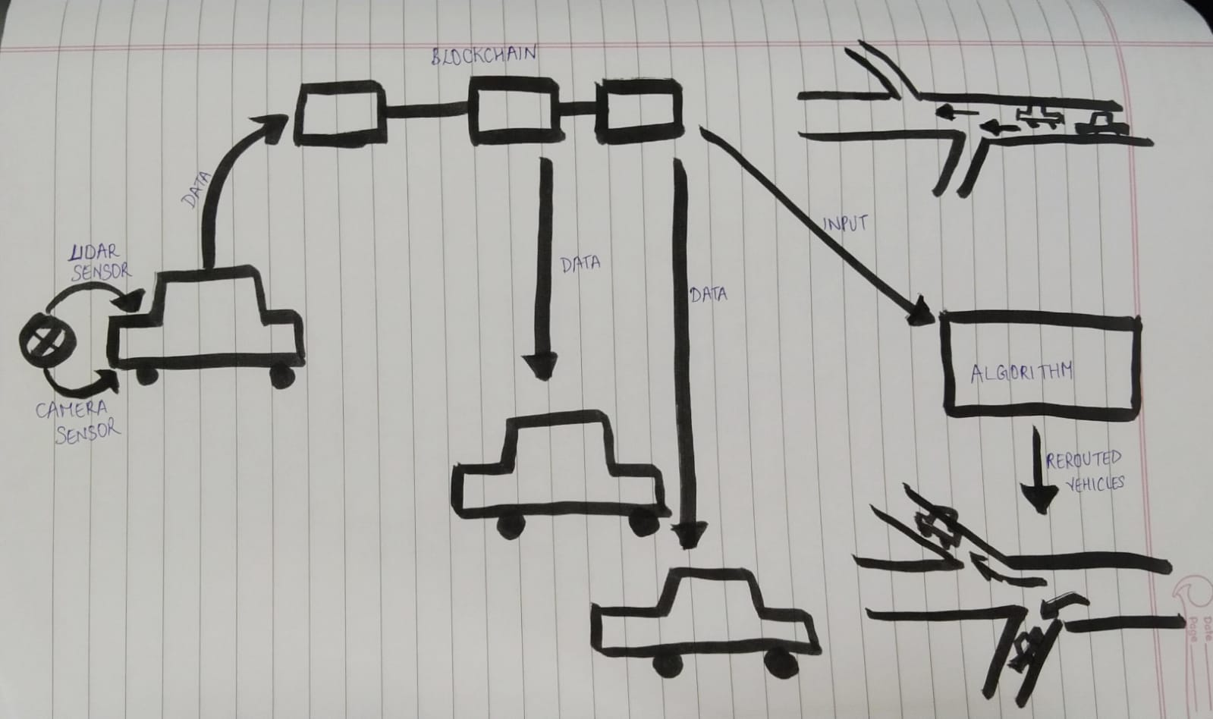

4.4Implementation

4.4.1Pseudo code

1. InitializeBlockchain()

1.1 Set up blockchain infrastructure

1.2 Configure smart contracts

2. TelematicDevice()

2.1 while (true)

2.1.1 trafficCongestion = MeasureTrafficCongestion()

2.1.2 collisionForce = MeasureCollisionForce()

2.1.3 StoreAccidentDataInBlockchain(trafficCongestion, collisionForce)

3. AutonomousVehicle()

3.1 while (true)

3.1.1 accidentData = GetAccidentDataFromBlockchain()

3.1.2 bestRoute = AStarAlgorithm(accidentData)

3.1.3 RerouteAutonomousVehicle(bestRoute)

4. MeasureTrafficCongestion()

4.1 Implement telematic devices logic

4.2 Return traffic congestion level

5. MeasureCollisionForce()

5.1 Implement telematic devices logic

5.2 Return collision force level

6. StoreAccidentDataInBlockchain(trafficCongestion, collisionForce)

6.1 Add new block to the blockchain with trafficCongestion and collisionForce data

7. GetAccidentDataFromBlockchain()

7.1 Retrieve latest accident data from the blockchain

7.2 Return accident data

8. AStarAlgorithm(accidentData)

8.1 Implement A* algorithm logic

8.2 Use accidentData to adjust route calculations based on traffic conditions

8.3 Return the best route

9. RerouteAutonomousVehicle(bestRoute)

9.1 Implement logic to update vehicle navigation system with the new route

4.4.2 Output

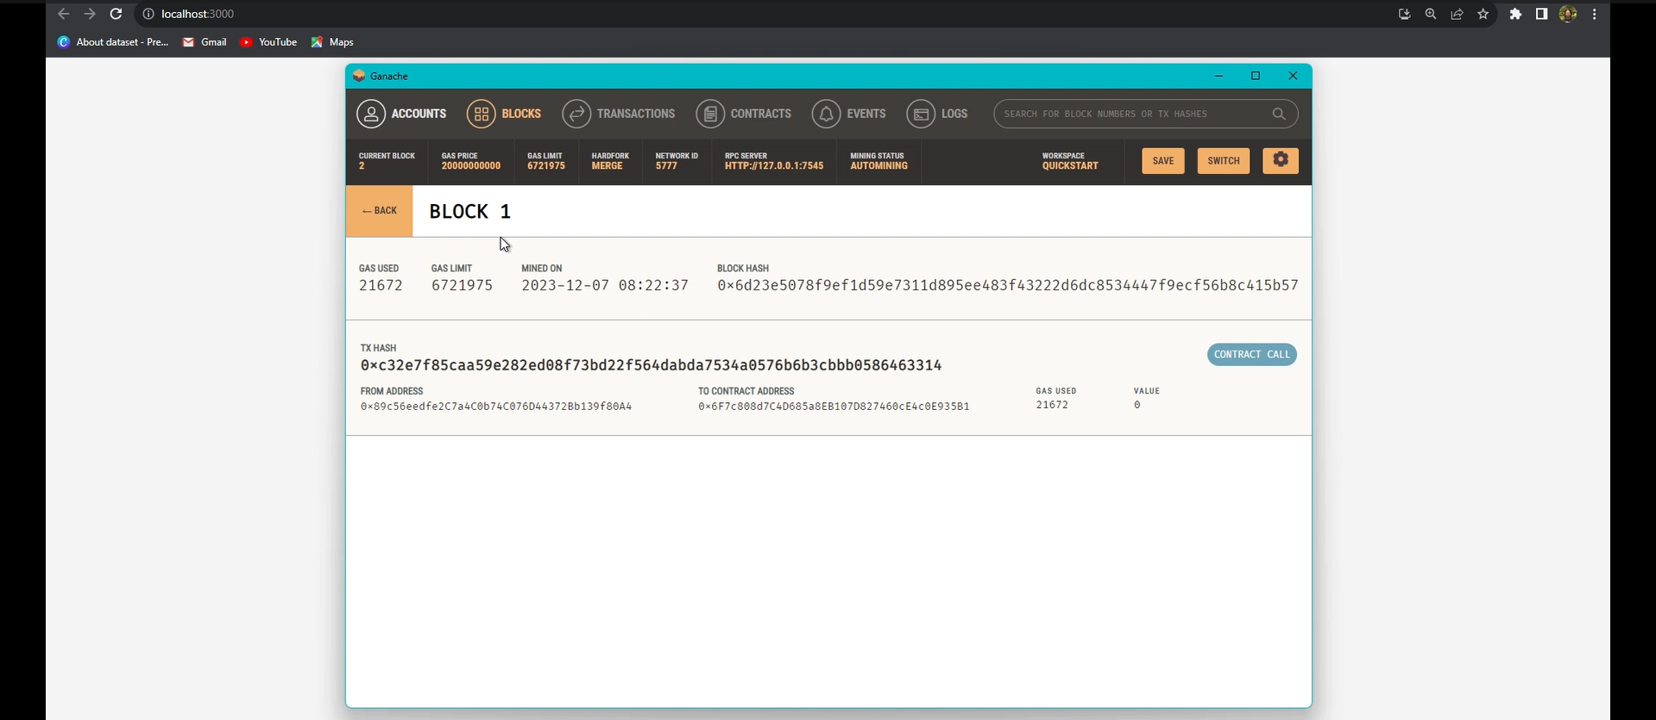

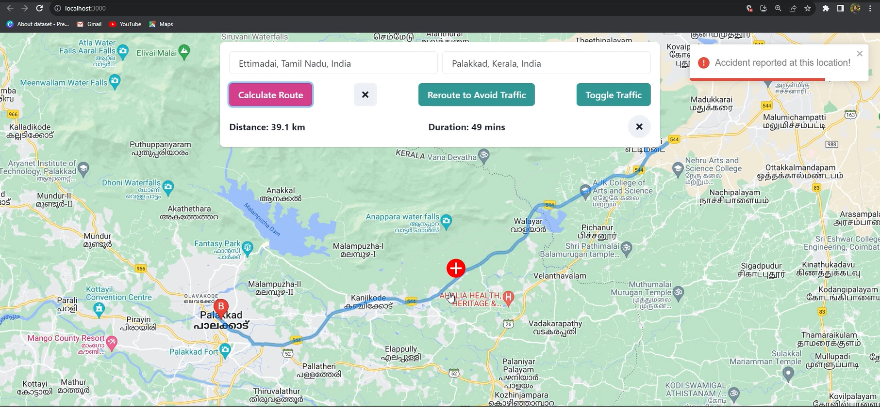

References/Bibliography:

# 

1. Nguyen, Huong, et al. "Situation awareness for autonomous vehicles using blockchain-based service cooperation." International Conference on Advanced Information Systems Engineering. Cham: Springer International Publishing, 2022.
2. Moradi, Nima, İhsan Sadati, and Bülent Çatay. "Last mile delivery routing problem using autonomous electric vehicles." Computers & Industrial Engineering (2023): 109552.
3. Perumal, P. Shunmuga, et al. "LaneScanNET: A deep-learning approach for simultaneous detection of obstacle-lane states for autonomous driving systems." Expert Systems with Applications 233 (2023): 120970.
4. Guo, Hao, et al. "Proof-of-event recording system for autonomous vehicles: A blockchain-based solution." IEEE Access 8 (2020): 182776-182786.
5. Varga, László Z. "Solutions to the routing problem: towards trustworthy autonomous vehicles." Artificial Intelligence Review 55.7 (2022): 5445-5484.
6. Sheng, Shili, et al. "Trust-based route planning for automated vehicles." Proceedings of the ACM/IEEE 12th International Conference on Cyber-Physical Systems. 2021.
7. Shi, Xiupeng, et al. "An automated machine learning (AutoML) method of risk prediction for decision-making of autonomous vehicles." IEEE Transactions on Intelligent Transportation Systems 22.11 (2020): 7145-7154.
8. Liu, Yixuan, and Andrew B. Whinston. "Efficient real-time routing for autonomous vehicles through bayes correlated equilibrium: An information design framework." Information Economics and Policy 47 (2019): 14-26.
9. Agafonov, Anton, and Aleksandr Borodinov. "A route reservation approach for an autonomous vehicles routing problem." MATEC Web of Conferences. Vol. 220. EDP Sciences, 2018.
10. Reebadiya, Dakshita, et al. "Blockchain-based secure and intelligent sensing scheme for autonomous vehicles activity tracking beyond 5g networks." Peer-to-Peer Networking and Applications 14 (2021): 2757-2774.
11. Li, Tang, et al. "An analysis of the value of optimal routing and signal timing control strategy with connected autonomous vehicles." Journal of Intelligent Transportation Systems (2022): 1-15.
12. <https://www.linkedin.com/advice/1/what-benefits-challenges-using-dynamic-routing-protocols>
13. <https://medium.com/analytics-vidhya/datasets-for-machine-learning-in-autonomous-vehicles-dd13bae5925b>