#### 3.2.2.1 Test Configurations

**Purpose**: Configuration is kind of installation. This interface check a configuration and simulates the creation of the data relating to the test. Test configuration defines each Test along associated parameter details and limit details against every defined Standard. These configurations along with parameters, limit details are further used in serial number test execution in test lab.

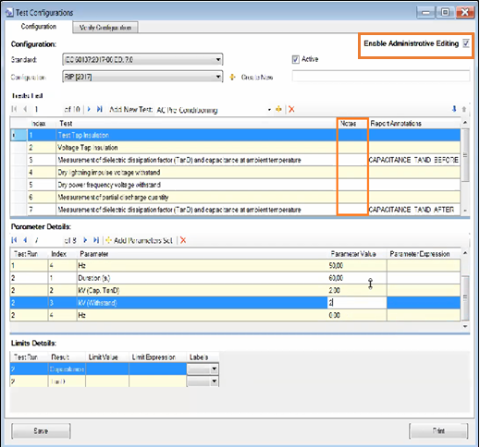

Figure 38.3.10.1: Current OMW Test Client: Test Configurations Screen

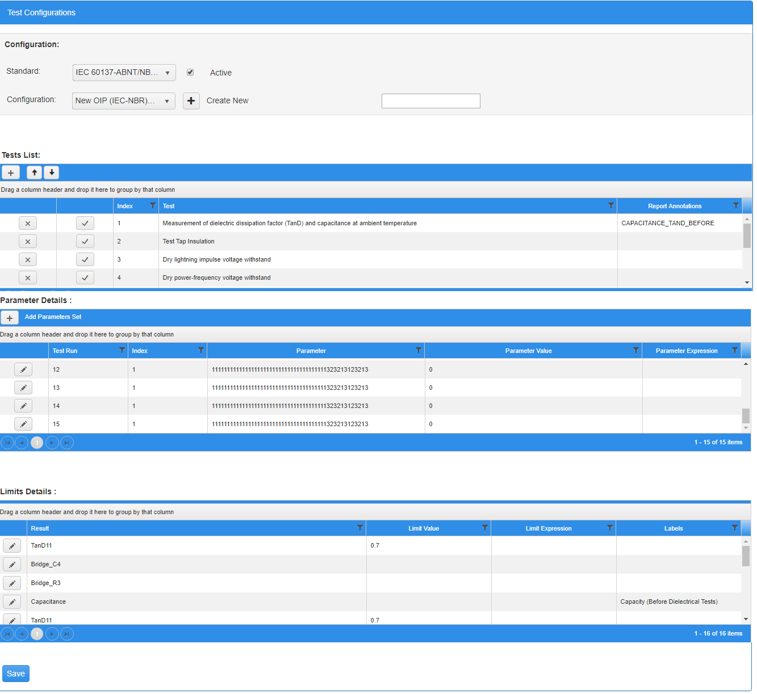

Figure 38.3.10.2: Proposed OMW Rebuilding: Tests - Test Configurations Screen

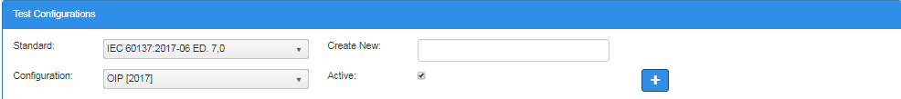

Figure 38.3.10.2.1: Proposed OMW Rebuilding: Tests -Test Configurations Screen– Test Configurations Section

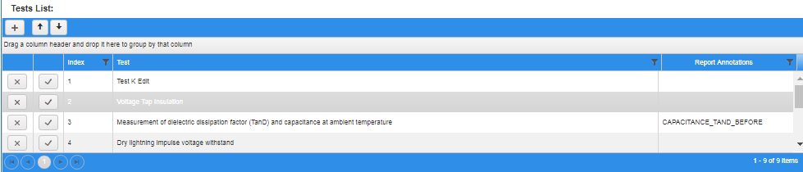

Figure 38.3.10.2.2: Proposed OMW Rebuilding: Test - Test Configurations Screen – Tests List Section

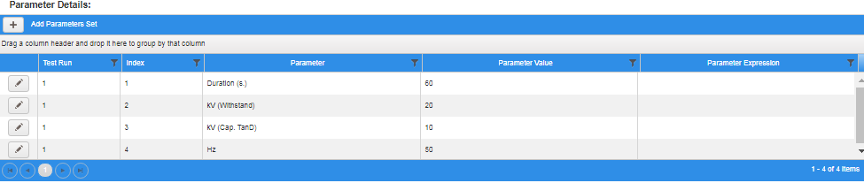

Figure 38.3.10.2.3: Proposed OMW Rebuilding: Test - Test Configurations Screen – Parameter Details Section

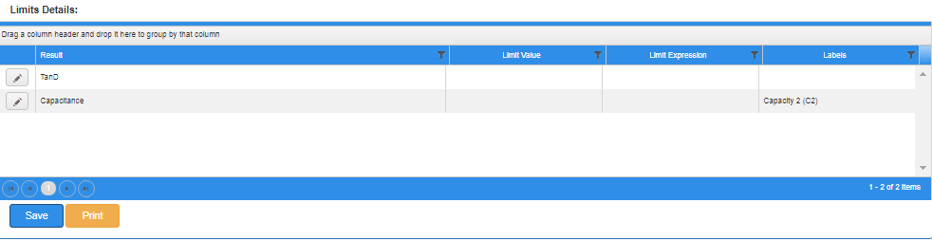

Figure 38.3.10.2.4: Proposed OMW Rebuilding: Test - Test Configurations Screen – Limit Details Section

**Details:**

Following changes would be accomplished in OMW web application:

1. Notes field will be removed from Test grid of Test Configuration screen (Figure 38.3.10.1)
2. “Enable Administrative Editing” button will be removed from Test Configuration screen (Figure 38.3.10.1)

By selecting Standard data from drop down (Standard data is coming from Standards screen, Refer Section 3.2.2.3.7), Configuration data will auto populate**.** Based on the Standard and Configuration selection, All Tests List will be displayed Tests List grid section. This Test list data is coming from Tests Screen. (Refer Section 3.2.2.3.1)

Further selecting any Test record from Tests List grid, it will display the List of All Parameters in Parameters Details grid section, Parameter List is coming from Test Parameters Screen. (Refer Section 3.2.2.3.2 ) Further selecting any Test record from Tests List grid, it will display the List of Limit details, Limit details list is coming from Limit Expression Screen (Refer Section 3.2.2.3.2 ).

Following are the buttons available on the screen:

1. Test Configurations Section: ( Figure 38.3.10.2.1 )

* ** (Create New):** By entering Configuration name in “Create New” field and then clicking on “+” button, will add the new Configuration record. However, Configuration name should be Unique, it will not allow to add already existing Configuration name, which already exists in system. ( Figure 38.3.12.2.1 )

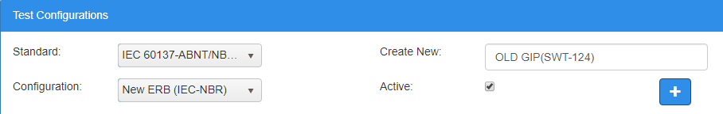

Figure 38.3.12.2.1: Proposed OMW Rebuilding**:** Add New Configuration screen

1. Tests Lists Section : ( Figure 38.3.10.2.2 )

* ** (Add New Test):** By Clicking on Add (+) New Test button, a new window (Figure 38.3.12.2.2) will be displayed with “Test” and “Report Annotations” fields along with “Save and Cancel buttons.

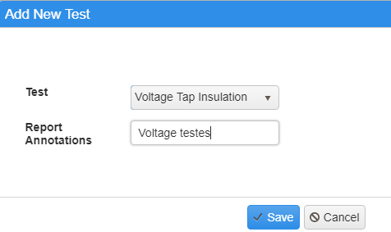

Figure 38.3.12.2.2: Proposed OMW Rebuilding**:** Add New Test screen

*  **Delete :** Delete button is placed in each record of Test Results grid. By clicking on this button, a confirmation message appears with message “Are you sure, you want to delete this record?” with “OK” and “Cancel” buttons.
*  **Select:** By clicking on Select button, Related Parameter list will be showed in Parameter Details grid.
* ** Up:** By clicking on Up button, selected test record will be moved upwards. If it is first test record, nothing happens.
* ** Down:** By clicking on Down button, selected test record will be moved downwards. If it is last test record, nothing happens.

1. Parameter Details Section: : ( Figure 38.3.10.2.3 )

*  **Add Parameter Set :** “Add Parameters Set” button will add the new Parameter Set record and enter all data of fields. All parameters for the selected test record are added. ( Refer Section 3.2.2.3.2 )
*  **Edit**: Edit button is placed in each record of Parameter Details grid. By clicking on this button, an edit window to appear (Figure 38.3.12.2.3 ) to edit the fields “Parameter Value” and “Parameter Expressions” along with “Update” and “Cancel” buttons.

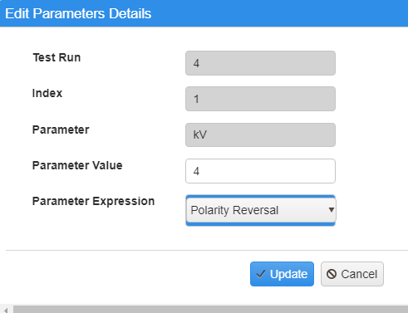

Figure 38.3.12.2.3: Proposed OMW Rebuilding**:** Edit Parameters Details Screen

1. Limit Details Section: : ( Figure 38.3.10.2.4 )

*  **Edit** : Edit button is placed in each record of Limits Detail grid. By clicking on this button, an edit window (Figure 38.3.12.2.4) appears to edit the field “Labels” along with “Update” and “Cancel” buttons.

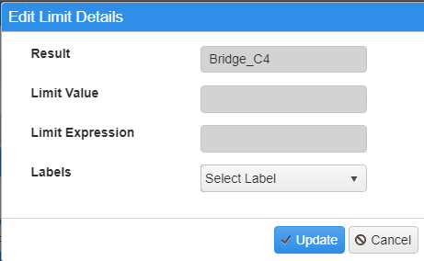

Figure 38.3.12.2.4: Proposed OMW Rebuilding**:** Edit Parameters Details Screen

* **(Save):** Save button will save all the entered data of screen.
* **Print :** Print button will allow to print the screen.

#### 3.2.2.1.1 Verify Configurations

**Purpose**: Verify configuration is the replica of Test Configuration screen in read only mode. That means it is same like Test Configuration screen but without any Button(s) and Edit mode.



Figure 38.3.12.2.4.0.1: Current OMW**:** Verify Configuration Screen

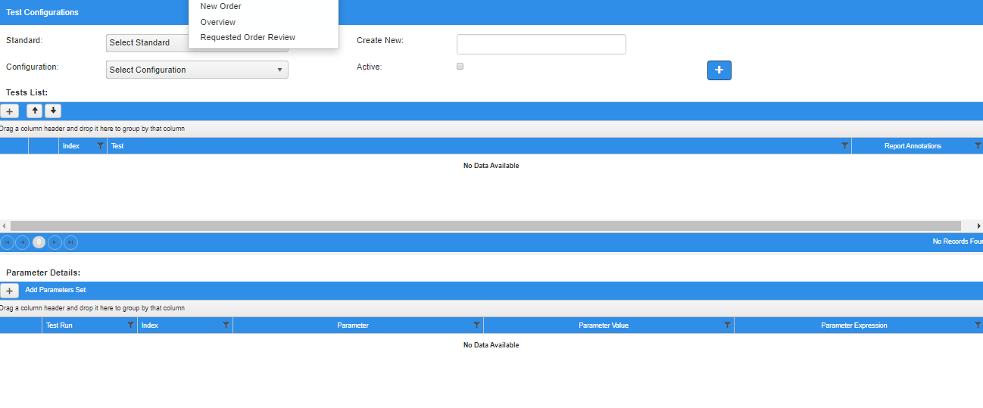

Figure 38.3.12.2.4.0.2: Proposed OMW Rebuilding Verify Configuration Screen

#### 3.2.2.2 Tooling

Consists of following menus items:

* Bridges
* Capacitors
* Circuits
* Labs

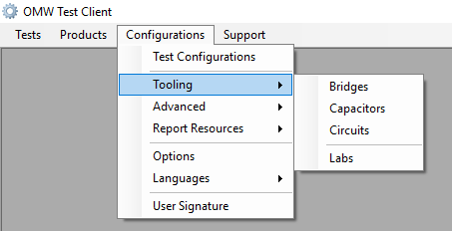

Figure 38.3.12.2.4.1: Current OMW Test Client: Configurations - Tooling Menu

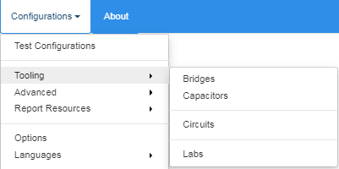

Figure 38.3.12.2.4.2: Proposed OMW Rebuilding: Configurations -Tooling Menu

#### 3.2.2.2.1 Bridges

**Purpose:** The purpose of “Bridges” screen is to set values related to the various Bridges used for testing. This screen is used to maintain bridge as sharing bridge. I.e. Electrical Instrumentation.

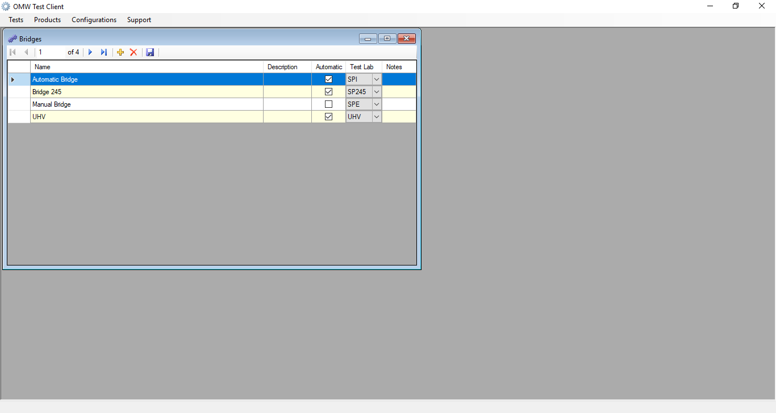

Figure 38.3.12.2.4.3: Current OMW Test Client: Configurations -Tooling - Bridges Screen

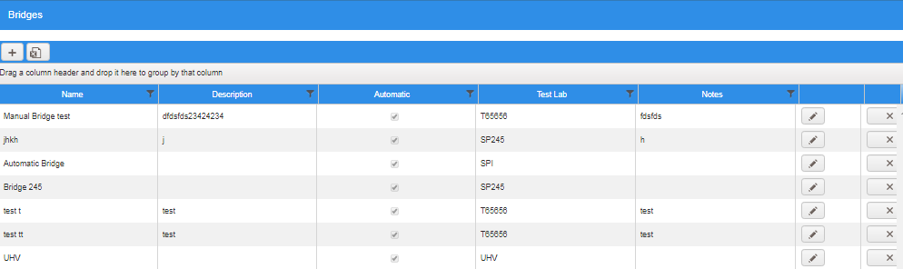

Figure 38.3.12.2.4.4: Proposed OMW Rebuilding: Configurations - Tooling - Bridges Screen

**Details:** Following are the buttons available on the screen:

* ** (Add) :** Add (+) button opens a new window (Figure 38.3.12.2.4.5 ) to add a new record with below fields displayed along with “Save” and “Cancel” buttons.
* Name
* Description
* Automatic
* Test Lab
* Notes

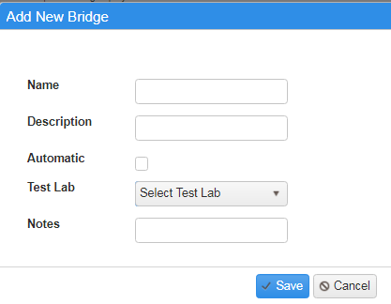

Figure 38.3.12.2.4.5: Proposed OMW Rebuilding **:** Add New Bridge screen

* ** (Export as Excel):** By clicking on this button all records will be exported in excel format.
* **(Edit):** Edit button is placed in each record of Bridges grid. By clicking on this button, an edit window appears (just like Add functionality) to edit the record along with “Update” and “Cancel” buttons.

** (Delete):** Delete button is placed in each record of Bridges grid**.** By clicking on this button, a confirmation message appears with message “Are you sure, you want to delete this record?” with “OK” and “Cancel” buttons.

#### 3.2.2.2.2 Capacitors

**Purpose:** The purpose of Capacitor screen allows setting the records related to the capacitors used during the test as internal Settings. A new Parameters section appears by clicking on any Capacitors record, displayed on bottom of the screen.

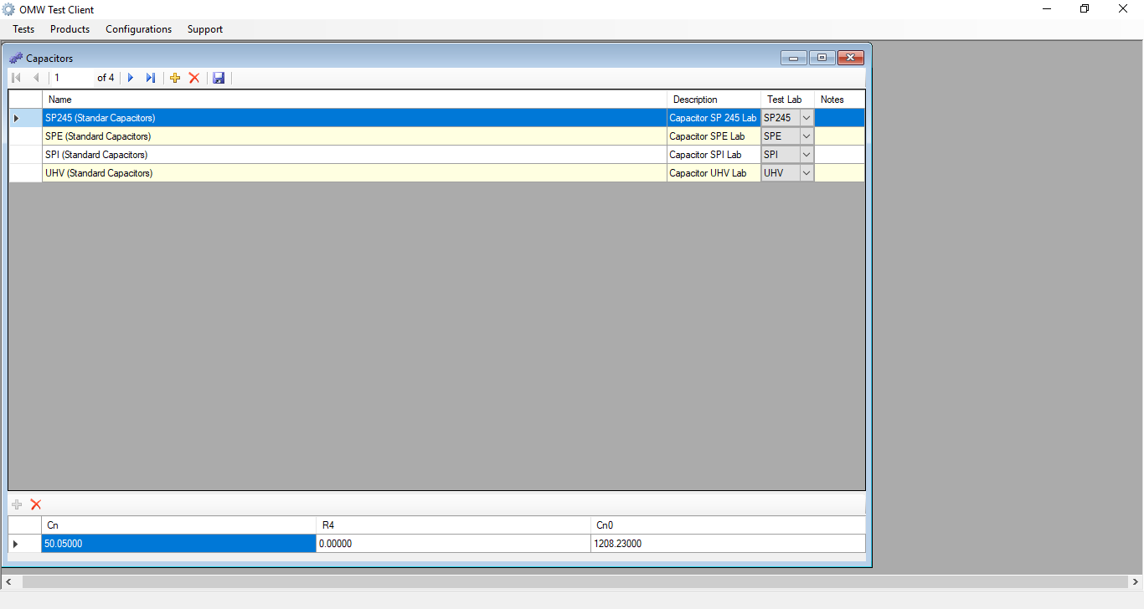

Figure 38.3.13.1: Current OMW Test Client: Configurations - Tooling - Capacitor Screen

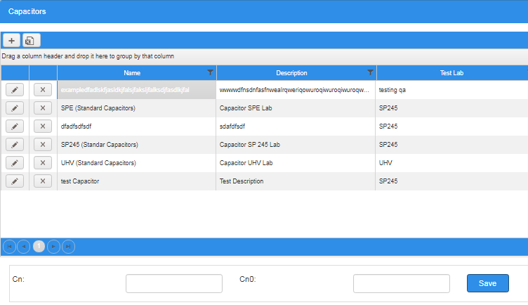

Figure 38.3.13.3: Proposed OMW Rebuilding: Configurations - Tooling - Capacitors Screen-Parameter section

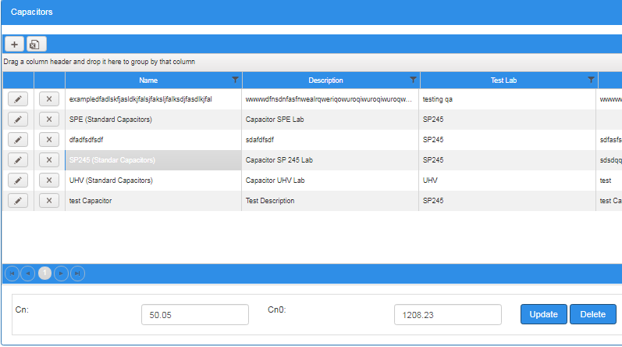

Figure 38.3.13.4: Proposed OMW Rebuilding: Configurations -Tooling - Capacitors Screen -Parameter section

**Details:**

Following changes would be accomplished in OMW web application:

1. R4 field will be Removed from parameters section (Figure 38.3.13.1)

Following are the buttons available on the screen:

* ** (Add):** Add (+) button opens a new window (Figure 38.3.13.5) to add a new record with below fields displayed along with “Save” and “Cancel” buttons.
* Name
* Description
* Test Lab
* Notes

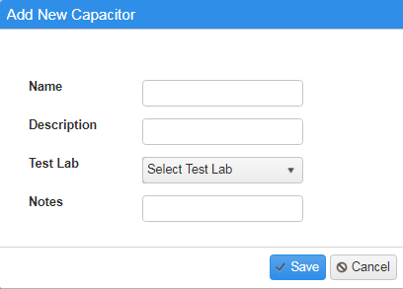

Figure 38.3.13.5: Proposed OMW Rebuilding **:** Add New Capacitor screen

* ** (Export as Excel):** By clicking on this button all records will be exported in excel format.
* **(Edit):** Edit button is placed in each record of Capacitors grid. By clicking on this button, an edit window appears (just like Add functionality) to edit the record along with “Update” and “Cancel” buttons.
* **(Delete):** Delete button is placed in each record of Capacitors grid**.** By clicking on this button, a confirmation message appears with message “Are you sure, you want to delete this record?” with “OK” and “Cancel” buttons.
* **Save:** Save button appears when clicking on any capacitor record,displayed on bottom of the screen along with Cn and Cn0 fields for save Cn and Cn0 parameters (Figure 38.3.13.3).
* **Update:** Update button appears when clicking on any record,displayed on bottom of the screen along with Cn and Cn0 fields, when Cn and Cn0 is already saved and need to update further (Figure 38.3.13.4).
* **Delete:** Update button appears when clicking on any record,displayed on bottom of the screen along with Cn and Cn0 fields, when Cn and Cn0 is already saved and need to delete further (Figure 38.3.13.4).

#### 3.2.2.2.3 Circuits

**Purpose:** The purpose of Circuits screen is to configure the test circuits as internal settings.

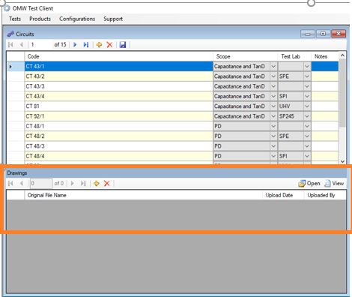

Figure 38.3.14.1: Current OMW Test Client: Configurations – Tooling - Circuits Screen

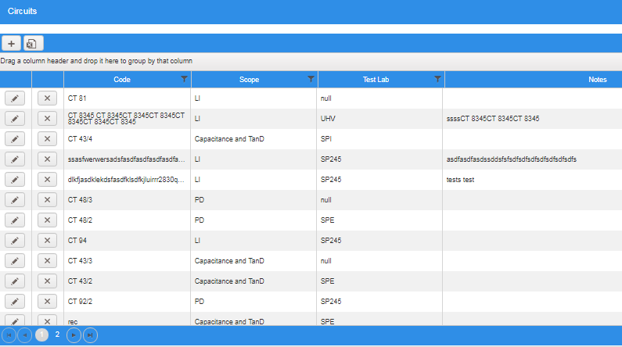

Figure 38.3.14.2: Proposed OMW Rebuilding: Configurations - Tooling - Circuits Screen

**Details:**

Following changes would be accomplished in OMW web application:

1. Drawings section will be removed. (Figure 38.3.14.1)

Following are the buttons available on the screen:

* ** (Add):** Add (+) button opens a new window (Figure 38.3.14.2.1) to add a new record with below fields displayed along with “Save” and “Cancel” buttons.
* Code
* Scope
* Test Lab
* Notes

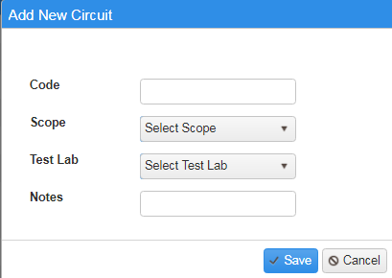

Figure 38.3.14.2.1: Proposed OMW Rebuilding**:** Add New Circuit screen

* ** (Export as Excel):** By clicking on this button all records will be exported in excel format.
* **(Edit):** Edit button is placed in each record of Circuits grid. By clicking on this button, an edit window appears (just like Add functionality) to edit the record along with “Update” and “Cancel” buttons.
* **(Delete):** Delete button is placed in each record of Circuits grid**.** By clicking on this button, a confirmation message appears with message “Are you sure, you want to delete this record?” with “OK” and “Cancel” buttons.

#### 3.2.2.2.4 Labs

**Purpose:** The purpose of Labs screen allows to configure the test labs as internal settings.

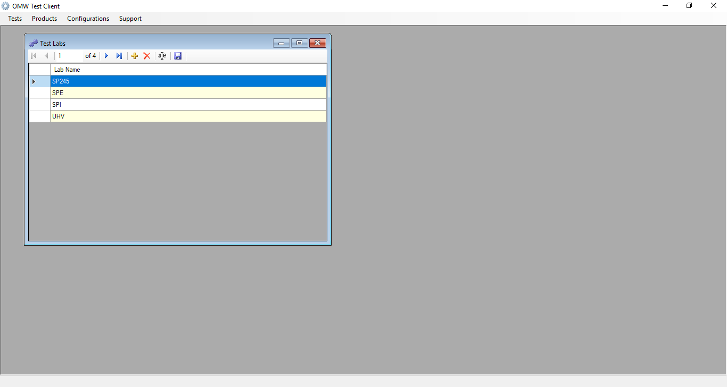

Figure 38.3.15.1: Current OMW Test Client: Configurations - Tooling - Labs Screen

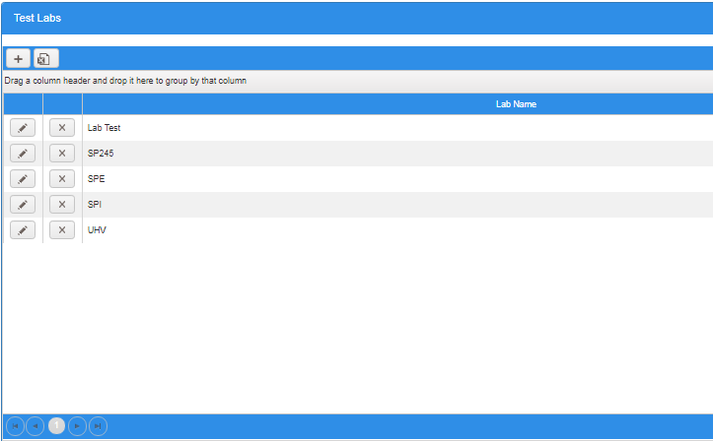

Figure 38.3.15.2: Proposed OMW Rebuilding: Configurations - Tooling - Labs Screen

**Details:**

Following are the buttons available on the screen:

* ** (Add):** Add (+) button opens a new window (Figure 38.3.15.2.1) to add a new record with below fields displayed along with “Save” and “Cancel” buttons.
* Lab Name

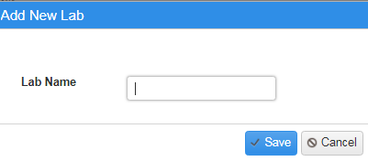

Figure 38.3.15.2.1: Proposed OMW Rebuilding**:** Add New Lab screen

* ** (Export as Excel):** By clicking on this button all records will be exported in excel format.
* **(Edit):** Edit button is placed in each record of Labs grid. By clicking on this button, an edit window appears (just like Add functionality) to edit the record along with “Update” and “Cancel” buttons.
* **(Delete):** Delete button is placed in each record of Labs grid**.** By clicking on this button, a confirmation message appears with message “Are you sure, you want to delete this record?” with “OK” and “Cancel” buttons.

#### 3.2.2.3 Advanced

This section is used to define the settings related to the Advanced used for the testing.

Consists of following menus items:

* Tests
* Test Parameters
* Test Results
* Um Expressions
* Limit Expressions
* Standard Ratings Mapping
* Standards
* Standards (Label Printing)

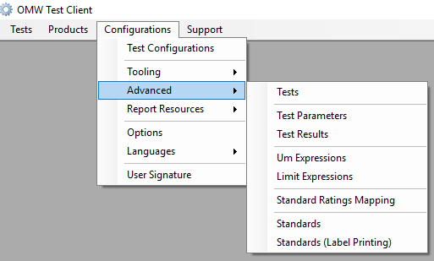

Figure 38.3.16.1: Current OMW Test Client: Configuration - Advanced Menu

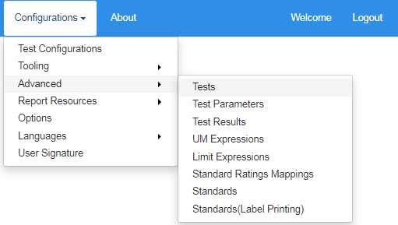

Figure 38.3.16.2: Proposed OMW Rebuilding: Configurations - Advanced Menu

#### 3.2.2.3.1 Tests

**Purpose:** The purpose of Tests screen allows to Add/configure the all tests.

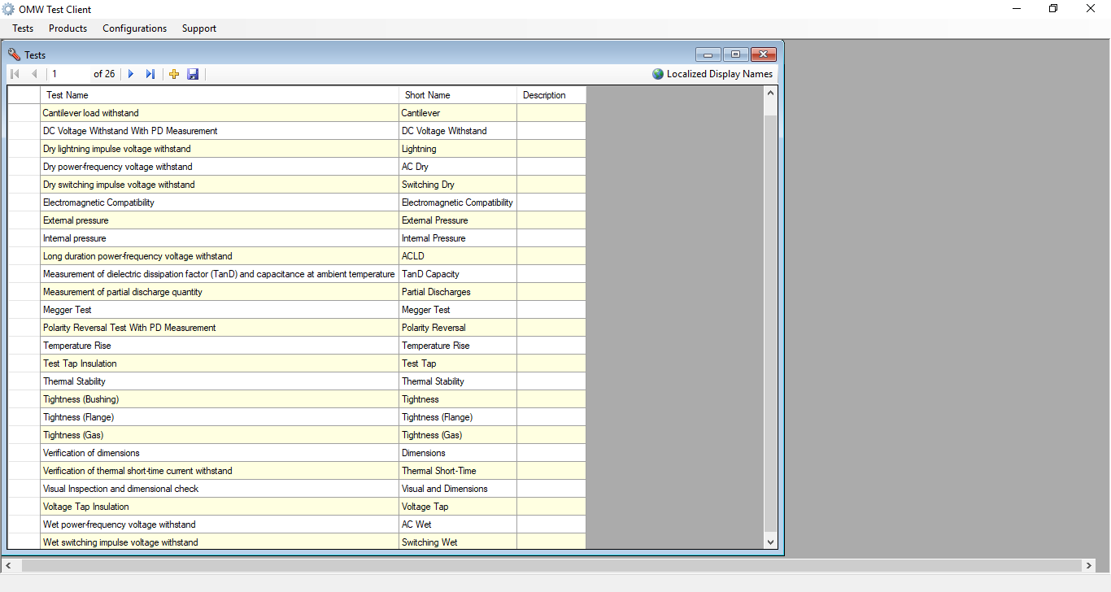

Figure 38.3.17.1: Current OMW Test Client: Configurations - Advanced - Tests Screen

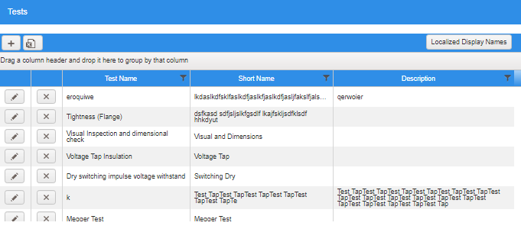

Figure 38.3.17.2: Proposed OMW Rebuilding: Configurations - Advanced - Tests Screen

**Details:**

Following are the buttons available on the screen:

* ** (Add):** Add (+) button opens a new window (Figure 38.3.17.2.1) to add a new record with below fields displayed along with “Save” and “Cancel” buttons.
* Test Name
* Short Name
* Description

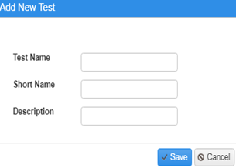

Figure 38.3.17.2.1: Proposed OMW Rebuilding**:** Add New Test screen

* ** (Export as Excel):** By clicking on this button all records will be exported in excel format.
* **Localized Display Name :** By clicking on any Tests record and then click on “Localized Display Name” button, a new window appears along with Add, Delete, Update buttons, to list out the display name of test record in different languages like Italian, Russian, French, Spanish, Portuguese, German, English.

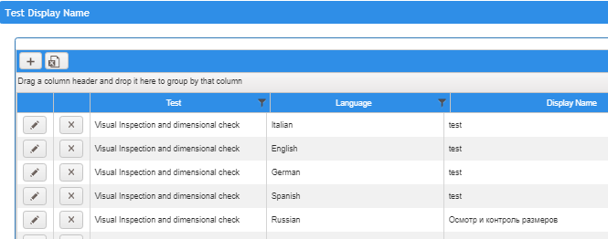

Figure 38.3.17.2.2: Proposed OMW Rebuilding**:** Localized Display Name screen

* **(Edit):** Edit button is placed in each record of Tests screen. By clicking on this button, an edit window appears (just like Add functionality) to edit the record along with “Update” and “Cancel” buttons.
* ** (Delete):** Delete button is placed in each record of Tests grid**.** By clicking on this button, a confirmation message appears with message “Are you sure, you want to delete this record?” with “OK” and “Cancel” buttons.

#### 3.2.2.3.2 Test Parameters

**Purpose:** The purpose of “Test Parameters” screen allows adding and keeping track all the related test parameters as per the selected Test.

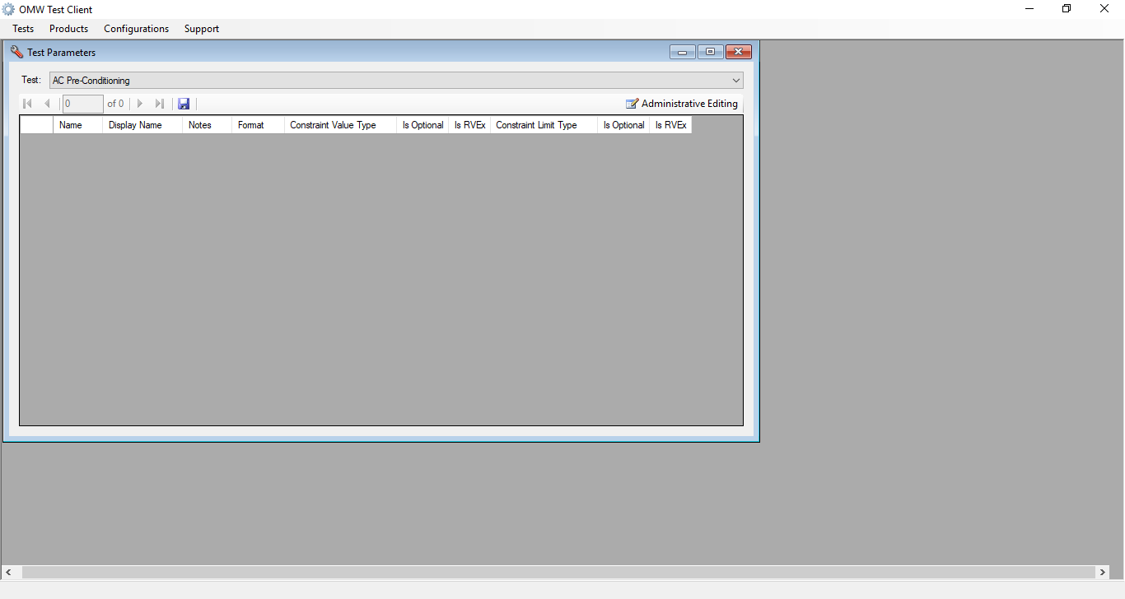

Figure 38.3.18.1: Current OMW Test Client: Configurations: Advanced - Test Parameters Screen

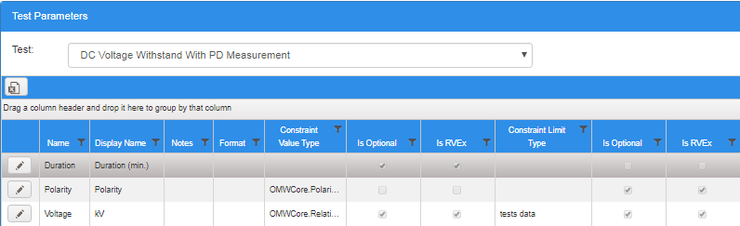

Figure 38.3.18.2: Proposed OMW Rebuilding: Configurations - Advanced - Test Parameters Screen

**Details:**

Following are the buttons available on the screen:

* ** (Export as Excel):** By clicking on this button all records will be exported in excel format.
* **(Edit):** Edit button is placed in each record of Test Parameters screen. By clicking on this button, an edit window (Figure 38.3.18.2.1) appears to edit the record along with “Update” and “Cancel” buttons.

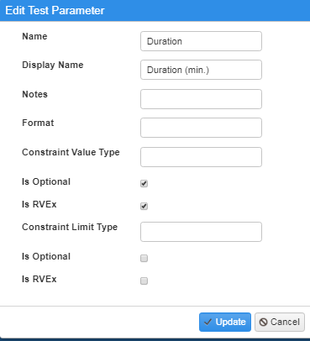

Figure 38.3.18.2.1: Proposed OMW Rebuilding**:** Edit Test Parameters Screen

#### 3.2.2.3.3 Test Results

**Purpose:** The purpose of “Test Results” screen is to add and keep track all the Test results of products that are tested.

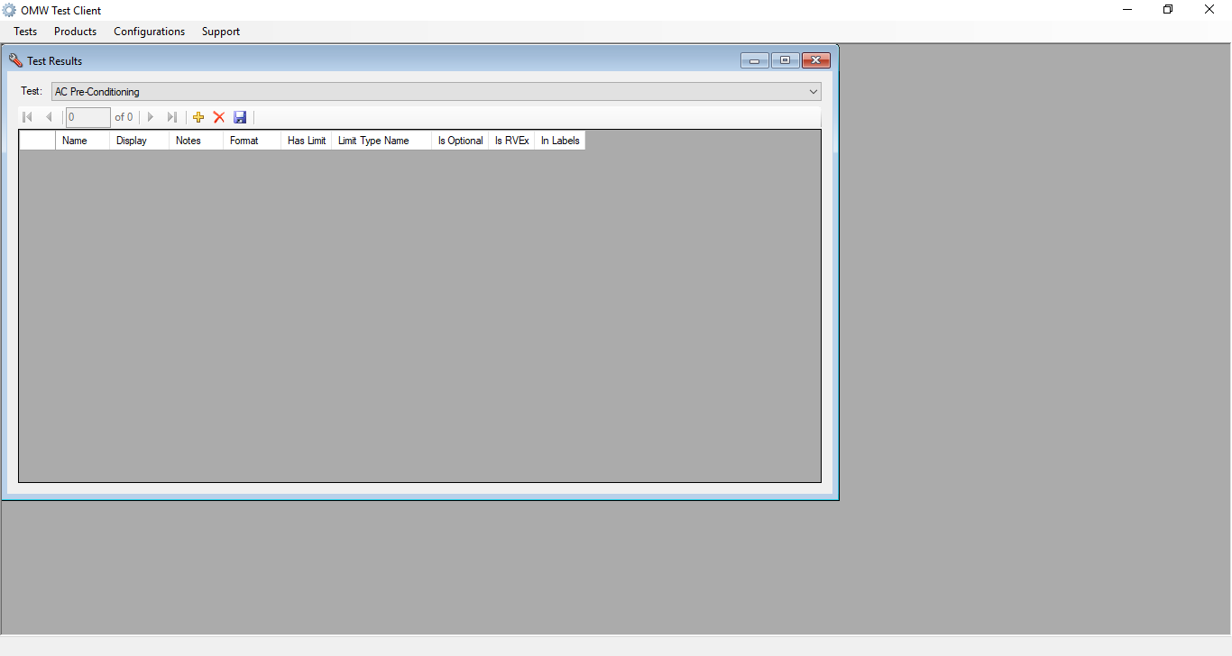

Figure 38.3.19.1: Current OMW Test Client: Configurations - Advanced - Test Results Screen

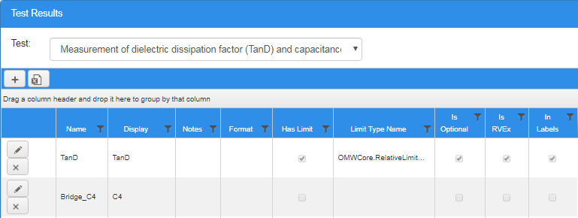

Figure 38.3.19.2: Proposed OMW Rebuilding: Configurations - Advanced - Test Results Screen

**Details:** Following are the buttons available on the screen:

* ** (Add):** Add (+) button opens a new window (Figure 38.3.19.2.1) to add a new record with below fields displayed along with “Save” and “Cancel” buttons.
* Name
* Display
* Notes
* Format
* Has Limit
* Limit Type Name
* Test
* Is Optional
* Is RVEx
* In Labels

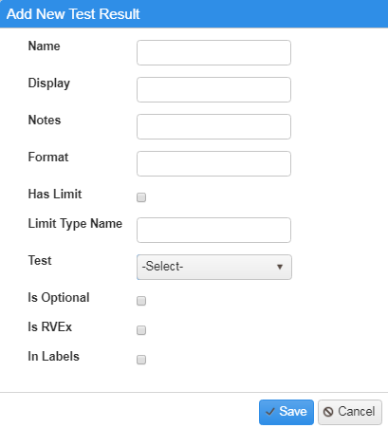

Figure 38.3.19.2.1: Proposed OMW Rebuilding**:** Add New Test Result screen

* ** (Export as Excel):** By clicking on this button all records will be exported in excel format.
* **(Edit):** Edit button is placed in each record of Test Results grid. By clicking on this button, an edit window appears (just like Add functionality) to edit the record along with “Update” and “Cancel” buttons.
* **(Delete):** Delete button is placed in each record of Test Results grid**.** By clicking on this button, a confirmation message appears with message “Are you sure, you want to delete this record?” with “OK” and “Cancel” buttons.

#### 3.2.2.3.4 Um Expressions

**Purpose:** The purpose of “Um Expressions” screen is to add and keep track all the Expressions measurement data of Expression Types like Product Standard properties, Standard Rating Conversions.

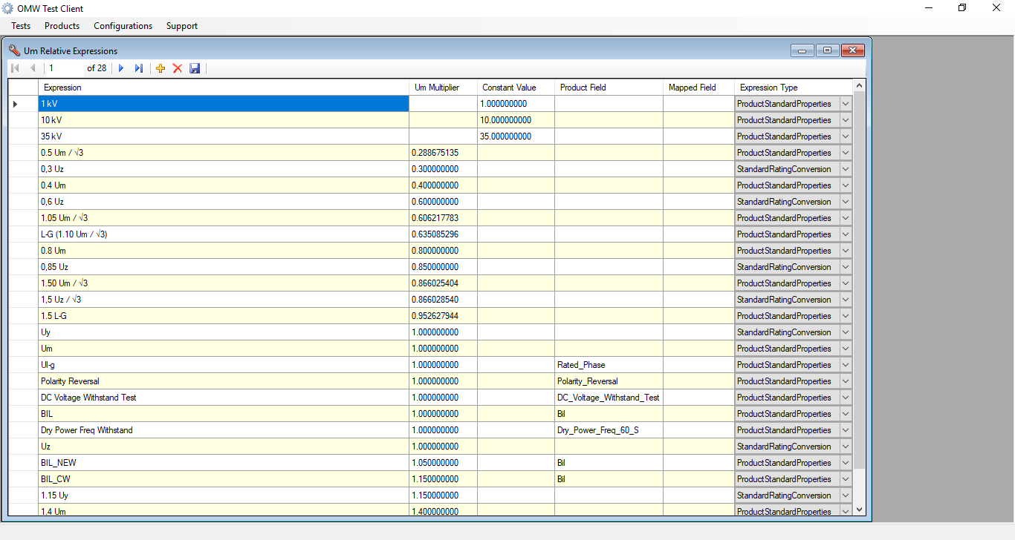

Figure 38.3.20.1: Current OMW Test Client: Configurations - Advanced - Um Expressions Screen

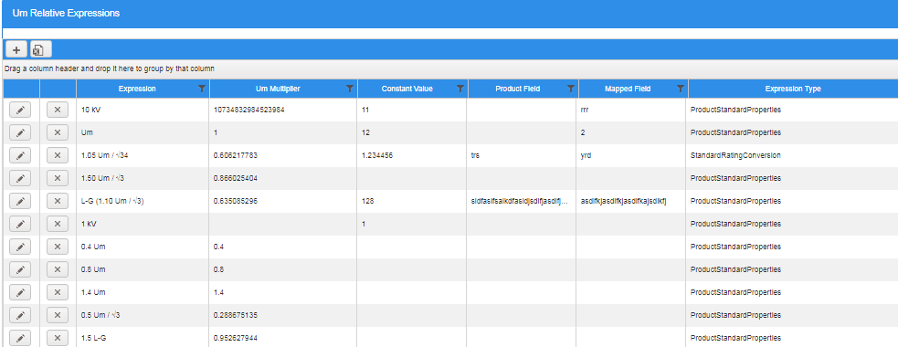

Figure 38.3.20.2: Proposed OMW Rebuilding: Configurations - Advanced - Um Expressions Screen

**Details:**

Following are the buttons available on the screen:

* ** (Add):** Add (+) button opens a new window (Figure 38.3.20.2.1) to add a new record with below fields displayed along with “Save” and “Cancel” buttons.
* Expression
* Um Multiplier
* Constant Value
* Product Field
* Mapped Field
* Expression Type

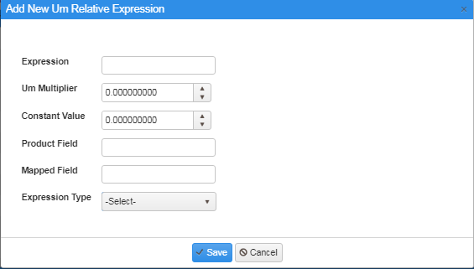

Figure 38.3.20.2.1: Proposed OMW Rebuilding**:** Add New Um Expressions Screen

* ** (Export as Excel):** By clicking on this button all records will be exported in excel format.
* **(Edit):** Edit button is placed in each record of Um Expressions grid. By clicking on this button, an edit window appears (just like Add functionality) to edit the record along with “Update” and “Cancel” buttons.
* **(Delete):** Delete button is placed in each record of Um Expressions grid**.** By clicking on this button, a confirmation message appears with message “Are you sure, you want to delete this record?” with “OK” and “Cancel” buttons.

#### 3.2.2.3.5 Limit Expressions

**Purpose:** The purpose of “Limit Expressions” screen is to add and keep track of all the Technologies’ properties like their “Applied voltage”, “Label”, “Limit value”.

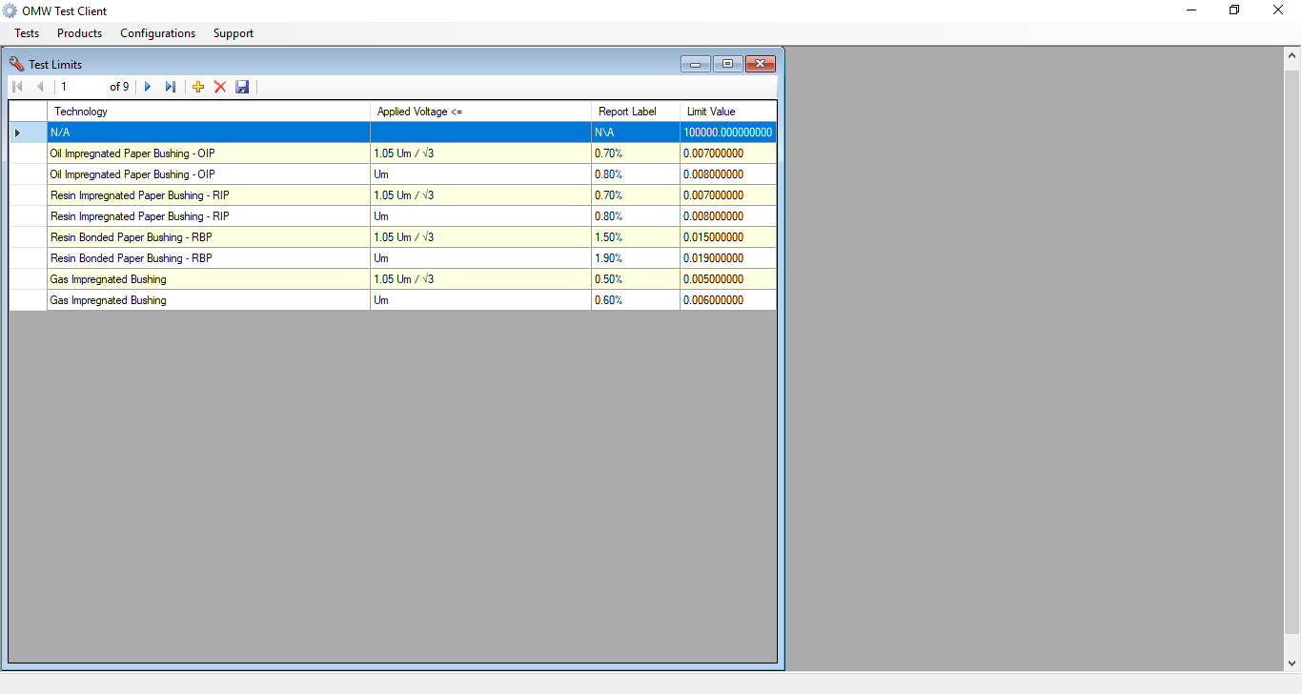

Figure 38.3.21.1: Current OMW Test Client: Configurations - Advanced - Limit Expressions Screen

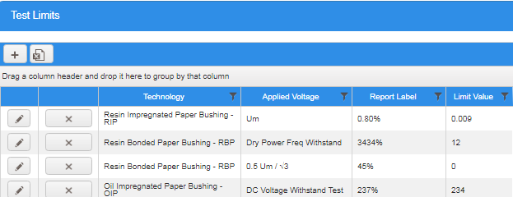

Figure 38.3.21.2: Proposed OMW Rebuilding: Configurations - Advanced - Limit Expressions Screen

**Details:**

Following are the buttons available on the screen:

* ** (Add):** Add (+) button opens a new window (Figure 38.3.21.2.1) to add a new record with below fields displayed along with “Save” and “Cancel” buttons.
* Technology
* Applied Voltage
* Report Label
* Limit Value

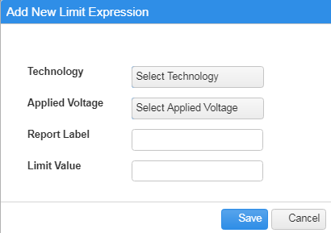

Figure 38.3.21.2.1: Proposed OMW Rebuilding**:** Add New Limit Expression screen

* ** (Export as Excel):** By clicking on this button all records will be exported in excel format.
* **(Edit):** Edit button is placed in each record of Limit Expressions grid. By clicking on this button, an edit window appears (just like Add functionality) to edit the record along with “Update” and “Cancel” buttons.
* ****(**Delete):** Delete button is placed in each record of Limit Expressions grid**.** By clicking on this button, a confirmation message appears with message “Are you sure, you want to delete this record?” with “OK” and “Cancel” buttons.

#### 

#### 3.2.2.3.6 Standard Ratings Mappings

**Purpose:** The purpose of “Standard Ratings Mappings” screen is to add and keep track of all the Standard’s’ properties for mapping like their “Voltage Classification”, “Maximum Voltage to Ground l”, “Minimum Creep” etc.

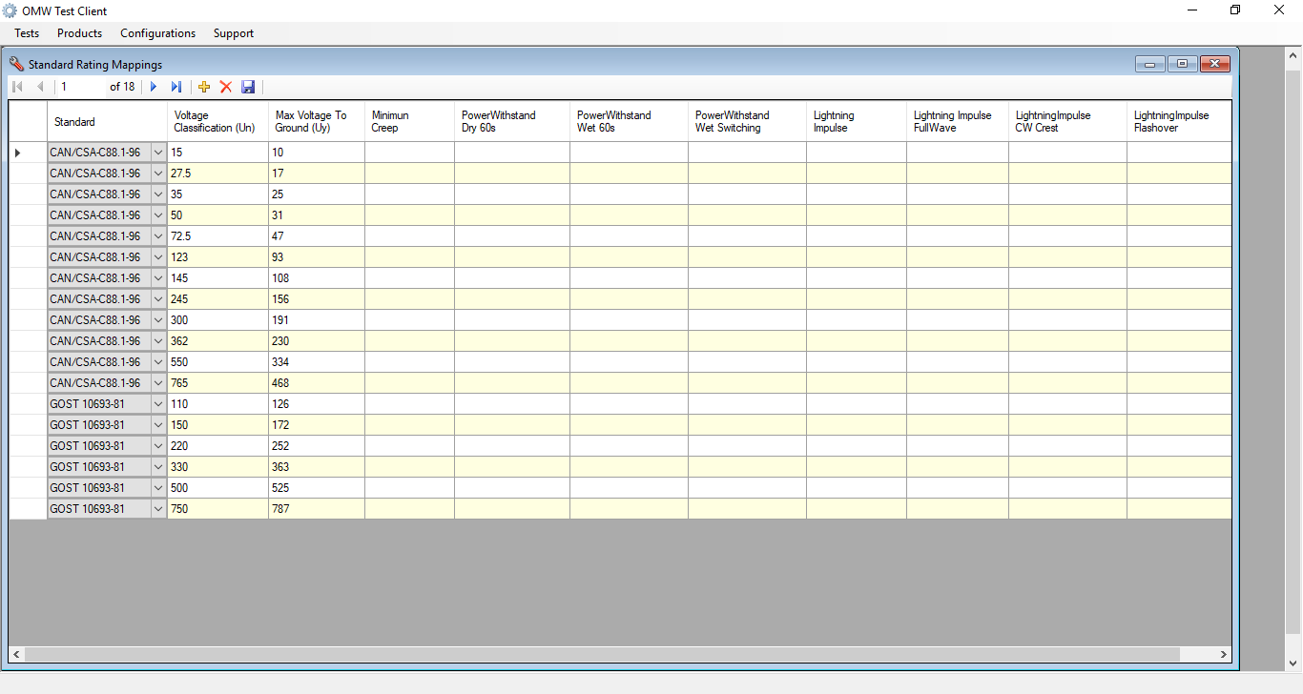

Figure 38.3.22.1: Current OMW Test Client: Configurations - Advanced - Standard Ratings Mappings Screen

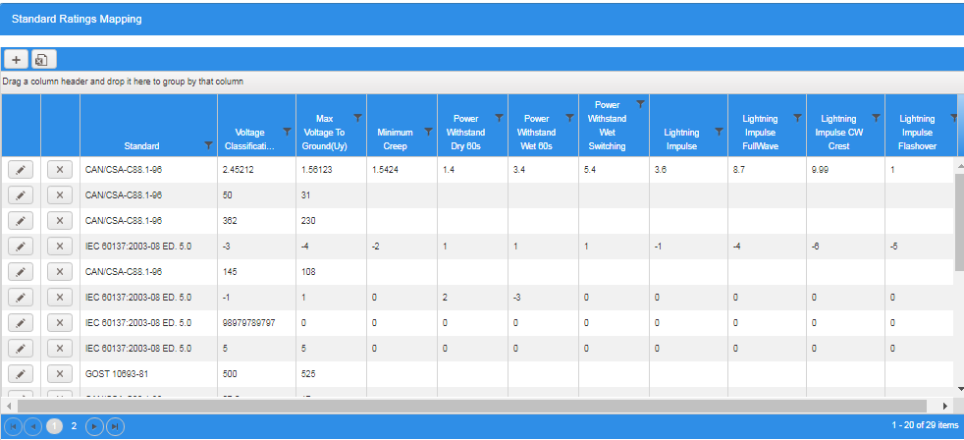

Figure 38.3.22.2: Proposed OMW Rebuilding: Configurations -Advanced - Standard Ratings Mappings Screen

**Details:**

Following are the buttons available on the screen:

* ** (Add):** Add (+) button opens a new window (Figure 38.3.22.2.1 )to add a new record with below fields displayed along with “Save’ and “Cancel” buttons.
* Standard
* Voltage Classification
* Max Voltage to Ground
* Minimum Creep
* Power Withstand Drt60s
* Power Withstand Wet60s
* Power Withstand Wet Switching
* Lighting Impulses
* Lighting Impulses FullWave
* Lighting Impulsive CW Crest
* Lighting Impulses Flashover

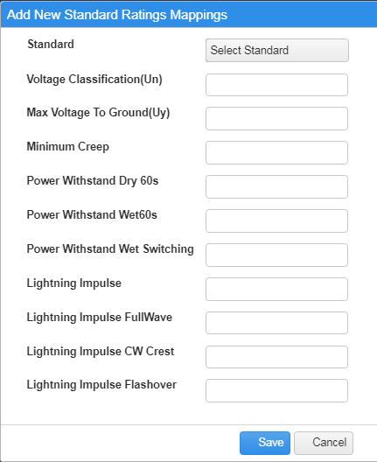

Figure 38.3.22.2.1: Proposed OMW Rebuilding**:** Add New Standard Ratings Mappings Screen

* ** (Export as Excel):** By clicking on this button all records will be exported in excel format.
* **(Edit):** Edit button is placed in each record of Standard Ratings Mappings grid. By clicking on this button, an edit window appears (just like Add functionality) to edit the record along with “Update” and “Cancel” buttons.
* ****(**Delete):** Delete button is placed in each record of Standard Ratings Mappings grid**.** By clicking on this button, a confirmation message appears with message “Are you sure, you want to delete this record?” with “OK” and “Cancel” buttons.

#### 3.2.2.3.7 Standards

**Purpose:** The purpose of “Standards” screen is to add and keep track of all the Standard Data with their Labels Standard and Standard Tendering.

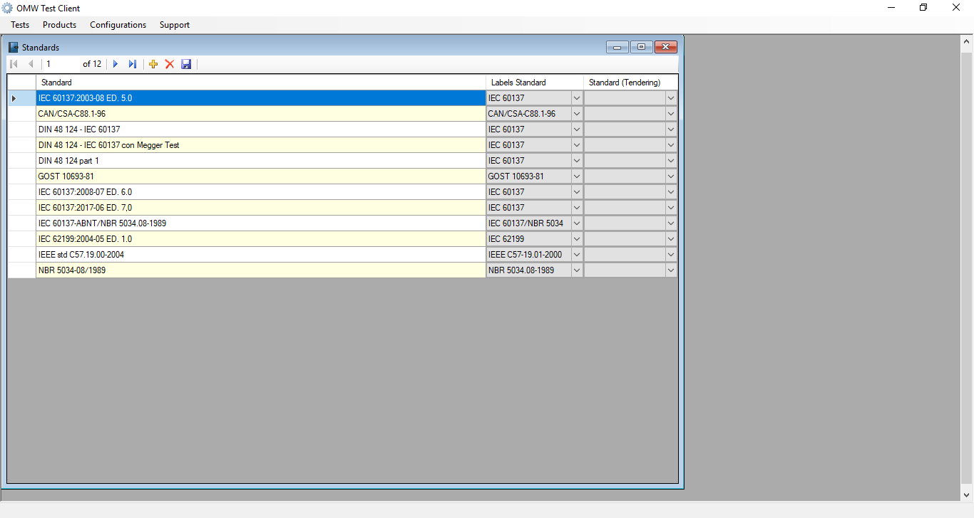

Figure 38.3.23.1: Current OMW Test Client: Configurations - Advanced - Standards Screen

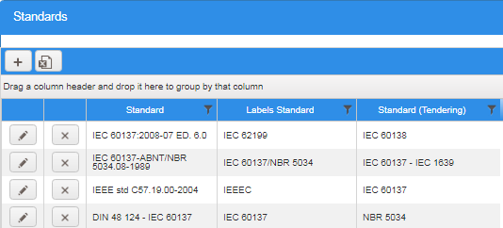

Figure 38.3.23.2: Proposed OMW Rebuilding: Configurations - Advanced - Standards Screen

**Details:**

Following are the buttons available on the screen:

* ** (Add):** Add (+) button opens a new window (Figure 38.3.23.2.1) to add a new record with below fields displayed along with “Save” and “Cancel” buttons.
* Standard
* Labels Standard
* Standard(Tendering)

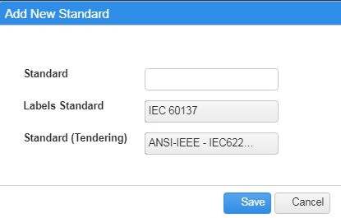

Figure 38.3.23.2.1: Proposed OMW Rebuilding**:** Add New Standard Screen

* ** (Export as Excel):** By clicking on this button all records will be exported in excel format.
* **(Edit):** Edit button is placed in each record of Standards grid. By clicking on this button, an edit window appears (just like Add functionality) to edit the record along with “Update” and “Cancel” buttons.
* ****(**Delete):** Delete button is placed in each record of Standards grid**.** By clicking on this button, a confirmation message appears with message “Are you sure, you want to delete this record?” with “OK” and “Cancel” buttons.

#### 3.2.2.3.8 Standards (Label Printings)

**Purpose:** The purpose of “Standards (Label Printings)” screen is to add and keep track of all the Standards Name with IDs.

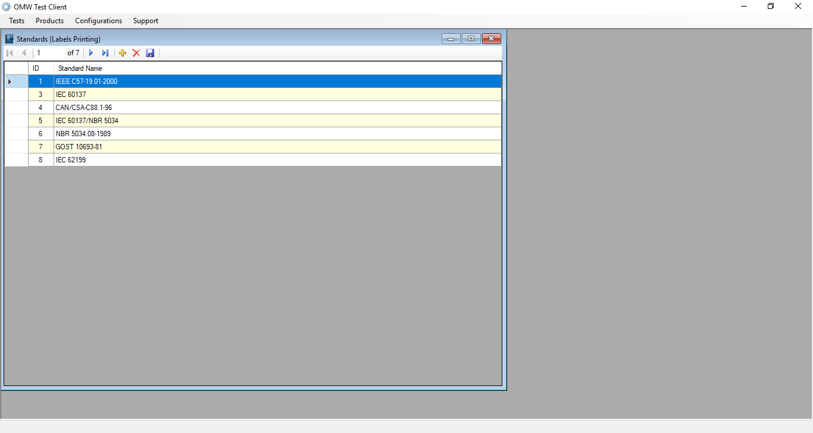

Figure 38.3.24.1: Current OMW Test Client: Configurations - Advanced - Standard (Label Printings) Screen

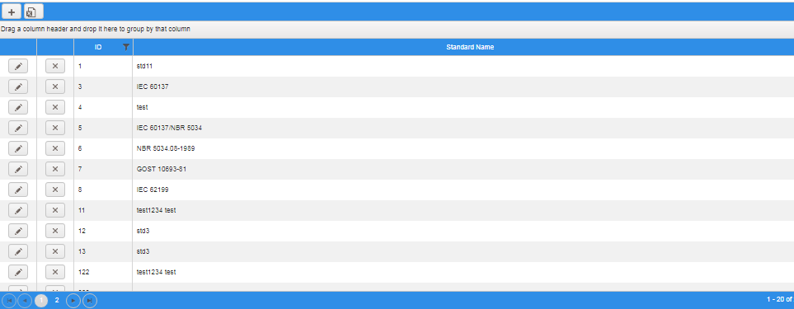

Figure 38.3.24.2: Proposed OMW Rebuilding: Configurations - Advanced - Standard (Label Printings) Screen

**Details:**

Following are the buttons available on the screen:

* ** (Add):** Add (+) button opens a new window( Figure 38.3.24.2.1) to add a new record with below fields displayed along with with “Save” and “Cancel” buttons
* ID
* Standard Name

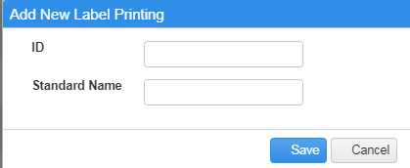

Figure 38.3.24.2.1: Proposed OMW Rebuilding**:** Add New Label Printing Screen

* ** (Export as Excel):** By clicking on this button all records will be exported in excel format.
* **(Edit):** Edit button is placed in each record of Standard Label Printing grid. By clicking on this button, an edit window appears (just like Add functionality) to edit the record along with “Update” and “Cancel” buttons.
* ****(**Delete):** Delete button is placed in each record of Standard Label Printing grid**.** By clicking on this button, a confirmation message appears with message “Are you sure, you want to delete this record?” with “OK” and “Cancel” buttons.

#### 3.2.2.4 Report Resources

This section is used to define the resources glossary related to the reports used under Configuration.

Consists of following menus items:

* Report String Resources

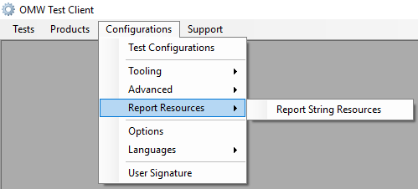

Figure 38.3.25.1: Current OMW Test Client: Configurations - Report Resources Menu

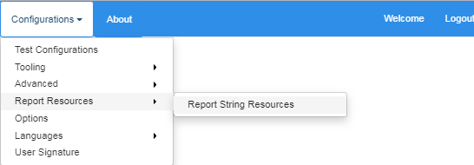

Figure 38.3.25.2: Proposed OMW Rebuilding: Configurations - Report Resources Menu

#### 3.2.2.4.1 Report String Resources

**Purpose**: This setting contains the multilingual glossary used by the system for the creation of the bulletin of the tests in different languages.

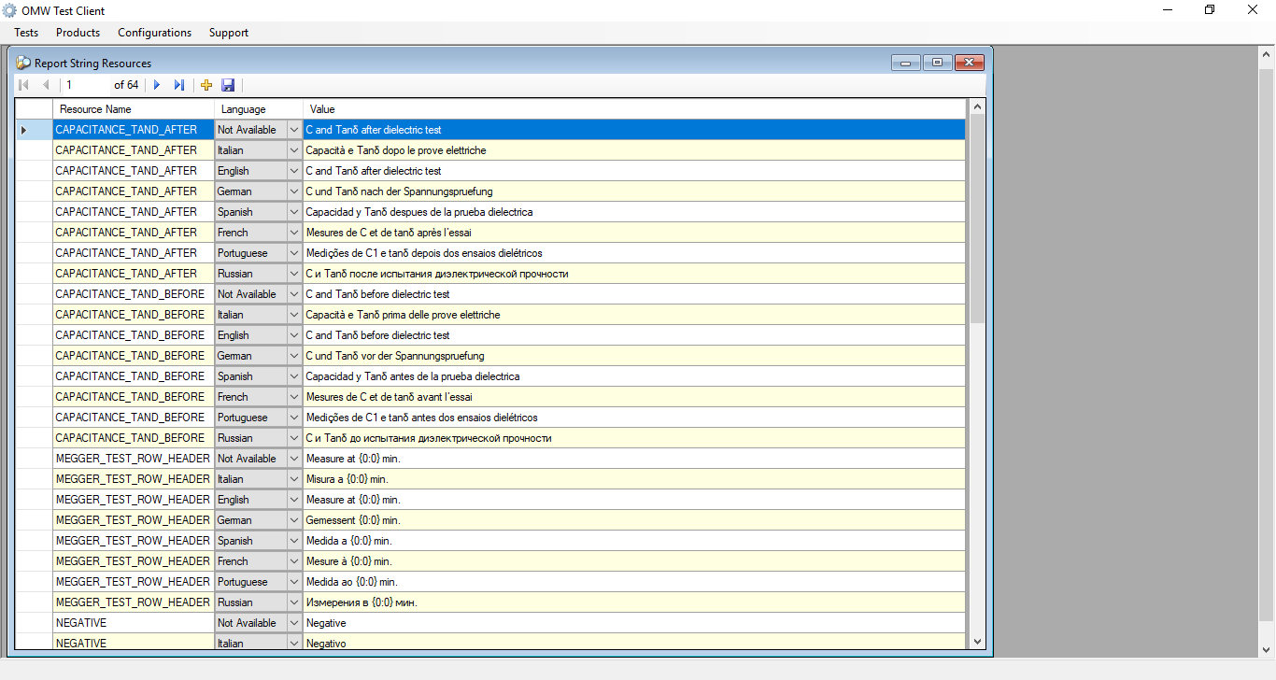

Figure 38.3.26.1: Current OMW Test Client: Configurations-Report Resources-Report String Resources Screen

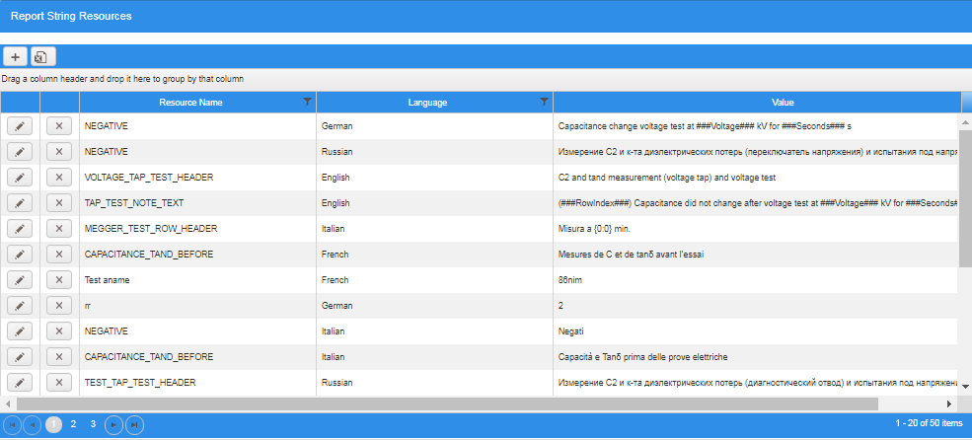

Figure 38.3.26.2: Proposed OMW Rebuilding: Configurations - Report Resources - Report String Resources Screen

**Details:**

Following are the buttons available on the screen:

* ** (Add):** Add (+) button opens a new window ( Figure 38.3.26.2.1 )to add a new record with below fields displayed along with with “Save” and “Cancel” buttons
* Resource Name
* Language
* Value

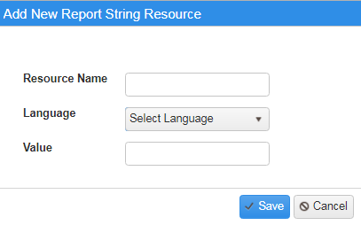

Figure 38.3.26.2.1: Proposed OMW Rebuilding **-** Add New Report String Resource Screen

* ** (Export as Excel):** By clicking on this button all records will be exported in excel format.
* **(Edit):** Edit button is placed in each record of Report String Resources grid. By clicking on this button, an edit window appears (just like Add functionality) to edit the record along with “Update” and “Cancel” buttons.
* ****(**Delete):** Delete button is placed in each record of String Report Resources grid**.** By clicking on this button, a confirmation message appears with message “Are you sure, you want to delete this record?” with “OK” and “Cancel” buttons.

## **3.3 OMW Integrations**

### **3.3.1 SAP Integration**

**Existing SAP Integration**:

Following is the current OMW-SAP interface setup details:

* Daily 2 transactions happen related to this interface and respective .dat files from SAP will be placed in the shared folder(\\sassg35002\QTW\)
* Based on our understanding the job schedule on the server will execute the script to move the data in .DAT files into OMW database tables.
* In SAP FEED, need to filter the BOM data with prefix “RX”.
* It has been identified the executable in the folder \\sassg35002\QTW\OMWFeederService to extract and load the .DAT files into OMW.
* After processing these files (loading into OMW), these .DAT files will be moved to \\sassg35002\QTW\ProcessedArchive folder.
* Material costs .DAT file has many columns but OMW takes only Column B, G, H (Code BOM, Material cost and Efforts Cost). However, OMW takes only Efforts (Efforts cost/Hourly rate).
* Hourly rate can be configured in the OMW->Tools->System settings->System settings->SAPFeeding_Hourly costs.
* Customer data from SAP will be loaded into OMW based on SIGIP code.
* Business has confirmed that the existing architecture can be continued but need to handle the challenges after cloud setup.
* A respective shared folder detail in cloud environment needs to be communicated to SAP team after thorough testing.

Below is the GE Box link for Sample templates of these .DAT files (Customer data and Materials cost data).

**Files:** 1. MATCOSTS_TAI_PT1_XXXX_0005_20190207_220002.DAT

          2. CUSTOMER_TAI_PT1_XXXX_0005_20190208_010004.DAT

**URL:** <https://ge.ent.box.com/folder/66423102321>

<https://ge.box.com/s/tp708ry24u175k3qmiltx2nfx2vrw7ld>

**Proposed SAP Integration**:

The data from ALTAIS to OMW application is integrated using WEB API Services

The data is retrieved from ALTAIS (SAP) is received in XML format:

<https://ge.box.com/s/c43v3kzipi3k5al658nb83xt8jllwncv> :

**Note**: Following is the Requirement Specification Details of SAP:

<https://ge.box.com/s/tp708ry24u175k3qmiltx2nfx2vrw7ld>

### **3.3.2 SPEAKAGE Integration**

**Purpose**

* Integrate application in order to avoid overlapping of business activities in SPEAK and OMW
* The integration will be applicable for all offers created after the deployment of OMW web application

**Note** – Following is the Requirement Specification Details for SPEAKAGE Integration:

<https://ge.box.com/s/m21q2vkkegk7toua2b3itf6pkgezq59m>

Following is the reference data passing from OMW to SPEAKAGE and vice versa::

<https://ge.box.com/s/z93ly2rml8u3jpcq8tzmrmf8b50gfnnf>

### **3.3.3 MS Outlook Plugin**

**Purpose:** Outlook Plugin functionality gives the facility to open the Outlook Mail, connects to OMW web application and sends the Quotes, Offers, Orders and Drawings related information in attachment format to OMW web application. Similarly provided the ability to attach documents/test reports/drawings from Offer, Orders and Drawings from OMW web application to Outlook as per requirement.

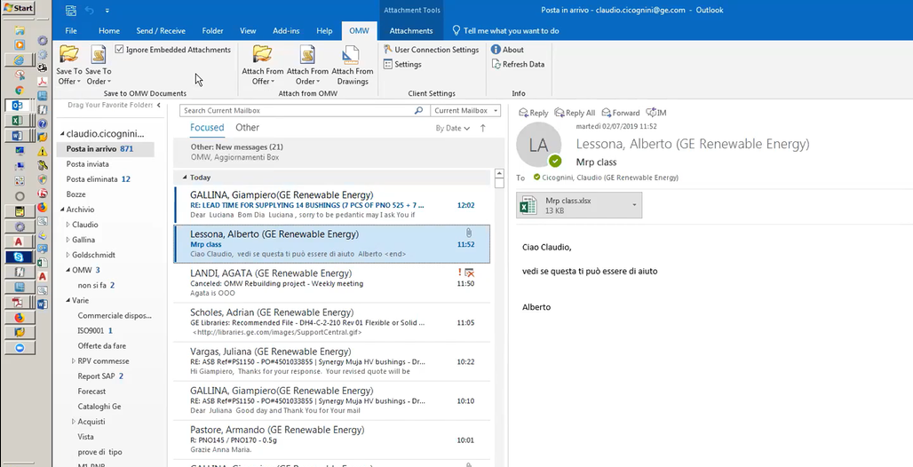

Figure 38.3.37.1: Current OMW: Outlook Plugin

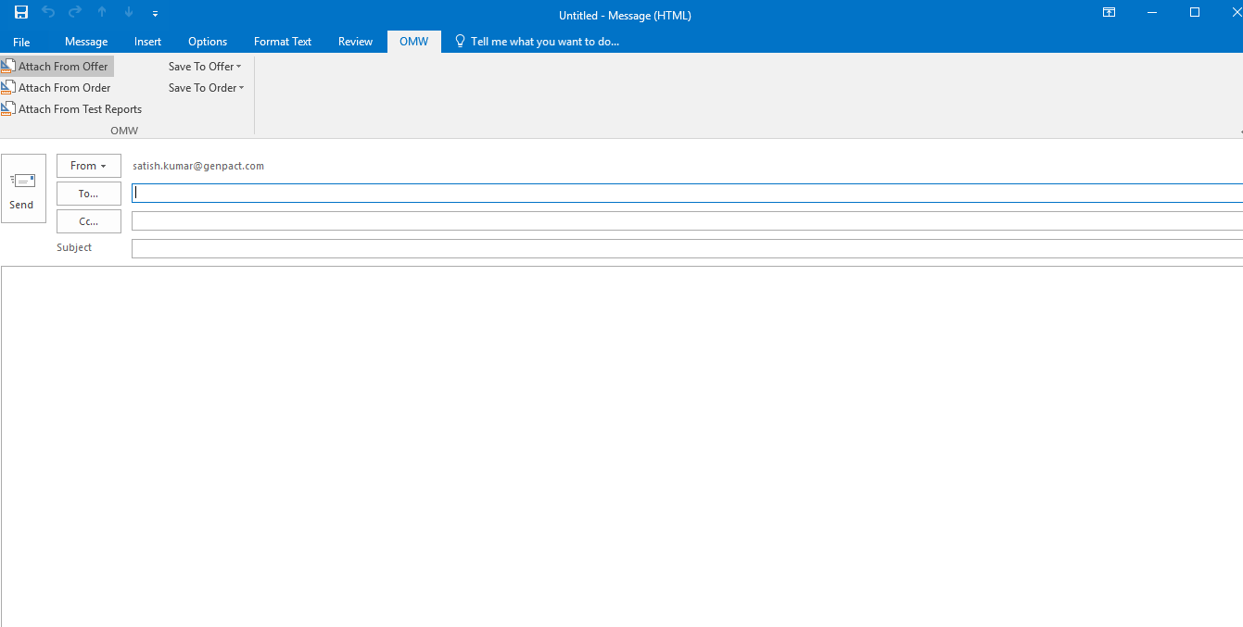

Figure 38.3.37.2: Proposed OMW Rebuilding: Outlook Plugin

**Details:**

Following changes would be accomplished in OMW web application:

1. Save All Attachments from Save to Offer Section will be merged with Save Attachment (Figure 38.3.37.3).
2. Save All Attachments from Save to Order Section will be merged with Save Attachment (Figure 38.3.37.5).

Following are the Items available on Outlook Plugin to align with OMW web Application:

#### 3.3.3.1 Save to Offer

**Purpose:** Save to Offer provides the functionality to save the selected email content as attachment to Offer section of OMW web application.

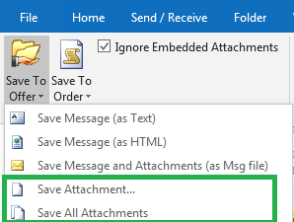

Figure 38.3.37.3: Current OMW: Outlook Plugin: - Save to Offer Option

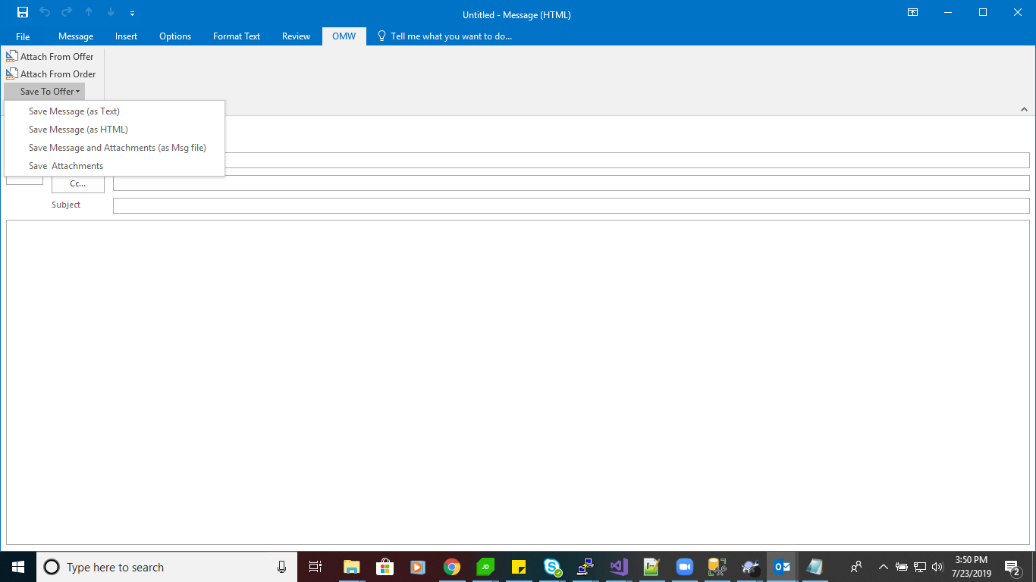

Figure 38.3.37.4: Proposed OMW Rebuilding: Outlook Plugin – Save to Offer Option

**Details:** Following are the itemsavailable in Save to Offer Menu:

* **Save Message (as Text):** By Clicking on option “Save Message (as Text)”, Offer Overview screen will open (with all filter options along with search functionality). After searching the offers, records will be displayed under Offer Overview grid. Selecting the required offer from grid and clicking on “Select button”, it will attach the email content as text file format along with keeping Subject of email as Title of attachment.
* **Save Message (as HTML): “**Save Message (as HTML)” functionality is similar to as “Save Message (as Text)”. The only difference is Email content will be saved in HTML file format.
* **Save Message and Attachments (as Msg file) : “**Save Message and Attachments (as Msg file)“ functionality workflow is similar to as “Save Message(as Text)”. The only difference is Email content along with all attachments of email will be saved in MSG file document format.
* **Save Attachments:** Save Attachments functionality workflow is also similar as like other options (Save Message (as Text), Save Message and Attachments (as Msg file)). Only the difference is, It will provide the pop up window option to save all attachments or required attachments (check box will be provided to select Attachment from all list of attachments) of existing selected email attachments onto Offer record.

#### 3.3.3.2 Save to Order

**Purpose:** Save to Order provides the functionality to save the selected email content as attachment to Order section of OMW Application.

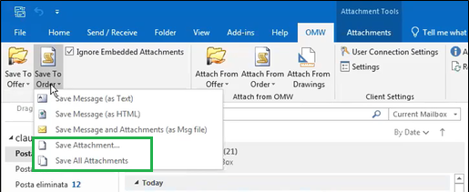

Figure 38.3.37.5: Current OMW: Outlook Plugin – Save to Order Option

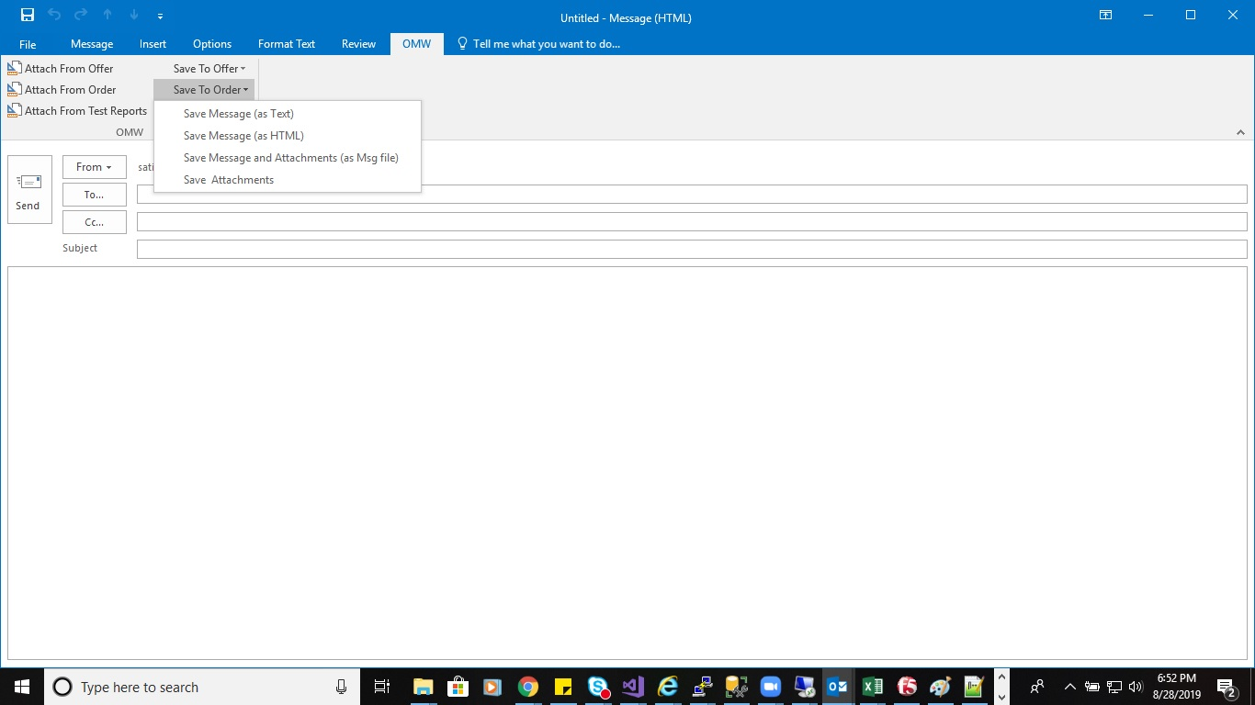

Figure 38.3.37.6: Proposed OMW Rebuilding: Outlook Plugin – Save to Order Option

**Details:** Following are the itemsavailable on Save to Order Menu:

* **Save Message (as Text):** By Clicking on option “Save Message (as Text)”, Order Overview screen will open (with all filter options along with search functionality). After searching the orders, records will be displayed under Order Overview grid. Selecting the required Order from grid and click on “Select button”, it will attach the email content as text file format along with keeping Subject of email. As Title of attachment.
* **Save Message (as HTML):** “Save Message (as HTML)” functionality is similar to as “Save Message (as Text)”. The only difference is Email content will be saved in HTML file format.
* **Save Message and Attachments (as Msg file):** “Save Message and Attachments (as Msg file)“functionality workflow is similar to as “Save Message (as Text)”. The only difference is Email content along with all attachments of email will be saved in MSG file document format.
* **Save Attachments:** Save Attachments functionality workflow is also similar as like other options (Save Message (as Text), Save Message and Attachments (as Msg file)). Only the difference is, It will provide the pop up new window option to save all attachments or required attachments ( check box will be provided to select Attachment from all list of attachments) of existing selected email attachments onto Order record .

#### 3.3.3.3 Attach from Offer

**Purpose:** Attach from Offer provides the functionality to attach the offer document(s) from OMW web application to created Outlook email as attachment(s).

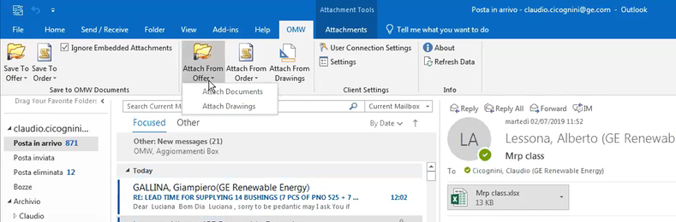

Figure 38.3.37.7: Current OMW: Outlook Plugin – Attach from Offer Option.

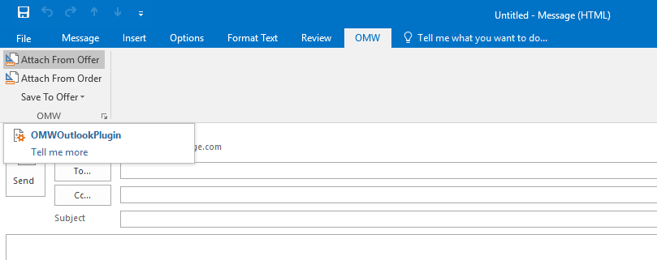

Figure 38.3.37.8: Proposed OMW Rebuilding: Outlook Plugin –Attach From Offer Option

**Details:**

Attach from Offer will have following Submenus:

* **Attach Documents:** Following are the steps of functionality:
* Step 1: Create the email, Select “Attach from Offer “from Outlook OMW tab, it will pop up Offer Overview screen.
* Step 2: Search desired offer from Offer Overview Screen, select the Offer from grid.
* Step 3: Go to the Documents tab of Offer editor screen.
* Step 4: Select required document(s) from grid of documents tab. Click on Attach button which is placed above the grid of documents tab.
* Step 5: Selected documents that will be attached to the created email’s attachment section.

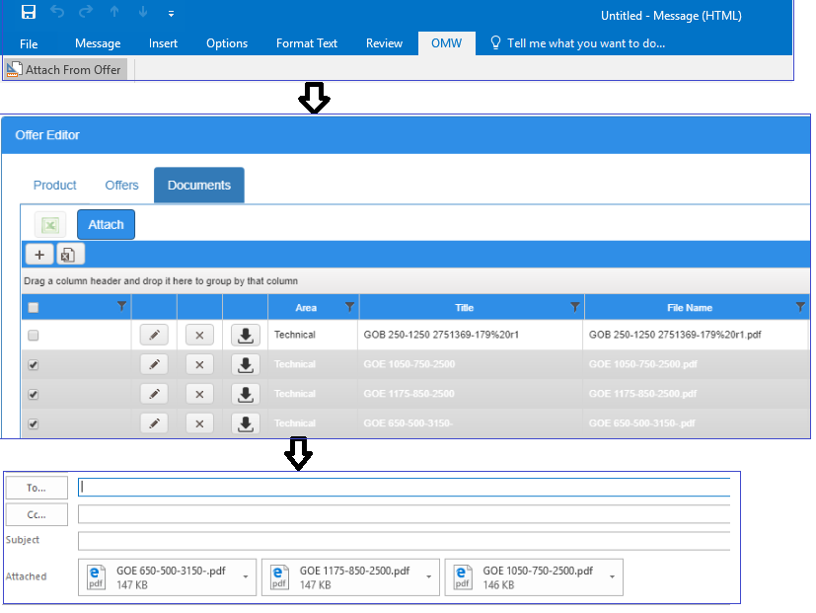

Figure 38.3.37.9: Proposed OMW Rebuilding: Attach from Offer functionality flow

#### 3.3.3.4 Attach from Order

**Purpose:** Attach from Order provides the functionality to attach the order document(s) from OMW web application to created Outlook email as attachment(s).

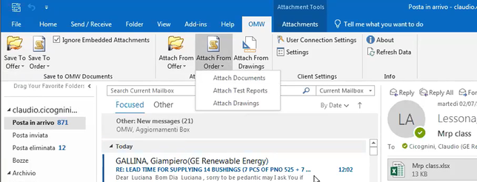

Figure 38.3.37.10: Current OMW Outlook Plugin – Attach from Order Option.

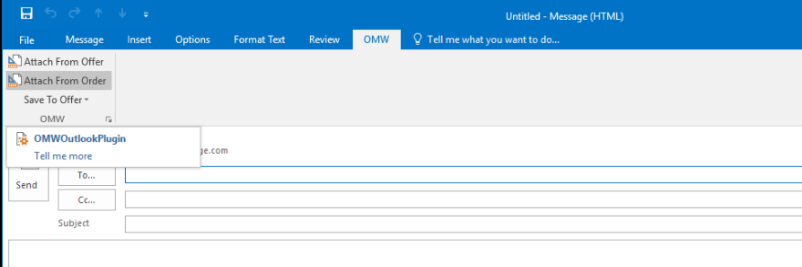

Figure 38.3.37.11: Proposed OMW Rebuilding-Outlook Plugin-Attach from Order Option

**Details:**

Attach from Order will have following submenus:

* + **Attach Documents:** Following are the steps of functionality:
* Step 1: Create the email, select “Attach Document” option “Attach from Order“ menu from Outlook OMW tab, it will display Order Overview screen.
* Step 2: Search desired order record from Order Overview Screen, select the Order from grid.
* Step 3: Go to the Documents tab of Order Editor Screen.
* Step 4: Select required document(s) from grid of documents tab. Click on Attach button which is places above the grid of documents tab.
* Step 5: Selected documents will be attached to the created email’s attachment section.

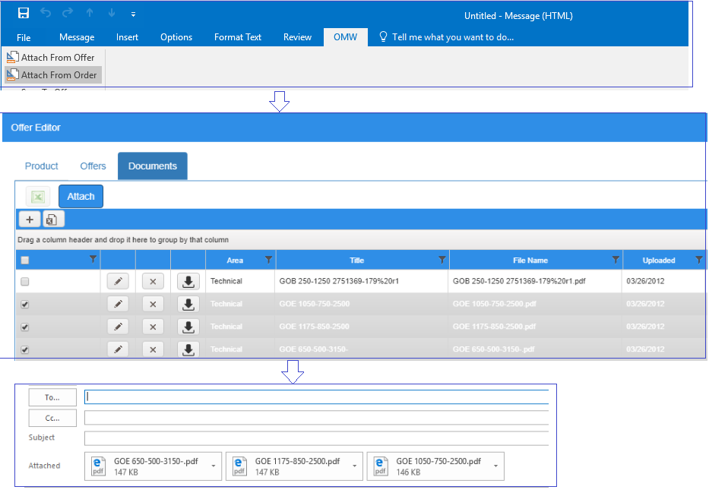

Figure 38.3.37.12: Proposed OMW Rebuilding: Outlook Plugin-Attach from Order –Documents flow

* + **Attach From Test Reports:** Following are the steps of functionality
* Step 1: Create the email, select “Attach Test Report” option from “Attach from Order “menu, from Outlook OMW tab. it will display Test Results screen.
* Step 2: Search order number from Test Results Screen that has Test report that needs to be attached,
* Step 3: Click on Attach button, which is placed above the grid.
* Step 4: Selected Test Report(s) (which are present as attachment button) that will be attached to the created email’s attachment section.

## **3.4 Reports**

Logo needs to be changed to “GE” image for all PDF/Word reports.

Consists of following menus items:

* Financial
* Offer-Order Report

### **3.4.1 Financial**

Consists of following sub menu items:

* Financial Summary Report ( EAS Commensa)
* Financial Summary Report ( EAS Fatturazione)
* Financial Details Report ( EAS Commensa)
* Financial Details Report ( EAS Fatturazione)

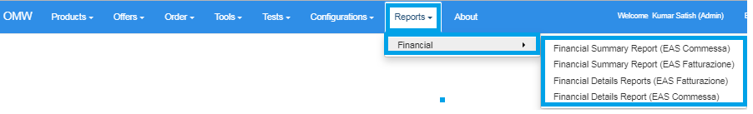

Figure 50.1: Proposed OMW Rebuilding: Reports - Financial Menu

### **3.4.1.1 Financial - Summary Report**

Purpose: Financial Summary reports displays the related data of offer with EAS (**Commensa**) and EAS (**Fatturazione**) selected information

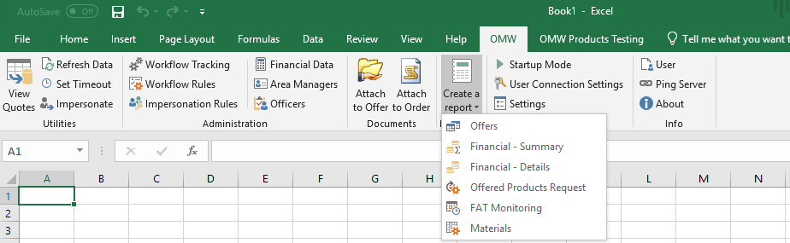

Figure 50.1.1: Current OMW Excel Plugin: Financial - Summary Report Menu

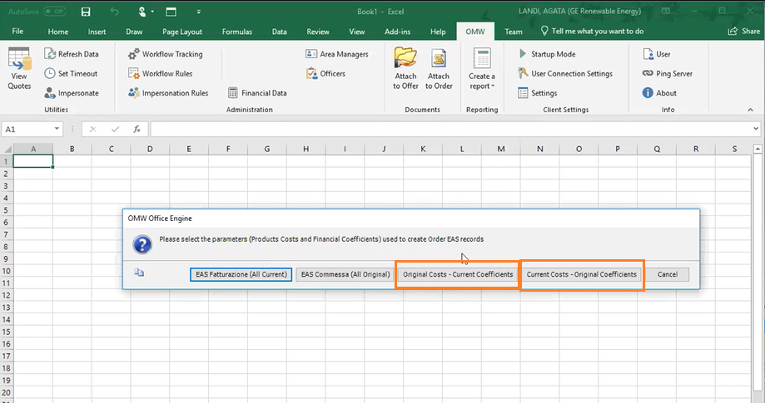

Figure 50.2: Current OMW Excel Plugin: Financial - Summary Report Interface

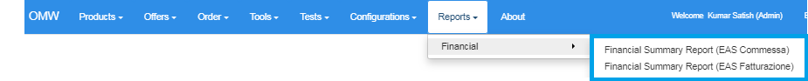

Figure 50.3: Proposed OMW Rebuilding: Reports - Financial Summary Reports

**Details**:

Following changes would be accomplished in OMW web application:

1. Financial Summary Report was earlier part of OMW Excel Plugin ( Figure 50.1.1 ) , now placed under Reports -> Financial as 2 different reports:
   1. Financial Summary Report ( EAS Commensa) (Figure 50.3)
   2. Financial Summary Report ( EAS Fatturazione) (Figure 50.3)
2. Report named “Original Costs- Current Coefficients” will be removed from Financial Summary Report (Figure 50.2).
3. Report name “Current Costs- Original Coefficients” will be removed from Financial Summary Report (Figure 50.2).
4. **Financial Summary (EAS Commensa):** This report displays the data of Order, offer information of EAS (Commensa) checked data, as per Order date selection. Following are the columns that are displayed: under report: ( Figure 50.5)
5. Offer ID
6. Quote ID
7. Order ID
8. Offer Number
9. Offer Revision
10. Offer Year
11. Area Manager
12. Offer Date
13. Customer
14. Country Code
15. Country
16. Currency
17. Exchange Rate
18. Direct Labour
19. Materials And Sourcing
20. Production Costs
21. Other Direct Costs
22. Costs Of Sales
23. Total Before Interests
24. Full Cost
25. Net Margin
26. Selling Price
27. Margin On DirectCosts
28. Gross Margin
29. Production Overheads
30. Non Production Overheads
31. Total Overheads
32. Direct Costs
33. Net Margin Before Interests
34. Selling Price Unit
35. Margin On Direct Costs Pct
36. Gross Margin Pct
37. Net Margin Pct
38. Order Number
39. Order Date
40. Direct Labour
41. Materials And Sourcing
42. Production Costs
43. Other Direct Costs
44. Costs Of Sales
45. Total Before Interests
46. Full Cost
47. Net Margin
48. Selling Price
49. Margin On Direct Costs
50. Gross Margin Production Overheads
51. Non Production Overheads
52. Total Overheads
53. Direct Costs
54. Net Margin Before Interests
55. Selling Price Unit
56. Margin On Direct Costs Pct
57. Gross Margin Pct
58. Net Margin Pct

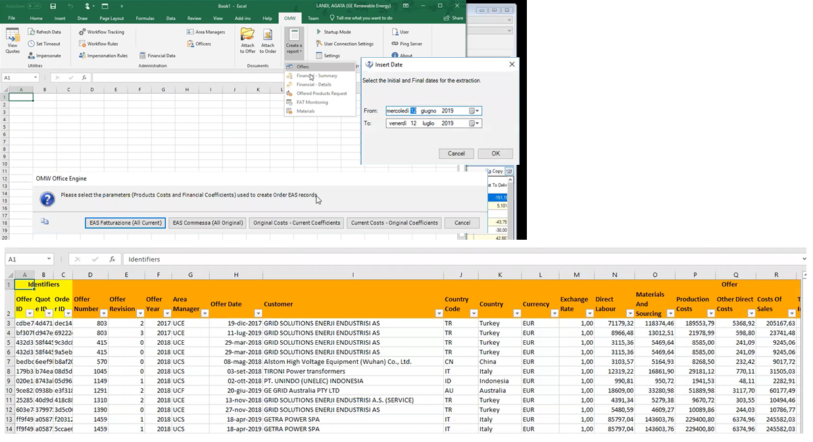

Figure 50.4: Current OMW Excel Plugin: Financial Summary- EAS Commensa Report

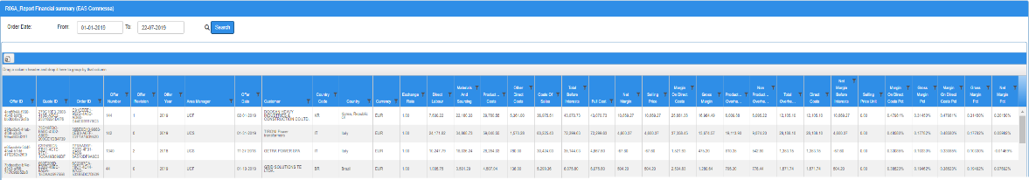

Figure 50.5: Proposed OMW Rebuilding: Financial Summary- EAS Commensa Report.

Following are the buttons available on screen:

* **Search:** Search button displays the Financial summary data as per Order Date selection filter. By default, Order Date take the one-month order date (Current date to previous one-month date range) range. ( Figure 50.5 )
* **Export to Excel:** This will export the data of grid along with all columns into Excel format ( Figure 50.5 )

1. **Financial Summary (EAS Fatturazione):** This report displays the data of offer, quote and OfferBase information of EAS (Fatturazione) checked data, as per Order date selection. Following are the columns that are displayed: under report: ( Figure 50.7)
2. Offer ID
3. Quote ID
4. Order ID
5. Offer Number
6. Offer Revision
7. Offer Year
8. Area Manager
9. Offer Date
10. Customer
11. Country Code
12. Country
13. Currency
14. Exchange Rate
15. Direct Labour
16. Materials And Sourcing
17. Production Costs
18. Other Direct Costs
19. Costs Of Sales
20. Total Before Interests
21. Full Cost
22. Net Margin
23. Selling Price
24. Margin On Direct Costs
25. Gross Margin
26. Production Overheads
27. Non Production Overheads
28. Total Overheads
29. Direct Costs
30. Net Margin Before Interests
31. Selling Price Unit
32. Margin On Direct Costs Pct
33. Gross Margin Pct
34. Net Margin Pct
35. Order Number
36. Order Date
37. Direct Labour
38. Materials And Sourcing
39. Production Costs
40. Other Direct Costs
41. Costs Of Sales
42. Total Before Interests
43. Full Cost
44. Net Margin
45. Selling Price
46. Margin On Direct Costs
47. Gross Margin
48. Production Overheads
49. Non Production Overheads
50. Total Overheads
51. Direct Costs
52. Net Margin Before Interests
53. Selling Price Unit
54. Margin On Direct Costs Pct
55. Gross Margin Pct
56. Net Margin Pct



Figure 50.6: Current OMW Excel Plugin: Financial Summary- EAS Fatturazione Report

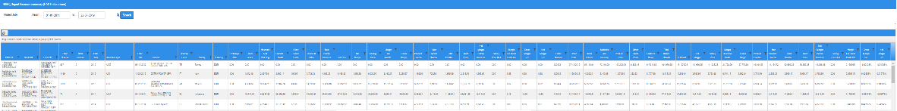

Figure 50.7: Proposed OMW Rebuilding: Financial Summary- EAS Fatturazione Report

Following are the buttons available on screen:

* **Search:** Search button displays the Financial summary data as per Order Date selection filter. By default, Order Date take the one-month order date (Current date to previous one-month date range) range. ( Figure 50.7 )
* **Export to Excel:** This exports data of grid along with all columns in Excel format ( Figure 50.7 )

### **3.4.1.2 Financial - Details Report**

Purpose: Financial Details list out the Order and offer related information, which is further classified into two different type of Report 1. Financial Details – EAS Commensa and 2 Financial Details - EAS Fatturazione.



Figure 51.1.1: Current OMW Excel Plugin: Financial - Details Report Menu

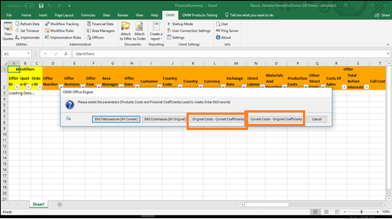

Figure 51.2: Current OMW Excel Plugin: Financial - Details Report Interface

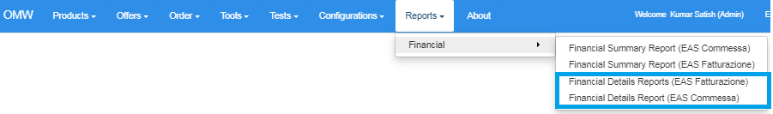

Figure 51.3: Proposed OMW Rebuilding: Reports - Financial Details Reports

**Details**:

Following changes would be accomplished in OMW web application:

1. Financial Details Report was earlier part of OMW Excel Plugin ( Figure 51.1.1 ) , now placed under Reports -> Financial as 2 different reports:
2. Financial Details Report ( EAS Commensa) (Figure 51.3)
3. Financial Details Report ( EAS Fatturazione) (Figure 51.3)
4. Report named “Original Costs- Current Coefficients” will be removed from Financial Summary Report (Figure 51.2).
5. Report name “Current Costs- Original Coefficients” wil be removed from Financial Summary Report (Figure 51.2).
6. **Financial Details (EAS Commensa):** This report displays the data of Order, offer information of EAS (Commensa) checked data, as per Order date selection. Following are the columns that are displayed: under report: ( Figure 51.5):
7. Offer ID
8. Quote ID
9. Order ID
10. Offer Number
11. Offer Revision
12. Offer Year
13. Area Manager
14. Offer Date
15. Customer
16. Country Code
17. Country
18. Currency
19. Exchange Rate
20. Direct Labour
21. Materials And Sourcing
22. Production Costs
23. Other Direct Costs
24. Costs Of Sales
25. Total Before Interests
26. Full Cost
27. Net Margin
28. Selling Price
29. Margin On Direct Costs
30. Gross Margin
31. Production Overheads
32. Non Production Overheads
33. Total Overheads
34. Direct Costs
35. Net Margin Before Interests
36. Selling Price Unit
37. Margin On Direct Costs Pct
38. Gross Margin Pct
39. Net Margin Pct
40. Order Number
41. Order Date
42. Direct Labour
43. Materials And Sourcing
44. Production Costs
45. Other Direct Costs
46. Costs Of Sales
47. Total Before Interests
48. Full Cost
49. Net Margin
50. Selling Price
51. Margin On Direct Costs
52. Gross Margin
53. Production Overheads
54. Non Production Overheads
55. Total Overheads
56. Direct Costs
57. Net Margin Before Interests
58. Selling Price Unit
59. Margin On Direct Costs Pct
60. Gross Margin Pct
61. Net Margin Pct
62. Order Price
63. Margin On Direct Costs
64. Gross Margin
65. Production Overheads
66. Non Production Overheads
67. Total Overheads Direct Costs
68. Net Margin Before Interests
69. Unit Order Price
70. Margin On Direct Costs Pct
71. Gross Margin Pct
72. Net Margin Pct
73. Current Item Status



Figure 514: Current OMW Excel Plugin: Financial Details- EAS Commensa Report



Figure 51.5: Proposed OMW Rebuilding: Financial Details- EAS Commensa Report

Following are the buttons available on screen:

* **Search:** Search button display the Financial Details data as per Order Date selection filter. By default, Order Date take the one-month order date (Current date to previous one-month date range) range. (Figure 51.5 )
* **Export to Excel:** This exports all data of grid along with all columns to Excel format (Figure 51.5 )

1. **Financial Details (EAS Fatturazione):** This report displays the data of Order, offer information of EAS (Fatturazione) checked data, as per Order date selection. Following are the columns that are displayed: under report: ( Figure 51.7):
2. Offer ID
3. Quote ID
4. Order ID
5. Offer Number
6. Offer Revision
7. Offer Year
8. Area Manager
9. Offer Date
10. Customer
11. Country Code
12. Country
13. Currency
14. Exchange Rate
15. Direct Labour
16. Materials And Sourcing
17. Production Costs
18. Other Direct Costs
19. Costs Of Sales
20. Total Before Interests
21. Full Cost
22. Net Margin
23. Selling Price
24. Margin On Direct Costs
25. Gross Margin
26. Production Overheads
27. Non Production Overheads
28. Total Overheads
29. Direct Costs
30. Net Margin Before Interests
31. Selling Price Unit
32. Margin On Direct Costs Pct
33. Gross Margin Pct
34. Net Margin Pct
35. Order Number
36. Order Date
37. Direct Labour
38. Materials And Sourcing
39. Production Costs
40. Other Direct Costs
41. Costs Of Sales
42. Total Before Interests
43. Full Cost
44. Net Margin
45. Selling Price
46. Margin On Direct Costs
47. Gross Margin
48. Production Overheads
49. Non Production Overheads
50. Total Overheads
51. Direct Costs
52. Net Margin Before Interests
53. Selling Price Unit
54. Margin On Direct Costs Pct
55. Gross Margin Pct
56. Net Margin Pct
57. Order Price
58. Margin On Direct Costs
59. Gross Margin
60. Production Overheads
61. Non Production Overheads
62. Total Overheads Direct Costs
63. Net Margin Before Interests
64. Unit Order Price
65. Margin On Direct Costs Pct
66. Gross Margin Pct
67. Net Margin Pct
68. Current Item Status



Figure 51.6: Current OMW Excel Plugin: Financial Details- EAS Fatturazione Report



Figure 51.7: Proposed OMW Rebuilding: Financial Details- EAS Fatturazione Report

Following are the buttons available on screen:

* **Search:** Search button display the Financial Details data as per Order Date selection filter. By default, Order Date take the one-month order date (Current date to previous one-month date range) range. ( Figure 51.7 )
* **Export to Excel:** This exports all present data of grid along with all columns.to Excel format ( Figure 51.7 )

### **3.4.2 Offer-Order Report**

**Purpose:** Offer-Order Report provides the facility to customize the report, provides the flexibility to select the required field(s) or unselect the field(s).So Offer-Order report provides the way to generate the report in such a manner, which is using the Offer, Order, products filters at one place and showing all of them at one place that is in offer-order report.

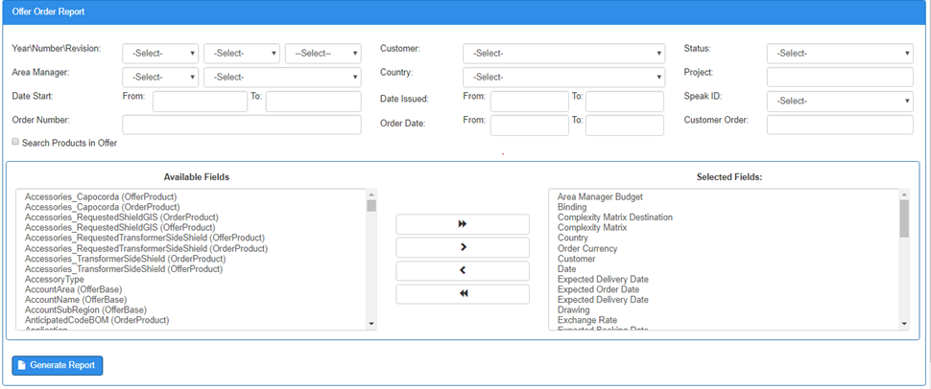

Figure 51.8: Proposed OMW Rebuilding: Offer-Order Report screen

**Details**:

Following are the search parameters available on screen:

* Year/ Number/Revision
* Customer
* Status
* Area Manager
* Country
* Project
* Data Start From & To
* Data Issued From & To
* Speak ID
* Order Number
* Order Date From & To
* Customer Order
* Search Product in Offer: Check box- By checking checkbox, Screen will extend and will show the product search parameters ( Refer Section 3.1.2.1.1 )

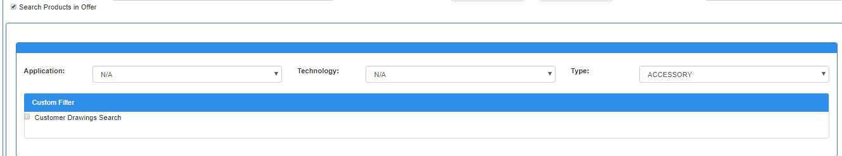

Figure 51.9: Proposed OMW Rebuilding: Offer-Order Report - Search Product in Offer Section

By default there will be 46 fields in selected fields section, which can be removed or additional fields can be added from list of Available Fields section.

Following are the steps to generate the Offer – Order report:

* 1. Select/input the data in fields of Search section as per required .
  2. Select the Selected Fields from Available field(s) and click on right arrow, it will be moved to “Selected fields” list. By default there are 46 fields are listed out in “Selected Fields” section.
  3. Click on “Generate Report” button, report will be downloaded on local drive.

Offer-Order report is located at GE Box location

<https://ge.box.com/s/04v6tu6m617zztf5m218ph2hbkulkxe5>

## **3.5 Authentication and Authorization**

### **3.5.1 SSO Authentication**

**Purpose:** OMW web application users are authenticated based on GE SSO using GE Single-Sign On framework and availability of user details in Users screen.

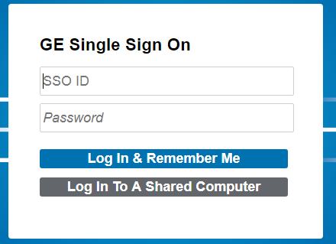

Figure 52.1.1: GE Single Sign On Authentication Screen

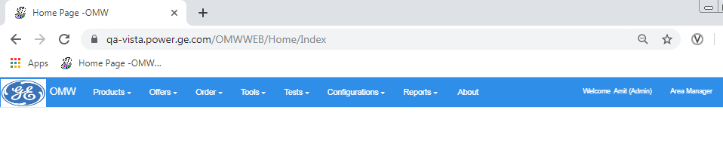

Figure 52.1.3: Proposed OMW Rebuilding: Home Page with Login Details

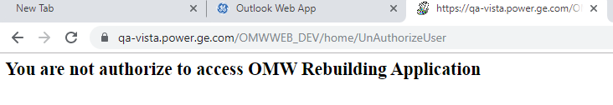

Figure 52.1.4: Proposed OMW Rebuilding: Home Page with Unauthorized Login attempt.

**Details**:

When user wishes to open the OMW Rebuilding web application, he/she will be prompted to enter GE SSO and password as per GE Single On process (Figure 52.1.1). If user is successfully authenticated, following happens:

1. If user’s SSO exists in Users screen, he will be able to login into OMW web application with following text displayed in right of the screen ( Figure 52.1.3 ):

Welcome <firstname><admin> <userrole>

where firstname = user’s first name, admin = Is Admin flag and userrole = user’s role as per Users Screen (Refer Section 3.1.5.1.6)

2) If user’s SSO does not exists in Users screen, he/she will not be able to login into OMW web application with screen displayed with following text displayed in center of the screen ( Figure 52.1.4).

### **3.5.2 Role Based Authentication**

**Purpose:** Based on role of the user, different sections of the OMW web application will be accessible as per following table:

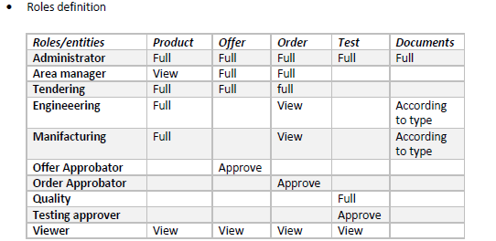

**Details**:

Role based Authentication details have been documented in following GE Box location:

<https://ge.box.com/s/ridssxsha8dp5j198j3z3w8sdm5ochkx>

### **3.5.3 Logout**

**Purpose:** When user clicks on the logout button, user is logged out of OMW web application

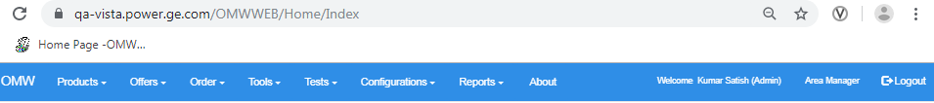

Figure 52.5: Proposed OMW Rebuilding: Logout Button

# **4. Solution Design and Architecture details**

OMW web application will be built using ASP.NET web application platform and will use SQL Server database.

## **4.1 Existing OMW Architecture**

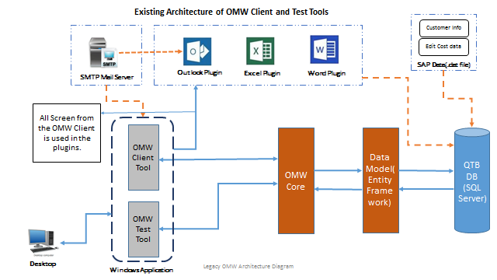

Figure 54: Screen displays the existing OMW architecture.

OMW client application is existing OMW application, which is installed on the end user desktops/ laptops. The OMW application interacts with the OMW SQL Server database through OMW Core and Data Model layer. OMW application is having an existing interface with SAP for storing the Customer data and Material cost information in OMW database. OMW Microsoft Office plugins are also available for the end user for certain activities. These MS office plugins have access to SMTP Mail servers to trigger email alerts during the workflow process and also have a connection OMW database.

## **4.2 OMW Rebuilding Architecture**

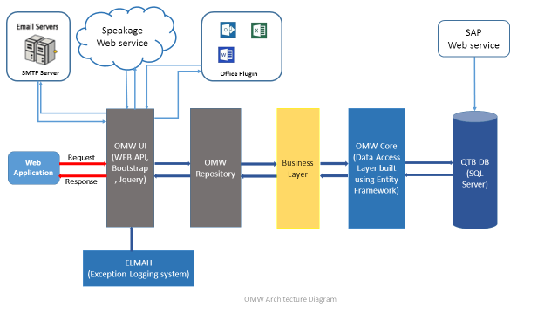

Figure 55: Screen displays the OMW rebuilding architecture.

As per the proposed architecture of OMW rebuilding, OMW web application and database will be hosted on AWS (Cloud) environment. OMW web application is being developed using .Net framework MVC architecture and will be having multiple layers (OMW User Interface, OMW Repository, Business Layer and OMW Core). As part of the OMW rebuilding, developing the exception handling and logging mechanism to track every crucial action in the application has been considered.

**Validation and Error Handling Mechanism:**  All the field level validations are ensured to be displayed in each screen and required screen level validations are handled with respective messages being displayed at top of the screen.

# **5. Infrastructure Requirements**

* AWS environment details (Applications and database)

AWS environment for OMW web application will be categorized as follows:

1. Dev Environment – For Dev / QA environment
2. Staging Environment – For UAT environment ( might be combined with Prod environment )
3. Prod Environment – For Production environment

@POWER Artemis - TCS Team under leadership of ipsita.ojha@ge.com can be contacted for further details.

* Security and compliance requirements

OMW Web application will be GE SSO enabled using SAML authentication mechanism.

* User access requirements

GE Grid – One IDM process, will govern user Access for new application users

* Service Management requirements

Web application QA testing will be performed using HP ALM tool.

Once web application is deployed to production environment, Service Now will be used for maintenance and support of the application as per following:

* + Service Now CI - 1002621462
  + Service Now Support Group DL - @EC L2-Italy Support
  + Application Functional Owner - claudio.cicognini@ge.com
* Performance requirements

Performance testing will be done for 2 weeks prior to User Acceptance Testing using automated testing using tools like Load Runner.

* Remote access management

Remote access to web application will be managed by GE VPN guidelines.

* Servers accessibility

AWS Servers will be accessible to the development/infrastructure team using GE VPN and PUTTY tool.

# **6. Database Migration details**

**Current Database Details:**

* Present database is configured in SQL Server 2012
* On Prem Server : SASSG35002.dom2.ad.sys ( IP - 11.0.7469.6 )

Following approach will be taken for database migration in AWS environment

* **Pre-migration Phase:**

Following tasks need to be reviewed and documented on the **SOURCE** server:

* Database sizes and data / Log file location
* Server and Database properties (Collation, Auto Stats, database Owner, Recovery Model, Compatibility level, etc.)
* Collect the information of dependent applications, make sure application services will be stopped during the database migration
* Database logins, users and their permissions
* Dependent objects (SQL Agent Jobs and Linked Servers)
* Document maintenance plans

On the **TARGET** server, following tasks to be conducted:

* Verify adequate disk space exists
* Appropriate folders have been created
* SQL Server is correctly installed and configured with latest Service Pack and Cumulative Update
* Set SQL Server properties; memory, tempdb size, auto growth and drive location.
* Appropriate connectivity exists with application servers, web servers, etc.
* Create databases consistent with planned database migrations
* **Database Migration Phase:**

Following tasks need to be performed:

* From SOURCE server, get recent list of database and file location list
* On SOURCE SQL Server, Script migrate user LOGIN information between servers, save output for subsequent step.
* Use native SQL Server to back up databases from SOURCE, use backup compression to reduce size of backup (optionally, use detach database, copy database files, then reattach database)
* On SOURCE server, place databases in Read Only mode
* Restore databases to TARGET
* On TARGET SQL, apply script to migrate users/group security (Created in Step 3)
* Update any custom SSRS DSNs to point to TARGET server.
* On SOURCE server, script any required SQL Server Agent Jobs to create
* On TARGET, using the file create and then transfer/execute job creation on TARGET. Create schedules as needed.
* **Post-migration checks Phase:**

Following tasks need to be performed:

* Point the application to the new database server address, or Availability Group LISTENER for AlwaysOn Availability Groups (Connection strings, etc. to altered by the application support team)
* Restart / review Network connections between all stake holding servers (Network Team)
* Check the SQL Server Error Log and Windows Error logs for any failures
* Confirm application functionality with end users

# **7. Reporting strategy**

The reports for OMW application will be created using following platforms:

* SSRS – Excel format
* iTextSharp – PDF format
* Microsoft Interop Services – Word , Excel Format

# **8. Technology and Framework Details**

Following Overview of software versions and other technical details for the Rebuilding OMW Applications

|  |  |
| --- | --- |
|  |  |

|  |  |  |  |
| --- | --- | --- | --- |
| **Technology / Architectural component** | | | **Software Version** |
| Asp.Net MVC,C#.Net, Web API ,JQuery, Bootstrap and Entity Framework | | | Visual Studio 2017 |
| MS SQL Server ,SSRS Reports | | | SQL SERVER 2017 |
| Tortoise SVN | | | Version 1.11.1 |
|  |  |

# **9. Testing Details**

QA team will commence functional testing of the application post receiving the unit-tested deployment from the development team.

QA testing will happen in each sprint – last week of each sprint.

The defect life cycle management will be maintained using HP Application Lifecycle Management (HP ALM) tool.

QA team will use HP ALM for creation of test scenarios and logging bugs, while development team will use HP ALM tool for tracking/closure of bugs.

Following aspects of testing will be taken care of during the testing process for each sprint.

* Verify Software requirements are complete and accurate
* Prepare and document test cases
* Test the application & manage defect tracking
* Provide testing summary reports

Performance testing is performed on the application post Integration & Regression testing using preferably JMeter/Load Runner.

Integration testing will be performed with integrations like SAP, SPEAKEAGE etc.

The business stakeholders will take up User Acceptance Testing (UAT).

# **10. Code repository and Build/release mechanism**

Source Code repository/versioning will be maintained in SVN. Following code repository has been created: <http://svn.gs.ec.ge.com/it/OMW_Rebuilding/>

Locally, Tortoise SVN is to be installed for connecting to SVN repository.

# **11. Project Execution in Agile Methodology**

This project will be executed in the Agile Methodology (SCRUM) and eight sprints will be executed to deliver the application with agreed scope.

SCRUM Master or Project Manager ensures that: -

* Ensures Team is on track
* Removes Impediments
* Conducts Stand up, Planning review and retrospective calls
* Collaborates with stakeholders
* Regular Status updates to CI Owners/CIOS

Following is the plan of each sprint.

* ***Sprint Period - Week 1*** 
  + Review recommendation from Discovery/previous phase/Sprint phase
  + Prioritize backlog items as per sprint planning discussions and Send out communication post planning meeting /publish planned deliverables.
  + Finalizing plan of 3-week Sprint thoroughly based on Criticality and convenience
  + Invite all appropriate stakeholders to Planning meeting
* ***Sprint Period - Week 2&3*** 
  + Development team works on assigned backlog items
  + Update progress on daily basis in SCRUM call
  + Raise Impediments and collaborate with CI owners to resolve them
  + Unit testing of the deliverables.
* ***Sprint period - Week 4*** 
  + Complete the internal QA testing and fix and release any bugs reported
  + Showcase the achievements to key stakeholders
  + Review and plan for Retrospective meetings
  + Document Learning and incorporate it in next Sprint

# **12. Assumptions**

There are following assumptions for OMW web application:

* Multi lingual support will be provided only for seven languages including English. It will be provided only for printing functionalities in reports and not for whole web application.
* SPEAKAGE integration happens through propriety APIs.
* List of GS global processes & tools will be provided by Grid team.
* Web application will target only Google Chrome browser version 71.0.3578
* All the systems to be integrated will have APIs available. If not, then respective team has to provide the APIs.
* Web Application will always be compatible only with latest versions of Google Chrome and Internet Explorer browsers.
* Integration with SPEAKAGE/SAP is done with help of API calls and will be provided by respective teams.
* SQL Server Database backup will be performed by SQL Server support team at predefined regular intervals.
* MS Exchange information / configuration for setting up email boxes will be provided / supported by Infrastructure team.
* Email addresses / Distribution lists for sending emails/triggers/reports will be provided by business.
* Various report templates will be provided by business.
* In the Legacy OMW application, users had the facility to copy individual record in the table and paste in the Excel. While in the OMW rebuilding web application users will have provision to export all the records in the table to Excel format.
* GE Grid team will provide list of application users for UAT testing.
* OMW Web application will not have any restriction on the file format during any uploads until mentioned explicitly for any particular scenarios.
* OMW Web application will not restrict the file size for any uploads until mentioned specifically.

# **13. Help/dependencies**

These are following dependencies on which have been identified:

* AWS COE Team – For setting up Dev/QA , UAT and Prod AWS environment and SQL Server database migration and installation of required softwares and opening of ports etc for external communication
* OMW Business Team – For further clarification of various business workflows
* PDM Team – Lead by luca.Perego@ge.com for PDM Integration
* Speakage Team – Lead by Shahneel.Baray@ge.com for Speakage Integration
* HP ALM Team – Lead by @GE EC L2-HPQC Support for HP ALM access for team members and training in HP ALM
* SVN Team – Lead by @EC L2-Stamp Support team for SVN code repository setup and maintenance.

# **14. Application Security/Vulnerability Assessment**

OMW application has been identified as ‘Critical’. So following Security/Vulnerability assessments need to be carried out:

* SAST testing –
  + Will be implemented by Coverity tool.
  + Should be run every time a change is made to the application.
  + Coverity EXE has to be installed by Coverity team.
* DAST testing –
  + Should be completed every 2 years.
  + Scanning will identify any security vulnerabilities.
  + Need to register application in DAST tool.
  + Development Team will fix only Critical / High failures.
* AVA testing –
  + Should be completed every 2 years using the GE ‘BEASSTT’ portal.
  + GE Grid team will be notified from AVA Testing COE.
  + Development Team will fix only Critical / High failures.

# **15. Risks and Mitigation Plans**

Following are the risks identified at various stages of this project and planned mitigation activities.

|  |  |  |
| --- | --- | --- |
| **S. No.** | **Risks** | **Mitigations** |
| 1 | Setup of AWS Cloud Environment | Dev / QA environment can be setup on other GE Grid Windows Servers |
| 2. | Legacy OMW application setup due to registry permissions | Application can be accessed remotely using Remote Connection and TeamViewer. |
| 3 | Database Migration might be delayed due to non-availability of AWS environment | SQL Server Database can be setup on other GE Grid Windows Servers |

|  |  |  |
| --- | --- | --- |
|  |  |  |

# **16. References**

Following is the GE Box link for the project, which contains all artifacts/documents/reports samples:

**Path:** <https://ge.box.com/s/4h5690a798n3gghgmvygz4xxemsavtx8>