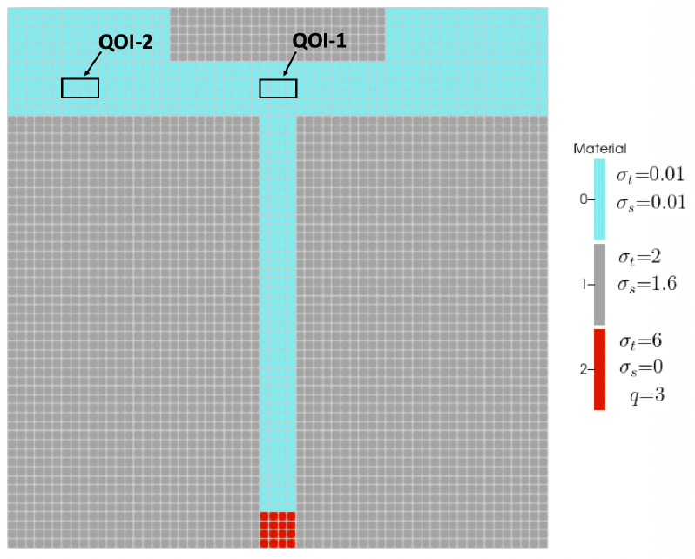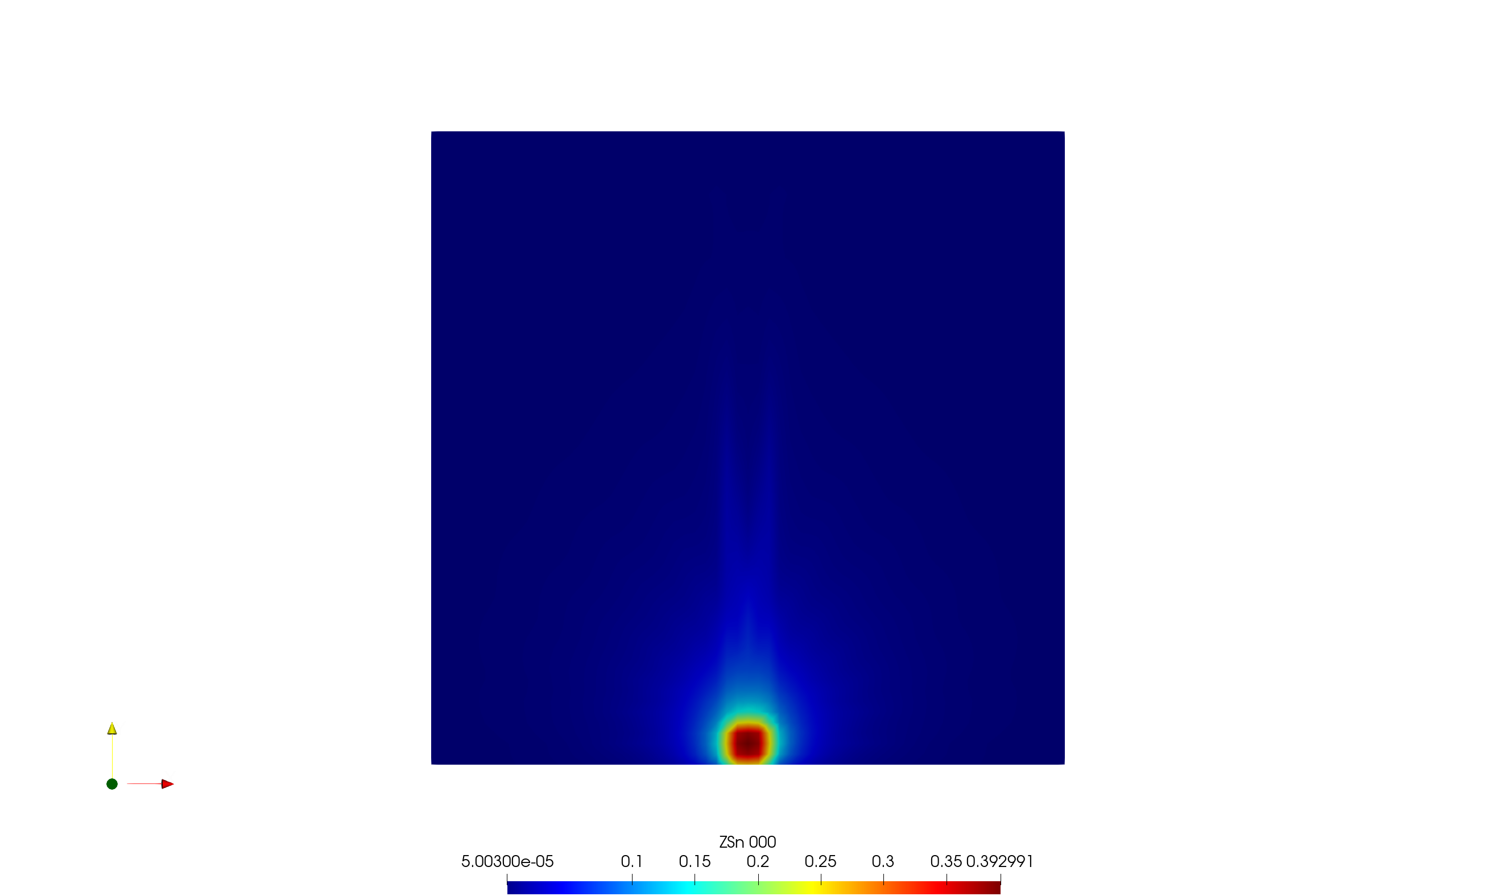

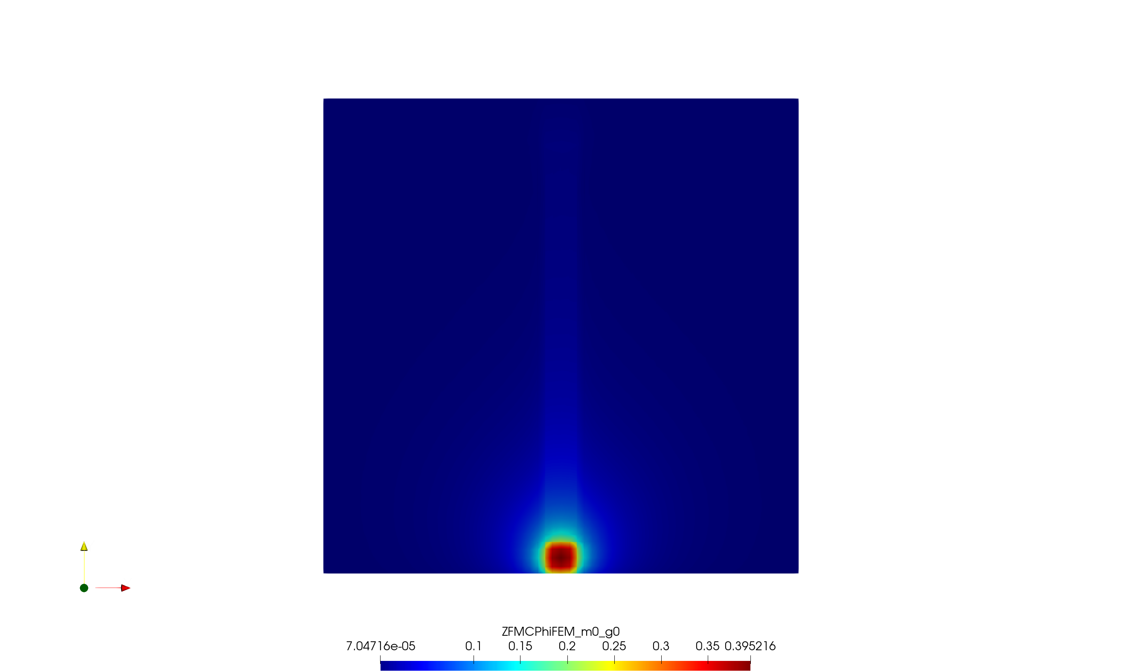

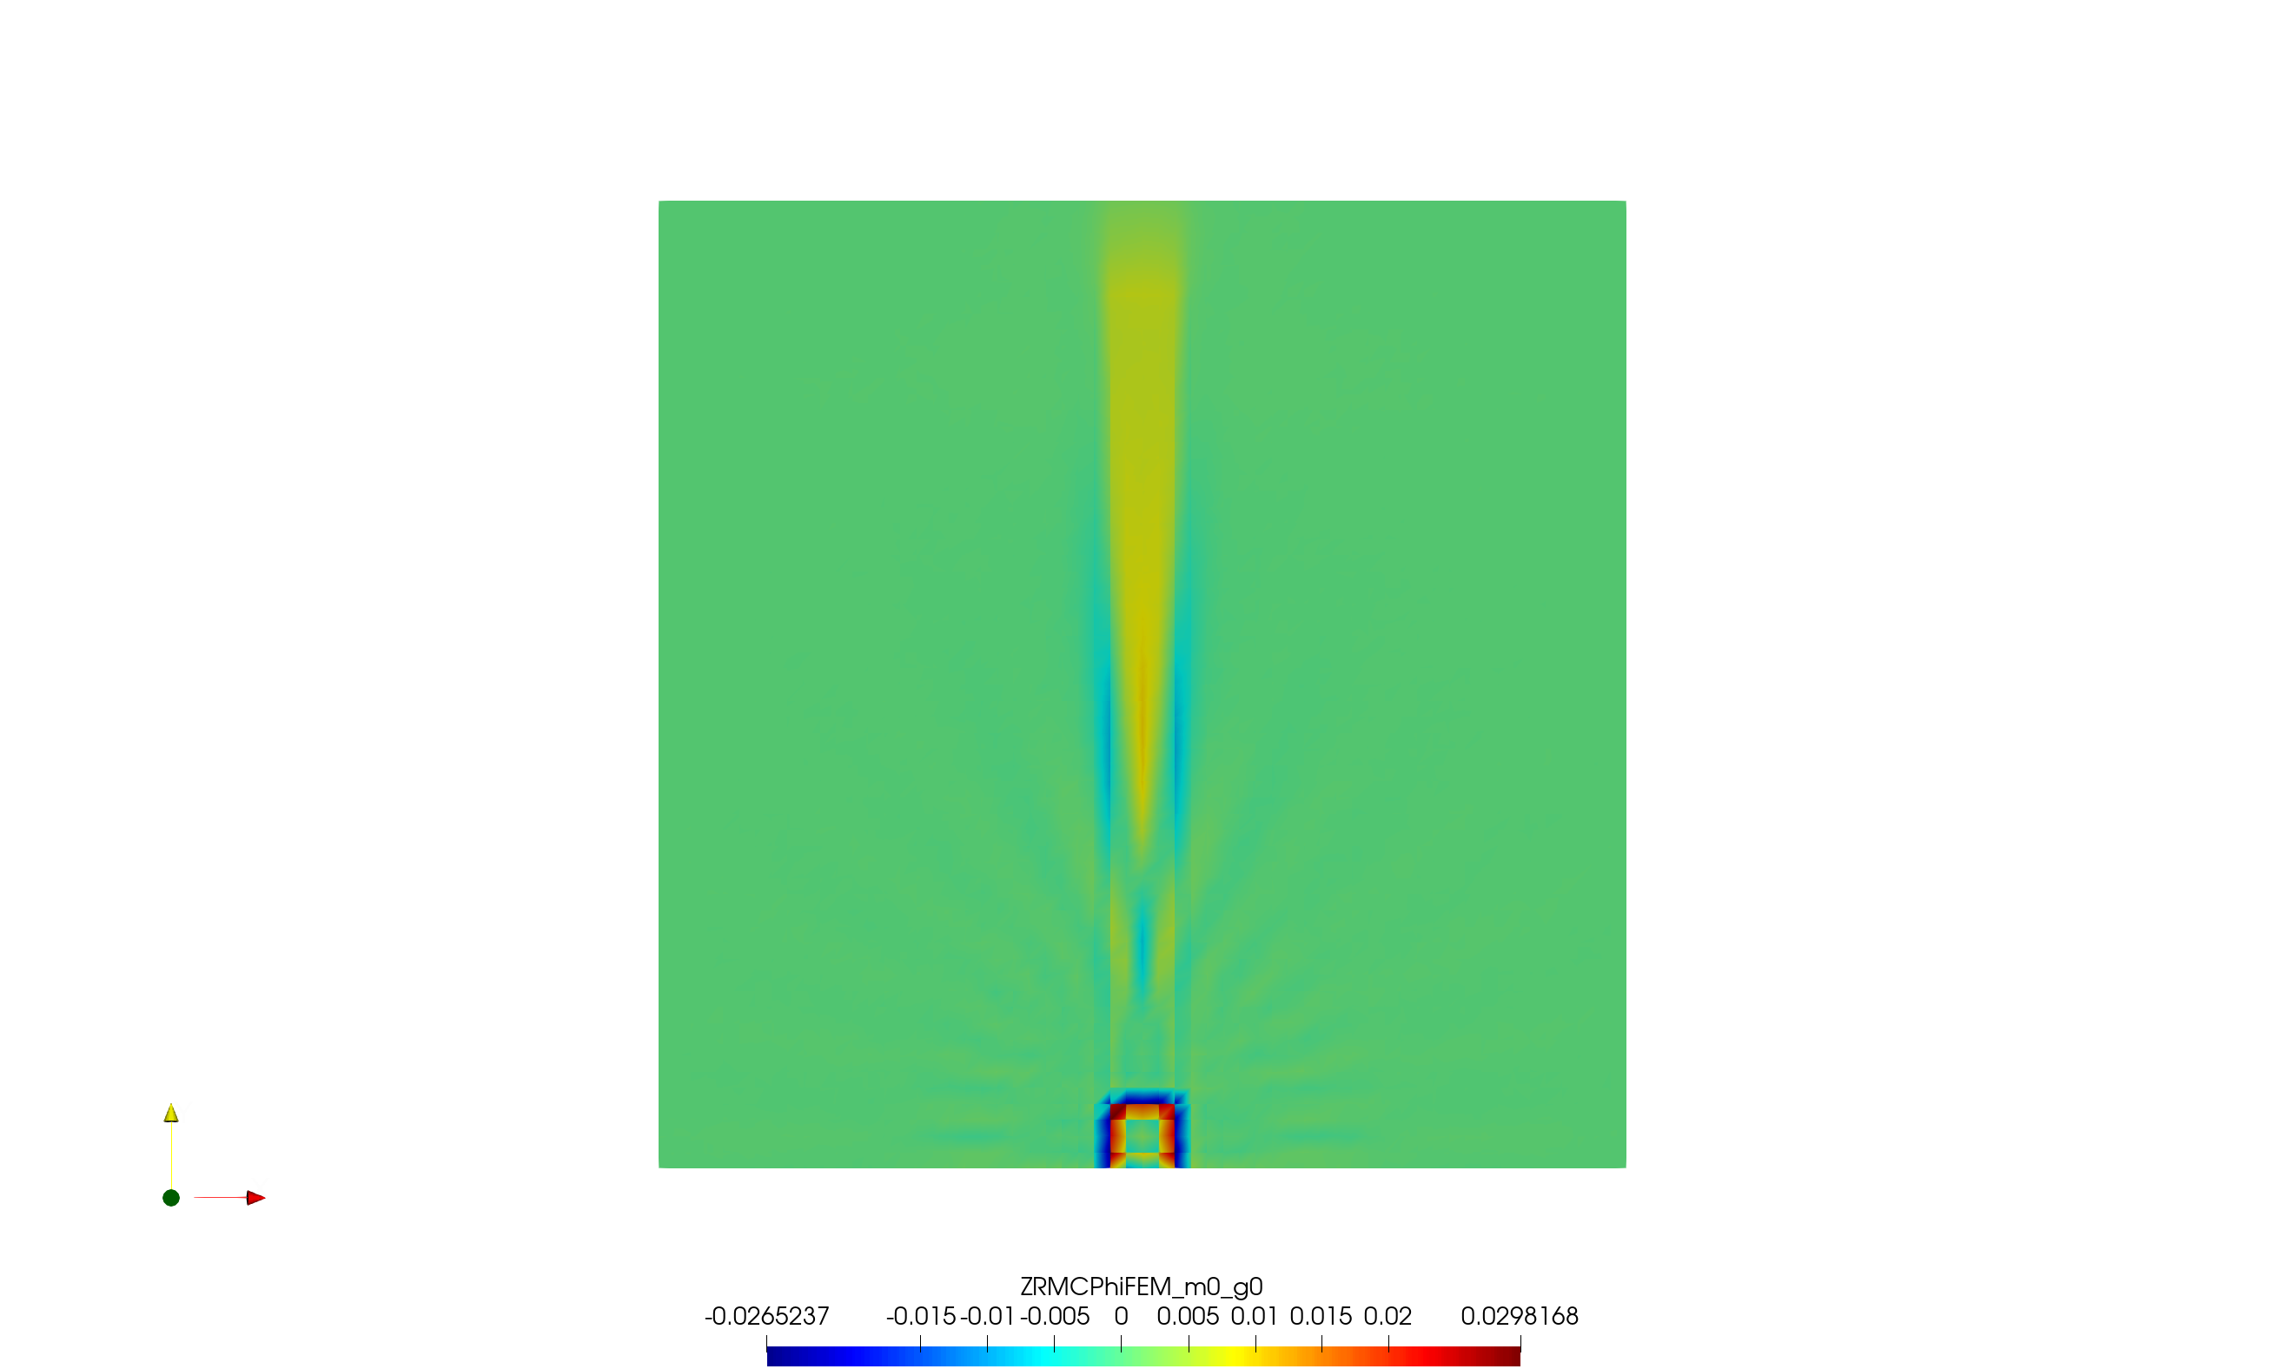

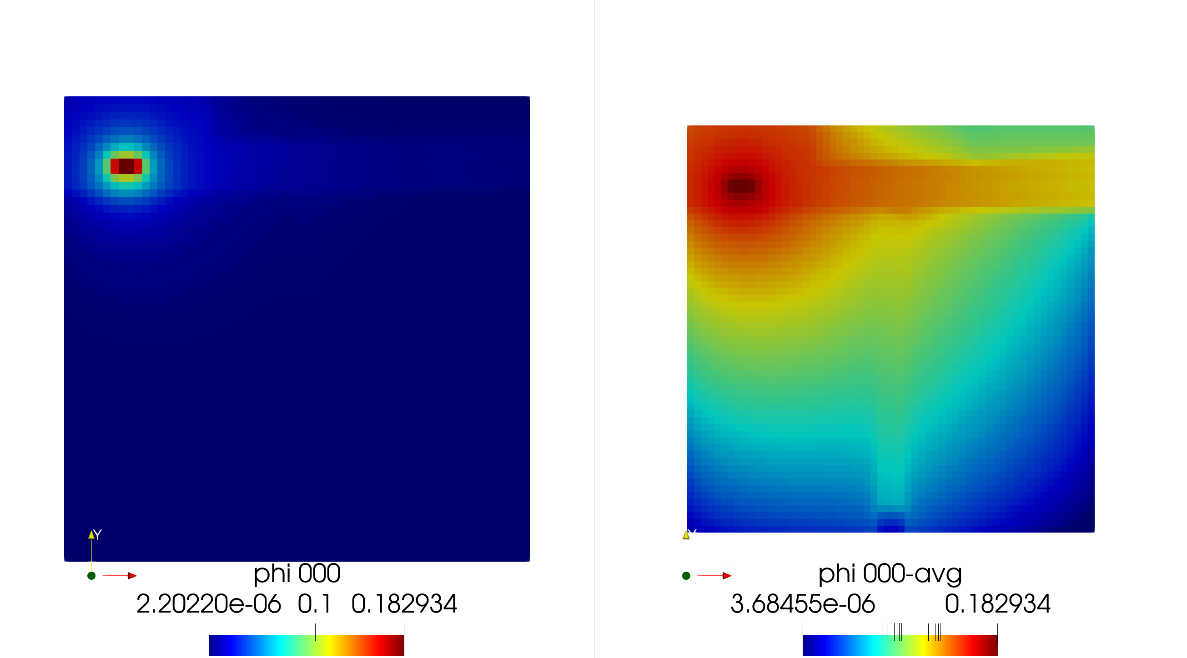

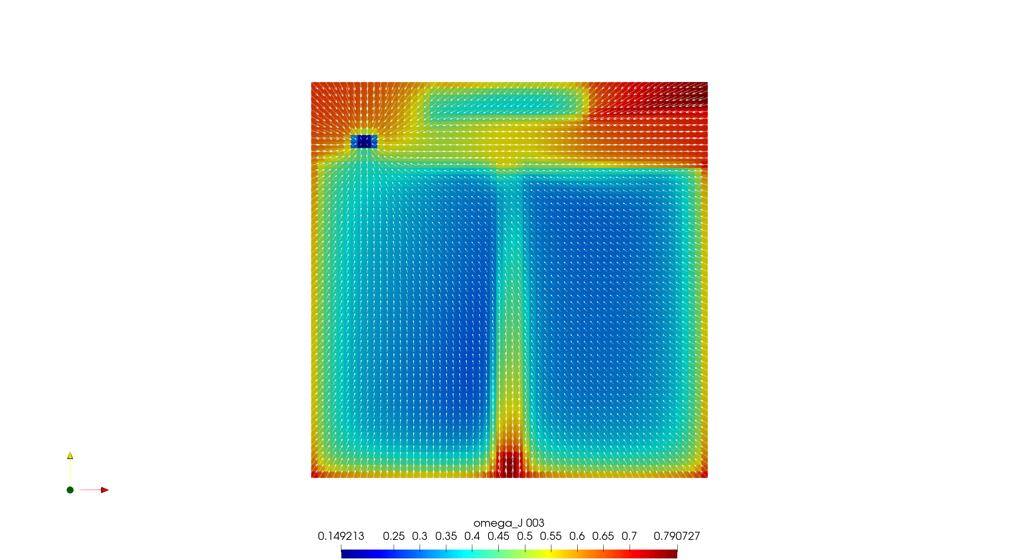

|  |  |  |
| --- | --- | --- |
| FMC |  |  |
|  | StdDev | Improvement |
| No biasing | 2.4028E-05 | 1.00 |
| Importance biased | 2.2743E-05 | 1.12 |
| Importance+angle biased | 2.1628E-05 | 1.23 |
|  |  |  |
| RMC |  |  |
|  | StdDev | Improvement |
| No biasing | 1.4003E-05 | 1.00 |
| Importance biased | 1.8667E-05 | 0.56 |
| Importance+angle biased | 1.8787E-05 | 0.56 |

