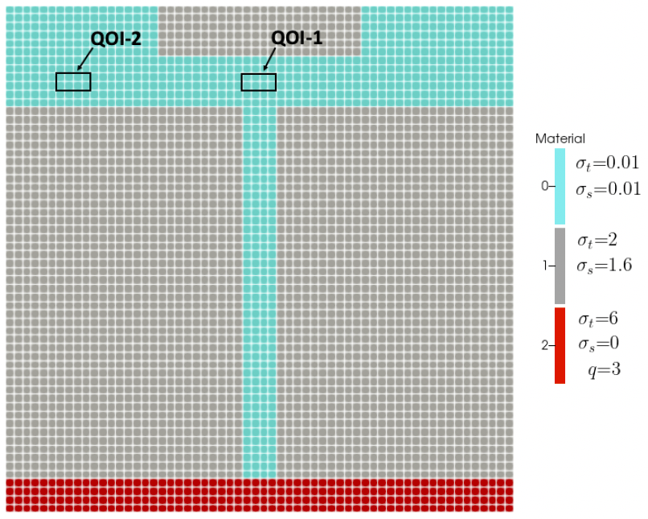

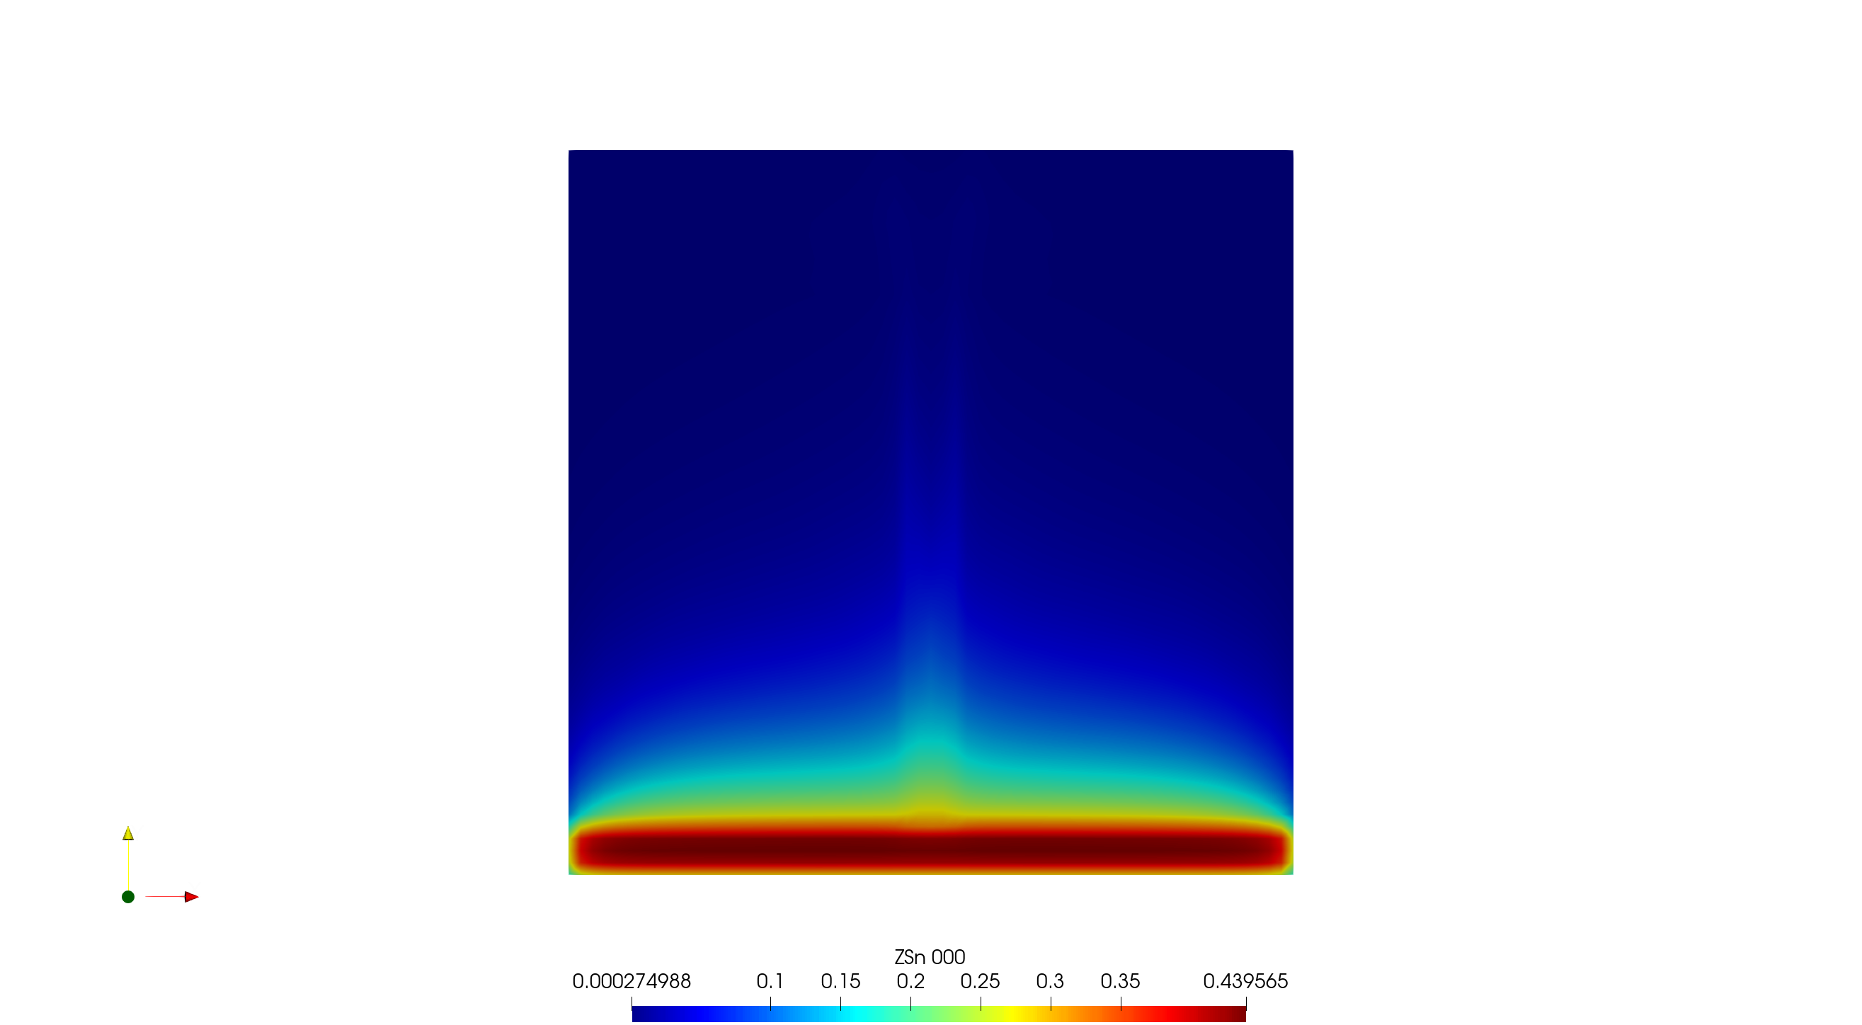

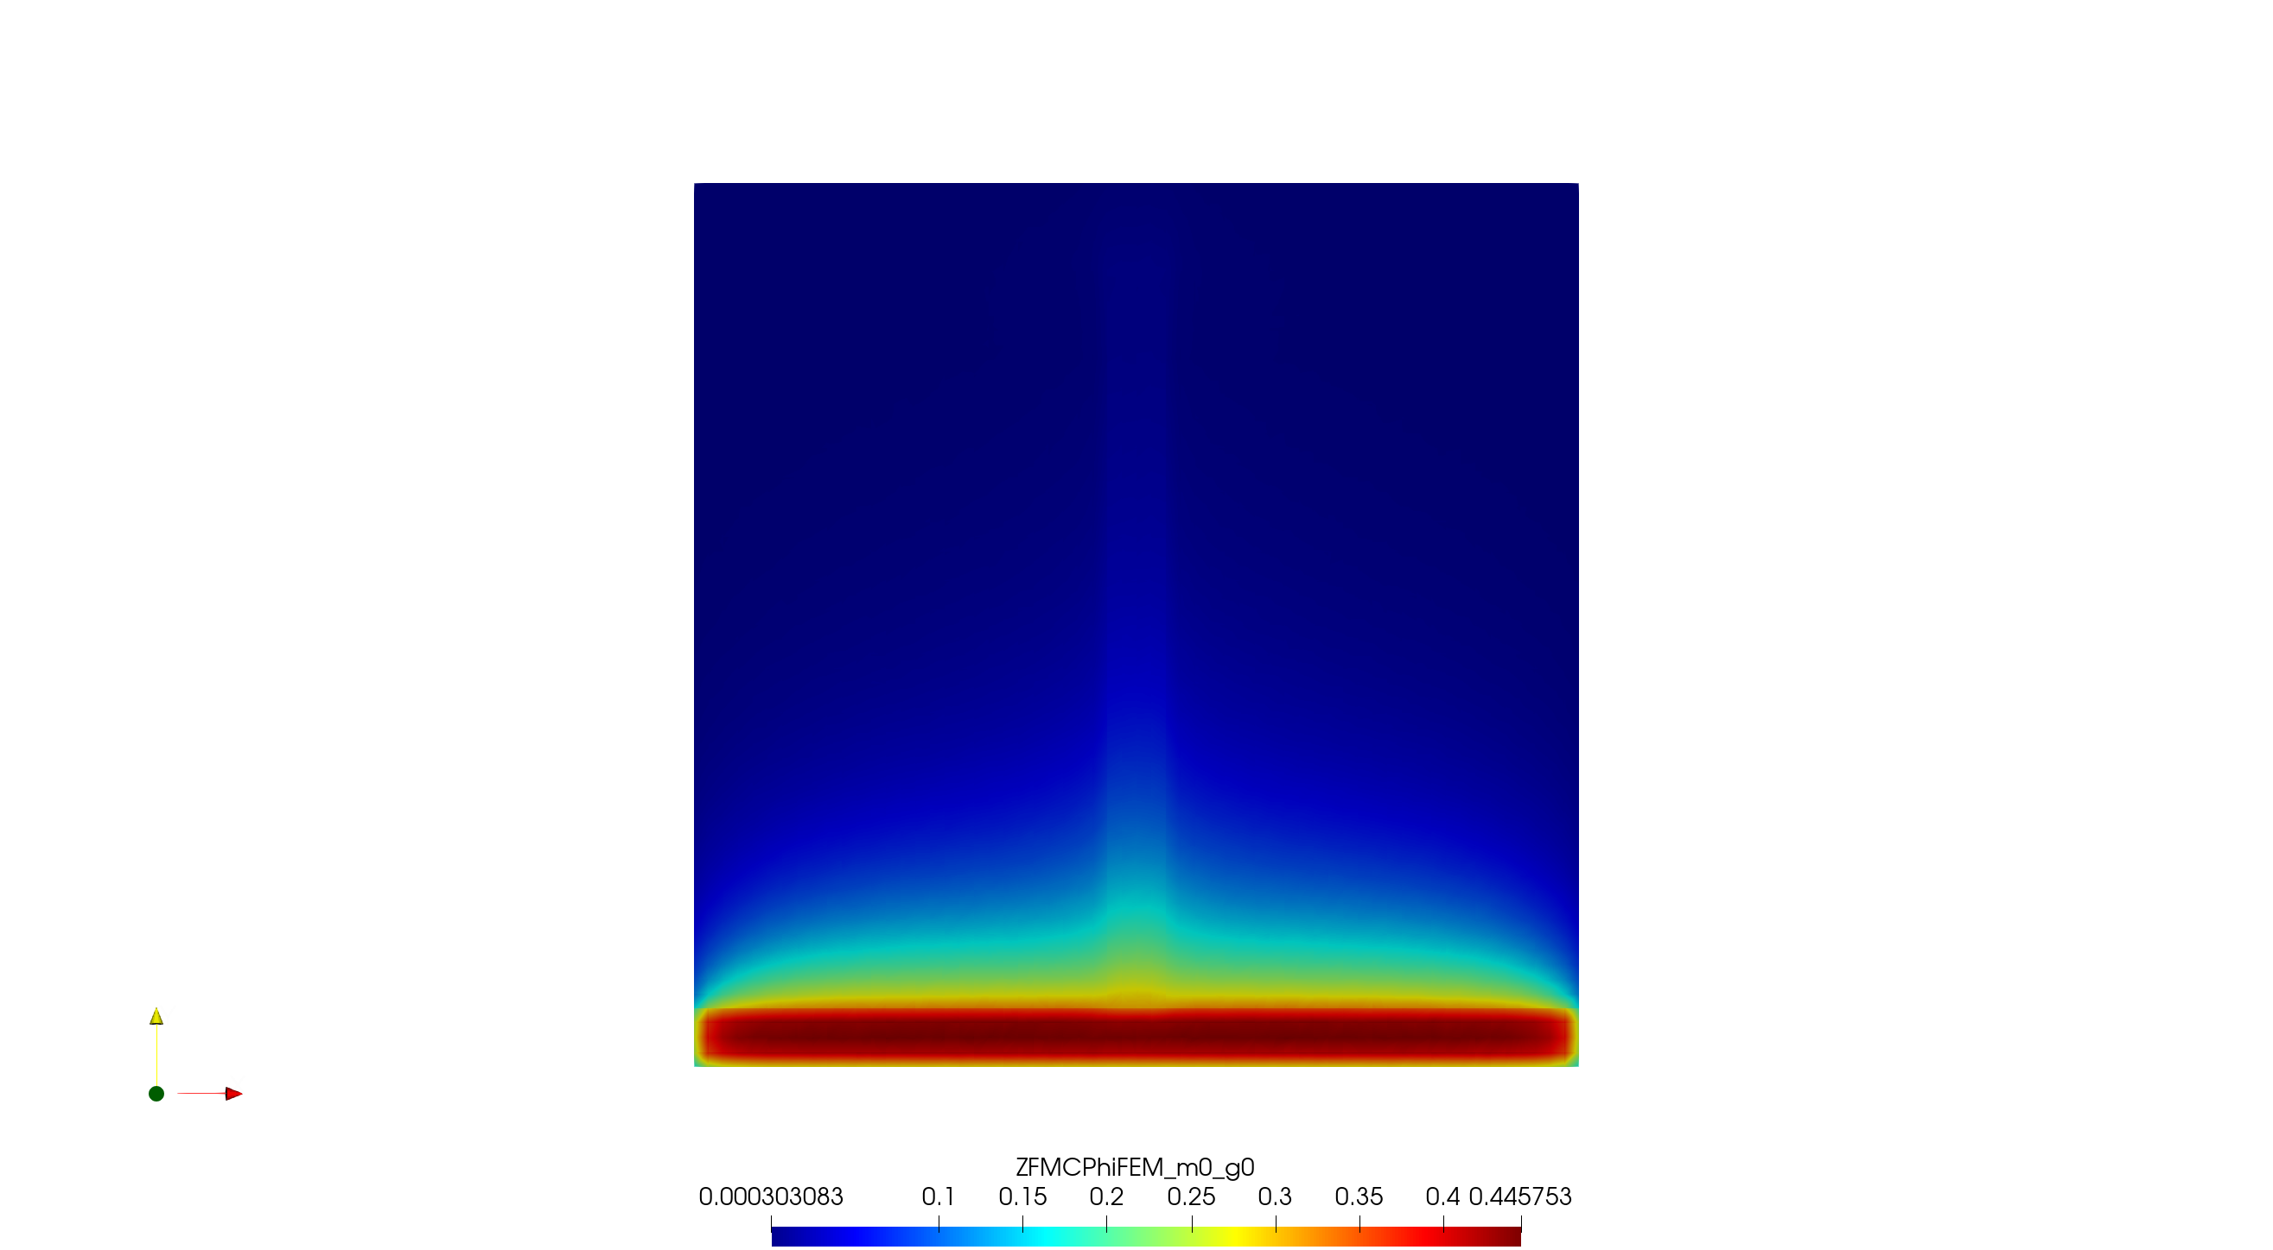

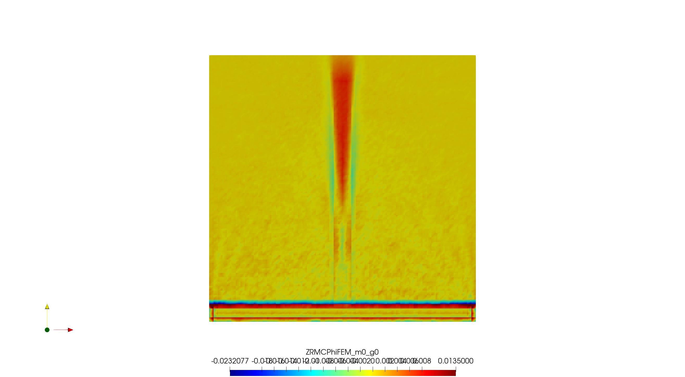

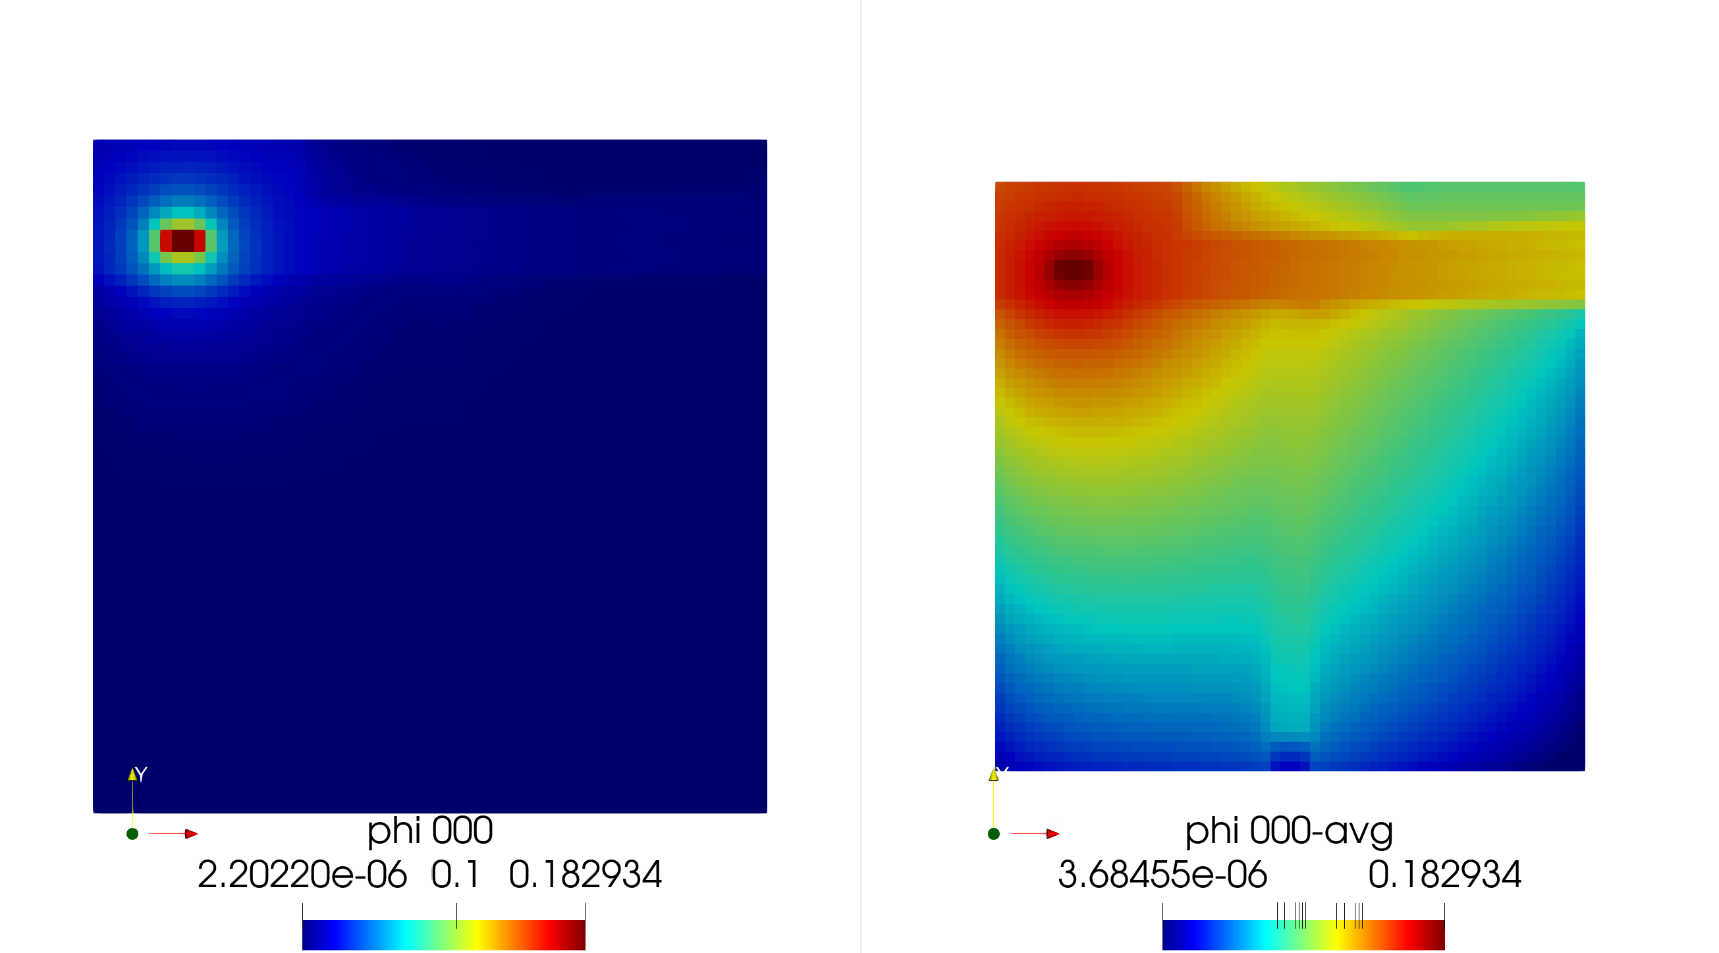

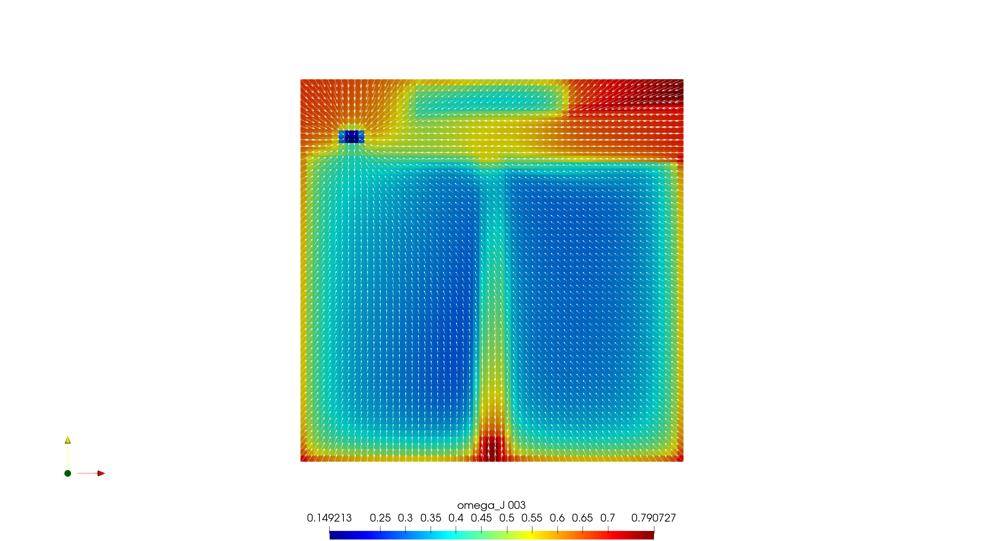

|  |  |  |
| --- | --- | --- |
| FMC |  |  |
|  | StdDev | Improvement |
| No biasing | 1.0899E-04 | 1.00 |
| Importance biased | 8.9558E-05 | 1.48 |
| Importance+angle biased | 6.2713E-05 | 3.02 |
|  |  |  |
| RMC |  |  |
|  | StdDev | Improvement |
| No biasing | 4.5375E-05 | 1.00 |
| Importance biased | 3.6239E-05 | 1.57 |
| Importance+angle biased | 3.6122E-05 | 1.58 |

