Jeff Beaupre

ICS 340 Project 2

README

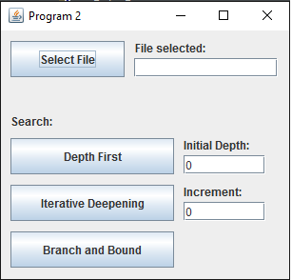

2

5

6

7

4

3

1

1. Select File – Launches FileChooser , once file is selected it will build the graph and display in the console
2. File Selected – displays the name of the file that was choosen
3. Depth First – Preforms a depth first search on the selected file, displays to console, does not save to file
4. Iterative Deepening – Preforms an Iterative deepening depth first search, displays to console and Saves to File. Uses the Initial Depth and Increment TextFields
5. Initial Depth – the first depth to go to for first iteration
6. Increment- the amount to add to the initial depth for subsequent iterations
7. Branch and Bound: Not yet implemented