Screenshots
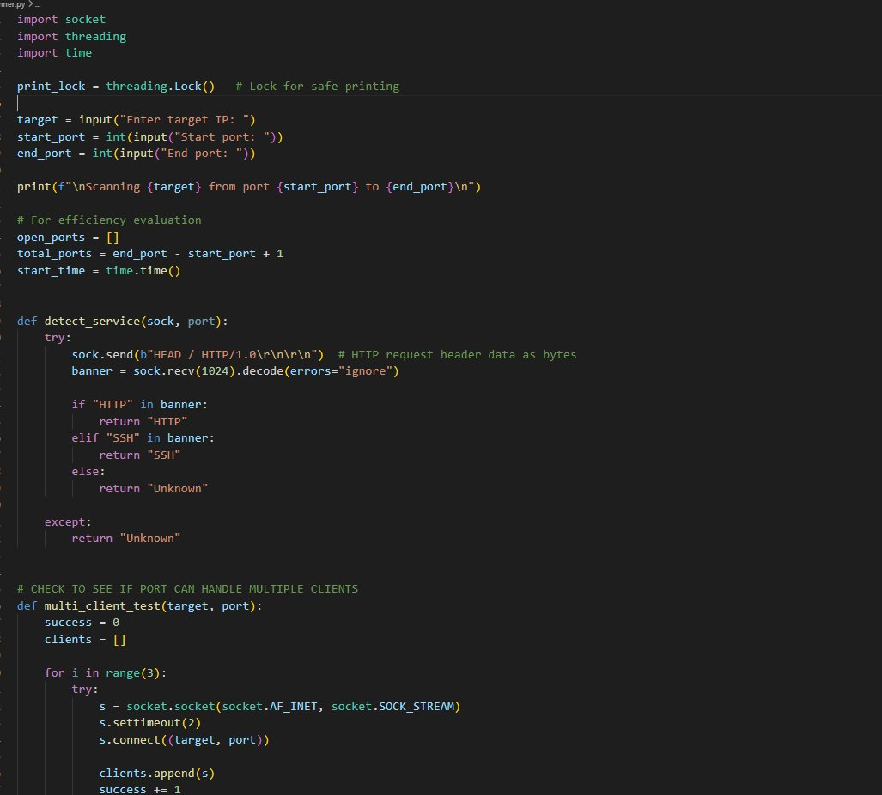
Figure 1: Code snippet showing the port scanner implementation — socket setup, service detection via banner grabbing, and multi-client testing logic.

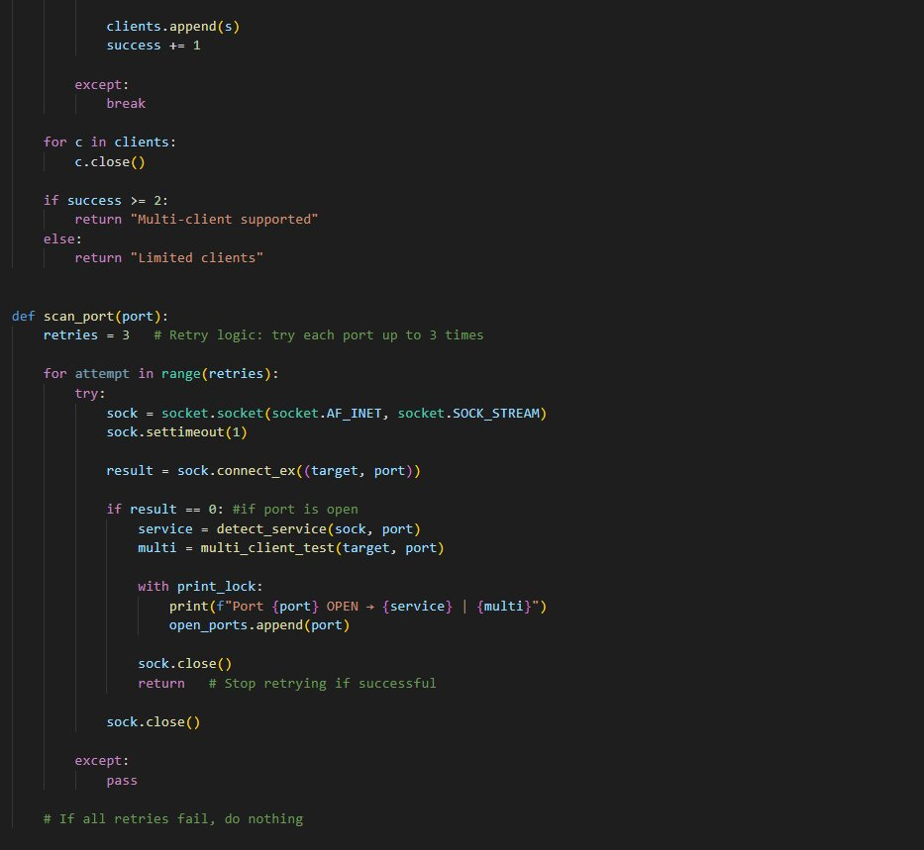
Figure 2: Continuation of the scanner code demonstrating retry logic, TCP connection attempts, and thread-safe open port tracking.

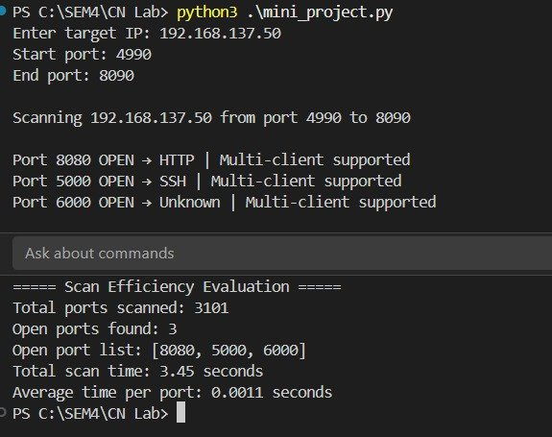
Figure 3: Terminal output showing a successful scan of 192.168.137.50 across ports 4990–8090, detecting HTTP, SSH, and an unknown service with multi-client support confirmed.

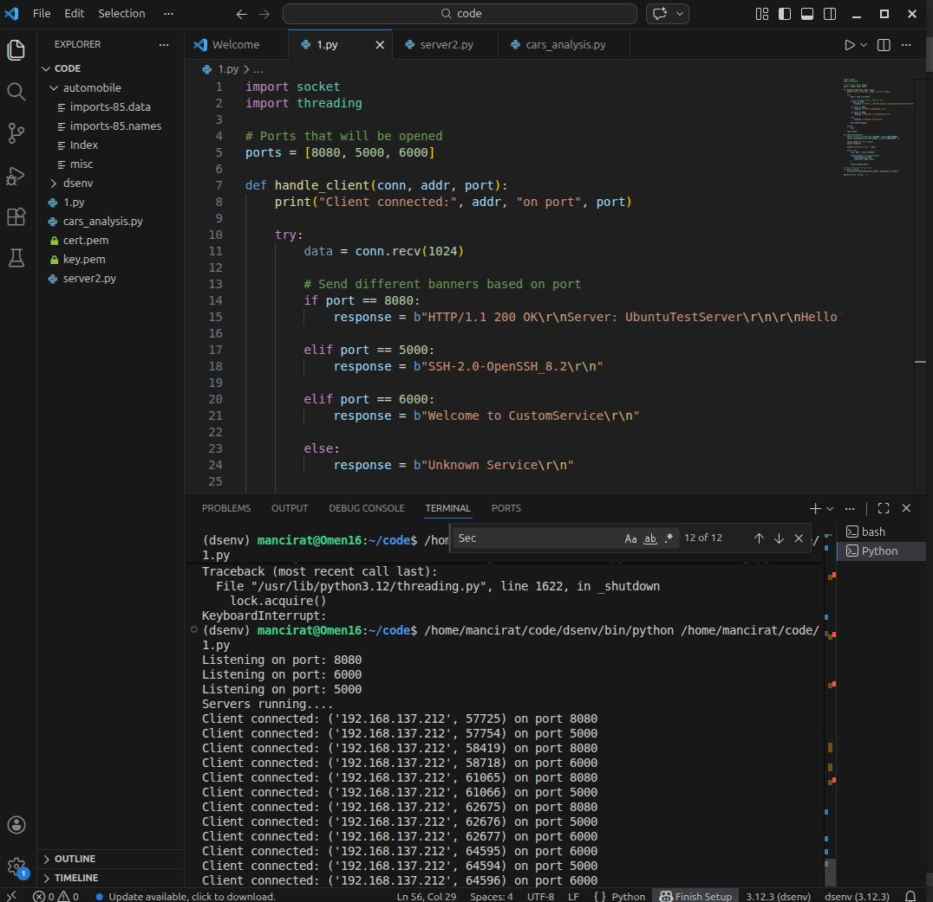
Figure 4: VS Code environment displaying the multi-port server script alongside its terminal output, showing concurrent client connections on ports 8080, 5000, and 6000.

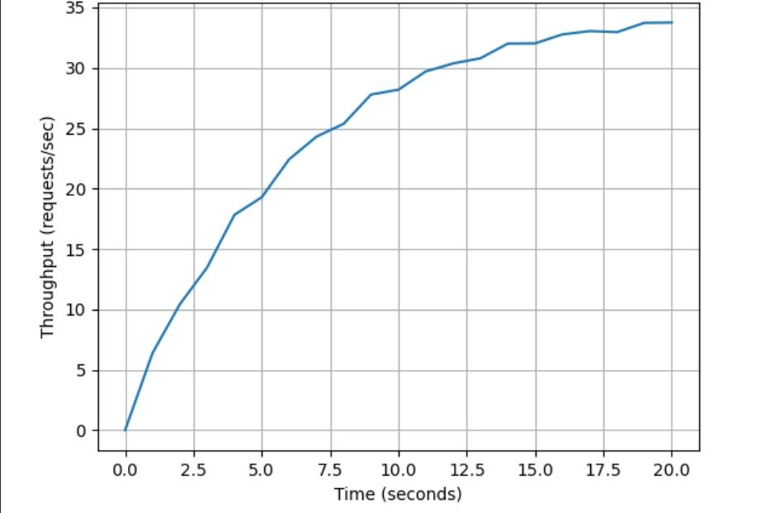
Figure 5: Real-time throughput graph showing requests/sec over 20 seconds. Throughput rises steeply as threads ramp up, then plateaus around 33–34 requests/sec.

