**Synopsis**

[**IR Remote Controlled Home Automation Using . PIC Microcontroller**](https://circuitdigest.com/microcontroller-projects/ir-remote-controlled-home-automation-using-pic) **.**

Introduction to Embedded System and Programming

|  |  |  |
| --- | --- | --- |
| Roll Number | Registration Id. | Name |
|  |  |  |
| 30 | 11714912 | Nakul Chauhan |
|  |  |  |
|  |  |  |

*Under the Guidance of*

***Navjot Rathore***



**Lovely School of Electrical and Electronics Engineering Lovely Professional University Punjab**

**Abstract:**

In this project, I will be using a PIC microcontroller to remotely control few AC loads which are present our house by just using an IR remote.

At the end of this project we will be able to toggle (ON/OFF) any AC load using an ordinary Remote from the comfort of Chair/Bed. All these can be done with simple clicks on IR remote. We can use any of TV/DVD/MP3 remote for this project. The different IR signals from the remote are received by the microcontroller which then controls the respective relays via a relay driver circuit. These relays are used to connect and disconnect the AC Loads (Lights/Fan). This project can be further expanded to control speed of fan with help of triac. In future I have decided to replace the IR remote with Smartphone, so that controlling of AC loads will be done through Samartphone.

### **Working Explanation:**

The working of this project is fairly simple to understand. When a button is pressed on the**IR Remote** it sends a sequence of code in form of encoded pulses using 38 Khz modulating frequency. These pulses are received by the **TSOP1738** sensor and then read by the Controller. The Controller then decodes the received train of the pulses into a hex value and compares it with the predefined hex values in our program.

If any match occurs then the controller performs a relative operation by triggering the respective Relay and the corresponding result is also indicated by on-board LEDs. Here in this project, I have used 4 bulbs (small bulbs) of different colors as lighting loads and another bulb (bigger bulb).

I have selected key 1 to toggle the relay1, 2 to toggle the relay2, 3 to toggle the relay3 and 4 to toggle the relay4.

There are many types of IR Remotes available for different devices, but most of them work around 38 KHz Frequency. Here in this project, I am going to control home appliances using IR TV remote and for detecting the IR signals, we use a TSOP1738 IR Receiver. This TSOP1738 sensor can sense 38 Khz Frequency signal. The working of IR remote and the TSOP1738 is covered in detail in this article: IR Transmitter and Receiver

Our PIC microcontroller operates at +5V and the Relays operate at +12V, Hence we use a transformer to step down the 220V AC and rectify it using a full bridge rectifier. This rectified DC voltage is then regulated to +12V and +5V by using the regulator ICs 7812 and 7805 respectively.

To trigger the relay we make use of transistors like BC547 which can act as an electronic switch to turn ON/OFF the relays based on the signal from the PIC microcontroller.

**Block Diagram:**

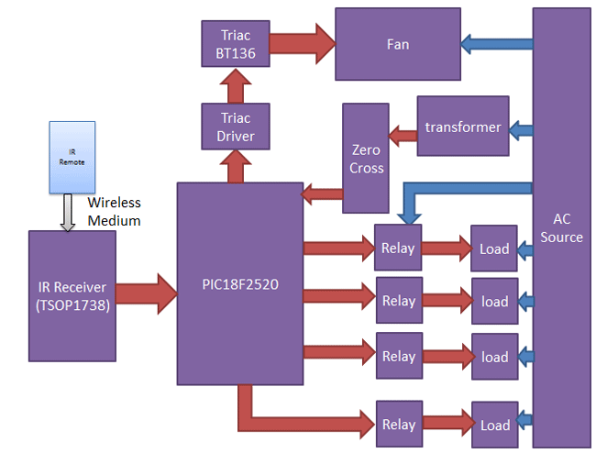

Note: Above diagram includes controlling of fan also. But in my project I will be

doing this project excluding controlling of fan.

**Components Required:**

* PIC18f2520 Microcontroller
* TSOP1738
* IR TV/DVD Remote
* Transistor BC547
* Relays 12 volt
* 16x2 LCD
* Power supply 12v
* Terminal connector
* Transformer 12-0-12                                                                    -
* Voltage Regulator

**Result:**

At the end a single IR remote which is easily available in our home will be able to control our maximum household appliances.

**References**:

<https://circuitdigest.com>

[https://www.edgefxkits.com](https://www.edgefxkits.com/)

<https://en.wikipedia.org>

**Working of MQ-2(Smoke sensor):**

MQ2 sensor is used because it detects the gas very easily and fast, it can be implemented over the digital or analog pin. It offers low conductivity in air when there is no gas present in air. If there is a combustible gas presence in the air , MQ2 gas sensor offers high conductivity. The high conductivity depends upon the concentration of the gas present in the atmosphere. The sensor used will be able to convert the conductivity into the output voltage of the sensor , so the output voltage will be used as reference to assure the presence and the absence of the sensor.

The most important thing to take care int his sensor is that it has to be kept for the pre-heating time before we can start to work with it. It works with the input voltage of 5v.

**Application :**

* Detects or measure Gases like LPG, Alcohol, Propane, Hydrogen, CO and even methane
* Air quality monitor
* Gas leak alarm
* Safety standard maintenance
* Maintaining environment standards in hospitals