***MACHINE LEARNING:***

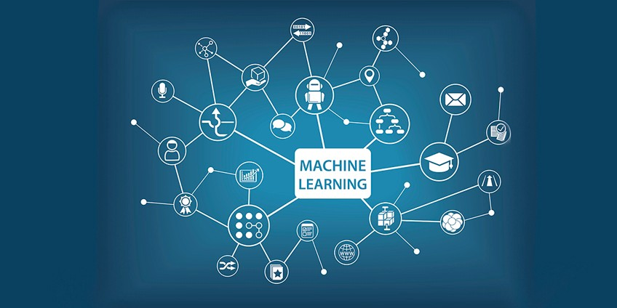

Machine learning is an application of artificial intelligence (AI) that provides systems the ability to automatically learn and improve from experience without being explicitly programmed. **Machine learning focuses on the development of computer programs** that can access data and use it learn for themselves.

It is a scientific study of algorithms and statistical models that computer systems use to effectively perform a specific task without using explicit instructions, relying on patterns and inference instead. It is seen as a subset of artificial intelligence. Machine learning algorithms build a mathematical model based on sample data, known as "training data", in order to make predictions or decisions without being explicitly programmed to perform the task. Machine learning algorithms are used in a wide variety of applications, such as email filtering, and computer vision, where it is infeasible to develop an algorithm of specific instructions for performing the task. Machine learning is closely related to computational statistics, which focuses on making predictions using computers. The study of mathematical optimization delivers methods, theory and application domains to the field of machine learning. Data mining is a field of study within machine learning, and focuses on exploratory data analysis through unsupervised learning. In its application across business problems, machine learning is also referred to as predictive analytics.

**Some machine learning methods**

Machine learning algorithms are often categorized as supervised or unsupervised.

* **Supervised machine learning algorithms**can apply what has been learned in the past to new data using labeled examples to predict future events. Starting from the analysis of a known training dataset, the learning algorithm produces an inferred function to make predictions about the output values. The system is able to provide targets for any new input after sufficient training. The learning algorithm can also compare its output with the correct, intended output and find errors in order to modify the model accordingly.
* In contrast, **unsupervised machine learning algorithms**are used when the information used to train is neither classified nor labeled. Unsupervised learning studies how systems can infer a function to describe a hidden structure from unlabeled data. The system doesn’t figure out the right output, but it explores the data and can draw inferences from datasets to describe hidden structures from unlabeled data.
* **Semi-supervised machine learning algorithms** fall somewhere in between supervised and unsupervised learning, since they use both labeled and unlabeled data for training – typically a small amount of labeled data and a large amount of unlabeled data. The systems that use this method are able to considerably improve learning accuracy. Usually, semi-supervised learning is chosen when the acquired labeled data requires skilled and relevant resources in order to train it / learn from it. Otherwise, acquiringunlabeled data generally doesn’t require additional resources.
* **Reinforcement machine learning algorithms**is a learning method that interacts with its environment by producing actions and discovers errors or rewards. Trial and error search and delayed reward are the most relevant characteristics of reinforcement learning. This method allows machines and software agents to automatically determine the ideal behavior within a specific context in order to maximize its performance. Simple reward feedback is required for the agent to learn which action is best; this is known as the reinforcement signal.

## Applications of Machine Learning:

### Financial Services

Companies in the financial sector are able to identify key insights in financial data as well as prevent any occurrences of financial fraud, with the help of machine learning technology. The technology is also used to identify opportunities for investments and trade. Usage of cyber surveillance helps in identifying those individuals or institutions which are prone to financial risk, and take necessary actions in time to prevent fraud.

### Marketing and Sales

Companies are using machine learning technology to analyze the purchase history of their customers and make personalized product recommendations for their next purchase. This ability to capture, analyze, and use customer data to provide a personalized shopping experience is the future of sales and marketing.

### Government

Government agencies like utilities and public safety have a specific need FOR Ml, as they have multiple data sources, which can be mined for identifying useful patterns and insights. For example sensor data can be analyzed to identify ways to minimize costs and increase efficiency. Furthermore, ML can also be used to minimize identity thefts and detect fraud.

### Healthcare

With the advent of wearable sensors and devices that use data to access health of a patient in real time, ML is becoming a fast-growing trend in healthcare. Sensors in wearable provide real-time patient information, such as overall health condition, heartbeat, blood pressure and other vital parameters. Doctors and medical experts can use this information to analyze the health condition of an individual, draw a pattern from the patient history, and predict the occurrence of any ailments in the future. The technology also empowers medical experts to analyze data to identify trends that facilitate better diagnoses and treatment.

### Transportation

Based on the travel history and pattern of traveling across various routes, machine learning can help transportation companies predict potential problems that could arise on certain routes, and accordingly advise their customers to opt for a different route. Transportation firms and delivery organizations are increasingly using machine learning technology to carry out data analysis and data modeling to make informed decisions and help their customers make smart decisions when they travel.

**Genetic Algorithm:**

A **genetic algorithm** is a search heuristic that is inspired by Charles Darwin’s theory of natural evolution. This algorithm reflects the process of natural selection where the fittest individuals are selected for reproduction in order to produce offspring of the next generation.

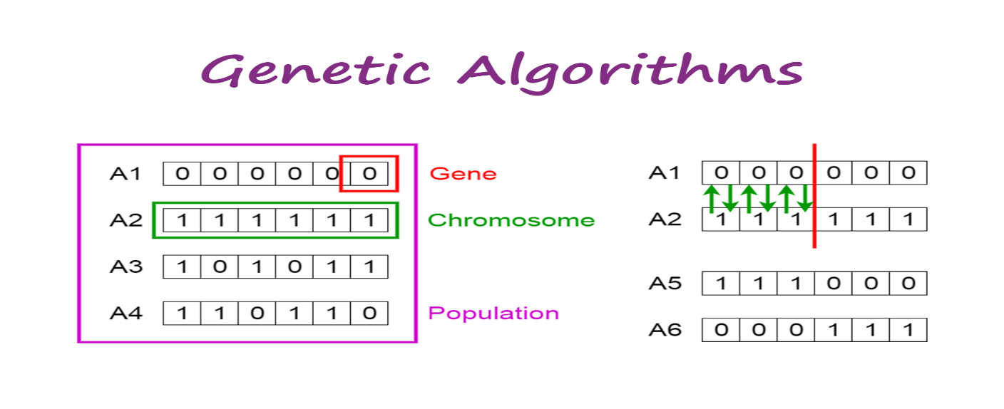

**Notion of Natural Selection**

The process of natural selection starts with the selection of fittest individuals from a population. They produce offspring which inherit the characteristics of the parents and will be added to the next generation. If parents have better fitness, their offspring will be better than parents and have a better chance at surviving. This process keeps on iterating and at the end, a generation with the fittest individuals will be found.

This notion can be applied for a search problem. We consider a set of solutions for a problem and select the set of best ones out of them.

Five phases are considered in a genetic algorithm.

1. Initial population
2. Fitness function
3. Selection
4. Crossover
5. Mutation

**Initial Population**

The process begins with a set of individuals which is called a **Population**. Each individual is a solution to the problem you want to solve.

An individual is characterized by a set of parameters (variables) known as **Genes**. Genes are joined into a string to form a **Chromosome** (solution).

In a genetic algorithm, the set of genes of an individual is represented using a string, in terms of an alphabet. Usually, binary values are used (string of 1s and 0s). We say that we encode the genes in a chromosome.

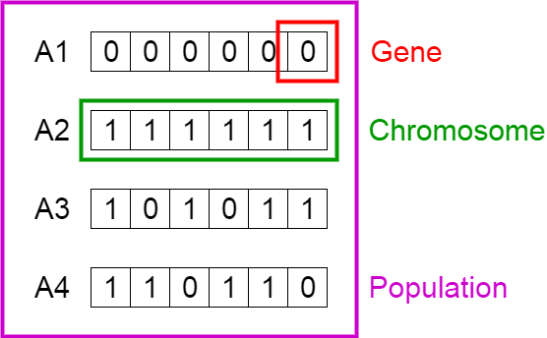

Population, Chromosomes and Genes

**Fitness Function**

The **fitness function** determines how fit an individual is (the ability of an individual to compete with other individuals). It gives a **fitness score** to each individual. The probability that an individual will be selected for reproduction is based on its fitness score.

**Selection**

The idea of **selection** phase is to select the fittest individuals and let them pass their genes to the next generation.

Two pairs of individuals (**parents**) are selected based on their fitness scores. Individuals with high fitness have more chance to be selected for reproduction.

**Crossover**

**Crossover** is the most significant phase in a genetic algorithm. For each pair of parents to be mated, a **crossover point** is chosen at random from within the genes.

For example, consider the crossover point to be 3 as shown below.

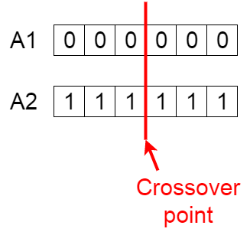

Crossover point

**Offspring** are created by exchanging the genes of parents among themselves until the crossover point is reached.

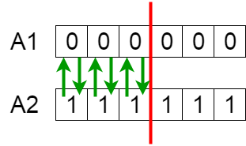

Exchanging genes among parents

The new offspring are added to the population.

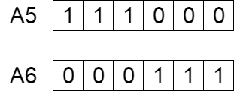

New offspring

**Mutation**

In certain new offspring formed, some of their genes can be subjected to a **mutation** with a low random probability. This implies that some of the bits in the bit string can be flipped.

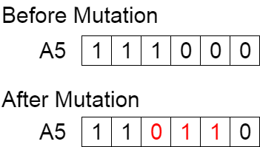

Mutation: Before and After

Mutation occurs to maintain diversity within the population and prevent premature convergence.

**Termination**

The algorithm terminates if the population has converged (does not produce offspring which are significantly different from the previous generation). Then it is said that the genetic algorithm has provided a set of solutions to our problem.