**A MINI-PROJECT REPORT**

**ON**

**THYRISTOR FIRING ANGLE CONTROL FOR BATTERY CHARGING**

SUBMITTED TO THE SAVITRIBAI PHULE PUNE UNIVERSITY, PUNE

IN THE PARTIAL FULFILLMENT FOR THE AWARD OF THE DEGREE

**OF**

**THIRD YEAR OF ENGINEERING**

**IN**

**ELECTRONICS AND TELECOMMUNICATION**

**BY**

## Nakul Dandekar Exam. No. T190363071

**Prathmesh Girme Exam. No. T1903633119**

**Pratik Jadhav Exam. No. T190363142**

**UNDER THE GUIDANCE OF**

**MS. KOMAL WANZARE**



**DEPARTMENT OF ELECTRONICS AND TELECOMMUNICATIONENGG**.

**STES’S**

**SMT. KASHIBAI NAVALE COLLEGE OF ENGINEERING**

**VADGAON BK., OFF.SINHGAD ROAD**

**PUNE 411041**

**2022– 2023**



**CERTIFICATE**

This is to certify that the mini project report entitled

“**THYRISTOR FIRING ANGLE CONTROL FOR BATTERY CHARGING**”

**Submitted by**

## Nakul Dandekar Exam. No. T190363071

Prathmesh Girme Exam No. T1903633119

Pratik Jadhav Exam No. T1903633142

Is a bonafide work carried out by them under the supervision of Ms. Komal Wanzare and it is approved for the partial fulfillment of the requirement of Savitribai Phule Pune University for the award of the Degree of Third Year of Engineering (Electronics and Telecommunication Engineering). This Mini-project report has not been earlier submitted to any other Institute or University for the award of any degree or diploma*.*

|  |  |
| --- | --- |
| Ms. Komal Wanzare | Ms. S.S. Jahagirdar/ Ms. K. A. Pujari |
| **Guide, Department of E & TC** | Mini-Project Coordinator |
|  | **Department of E&TC** |

|  |  |
| --- | --- |
| Dr. S.K. Jagtap | Dr. A.V. Deshpande |
| **Head** | **Principal** |
| **Department of E&TC** | **S.K.N.C.O.E, Pune-41** |

Place: Pune

Date: 25/04/2023

### CONTENTS

CERTIFICATE I

INDEX II

ACKNOWLEDGEMENT III LIST OF FIGURES IV

NOMENCLATURE V

**INDEX**

**CHAPTER TITLE PAGE NO.**

1. **INTRODUCTION** 7

* 1. BACKGROUND 7
  2. RELEVANCE 7
  3. PROJECT UNDERTAKEN 7
  4. OBJECTIVES 8
  5. ORGANIZATION OF PROJECT REPORT 8
  6. SUMMARY 8

2. **LITERATURE SURVEY**  9

* 1. INTRODUCTION 9
  2. REFERENCE PAPERS 9

3**. DESIGN AND DRAWING** 13

3.1 INTRODUCTION 13

* 1. BLOCK DIAGRAM 13
  2. BLOCK DIAGRAM DISCRIPTION 13
  3. COMPONENT USED 15
  4. CIRCUIT DIAGRAM 23
  5. CODE 23
  6. SUMMARY 27

1. **IMPLEMENTATION** 28

4.1 HARDWARE 28

4.2 HARDWARE DETAILS 28

4.3 SUMMARY 29

5. **RESULTS** 30

* 1. SIMULATION RESULT 31
  2. FINAL RESULT 31

6. CONCLUSIONS 32

7. REFERENCES 33

**ACKNOWLEDGEMENT**

I take this opportunity to thank all those who have contributed to the successful completion of this Mini Project. I would like to express my sincere thanks to my guide Prof. K. C WANZARE who has encouraged us to work and provided valuable guidance wherever required. We express our immense pleasure and thankfulness to mini project coordinators Ms. S.S. Jahagirdar & Ms. K. A. Pujari who guided us on every possible stage. We also extend our gratitude to Dr. S. K. JAGTAP (HOD OF ENTC DEPARTMENT) who has provided facilities to explore this subject with more enthusiasm. We express our immense pleasure and thankfulness to Dr. A. V. Deshpande (Principal S.K.N.C.O.E) has provided facilities to explore this subject with more enthusiasm, I like to thank all the teaching and non-teaching staff for their immense support and their cooperation.

**LIST OF FIGURES**

|  |  |
| --- | --- |
| **FIGURE NO.** | **FIGURE NAME** |
| 1 | Block Diagram of Thyristor Firing Angle Control for Battery Charging |
| 2 | ATmega Microcontroller |
| 3 | MOC3031 |
| 4 | BT136 |
| 5 | LCD 16X2 |
| 6 | TRANSFORMER 15-0-15 |
| 7 | 7805(linear voltage regulator |
| 8 | Heatsink & LM317 |
| 9 | Capacitors 1000uF/25V & 220uF/63V |
| 10 | 1n4007 diode |
| 11 | Circuit Diagram of Thyristor Firing Angle Control for Battery Charging |
| 12 | Final Result of thyristor firing angle control for battery charging |
| 13 | Varying Thyristor firing angle from 10degree to 90 degrees |
| 14 | Level 1(1-7) voltage required for battery charging |

**NOMENCLATURE**

* + MOC Molded Optocoupler/Microprocessor Output opto-isolator
  + BT136 Bidirectional Triode Thyristor
  + LCD Liquid Crystal Display
  + KM317 Linear Monolithic Integrated Circuit 3-Terminal Adjustable Positive

Voltage Regulator

**CHAPTER 1. INTRODUCTION**

* 1. BACKGROUND

In the field of power electronics, thyristors are widely used due to their ability to handle high voltage and current levels. Thyristor firing angle control is a technique used to regulate the flow of electrical current in a circuit by controlling the firing angle of a thyristor. This technique is commonly used in various applications, including motor speed control, voltage regulation, and battery charging.

* 1. RELEVANCE

Thyristor firing angle control is an important technique used in battery charging applications to control the charging current and voltage. It allows for precise control of the charging process, which is critical for ensuring that batteries are charged safely and efficiently.

Thyristor firing angle control allows for the adjustment of the time delay between the voltage applied to the battery and the current flow, which affects the charging current and voltage. By adjusting the firing angle of the thyristors, the charging voltage and current can be precisely controlled, which can help to prevent overcharging or undercharging of the battery.

Overcharging can cause damage to the battery, reduce its lifespan, and even pose a safety hazard. Undercharging, on the other hand, can result in reduced battery capacity and performance. Therefore, precise control of the charging process is essential for ensuring the longevity and safety of batteries.

In addition to battery charging, thyristor firing angle control is also used in other applications such as motor control, power factor correction, and lighting control. It is a versatile and widely used technique in power electronics and is essential for achieving efficient and safe operation of electrical systems.

* 1. PROJECT UNDERTAKEN

The aim of this project is to design and implement a thyristor firing angle control circuit for battery charging. The circuit will be controlled by a microcontroller-based system that will regulate the charging current according to the requirements of the battery being charged.

The project will involve the following steps:

* Designing and simulating the thyristor firing angle control circuit.
* Implementing the circuit on a breadboard or PCB.
* Programming the microcontroller to control the thyristor firing angle and regulate the charging current.
* Testing and validating the circuit with different battery types and charging requirements.
  1. OBJECTIVES
* To design and implement a thyristor-based power converter for battery charging.
* To develop a control algorithm for thyristor firing angle control to regulate the charging current and voltage of the battery.
* To test and validate the performance of the thyristor firing angle control system for battery charging in terms of efficiency, power factor, and charging time.
* To evaluate the impact of the thyristor firing angle control system on the battery life and performance.
* To optimize the thyristor firing angle control system parameters for maximum efficiency and battery life.
  1. ORGANIZATION OF PROJECT REPORT

This project report will consist of several sections, including an introduction, literature review, methodology, results, discussion, and conclusion. The literature review will provide an overview of the background and significance of thyristor firing angle control for battery charging, while the methodology section will describe the design and implementation of the circuit. The results section will present the experimental results obtained, while the discussion section will provide an analysis and interpretation of the results. The conclusion section will summarize the main findings of the project and highlight the significance of the research undertaken.

* 1. SUMMARY

In summary, this project aims to design and implement a thyristor firing angle control circuit for battery charging. The project is significant in the field of power electronics and will contribute to the advancement of battery charging technology.

**CHAPTER 2. LITERATURE SURVEY**

* 1. INTRODUCTION

The Thyristor Firing Angle Control for Battery Charging project is a power electronics-based system that regulates the charging of batteries by controlling the firing angle of thyristors. This system has gained significant attention due to its potential to improve the efficiency and extend the life of batteries used in various applications. In this literature survey, we will review some of the recent studies and research conducted on the topic of thyristor firing angle control for battery charging.

* 1. REFERENCE PAPERS:

1. Don Tan, “*Emerging System Applications and Technological Trends in Power Electronics :Power electronics is increasingly cutting across traditional boundaries*”. IEEE Power Electronics Magazine , Vol. 2,pp 38-47,Issue:22 June,2015

This article summarizes six emerging system applications, which include green energy system integrations; microgrids; all things grid connected; transportation electrification; smart homes, smart buildings, and smart cities; and energy harvesting. The four major technology trends playing a crucial role in driving the emerging system applications include adiabatic power conversion, monolithic power conversion, multilevel power converters, and wide-bandgap devices.

1. Muhammad H. Rashid , “*Power Electronics :Circuit, Devices and Applications*”, PearsonIndia,3rd a. Edition,2014

"Power Electronics: Circuit, Devices and Applications" by Muhammad H. Rashid is a comprehensive textbook on power electronics that provides a detailed introduction to the principles, devices, and applications of this important field of electrical engineering. The third edition of the book was published by Pearson India in 2014 and features significant updates and improvements over the previous editions. The book is organized into twelve chapters that cover various topics related to power electronics, starting with an introduction to power semiconductor devices and their characteristics, followed by chapters on rectifiers, choppers, inverters, and AC voltage controllers. The book also includes chapters on power electronics applications, such as DC and AC motor drives, power supplies, and power quality issues. Throughout the book, the author presents the material in a clear and concise manner, using a combination of theoretical explanations, circuit diagrams, and practical examples. The book also includes numerous solved examples, review questions, and exercise problems to help students understand and apply the concepts covered in the text. Overall, "Power Electronics: Circuit, Devices and Applications" is a valuable resource for students, engineers, and researchers interested in power electronics. The book's emphasis on practical applications and real-world examples makes it a useful reference for professionals working in the field, while its clear explanations and numerous exercises make it an ideal textbook for undergraduate and graduate courses in power electronics.

1. Arash A. Boora, FiruzZare ,Gerardand, Arindam Ghosh, “*Applications of power electronics in railway systems*”, Australasian Universities Power Engineering Conference (AUPEC ),Perth, Australia, pp 1-9,9- 12 Dec 2007.

The paper titled "Applications of Power Electronics in Railway Systems" provides an overview of how power electronics are used in various aspects of railway systems, including traction drives, braking systems, power supplies, and signaling systems. The authors discuss different types of traction drives, brakes, and power supplies used in modern railway systems, and explain how power electronics can be used to improve their efficiency and reliability. The paper also emphasizes the importance of power electronics in railway signaling systems for ensuring safe and efficient operation of railways. The paper was presented at the Australasian Universities Power Engineering Conference in 2007.

1. Himesh Joshi and Maryam ShojaeiBaghini , “*Versatile Battery Chargers for New Age Batteries*”, IEEE International Symposium on Electronic System Design(ISESD), Kochi,Kerala,India,pp279-284,19-21 Dec 2011

The paper titled "Versatile Battery Chargers for New Age Batteries" by Himesh Joshi and Maryam ShojaeiBaghini was presented at the IEEE International Symposium on Electronic System Design (ISESD) held in Kochi, Kerala, India in December 2011. The paper provides an overview of battery chargers for new age batteries, which are designed to meet the specific charging requirements of different types of batteries, including Lithium-ion, Nickel-Metal Hydride, and Lead-Acid batteries.The authors discuss the challenges associated with designing battery chargers that can accommodate the different charging requirements of these batteries, such as the need for constant voltage or constant current charging, and the importance of monitoring the battery temperature and voltage during the charging process.The paper also presents a design for a versatile battery charger that can be used with different types of batteries, and describes the various components and circuitry required for the charger. The authors explain how the charger can be programmed to accommodate the specific charging requirements of different batteries, and discuss the advantages of this versatile approach compared to using separate chargers for each type of battery. Overall, the paper provides an informative overview of battery chargers for new age batteries and presents a practical design for a versatile charger that can be used with different types of batteries.

1. B. P. McGrath,D. G. Holmes,P. McGoldrick and A. Mclver , “*Design of a soft switched6kW battery charger for traction applications*” , 37th IEEE Power Electronics SpecialistsConference(PESC), Jeju, South Korea ,pp 1-7, 18-22June2006

The paper titled "Design of a Soft Switched 6kW Battery Charger for Traction Applications" was presented at the 37th IEEE Power Electronics Specialists Conference held in Jeju, South Korea in 2006. The paper describes the design of a battery charger for traction applications that operates using a soft-switching technique. The authors explain how the soft-switching technique can be used to minimize switching losses and improve the efficiency of the charger. The paper discusses the various components and circuitry required for the charger and presents simulation and experimental results to demonstrate the effectiveness of the soft-switching technique. Overall, the paper provides an informative overview of the design of a soft-switched battery charger for traction applications, which could be of interest to researchers and engineers working in the field of power electronics.

1. EnsSchmenger ,Stefan Zeltner, Reinhard Kramer ,Stefan Endres and Martin Marz, “*A 3.7KW on –board charger based on modular circuit design*” 41st Annual Conference of IEEE Industrial ElectronicsSociety (IECCON), Yokohama ,Japan, pp 001382-001387, 9-12 Nov. 2015.

The paper titled "A 3.7KW On-Board Charger Based on Modular Circuit Design" was presented at the 41st Annual Conference of IEEE Industrial Electronics Society held in Yokohama, Japan in 2015. The paper presents the design of an on-board charger for electric vehicles that utilizes a modular circuit design. The authors explain how the modular design allows for flexibility and scalability in the design process, and enables the charger to be easily adapted to different power levels and battery types. The paper discusses the various components and circuitry required for the charger and presents simulation and experimental results to demonstrate the effectiveness of the modular circuit design. The authors also discuss the implementation of the charger in a prototype electric vehicle and present results from on-road testing. Overall, the paper provides an informative overview of the design of a modular on-board charger for electric vehicles, which could be of interest to researchers and engineers working in the field of power electronics and electric vehicle technology.

1. Martin Pittermann , Pavel Drabek and Bedrich Bednar, “*High voltage converter for purpose tominimizing of weight of traction transformer*” IEEE International Conference on Applied Electronics (ICAE), Pilsen, Czech Republic, pp 197-200,8-9 Sept,2015.

The paper titled "High Voltage Converter for the Purpose of Minimizing the Weight of Traction Transformer" was presented at the IEEE International Conference on Applied Electronics held in Pilsen, Czech Republic in 2015. The paper describes the design of a high voltage converter that is used to reduce the weight of a traction transformer in electric locomotives. The authors explain how the converter is used to step up the voltage of the power supply to the level required by the traction motor, thereby reducing the weight and size of the transformer. The paper discusses the various components and circuitry required for the converter and presents simulation and experimental results to demonstrate its effectiveness. The authors also discuss the implementation of the converter in a prototype electric locomotive and present results from on-road testing. Overall, the paper provides an informative overview of the design of a high voltage converter for the purpose of reducing the weight of a traction transformer in electric locomotives, which could be of interest to researchers and engineers working in the field of power electronics and electric vehicle technology.

**CHAPTER 3. DESIGN AND DRAWING**

* 1. INTRODUCTION

The design and drawing phase of this project involves the development of a thyristor firing angle control circuit for battery charging. The circuit will be controlled by a microcontroller-based system that will regulate the charging current according to the requirements of the battery being charged.

* 1. 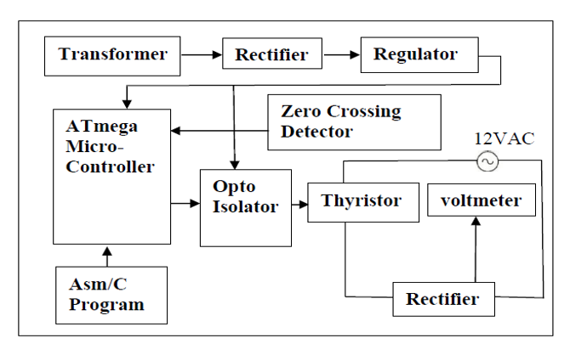BLOCK DIAGRAM

Fig.1.Block Diagram of Thyristor Firing Angle Control for Battery Charging

* 1. BLOCK DIAGRAM DESCRIPTION
* Power supply: A high voltage AC power supply is required to operate the battery charger.
* Transformer: The AC power supply is stepped down to a lower voltage using a transformer.
* Rectifier: The AC voltage is then rectified to DC voltage using a rectifier circuit. The rectifier circuit may consist of diodes or a bridge rectifier.
* Filter: The rectified DC voltage is smoothed using a filter circuit that typically consists of a capacitor.
* Control circuit: The thyristor firing angle control circuit is responsible for regulating the output voltage of the charger. The control circuit consists of an Atmega microcontroller that receives feedback from the battery to determine the required charging current and adjusts the firing angle of the thyristor accordingly.
* Thyristor: The thyristor acts as a switch in the circuit and controls the flow of current to the battery.
* Battery: The battery is the load in the circuit and receives the charging current from the charger.

The Atmega microcontroller is responsible for regulating the charging current delivered to the battery. It uses a feedback loop to determine the required charging current based on the battery voltage and adjusts the firing angle of the thyristor accordingly. The microcontroller also includes an analog-to-digital converter (ADC) that measures the battery voltage and converts it to a digital signal that can be processed by the microcontroller. The microcontroller then compares the measured battery voltage with the desired voltage and adjusts the firing angle of the thyristor to regulate the charging current.

The thyristor firing angle control circuit includes an optocoupler that isolates the microcontroller from the high voltage circuitry. The optocoupler ensures that the microcontroller is protected from voltage spikes and other disturbances that may occur in the high voltage circuitry. The microcontroller also includes a display module that shows the battery voltage and the charging current, allowing the user to monitor the charging process. Overall, the Atmega microcontroller provides a more sophisticated and precise method of regulating the charging current, ensuring that the battery is charged safely and efficiently.

* 1. COMPONENTUSED

|  |  |  |  |
| --- | --- | --- | --- |
| **SR** | **NAME** | **QTY** | **PRICE** |
| 1 | Atmega328 | 1 | 480 |
| 2 | MOC3031 | 1 | 45 |
| 3 | PC817 | 1 | 25 |
| 4 | BT136 | 1 | 30 |
| 5 | LCD 16X2 | 1 | 140 |
| 6 | Bridge | 2 | 30 |
| 7 | Mix resisters | 10 | 10 |
| 8 | Crystal 16MHz | 1 | 10 |
| 9 | Mix capacitor | 3 | 10 |
| 10 | Transformer 15-0-15 | 1 | 260 |
| 11 | Main cord | 1 | 30 |
| 12 | DC fan | 1 | 150 |
| 13 | 7805 | 1 | 15 |
| 14 | Heatsink | 1 | 10 |
| 15 | LM317 | 1 | 25 |
| 16 | Switch | 1 | 10 |
| 17 | Tactile switch | 2 | 5 |
| 18 | Ic base | 1 | 6 |
| 19 | 2 pin screw terminals | 2 | 8 |
| 20 | bridge | 2 | 20 |
| 21 | 1000uF/25V | 1 | 12 |
| 22 | 220uF/63V | 2 | 6 |
| 23 | 1N4007 diode | 1 | 2 |
|  |  |  |  |

* ATmega328:

The ATmega328 is a microcontroller from the Atmel AVR family, commonly used in various embedded systems and development boards like Arduino Uno. It features a high-performance, low-power 8-bit AVR RISC architecture, making it suitable for a wide range of applications, including power electronics control such as thyristor firing angle control for battery charging.

Here's a brief overview of the ATmega328 microcontroller:

Architecture: The ATmega328 is based on the Harvard architecture, featuring a modified Harvard architecture with separate memory spaces for program instructions and data. It operates at a clock speed of up to 20 MHz, providing fast and efficient processing.

Memory: It has a Flash memory of 32KB, which is used for storing the program code. The microcontroller also includes 2KB of SRAM for data storage and 1KB of EEPROM for non-volatile data storage.

GPIO and Peripherals: The ATmega328 offers a variety of general-purpose input/output (GPIO) pins, typically organized into multiple ports. These pins can be configured as digital inputs or outputs, and some of them also support analog input capabilities for voltage measurements. The microcontroller includes several built-in peripherals, including timers/counters, UART (Universal Asynchronous Receiver/Transmitter), SPI (Serial Peripheral Interface), and I2C (Inter-Integrated Circuit) interfaces.

Analog-to-Digital Converter (ADC): The ATmega328 features a 10-bit ADC that allows the microcontroller to measure analog voltages. This feature is essential for applications that require analog signal acquisition, such as battery voltage and current measurements.

PWM Generation: The ATmega328 has several built-in PWM channels, which can generate Pulse Width Modulation signals. These PWM signals are commonly used for controlling power electronics devices such as thyristors by adjusting the duty cycle to regulate the firing angle.

Interrupts: The microcontroller supports both external and internal interrupts, allowing it to respond quickly to external events and perform real-time tasks.

Communication: The ATmega328 can communicate with other devices using various protocols such as UART, SPI, and I2C. This enables connectivity and data exchange with external components or communication modules.

Development Tools and Community Support: The ATmega328 is widely supported by development tools, libraries, and an active community, making it easier to program and debug applications. The Arduino platform, in particular, provides a user-friendly environment for programming the ATmega328 and offers a vast ecosystem of libraries and example codes.

Overall, the ATmega328 is a versatile microcontroller with sufficient processing power, memory, and peripherals to implement thyristor firing angle control for battery charging applications. It provides the necessary capabilities for measuring battery parameters, generating PWM signals, and 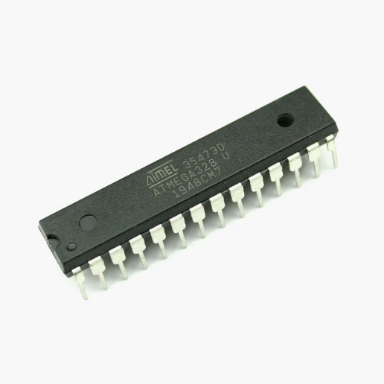implementing control algorithms to regulate the charging process.

Fig.2.ATMEL 35473D ATmega328 U

* MOC3031:

MOC3031 is an optocoupler device that combines an infrared emitting diode and a photo detector in a single package. It is widely used in electronics for applications such as AC motor control, lamp dimming, and power switching.

The MOC3031 optocoupler has the following features:

1. High isolation voltage: The MOC3031 provides high isolation voltage between the input and output, which ensures that the control circuit is well-protected from any high-voltage spikes.
2. Zero crossing detection: The MOC3031 has a built-in zero crossing detector that ensures the AC load is switched on only at the zero-crossing point of the AC waveform, which helps reduce the EMI and RFI generated in the circuit.
3. Low input current: The MOC3031 has a low input current, which makes it ideal for use in battery-operated applications where low power consumption is required.
4. Wide temperature range: The MOC3031 is designed to operate over a wide temperature range, making it suitable for use in harsh environments.
5. High current transfer ratio: The MOC3031 has a high current transfer ratio, which means that it can switch high current loads with ease.

Overall, the MOC3031 optocoupler is a reliable and versatile device that can be used in a wide range of applications. It is easy to use and provides excellent isolation between the input and output circuits, making it a popular choice in electronics design.

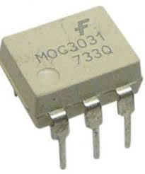

Fig.3.MOC3031

* BT136:

The BT136 is a commonly used triac semiconductor device that is designed for AC power control applications. The BT136 triac is a three-terminal device that has a main terminal (MT1), a gate terminal (G), and a second main terminal (MT2).

The BT136 triac has the following features:

High voltage capability: The BT136 triac can handle high voltage levels up to 600 volts, making it suitable for use in high power applications.

High current handling capacity: The BT136 triac can handle high current levels up to 4 amperes, which makes it suitable for controlling heavy loads.

Low gate trigger current: The BT136 triac can be triggered with a low gate current, making it easy to interface with digital circuits.

Overvoltage protection: The BT136 triac has built-in overvoltage protection that protects the device from high voltage spikes and transients.

Low holding current: The BT136 triac has a low holding current, which means that it can maintain its conducting state with a low current, reducing power dissipation.

Overall, the BT136 triac is a reliable and widely used semiconductor device that is ideal for AC power control applications. It is easy to use and provides excellent performance in terms of voltage and current handling, making it a popular choice in electronics design.

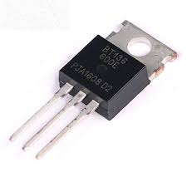

Fig.4.BT136

* LCD 16X2:

The LCD 16x2 is a popular type of alphanumeric liquid crystal display (LCD) module that is commonly used in electronics projects. The 16x2 indicates that the display consists of 2 rows of 16 characters each, for a total of 32 characters.

The LCD 16x2 module has the following features:

Display size: The LCD 16x2 has a display size of 2 lines, each with 16 characters, for a total of 32 characters.

Backlight: The LCD 16x2 module has a built-in LED backlight that makes it easy to read the display in low-light conditions.

Standard interface: The LCD 16x2 module uses a standard interface that makes it easy to connect to a microcontroller or other device.

Low power consumption: The LCD 16x2 module has low power consumption, making it ideal for use in battery-powered devices.

Custom characters: The LCD 16x2 module can display custom characters that can be programmed by the user, allowing for greater flexibility in display design.

Overall, the LCD 16x2 module is a versatile and widely used alphanumeric display that is easy to use and provides a clear, easy-to-read display in a compact form factor.

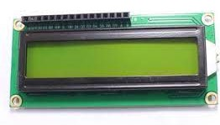

Fig.5.LCD 16X2

* TRANSFORMER 15-0-15:

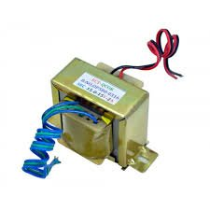A 15-0-15 transformer is commonly used in thyristor firing angle control for battery charging projects. It provides a dual 15-volt output with a centre tap, allowing bidirectional current flow. The transformer's AC output is rectified to DC using a bridge rectifier, and additional circuitry can be employed for voltage regulation. The transformer offers electrical isolation and should be selected based on the desired power rating and charging current requirements.

Fig.6.TRANSFORMER 15-0-15

* 7805(linear voltage regulator):

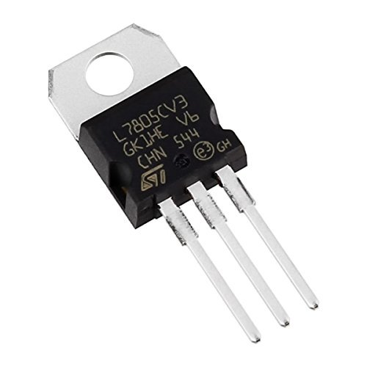The 7805 is a popular voltage regulator used in thyristor firing angle control for battery charging. It provides a stable +5V output for powering control circuitry like microcontrollers. It requires input and output capacitors for stability, has limited current capacity, and generates heat that needs to be managed. It ensures consistent voltage supply and helps protect the circuit components.

Fig.7.7805(linear voltage regulator)

* Heatsink & LM317:

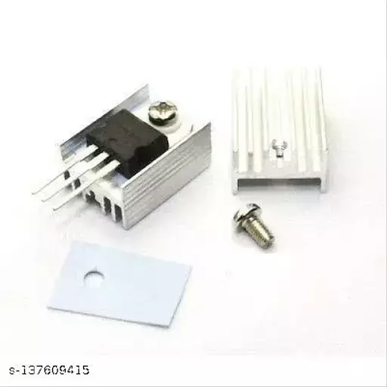The LM317 is an adjustable voltage regulator commonly used in thyristor firing angle control for battery charging. When working with higher input voltages, a heatsink is often necessary to dissipate heat and maintain stable operation. The heatsink provides a larger surface area for heat transfer, preventing overheating and ensuring reliable performance. Proper heatsink selection and mounting are essential for effective heat dissipation.

Fig.8. Heatsink & LM317

* Capacitors 1000uF/25V & 220uF/63V:

In thyristor firing angle control for battery charging projects, a 1000uF/25V capacitor is used for power supply smoothing and stability. It acts as a bulk capacitor to handle transient current demands. A 220uF/63V capacitor is employed for voltage regulation and noise filtering, ensuring a stable power supply for the voltage regulator and control circuitry. Proper capacitor selection is 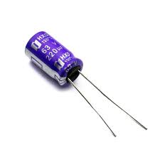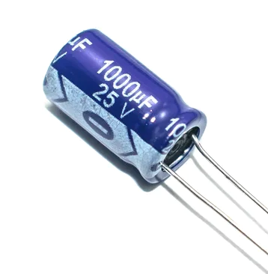important for reliable operation and maintaining a clean power supply.

Fig.9.Capacitors 1000uF/25V & 220uF/63V

* 1n4007 diode:

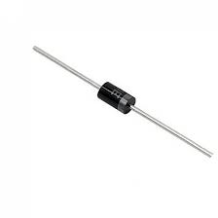The 1N4007 diode is used for rectification and reverse voltage protection in thyristor firing angle control for battery charging projects. It converts AC to DC, blocks reverse current flow, and handles up to 1A of current and 1000V of reverse voltage. It ensures proper current direction and protects sensitive components.

Fig.10.1n4007 diode

* 1. 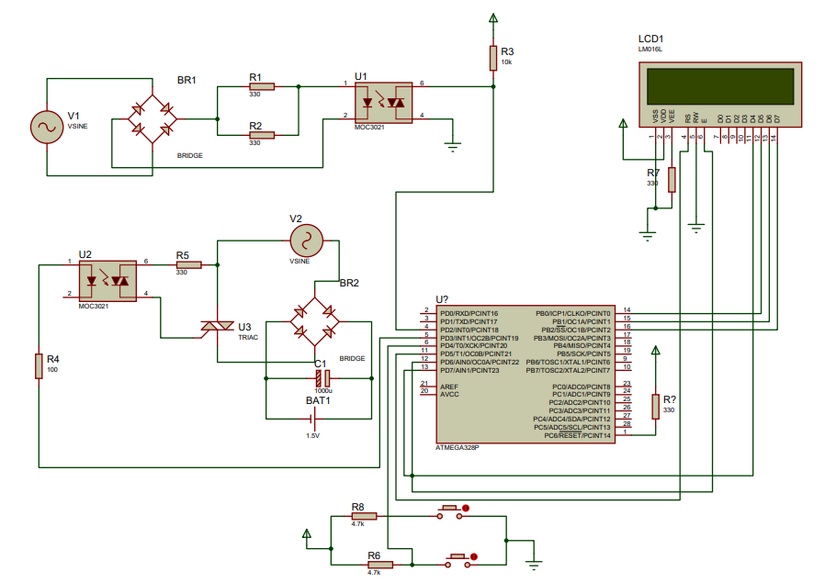CIRCUIT DIAGRAM

Fig.11.Circuit Diagram of Thyristor Firing Angle Control for Battery Charging

* 1. CODE

#include <LiquidCrystal.h>//import the LCD library

LiquidCrystal lcd(5, 6, 7, 8, 9, 13);// Pins used for RS,E,D4,D5,D6,D7

const int Pout=10;

const int zc= 2;

int k;

#define inc_sw 12

#define dec_sw 11

int incPrev, decPrev;

int Count = 150;

int L = 1;

#define SW 4

void setup()

{

pinMode(Pout, OUTPUT);

pinMode(zc, INPUT);

// pinMode(inc, INPUT);

pinMode(SW, INPUT);

pinMode(inc_sw, INPUT);

pinMode(dec_sw, INPUT);

digitalWrite(SW, HIGH);

digitalWrite(inc_sw, HIGH);

digitalWrite(dec_sw, HIGH);

lcd.begin(16,2);//LCD 16x2 initialization

lcd.setCursor(0,0);

lcd.print(" Thyrister ");

lcd.setCursor(0,1);

lcd.print(" Charger ");

delay(3000);

}

void loop()

{

lcd.clear();

lcd.setCursor(0,0);

lcd.print(" Thy. Charger ");

lcd.setCursor(0,1);

lcd.print("Level = ");

delay(100);

int inc = digitalRead(inc_sw);

int dec = digitalRead(dec_sw);

if((inc == LOW) && (Count < 750) && (inc != incPrev ))

{

delay(100);

Count = Count + 100;

L = L + 1;

}

//Decrement

if((dec == LOW) && (Count >150) && (dec != decPrev))

{

delay(100);

Count = Count - 100;

L = L - 1;

}

lcd.setCursor(8,1);

lcd.print(L);

delay(100);

if (!digitalRead(SW))

{

//k=analogRead(A0);

k=Count;

k=map(k,0,1023,8500,0);

digitalWrite(Pout,LOW);

attachInterrupt(digitalPinToInterrupt(zc), angle, FALLING);

}

else if (digitalRead(SW))

{

detachInterrupt(0); // disable power

lcd.setCursor(11,0);

lcd.print("OFF ");

lcd.setCursor(0,1);

lcd.print(" ");

}

incPrev = inc;

decPrev = dec;

}

void angle()

{

delayMicroseconds(k);

digitalWrite(Pout,HIGH);

delayMicroseconds(500);

digitalWrite(Pout,LOW);

}

* 1. SUMMARY

In summary, the design and drawing phase of this project will involve the selection and specification of the components used in the thyristor firing angle control circuit, as well as the development of the circuit diagram and layout. This phase is essential for the successful implementation of the circuit and will provide the foundation for the testing and validation phases of the project.

**CHAPTER 4**. **IMPLEMENTATION**

* 1. 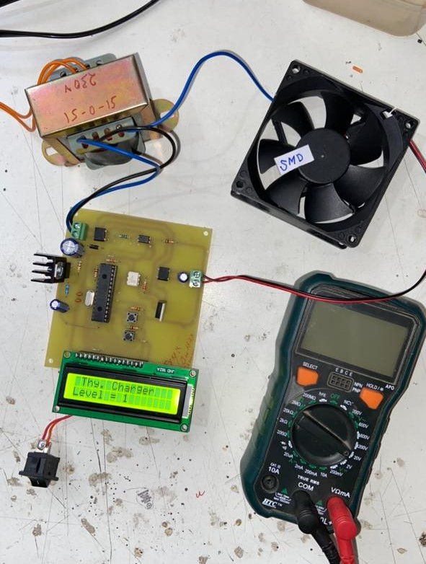HARDWARE:

Fig.12.Final Result of thyristor firing angle control for battery charging

* 1. HARDWARE DETAILS

The working of a thyristor firing angle control for battery charging project involves regulating the firing angle of thyristors to control the charging current supplied to the battery. Here's a brief overview of the working principle:

The project typically starts with an AC input voltage, which is first converted to DC using a rectifier circuit. This rectification process ensures that the alternating current is converted into a pulsating direct current waveform. The rectified DC voltage is then smoothed and regulated using capacitors and voltage regulators. This ensures a stable and precise voltage output for charging the battery. The firing angle control determines when and for how long the thyristors are triggered within each AC cycle. The firing angle is typically adjusted using a control signal generated by a microcontroller or microprocessor. The gate drive circuit is responsible for providing the necessary voltage and current to trigger the thyristors. It ensures proper timing and control of the thyristor switching by delivering precise gate pulses. The thyristors, typically silicon-controlled rectifiers (SCRs), act as switches in the circuit. When triggered by the gate pulses, they allow the charging current to flow to the battery. The firing angle determines the portion of each AC cycle during which the thyristors conduct and supply current. The charging current is monitored and regulated to maintain a desired charging rate for the battery. This regulation can be achieved by adjusting the firing angle based on the battery's state of charge or by using feedback from current sensors. The project may include various protection mechanisms to ensure safe operation. This can include overcurrent protection, overvoltage protection, temperature monitoring, and battery condition monitoring.

By adjusting the firing angle of the thyristors, the charging current to the battery can be controlled, allowing for precise charging and maintaining the battery's health and longevity. The control signals, gate drive circuit, and thyristor switching work together to regulate the charging process effectively.

* 1. SUMMARY

The Thyristor Firing Angle Control for Battery Charging project aims to regulate the charging of batteries by controlling the firing angle of a thyristor. The circuit diagram consists of a microcontroller, voltage and current sensors, a thyristor, and a load. The PCB layout involves designing the circuit on a printed circuit board, taking into account various factors for proper functionality and safety.

**CHAPTER 5**. **RESULTS**

* 1. 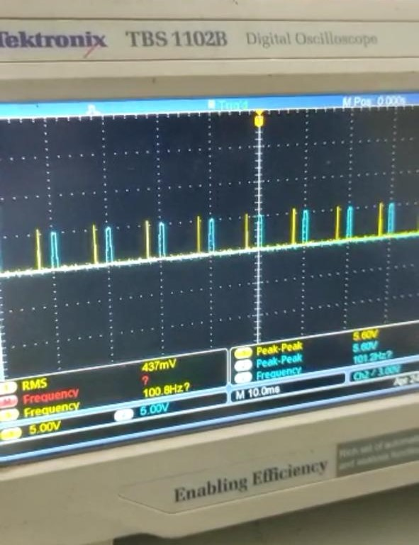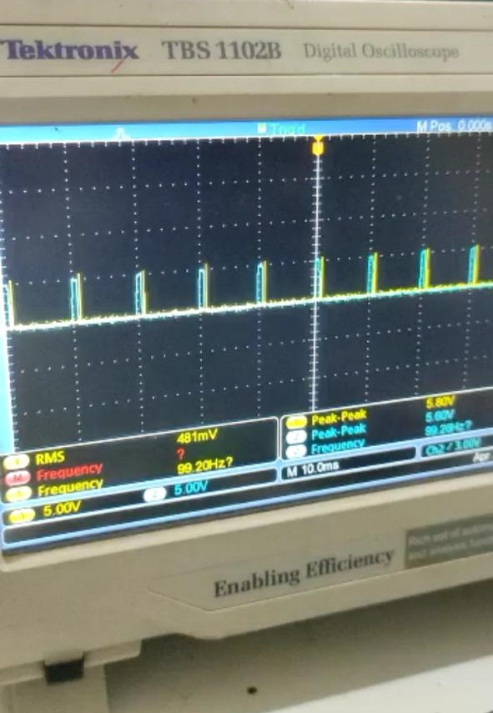SIMULATION RESULT

Fig.13.Varying Thyristor firing angle from 10degree to 90 degree

* 1. FINAL RESULT

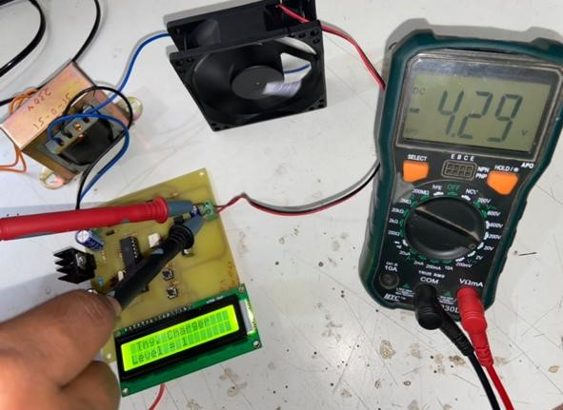

Fig.14. Level 1(1-7) voltage required for battery charging

**CHAPTER 6**. **CONCLUSIONS**

In conclusion, the thyristor firing angle control for battery charging project offers precise control over the charging current to ensure efficient and controlled charging of batteries. By adjusting the firing angle of the thyristors, the project regulates the flow of current to the battery, allowing for accurate charging rates and maintaining the battery's health and longevity. The project involves converting the AC input voltage to DC using rectifier circuits, regulating the voltage using capacitors and voltage regulators, and employing a gate drive circuit to trigger the thyristors at the desired firing angle. The thyristors act as switches, conducting current to the battery during specific portions of the AC cycle. The charging current is monitored and regulated through continuous adjustment of the firing angle based on battery conditions or feedback from current sensors. Protection mechanisms, such as overcurrent and overvoltage protection, ensure the safety of the circuit and the battery during the charging process. Overall, the thyristor firing angle control for battery charging project enables precise control over the charging process, optimizing battery performance and ensuring reliable and efficient charging. It offers flexibility in charging current adjustment and protection features, making it suitable for a wide range of battery charging applications.

**CHAPTER7. REFERENCES**

[1] Don Tan, “*Emerging System Applications and Technological Trends in Power Electronics :Power electronics is increasingly cutting across traditional boundaries*”. IEEE Power Electronics Magazine , Vol. 2,pp 38-47,Issue:22 June,2015

[2] Muhammad H. Rashid , “*Power Electronics :Circuit, Devices and Applications*”, PearsonIndia,3rd a. Edition,2014

[3] Arash A. Boora, FiruzZare ,Gerardand, Arindam Ghosh, “*Applications of power electronics in railway systems*”, Australasian Universities Power Engineering Conference (AUPEC ),Perth, Australia, pp 1-9,9- 12 Dec 2007.

[4] Himesh Joshi and Maryam ShojaeiBaghini , “*Versatile Battery Chargers for New Age Batteries*”, IEEE International Symposium on Electronic System Design(ISESD), Kochi,Kerala,India,pp279-284,19-21 Dec 2011

[5] B. P. McGrath,D. G. Holmes,P. McGoldrick and A. Mclver , “*Design of a soft switched6kW battery charger for traction applications*” , 37th IEEE Power Electronics SpecialistsConference(PESC), Jeju, South Korea ,pp 1-7, 18-22June2006

[6] EnsSchmenger ,Stefan Zeltner, Reinhard Kramer ,Stefan Endres and Martin Marz, “*A 3.7KW on –board charger based on modular circuit design*” 41st Annual Conference of IEEE Industrial ElectronicsSociety (IECCON), Yokohama ,Japan, pp 001382-001387, 9-12 Nov. 2015.

[7] Martin Pittermann , Pavel Drabek and Bedrich Bednar, “*High voltage converter for purpose tominimizing of weight of traction transformer*” IEEE International Conference on Applied Electronics (ICAE), Pilsen, Czech Republic, pp 197-200,8-9 Sept,2015.