**SYNOPSIS**

**YEAR/BRANCH AND DIVISION:** TE(E&TC) DIV: V  **GROUP NO.:** 6

**TITLE: Thyristor Firing Angle Control For Battery Charging**

**OBJECTIVES:**

* To supply the load and charge the primary battery in the case of failure of the main battery.
* To obtain an overall system efficiency ≥ 80%.
* To obtain a regulated output of 110V DC with output regulation ≤ 2.5%.
* To design a 2.5KW, 110V,70AH Thyristor Based Emergency Battery Charger for railway application.

(Write at least 3-4 objectives related to your work by consulting with your guide, Times New Roman, 12)

|  |  |  |  |
| --- | --- | --- | --- |
| Roll No. | Name of student | Email ID | Mob. No  (Mostly WhatsApp No) |
| 1 | Nakul Dandekar | nakuldandekar7@gmail.com | 7558774148 |
| 2 | Prathmesh Girme |  | 7218562132 |
| 3 | Pratik Jadhav | Itspratik360@gmail.com | 7387811455 |

**INTRODUCTION:**

The project is intended for charging battery(s) by DC from AC supply of power. DC power supplied for a battery’s charger is a derivative from a thyristor-controlled rectifier mechanism. AC supply of power is useful to a link rectifier consisting of diodes and a TRIAC achieving preferred power from the micro controller. This project of industrial battery charger brings into use zero crossing point of the waveform which is sensed by a comparator whose productivity is then supplied to the micro controller. The micro controller endow with necessary delay in triggering control to a TRIAC via opto isolator edge. As a final point the power is supplied to the load via triac in succession with the linking rectifier. The DC output which is rectified and controlled is provided to the load i.e., a resistor employed in our project as a substitute of a battery. The DC voltage thus produced is calculated by utilizing a multi-meter. In this industrial battery charger project, we have used a microcontroller which is from 8051 family which is edged via push button keys employed for rising or lessening the DC voltage for appropriate charging reasons. This particular project can be improved further by employing direct 230 volt power supply rather than 12 volt AC to the linked rectifier for obtaining high voltage to control for charging numerous of batteries connected in a sequence.

**BLOCK DIAGRAM:**

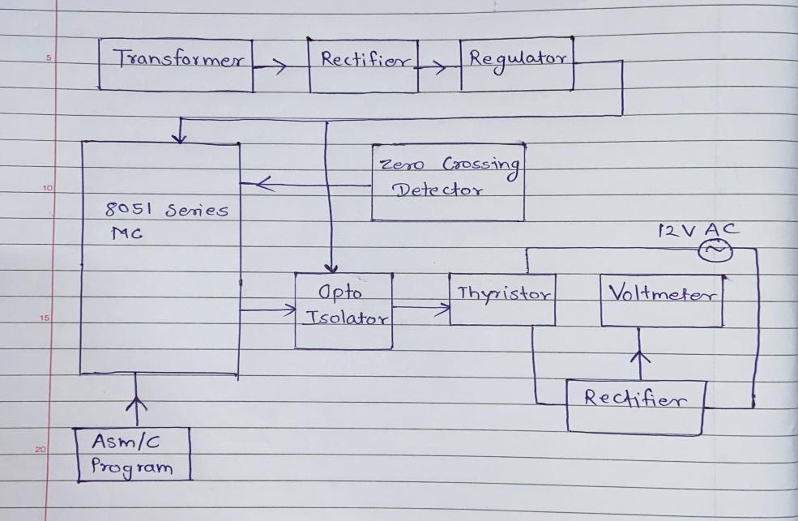

Figure 1: Block Diagram of **Industrial Battery Charger by Thyristor**

**BLOCK DIAGRAM DESCRIPTION:**

Battery charger by thyristor is a simple industrial adjustable system whereas different voltage battery charger by adjusting current using thyristor. Usually, we carry different charger as per battery voltage requirement, it is ok for 3 to 4 batteries but at industrial level there are many batteries use at a time and need to charge many at a time. So, there we cannot carry different charger for each battery. It is a waste of time, quite expensive and difficult to handle hence we use battery charger by using thyristor.

In thyristor firing angle control for battery charging, we use thyristor for controlling flow of current in circuit. Thyristor is made up from three terminals that is anode, cathode and gate. Where gate terminal which is used to control flow of current. In block diagram thyristor is connected to ATmega microcontroller and voltage level provide for battery is shown on LCD screen display for knowing more accurately in voltage level we connect dc cooling fan. When voltage level increase then fan speed also get increase.

**ADVANTAGES** **& APPLICATIONS:**

* We do not require to carry different chargers for different volt battery.
* Production of charger will reduce it will help to reduce extra e-waste or plastic waste.
* It is used industries.
* It is used in inverter.
* It is used in solar energy system.
* It is used in vehicle.
* It is used in uninterruptible power supply (UPS)

**CONCLUSION:** The emergency battery charger is connected in parallel to the main based battery charger. The DSP controlled firing circuits is more efficient, accurate and reliable compared to the analog firing circuit-based battery charger used in the conventional bogies of trains. The DSP controller-based battery charger consume lesser power and losses are also minimized to a greater extent.

**SUBMITTED BY:** **(Mini-Project Group No: 6)**

|  |  |  |
| --- | --- | --- |
|  | Roll No. | Name |
| 1. | E3510 | Nakul Dandekar |
| 2. | E3516 | Prathmesh Girme |
| 3. | E3520 | Pratik Jadhav |

|  |  |  |
| --- | --- | --- |
| Ms. Komal Wanzare | Ms. S.S. Jahagirdar/Ms. K.A. Pujari | Dr. S. K. Jagtap |
| **Mini-Project Guide** | **Mini-Project Coordinator** | **Head** |
| **Dept. of E & TC** | **Dept. of E & TC** | **Dept. of E & TC** |