

Darshan University

A Project Report on

“Taxi Management System”

Under the subject

Software Engineering (2101CS503)

B. Tech, Semester – VI

Computer Science & Engineering Department

Submitted By
Student Name: Student Name |  | EnrollmentNo.: Enrollment No
Academic Year
(2023-2024)
Internal Guide  Prof. XYZ  Darshan University |  | Dean-DIET  Dr. Gopi Sanghani  Darshan University
 | Computer Science & Engineering Department  Darshan University

DECLARATION

We hereby declare that the SRS, submitted along with the Software Engineering (2101CS503) for entitled “Taxi Management System” submitted in partial fulfilment for the Semester-5 of Bachelor Technology (B. Tech) in Computer Science and Engineering (CSE) Department to Darshan University, Rajkot, is a record of the work carried out at Darshan University, Rajkot under the supervision of (Guide name) and that no part of any of report has been directly copied from any students’ reports, without providing due reference.

Student Name

Student’s Signature

Date: __________

 | Computer Science & Engineering Department  Darshan University

CERTIFICATE

This is to certify that the SRS on “Taxi Management System” has been satisfactorily prepared by Student Name(Enrollment No) under my guidance in the fulfillment of the course Software Engineering (2101CS503) work during the academic year 2023-2024.

Internal Guide  Prof., Guide Name  Darshan University |  | Dean-DIET  Dr. Gopi Sanghani  Darshan University

Acknowledgement
I wish to express my sincere gratitude to my project guide Prof. Guide name and all the faculty members for helping me through my project by giving me the necessary suggestions and advices along with their valuable co- ordination in completing this work.

I also thank my parents, friends and all the members of the family for their precious support and encouragement which they had provided in completion of my work. In addition to that, I would also like to mention the Darshan University personals who gave me the permission to use and experience the valuable resources required for the project from the University premises.

Thus, in conclusion to the above said, I once again thank the faculties and members of Darshan University for their valuable support in completion of the project.

Thanking You
Student Name

ABSTRACT
The Taxi Management System (TMS) is designed to streamline and enhance the operations of taxi services through a comprehensive digital platform. This system caters to multiple user groups, including customers, drivers, managers, and administrators, providing a seamless experience for booking, managing, and tracking taxi services.
The core functionalities of the TMS include user registration and authentication, real-time taxi booking, GPS-based tracking, and secure payment processing. Customers can easily book rides, track their taxis in real-time, and make payments through various methods. They also have the ability to rate drivers and provide feedback, contributing to continuous service improvement.
For drivers, the TMS offers features such as ride assignments, navigation assistance, and a platform to manage their schedules and earnings. Drivers can accept or decline ride requests, follow optimized routes, and communicate with customers directly through the application.
Managers benefit from a robust dashboard that provides real-time analytics and reports on system performance, user activity, and financial metrics. They can oversee driver performance, manage customer complaints, and execute promotional campaigns to enhance user engagement.
Administrators have access to advanced system configuration options, security management tools, and compliance monitoring features. They can enforce role-based access control, ensure data security through encryption, and maintain regulatory compliance with local transportation laws and international data protection standards.
Overall, the Taxi Management System aims to provide a user-friendly, secure, and efficient solution for managing taxi services, improving the experience for customers, drivers, and administrators alike.
Main purpose of this system is to reduce human efforts as much as possible.

Table of Contents
Table of Contents 6
List of Figures I
List of Tables II
1 Introduction 1
1.1 Product perspective 1
1.2 Product features 1
1.2.1 There are four different users who will be using this product: 1
1.2.2 The features that are required for the Customer are: 1
1.2.3 The features that are required for the Driver are: 1
1.2.4 The features that are required for the Manager are: 1
1.2.5 The features that are required for the Admin are: 1
1.3 Functional Requirement 2
1.3.1 Customer 2
1.3.2 Driver 2
1.3.3 Manager 2
1.3.4 Admin 3
1.4 Non-Functional Requirement 3
1.4.1 Usability: 3
1.4.2 Accuracy: 3
1.4.3 Availability: 3
1.4.4 Scalability: 3
1.4.5 Security: 3
1.4.6 Maintainability: 4
2 Design and Implementation Constraints 5
2.1 Use case diagram 5
2.2 Activity diagram and Swimlane diagram 6
2.3 Sequence diagram 10
2.4 State diagram 11
2.5 Class diagram 12
2.6 Data flow diagram 13
2.6.1 Context diagram (level-0) 13
2.6.2 DFD Level-1 14
3 External interface requirement (Screens) 15
3.1 Screen-1: Registration For 15
3.2 Screen-2:Payment Screen 16
3.3 Screen-3: Add to cart screen 16
3.4 Screen-4: Taxi booking screen 18
3.5 Screen-5:Add borrower book 18
4 Database design 20
4.1 List of Tables 20
5 Stories and Scenario 21
5.1 Story-1: Booking a Taxi 21
5.1.1 Scenario# S1.1 21
5.1.2 Scenario# S1.2 21
5.1.3 Scenario# S1.3 21
5.1.4 Scenario# S1.4 22
5.1.5 Scenario# S1.5 22
6 Test cases 23
7 References 27

List of Figures

Figure 2.1-1 Use case diagram for Taxi management system 5
Figure 2.2-2 Activity diagram for Taxi Booking Issue 6
Figure 2.2-3 Activity diagram for payment 8
Figure 2.2-4 Swimlane diagram for payment Issue 9

List of Tables

Table 3.1-1 Screen element of Registration form 15
Table 3.2-2 Screen element of add to cart screen 17
Table 3.2-3 Screen element of add to cart screen 18
Table 4.1-4 Table: Customer 20
Table 4.1-5 Table: Driver 20
Table 4.1-6 Table: Payment 20
Table 4.1-7 Table: Taxi 20

Introduction

Product perspective

The Taxi Management System (TMS) is designed to streamline the operations of taxi companies, providing an integrated platform for managing bookings, drivers, vehicles, and customer interactions. The system aims to enhance operational efficiency, improve customer satisfaction, and provide real-time insights into the business.

Product features

There are four different users who will be using this product:
- Customer
- Driver
- Manager
- Admin

The features that are required for the Customer are:
- Customers can book a taxi for immediate pickup or schedule a ride for a future time and date
- Customers can choose from different types of rides (e.g., standard, premium, shared).
- Customers can update their personal details, including name, contact information, and profile picture.
- Customers can view an estimated fare for their ride before booking.
- Customers can track their taxi in real-time on a map from the time of booking until the ride is completed.
- Customers can contact customer service through phone, email, or chat.

The features that are required for the Driver are:
- Drivers can upload necessary documents such as driver’s license, vehicle registration, and insurance papers.
- Drivers can share their real-time location with customers for better coordination.
- Drivers can view a summary of their daily, weekly, and monthly earnings.
- Drivers can rate customers after each ride
- Drivers can set their availability status (online/offline) and update it as needed
- Drivers can contact support through the app for any issues or assistance.

The features that are required for the Manager are:
- Provides a comprehensive overview of system operations, including active rides, available drivers, and system performance metrics
- Displays real-time data on bookings, revenue, driver performance, and customer feedback.
- Tools to address and resolve ride-related issues, such as delays, customer complaints, or ride cancellations.

The features that are required for the Admin are:
- Create and manage different user roles (e.g., customer, driver, manager) and define their permissions.
- Add, update, or remove user accounts and handle user authentication and authorization.
- Define and update geographical service areas where the taxi services are available.
- Tools to detect, report, and respond to security incidents and breaches.
- Provide tools for customer and driver support teams to manage inquiries, complaints, and issues effectively.

Functional Requirement

Customer
- Registration: Customers can create an account using their email, phone number, or social media accounts.
- Login: Customers can log in to their accounts.
- Select Route: The system shall provide an interactive map for customers to pinpoint their locations.
- Ride Options: Customers can choose from various ride options (e.g., standard, premium, shared rides).
- Book Taxi: Option to book a ride for a future date and time.
- Confirm Booking: Confirmation of booking with details via push notification, SMS, or email.
- Select Payment Method: Support for various payment methods (credit/debit cards, digital wallets).
- Make Payment: make a payment of taxi bill.
- See Live Location of Taxi: Real-time GPS tracking of the booked taxi on a map.
- See ratings: Option to see ratings of the driver.
- Give ratings: Option to rate the ride and the driver after the trip.
- Recent Bookings: View a history of all past rides and transactions.
- Logout: Customers can logout from their accounts.

Driver
- Registration: Drivers can create an account using their email, phone number, or social media accounts.
- Login: Drivers can log in to their accounts.
- View Feedback: Access to their ratings and feedback from customers.
- Accept/Reject customer’s request: Option to accept or reject ride requests.
- See Customer’s Location: Real-time location sharing with customers for tracking the ride.
- Rate Customers: Option to rate customers after the trip.
- Give car’s complaint: Add, update, or remove vehicle details (model, make, license plate).
- Take salary: Access detailed salary statements and breakdowns of all earnings, including base fare, tips, bonuses, and incentives.
- Financial History: Maintain a comprehensive financial history of all earnings, deductions, and payouts.
- Logout: Drivers can logout from their accounts.

Manager
- Registration: Manager can create an account using their email, phone number, or social media accounts.
- Login: Manager can log in to their accounts.
- Give salary: Manage and process payments to drivers based on completed rides and fare structure.
- Take salary: Access detailed salary statements and breakdowns of all earnings, including base fare, tips, bonuses, and incentives.
- View salary details: Ensure accurate reconciliation of payments made through various methods (credit/debit cards, digital wallets).
- View customer’s feedback: Provide channels for direct communication with customers for support and feedback.
- View driver’s feedback: Facilitate communication with drivers for updates, instructions, and emergency alerts.
- Give feedback: Give feedbacks based on various parameters (e.g., time period, driver, location).
- Hire new driver: Can hire new drivers.
- Remove driver: Can remove drivers.
- View driver’s details: View and manage driver profiles, including personal information, vehicle details, and performance metrics.
- View customer’s details: Access and manage customer profiles, including personal information and ride history.
- View Taxi details: Access detailed history of all rides, including customer and driver details, route, fare, and any issues reported.
- Add new taxi: Can add new taxi.
- Remove taxi: Remove unusable taxi.
- Logout: Managers can logout from their accounts.

Admin
- Login: Admin can log in to their accounts.
- View customer’s feedback: Provide channels for direct communication with customers for support and feedback.
- View driver’s feedback: Facilitate communication with drivers for updates, instructions, and emergency alerts.
- View manager’s feedback: Facilitate communication with managers for updates, instructions, and emergency alerts.
- View customer’s details: Access and manage customer profiles, including personal information and ride history.
- View driver’s details: View and manage driver profiles, including personal information, vehicle details, and performance metrics.
- View manager’s details: View and manage manager profiles, including personal information and other activities.
- Add manager: Can hire new manager.
- Remove manager: Can remove manager.
- Pay salary: Pay salary to all managers.
- Generate reports: Generate automated reports on system performance, user activity, financial metrics, and compliance.

Non-Functional Requirement

Usability:
- The UI should be simple enough for everyone to understand and get the relevant information without any special training. Different languages can be provided based on the requirements.

Accuracy:
- The data stored about the books and the fines calculated should be correct, consistent, and reliable.

Availability:
- The System should be available for the duration when the library operates and must be recovered within an hour or less if it fails. The system should respond to the requests within two seconds or less.

Scalability:
- Scalability means that the system must be able to accommodate larger volumes (whether of users, throughput, data) over time, and also includes NFRs such as elasticity, which is the ability to scale up and down quickly, as needed.

Security:
- How well a system protects against unauthorized access and data breaches.

Maintainability:
- The software should be easily maintainable and adding new features and making changes to the software must be as simple as possible. In addition to this, the software must also be portable.

Design and Implementation Constraints

Use case diagram

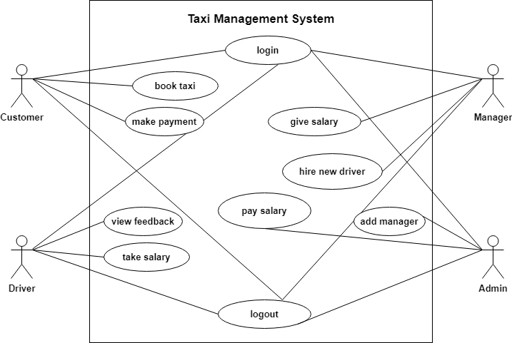

Figure 2.1-1 Use case diagram for Taxi management system

Activity diagram and Swimlane diagram

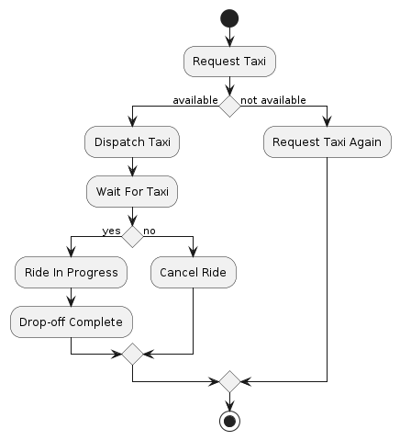

Figure 2.2-2 Activity diagram for Taxi Booking Issue
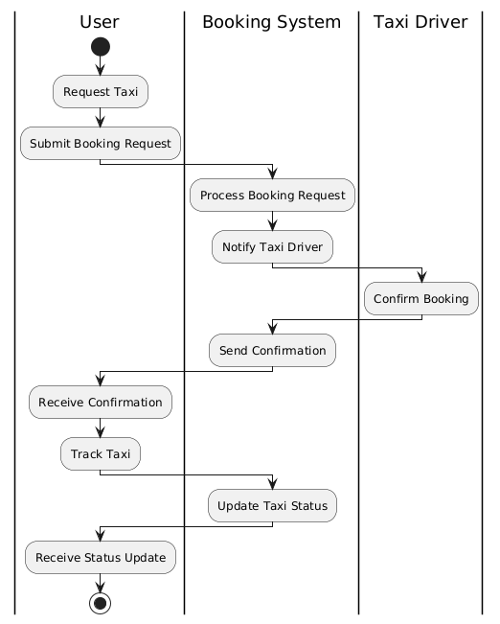
Figure 2.2-3 Activity diagram for Taxi Booking Issue

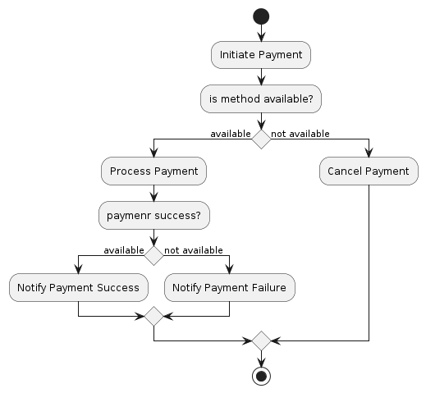
Figure 2.2-3 Activity diagram for payment
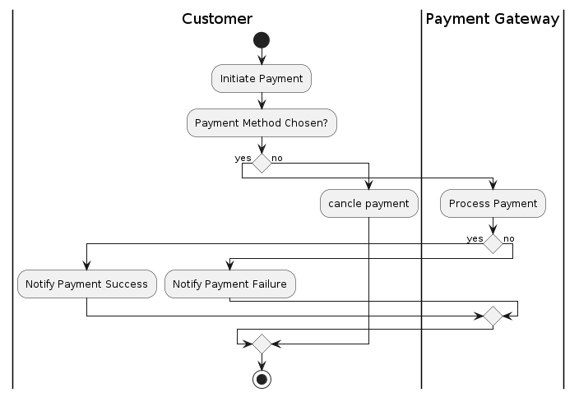
Figure 2.2-4 Swimlane diagram for payment Issue

Figure 2.2-5 Swimlane diagram for taxi booking Issue

Sequence diagram

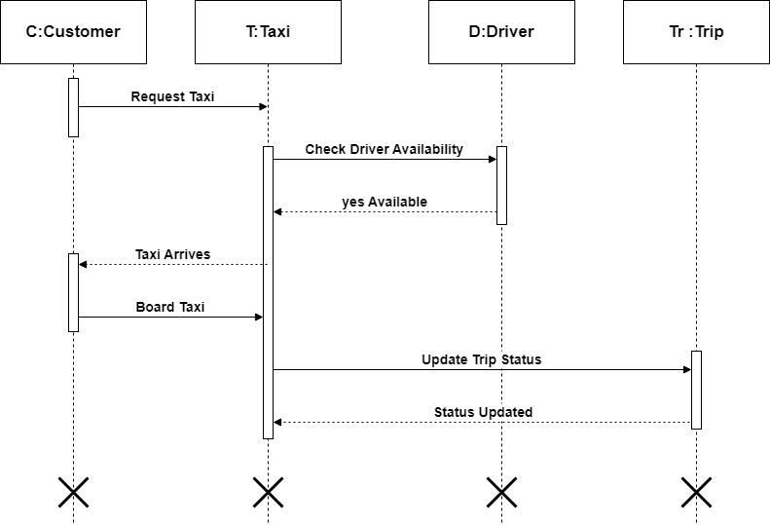

Figure 2.3-6 Sequence diagram for taxi booking Issue

State diagram

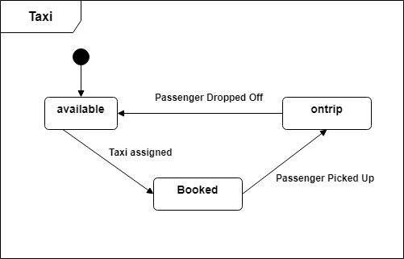

Figure 2.4-7 State diagram of Taxi
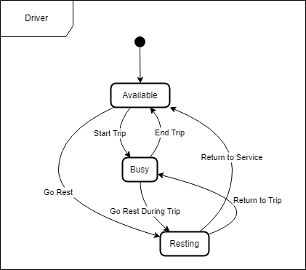

Figure 2.4-8 State diagram for Librarian

Class diagram

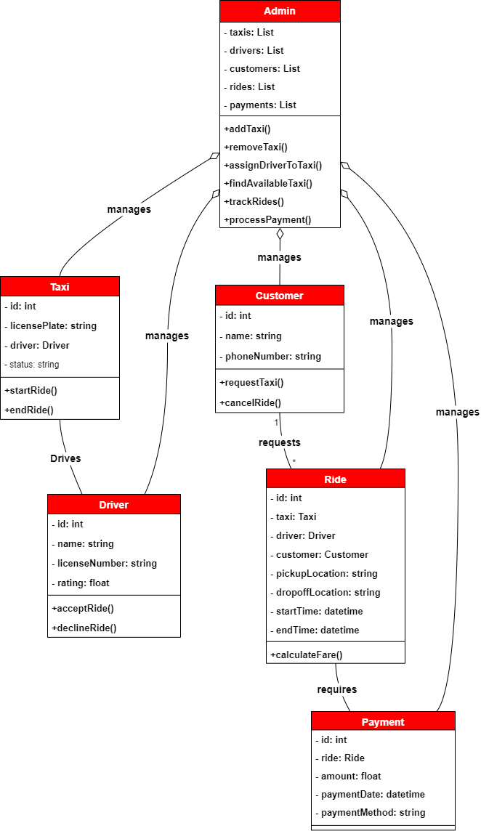

Figure 2.5-9 Class diagram for Library management system

Data flow diagram

Context diagram (level-0)

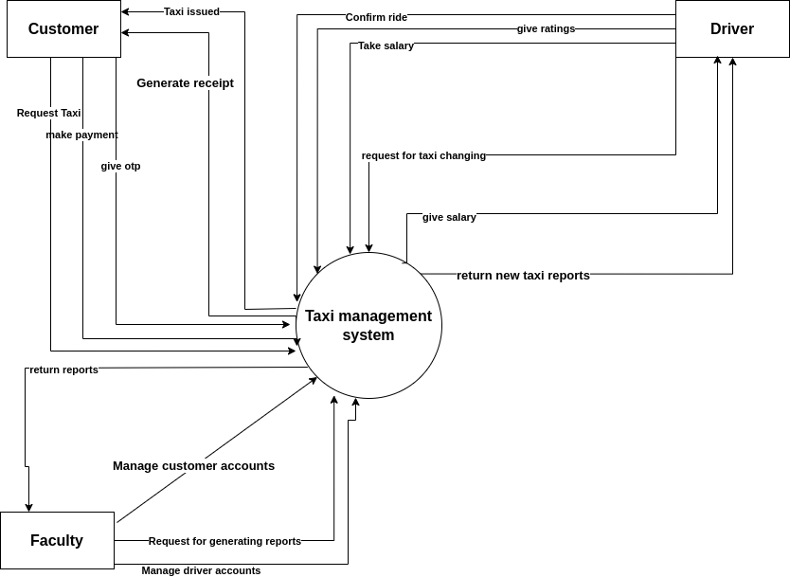
Figure 2.6-10Context diagram for Taxi management system

DFD Level-1
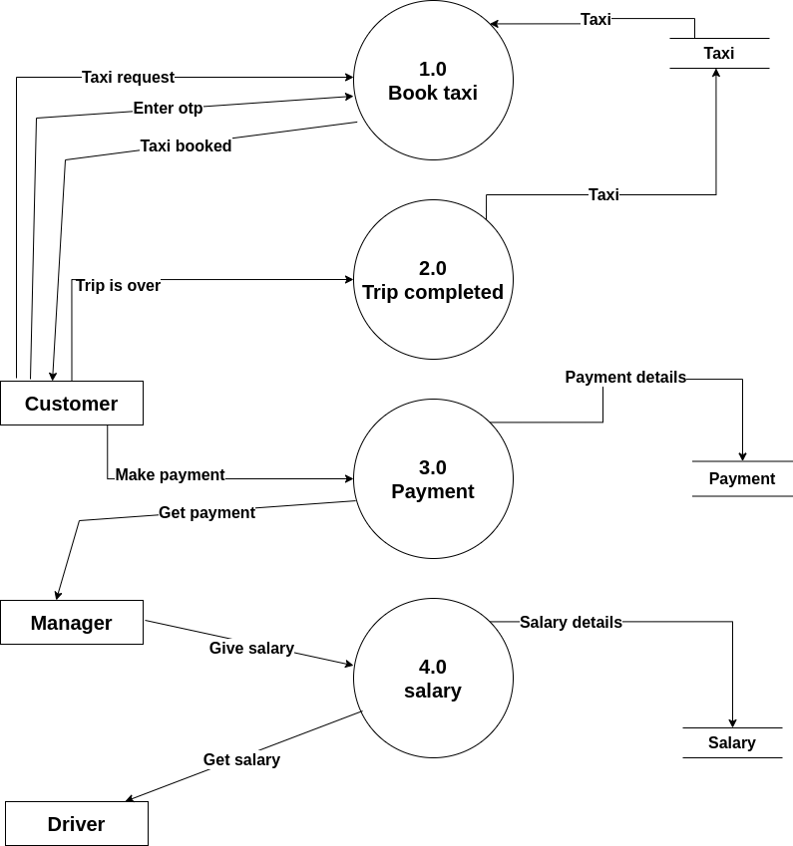

Figure 2.6-11 DFD level-1 for Library management system

External interface requirement (Screens)

Screen-1: Registration For

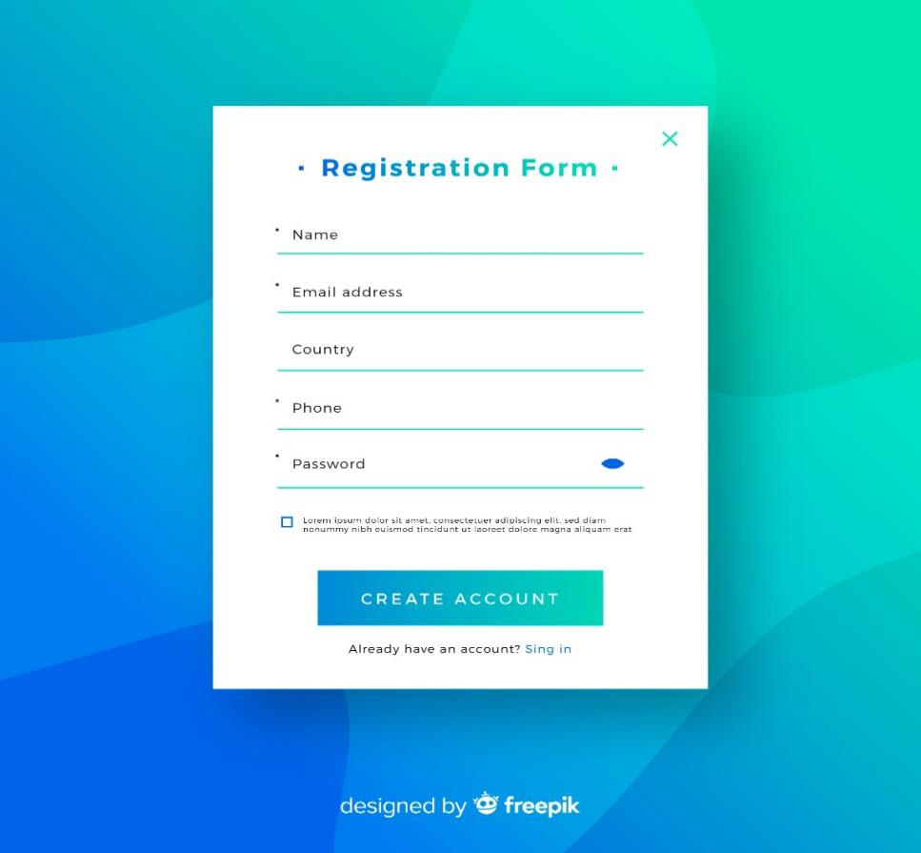
Figure 3.1-12 Screen-1: Registration Form

Purpose: This form will allow the target end-users to register in the system. To register, the following information will be encoded in the system.

Table 3.1-1 Screen element of Registration form
Sr. | Screen Element | Input Type | O/M | 1/N | Description
1 | name | Textbox | M | 1 | Username field should be editable and accept the Username.
2 | Email address | Textbox | M | 1 | Email field should be editable and accept the email with proper format.
3 | Password | Password | M | 1 | Password field should be editable and accept the password and display as star or dot.
4 | country | Textbox | O | 1 | Country field allows user to enter their county it should be editable
5 | Phone | Textbox | M | 1 | Phone number field should be editable and accept the phone number.
6 | I agree to the terms | Checkbox | M | 1 | Checkbox for accepting terms and condition.
7 | I already have an account | Link | ------ | ------ | Link for navigate to login page for registered user.
8 | Create account | Button | ------ | ------ | It is a button for store the entered data into database.

Screen-2:Payment Screen

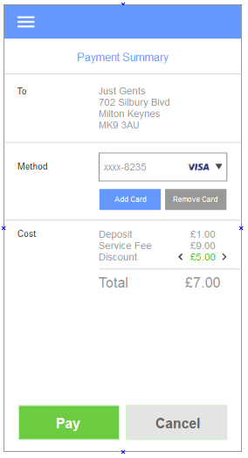

Figure 3.2-14 Screen-2:payment screen
Purpose: The payment screen securely collects user payment information and confirms the purchase details. It ensures a smooth transaction process, allowing users to review their order before finalizing the purchase.

Table 3.2-2 Screen element of Payment screen
Sr. | Screen Element | Input Type | O/M | 1/N | Description
1 | To | Textbox | M | 1 | Person to whom we are paying.
2 | Method | Select/options | M | 1 | Select our payment method.
3 | Add card | Button | M | 1 | Add our credit/debit card.
4 | Remove card | Button | M | 1 | remove our credit/debit card.
5 | Cost | Text box | M | 1 | It shows the total cost of all products.
6 | Pay | Button | M | 1 | Confirm the payment.
7 | Cancel | Button | M | 1 | Cancel the payment.

Screen-3: Add to cart screen

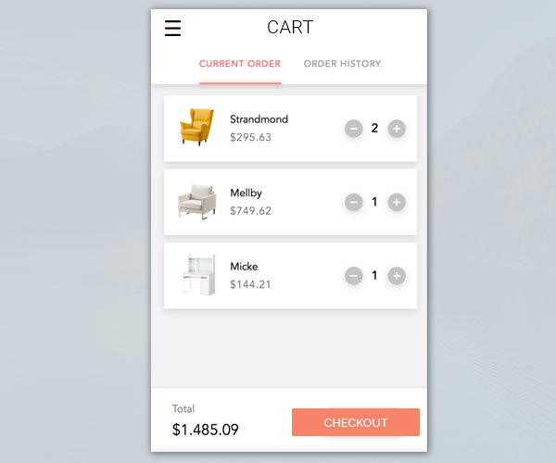

Figure 3.3-15 Screen-3: add to cart screen
Purpose: The "Add to Cart" screen confirms that an item has been added and allows users to review their selections. It encourages continued shopping by providing options to view the cart or keep browsing for more items.

Table 3.3-2 Screen element of add to cart screen
Sr. | Screen Element | Input Type | O/M | 1/N | Description
1 | Current order | Button | M | 1 | It shows products that we are currently buying.
2 | Order history | Button | M | 1 | It shows all products that we have bought in past.
3 | + | Button | M | 1 | Increase the quantity of product
4 | - | Button | M | 1 | Descrease the quantity of product
5 | Total | Text box | M | 1 | It shows the total cost of all products.
6 | Checkout | Button | M | 1 | Confirm the order and redirect to the payment screen.

Screen-4: Taxi booking screen

Figure 3.4-16 Screen-4: Taxi booking screen
Purpose: The taxi booking screen allows users to enter their pickup and drop-off locations, select ride options, and view fare estimates. It streamlines the booking process, ensuring users can easily request a ride and track their driver in real-time.
Table 3.4-3 Screen element of add to cart screen

Sr. | Screen Element | Input Type | O/M | 1/N | Description
1 | Bell icon | Button | M | 1 | It shows all notifications.
2 | Pickup location | Textbox | M | 1 | Enter your pickup location.
3 | Drop location | Textbox | M | 1 | Enter your drop location.
4 | continue | Button | M | 1 | Complete the booking process.
5 | Now | Text box | M | 1 | Book taxi now.
6 | Later | Button | M | 1 | Book taxi later.
7 | Hourly | Button | M | 1 | Book taxi in a specific time.

Screen-5:Add borrower book
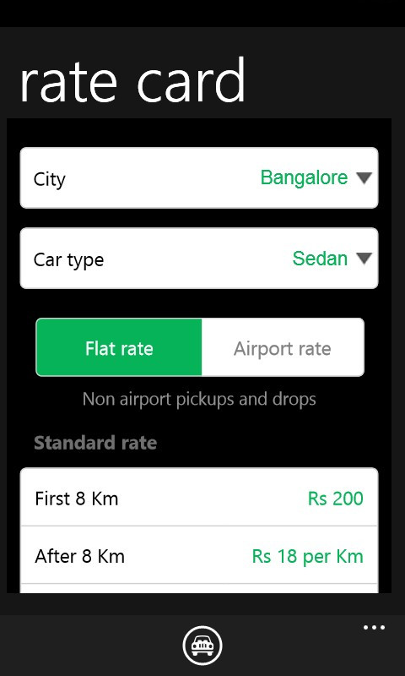

Figure 3.5-17 Screen5: Add borrower book

Purpose: The "Calculate Rate" feature on a taxi booking screen provides users with an estimated fare based on distance, time, and any applicable surcharges. It helps users make informed decisions about their ride options and budget before confirming the booking.

Table 3.5-5 Screen element of Add borrower book
Sr. | Screen Element | Input Type | O/M | 1/N | Description
1 | City | Select/options | M | 1 | Select your city.
2 | Car type | Select/ options | M | 1 | Select taxi type.
3 | Flat rate | Button | O | 1 | A set fee for a specific route or distance, regardless of time or traffic conditions.
4 | Airport rate | Button | O | 1 | A specific fare structure for rides to or from the airport, which may vary from standard rates.
5 | Standard rate | Textbox | M | 1 | The regular fare charged for taxi services based on a combination of distance travelled and time taken.

Database design

List of Tables
- Customer
- Driver
- Payment
- Taxi
- Manager

Table 4.1-4 Table: Customer
Column | Data Type | Null | Keys & Constrains | Default Value & Description
CustomerID | int | NN | PK (Auto Increment)
CustomerName | varchar(100) | NN
Password | varchar(100) | AN
ContactNo | int | AN
Email | varchar(50) | AN

Table 4.1-5 Table: Driver
Column | Data Type | Null | Keys & Constrains | Default Value & Description
DriverID | int | NN | PK (Auto Increment)
DriverName | varchar(100) | AN
Password | varchar(100) | AN
TaxiID | int | AN | FK | Reference of Taxi table
ManagerID | INT | AN | FK | Reference of Manager table

Table 4.1-6 Table: Payment
Column | Data Type | Null | Keys & Constrains | Default Value & Description
PaymentID | int | NN | PK (Auto Increment)
PaymentType | varchar(100) | AN
PaymentDate | datetime | AN
CustomerID | int | AN | FK | Reference of Customer table

Table 4.1-7 Table: Taxi
Column | Data Type | Null | Keys & Constrains | Default Value & Description
TaxiID | int | NN | PK (Auto Increment)
TaxiType | varchar(100) | AN
NumberPlate | varchar(100) | AN

Table 4.1-8 Table: Manager
Column | Data Type | Null | Keys & Constrains | Default Value & Description
ManagerID | int | NN | PK (Auto Increment)
ManagerName | varchar(100) | AN
Email | varchar(100) | AN

Stories and Scenario

Story-1: Booking a Taxi
Story # S1 | : | As a customer,  I want to book a taxi using a mobile app or website,  So that I can get a ride from my current location to my desired destination without having to call a taxi service
Priority | : | High
Estimate | : | XL
Reason | : | By using a system that shows real-time availability and estimated arrival times, users can select the most suitable taxi and reduce waiting times.

Scenario# S1.1
Scenario# S1.1 | : | Successful Taxi Booking
Prerequisite | : | Customer is logged in to the Taxi management system.
Acceptance Criteria | : | Given:  the user is on the taxi booking page of the mobile app or website,  When:  The user enters their pickup location and destination,  then the system should display a list of available taxis with estimated arrival times and fare estimates.  Then the user should receive a notification with the booking confirmation and a receipt upon payment.

Scenario# S1.2
Scenario# S1.2 | : | Taxi Booking with a Specific Vehicle Type
Prerequisite | : | Customer is logged in to the Taxi management system.
Acceptance Criteria | : | Given: the user is on the taxi booking page,  When: the user enters their pickup location and destination.  Then the system should display available taxis and provide a filter option for vehicle types (e.g., sedan, SUV, luxury).

Scenario# S1.3
Scenario# S1.3 | : | Booking a Taxi with Multiple Stops
Prerequisite | : | Customer is logged in to the Taxi management system.
Acceptance Criteria | : | Given: the user is on the taxi booking page,  When: the user enters their pickup location and destination and chooses the option to add multiple stops.  Then: the system should allow the user to input additional stop locations.

Scenario# S1.4
Scenario# S1.4 | : | Booking Cancellation
Prerequisite | : | Customer is logged in to the Taxi management system.
Acceptance Criteria | : | Given: the user has an active taxi booking,  When: the user decides to cancel the booking before the taxi arrives,  Then: the system should provide an option to cancel the booking in the app or website.

Scenario# S1.5
Scenario# S1.5 | : | No Available Taxis
Prerequisite | : | Customer is logged in to the Taxi management system.
Acceptance Criteria | : | Given: the user is on the taxi booking page  When: the user enters their pickup location and destination,  then the system should search for available taxis. When no taxis are available in the selected area,  Then: the system should display a message informing the user that no taxis are available and suggest alternative options, such as waiting or trying a different location.

Test cases
Project Name: | Taxi Booking | Test Designed by: | Ansh Gadhiya
Module Name: | Registration | Test Designed date: | 22-08-2024
Release Version: | 1.0 | Test Executed by: | R. B. Gondaliya
 |  | Test Execution date: | 15-01-2023

Pre-condition: Web application should be accessible
Test Case ID | Test Title | Test Type | Description | Test Case ID
TC_001 | User Registration with Valid Data | Functional | Verify that a new user can register successfully with valid data. | TC_001
TC_002 | User Registration with Invalid Email Address | Functional | Verify that the system rejects registration with an invalid email address. | TC_002
TC_003 | User Registration with Password Mismatch | Functional | Verify that the system rejects registration if the password and confirmation password do not match. | TC_003
TC_004 | User Registration with Existing Username | Functional | Verify that the system rejects registration if the username is already taken. | TC_004

Test Case Title | User Registration with Valid Data
Test Type | Functional
Test Priority | High
Pre-condition | The user is on the registration page of the application.

Test Step | Test Case Description | Expected Result | Actual Result | Status | Comment | Data | BUG ID
1 | Access Web application URL | The site launched properly | Site launched successfully | Pass |  | https://accounts.google.com/ServiceLogin
2 | Enter a valid username. | Username field should be editable and accept the Username | Username input accepted | Pass |  | Username:  ansh_gadhiya
3 | Enter valid Password in Password field | Password field should be editable and accept the password and display as star or dot | Password input displayed in dot and accepted | pass |  | Password:  12345
4 | Click on Register button | User should Registerd into site and navigated to Login page | The user should be redirected to the login page. | pass

Test Case Title | User Registration with Invalid Email Address
Test Type | Functional
Test Priority | Medium
Pre-condition | The user is on the registration page of the application.

Test Step | Test Case Description | Expected Result | Actual Result | Status | Comment | Data | Bug ID
1 | Enter a valid username. | Username field should be editable and accept the Username | Username input accepted | Pass |  | Username:  ansh_gadhiya
2 | Enter an invalid email address (e.g., missing “@”). | Should be display an error message enter valid email format | Display an error of wrong email format | Pass
3 | Enter a valid password. | Password field should be editable and accept the password and display as star or dot | Password input displayed in dot and accepted | Pass
4 | Click on Register button | Set required field validation message for Email | Display an error of wrong Email | Fail | Not performa a validation function fix it |  | Bug_002

Test Case Title | User Registration with Password Mismatch
Test Type | Functional
Test Priority | Medium
Pre-condition | The user is on the registration page of the application.

Test Step | Test Case Description | Expected Result | Actual Result | Status | Comment | Data | Bug ID
1 | Enter a valid username. | Username field should be editable and accept the Username | Username input accepted | Pass |  | Username:  ansh_gadhiya
2 | Enter a valid email address.. | Email field should be editable and accept the Email | Username input accepted | Pass |  | Email:  anshgadhiya@gmail.com
3 | Enter a different password in the confirmation field. | The system should display an error message indicating that the passwords do not match. | Display an error of wrong Password | Pass
4 | Click the "Register" button | The system should display an error message indicating that the passwords do not match. | Display an error of wrong Password | fail

Test Case Title | User Registration with Existing Username
Test Type | Functional
Test Priority | Medium
Pre-condition | The user is on the registration page of the application.

Test Step | Test Case Description | Expected Result | Actual Result | Status | Comment | Data | Bug ID
1 | Enter an existing username. | The system should display an error message indicating that the username is already taken. | Display an error of wrong Password | Fail
2 | Enter a valid email address.. | Email field should be editable and accept the Email | Email input accepted | Pass |  | Email:  anshgadhiya@gmail.com
3 | Enter a valid password. | Password field should be editable and accept the password and display as star or dot. | Password input displayed in dot and accepted | Pass |  | Password:  12345678
4 | Click the "Register" button | The system should display an error message indicating that the Username is already taken. | Display an error of Existing Username | fail

References

- http://www.w3schools.com/html/html_intro.asp
- https://www.w3schools.com/php/default.asp
- https://www.javatpoint.com/uml

