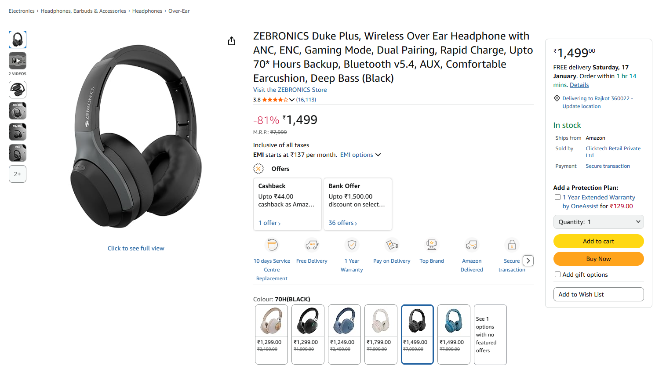

Sr. | Screen Element | Input Type | O/M | 1/N | Description
1 | Add to cart | Button | O | 1 | Add to cart field should add the product in the cart.
2 | Buy Now | Button | O | 1 | Buy Now field should take the customer to the buy product page and also add the product in it.
3 | Quantity | Dropdown | M | N | Quantity field should be editable and customer should be able to specify the product quantity.
4 | Add to Wish List | Dropdown | O | N | Add to Wish List field should be editable and the customer can choose the desired Wish List.
5 | Add gift options | Checkbox | O | 1 | Add gift options should be editable and it should add the gift options.
6 | Add a Protection Plan | Checkbox | O | 1 | Add a Protection plan field should be editable and it should add a protection plan.

