Final Report: Exploring the Latent Space of a Variational Autoencoder (VAE) on Fashion MNIST Dataset

1. Introduction
Variational Autoencoders (VAEs) are powerful generative models designed to learn a probabilistic mapping from the data space to a lower-dimensional latent space. Unlike traditional autoencoders, VAEs enforce a distributional structure on the latent space, enabling the generation of new data points. In this project, the VAE is applied to the Fashion MNIST dataset, which contains 28x28 grayscale images of various fashion items like t-shirts, shoes, and trousers.
The primary objectives of this study were:
- Latent Space Exploration: Visualize how the VAE encodes Fashion MNIST data.
- Sample Generation: Generate new, unseen samples from the learned latent space.
- Interpolation: Manipulate the latent space by interpolating between two points and observing the smooth transformation of generated images.
- Performance Metrics: Evaluate the model’s quality using metrics like SSIM (Structural Similarity Index).

2. Implementation Details
2.1. VAE Model Architecture
The VAE model consists of an encoder and a decoder:
- Encoder: Maps the input image to a latent space. The encoder consists of two fully connected layers that output the mean (mu) and log-variance (logvar), which are used to generate samples from the latent space.
- Decoder: Reconstructs the input image from the latent space vector. The decoder takes the latent vector and uses two fully connected layers to reconstruct the image.
- Reparameterization Trick: This trick allows for the backpropagation through the random sampling step in the latent space.
The VAE was trained with a latent dimension of 2 to allow for easier visualization of the latent space.

2.2. Data Preprocessing and Loading
The Fashion MNIST dataset was loaded using torchvision.datasets.FashionMNIST. The images were transformed into 1D vectors of size 28x28 (784 pixels) and normalized using PyTorch’s built-in transformations. The training and test data were loaded using the DataLoader class, with the batch size set to 64 for efficient training.

2.3. Training Process
The model was trained for 200 epochs using the Adam optimizer with a learning rate of 1e-3. The loss function is a combination of:
- Binary Cross-Entropy (BCE): Measures the difference between the input and the reconstructed output.
- KL Divergence: Regularizes the learned latent space to follow a standard normal distribution, promoting generalization.

EPOCH 1:
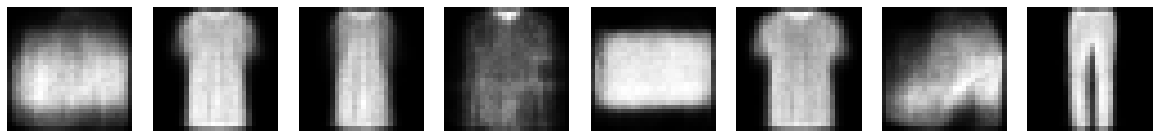

EPOCH 50:
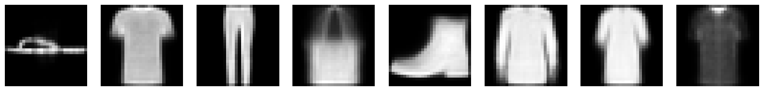

EPOCH 100:
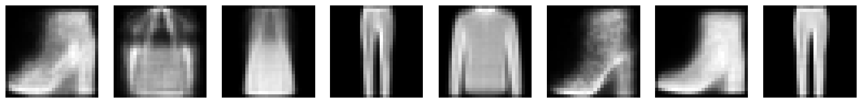

EPOCH 150:
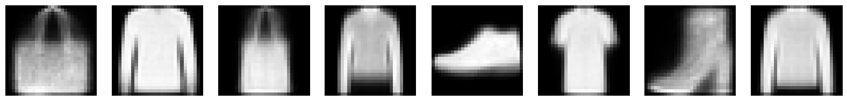

EPOCH 200:
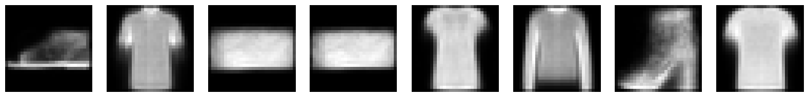

3. Results & Analysis
3.1. Latent Space Visualization (PCA & t-SNE)
The latent space of the VAE was visualized using PCA (Principal Component Analysis) and t-SNE (t-Distributed Stochastic Neighbor Embedding), both of which reduce the dimensionality of the latent space to two dimensions for visualization:
- PCA was used to show the global structure of the latent space.
- t-SNE was used to capture finer-grained clusters in the latent space.

PCA Latent Space Visualization
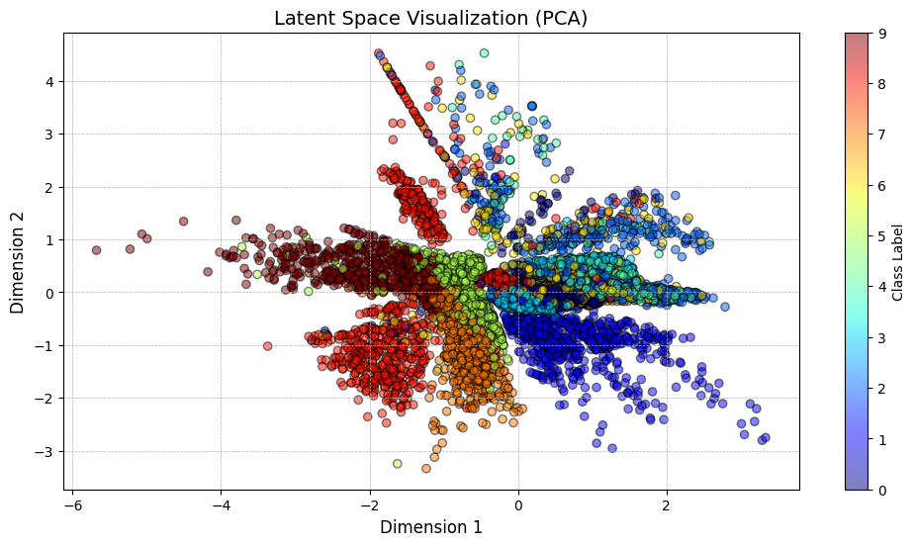

t-SNE Latent Space Visualization
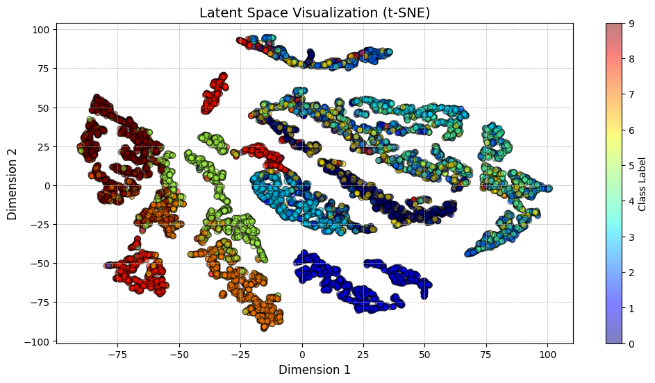
Both visualizations demonstrate how different fashion items (e.g., t-shirts, shoes, and trousers) are grouped together in the latent space, indicating that the VAE successfully learns meaningful representations of the input data.

3.2. New Sample Generation
New fashion samples were generated by sampling from the latent space. By randomly generating latent vectors (from a standard normal distribution), the decoder generates images that resemble items from the Fashion MNIST dataset, but that were not part of the training set.
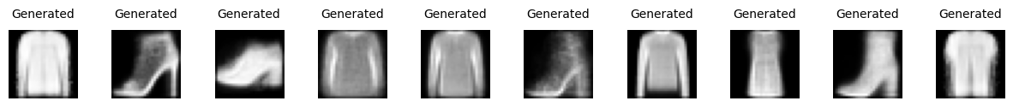These generated images demonstrate the VAE’s ability to produce realistic samples from the learned latent space, showcasing its generative power.

3.3. Interpolation in Latent Space
Interpolation between two random points in the latent space was conducted to observe how the VAE smoothly transforms one image type into another. The interpolation was done over 10 steps, gradually transitioning between images (e.g., from shoes to t-shirts).

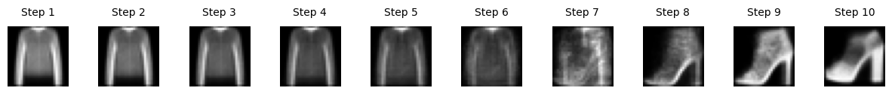The results show smooth transitions in the generated images, confirming that the latent space is continuous.

3.4. Loss Curve
The training loss over the 200 epochs was tracked, and the curve shows a consistent decrease in loss as the model converged. The loss started at approximately 285 and converged to around 237.
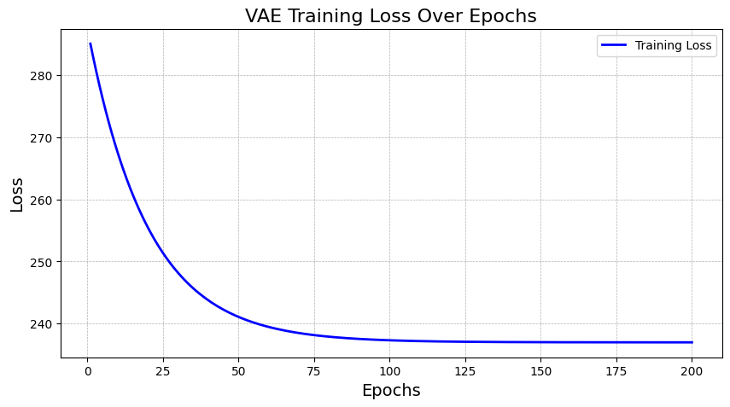
3.5. Performance Metrics (SSIM Score)
The SSIM (Structural Similarity Index) score was calculated to evaluate the quality of the reconstructed images. The average SSIM score achieved was 0.5802, which indicates moderate quality in the image reconstructions.
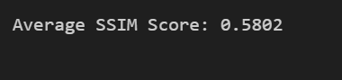This score suggests that while the VAE does a reasonable job reconstructing the images, there is room for improvement, especially in fine details.

3.6. K-Means Clustering
K-Means clustering was applied to the latent space to investigate how different fashion items are grouped. The results showed that items like shoes, t-shirts, and trousers are grouped into distinct clusters, further validating the model's ability to capture meaningful structure in the latent space.
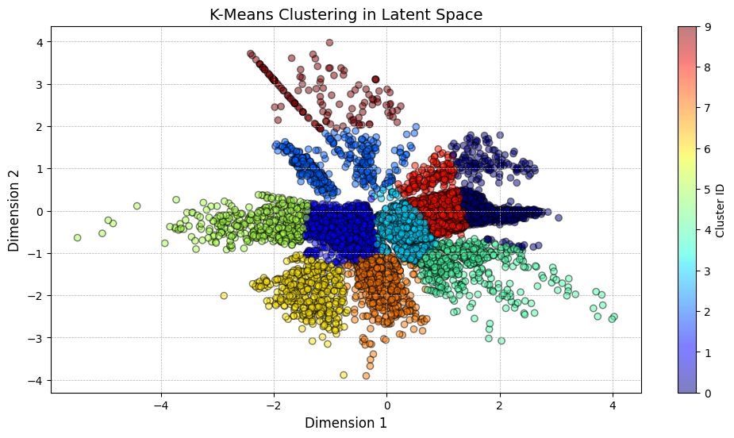The clustering results show that similar items (e.g., shoes and t-shirts) are closely clustered in the latent space.

4. Conclusion
The VAE model effectively learns a continuous and structured latent space representation of the Fashion MNIST dataset. Key insights from the exploration include:
- Latent Space Structure: The latent space learned by the VAE has a meaningful structure where similar items cluster together.
- Smooth Interpolation: Interpolating between two latent vectors results in smooth transformations between different fashion items, showing the continuous nature of the latent space.
- Generative Power: The model can generate new, realistic samples by sampling from random latent vectors.
- Reconstruction Quality: The model’s reconstruction quality, measured using SSIM, shows moderate performance, with potential for improvement.

5. Next Steps
- Increase Latent Dimension: Experimenting with a higher latent dimension (e.g., 50 or 100) could result in improved image generation and higher-quality reconstructions.
- Use Convolutional VAE: Using convolutional layers instead of fully connected layers can help the model capture spatial hierarchies in the images, leading to better performance, especially for higher-resolution data.
- SLERP Interpolation: Implementing spherical linear interpolation (SLERP) might improve interpolation between latent vectors, providing smoother transitions compared to linear interpolation.

