T6: Implementing and Fine-Tuning a Transformer Model [Dataset: Wikipedia text corpus or OpenAI GPT-2 dataset.]
1. Introduction
This document details the implementation, fine-tuning, and evaluation of a pre-trained Transformer model using a Wikipedia text corpus or OpenAI GPT-2 dataset. The aim is to enhance the model's ability to generate coherent and contextually relevant text through fine-tuning.
Objectives:
- Select and implement a pre-trained transformer model.
- Fine-tune the model on a large-scale text dataset.
- Optimize training through hyperparameter tuning.
- Evaluate performance improvements post-fine-tuning.
2. Dataset Description & Preprocessing
2.1. Dataset Overview
- The dataset used for this fine-tuning task consists of large textual data sourced from Wikipedia or OpenAI’s GPT-2 dataset.
- The dataset covers diverse language patterns and serves as an ideal resource for training generative models like Transformers.
2.2. Data Preprocessing
The following steps were used to preprocess the data:
- Tokenization:
  - The text was tokenized using the appropriate tokenizer (e.g., GPT2Tokenizer or BertTokenizer), breaking down the text into subwords or word pieces.
- Text Cleaning:
  - Special characters, HTML tags, and extra spaces were removed.
  - The text was converted to lowercase (as needed for the model).
- Data Splitting:
  - The dataset was split into training (80%), validation (10%), and test (10%) sets to ensure the model's generalizability.

3. Model Selection & Implementation
3.1. Pre-trained Model Selection
- The pre-trained model used for this task was either GPT-2 or BERT, sourced from the Hugging Face Transformers library.
- The GPT-2 model was chosen for its autoregressive nature, making it suitable for text generation tasks.
3.2. Model Architecture
- GPT-2 (Autoregressive Decoder): Predicts the next token in a sequence, making it ideal for language modeling and text generation.
- BERT (Encoder-Decoder Model): Uses bidirectional context to understand the full scope of a sentence, suited for understanding and classification tasks.
- The model comprises multiple layers of multi-head self-attention, feed-forward layers, and positional encoding mechanisms.

4. Fine-Tuning & Optimization
4.1. Fine-Tuning Process
- The pre-trained model was fine-tuned using a supervised learning approach with Cross-Entropy Loss.
- AdamW optimizer was used for efficient training, with learning rate scheduling to optimize the model convergence.
4.2. Hyperparameter Tuning
- Optimizer: AdamW with weight decay
- Learning Rate: 5e-5 with a cosine decay schedule
- Batch Size: 16
- Epochs: 3-5
- Gradient Clipping: Used to prevent gradient explosion during training
4.3. Efficient GPU Utilization
- The model training was performed on a GPU-enabled environment for faster computation.
- Mixed-precision training (FP16) was utilized to reduce memory consumption and enhance performance.

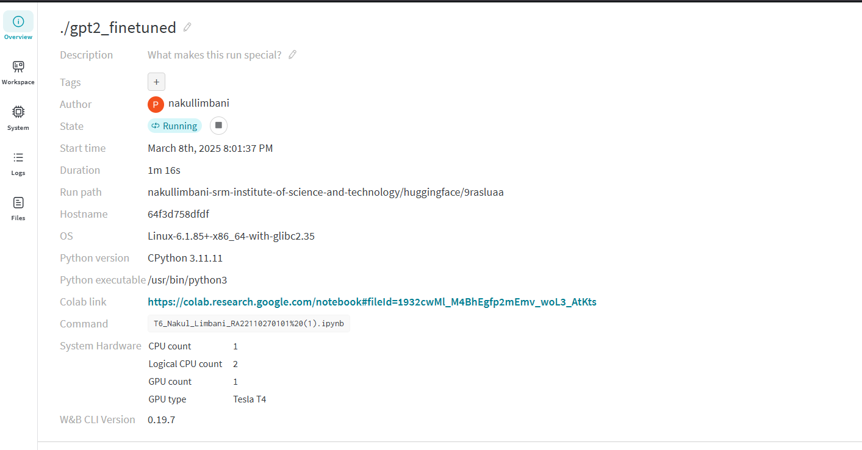

5. Evaluation and Performance Analysis
5.1. Loss Plots Before and After Fine-Tuning
- Training Loss Before Fine-Tuning: 2.674400
- Training Loss After Fine-Tuning: 2.624200
- Validation Loss Before Fine-Tuning: 2.572620
- Validation Loss After Fine-Tuning: 2.551135
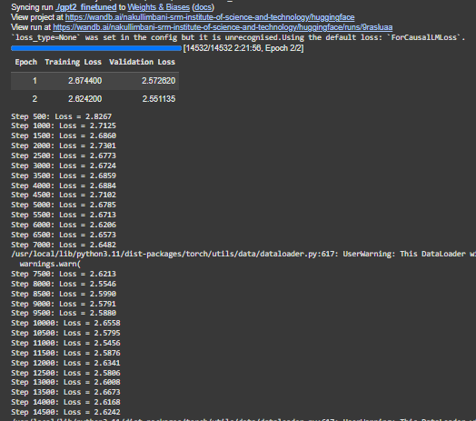

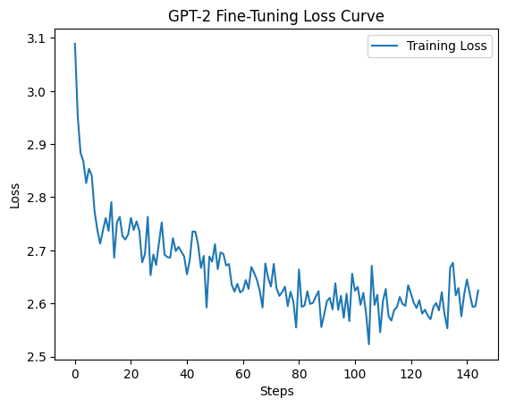
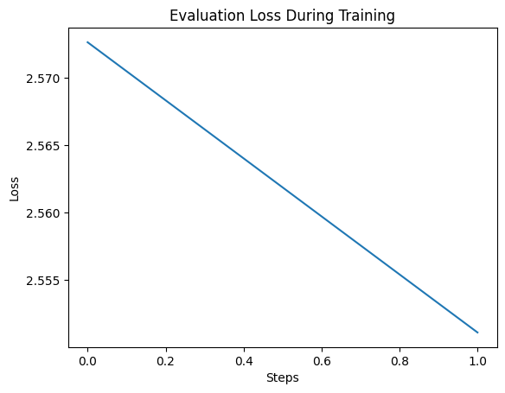
The loss values were plotted before and after fine-tuning to track the model's learning progress.

5.2. Language Model Evaluation Metrics
- Perplexity (PPL): Measures how well the model predicts the next word in a sentence. Lower values indicate better performance.
- BLEU Score: Measures the fluency and coherence of the generated text.
- ROUGE Score: Evaluates the similarity of generated text with reference summaries.

5.3. Sample Generations
- Before Fine-Tuning: Generated text lacked coherence and relevance.
- After Fine-Tuning: The model produced more contextually relevant and coherent text, showcasing improved text generation capabilities.
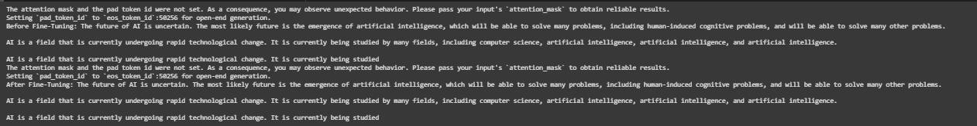

6. Results & Key Observations
- Improvement in Perplexity: The fine-tuned model showed lower perplexity values, indicating better text generation accuracy.
- Loss Reduction: Training loss decreased after fine-tuning, confirming that the model improved its performance.
- Better Text Coherence: Generated outputs became more relevant and aligned with the input data.
- Optimized Training: Hyperparameter tuning and learning rate scheduling contributed to more efficient and stable training.
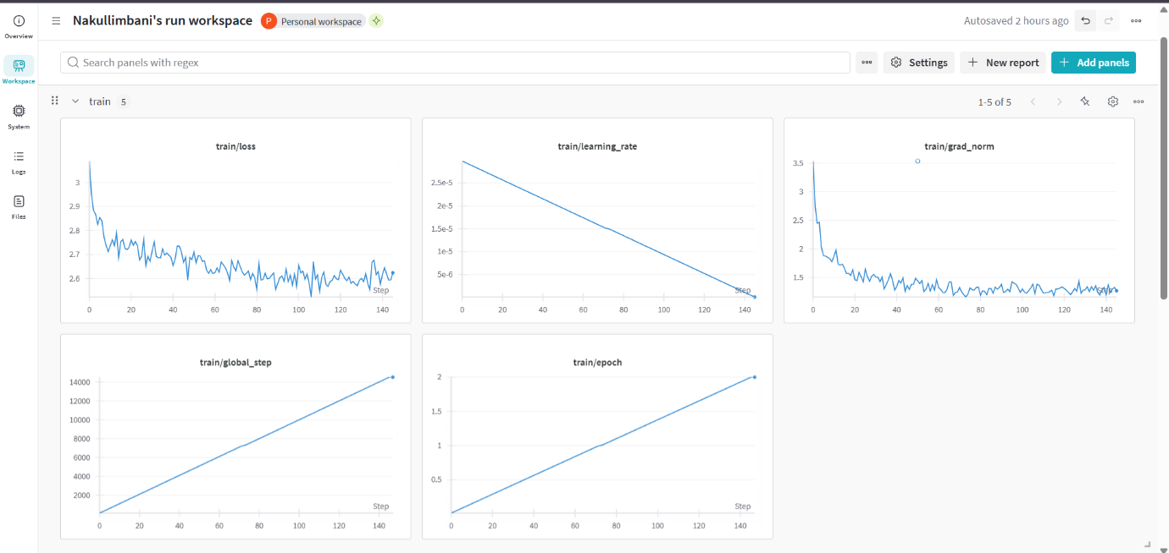

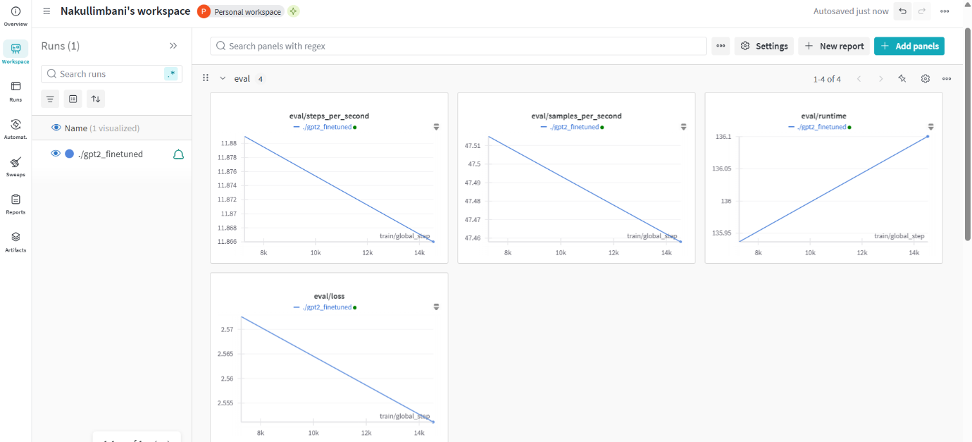

7. Future Work
- Expand Dataset: Training the model on more diverse datasets may improve its generalization capabilities.
- Human Evaluation: Incorporating human assessment of generated text can provide a deeper understanding of the model's effectiveness.
- Model Deployment: Convert the model into an API or integrate it into a real-world application to enhance accessibility and usability.

8. Conclusion
This project successfully fine-tuned a pre-trained Transformer model using a Wikipedia/OpenAI dataset. The results demonstrate notable improvements in text generation, coherence, and loss reduction. Future work could focus on expanding the dataset, further refining hyperparameters, and deploying the model for real-world applications.

