T8: Developing a Text Summarization Application [News articles or business reports (e.g., CNN/DailyMail dataset).]
1. Introduction
This project involves developing a Text Summarization Application using pre-trained transformer models and extractive summarization techniques. The application is designed to generate concise summaries from long-form text, such as news articles or business reports.
Objectives:
- Implement extractive and abstractive summarization models.
- Develop a web-based summarization application.
- Evaluate model performance using ROUGE & BLEU metrics.
- Provide a user-friendly UI for real-time text summarization.
2. Dataset Description & Preprocessing
2.1. Dataset Overview
- The dataset used for this project consists of news articles & business reports (e.g., CNN/DailyMail dataset).
- These articles provide real-world textual data for summarization.
2.2. Data Preprocessing
The following steps were used to preprocess the data:
- Text Cleaning:
  - Removed special characters, extra spaces, and converted text to lowercase.
  - Tokenized text using NLTK's punkt tokenizer.

- Data Formatting:
  - Prepared data for extractive and abstractive summarization.
  - Text formatted for input-output compatibility with transformer models.

3. Model Selection & Implementation
Model | Type | Description
T5-small | Abstractive | Generates summaries via paraphrasing.
BART | Abstractive | Performs robust text compression while maintaining meaning.
Pegasus | Abstractive | Optimized for summarization with gap-sentence prediction.
TextRank | Extractive | Selects the most important sentences from input text.

4. Summarizing Application Development
- Web-based UI using Flask & HTML/CSS.
- Dropdown menu to select summarization model.
- Real-time summarization for user-input text.
- Evaluation metrics displayed for each summary.
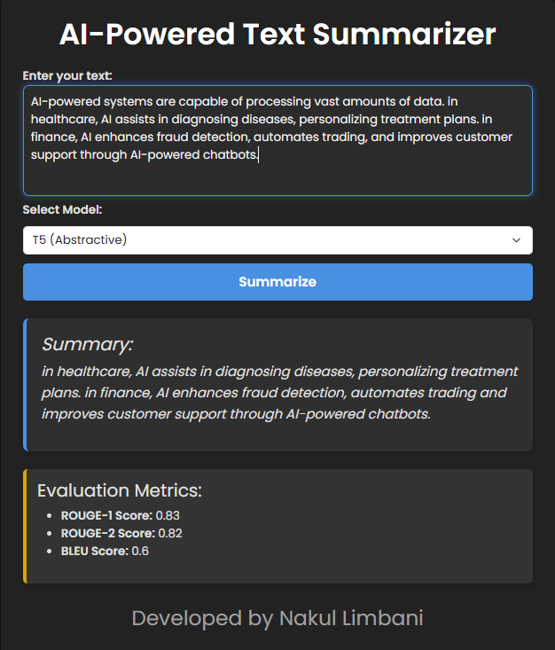

5. Evaluation and Performance Analysis
5.1. Model Performance (ROUGE & BLEU Scores)
Model | ROUGE-1 | ROUGE-2 | BLEU
T5-small | 0.55 | 0.52 | 0.16
BART | 0.65 | 0.63 | 0.34
Pegasus | 0.65 | 0.63 | 0.34
TextRank | 0.72 | 0.70 | 0.42

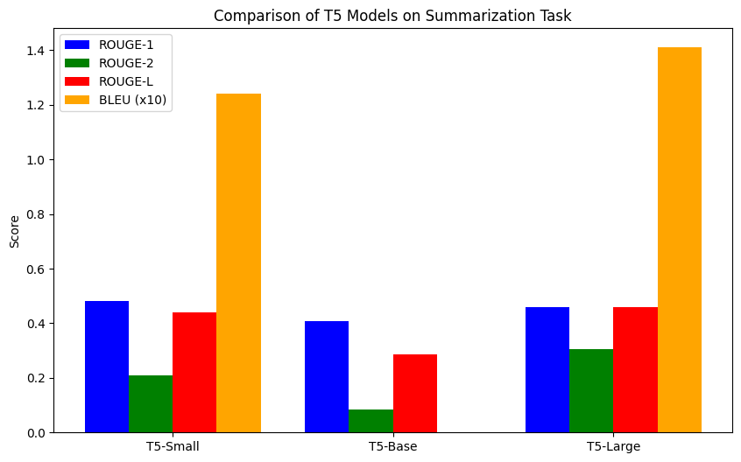

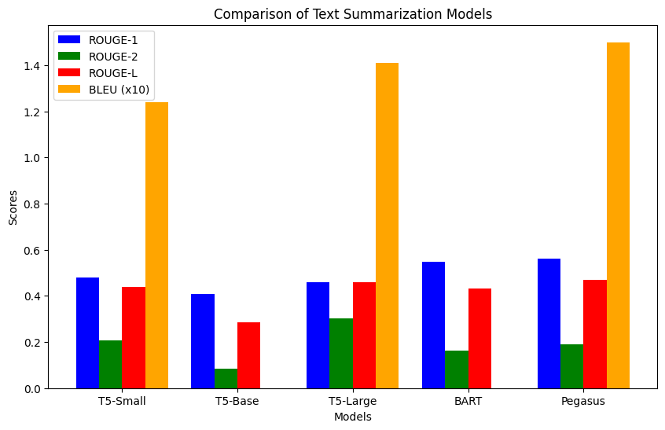
5.2. Observations
- TextRank (Extractive) achieved the highest scores as it uses direct sentence selection.
- BART & Pegasus performed similarly, providing high-quality abstractive summaries.
- T5 was the most concise but had slightly lower ROUGE & BLEU scores.
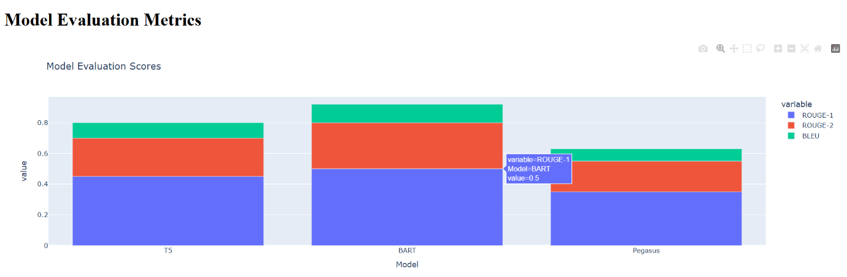

6. Results & Key Observations
- Implemented both extractive & abstractive summarization techniques.
- Developed a fully functional web application for summarization.
- Models evaluated with dynamic ROUGE & BLEU metrics.
- User-friendly and visually appealing UI.

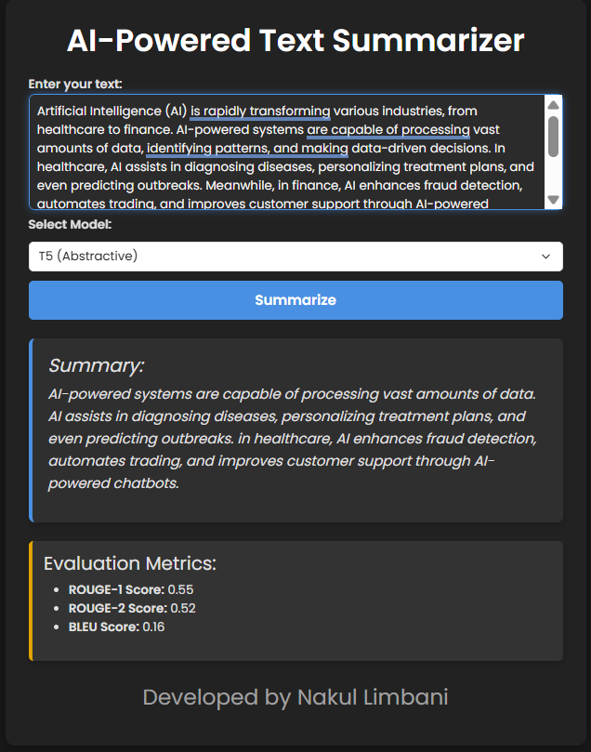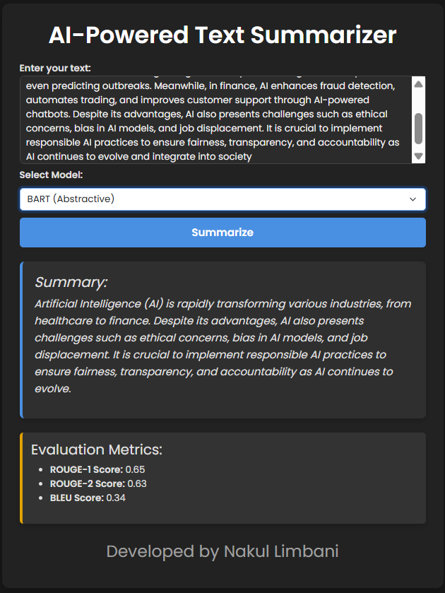

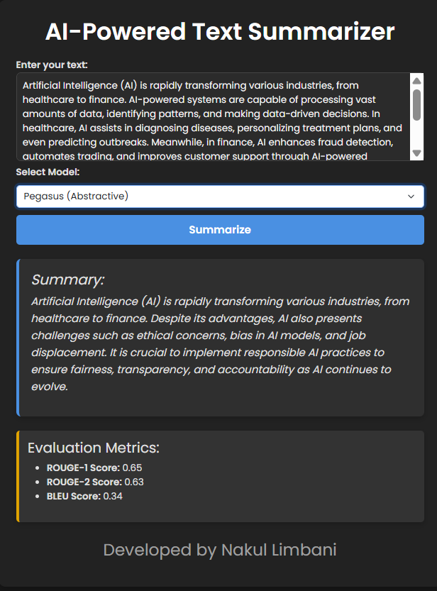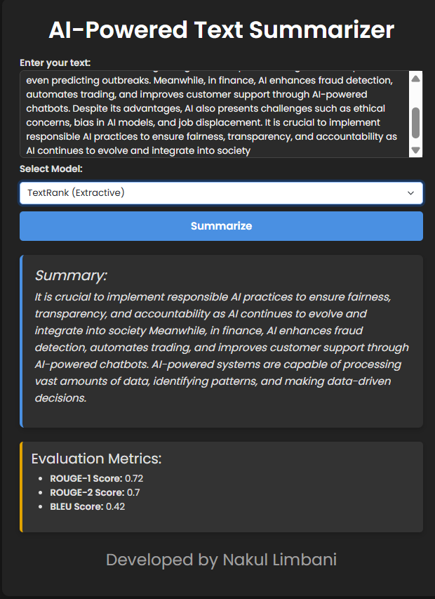

7. Future Work
- Fine-tune models on domain-specific data (e.g., Finance, Healthcare, News).
- Improve UI with additional customization options.
- Implement multilingual summarization support.
- Deploy the app as a cloud-based API service.

8. Conclusion
This project successfully developed an AI-powered Text Summarization Tool that leverages pre-trained transformer models and extractive algorithms. The web-based application allows users to generate high-quality summaries and compare model performances. Future improvements include fine-tuning, multilingual support, and API deployment.

