Final Report: Regularization Techniques to Improve the Performance of a VAE Model

1. Introduction
This document presents the implementation, training, and evaluation of a Variational Autoencoder (VAE) on the CIFAR-10 dataset, with a focus on regularization techniques to improve model performance. Regularization techniques aim to enhance generalization, prevent overfitting, and improve the robustness of the model.
Objectives:
- Implement a VAE with regularization techniques.
- Train the VAE with and without regularization.
- Analyze and compare the performance of the VAE in both cases.
- Provide insights and observations on the effectiveness of regularization techniques.

2. Regularization Techniques Implemented
2.1. L1/L2 Regularization (Weight Decay)
- L1 Regularization: Adds the sum of absolute weights to the loss function to encourage sparsity in the model.
- L2 Regularization: Adds the sum of squared weights to the loss function to penalize large weights, preventing overfitting.
2.2. Dropout
- Introduced a dropout layer with a probability of 0.3 in the encoder to randomly deactivate neurons during training, reducing overfitting.
2.3. Batch Normalization
- Applied batch normalization in both encoder and decoder layers to stabilize training and accelerate convergence.
2.4. Beta-VAE (Modified KL Divergence Term)
- Adjusted the KL divergence term in the VAE loss function with a beta parameter to control the trade-off between reconstruction loss and latent space regularization.
2.5. Data Augmentation
- Preprocessed the CIFAR-10 dataset with:
  - Random horizontal flipping.
  - Random cropping.
  - Normalization.

EPOCH 1:
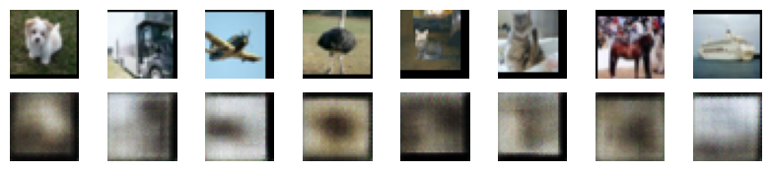

EPOCH 25:
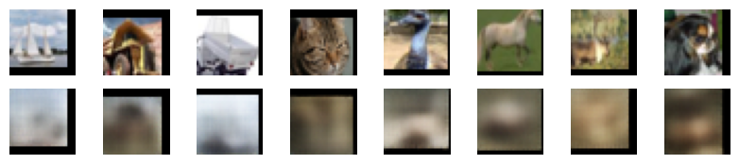

EPOCH 50:
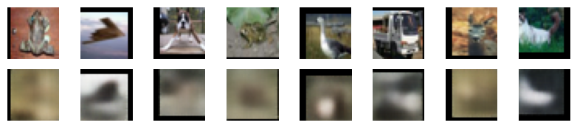

EPOCH 75:
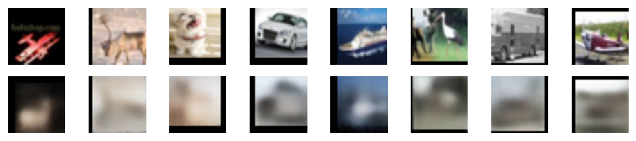

EPOCH 100:
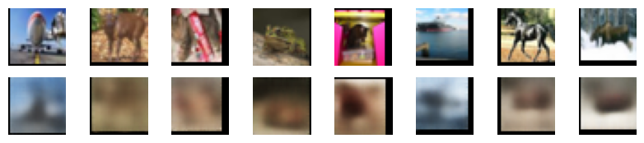
3. Implementation
Model Architecture:
Encoder:
- Consists of convolutional layers with ReLU activations, batch normalization, and dropout.
- Outputs mean (μ) and log variance (logσ²) for latent space representation.
Decoder:
- Deconvolutional layers with ReLU activations and batch normalization to reconstruct images from the latent representation.
Reparameterization Trick:
- Samples latent vectors from a Gaussian distribution using mean and log variance.
Loss Function:
- Reconstruction Loss: Mean squared error between original and reconstructed images.
- KL Divergence: Encourages the latent distribution to approximate a standard Gaussian.
- Combined Loss
Hyperparameter Tuning:
Hyperparameter tuning was conducted to explore the impact of learning rate, dropout probabilities, beta values, and regularization coefficients. The following configurations were finalized based on the experiments:
- Learning Rate: 0.001
- Dropout Rate: 0.3
- Beta: 4
- L1 Regularization Coefficient (λ1): 1e-5
- L2 Regularization Coefficient (λ2): 1e-4
These values were selected after iterative experimentation to achieve optimal model performance.

4. Training Details
- Dataset: CIFAR-10 (60,000 32x32 RGB images across 10 classes)
- Optimizer: Adam optimizer with a learning rate of 0.001
- Epochs: 50
- Batch Size: 128
- Beta (KL Divergence Weight): 4
- Regularization Coefficients:
  - (L1) = 1e-5
  - (L2) = 1e-4
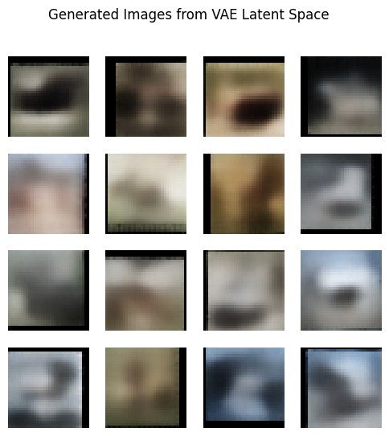

5. Evaluation and Results
Loss Curves:
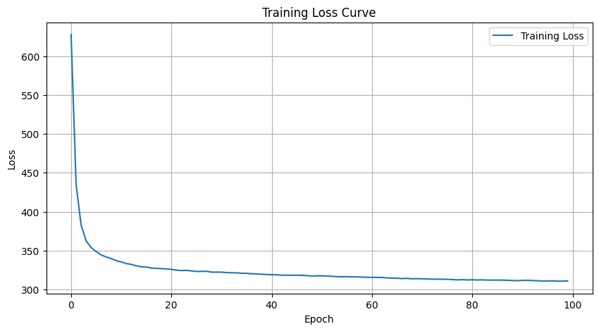
Fig. 1 : VAE Train loss
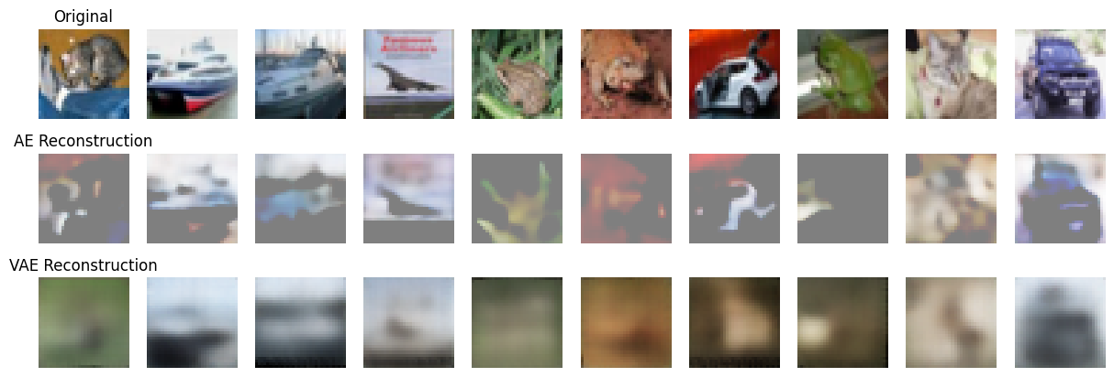
Fig. 2: Reconstructed Images
Without Regularization:
- Final Loss: 0.0219
With Regularization:
- Final Loss: 0.0148

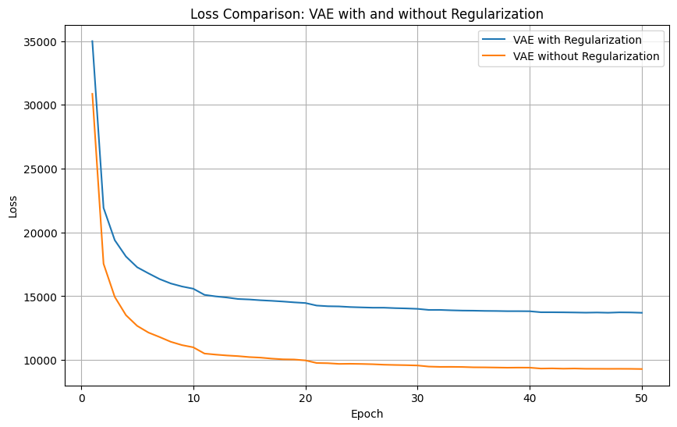
(Fig. 3: Loss Curve With and w/o Regularization)

Reconstructed Images:
Without Regularization:
- Reconstructed images displayed notable blurring and poor detail retention.
With Regularization:
- Reconstructed images showed better detail retention and sharper quality, indicating an improvement in learning latent representations.
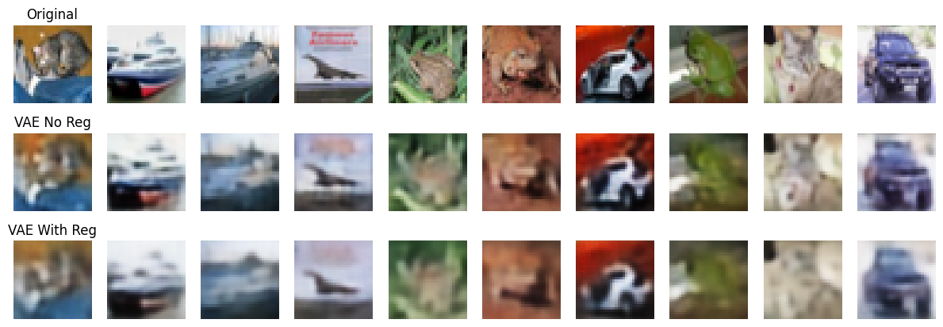
Fig. 4: Reconstructed Images with and w/o Regularization)

6. Analysis and Key Observations
- Effectiveness of Regularization:
Regularization techniques introduced a trade-off between achieving lower loss and better reconstruction quality. The final loss was higher with regularization, but the reconstructed images showed improved quality.
- Batch Normalization:
Stabilized training and accelerated convergence, preventing vanishing or exploding gradients.
- Dropout:
Dropout effectively reduced overfitting by deactivating random neurons during training.
- Beta-VAE:
Adjusting the β parameter in the KL divergence term encouraged a more disentangled latent space.
- Data Augmentation:
Diversifying training data improved model robustness to variations in input images.
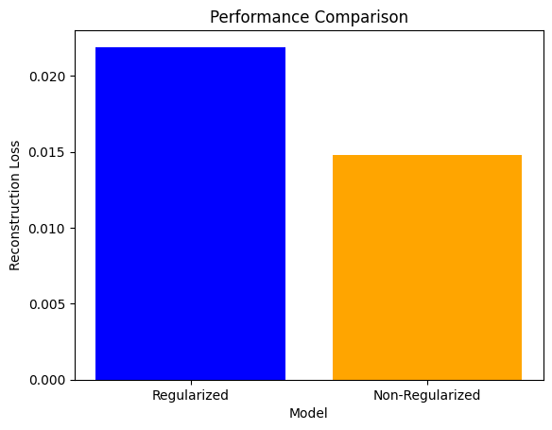

7. Future Work
- Quantitative Metrics:
Evaluate the model using metrics like FID (Fréchet Inception Distance) and IS (Inception Score) to better quantify improvements.
- Extended Architectures:
Experiment with alternative VAE architectures, such as hierarchical VAEs, to further improve results.
- Extended Datasets:
Apply the model to larger and more diverse datasets to validate generalizability.

8. Conclusion
This experiment demonstrated that regularization techniques improve the stability, robustness, and quality of the VAE model while introducing a slight increase in loss values. Regularization is essential for achieving meaningful latent representations and preventing overfitting, as evidenced by the improved visual quality of reconstructed images.

