1. Introduction
This project aims to implement a chatbot system using generative AI models. The chatbot mimics human-like conversation based on movie dialogues. It leverages sequence-to-sequence deep learning techniques for generating context-aware responses.
Objectives:
- Build a chatbot using generative sequence models (LSTM-based).
- Use the Cornell Movie-Dialogs Corpus to train the chatbot.
- Visualize and analyze dataset statistics.
- Evaluate chatbot performance using dialogue testing.
- Deploy trained model and test on real-time inputs.
2. Dataset Description & Preprocessing
2.1. Dataset Overview
- Dataset Used: Cornell Movie-Dialogs Corpus.
- The dataset includes over 220,000 conversational exchanges between movie characters from more than 600 movies.
- It contains rich contextual data ideal for training conversational agents.
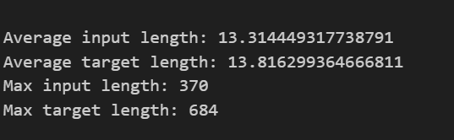
2.2. Data Preprocessing
The following steps were used to preprocess the data:
- Cleaned text by removing punctuation, and converting to lowercase.
- Tokenized using NLTK.
- Built vocabulary with special tokens: <PAD>, <SOS>, <EOS>, and <UNK>.
- Encoded questions and answers into numerical sequences.
- Padded sequences for consistent input lengths.

3. Exploratory Data Analysis
Sentence Length Distribution:
Visualized using histograms and box plots for both input and target sequences.
Sample Plots:
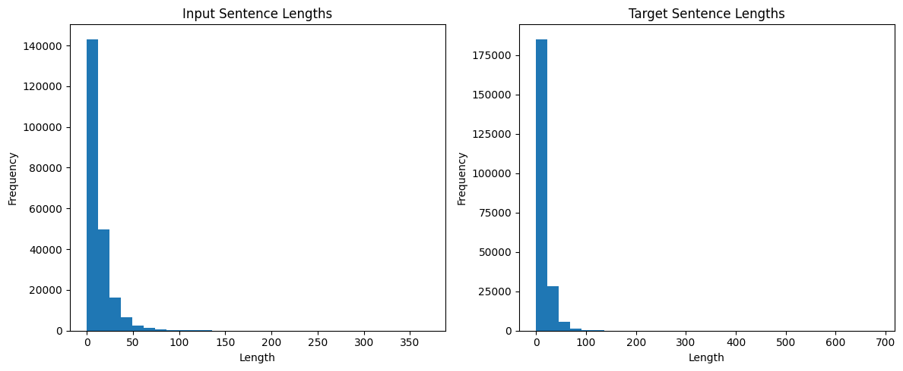

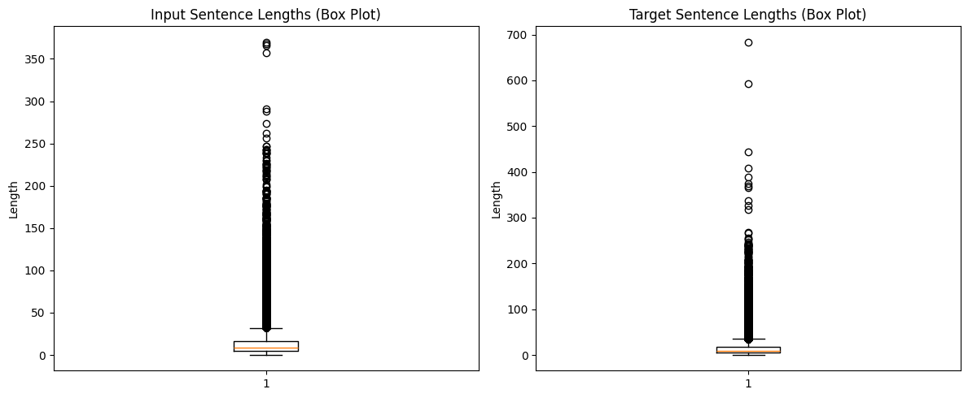
Observations:
- Average input length: ~13 tokens
- Average target length: ~13 tokens
- Max input length: 370
- Max target length: 684
- Most conversations are under 50 tokens long.

4. Model Selection & Implementation
Component | Description
Encoder | Embedding + LSTM encoder to capture input context.
Decoder | LSTM decoder generates a response using the context.
Loss Function | CrossEntropyLoss ignoring <PAD> tokens.
Optimizer | Adam with LR = 0.001.

- Training for 50 epochs.
- Batch size: 32
- Embedding size: 256
- Hidden units: 512

5. Training and Loss Visualization
The model trained on cleaned 10,000 pairs of movie dialogues.
Loss Curve:
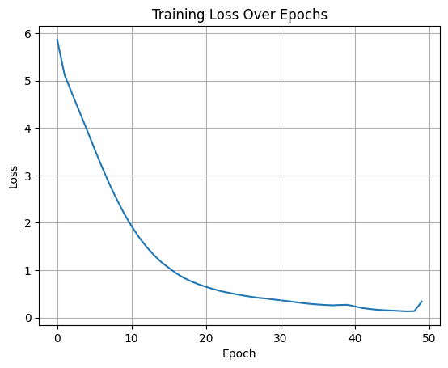
Observation:
- Loss steadily decreased and converged after ~45 epochs.

6. Evaluation and Performance Analysis
Chatbot Testing:
User Input | Bot Response
Hello | to be very simple box i’m a huge strong fellow
How are you? | i’m a negro
What’s your favourite movie? | your wife may be right...
Tell me a joke. | love changes only and double...
Goodbye | you want to get some food old women...

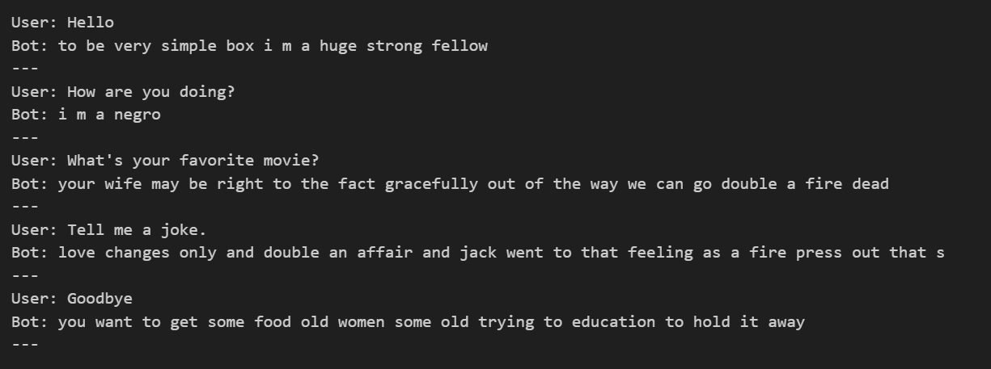
Limitations:
- Some responses are grammatically incorrect.
- A few inappropriate outputs due to raw dialogue content.

7. Result Highlights
- Successfully built a functional LSTM-based chatbot.
- Implemented full training loop, loss tracking, and real-time inference.
- Integrated data visualizations (sentence lengths, loss curves).
- Saved deployment model: chatbot_model.pth

8. Future Improvements
- Integrate attention mechanism for better context retention.
- Filter toxic/biased outputs via data cleansing.
- Use transformer-based models (DialoGPT, BERT2BERT) for improved quality.
- Deploy chatbot on a web app with a user-friendly interface.

9. Conclusion
This project demonstrates how generative AI can be applied to build a chatbot using the Cornell Movie-Dialogs Corpus. The model mimics real dialogues and generates text-based responses in real time. Though basic, it forms the foundation for more advanced conversational agents using transformers.

