T09 : Develop a Generative Model for Creating Personalized Marketing Content
1. Introduction
This project focuses on building a Generative Model for creating personalized marketing emails using the Enron Email Dataset. The model is built using Long Short-Term Memory (LSTM) networks with Bidirectional layers to enhance the model's ability to generate contextually relevant emails.
Objectives:
- Train a generative model on the Enron Email Dataset.
- Use LSTM architecture for text generation.
- Generate realistic and coherent marketing email text.
- Evaluate the model's performance and fine-tune its generation capabilities.
2. Dataset Description & Preprocessing
2.1. Dataset Overview
The Enron Email Dataset is a collection of real emails sent by Enron Corporation employees. For this project:
- Corpus Size: 399,950 email sequences.
- Dataset Shape:
  - Shape of X: (399950, 50, 1)
  - Shape of y: (399950, 29)

2.2. Data Preprocessing
To prepare the data:
- Text Cleaning: Removed unnecessary characters, and punctuation, and standardized the case.
- Data Transformation: Each email is split into sequences of 50 characters, and the target is the next character in the sequence.
- Normalization & Encoding:
  - Character to integer mapping for input sequences.
  - One-hot encoding for target sequences (next character prediction).

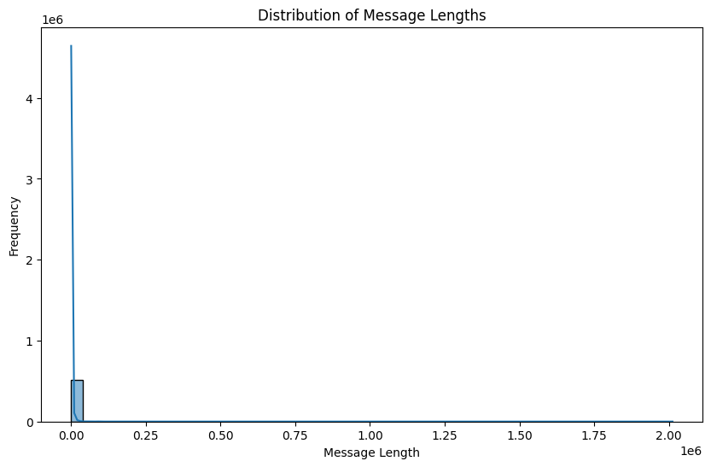
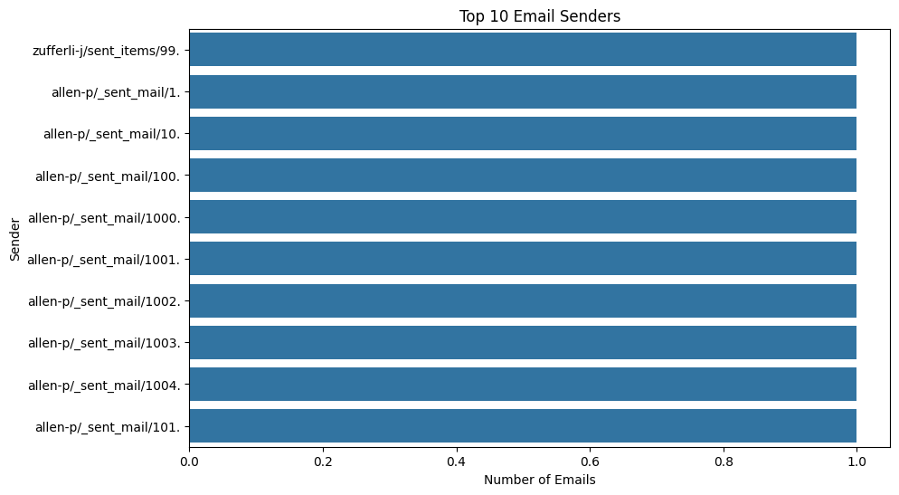

3. Model Selection & Implementation
The model uses an LSTM-based architecture with the following layers:
- Bidirectional LSTM Layer: For capturing both past and future context.
- Dropout: For regularization.
- Dense Layer: For predicting the next character using softmax activation.
Model Summary:
- Total Parameters: 5,267,997
- Bidirectional LSTM Layer: 2,105,344 parameters
- LSTM Layer: 3,147,776 parameters
- Dense Layer: 14,877 parameters

Model architecture visualization:

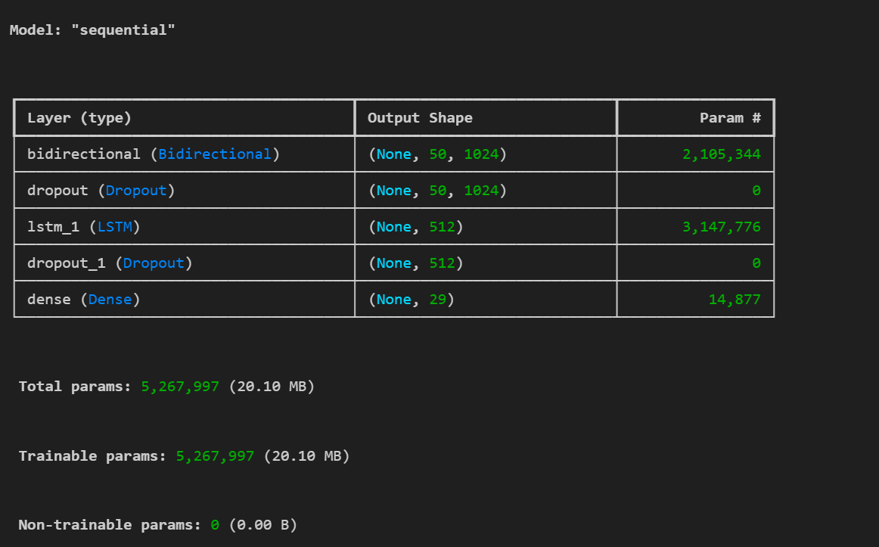

4. Model Training & Evaluation
4.1 Training Overview
- The model was trained for 50 epochs using a batch size of 128. The training loss gradually decreased, and the model achieved a final training loss of 0.45.
Training Loss Graph:
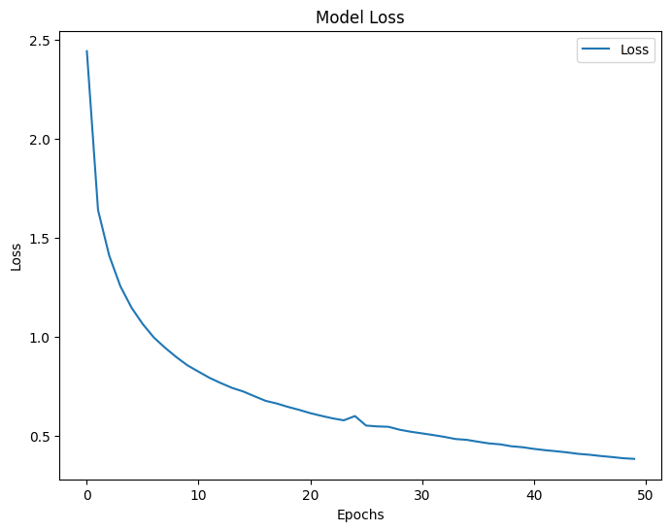
4.2 Performance Metrics
After training, the model was evaluated on a test dataset. The test loss and perplexity were calculated as:
- Test Loss: 0.17
- Perplexity: 1.19
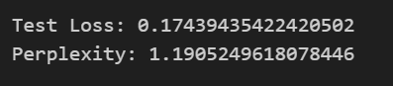

5. Generated Text Samples
5.1. Post Processing Generated Text
After generating text, the postprocessing function was applied to correct incomplete phrases and sentence fragments. Here’s an example of the postprocessed output:
Generated Text (before postprocessing):
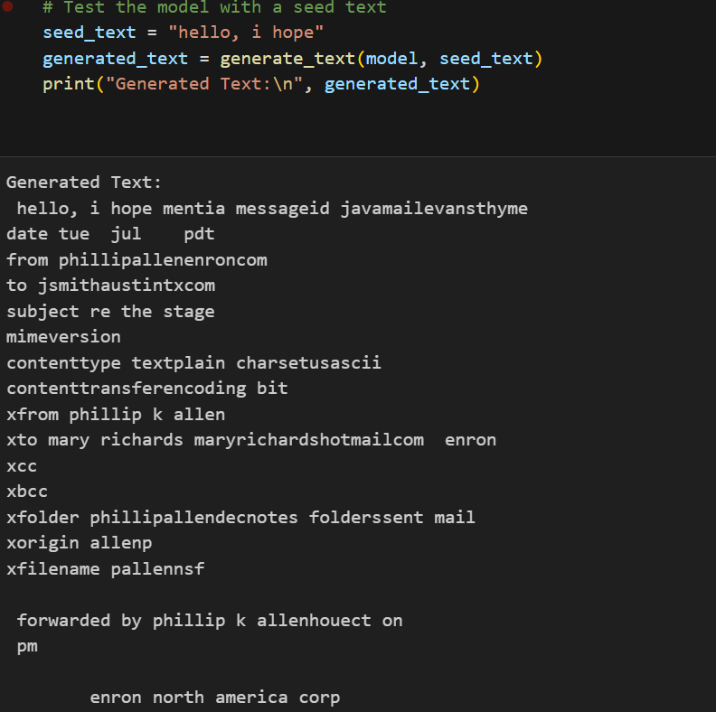
Postprocessed Text:
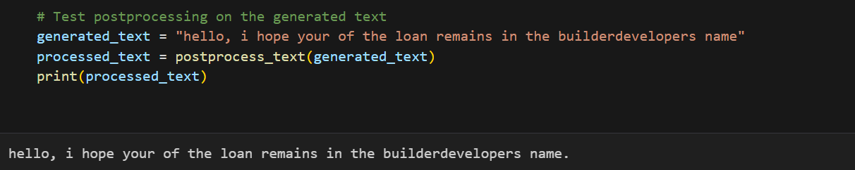

5.2 Temperature-based Sampling
The model's output was generated with different temperature values, affecting the randomness of the text generation.
Temperature = 0.2: Generates very predictable text.
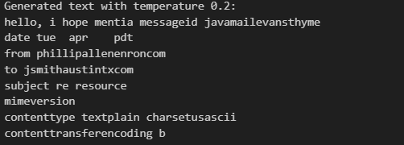
Temperature = 0.5: A balance between randomness and predictability.
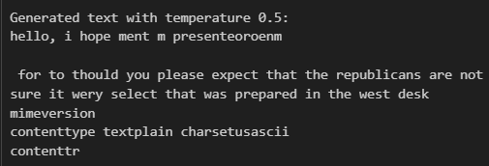
Temperature = 1.0: Generates more creative and diverse text.
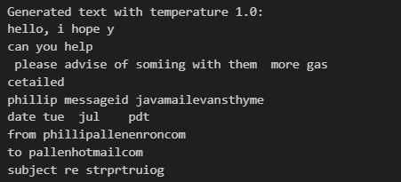
Generated Text with Different Temperatures:
Sample Output:
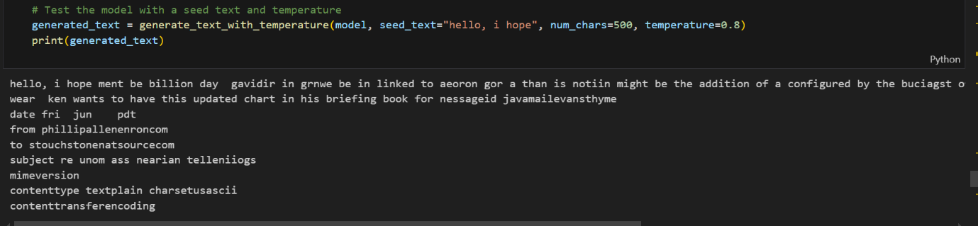

6. Results & Analysis
6.1 Evaluation of Generated Text
The generated emails mostly retained their structure but had incoherent fragments or missing information. The postprocessing helped improve these issues, although some text was still nonsensical.

6.2 Top 20 Most Frequent Words in Cleaned Messages

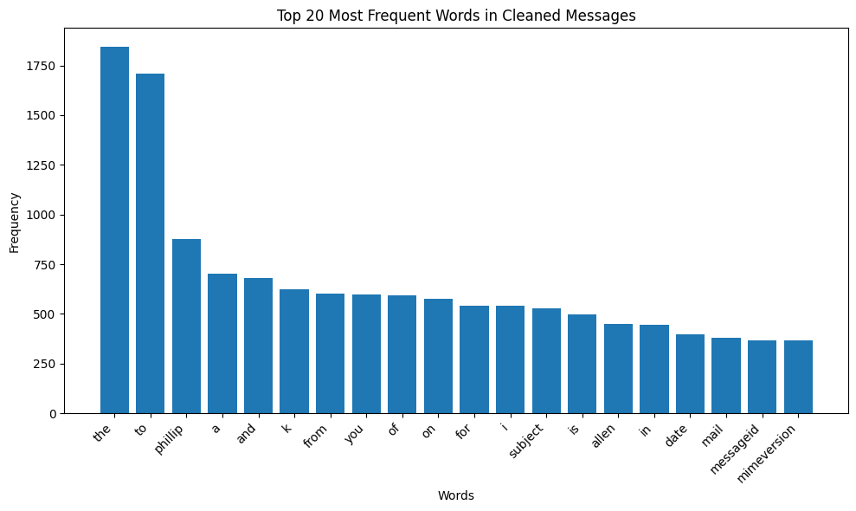

6.3 Word Cloud of Most Frequent Words
A word cloud was generated to represent the frequency of words across the dataset visually.
Word Cloud:
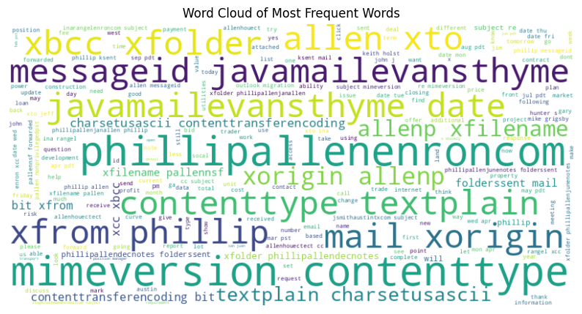
7. Future Work
Enhance Text Coherence: Work on improving the syntactical structure of generated text.
Domain-Specific Tuning: Fine-tune the model on more specialized email datasets (e.g., marketing emails).
Deployment: Create a web interface for real-time email generation.

8. Conclusion
The Generative AI model for marketing emails shows promising results. While the text generated is largely coherent, improvements in postprocessing and fine-tuning are needed for more realistic results. Future work will focus on refining the model for better performance and real-world deployment.

