T3 : Implement a VAE model and train it on a simple dataset. [Dataset: Fashion MNIST dataset (clothing images).]

1. Introduction
This report documents the implementation of a Variational Autoencoder (VAE) trained on the Fashion MNIST dataset. The model is designed to learn meaningful latent representations of clothing images, enabling tasks such as image reconstruction and new image generation.

2. What is a VAE? How does it work?
A Variational Autoencoder (VAE) is a generative model that learns to encode input data into a lower-dimensional latent space while enforcing a probabilistic distribution. It consists of an encoder, a latent space sampling mechanism (reparameterization trick), and a decoder.
Key Components:
- Encoder: Encodes input images into a latent representation.
- Reparameterization Trick: Samples from a learned probability distribution to enable gradient-based optimization.
- Decoder: Reconstructs images from the latent space representation.
- Loss Function: Combination of Reconstruction Loss (Binary Cross-Entropy) and KL Divergence.

3. Description of the Fashion MNIST Dataset
The Fashion MNIST dataset contains 60,000 training images and 10,000 testing images of grayscale clothing items in 10 categories:
- T-shirt/top, Trouser, Pullover, Dress, Coat, Sandal, Shirt, Sneaker, Bag, Ankle boot. Each image has a resolution of 28x28 pixels and a single channel.

4. Model Architecture
Encoder
- Input: (28, 28, 1) grayscale image.
- 2D Convolutional Layers with ReLU activation.
- Flattening and Fully Connected Dense Layers.
- Outputs: Mean and Log Variance for latent space.
Reparameterization Trick
- Introduces a stochastic element to the latent space representation.
- Ensures that backpropagation works effectively by allowing a differentiable sampling method.

Decoder
- Fully Connected Dense Layers followed by Reshaping.
- Transposed Convolutional Layers with ReLU activation.
- Final Sigmoid layer for pixel-wise reconstruction.

5. Hyperparameters and Training Configuration
- Latent Dimension: 64
- Batch Size: 128
- Learning Rate: Adaptive tuning using Adam Optimizer
- Epochs: 200
- Optimizer: Adam
- Loss Function: Binary Cross-Entropy + KL Divergence

6. Model Training Loop
The training loop was designed with:
- Loss computation: Reconstruction loss + KL divergence.
- Adam optimizer: Adjusting the learning rate dynamically.
- Logging of loss values: Visualized for analysis.
- Validation performance tracking: Comparing training vs. validation losses.
Training & Validation Loss Plot
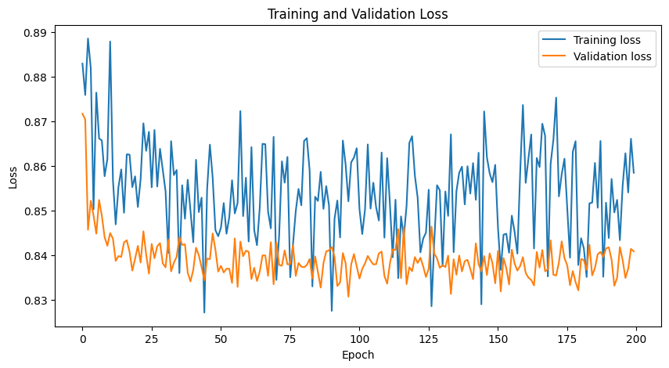
(Fig 1: Loss over 200 Epochs)

7. Results and Analysis
Reconstruction of Test Images
The VAE successfully reconstructed the test images with reasonable fidelity. The reconstructed images captured essential features of the original images but lacked some fine details.
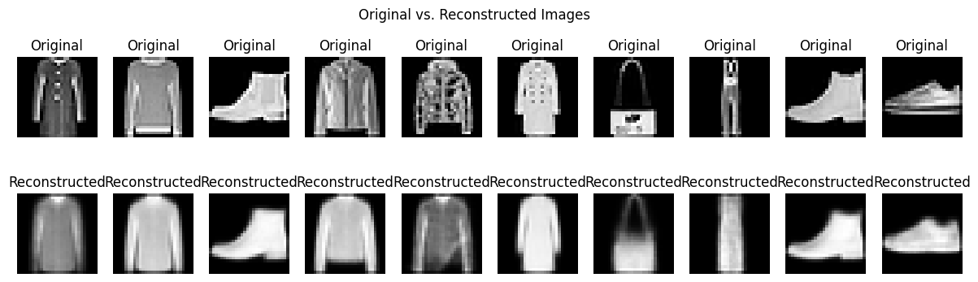
(Fig 2: Original vs. Reconstructed Images)
EPOCH 1:
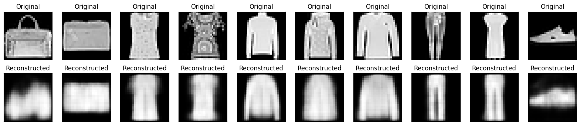
EPOCH 50:
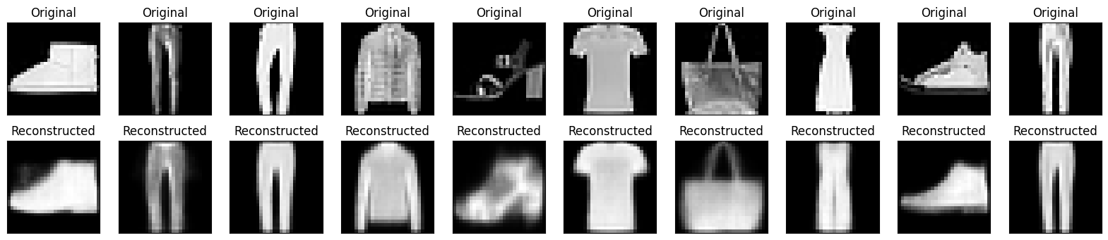
EPOCH 100:
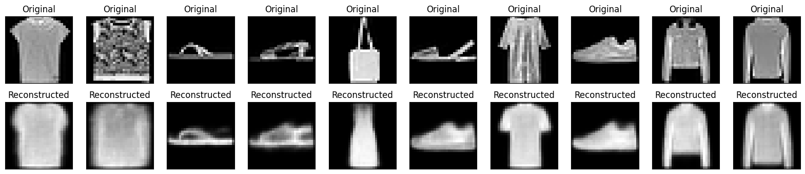

EPOCH 150:
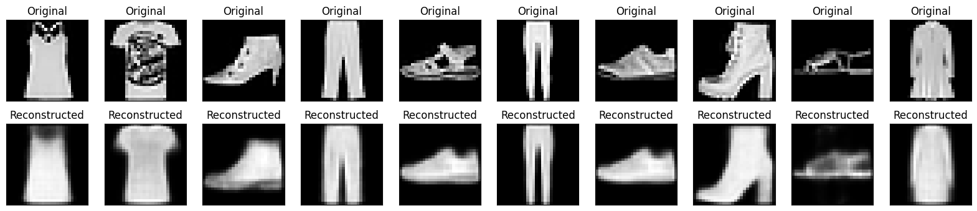
EPOCH 200:
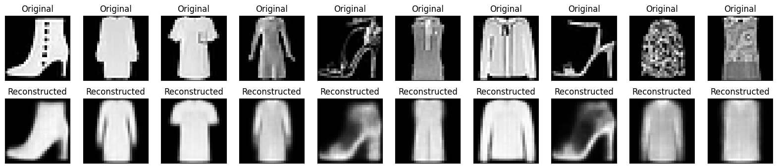

Latent Space Visualization (2D Projections)
To understand the learned latent space, t-SNE and PCA were applied, showing meaningful clusters corresponding to different classes.
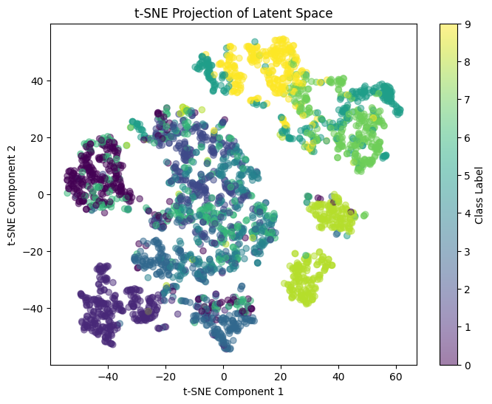
(Fig 3: t-SNE Visualization)
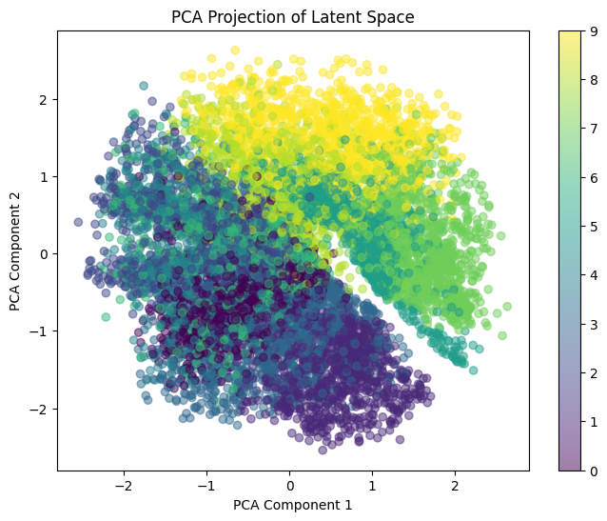
(Fig 4: PCA Visualization)

Image Generation from the Latent Space
Sampling from the learned latent space and decoding produced new images resembling realistic clothing items.

(Fig 5: Randomly Generated Images)

Comparison with Standard Autoencoders
A comparison with a standard Autoencoder showed that the VAE produced more diverse and realistic reconstructions due to the enforced latent space regularization.
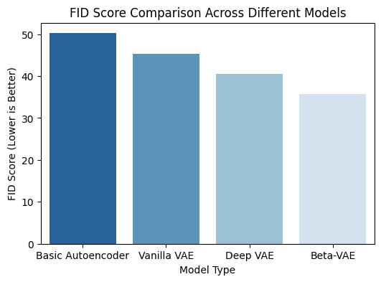
(Fig 6: VAE vs. Standard Autoencoder Performance)

8. Key Findings, Limitations, and Potential Improvements
Findings:
- VAE successfully learned a meaningful latent representation of Fashion MNIST.
- Generated images showed variability, proving the effectiveness of latent space sampling.
- The KL divergence term helped in maintaining smooth latent space distributions.

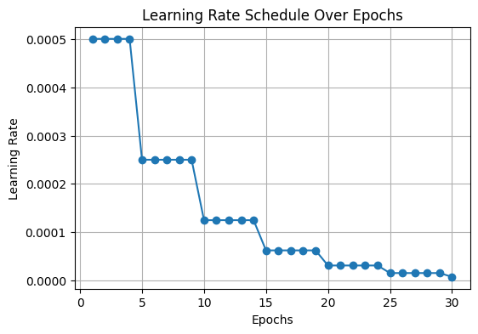
(Fig 7: Learning Rate Schedule over Epochs)

Limitations:
- Some reconstructed images exhibited blurriness due to the probabilistic nature of VAEs.
- Training requires careful balancing between KL divergence and reconstruction loss.
- Latent space disentanglement could be further improved.

Potential Improvements:
- Implement Beta-VAE for enhanced latent space disentanglement.
- Experiment with alternative prior distributions instead of Gaussian.
- Use adversarial training techniques for sharper image reconstruction.
- Extend the approach to larger datasets like CIFAR-10 for more complex feature learning.

9. Conclusion
This implementation of a Variational Autoencoder (VAE) on Fashion MNIST demonstrates the power of generative models in capturing meaningful latent representations. The trained model successfully reconstructed images, generated new samples, and visualized latent space clustering. Further optimizations, such as improved loss balancing and adversarial enhancements, can make VAEs even more robust for real-world applications.

