Sector Residual Reversion: An ETF-Hedged Residual Reversion Strategy in US Large-Cap Stocks
Nakul Pillai

1. Hypothesis Pitch
When a large US stock moves sharply for reasons specific to that company, rather than because its whole sector moved, part of that move should reverse the next day. This study tests whether the reversal is big enough to trade once costs are paid.
This informs the strategy. Each day, take every S&P 500 stock and remove the part of its return that its sector ETF explains. What is left is the residual. Divide the residual by its own recent volatility to get a z-score. Buy the stocks whose residual was unusually negative (z of -1 or lower), short the ones whose residual was unusually positive (z of +1 or higher), enter at the next open and exit at the open after that. Whatever sector exposure is left over is offset with a position in the sector ETFs, so the book is dollar-neutral and close to market-neutral.
Short-term reversal is one of the oldest documented effects in equities (Jegadeesh 1990; Lehmann 1990; verify both). Residual-reversal and ETF-hedged statistical arbitrage are discussed by, for example, Avellaneda and Lee (2010; verify). A standing concern is that the gross profits have shrunk and that trading costs absorb what is left (Nagel 2012, on liquidity provision; verify). This study does not claim a new idea. It tests an old one with free daily data, point-in-time index membership and a pre-registered, one-shot holdout, so that the answer can be trusted whichever way it points.
The mechanism is liquidity pressure. A move that follows from sector news is more likely to be information and so should stick. The leftover, stock-specific part is more likely to come from one-sided trading that pushes the price away from fair value for a day, and that part should revert. Splitting the move in two is the point of the strategy.
The parameters and the decision rule were locked in a written pre-registration before any data was downloaded. The in-sample period is 1 October 2018 to 31 December 2023 (1,321 trading days). The holdout is 1 January 2024 to 30 September 2026 (689 trading days) and was run once. The holdout calendar is the same as in my news-sentiment study, so the two could be combined later. The pre-registered prior was a result that I called "gross-only": a detectable effect before costs that does not survive costs. A null result was declared in advance to be a clean result.
What would prove this wrong, fixed in advance:
- H1a. In the holdout, the mean Fama-MacBeth coefficient of next-day residual on today's residual is not negative with a Newey-West (5 lags) t-statistic below -2. That would mean there is no reliable next-day reversal in residuals.
- H1b. In the holdout, the net Sharpe ratio at 5 basis points per side does not have a 95% bootstrap confidence interval entirely above zero, or the alpha against SPY does not have a t-statistic above 2. A reversal that exists but is smaller than the cost is not a strategy.

The hypothesis is SUPPORTED only if both H1a and H1b hold. It is GROSS-ONLY if H1a holds, the gross Sharpe interval is above zero, and H1b fails. Anything else is NOT SUPPORTED. I chose not to add an "inconclusive" verdict. Beating SPY on Sharpe is reported but is not a pass criterion, because a market-neutral book can trail a rising index even with real alpha.
Four design decisions were made before the build. I dropped a planned ETF-versus-basket negative control. I used point-in-time membership rather than today's holdings. I stayed with daily data, since an intraday study would be separate. And I shortened the holdout from 4.75 to 2.75 years, accepting lower power.

2. Data Pipeline
Universe. S&P 500 members at each date, across all 11 GICS sectors, each hedged against its SPDR sector ETF (XLK, XLF, XLE, XLV, XLY, XLP, XLI, XLB, XLU, XLRE and XLC). A stock needs a prior close of at least $5 to be eligible. The benchmark is SPY, and ^IRX is the risk-free proxy used only for benchmark excess returns.
Membership. Membership is rebuilt by starting from today's Wikipedia constituent list (503 tickers) and undoing the additions and removals in Wikipedia's change table, working backwards. The change table now sits on the "Historical components of the S&P 500" page rather than the page named in my spec, which is logged as a deviation. Five reconstruction issues are logged in a file and were not silently fixed.
Prices. Prices come from Yahoo Finance through yfinance with auto_adjust=False. Close is adjusted for splits but not for dividends, so the $5 filter can differ slightly from true traded prices. Returns use Adj Close, and open-to-open returns use an adjusted open computed as Open x AdjClose / Close. The data has no delisting returns.
Sample. Price data starts on 1 June 2018 as a warm-up. Signals start on 1 October 2018, because XLRE and XLC exist by then and the 2018 GICS restructuring makes sector labels cleaner. The raw prices were split into in-sample and holdout files at download. Every return and regression observation is stamped by its exit date, so the first holdout trades use signals from the last in-sample days, but no in-sample statistic uses a holdout price.
Coverage. Table 1 shows what share of point-in-time members could actually be traded each year. Stocks that were removed from the index (acquired, bankrupt or shrunk) often have no Yahoo prices and no sector label, so survivors are over-represented, most strongly early on.
Year | Avg. point-in-time members | With price data | With sector label | Usable for trading
2018 | 508.0 | 86.0% | 87.6% | 86.0% (below 90%)
2019 | 506.4 | 88.0% | 89.2% | 88.0% (below 90%)
2020 | 506.0 | 90.3% | 91.1% | 90.3%
2021 | 506.0 | 91.8% | 92.6% | 91.8%
2022 | 504.7 | 93.8% | 94.7% | 93.8%
2023 | 504.0 | 95.6% | 96.5% | 95.6%
2024 | 504.0 | 96.5% | 97.3% | 96.5%
2025 | 504.0 | 97.7% | 98.3% | 97.7%
2026 (to 30 Sep) | 504.0 | 99.0% | 99.6% | 99.0%
Table 1: Coverage by calendar year, average over sessions (coverage_by_year.csv). Holdout-year price coverage was filled in at Stage 3, after the lock.
In the in-sample window, 613 tickers were members. 532 had price data and 81 did not, and none had a missing sector label. Of the 157 in-sample members that are no longer in the index, 76 (48%) are usable, against 100% of the survivors. In the holdout window, 21 members had no downloadable prices (ANSS, AVB, CDAY, CMA, CTLT, CTRA, DAY, DFS, EA, FLT, HES, HOLX, IPG, JNPR, K, MRO, PXD, QRVO, SATS, WBA and WBD).
Price quality. There are no duplicate rows and no NaN or non-positive prices in either window. In sample there are 11 daily moves above 50% in absolute value, and in the holdout 20. None coincided with a split flag. All were kept as downloaded and nothing was winsorised. Eleven of the holdout rows belong to the ticker STI and three to SBNY, both former index members. STI's Yahoo prices start on 2022-05-02 although SunTrust left the index in December 2019, which suggests the ticker now belongs to a different company. SBNY (Signature Bank) left the index in March 2023 and has no in-sample prices. I checked the membership table: STI was a member only from 2018-06-01 to 2019-12-06 and SBNY only from 2021-12-20 to 2023-03-14, so for neither ticker do membership and prices overlap, and neither could be traded. I did not open the trade log itself. One holdout ticker (FISV) is missing one NYSE session.
Data limits, stated openly. The data is free, and Yahoo adjusted data can contain errors. Current sector labels are applied to the whole sample, so reclassifications are not tracked. Visa, Mastercard and PayPal were Information Technology until March 2023, and they are excluded in a robustness check. The reconstructed membership table may be incomplete.

3. Methodology
This section walks through the study in the order it was actually run, from the first decision to the final result, with counts where they exist. The full trading rules are in Section 4.1.

3.1 From the Idea to the Pre-registration
The first step was to write down the hypothesis, the decision rule, my prior and every parameter in a pre-registration file, before any data was downloaded. The windows were fixed at the same time: an in-sample period from October 2018 to December 2023, and a holdout from January 2024 to September 2026. From then on, any change had to be recorded as a dated deviation with a statement of whether it was made before or after any result was seen. The data layer was built behind a swappable DataProvider interface, so a Bloomberg or WRDS source can replace Yahoo and Wikipedia later without touching the signal or backtest code.

3.2 Collecting the Data and Building Membership
Stage 0 downloaded the raw Yahoo and Wikipedia data, cached it on disk and recorded file hashes in a manifest, so that every later run uses identical inputs. Prices were split into in-sample and holdout files at download, and the code refuses to load the holdout file unless a lock file exists. Membership was rebuilt from today's 503-ticker list backwards through the change table. Stage 0 ends with a coverage report (Table 1) and a data-quality report, which is where the STI and SBNY moves were found.

3.3 Building the Signal
For each stock and day, beta is a 60-day rolling regression slope of the stock on its sector ETF, using data only through the previous day, with at least 50 observations. The residual is the stock return minus beta times the ETF return. The signal z is the residual divided by its trailing 60-day standard deviation, again through the previous day. A stock is eligible on a date if it is an index member that day, closed at $5 or more, has a defined beta and z, and the date is on or after 1 October 2018. The rolling betas are computed with rolling sums rather than a regression per window, which is what makes the full panel cheap to compute.
In the holdout, 24.3% of eligible stock-days have an absolute z of 1 or more (Figure 1). The distribution has fat tails, so the plot clips at +/-8 and about 300 observations pile up at each edge.
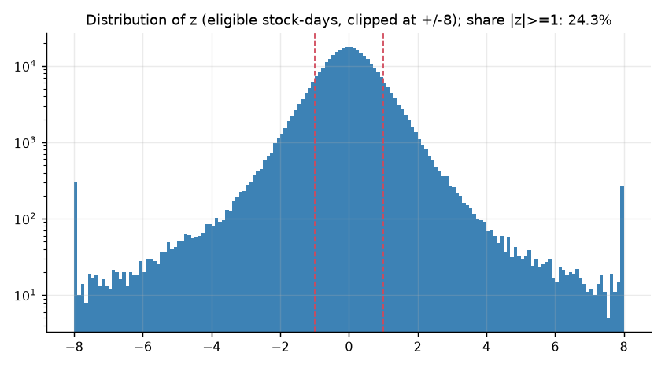
Figure 1: Distribution of the signal z over eligible stock-days in the holdout, clipped at +/-8 (log scale). Dashed lines mark the +/-1 trading thresholds.

3.4 Turning the Signal into Positions
Signals are read at the close of day t, trades are entered at the open of t+1 and closed at the open of t+2. Long and short legs each carry half of the gross book. The ETF hedge cancels the net sector beta of the stock positions. Profit and loss is charged at the exit date, and costs are charged on changes in target weights. If either leg is empty on a day, there is no position that day.

3.5 Testing the Code Before Looking at Any Return
Before any real return was looked at, the pipeline was tested on made-up data and with unit tests. The pipeline recovers a planted reversal, finds nothing in a null world, and finds nothing when each stock is hedged against a deliberately wrong ETF. All Stage 1 checks passed (200 simulations per world) before the in-sample analysis was allowed to run.
Check | Result | Passed
1a Planted AR(1) residual reversal (phi = -0.10): mean Fama-MacBeth coefficient within 0.02 of -0.10 | -0.0984 | Yes
1a Planted: mean gross daily return above 0 | 1.43e-03, positive in 100% of simulations | Yes
1b Null world (phi = 0): share of simulations with Fama-MacBeth |t| > 2 at most 10% | 3.0% | Yes
1b Null: share with net-Sharpe interval entirely above 0 at most 10% | 0.0% | Yes
1c Placebo on real in-sample data, each stock hedged against a random wrong ETF (20 shuffles): share flagged at most 10% | 0% (median FM t = -1.40, median net Sharpe = -1.60) | Yes
1d Unit tests, including look-ahead and cost tests | 13 passed | Yes
Table 2: Simulation validation (stage1_checks.csv).
In the planted world the mean gross Sharpe was 20.19 and the mean net Sharpe 7.39, with the gross interval above zero in 100% of simulations. In the null world the gross interval was above zero in 2.5% of simulations and the mean coefficient was about zero. There are two cautions. A planted Sharpe of about 20 shows how large a coefficient of -0.10 is in a frictionless daily panel of hundreds of names. Real effects will be far smaller, so these checks prove the code works, not that the real effect is detectable. And a wrong-ETF hedge still removes most market beta, so any generic short-term reversal would also appear in the placebo. The placebo's median gross Sharpe was 0.80, against 0.35 for the correct hedge in the in-sample primary result. I flag that and do not interpret it.

3.6 In-Sample Analysis and the Freeze
Stage 2 ran the in-sample analysis. It was used to inspect the design and was never used to change a pre-registered parameter. Once it was done, a freeze script hashed the configuration, the membership table and the data manifest into FREEZE.json, committed everything, and tagged the commit prereg-frozen.

3.7 Running the Holdout Once and Reporting Everything
Stage 3 was run once with a --confirm flag. It wrote HOLDOUT_LOCK, which is what unlocks the holdout prices, and it refuses to run twice. Every variant, period and cost level is reported, whatever it shows, and only the pre-registered rule decides the verdict. Table 3 shows how the universe narrows to positions, and Table 4 is the audit trail.
Step (holdout window) | Count
Point-in-time index members, average per session | about 504
Usable (prices and sector label available) | 96.5% in 2024, 97.7% in 2025, 99.0% in 2026
Eligible stock-days with |z| of 1 or more | 24.3%
Average names held per day | 59.6 long and 59.7 short
Sessions with a position | 688 of 689
Table 3: From index members to positions, holdout (coverage_by_year.csv, ho_strategy_tables.csv and the z-distribution figure).
Item | Evidence
Freeze | Git tag prereg-frozen on commit a531ca8, 2026-10-27 17:09:53 UTC. FREEZE.json holds SHA-256 hashes of config.yaml, membership.parquet and MANIFEST.json, and all three still match.
Lock | HOLDOUT_LOCK written at 17:10:02 UTC, referencing commit a531ca8.
Holdout outputs | Written 17:10:23 to 17:10:25 UTC, after the lock. Results commit 5c9180d at 17:11:58.
Config | config.yaml is unchanged between the freeze tag and the final commit.
In-sample files | Rewritten at 17:11 after the holdout, but byte-identical to the frozen versions.
Table 4: Audit trail (git log, file timestamps, FREEZE.json and HOLDOUT_LOCK). I cannot verify from files alone that holdout prices were not looked at before the freeze. The code prevents loading them without the lock, and Stage 0 split them off at download.

4. Strategy and Backtest

4.1 Strategy and Backtest Mechanics
Each stock's beta is a 60-day rolling OLS slope on its sector ETF through day t-1, with at least 50 observations. The regression is fitted with an intercept and the intercept is then dropped, so the residual is the return minus beta times the ETF return. The signal z is the residual divided by its trailing 60-day standard deviation through t-1.
The strategy goes long every stock with z of -1 or lower and short every stock with z of +1 or higher. The long and short legs each carry 0.5 of gross exposure, so the stock book is dollar-neutral. The ETF hedge in each sector is minus the sum of weight times beta over that sector's names. The signal is read at the close of day t, the trade is entered at the open of t+1 and exited at the open of t+2, so the holding period is one day and the book is rebuilt every day. A day on which either leg is empty has no position.
Costs are 5 basis points per side on stocks (with 2 and 10 basis points as sensitivities), 1 basis point per side on the ETF hedge, and a flat 50 basis points a year borrow on short notional, which is my own assumption. Costs are charged on changes in target weights, and drift inside the holding period is ignored. A held name with a missing price contributes a zero return.
Two timing variants are reported only as checks. close_close_lag is an alternative lag, and same_close enters at the very close that produced the signal, which cannot be traded, so it is an upper bound.

4.2 Results
Six measures are reported:
- Annual return and volatility: the average yearly return and the yearly standard deviation of daily returns.
- Sharpe ratio: mean daily return over its standard deviation, times the square root of 252, with flat days counted as zero and no risk-free subtraction because the book is dollar-neutral. The 95% interval is a stationary bootstrap with mean block length 10 and 10,000 resamples.
- Maximum drawdown: the worst peak-to-trough loss along the way.
- Alpha against SPY: the intercept of the daily strategy return on the SPY open-to-open return, annualised, with a Newey-West t-statistic using 5 lags.
- Hit rate: the share of active days with a positive net return.
- Breakeven cost: the cost per side at which net profit is zero.

Cumulative return, Sortino ratio and win rate are not reported, because they are not in the saved results and I did not estimate them by hand. Gross results are shown next to net results at 2, 5 and 10 basis points per side. The decision rule uses 5 basis points.

4.2.1 In Sample Comparison
In sample (1 October 2018 to 31 December 2023, 1,321 sessions, of which 1,302 held a position), the primary specification gives:
Primary spec (open-to-open, sector-ETF hedge, |z| of 1 or more, 1-day hold) | Ann. return | Ann. vol | Sharpe | 95% CI | Max drawdown | Alpha vs SPY (NW t)
Gross | 2.4% | 6.9% | 0.35 | (-0.48, 1.20) | -12.3% | 1.8% (0.64)
Net, 2 bp per side | -7.9% | 6.9% | -1.15 | (-2.00, -0.35) | -39.0% | -8.5% (-3.05)
Net, 5 bp per side | -21.0% | 6.9% | -3.05 | (-4.07, -2.15) | -67.4% | -21.6% (-7.78)
Net, 10 bp per side | -42.8% | 6.9% | -6.20 | (-7.70, -4.98) | -89.5% | -43.4% (-15.73)
Table 5: In-sample performance (is_strategy_tables.csv). Turnover 1.73x per day; average 56.7 longs and 57.9 shorts; breakeven cost 0.18 bp per side; hit rate 38.2% at 5 bp.
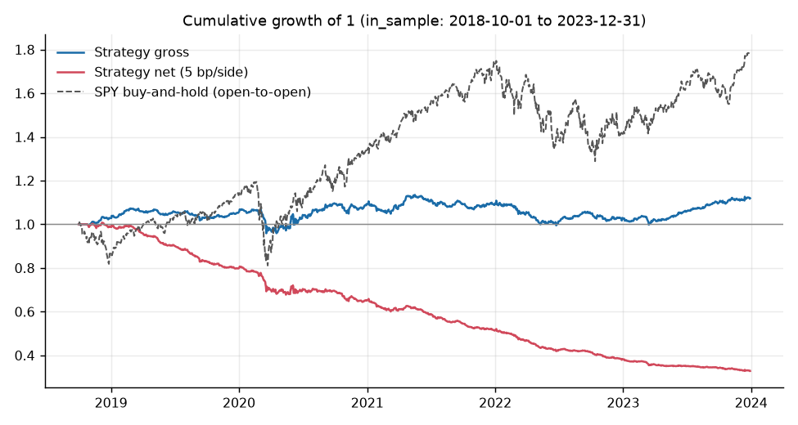
Figure 2: Cumulative growth of 1, in-sample: strategy gross, strategy net at 5 bp per side, and SPY buy-and-hold (open-to-open).
In sample the strategy earned 2.4% a year before costs and lost 21.0% a year after 5 basis points per side, a net Sharpe ratio of -3.05. The gross Sharpe of 0.35 has a confidence interval from -0.48 to 1.20, so it is not distinguishable from zero. The gross line in Figure 2 is close to flat and the net line falls steadily, which says that costs account for the loss. The smallest Sharpe ratio this in-sample window could detect is 0.86.
Against H1a, the Fama-MacBeth coefficient is -0.0069 with a Newey-West t-statistic of -1.43 over 1,303 days. The sign is as predicted but it is not significant at the pre-registered threshold. The in-sample result would have satisfied neither H1a nor H1b. Nineteen sessions were flat, which I read as the 50-day beta and 50-day z warm-up from 1 June 2018 delaying the first signals by about 17 sessions past the nominal start. That is my reading of the counts, not a logged fact. Sharpe minus SPY buy-and-hold was -3.61 (interval -4.82 to -2.62), which is reported but is not part of the rule.

4.2.2 Out of Sample Comparison
In the holdout (1 January 2024 to 30 September 2026, 689 sessions, of which 688 held a position), the primary specification gives:
Primary spec | Ann. return | Ann. vol | Sharpe | 95% CI | Max drawdown | Alpha vs SPY (NW t)
Gross | -1.5% | 6.3% | -0.24 | (-1.47, 0.96) | -14.4% | -2.1% (-0.53)
Net, 2 bp per side | -12.1% | 6.3% | -1.91 | (-3.14, -0.69) | -32.8% | -12.7% (-3.15)
Net, 5 bp per side | -25.5% | 6.3% | -4.02 | (-5.39, -2.75) | -52.2% | -26.0% (-6.50)
Net, 10 bp per side | -47.8% | 6.3% | -7.53 | (-9.22, -6.10) | -73.0% | -48.3% (-12.11)
Table 6: Holdout performance (ho_strategy_tables.csv). Turnover 1.77x per day; average 59.6 longs and 59.7 shorts; breakeven cost -0.71 bp per side; hit rate 36.9% at 5 bp. Beta to SPY is 0.029. The decision-metrics file reports the intervals as (-1.46, 1.01) gross and (-5.38, -2.75) net; I did not investigate why they differ slightly from this table, and neither changes the conclusion.
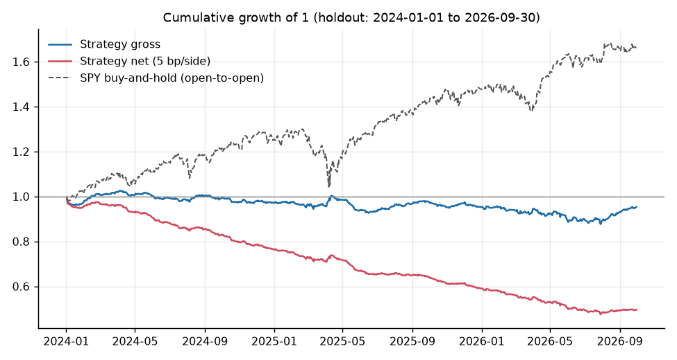
Figure 3: Cumulative growth of 1, holdout: strategy gross, strategy net at 5 bp per side, and SPY buy-and-hold (open-to-open).
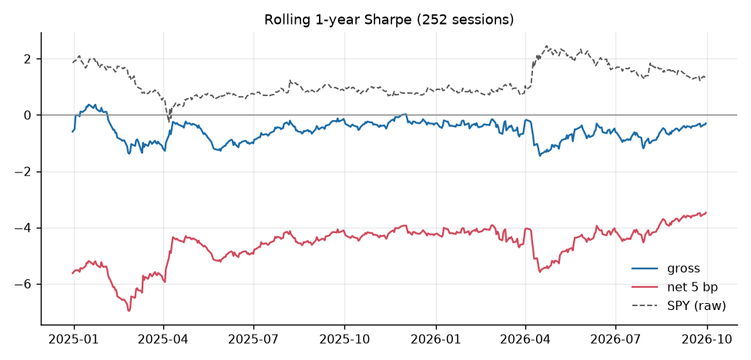
Figure 4: Rolling one-year (252-session) Sharpe ratio in the holdout: gross, net at 5 bp per side, and raw SPY.
The holdout was run once, after the freeze. The strategy lost money at every cost level tested, and even before costs it did not earn a positive return: -1.5% a year, with a Sharpe of -0.24 and an interval from about -1.5 to 1.0. The net Sharpe at 5 basis points was -4.02. SPY buy-and-hold had a Sharpe of 0.98 over the same window, and an equal-weight basket of the 11 sector ETFs 0.79. Figures 3 and 4 show the gross line drifting slightly below 1 and the net line falling steadily while SPY rises. The rolling one-year net Sharpe never gets close to zero.
The alpha against SPY is -26.0% a year with a t-statistic of -6.50 and a beta of 0.029. It is negative because costs drag on a market-neutral book, not because of a bet against the market. Sharpe minus SPY buy-and-hold was -5.00 (paired-bootstrap interval -6.95 to -3.21). The smallest Sharpe ratio this 2.75-year holdout could detect is 1.19.
Decision rule. The pre-registered rule applied to the holdout gives NOT SUPPORTED:
Condition | Holdout value | Met?
H1a: Fama-MacBeth mean coefficient negative and Newey-West t below -2 | -0.0040, t = -0.66 | No
H1b(i): net Sharpe at 5 bp, bootstrap interval entirely above 0 | -4.02, interval (-5.38, -2.75) | No
H1b(ii): alpha vs SPY with t above 2 | -26.0% a year, t = -6.50 | No
GROSS-ONLY needs H1a plus gross Sharpe interval above 0 | H1a fails; gross interval (-1.46, 1.01) | No
Table 7: Decision rule applied to the holdout (ho_decision_metrics.json).
In one sentence: the strategy lost money after costs in both periods and, unlike my prior, it did not even show a detectable effect before costs.

5. Methodology Defence

5.1 Pre-registered Parameters
The parameters were written down on 27 October 2026, before any data was downloaded. Any later change is a dated deviation and not a silent edit. Four deviations were logged, all dated 27 October 2026. None changed a pre-registered parameter or the decision rule, and config.yaml is byte-identical between the freeze tag and the final commit.
Parameter | Locked value
Universe | S&P 500 members at each date (point-in-time), 11 GICS sectors
Hedge | Own sector SPDR ETF (stocks); sector ETFs for the net hedge
Beta window | 60 trading days, minimum 50, through t-1
z-score window | 60 trading days of residuals, minimum 50, through t-1
Signal thresholds | Long z of -1 or lower, short z of +1 or higher
Legs | 0.5 gross each (dollar-neutral)
Minimum price | $5 on the prior close
Timing | Signal at close t, enter open t+1, exit open t+2
Costs | 5 bp per side on stocks (2 and 10 as sensitivities), 1 bp on ETFs, 50 bp a year borrow
Inference | Fama-MacBeth with Newey-West (5 lags); stationary bootstrap, mean block 10, 10,000 resamples, 95%
Windows | In sample 2018-10-01 to 2023-12-31; holdout 2024-01-01 to 2026-09-30, run once
Random seed | 20240601
Decision rule | SUPPORTED, GROSS-ONLY or NOT SUPPORTED, as in Section 1
Table 8: Locked parameters (config.yaml).
Date | Deviation | When made | Effect
2026-10-27 | The S&P 500 changes table moved from the page named in my spec to "Historical components of the S&P 500". The method is unchanged. | Before Stage 1 | None on any estimate; logged for transparency
2026-10-27 | Ten implementation interpretations where the spec was silent. Examples: beta is fitted with an intercept that is then dropped; P&L is stamped by exit date; weights are targets and drift is ignored; a missing price contributes zero return. | Before any signal was computed | Part of the pre-registration; no parameter change
2026-10-27 | The per-sector Fama-MacBeth table needed a minimum cross-section of 10 names instead of 20, because Communication Services had zero usable days and Energy 369. The overall regression that enters H1a still uses 20. | During Stage 2, before the freeze | Exploratory per-sector table only; primary results identical on re-run
2026-10-27 | The wording of the empty-leg diagnostic in the results pack was corrected after the holdout, because it counted days over the whole sample, not just the holdout. | After Stage 3 | Wording only; no number or verdict changed; nothing was re-run
Table 9: Dated deviations (DEVIATIONS.md, summarised).

5.2 Testing the Mechanism
The primary test regresses the next-day residual on today's residual each day, takes the mean slope across days (Fama-MacBeth), and reports the Newey-West t-statistic with 5 lags. A negative coefficient means reversal. For reference, the validation world with a planted reversal of -0.10 returned -0.0984.
Period | Mean coefficient | Newey-West t | Secondary (open-to-open) coefficient
In sample | -0.0069 | -1.43 | -0.010 (t = -2.04)
Holdout | -0.0040 | -0.66 | +0.005 (t = +0.83)
Table 10: Fama-MacBeth test of residual reversal. The holdout primary row decides H1a. The secondary regression uses the tradable open-to-open residual and is not part of the rule.
The holdout coefficient is negative, as hypothesised, but it is about one twenty-fifth of the planted effect and indistinguishable from zero (Newey-West standard error 0.006, 689 days). The tradable secondary regression has the wrong sign in the holdout. The timing variants agree: the close_close_lag gross Sharpe is 0.19 in the holdout (interval -0.86 to 1.25) and the non-tradable same_close upper bound is 0.13 (interval -1.08 to 1.37). In sample the same two variants were -0.07 and 0.49 (interval -0.28 to 1.31). None differs from zero, so the mechanism is not visible at this horizon in this data. The holdout was also split in two: the gross Sharpe was -0.44 in the first half (2024-01-02 to 2025-05-15) and -0.08 in the second, and neither interval excludes zero.

5.3 Threshold Sensitivity
The threshold of 1 and the one-day hold were fixed in advance, so the other settings are exploratory checks of whether the verdict depends on that choice. They were never used to choose anything. Because many comparisons are made, a few will look better by chance.
Variant (holdout, 5 bp per side) | Gross Sharpe | Net Sharpe
Threshold 0.5 | 0.13 | -4.07
Primary (threshold 1.0) | -0.24 | -4.02
Threshold 1.5 | -0.16 | -3.26
Threshold 2.0 | 0.26 | -2.04
Hold 2 days (overlapping sleeves) | -0.22 | -2.91
Hold 3 days | 0.10 | -2.05
Hold 5 days | 0.14 | -1.49
Continuous weights (-z clipped at +/-3) | 0.10 | -3.79
Excluding |z| above 4 | -0.29 | -4.13
Table 11: Exploratory holdout variants. Every gross interval includes zero. Longer holds and higher thresholds cut turnover and shrink the cost drag, but no variant produces a positive net Sharpe.
The verdict does not depend on the thresholds or the holding period. The least bad net result is the five-day hold at -1.49, which is still a loss and rests on a gross Sharpe of 0.14 that is not distinguishable from zero.

5.4 Hedge Choice
The sector-ETF hedge was chosen in advance because the signal is a sector residual, so the same ETF that defines the residual should also take out the leftover exposure. Four robustness variants were pre-registered and none of them is part of the decision rule.
Variant (holdout) | Gross Sharpe (95% CI) | Net Sharpe at 5 bp (95% CI)
Primary (sector-ETF hedge) | -0.24 (-1.47, 0.96) | -4.02 (-5.39, -2.75)
(i) SPY-only hedge | 0.04 (-1.05, 1.13) | -2.77 (-4.04, -1.62)
(ii) Excluding Visa, Mastercard, PayPal | -0.29 (-1.50, 0.93) | -4.00 (-5.36, -2.77)
(iii) Excluding the 10 largest names by 60-day average dollar volume | -0.21 (-1.43, 1.06) | -4.01 (-5.39, -2.73)
Unhedged signal (stock book only, no ETF leg) | -0.22 (-1.34, 0.89) | -3.53 (-4.71, -2.43)
Table 12: Holdout robustness (results_pack.md). Excluding the mechanically self-hedged mega caps does not rescue the result.
The hedge choice matters little. A SPY-only hedge gives a better net Sharpe (-2.77), which I did not investigate, and its gross interval still includes zero. Dropping the ETF leg altogether, or removing the ten largest names, which are partly their own sector ETF, leaves the picture unchanged. For reference, SPY buy-and-hold had a Sharpe of 0.98 over the holdout (interval 0.00 to 2.18) on excess returns.

6. Pitfall Checklist

6.1 Look-ahead Bias
Beta and the z-score denominator at day t use data only through day t-1, and a unit test checks exactly that. A second test changes all data after a date and confirms that profit and loss up to that date does not move. Signals are read at the close and traded at the next open, and every return observation is stamped by its exit date. The holdout prices cannot be loaded unless the lock file exists, and a further test checks that. Two caveats remain. Betas are estimated on close-to-close returns but applied to open-to-open holds, and the ETF hedge uses the same betas, so there is a timing mismatch in the hedge, not in the signal. And I cannot verify from the files alone that holdout prices were not looked at before the freeze.

6.2 Survivorship Bias
Survivorship bias is reduced but not eliminated. Membership is point in time, so removed stocks do enter the universe when they were members. But removed stocks have weaker free-price coverage and no sector label: usable coverage was 86.0% in 2018 and 88.0% in 2019, both below my 90% flag, rising to 99.0% by 2026. In sample, only 48% of the 157 removed members are usable, against 100% of the survivors, so the tested universe over-represents survivors, most strongly early on. There are no delisting returns, so a stock that was removed because it collapsed has no final loss. The effect on a market-neutral reversal book is unclear in sign, and since the holdout result is a null, I do not expect it to change the verdict. At least one former member (STI) has Yahoo prices that look like they belong to another company, and neither STI nor SBNY could have been traded because membership and prices never overlap.

6.3 Overfitting/ Data Snooping
The threshold, the windows, the costs and the decision rule were fixed before any data was seen. The code was tested on simulated data before it was allowed to see real returns, and the real holdout was run once with no code change. The in-sample period was used to examine the design and never to change a parameter. The exploratory variants in Sections 5.3 and 5.4 are labelled as such and were not used to choose anything.
The per-sector results are the clearest case of multiple comparisons. Only one of the 11 sectors shows a gross Sharpe interval entirely above zero in the holdout: Utilities (gross Sharpe 1.46, interval 0.12 to 2.77; net at 5 basis points 0.11, interval -1.18 to 1.36; Fama-MacBeth t = -1.77). With 11 sectors and several tests, one such result is what chance alone would produce, and the net result is not different from zero. In sample, Materials (gross Sharpe 1.24; Fama-MacBeth t = -3.2) and Industrials (t = -3.1) stood out, and neither held up in the holdout (Materials gross Sharpe -0.42, t = -0.34; Industrials t = -1.08). Financials has a holdout t of -2.22 with a gross interval that includes zero. I draw no conclusion from any of these and do not propose a sector-specific follow-up on their strength.

6.4 Transaction Costs/Slippage
Costs decide this result. The book turns over about 1.77 times per day (about 446 times a year), so at 5 basis points per side the cost drag is roughly 22% a year (my arithmetic: 5 bp x 1.77 x 252). The breakeven cost per side, the cost at which net profit is zero, was 0.18 basis points in sample and -0.71 in the holdout. A negative breakeven means the strategy lost money even with free trading. At 2 basis points per side, which is optimistic for large caps at the open, the holdout net Sharpe is still -1.91.
Cost per side | In-sample net Sharpe | Holdout net Sharpe
0 bp (gross) | 0.35 | -0.24
2 bp | -1.15 | -1.91
5 bp (decision rule) | -3.05 | -4.02
10 bp | -6.20 | -7.53
Table 13: Net Sharpe ratio by cost level and period (is_strategy_tables.csv, ho_strategy_tables.csv).
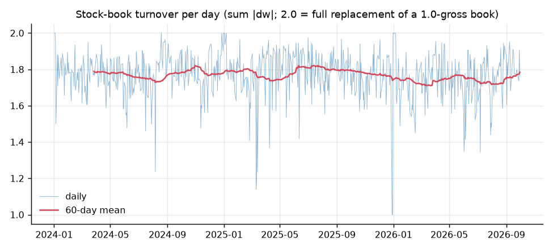
Figure 5: Daily turnover of the stock book in the holdout (sum of absolute weight changes; 2.0 is a full replacement of a 1.0-gross book), with the 60-day mean.
Figure 5 shows that turnover is steady, with a 60-day average between roughly 1.7 and 1.8 throughout the holdout. The cost assumptions are also simple. Fills are assumed at the open price, which real trades would not match. Borrow is a flat 50 basis points a year on all shorts, which is my assumption and is much too low for hard-to-borrow names. There is no market impact and no capacity estimate. The ETF leg turns over about 0.51 per day on its own at 1 basis point per side.

6.5 Out-of-Sample Validation
The holdout (January 2024 to September 2026) was run once, after the freeze, and it gave the same answer as in sample, only weaker: a coefficient of -0.0040 (t = -0.66) against -0.0069 in sample, a gross Sharpe near zero in both, and a net Sharpe far below zero. Nothing from the holdout was used to design or change anything. The sectors that stood out in sample did not hold up in the holdout. The main limit is power. A holdout of about 2.75 years can only detect a Sharpe ratio of 1.19 or more, so a modest real gross edge could have been missed. The honest reading is that no effect was detected and the cost failure is clear, not that no effect exists.

Empty legs and missing prices
One empty-leg day (no long leg, so no trade) fell in the holdout, and the count of position-days with a missing price was zero. In the in-sample period no empty-leg days occurred. A held name with a missing price would have contributed a zero return, and no delisting returns exist, so a stock that disappears would not show a final loss.

7. Efficiency Touchpoint
Efficiency here means how much it costs, in time and in data access, to run the strategy, and how fast it needs to react. Run times were not recorded in the results files, so I give only what I can support. The 13 simulation unit tests took 2.96 seconds in total. File timestamps from the run day show the holdout outputs written about 23 seconds after the lock file, but that includes writing the results, so it is not a measured runtime. The Stage 0 data files were written between 16:57 and 17:00 on the same day, so the download and membership build took a few minutes. The rolling betas are computed with rolling sums, so the cost grows roughly with the number of stock-days, and the in-sample price file holds about 806 thousand rows.
Data access is the cheaper part. The whole study runs on free Yahoo and Wikipedia data, cached on disk, with every raw file hashed in a manifest. A paid, survivorship-free source would improve coverage, and the provider interface is built so that Bloomberg or WRDS can replace the free source without touching the signal or backtest code. That re-run is postponed, not done.
The real efficiency question is trading, not computing. The signal is read at the close and traded at the next open, so no fast execution is needed. But the book turns over about 1.77 times per day across about 120 positions, so every day involves a lot of small trades, and the cost of that is what sinks the strategy. A longer holding period would cut turnover, but in the exploratory results even a five-day hold did not turn a net profit.

8. Risk Touchpoint
The strategy is designed to carry little market risk. In the holdout its beta to SPY was 0.029 and its annualised volatility was 6.3% (6.9% in sample). It holds about 60 longs and 60 shorts on an average day, and the ETF leg removes leftover sector exposure.
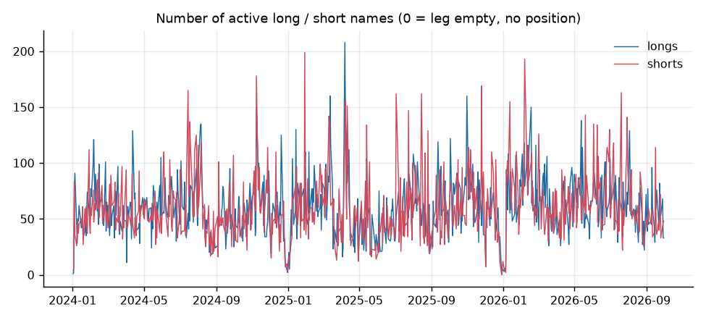
Figure 6: Number of active long and short names per day in the holdout. A reading of zero means the leg was empty and there was no position.
The number of names changes a lot from day to day. In the holdout it ranges from a few names to about 200 on a single day, and it drops to near zero on a few days, at the start of the window and around the turn of 2026 (Figure 6). A day with few names concentrates the book in a few stocks and gives up diversification. In the holdout only one day had no position at all.
The large drawdowns come from costs, not from shocks. The holdout maximum drawdown was -14.4% before costs and -52.2% after 5 basis points per side, and in sample -12.3% and -67.4%. The gross figure is the one that measures risk from the signal itself. I could not report the worst single-day loss, because daily profit and loss is not saved in the results files, so that is a gap in this report.
Several risks are not captured. Shorting costs and availability are ignored beyond a flat 50 basis points a year, and a crowded reversal book can be hit by short squeezes and by sharp unwinds when many funds hold the same trade. A stock gaps overnight before it can be traded. Fills at the open are idealised. A bad price from the free data source could produce a false signal: 11 in-sample and 20 holdout daily moves above 50% were kept as downloaded. And the findings come from one region, one index and one market regime, so they may not generalise.

9. Reflection
The hypothesis is not supported. The reversal coefficient was -0.0040 (t = -0.66), the gross Sharpe ratio was -0.24 with an interval that includes zero, and the net Sharpe at 5 basis points was -4.02, so none of the conditions in the decision rule was met. The sign of the coefficient is the one the hypothesis predicts, but its size is about one twenty-fifth of what the pipeline recovers in a simulated world.
The result is weaker than my pre-registered prior. I expected a detectable effect before costs that costs would then erase. The data did not give even that. The strategy fails on cost before it fails on signal, because it turns over about 1.77 times of its book every day, and the breakeven cost was 0.18 basis points in sample and -0.71 in the holdout. Because the holdout can only detect a Sharpe of about 1.19 or more, I cannot rule out a small gross effect. The evidence is against a tradable edge at this horizon, at this cost level and in this data. It is not proof that no residual reversal exists.
The pipeline itself is a result. It recovers a planted effect, stays quiet in a null world and under a deliberately wrong hedge, and the audit trail from freeze to a one-shot holdout is intact. Later strategies in the lab can reuse it. There are no leads worth carrying forward. The Utilities result and the five-day hold are exploratory outputs from many comparisons, neither survives costs, and acting on either would be data snooping.
If I did this again, I would change the question rather than rescue this one. Some extensions I would add:
- Realistic execution: an intraday execution check of the open fills, with a spread and market-impact model, and a borrow-cost model by stock instead of a flat 50 basis points.
- Better data: a re-run on a survivorship-free source such as Bloomberg or WRDS, with delisting returns and historical sector classifications, to remove the biggest data limits.
- Lower turnover: a separate, pre-registered study of longer holds or a stronger threshold, treated as a new hypothesis on a new holdout, not a tweak to this one.
- Combination with other signals: testing whether a residual-reversal signal adds anything on top of my news-sentiment work, on the shared holdout calendar.
- Longer sample: a longer holdout, which would raise the power above a minimum detectable Sharpe of 1.19.

The result is reported as a clean negative, with the same weight as a successful one.

References
- Avellaneda, M. and Lee, J.-H. (2010). Statistical arbitrage in the US equities market. Quantitative Finance, 10(7). [verify details]
- Fama, E. and MacBeth, J. (1973). Risk, return, and equilibrium: empirical tests. Journal of Political Economy, 81(3). [verify details]
- Jegadeesh, N. (1990). Evidence of predictable behavior of security returns. Journal of Finance, 45(3). [verify details]
- Lehmann, B. (1990). Fads, martingales, and market efficiency. Quarterly Journal of Economics, 105(1). [verify details]
- Nagel, S. (2012). Evaporating liquidity. Review of Financial Studies, 25(7). [verify details]
- Newey, W. and West, K. (1987). A simple, positive semi-definite, heteroskedasticity and autocorrelation consistent covariance matrix. Econometrica, 55(3). [verify details]
- Politis, D. and Romano, J. (1994). The stationary bootstrap. Journal of the American Statistical Association, 89(428). [verify details]
- Wikipedia. List of S&P 500 companies and Historical components of the S&P 500 (accessed October 2026).
- Yahoo Finance via yfinance. Daily price data (accessed October 2026).

