**ASSIGNMENT 1 (MODULE 1)**

1)What is software? What is software engineering?

***=> Software :***

- Software is a collection of programs and data that instruct a computer on how to perform specific tasks.

***=> Software Engineering :***

- Software engineering is the disciplined process of designing, developing, testing, and maintaining software systems to meet user needs.

2) Explain types of software.

1. System Software

e. g notepad, clock, calc, calender

2. Application Software

e.g whats app, instagram, LinkedIn, Pinterest

3. Driver software

4. Programming Software

e. g compiler, interpreter, assembler

🡪System Software :

System software is designed to manage and control computer hardware and provide a platform for running application software.

🡪Application Software :

Application software is designed to help users perform specific tasks or activities, such as word processing, web browsing, or gaming.

🡪Driver Software :

Driver software enables communication between the operating system and hardware devices, allowing them to function properly.

🡪Programming Sotware :

Programming software provides tools and environments for developers to write, test, and debug code, such as compilers and integrated development environments (IDEs).

3) What is SDLC? Explain each phase of SDLC.

🡪SDLC :

The Software Development Life Cycle (SDLC) is a structured process that outlines the stages involved in the development of software, including planning, designing, coding, testing, deployment, and maintenance.

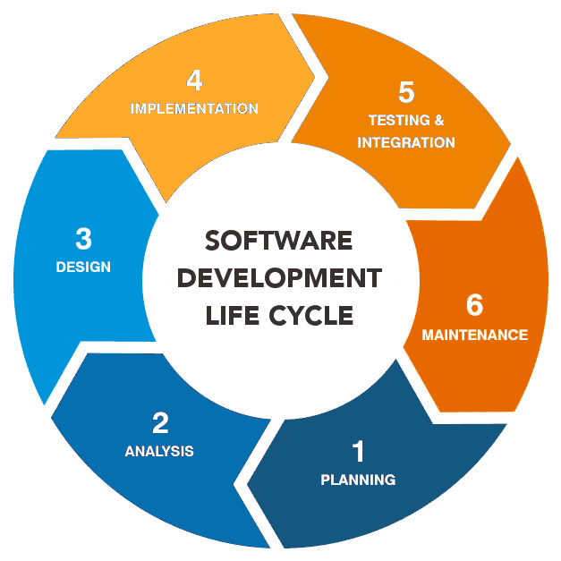

🡪 **Planning :**

* Define the purpose, goals, and scope of the project.
* Identify project feasibility (technical, operational, financial).
* Develop a project plan and allocate resources.

🡪 **Analysis :**

* Gather and document user and system requirements.
* Identify functional and non-functional needs.
* Create a Requirements Specification document.

🡪 **Design :**

* Plan the system architecture, user interfaces, data flow, and technical details.
* Develop models like flowcharts, diagrams, and pseudo-code.
* Create a Design Specification Document.

🡪 **Development (Implementation) :**

* Write the actual code based on the design specifications.
* Follow coding standards, use version control, and perform peer reviews.

🡪 **Testing :**

* Test the software for bugs, defects, and performance issues.
* Conduct unit, integration, system, and acceptance testing.
* Ensure the software meets requirements.

🡪**Deployment :**

* Release the software to a live environment.
* Perform installation, configuration, and initial support.
* Ensure the system works as expected in real-world conditions.

🡪**Maintenance :**

* Provide updates, bug fixes, and enhancements.
* Monitor system performance and resolve user-reported issues.
* Adapt the software to changing requirements or environments.

4)What is DFD? Create a DFD diagram on Flipkart .

- A Data Flow Diagram (DFD) is a visual representation of how data flows within a system. It depicts processes, data stores, external entities, and data movement.

-Components of DFD :

1. External Entities

2. Processes

3. Data Stores

4. Arrow

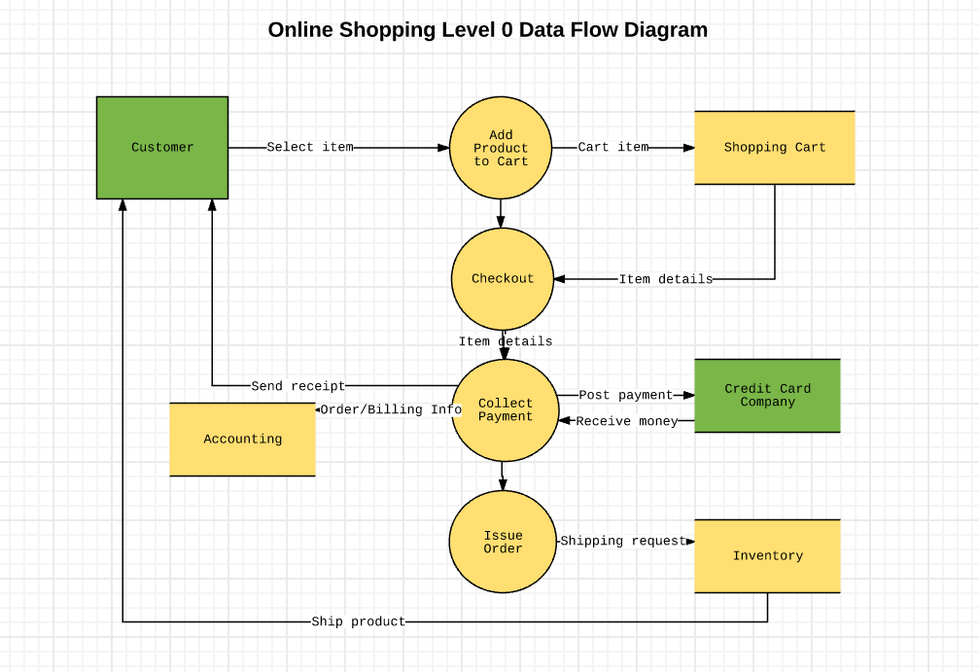

5) What is Flow chart? Create a flowchart to make addition of two

numbers .

- A flowchart is a graphical representation of a process, showing the sequence of steps or decisions required to complete a task.

-Components of Flowchart :

1. Start / End

2. Processes

3. Decisions

4. Arrows

5. Input / Output

*🡪 Flowchart to make addition of two numbers :*

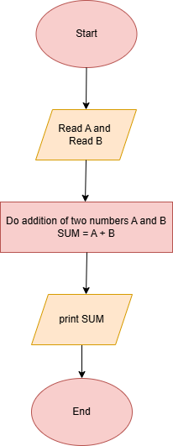

6) What is Use case Diagram? Create a use-case on bill payment on paytm.

- A Use Case Diagram is a visual representation of the interactions between users (actors) and a system. It illustrates what the system does from a user's perspective, focusing on functionality rather than technical details.

*🡪 Use-case on bill payment on paytm :*

