UNIBRIDGE
A Centralized Student Management System

Acknowledgement
I would like to express my sincere gratitude to my mentors, faculty members, and everyone who provided guidance and support throughout the development of this project. Their valuable suggestions and encouragement helped me successfully complete this work. I am also thankful for the learning resources and documentation that enhanced my understanding of ReactJS, Spring Boot, MongoDB, Swagger, and Postman.

Project Overview
UniBridge is a centralized student management system developed using ReactJS, Spring Boot, and MongoDB. The application provides modules for Student Management, Department Management, Course Management, Enrollment Management, and Dashboard Analytics. The system simplifies academic administration by offering a user-friendly interface and RESTful APIs for data management.

Objectives
- Manage students, departments, and courses in a centralized platform.
- Implement CRUD operations for academic records.
- Establish relationships between students, departments, and courses.
- Provide RESTful APIs using Spring Boot.
- Store and retrieve data efficiently using MongoDB.
- Improve accessibility, scalability, and maintainability.

Tools and Technologies
Frontend: ReactJS, Bootstrap, React Router
Backend: Spring Boot, Java
Database: MongoDB, MongoDB Compass
API Testing: Swagger UI, Postman
Build Tool: Maven
IDE: VS Code
Version Control: Git & GitHub

Modules
- Student Management – Add, update, delete, and view student records.
- Department Management – Manage departments and department codes.
- Course Management – Maintain course information.
- Enrollment Management – Assign courses to students.
- Dashboard – Display statistics for students, departments, and courses.

Project Screenshots

Dashboard Module
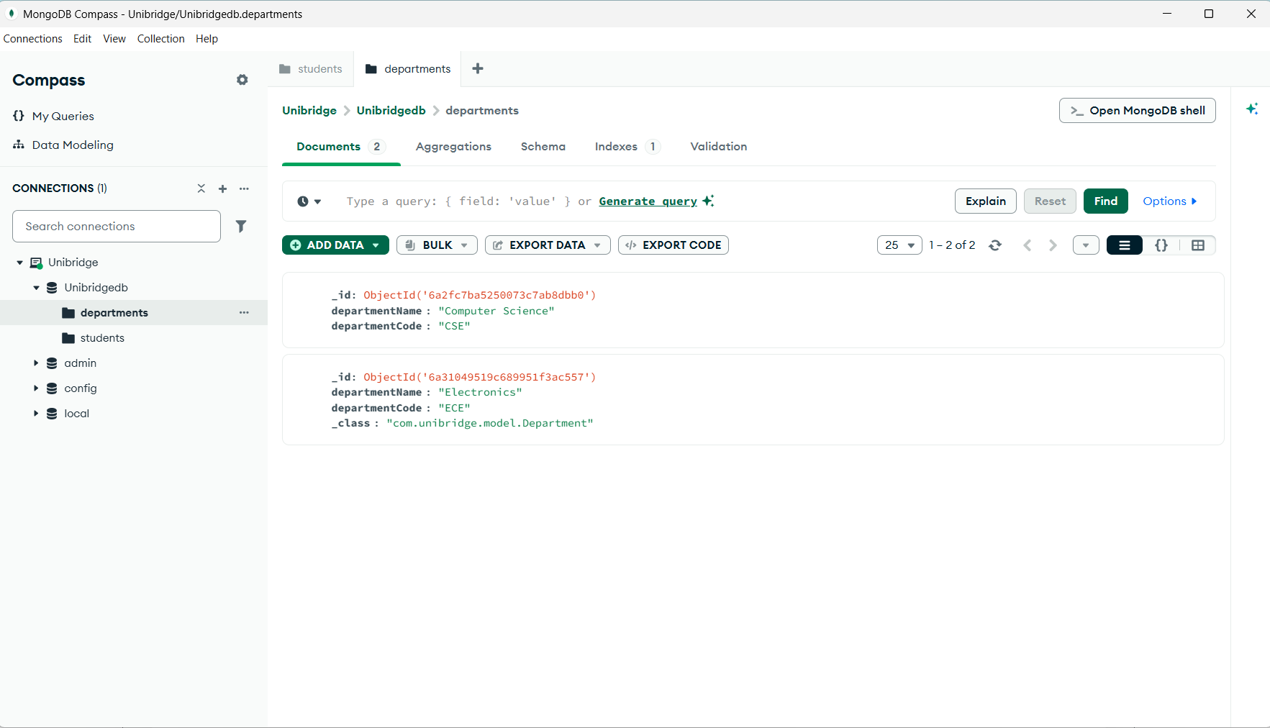
This screenshot displays the MongoDB database used by the UniBridge system. The database contains collections such as Students, Courses, Departments, and Enrollments. MongoDB Compass is used to manage and visualize stored documents, ensuring efficient data storage and retrieval for the application.

Course Management Module
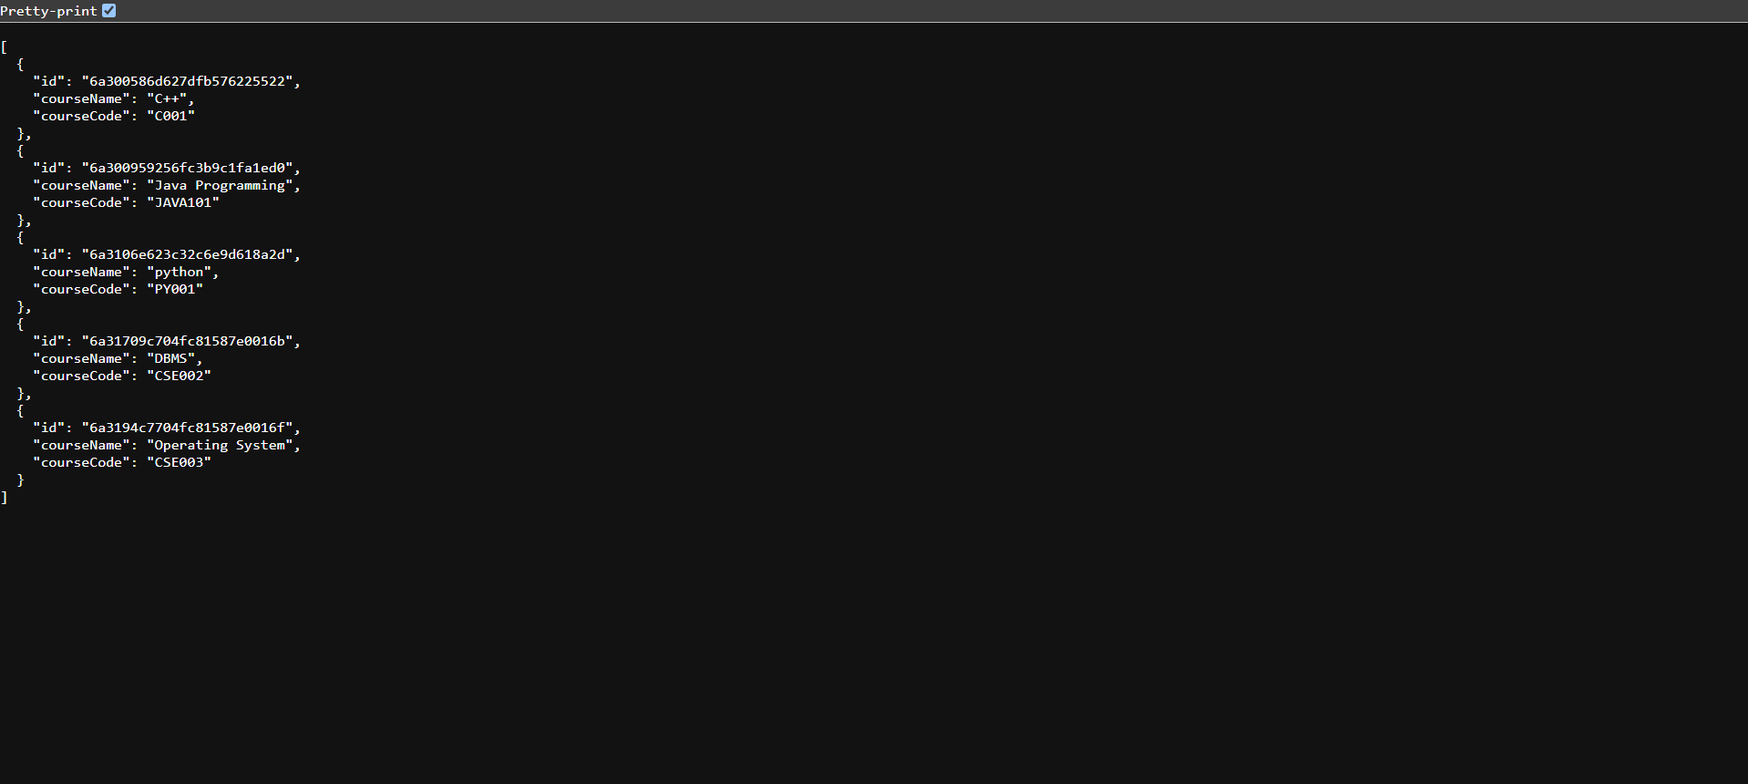
This screenshot shows the Course collection where course details such as course name and course code are stored. The collection supports backend API operations and dynamic frontend rendering through the ReactJS interface.

Department Management Module
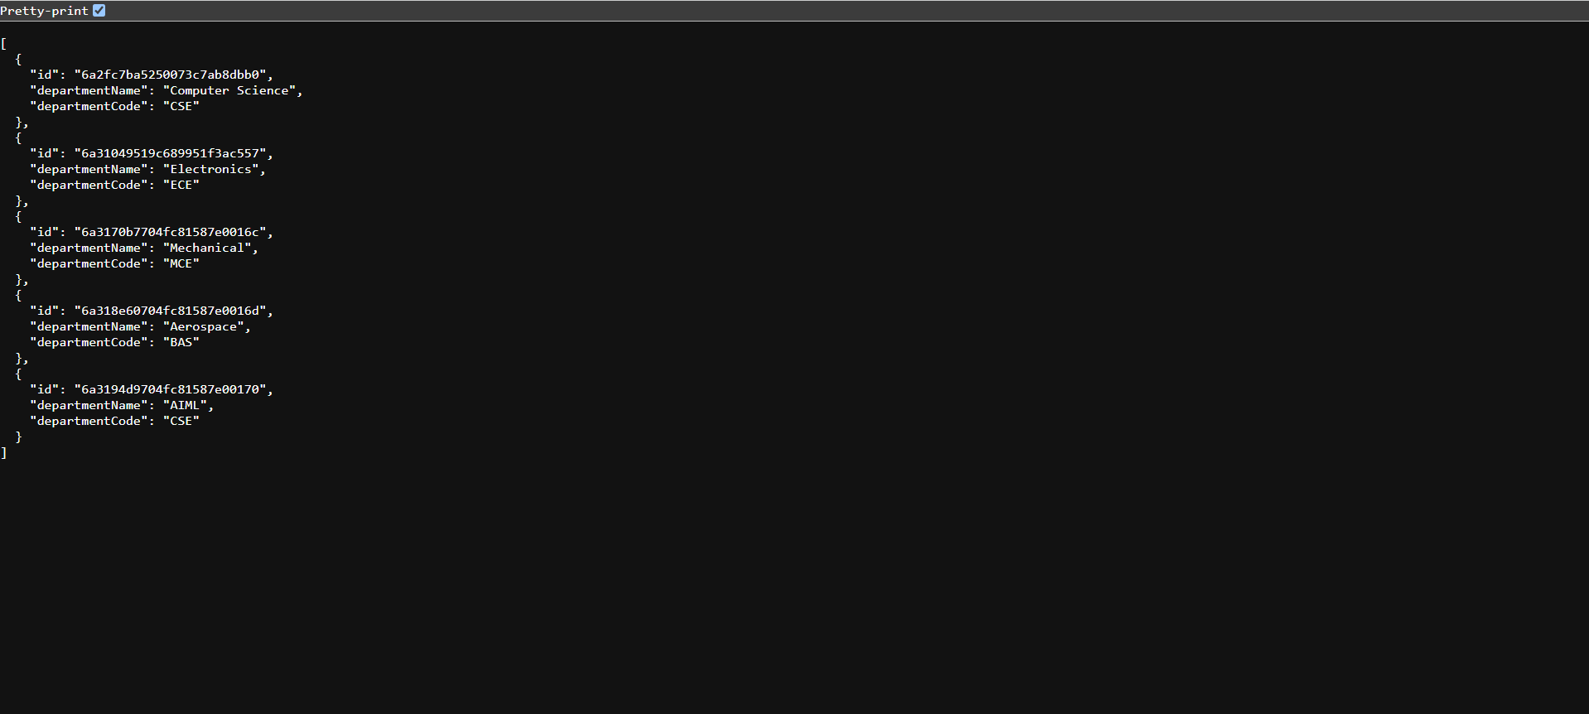
This screenshot displays the Department collection containing academic department information including department names and department codes. It helps maintain relationships between students, courses, and departments.

Enrollment Module
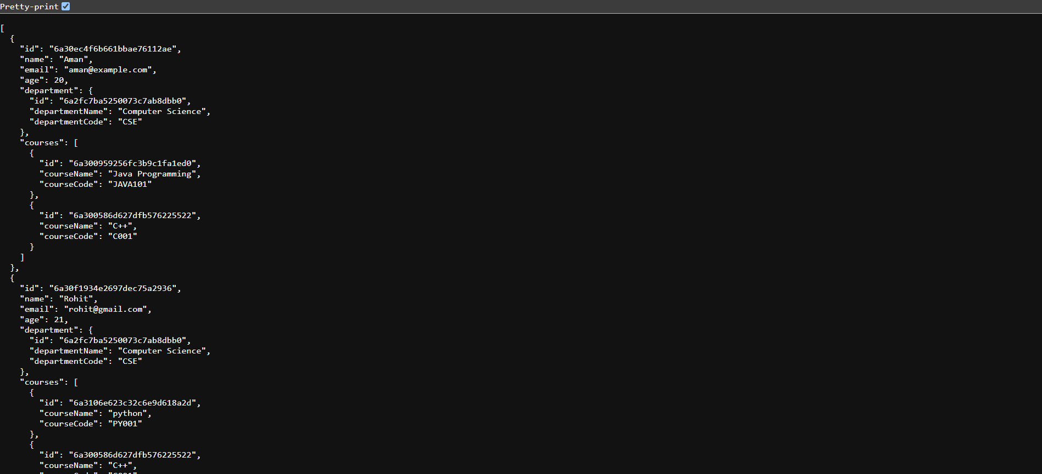
This screenshot shows the Enrollment collection which records the relationship between students and courses. It enables course registration tracking and academic record management.

MongoDB Database
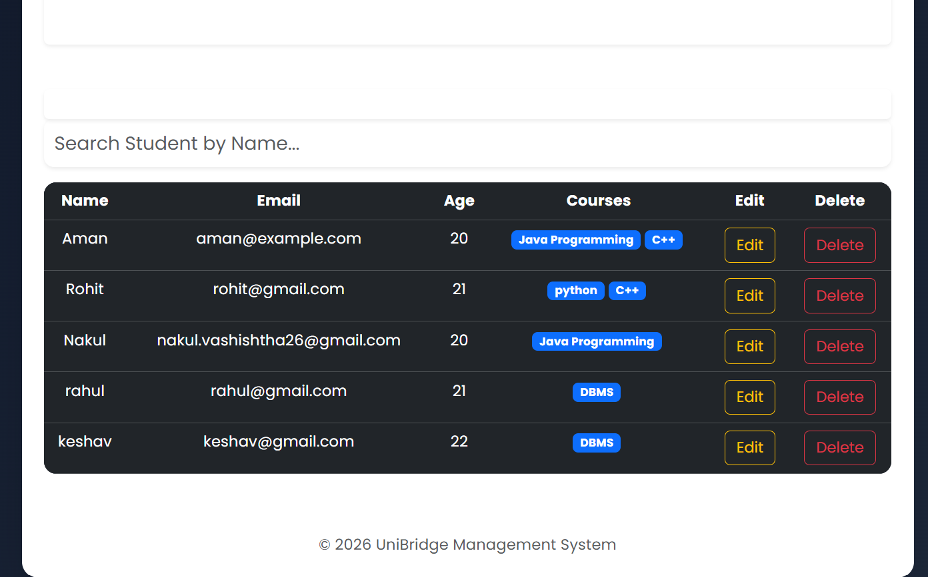
This screenshot presents the Student Management module where administrators can add, update, delete, and view student information. The interface demonstrates successful integration between ReactJS, Spring Boot, and MongoDB.

Students API Response
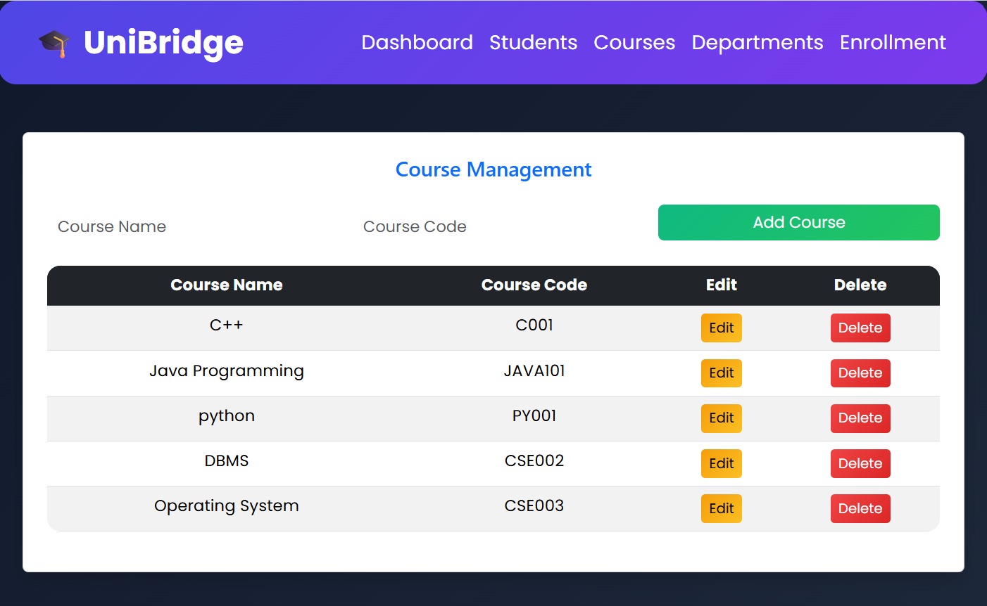
This screenshot displays the Course Management interface. Administrators can manage course records through CRUD operations while data is synchronized with MongoDB using RESTful APIs.

Departments API Response
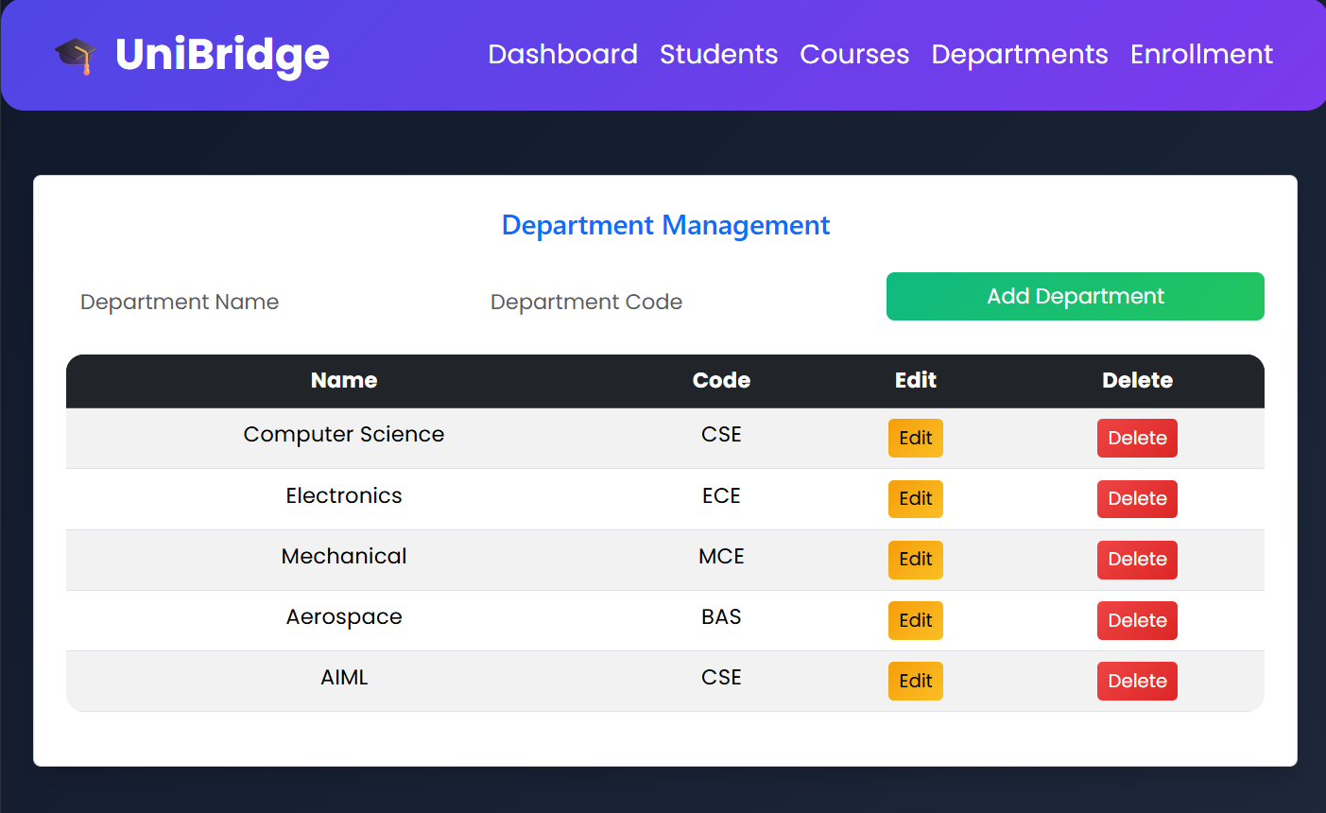
This screenshot illustrates the Department Management interface used to maintain department records. Users can add, edit, and delete department information through a user-friendly dashboard.

Courses API Response
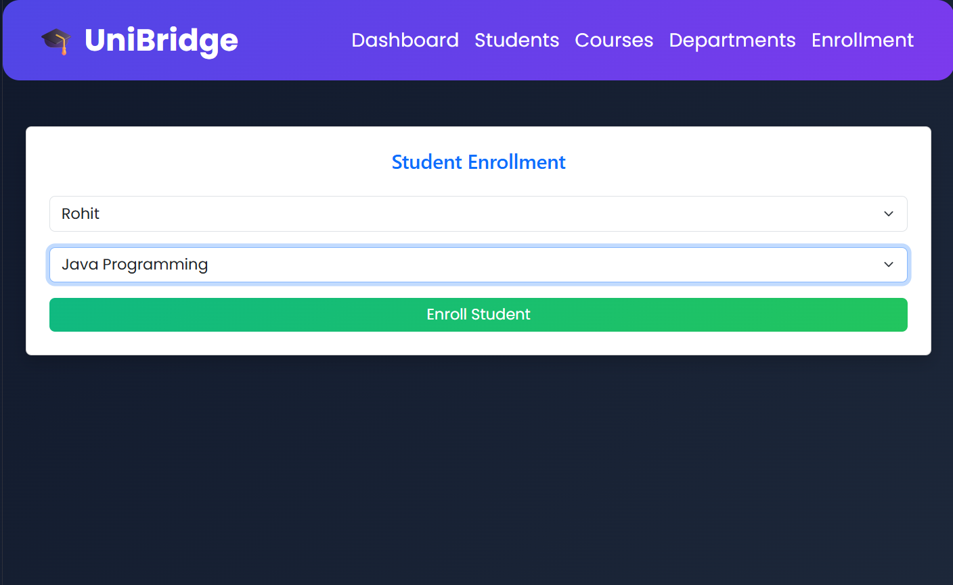
This screenshot shows the Student Enrollment interface where students can be assigned to courses. It demonstrates relationship mapping between collections and successful enrollment processing.

Expected Outcome
The system provides a reliable and scalable platform for managing academic information. It demonstrates full-stack development using ReactJS, Spring Boot, and MongoDB while implementing REST APIs, CRUD operations, and database relationships.

Future Scope
- JWT Authentication and Authorization
- Role-Based Access Control
- Cloud Deployment
- Advanced Search and Filtering
- Analytics and Reporting Dashboard

Developed By
Nakul Vashishtha
B.Tech CSE (Cloud Computing & Automation)
VIT Bhopal University

