Experiment 10
Aim: Develop a Laravel/Django based web application
Microsoft Windows [Version 10.0.26200.8039]
(c) Microsoft Corporation. All rights reserved.
C:\Users\ASUS\Desktop\Nakul\Practical 10>mkdir django_projects
C:\Users\ASUS\Desktop\Nakul\Practical 10>cd django_projects
C:\Users\ASUS\Desktop\Nakul\Practical 10\django_projects>python -m django startproject myproject
C:\Users\ASUS\Desktop\Nakul\Practical 10\django_projects>cd myproject
C:\Users\ASUS\Desktop\Nakul\Practical 10\django_projects\myproject>python manage.py startapp myapp
C:\Users\ASUS\Desktop\Nakul\Practical 10\django_projects\myproject>python manage.py runserver
Watching for file changes with StatReloader
Performing system checks...
System check identified no issues (0 silenced).
You have 18 unapplied migration(s). Your project may not work properly until you apply the migrations for app(s): admin, auth, contenttypes, sessions.
Run 'python manage.py migrate' to apply them.
April 09, 2026 - 15:10:00
Django version 6.0.4, using settings 'myproject.settings'
Starting development server at http://127.0.0.1:8000/
Quit the server with CTRL-BREAK.
[09/Apr/2026 15:10:20] "GET / HTTP/1.1" 200 22
C:\Users\ASUS\Desktop\Nakul\Practical 10\django_projects\myproject>
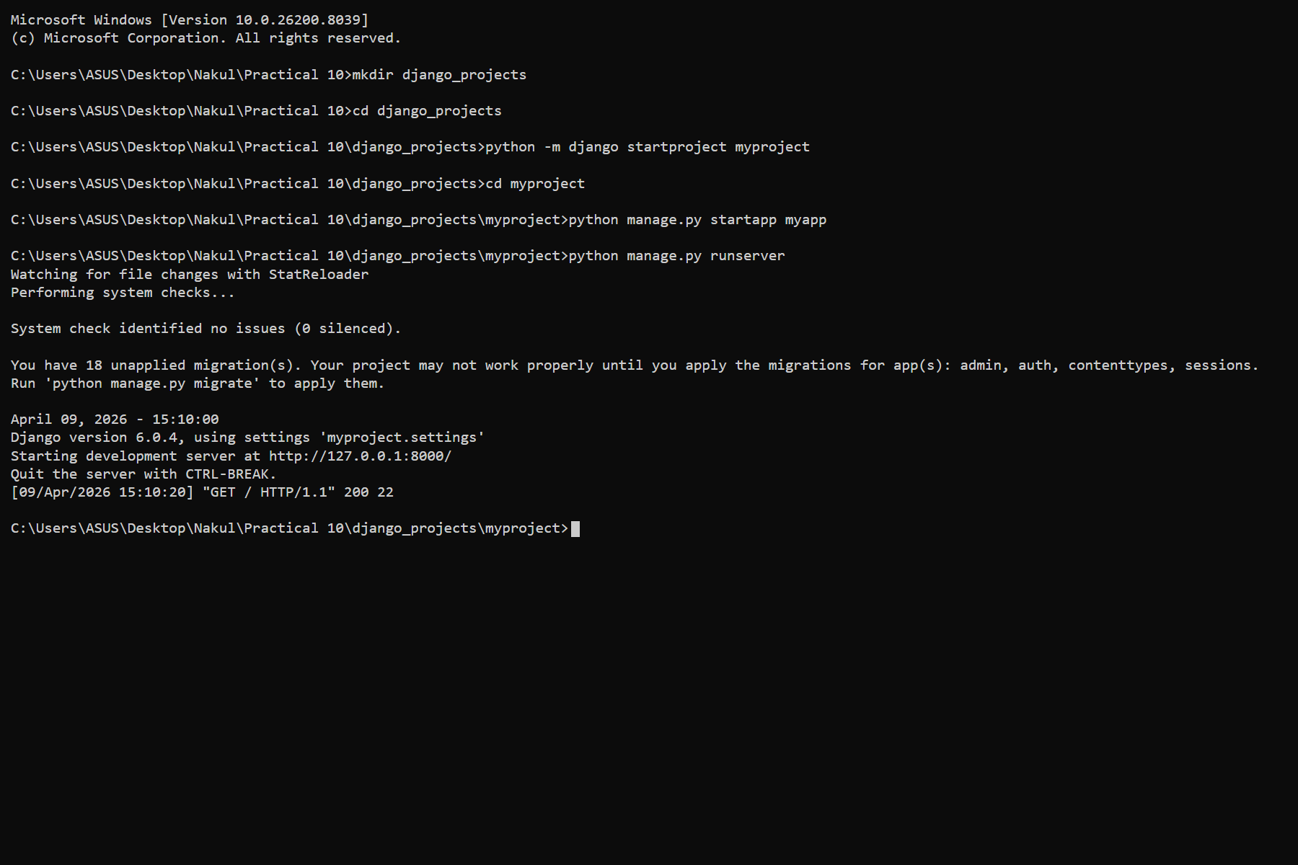


Experiment 11
AIM: Use OWASP ZAP to check security integrity
Microsoft Windows [Version 10.0.26200.8039]
(c) Microsoft Corporation. All rights reserved.
C:\Users\ASUS\Desktop\Nakul\Practical 11>zap.bat -daemon -host 127.0.0.1 -port 8080 -config api.disablekey=true
Found Java version 17.0.8
Available memory: 8192 MB
Using JVM args: -Xmx2048m
[ZAP-daemon] INFO org.zaproxy.zap.DaemonBootstrap - OWASP ZAP 2.14.0 started.
[ZAP-daemon] INFO org.zaproxy.zap.extension.api.ExtensionAPI - Starting ZAP API on 127.0.0.1:8080
[ZAP-daemon] INFO org.zaproxy.zap.DaemonBootstrap - ZAP is now listening on 127.0.0.1:8080
C:\Users\ASUS\Desktop\Nakul\Practical 11>curl -g "http://127.0.0.1:8080/JSON/spider/action/scan/?url=http://zero.webappsecurity.com/&recurse=true"
{"scan":"0"}
C:\Users\ASUS\Desktop\Nakul\Practical 11>curl -g "http://127.0.0.1:8080/JSON/core/view/alerts/?baseurl=http://zero.webappsecurity.com/"
{"alerts":[{"sourceid":"3","other":"","method":"GET","evidence":"<title>Zero - Log in</title>","pluginId":"10021","cweid":"200","confidence":"Medium","wascid":"13","description":"X-Content-Type-Options header missing","messageId":"1","url":"http://zero.webappsecurity.com/","reference":"http://msdn.microsoft.com/en-us/library/ie/gg622941","solution":"Ensure that the application/web server sets the Content-Type header appropriately.","alert":"X-Content-Type-Options Header Missing","param":"","attack":"","name":"X-Content-Type-Options Header Missing","risk":"Low","id":"0"}]}
C:\Users\ASUS\Desktop\Nakul\Practical 11>
