Q2A&B
CalculatorAppTest.java

import org.junit.jupiter.api.BeforeEach;
import org.junit.jupiter.api.DisplayName;
import org.junit.jupiter.api.Test;
import static org.junit.jupiter.api.Assertions.assertEquals;
import static org.junit.jupiter.api.Assertions.assertThrows;
public class CalculatorAppTest {
private Calculator calculator;
@BeforeEach
void setUp() {
calculator = new Calculator();
}
@Test
@DisplayName("Test Addition of Two Positive Numbers")
void testAdd() {
int result = calculator.add(5, 3);
assertEquals(8, result, "5 + 3 should equal 8");
}
@Test
@DisplayName("Test Subtraction Resulting in a Negative Value")
void testSubtract() {
int result = calculator.subtract(3, 10);
assertEquals(-7, result, "3 - 10 should equal -7");
}
@Test
@DisplayName("Test Multiplication with Zero")
void testMultiplyByZero() {
int result = calculator.multiply(7, 0);
assertEquals(0, result, "Multiplying any number by 0 should equal 0");
}
@Test
@DisplayName("Test Division of Two Numbers")
void testDivide() {
double result = calculator.divide(10, 4);
assertEquals(2.5, result, 0.0001, "10 / 4 should equal 2.5");
}
@Test
@DisplayName("Test Division by Zero Throws ArithmeticException")
void testDivideByZero() {
ArithmeticException exception = assertThrows(
ArithmeticException.class,
() -> calculator.divide(10, 0),
"Division by zero should throw an ArithmeticException"
);
assertEquals("/ by zero", exception.getMessage());
}
}

Output:
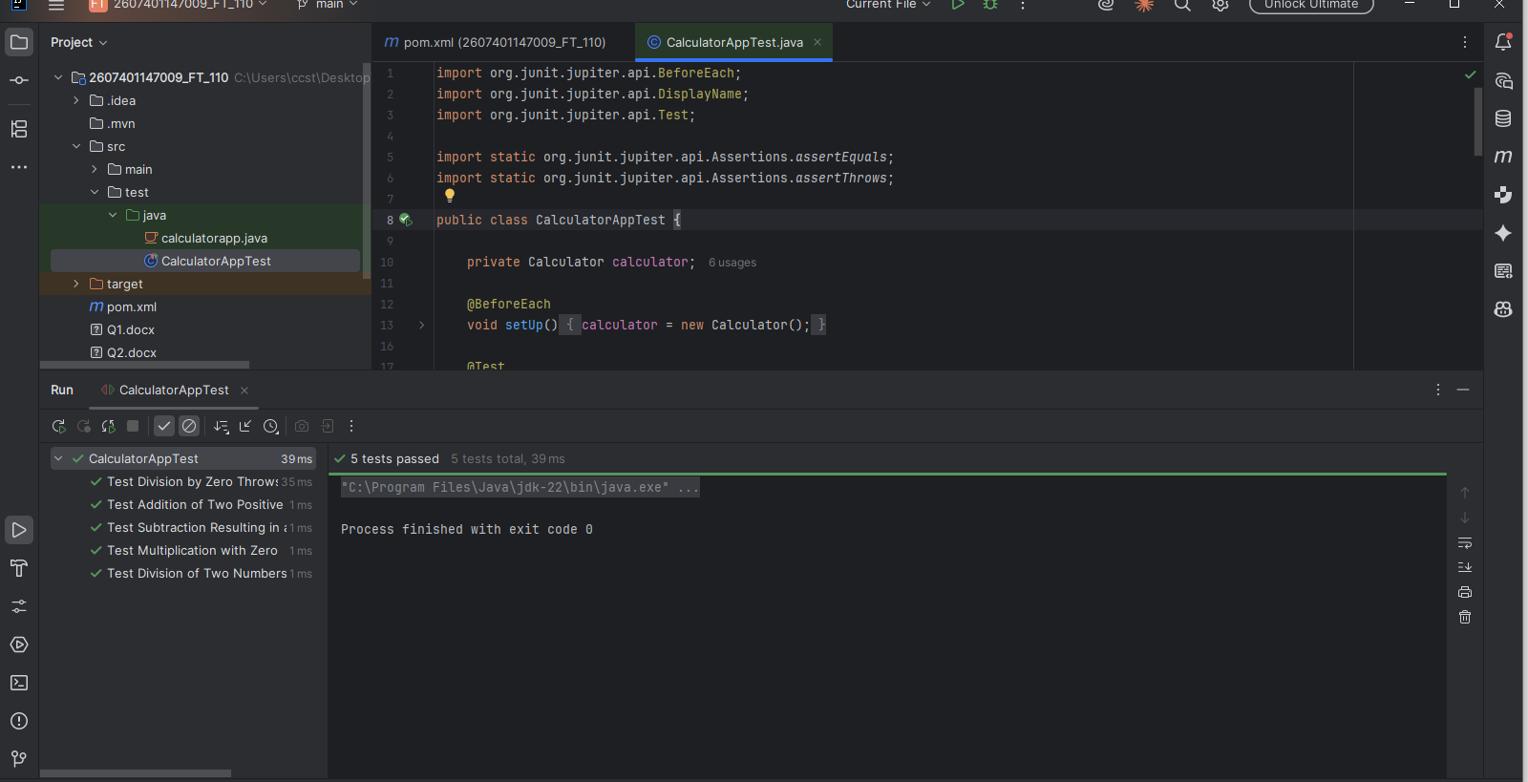

C&D
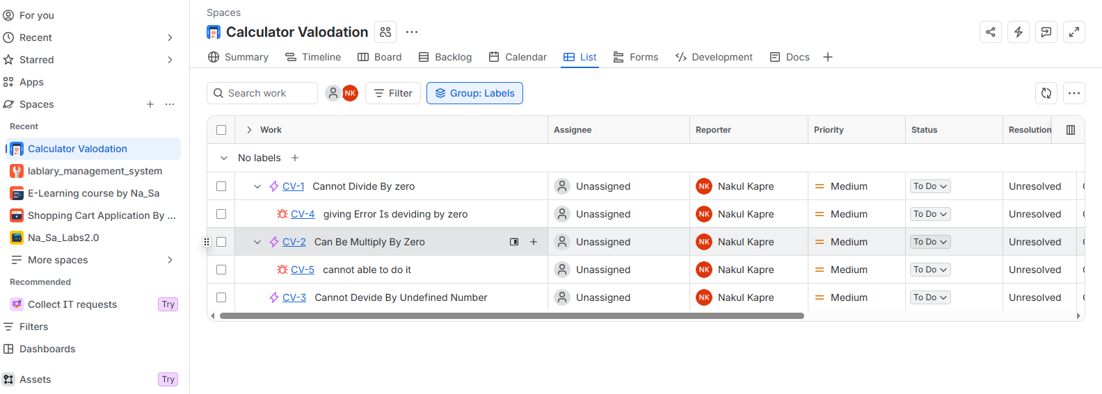

Created a bug

