WEEK 5 ASSIGNMENT
POWER BI DATA ANALYTICS
Data Preparation • Data Modeling • DAX • Interactive Dashboard
InternNova – Data Analytics Internship
Dataset: Sample - Superstore.xlsx
Student Name: _NAKUL MEHRA
Submission Date: _18 -10-2026
Course: MCA
Internship: InternNova – Data Analytics Internship
Assignment: Week 5 – Power BI Data Analytics

Contents
- Task 1 – Dataset Import and Overview
- Task 2 – Data Quality and Cleaning
- Task 3 – Data Types and Date Preparation
- Task 4 – Data Modeling
- Task 5 – DAX Measures and KPI Cards
- Task 6 – Visualizations and Interactive Dashboard
- Task 7 – Insights and Recommendations
- Testing, Conclusion and Checklist
Screenshots in this report are from the actual Power BI Desktop and Power Query images supplied for this assignment. Each is placed beside the task it demonstrates.

Task 1 – Dataset Import and Overview
Objective: Load Sample - Superstore.xlsx into Power BI Desktop and inspect the main table. The workbook was imported through Home → Get data → Excel workbook. Sample - Superstore was selected, and Transform Data opened Power Query Editor.
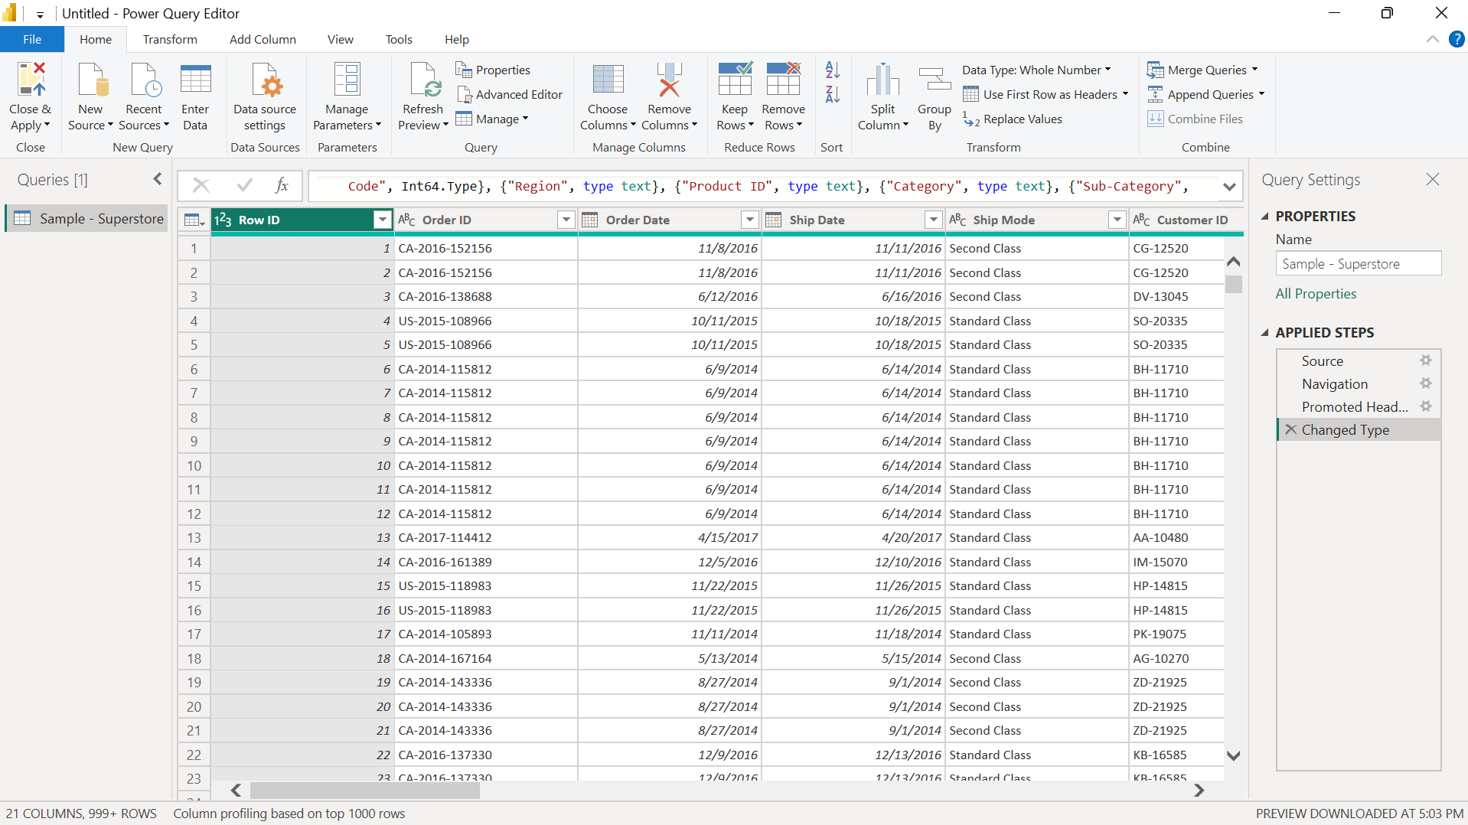
Figure 1. Sample - Superstore loaded in Power Query Editor.

Dataset overview
The dataset contains order-level retail records: order identifiers, order and shipping dates, customer details, geography, product/category fields, sales, quantity, discount and profit. The final model showed 9,994 rows. One customer can appear in many order rows, so a separate customer dimension is useful.

Task 2 – Data Quality and Cleaning in Power Query
Objective: Inspect the imported columns for errors, missing values and unusual distributions. Column Quality and Column Distribution were enabled in Power Query. The displayed preview shows 100% valid, 0% errors and 0% empty for the visible columns.
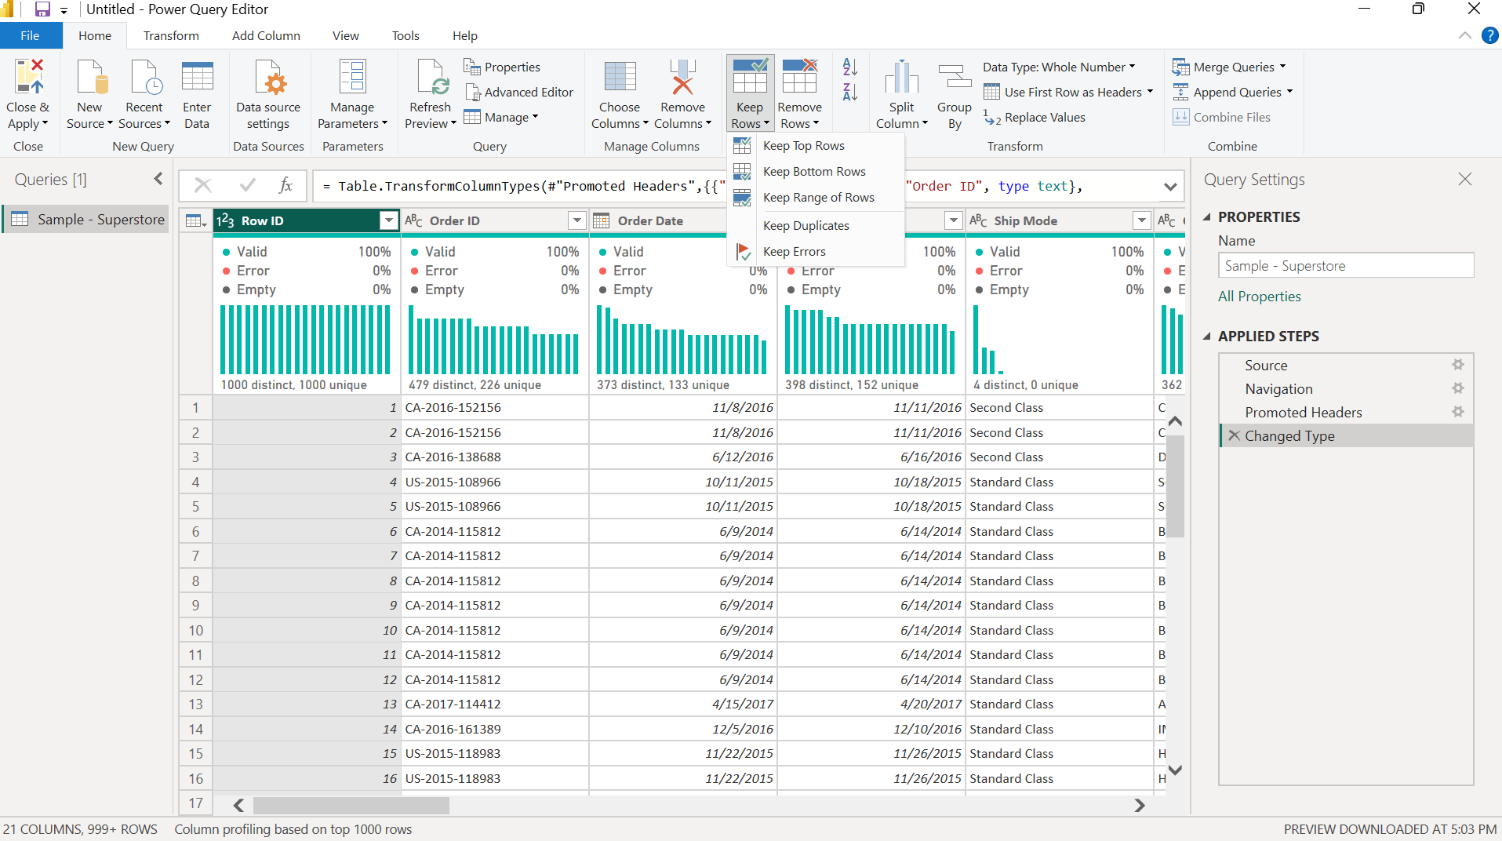
Figure 2. Column Quality and distribution profiling in Power Query.
Limitation: profiling shown in these screenshots is based on the top 1,000 rows. This is evidence for the preview, not proof that every row in the full dataset was exhaustively checked. The Applied Steps panel records repeatable preparation steps.
- Reviewed valid/error/empty indicators.
- Kept identifiers such as Row ID and Order ID as identifiers, not additive metrics.
- Checked numeric and date fields before creating visuals.
- Created a customer lookup query and removed duplicate customer records for modeling.

Task 3 – Data Types and Date Preparation
Objective: Assign correct types so calculations and dates work as expected. Row ID and Quantity use Whole Number; Order Date and Ship Date use Date; Sales, Profit and Discount use Decimal Number; customer IDs, names, order IDs, category, region and product names use Text.
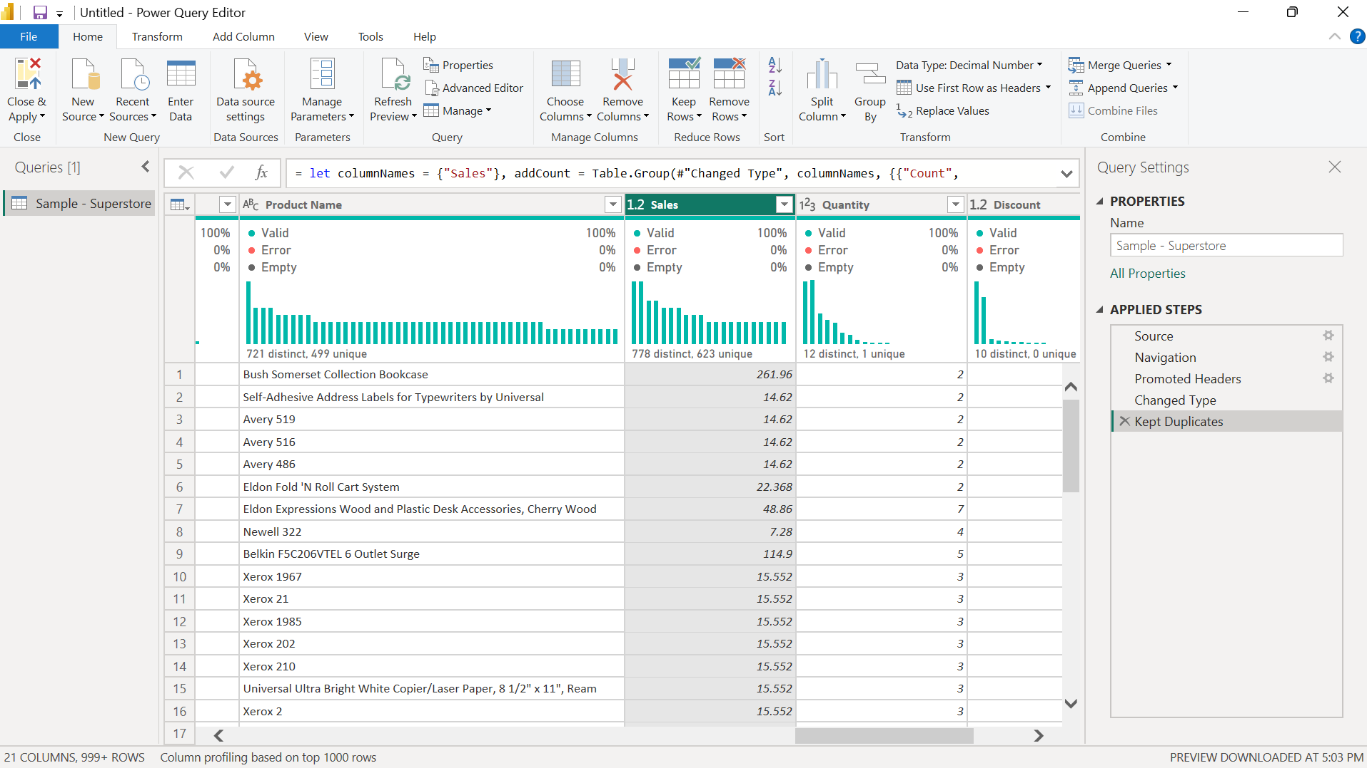
Figure 3. Data profiling and numeric column types.
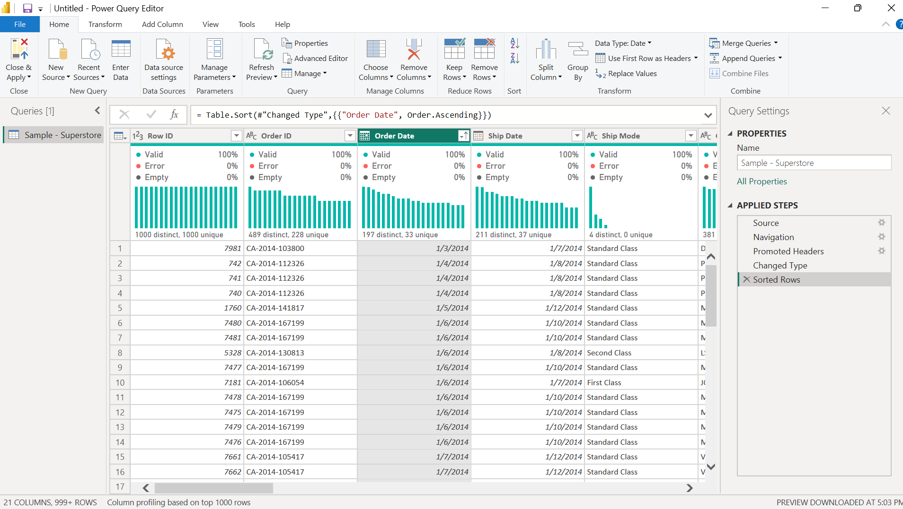
Figure 4. Order Date sorted in ascending order.
Sorting Order Date in ascending order helps inspect the timeline. The report visual axis should also be checked to ensure the displayed years remain chronological.

Task 4 – Data Modeling: DimCustomer and Relationship
Objective: Create a customer lookup table with unique keys. A Reference query named DimCustomer was made from the main table; Customer ID and Customer Name were retained and duplicates removed. The screenshot shows 793 distinct, unique customer records in the preview.
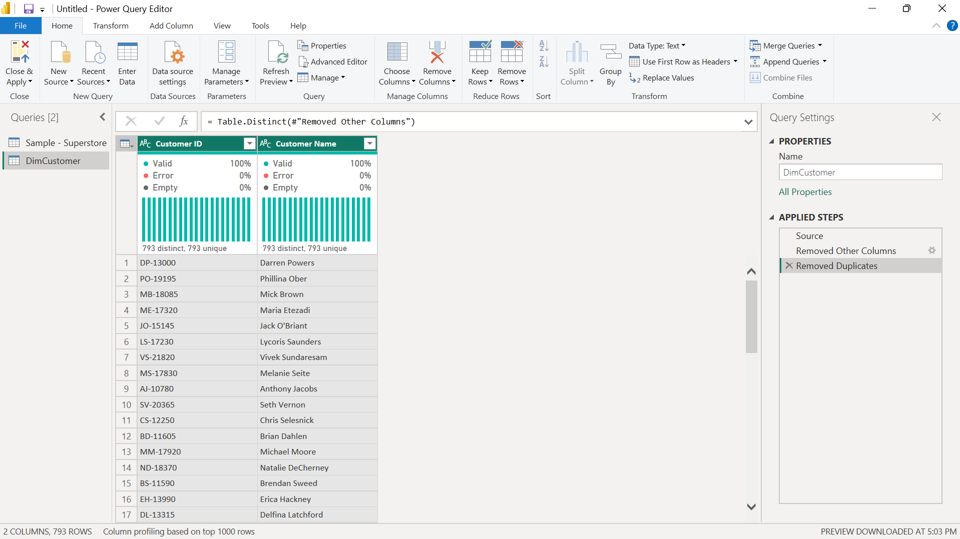
Figure 5. DimCustomer after keeping customer fields and removing duplicates.
A relationship connects Sample - Superstore[Customer ID] to DimCustomer[Customer ID]. It is active, Many-to-one (*:1), and uses Single cross-filter direction.
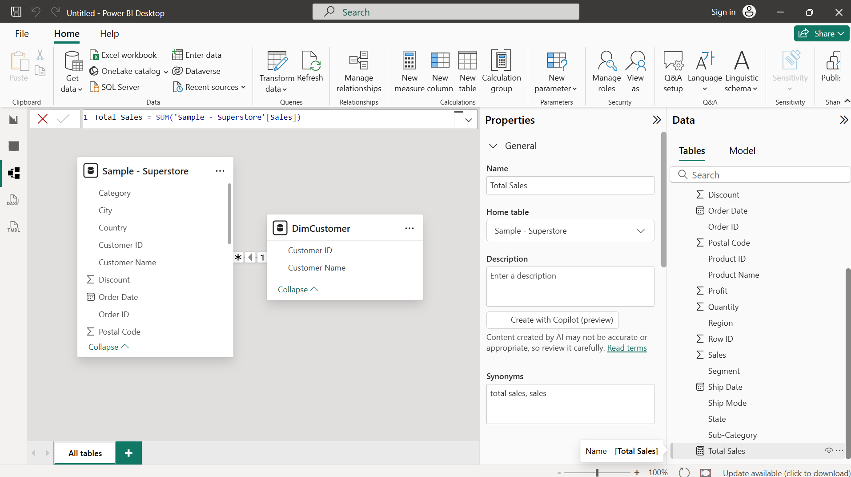
Figure 6. Active Many-to-one relationship between the fact table and DimCustomer.
Sample - Superstore acts as the fact table because it contains order-line transactions and numeric measures. DimCustomer is the dimension table, containing one row per customer. This model supports predictable customer filtering.

Task 5 – DAX Measures and KPI Cards
Objective: Create reusable calculations and display them as KPI cards. Measures respond to the current filter context.

Total Sales
Total Sales = SUM('Sample - Superstore'[Sales])
Adds sales for the current selection.

Average Sales
Average Sales = AVERAGE('Sample - Superstore'[Sales])
Calculates average sales per row.

Total Records
Total Records = COUNTROWS('Sample - Superstore')
Counts order-line records.

Maximum Sales
Maximum Sales = MAX('Sample - Superstore'[Sales])
Returns the highest individual sales value.

Minimum Sales
Minimum Sales = MIN('Sample - Superstore'[Sales])
Returns the lowest individual sales value.

Sales Percentage
Sales Percentage = DIVIDE([Total Sales], CALCULATE([Total Sales], REMOVEFILTERS('Sample - Superstore')), 0)
Calculates current sales as a share of sales with filters on the main table removed.
Measure validation: Sales Percentage may show 100% with no filters because numerator and denominator are equal. If the required denominator must stay constant when Region, Category or Customer filters are applied, remove the relevant dimension filters explicitly and test the measure.
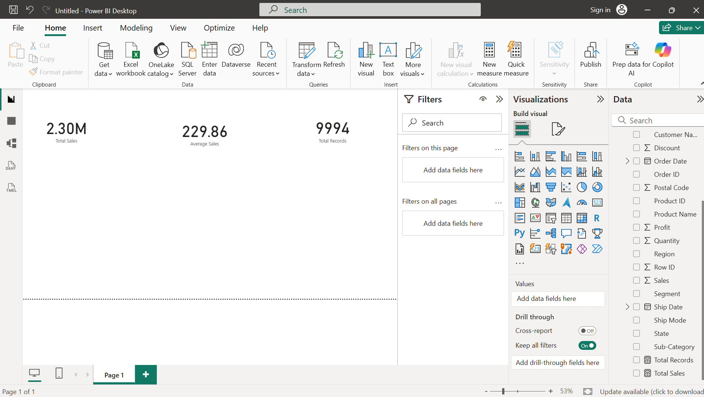
Figure 7. KPI cards being arranged on the Power BI canvas.
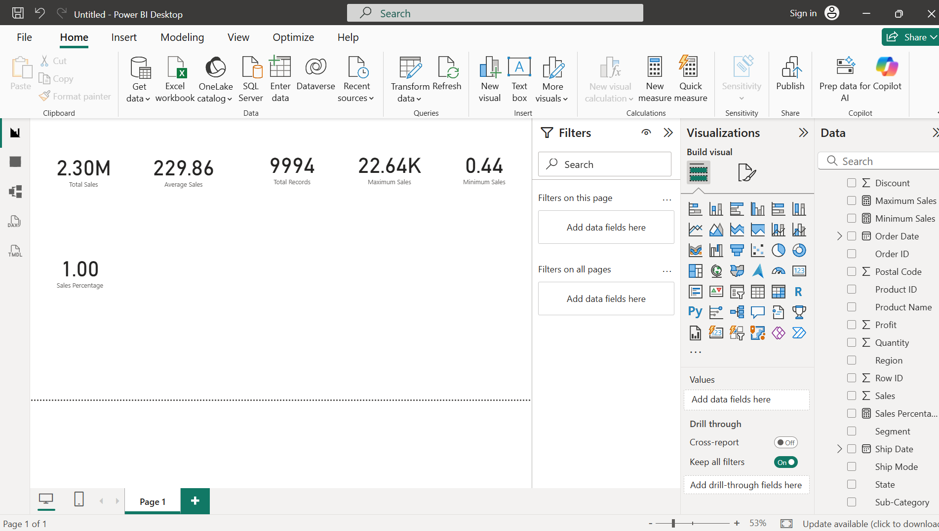
Figure 8. KPI card values displayed in Power BI.
Measure | Observed unfiltered result | Purpose
Total Sales | ≈ 2.30M | Overall sales value
Average Sales | ≈ 229.86 | Average per order-line row
Total Records | 9,994 | Number of rows
Maximum Sales | ≈ 22.64K | Highest individual sales value
Minimum Sales | 0.44 | Lowest individual sales value
Sales Percentage | 1.00 / 100% | Check denominator under filters

Task 6 – Visualizations and Interactive Dashboard
Objective: Present results in an easy-to-read report page with summary cards, charts, product details and slicers.
- Bar chart – Sales by Category: compares sales across product categories.
- Line chart – Sales Trend by Year: compares annual sales from 2014 to 2017.
- Donut chart – Sales by Customer Segment: compares Consumer, Corporate and Home Office.
- Product table – Product Name, Category, Sales and Profit: supports product-level review.
- Slicers – Category and Region: allow interactive filtering.
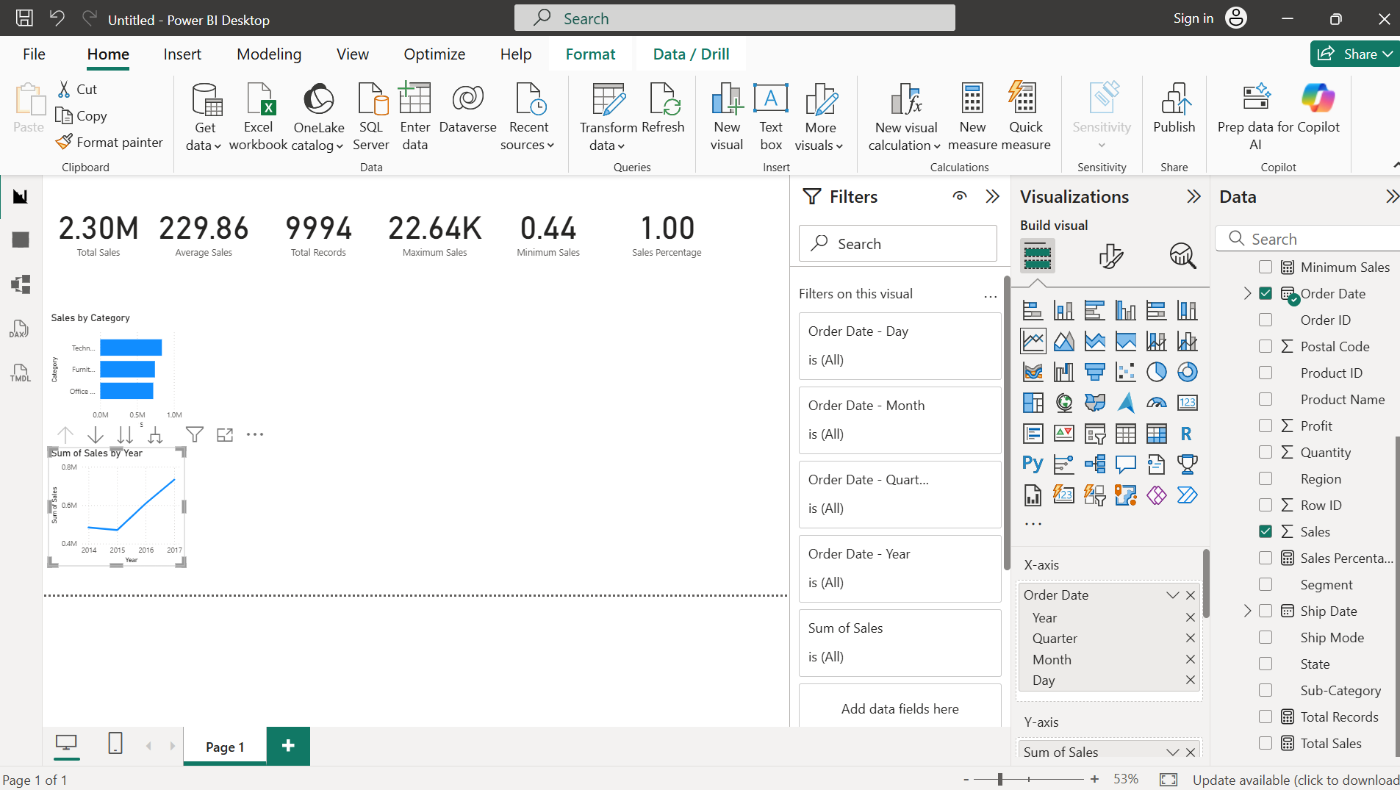
Figure 9. Category, yearly trend, customer segment and product table visuals.
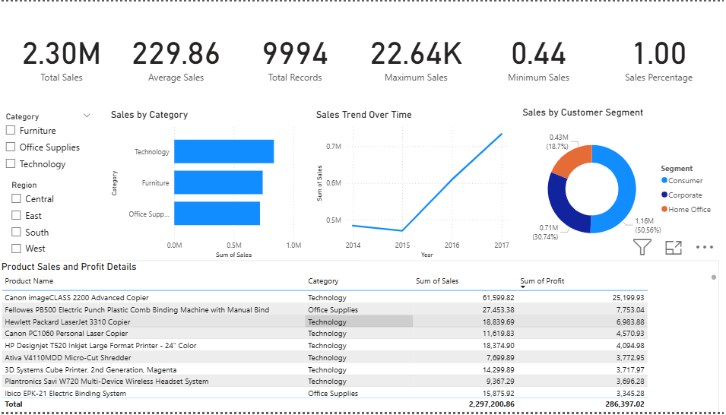
Figure 10. Actual dashboard screenshot with KPI cards and charts.
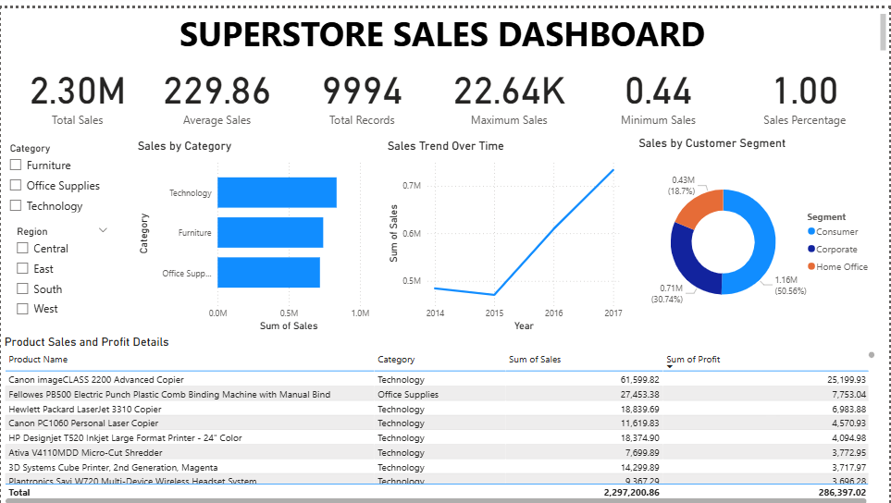
Figure 11. Dashboard title and report layout.
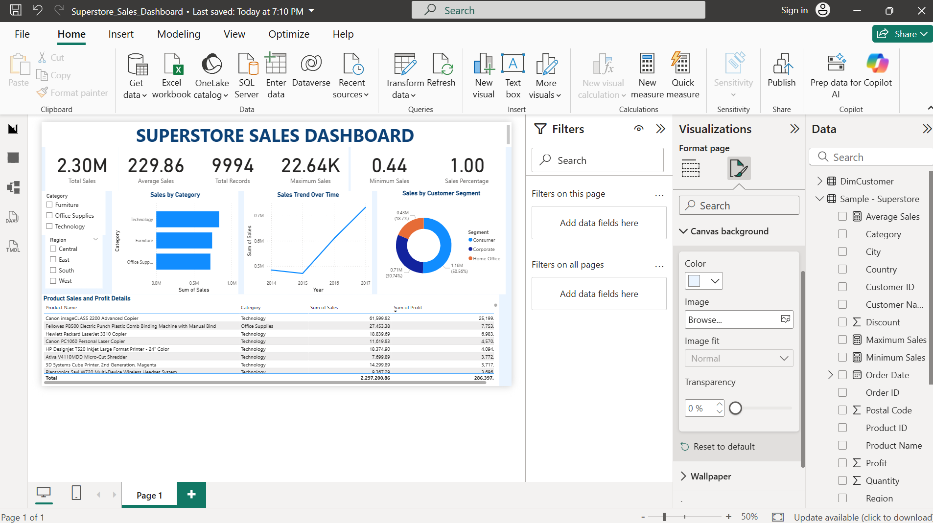
Figure 12. Power BI report page while checking slicers and filters.
Interactivity check: Select a Category or Region in the slicer and verify that relevant visuals respond. Reset slicers before recording the final overall KPI values.

Task 7 – Insights, Trends and Business Recommendations
The insights below use the dashboard and observed metrics. Rankings should be confirmed on the final unfiltered page because slicers can change the results.

Key insights
- Overall sales are approximately 2.30M in the unfiltered dashboard.
- The table contains 9,994 order-line records; this is not the number of unique orders or customers.
- The category chart enables comparison of category sales. Technology appeared strong in the earlier review; confirm its exact ranking on the final page.
- The annual trend chart covers 2014–2017. Later years appeared higher in the earlier review; confirm values before claiming a growth rate.
- The segment donut chart compares Consumer, Corporate and Home Office; sales share alone does not indicate profit share.
- The product table displays Sales and Profit together, helping identify products that sell well but contribute little profit or make a loss.
- Category and Region slicers support comparison across product groups and geographies.

Recommendations
- Inventory planning: maintain stock for high-sales products, but check profit before increasing discounts.
- Profitability review: investigate low/negative-profit products, discount levels, costs and shipping effects.
- Customer strategy: use segment and region filters to identify strong groups and tailor retention activity to observed results.
- Trend monitoring: review annual and, if available, monthly patterns to support demand planning.
- Dashboard validation: test slicers, number formatting and Sales Percentage denominator before presenting the report.

Testing, Conclusion and Submission Checklist

Validation checklist
- Confirm the model contains 9,994 rows.
- Check date, numeric and text data types.
- Confirm DimCustomer has unique Customer ID values.
- Verify the active *:1 relationship and Single cross-filter direction.
- Compare unfiltered KPI cards with the values in this report.
- Test Category and Region slicers and reset them for the final screenshot.
- Validate Sales Percentage under filters.
- Save the Power BI project as a .pbix file.
- Submit this PDF and the actual Power BI dashboard screenshot.

Conclusion
This assignment demonstrates the end-to-end Power BI workflow: importing a dataset, checking data quality, assigning types, preparing a customer dimension, creating a relationship, writing DAX measures, building visuals and testing interactivity. The report includes real screenshots from the supplied workflow, positioned beside the relevant task sections.
Prepared by: Nakul Mehra

