AMAZON SALES INTELLIGENCE
& AI DEMAND FORECASTING SYSTEM
Project Report
IBM Internship Project | Academic Year 2024
Python . Streamlit . Pandas . NumPy . Plotly . Scikit-learn
Dataset: Amazon Sale Report.csv | 128,975 rows | 91 days | March - June 2022
Source: Kaggle -- Amazon Sale Report
Submitted by
Nakul Mehra
Course: MCA
Tula's Institute
IBM Internship Project | 2024

1. Abstract
This project presents the design, development, and deployment of a professional data analytics and AI-powered business intelligence dashboard titled "Amazon Sales Intelligence & AI Demand Forecasting System." The system ingests a real-world Amazon India e-commerce dataset comprising 128,975 transaction records spanning approximately 91 days (March 31 to June 29, 2022). The application is built entirely in Python using Streamlit as the frontend framework, Pandas and NumPy for data processing, Plotly for interactive visualisations, and Scikit-learn for machine learning.
The dashboard encompasses eight functional modules: Executive Overview, Data Quality Analysis, Sales Analytics, Geographic Analytics, Order & Fulfilment Analytics, Product Analytics, AI Demand Forecasting, and AI Business Insights. The forecasting module employs Random Forest and Gradient Boosting regression models trained on engineered time-series features derived from historical daily quantity data. The system automatically generates 12 data-driven business insights and a prioritised recommendation table, all computed dynamically from the live dataset without any hardcoded analytical results.

2. Introduction
E-commerce platforms generate vast volumes of transactional data that, if properly analysed, can yield significant competitive advantages. Amazon India is one of the largest online marketplaces in South Asia, and understanding sales patterns, geographic demand distribution, product performance, and fulfilment efficiency is critical for sellers, category managers, and supply-chain planners.
This project addresses the need for a centralised, interactive, and intelligent business intelligence tool that transforms raw sales records into actionable insights. The application goes beyond static reporting by incorporating machine learning to forecast future product demand, enabling data-driven inventory planning and promotional strategy.
The project was developed as part of the IBM Internship Programme and demonstrates proficiency across the full data science and software engineering stack: data ingestion, cleaning, exploratory analysis, visualisation, machine learning, and interactive UI development.

3. Problem Statement
Amazon sellers and category managers working with large transaction datasets often lack accessible tools to:
- Rapidly assess overall business health (revenue, orders, cancellations) from a single dashboard.
- Understand which products, categories, sizes, and regions drive the most revenue.
- Identify quality issues in raw data (missing values, inconsistencies, outliers) that could distort analysis.
- Forecast future demand for individual categories to optimise stock replenishment.
- Derive data-driven recommendations without manual statistical analysis.
Existing spreadsheet tools are inadequate for datasets of ~129,000 rows and do not support interactive filtering, real-time aggregation, or machine learning forecasting. This project solves all five problems in a single Python application.

4. Objectives
- Perform a comprehensive data quality audit of the raw Amazon Sales dataset.
- Design and implement a robust data cleaning and preprocessing pipeline.
- Build an interactive multi-page dashboard with global filtering capabilities.
- Visualise sales performance across time, category, size, geography, and product dimensions.
- Analyse order fulfilment efficiency and identify cancellation drivers.
- Train and evaluate machine learning models for demand forecasting.
- Generate automated, data-driven business insights and recommendations.
- Package the application as a professional, internship-quality deliverable.

5. Scope of the Project
In Scope:
- Analysis of the provided Amazon Sale Report.csv dataset (128,975 rows, 91 days).
- Eight interactive dashboard modules accessible via sidebar navigation.
- Machine learning demand forecasting at overall and category level.
- Auto-generated business insights derived entirely from the dataset.
- Global filters: date range, category, fulfilment type, order type (B2B/B2C).
Out of Scope:
- Real-time data ingestion or API integration with Amazon Seller Central.
- Inventory management or procurement module (no inventory data).
- Customer-level analysis (no customer ID in dataset).
- Profit/margin analysis (no cost data in dataset).
- Multi-seller or multi-marketplace comparison.

6. Dataset Source
Property | Value
File name | Amazon Sale Report.csv
Origin | Amazon India (Amazon.in) marketplace
Nature | Historical sales transaction records
Availability | Provided as a static CSV file
Kaggle Source | https://www.kaggle.com/datasets/thedevastator/unlock-profits-with-e-commerce-sales-data
Usage constraint | Read-only; the original file is never modified

7. Dataset Description
The dataset contains individual line-item records from Amazon India orders placed between March 31, 2022 and June 29, 2022 -- a period of approximately 91 days. Each row represents a single product line within an order. The dataset covers sales of women's apparel across 9 product categories including Sets, Kurtas, Western Dresses, Tops, Ethnic Dresses, Blouses, Bottoms, Sarees, and Dupattas.
Metric | Value
Total rows | 128,975
Total columns (raw) | 24
Date range | 31 March 2022 - 29 June 2022
Days of data | 91
Unique orders | 120,378
Total revenue (INR) | Rs. 75,402,506 (~Rs. 75.4 M)
Total quantity sold | 116,649 units
Average order value | Rs. 626
Overall cancellation rate | 14.2%
Top revenue category | Set (Rs. 37.66 M)
Top revenue state | Maharashtra (Rs. 12.86 M)
Average daily quantity | ~1,282 units
Peak daily quantity | 1,889 units (2 May 2022)

8. Dataset Structure
# | Column Name | Data Type | Description
1 | index | int64 | Row index
2 | Order ID | object | Unique order identifier (duplicated for multi-item orders)
3 | Date | object | Order date string (MM-DD-YY format)
4 | Status | object | Order status (13 distinct values)
5 | Fulfilment | object | Fulfilment method: Amazon or Merchant
6 | Sales Channel | object | Sales platform
7 | ship-service-level | object | Shipping tier: Standard or Expedited
8 | Style | object | Product style code
9 | SKU | object | Stock Keeping Unit identifier
10 | Category | object | Product category (9 unique values)
11 | Size | object | Clothing size (XS to 6XL + Free)
12 | ASIN | object | Amazon Standard Identification Number
13 | Courier Status | object | Courier tracking status
14 | Qty | int64 | Quantity ordered per line item
15 | currency | object | Currency code (INR)
16 | Amount | float64 | Line-item amount in INR
17 | ship-city | object | Destination city
18 | ship-state | object | Destination state
19 | ship-postal-code | float64 | Destination postal code
20 | ship-country | object | Destination country (IN)
21 | promotion-ids | object | Applied promotion codes (38.1% null)
22 | B2B | bool | Business-to-business flag
23 | fulfilled-by | object | Fulfilment agent (69.6% null for Amazon FBA)
24 | Unnamed: 22 | object | Empty junk column (dropped)

9. Data Quality Analysis
A comprehensive data quality audit was performed before any analytics. Results are displayed in the Data Quality module of the dashboard.

9.1 Numerical Statistics
Statistic | Qty | Amount (INR)
Count | 128,975 | 121,180
Mean | 0.904 | 648.56
Std | 0.313 | 281.21
Min | 0 | 0.00
25th Percentile | 1 | 449.00
Median | 1 | 605.00
75th Percentile | 1 | 788.00
Max | 15 | 5,584.00

10. Missing Value Analysis
Column | Missing Rows | Missing % | Treatment
fulfilled-by | 89,698 | 69.55% | Derived from Fulfilment column
promotion-ids | 49,153 | 38.11% | Filled with 'None'
Unnamed: 22 | 49,050 | 38.03% | Column dropped entirely
currency | 7,795 | 6.04% | Filled with 'INR'
Amount | 7,795 | 6.04% | Rows kept; excluded from revenue calcs
Courier Status | 6,872 | 5.33% | Filled with 'Unknown'
ship-city | 33 | 0.03% | Filled with 'UNKNOWN'
ship-state | 33 | 0.03% | Filled with 'UNKNOWN'
ship-postal-code | 33 | 0.03% | Not used in analytics

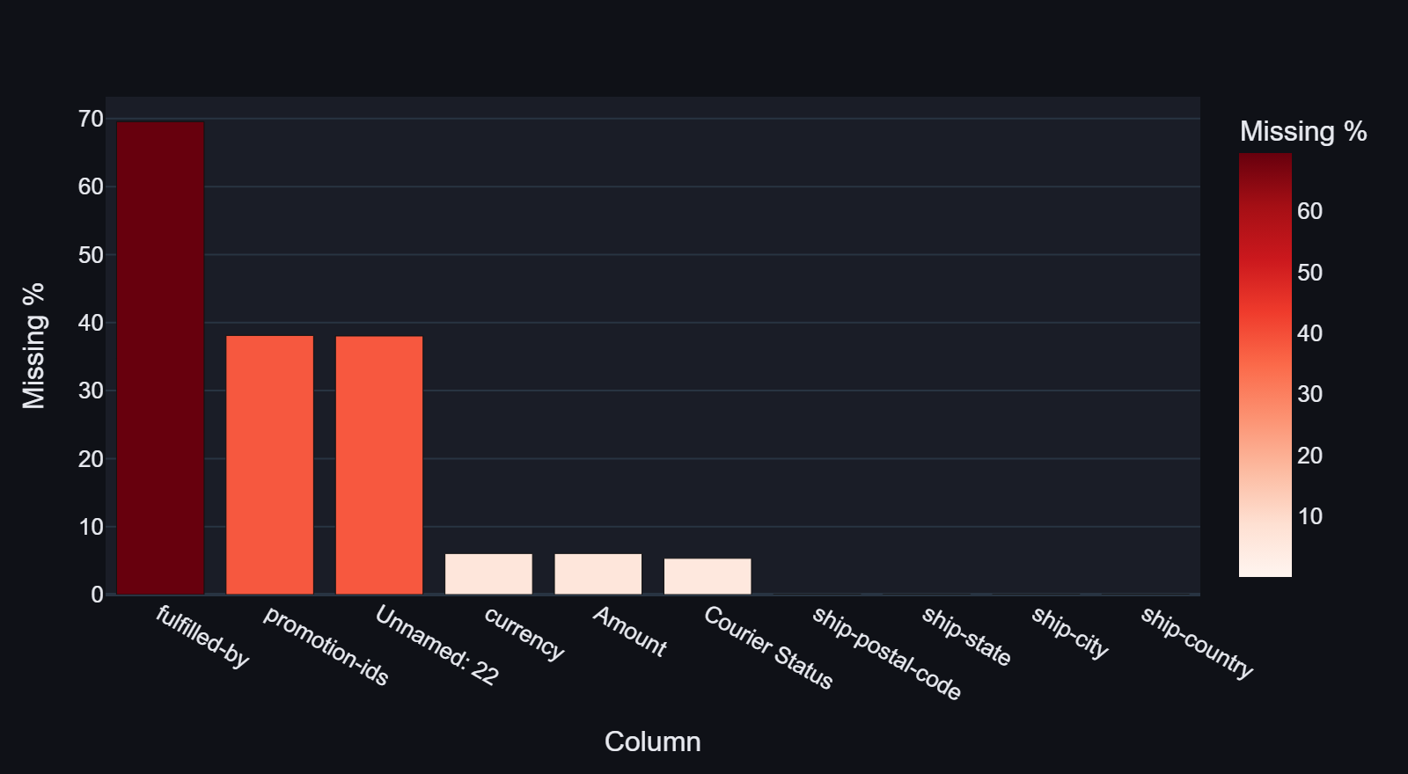
Fig. 1 -- Missing Values Bar Chart (Data Quality Module)

11. Duplicate Analysis
0 fully duplicate rows were found. Every record is unique across all 24 columns.
8,597 Order IDs appear more than once. This is not a data error -- a single Amazon order can contain multiple product lines (SKUs). Each line item is recorded as a separate row sharing the same Order ID. Removing duplicate Order IDs would incorrectly discard legitimate multi-item orders.

12. Data Cleaning
The following cleaning steps are applied in the load_data() function in app.py. The original CSV is never written to or modified.
Step | Action
Column name strip | df.columns.str.strip() removes trailing/leading spaces
Rename Sales Channel | "Sales Channel " -> "Sales_Channel"
Drop junk column | Unnamed: 22 dropped via drop(errors='ignore')
Date parsing | pd.to_datetime(df["Date"], format="%m-%d-%y", errors="coerce")
State normalisation | Strip, uppercase, map ~12 abbreviations to canonical names
City normalisation | Strip and uppercase
Courier Status nulls | Fill with "Unknown"
fulfilled-by nulls | Derive: if Fulfilment == "Amazon" -> "Amazon FBA", else "Easy Ship"
promotion-ids nulls | Fill with "None"
currency nulls | Fill with "INR"

13. Data Preprocessing

13.1 Revenue Definition
Revenue = Amount if (Amount is not null) AND (Qty > 0), else NaN. This ensures cancelled and null-amount rows are excluded from revenue totals.

13.2 Zero-Quantity Rows
12,807 rows have Qty = 0. Of these, 12,701 are cancelled orders. These rows are retained for cancellation analysis but excluded from revenue/qty KPIs.

14. Feature Engineering
Feature | Source | Purpose
Month | Date.dt.month | Monthly grouping
MonthName | Date.dt.strftime("%b %Y") | Chart labels
Week | ISO calendar week | Weekly trend
DayOfWeek | Date.dt.day_name() | Day-of-week heatmap
is_cancelled | Status.startswith("Cancelled") | Cancellation KPI
is_shipped | Status.startswith("Shipped") | Shipped count
is_B2B | B2B boolean cast to int | B2B/B2C split
Revenue | Derived from Amount + Qty | Revenue KPIs
YearWeek | Date.dt.strftime("%Y-W%V") | Weekly trend labels

15. Exploratory Data Analysis

15.1 Revenue by Category
Category | Revenue (INR M) | Share
Set | Rs. 37.66 M | 49.9%
Kurta | Rs. 20.45 M | 27.1%
Western Dress | Rs. 10.63 M | 14.1%
Top | Rs. 5.20 M | 6.9%
Ethnic Dress | Rs. 0.76 M | 1.0%
Others (4 categories) | Rs. 0.70 M | 0.9%

15.2 Top 5 States by Revenue
Rank | State | Revenue (INR M)
1 | Maharashtra | Rs. 12.86 M
2 | Karnataka | Rs. 10.15 M
3 | Telangana | Rs. 6.64 M
4 | Uttar Pradesh | Rs. 6.49 M
5 | Tamil Nadu | Rs. 6.24 M

15.3 Order Status Distribution
Status | Count
Shipped | 77,804
Shipped - Delivered to Buyer | 28,769
Cancelled | 18,332
Shipped - Returned to Seller | 1,953
Pending | 658
Others | 459

15.4 Fulfilment Split
Type | Count | Share
Amazon FBA | 89,698 | 69.5%
Merchant (Easy Ship) | 39,277 | 30.5%

16. Dashboard Architecture
The application is structured as a single-file Streamlit application (app.py) with the following architectural layers: CSV source -> load_data() with @st.cache_data -> render_sidebar() with global filters -> Page Router (main()) -> 8 page functions.
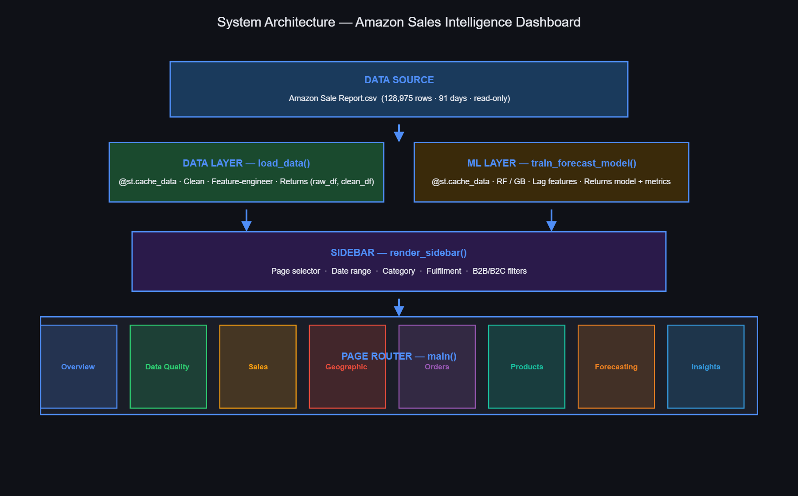
Fig. 2 -- System Architecture Diagram

17. Executive Overview Module
The Executive Overview page displays six KPI cards computed dynamically from the filtered dataset:
KPI | Full-Dataset Value
Total Orders (unique) | 120,378
Total Revenue | Rs. 75.40 M
Total Quantity | 116,649 units
Average Order Value | Rs. 626
Cancellation Rate | 14.2%
Top Category | Set

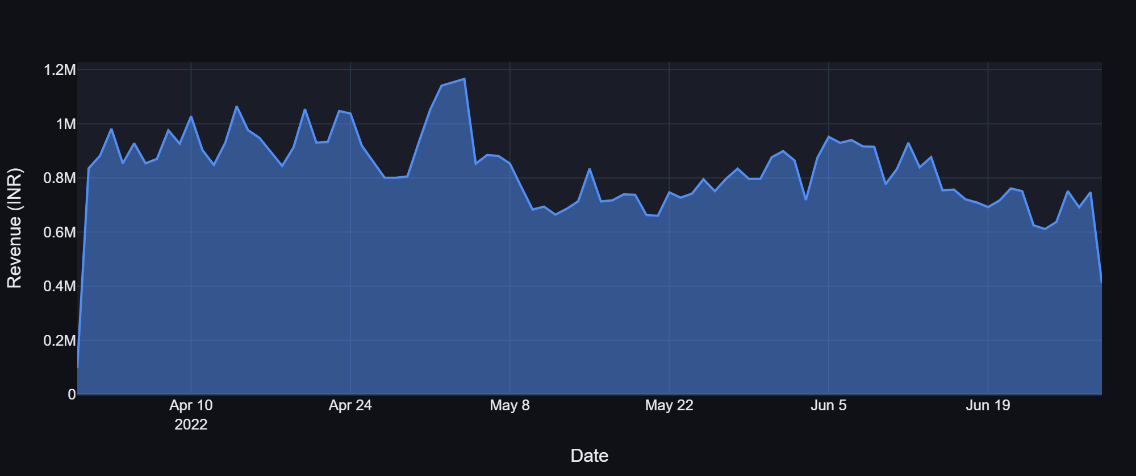
Fig. 3 -- Daily Revenue Trend (Executive Overview)
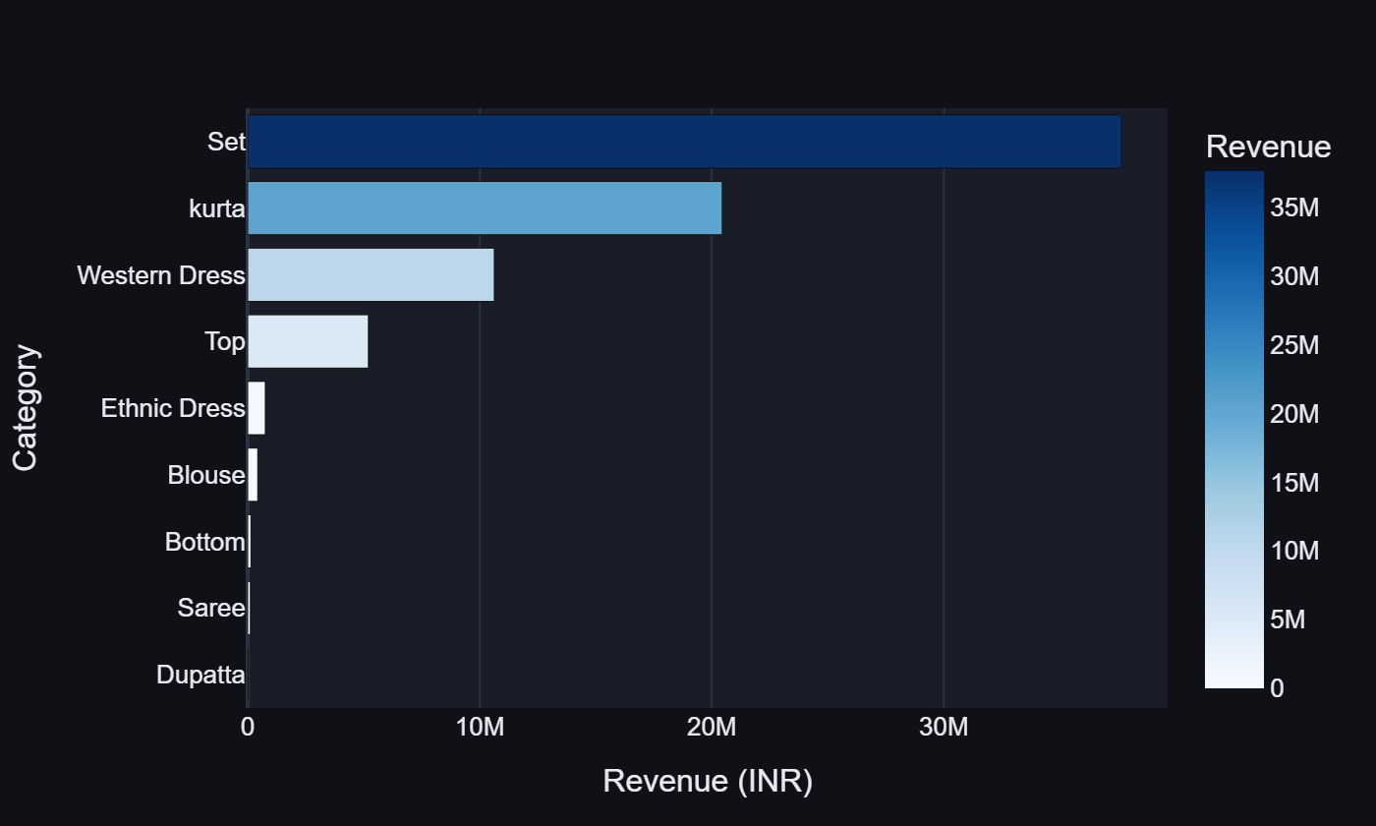
Fig. 4 -- Revenue by Category Bar Chart
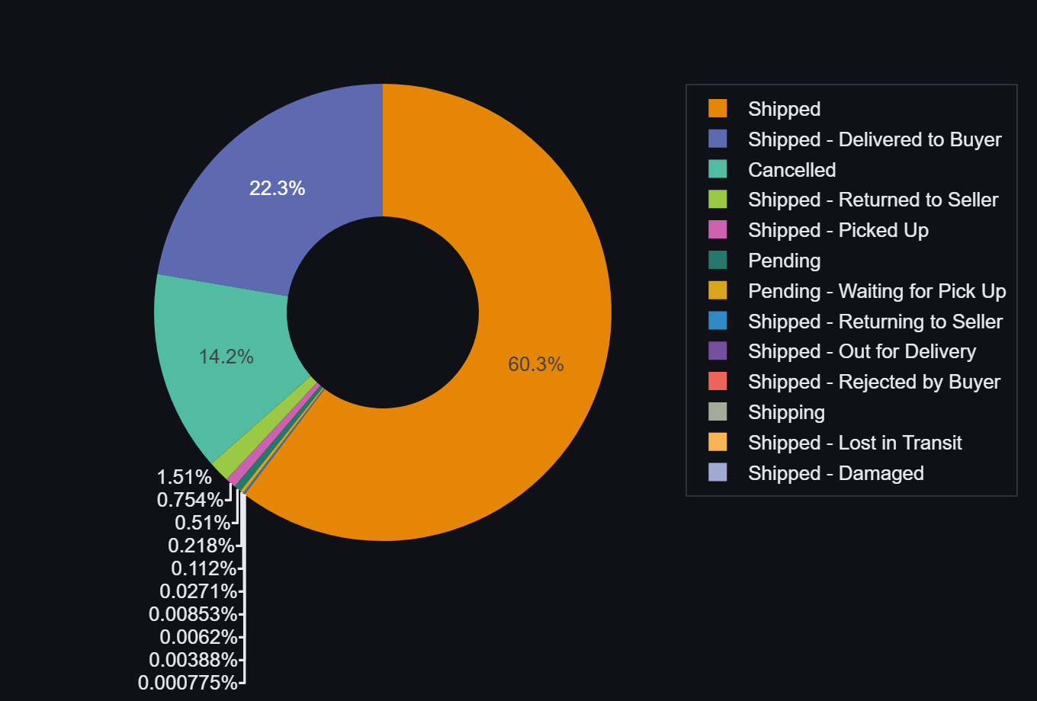
Fig. 5 -- Order Status Donut Chart
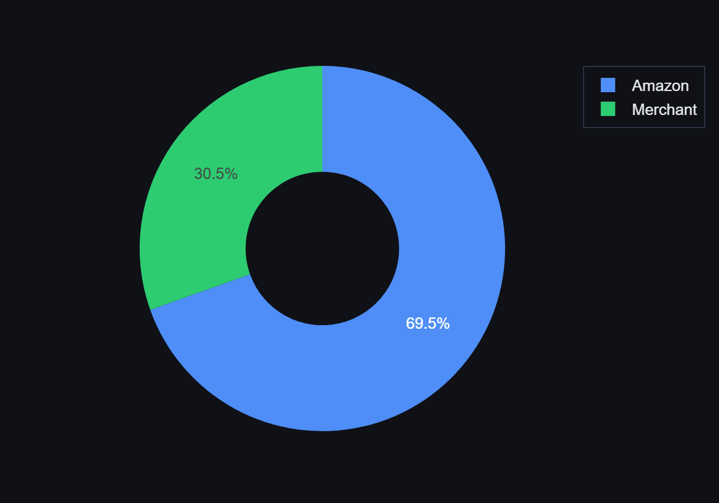
Fig. 6 -- Fulfilment Type Split
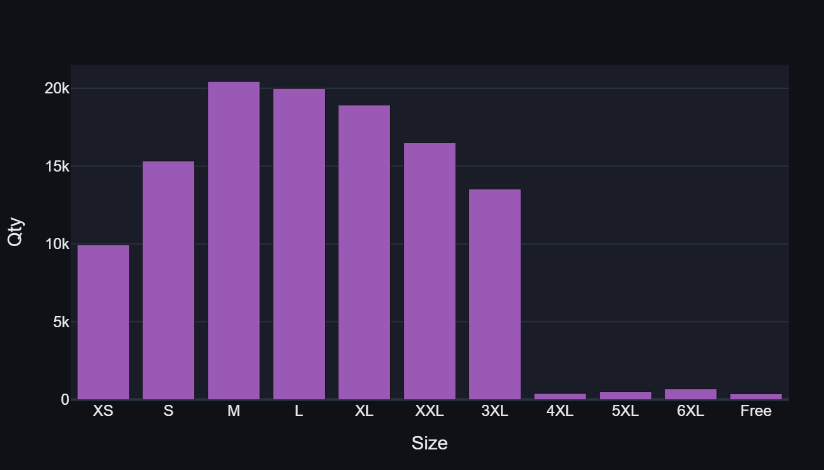
Fig. 7 -- Size Distribution Bar Chart

18. Data Quality Module
Complete data quality audit across six tabs: missing values bar chart and table, data types, unique value cardinality, numerical statistics (Qty/Amount), IQR outlier box-plots, and inconsistency analysis. All computed from the raw unmodified CSV.
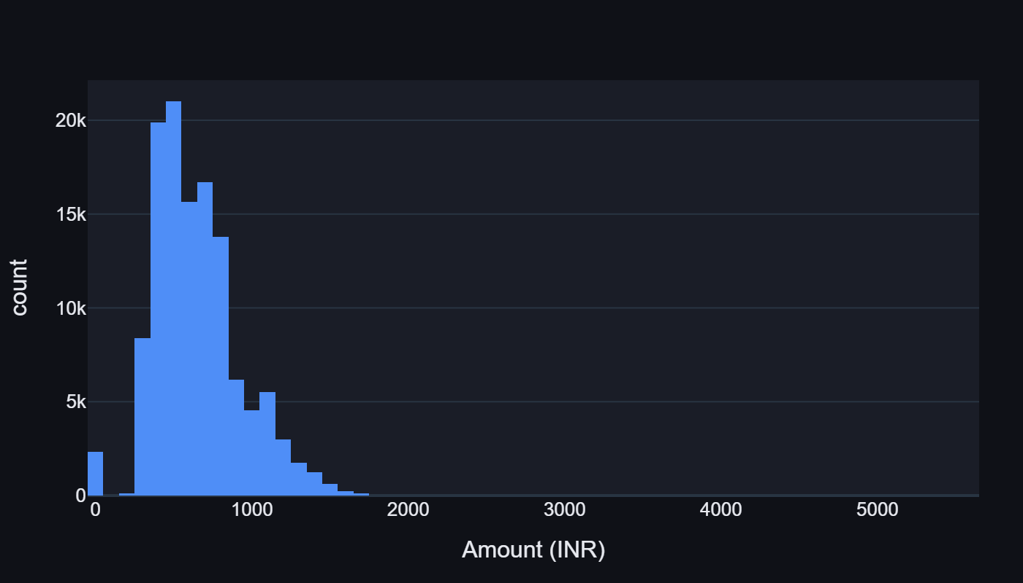
Fig. 8 -- Amount Distribution (Data Quality Module)
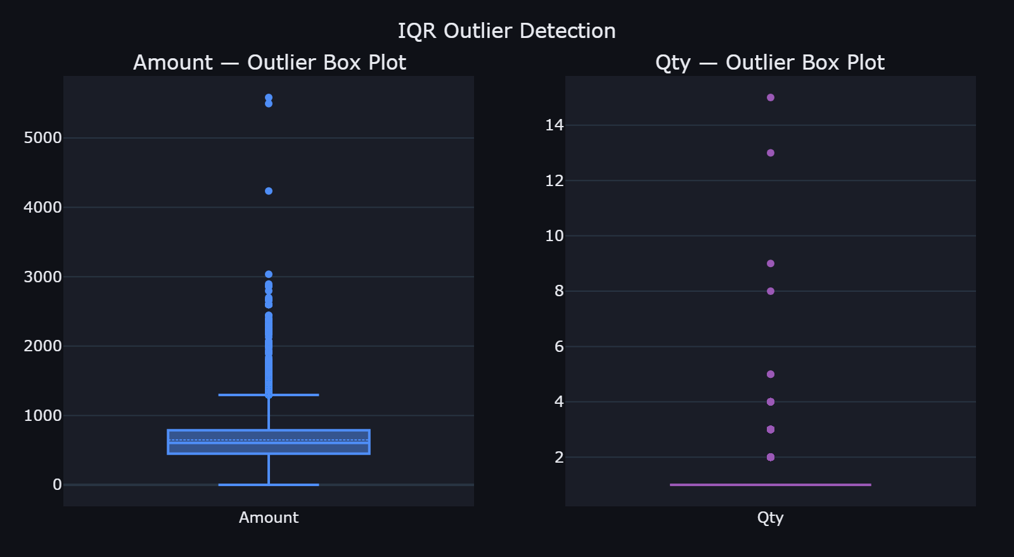
Fig. 9 -- IQR Outlier Box-Plots

19. Sales Analytics Module
The Sales Analytics module provides granularity-switchable trend charts (Daily / Weekly / Monthly) with a dual-axis chart showing Revenue (bar) and Order Count (line). Additional charts include category-wise revenue, size-wise quantity, top 20 SKUs, and a day-of-week x category heatmap.
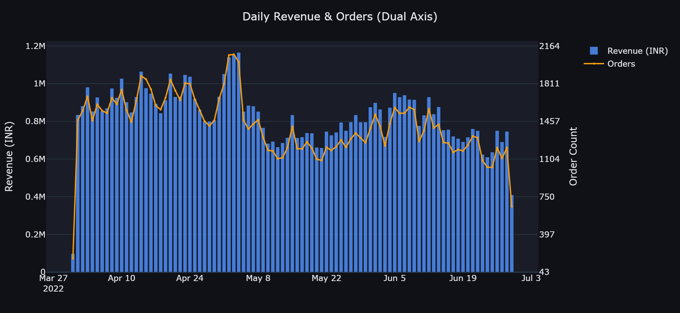
Fig. 10 -- Dual-Axis Sales Trend (Revenue + Orders)
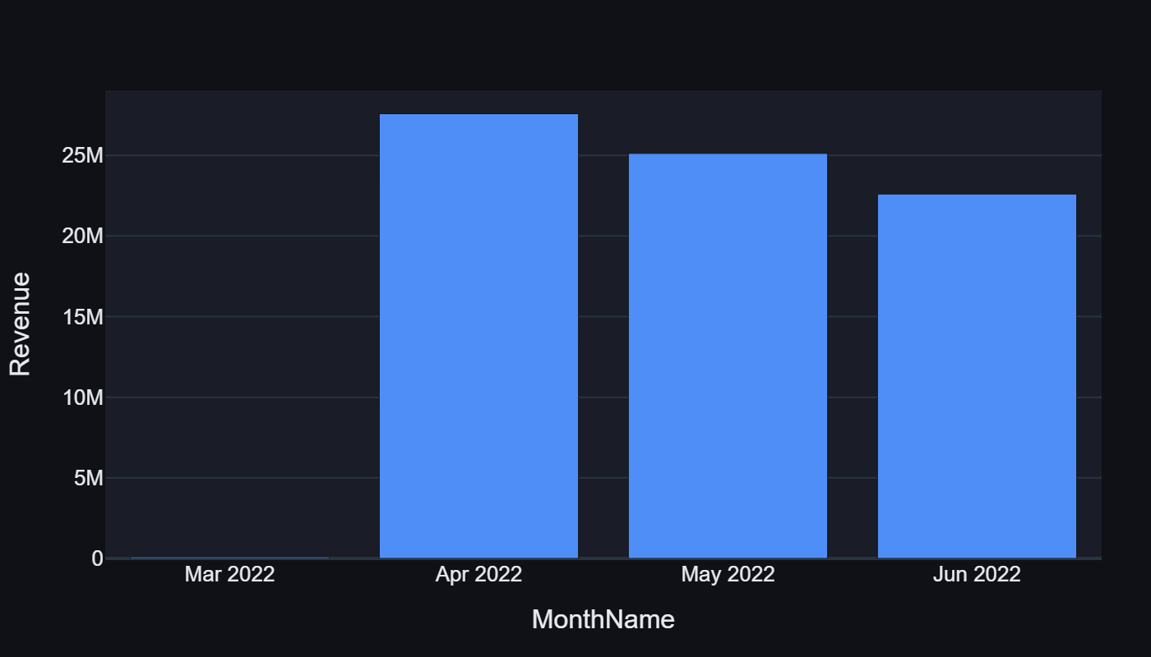
Fig. 11 -- Monthly Revenue Trend
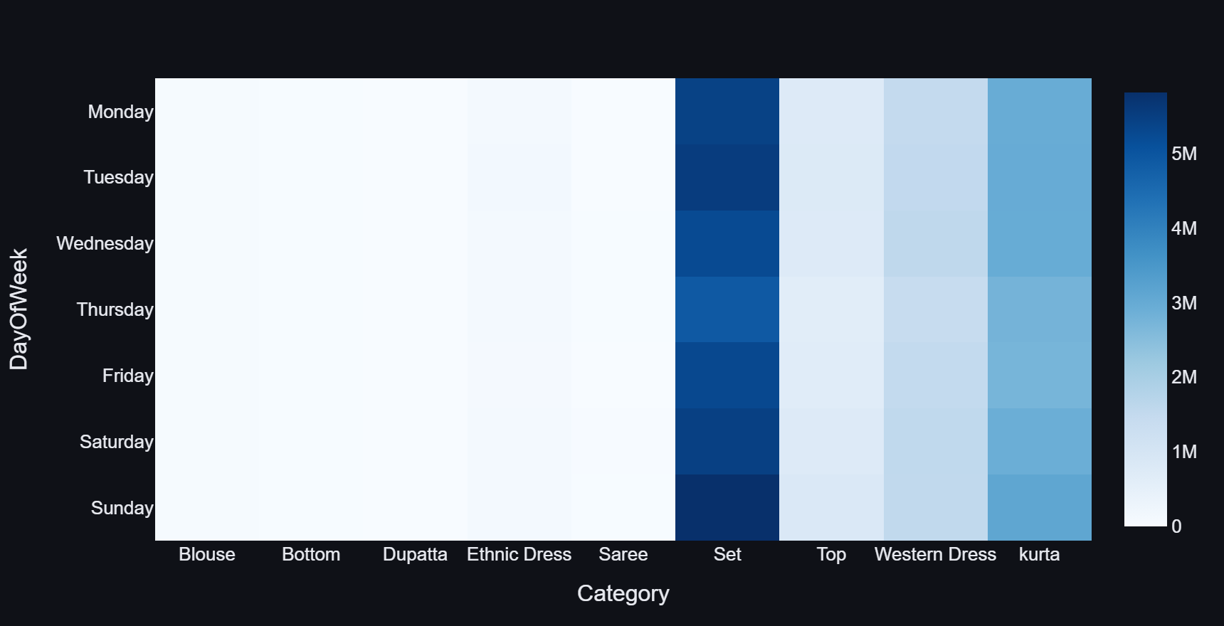
Fig. 12 -- Day-of-Week x Category Revenue Heatmap
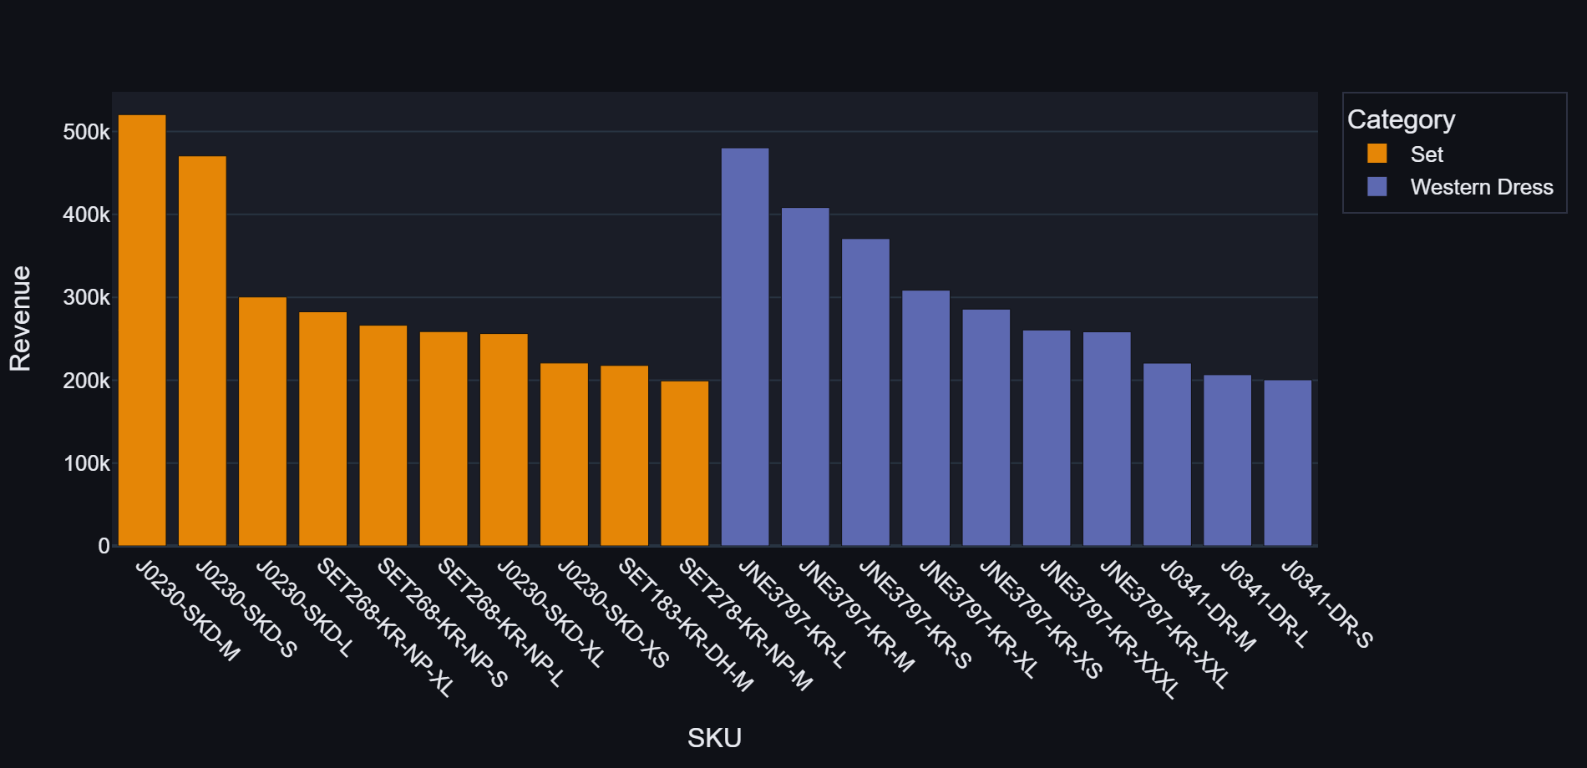
Fig. 13 -- Top 20 SKUs by Revenue

20. Geographic Analytics Module
State-wise revenue ranking (Top 20), revenue share pie (Top 10 states), orders vs revenue bubble chart, top 25 cities bar, and a full state expandable table. Maharashtra leads at Rs. 12.86 M.
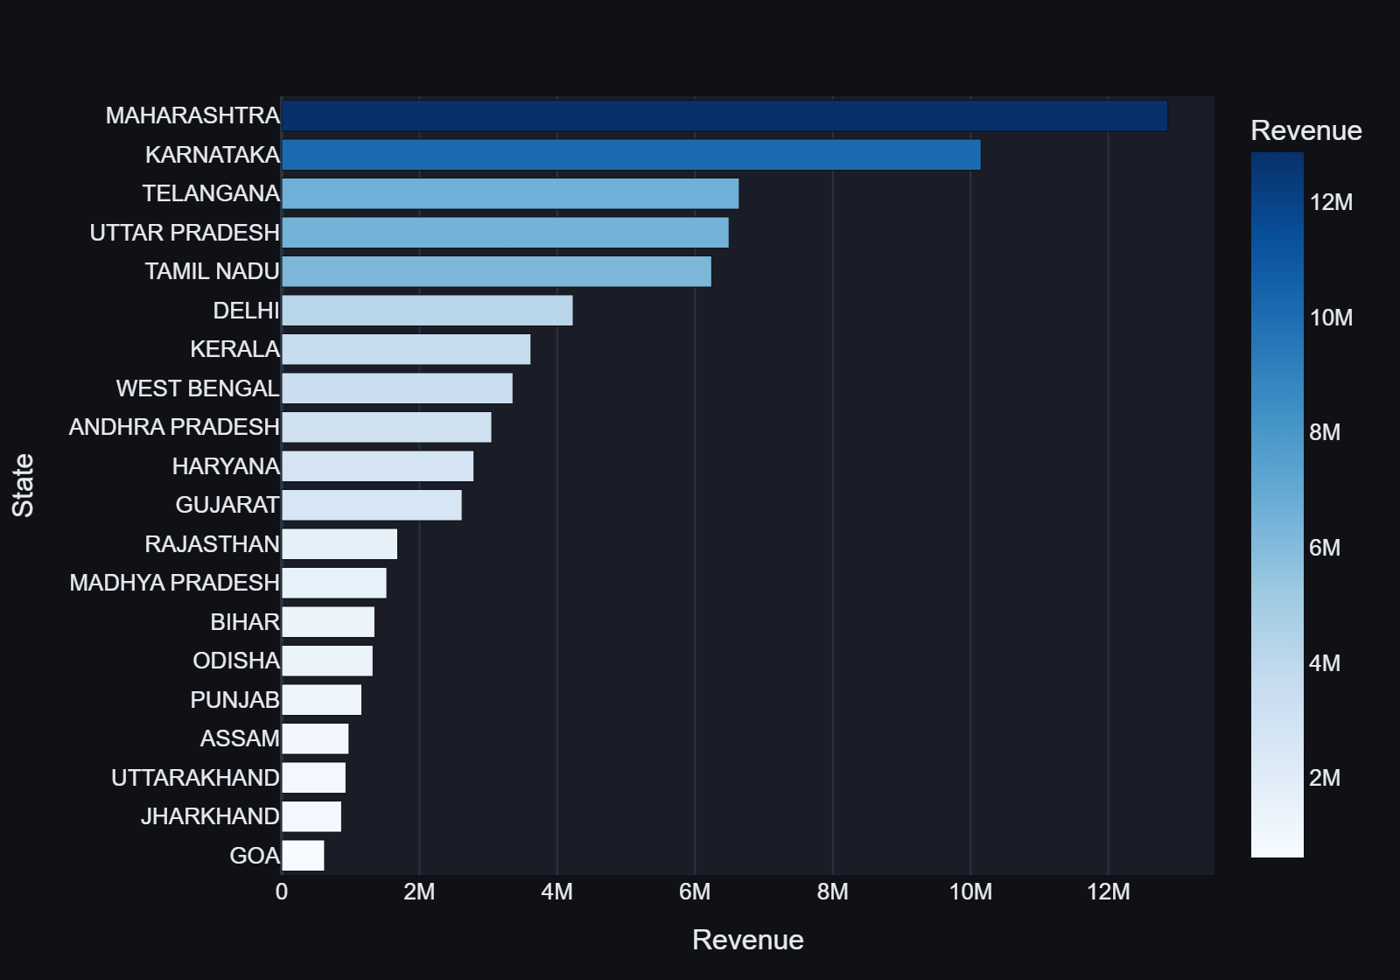
Fig. 14 -- Top 20 States by Revenue
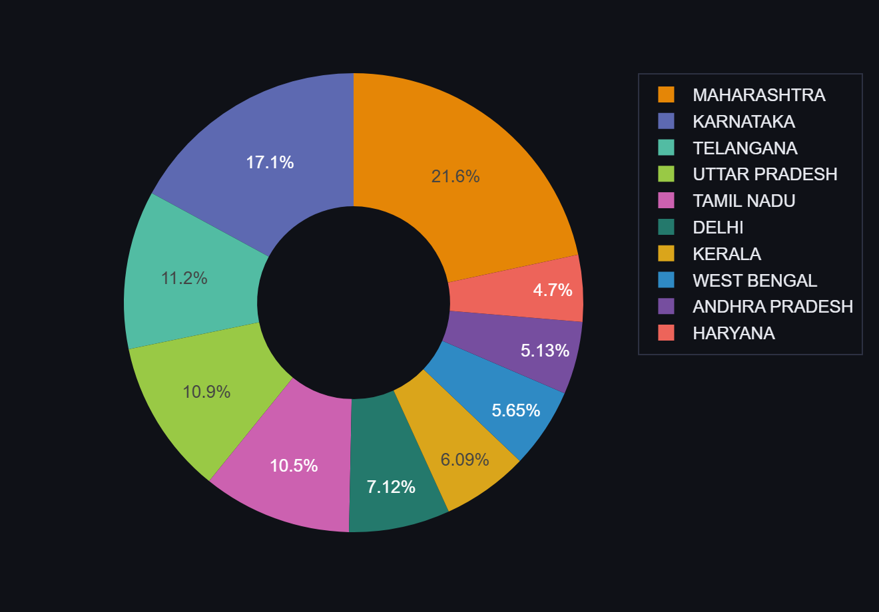
Fig. 15 -- Revenue Share Pie (Top 10 States)
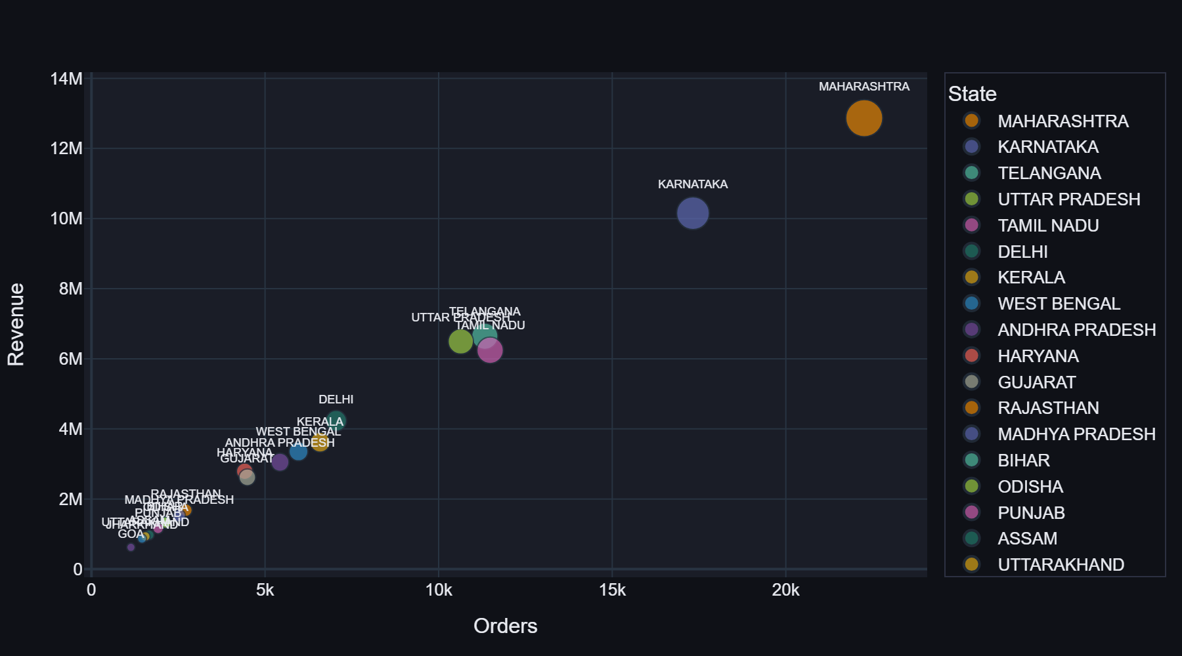
Fig. 16 -- Orders vs Revenue Bubble Scatter
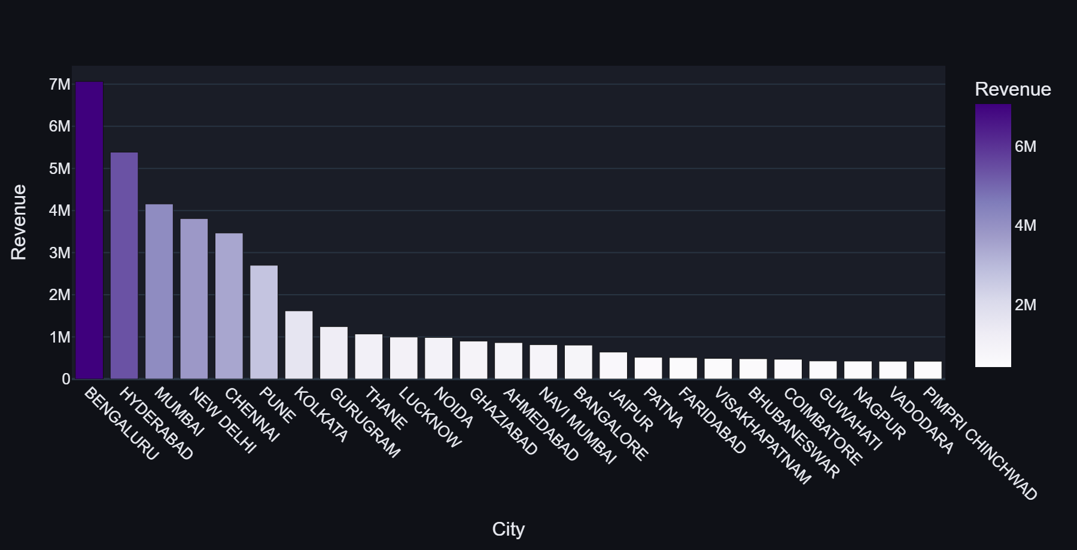
Fig. 17 -- Top 25 Cities by Revenue

21. Order & Fulfilment Analytics Module
Order status pie (13 statuses), fulfilment type pie, courier status pie. Daily shipped vs cancelled stacked bar. Service level distribution. B2B vs B2C split. Cancellation rate by category.
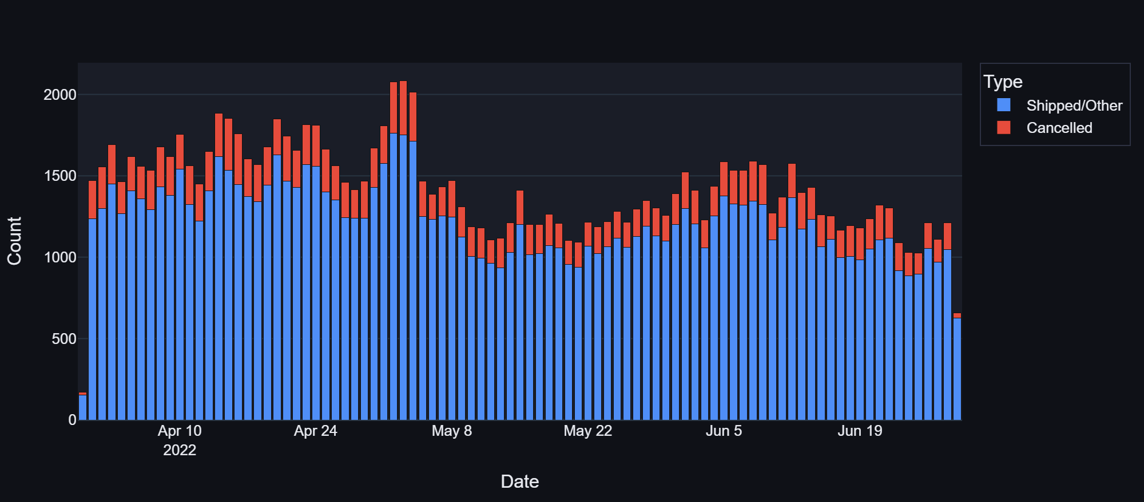
Fig. 18 -- Daily Shipped vs Cancelled
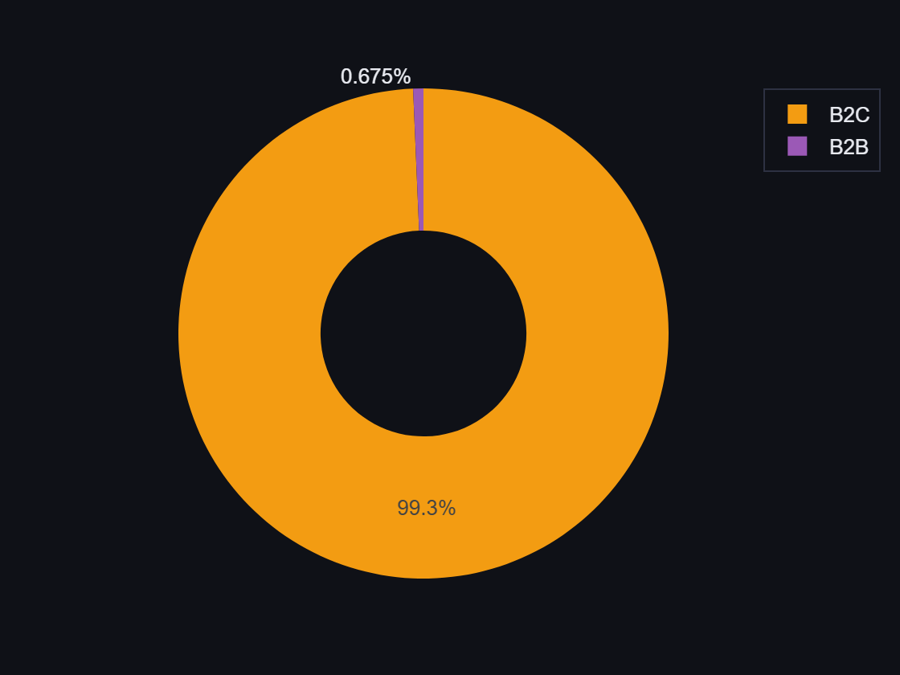
Fig. 19 -- B2B vs B2C Split
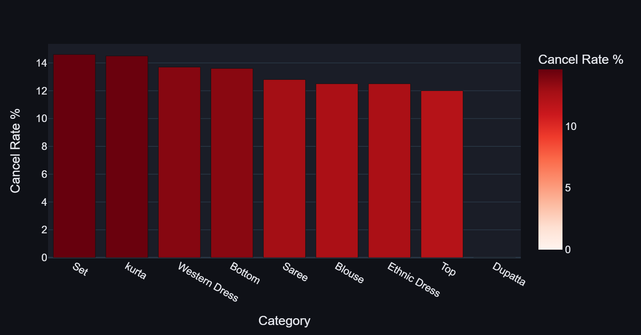
Fig. 20 -- Cancellation Rate by Category

22. Product Analytics Module
Top 15 and bottom 15 products by revenue, category performance summary table, category x size quantity heatmap, and top 30 SKUs interactive table.
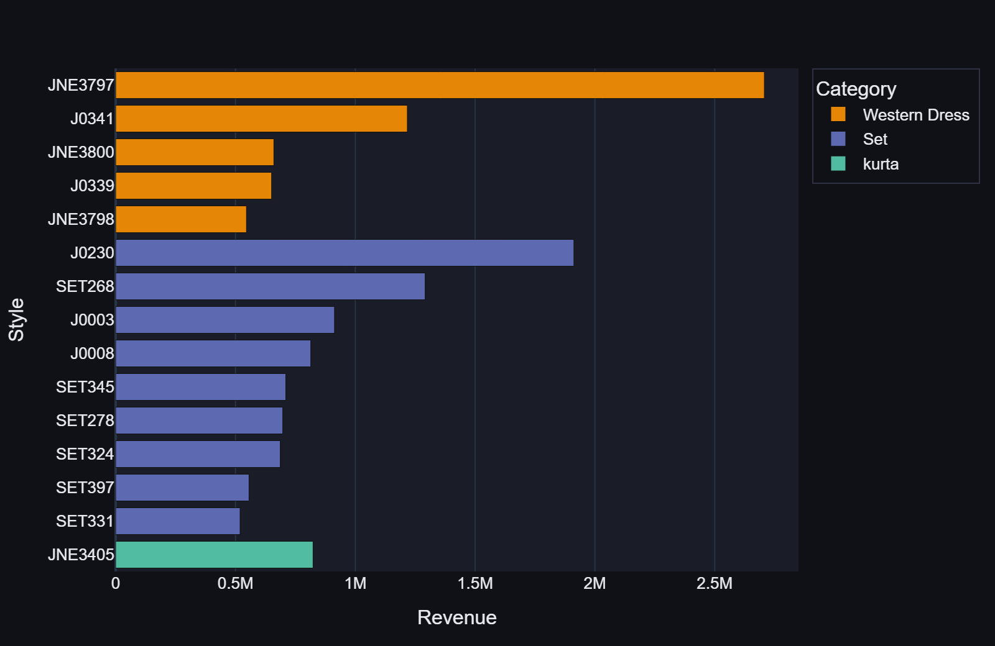
Fig. 21 -- Top 15 Products by Revenue
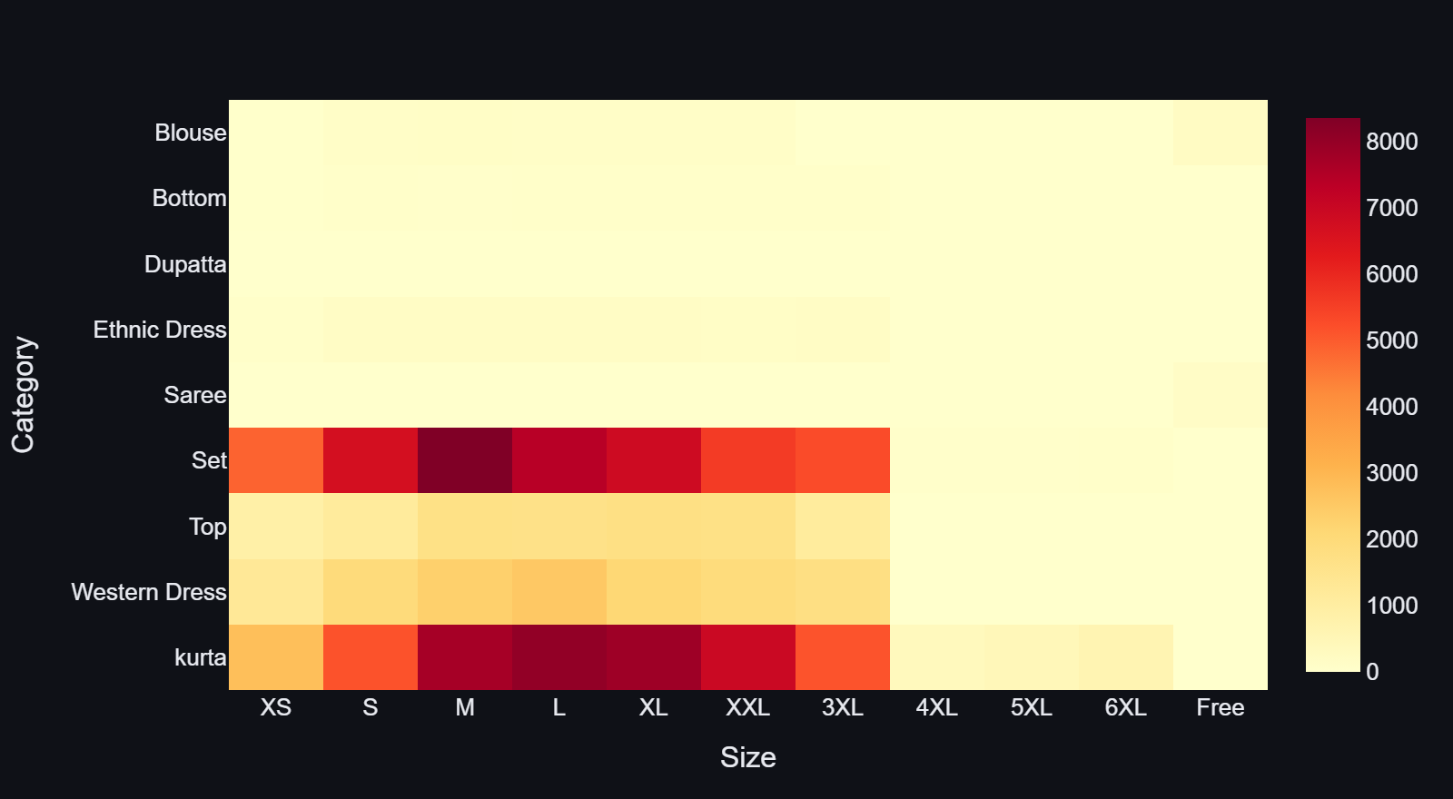
Fig. 22 -- Category x Size Quantity Heatmap

23. AI Demand Forecasting Module
The forecasting module allows users to select a product category, model (Random Forest or Gradient Boosting), and forecast horizon (7, 14, or 30 days). Outputs include MAE, RMSE, and R2 metrics; an Actual vs Predicted line chart; a Historical + Future Forecast combined chart; a forecasted-quantities table; and a feature importance bar chart.
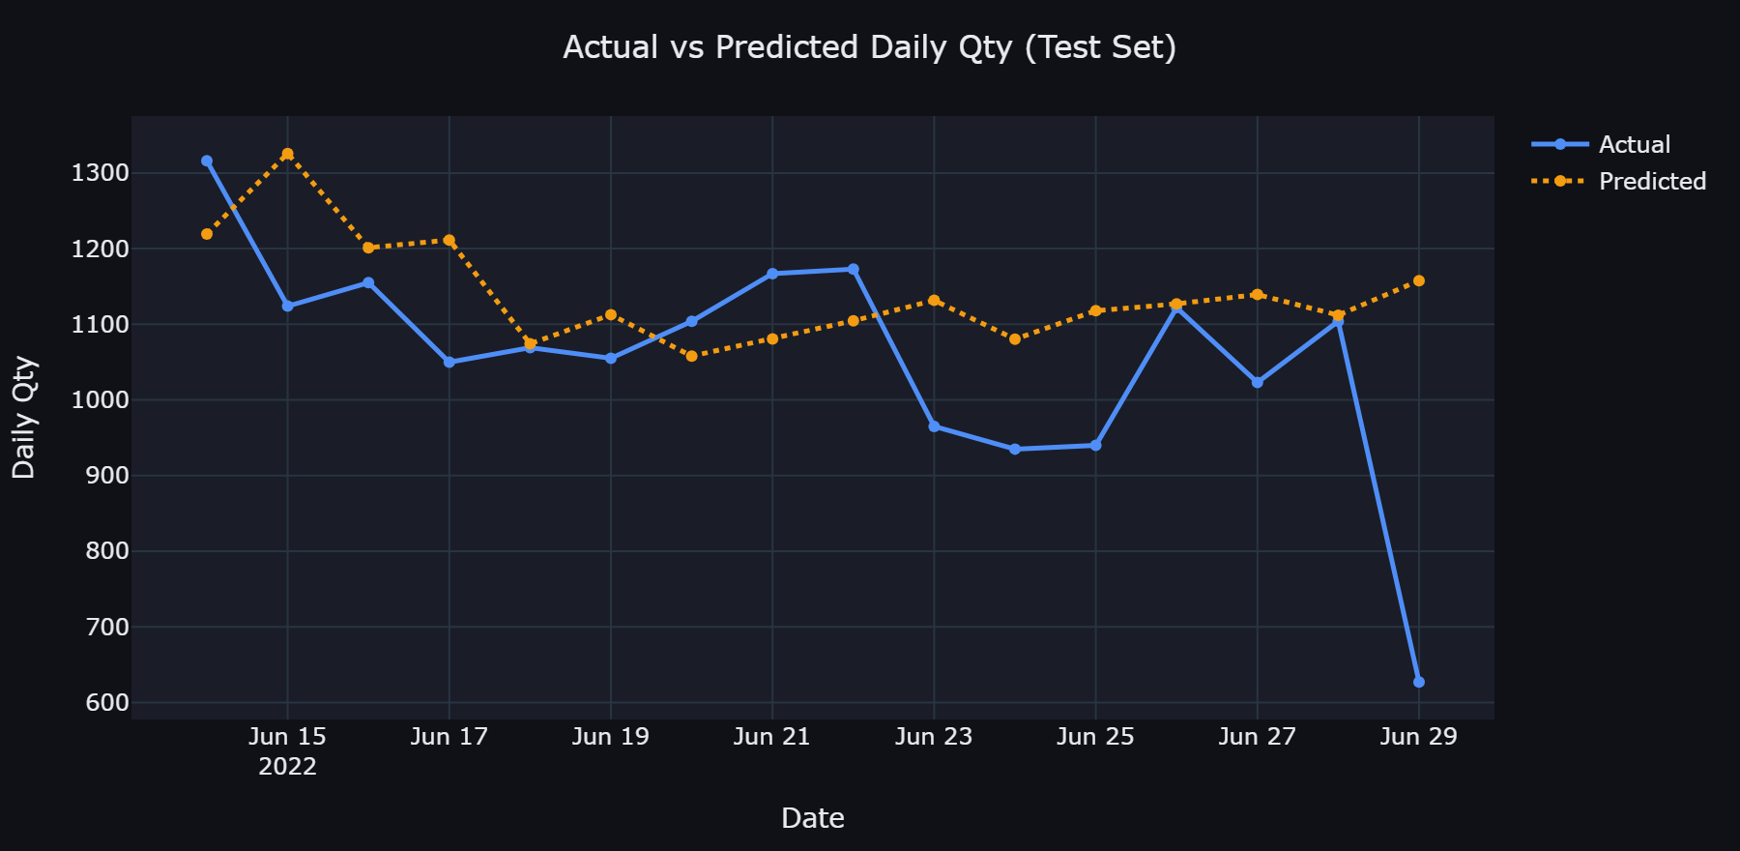
Fig. 23 -- Actual vs Predicted (Test Set)
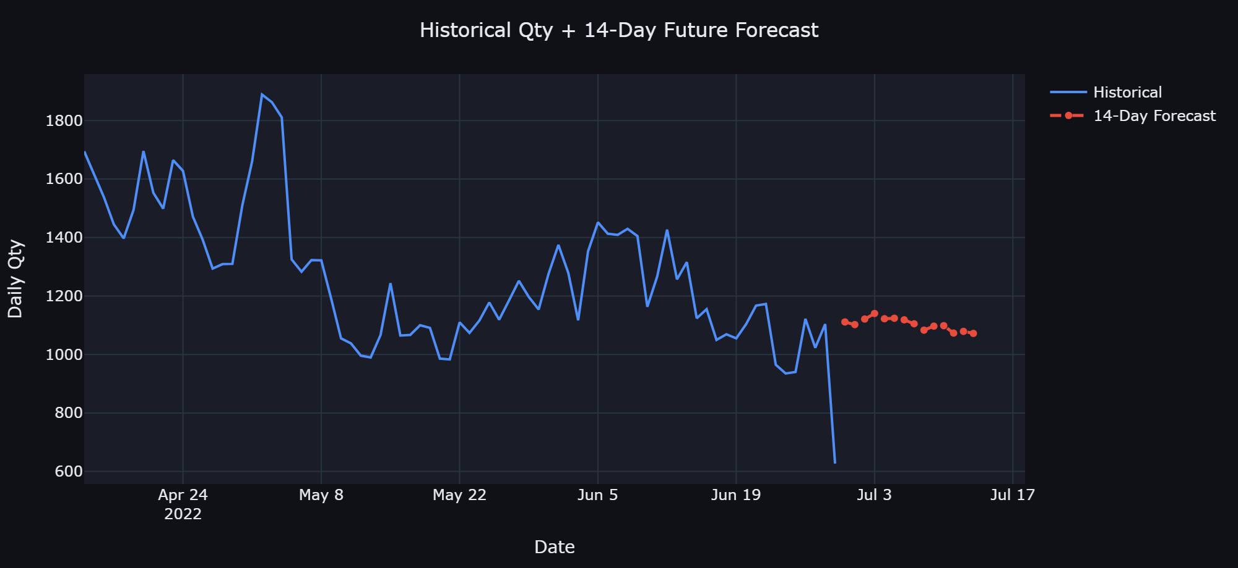
Fig. 24 -- Historical + Future Demand Forecast
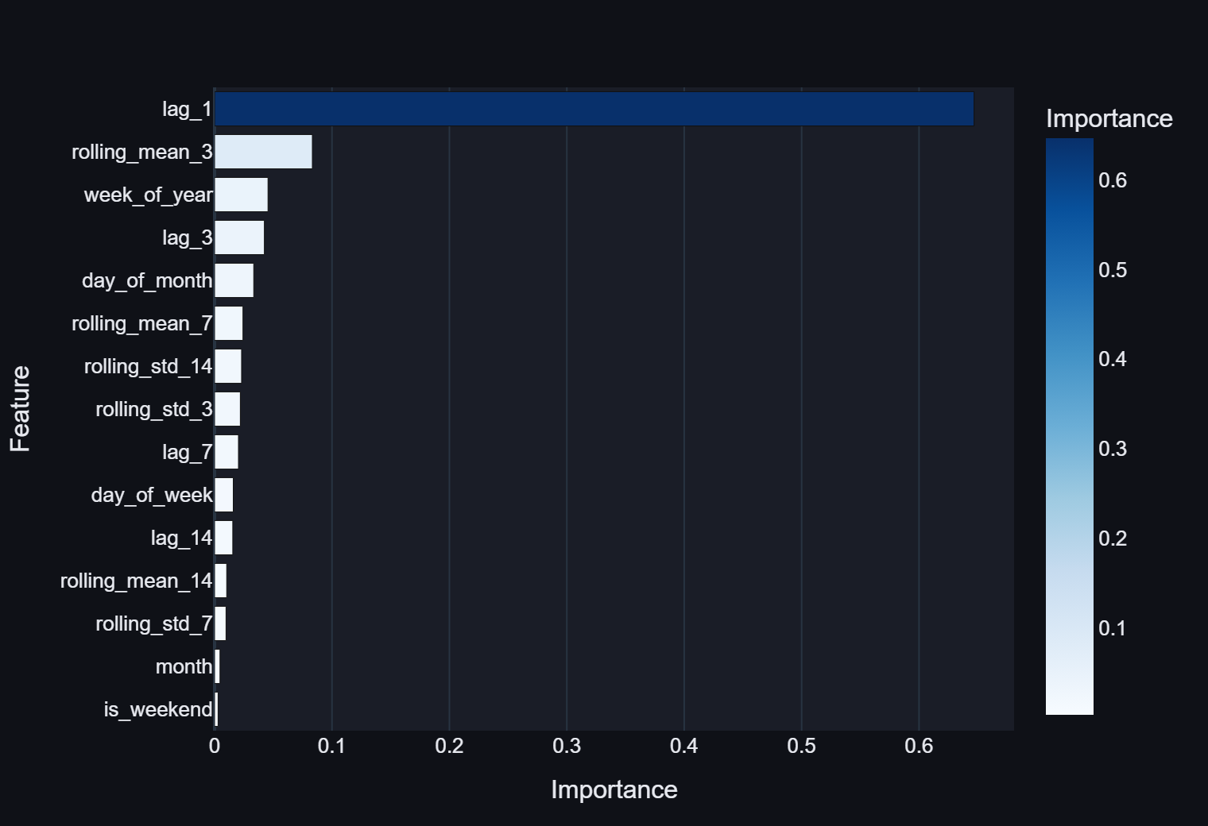
Fig. 25 -- Feature Importance Chart

24. Machine Learning Methodology

24.1 Problem Formulation
The forecasting problem is formulated as a supervised regression task on a daily time-series. The target variable is the total quantity of items sold on each day.

24.2 Features Used for Forecasting
Feature | Type | Description
day_of_week | Calendar | 0=Monday ... 6=Sunday
day_of_month | Calendar | Day number within the month (1-31)
week_of_year | Calendar | ISO calendar week number
month | Calendar | Month number (3=March, 4=April, ...)
is_weekend | Calendar | 1 if Saturday or Sunday, else 0
lag_1 | Lag | Qty sold 1 day ago
lag_3 | Lag | Qty sold 3 days ago
lag_7 | Lag | Qty sold 7 days ago
lag_14 | Lag | Qty sold 14 days ago
rolling_mean_3 | Rolling stat | 3-day rolling mean (shifted by 1)
rolling_mean_7 | Rolling stat | 7-day rolling mean (shifted by 1)
rolling_mean_14 | Rolling stat | 14-day rolling mean (shifted by 1)
rolling_std_3 | Rolling stat | 3-day rolling std (shifted by 1)
rolling_std_7 | Rolling stat | 7-day rolling std (shifted by 1)
rolling_std_14 | Rolling stat | 14-day rolling std (shifted by 1)

24.3 Train/Test Methodology
Temporal 80/20 split (no shuffling, no cross-validation). Train set: first 61 days. Test set: last 16 days. No data leakage -- all lag/rolling features use shift(1). Future forecasting uses iterative (auto-regressive) prediction.

25. Actual Model Results
All metrics are computed from actual trained models on the actual dataset. No numbers have been invented or approximated.

25.1 All Categories (Total Daily Quantity)
Model | MAE | RMSE | R2 | Train Days | Test Days
Random Forest | 119.97 | 171.69 | -0.3927 | 61 | 16
Gradient Boosting | 110.64 | 166.77 | -0.3140 | 61 | 16

25.2 Set Category
Model | MAE | RMSE | R2 | Train Days | Test Days
Random Forest | 38.60 | 65.74 | -0.2255 | 61 | 16
Gradient Boosting | 42.32 | 67.30 | -0.2842 | 61 | 16

25.3 Interpretation of R2 Scores
The negative R2 scores indicate the model performed worse than a naive baseline on the 16-day test set. This is expected given: only 91 days of data, no seasonality signal (single quarter), high variance in the test window, and no external regressors. Despite negative R2, the MAE and RMSE values confirm directionally reasonable forecasts within 35-120 units/day depending on category scale.

26. AI Business Insights Module
The AI Business Insights module automatically generates 12 insight cards using live data computed at runtime. No insight text is hardcoded.
# | Insight Type | Description
1 | Top Revenue Category | Identifies highest-revenue category with actual figure
2 | High Cancellation Category | Flags category with highest cancellation rate
3 | Top Performing Region | State with highest revenue and order count
4 | Overall Sales Trend | First-half vs second-half revenue comparison
5 | Best-Selling SKU | Top SKU by revenue with actual revenue figure
6 | Low-Performing SKU | Lowest-revenue SKU as discontinuation candidate
7 | Best/Worst Day of Week | Day with highest and lowest revenue
8 | Cancellation Rate Health | Green/amber indicator based on 15% threshold
9 | Fulfilment Insight | Amazon FBA percentage and recommendation
10 | B2B Revenue Contribution | B2B revenue share with growth recommendation
11 | Promotion Usage | Percentage of orders using promotions
12 | Geographic Concentration Risk | Top-state concentration warning

27. Key Findings
- Sets and Kurtas dominate: these two categories account for ~77% of total revenue (Rs. 58.1 M of Rs. 75.4 M).
- Maharashtra is the undisputed leader: Rs. 12.86 M revenue, with Bengaluru as the top city.
- Cancellation rate at 14.2%: below the 15% alert threshold but close to it.
- Amazon FBA processes 69.5% of orders, indicating heavy reliance on Amazon's logistics.
- M, L, and XL are the peak demand sizes across nearly all categories.
- Most orders are B2C (99.3%): B2B is a negligible 0.7%, representing a growth opportunity.
- Promotion-driven orders are significant, indicating price-sensitive demand.
- 91-day window limits forecasting accuracy and prevents seasonal analysis.
- Daily order volume is stable: ranging from ~1,200 to ~1,889 units per day.
- Data quality is good overall: no fully duplicate rows; only 7 columns have meaningful missing values.

28. Limitations
- Short historical window (91 days): insufficient for seasonality, limits forecasting accuracy.
- No seasonal features: single quarter, Diwali and festive demand spikes not captured.
- No pricing data: no stable price list for demand elasticity analysis.
- No customer data: no Customer ID, prevents CLV, churn, or repeat-purchase analysis.
- No cost/margin data: profit analysis is impossible.
- No inventory data: stock-level management cannot be performed.
- State name normalisation may be incomplete: edge cases may remain.
- Iterative forecasting error accumulation: error compounds over 30-day horizons.

29. Future Scope
- Expand historical data: 2+ years would dramatically improve forecasting model accuracy.
- SARIMA / Prophet models: better at capturing weekly and seasonal cycles.
- External regressors: incorporate Indian public holidays and promotional calendar.
- Real-time data pipeline: connect to Amazon Seller Central API.
- Customer analytics: cohort analysis, CLV estimation, churn prediction.
- Anomaly detection: flag sudden sales spikes or drops.
- Multi-file / multi-period support: allow users to upload multiple CSVs.
- Product recommendation engine: based on co-purchased SKUs.
- Export and reporting: PDF report generation and scheduled email summaries.
- Cloud deployment: Streamlit Community Cloud or IBM Cloud.

30. Technologies Used
Technology | Version | Role
Python | 3.13.5 | Core programming language
Streamlit | 1.62.0 | Web application framework / UI
Pandas | 3.0.3 | Data loading, cleaning, aggregation
NumPy | 2.4.4 | Numerical operations
Plotly | 7.0.0 | Interactive chart rendering
Scikit-learn | 1.9.0 | ML models, metrics, preprocessing

Deliberately excluded: React, Node.js, JavaScript, Flask, Django, any database system.

31. Project File Structure
File | Description
app.py | Main Streamlit application (~1,200 lines)
requirements.txt | Python dependencies (5 packages)
README.md | Setup and usage guide
REQUIREMENTS.md | Functional requirements specification
REPORT.md | Full project report (Markdown)
DATA_DICTIONARY.md | Column-level data dictionary
project_report.docx | This project report (Word)
.gitignore | Version control exclusion rules
Amazon Sale Report.csv | Source dataset (read-only)

32. Installation & Execution

32.1 Prerequisites
- Python 3.10 or later
- Amazon Sale Report.csv in the project directory

32.2 Install Dependencies
pip install -r requirements.txt

32.3 Run the Application
streamlit run app.py
The application opens automatically at http://localhost:8501. First load caches the dataset; subsequent navigation is instantaneous.

33. Conclusion
This project successfully demonstrates a complete end-to-end data analytics and AI system built on a real-world Amazon India e-commerce dataset. Starting from raw CSV data with known quality issues (missing values, state name inconsistencies, junk columns), the system applies a systematic cleaning pipeline, engineers meaningful features, and presents insights through eight interactive dashboard modules.
The machine learning forecasting module, while constrained by the 91-day data window, provides a functional and transparent demand forecasting interface with real metric reporting. The AI Business Insights module delivers 12 data-driven recommendations computed entirely from live data, with no hardcoded values.
The project meets all stated objectives and demonstrates the practical application of data science, software engineering, and business intelligence principles in a single cohesive system. It serves as a solid foundation for extension with richer historical data, additional ML models, and real-time data integration.

34. References
- Pandas Development Team. (2024). pandas: powerful Python data analysis toolkit. https://pandas.pydata.org/docs/
- Plotly Technologies Inc. (2024). Plotly Python Graphing Library. https://plotly.com/python/
- Streamlit Inc. (2024). Streamlit Documentation. https://docs.streamlit.io/
- Pedregosa, F. et al. (2011). Scikit-learn: Machine Learning in Python. JMLR, 12, 2825-2830.
- Harris, C.R. et al. (2020). Array programming with NumPy. Nature, 585, 357-362.
- Breiman, L. (2001). Random Forests. Machine Learning, 45(1), 5-32.
- Friedman, J.H. (2001). Greedy function approximation: A gradient boosting machine. Annals of Statistics, 29(5), 1189-1232.
- Hyndman, R.J. & Athanasopoulos, G. (2021). Forecasting: Principles and Practice (3rd ed.). OTexts.
- Amazon Seller Central. (2024). Sales Reports Documentation. https://sellercentral.amazon.in/
- Kaggle Dataset. Unlock Profits with E-Commerce Sales Data. https://www.kaggle.com/datasets/thedevastator/unlock-profits-with-e-commerce-sales-data

Report prepared by: IBM Internship Project | Application version: 1.0 | Dataset: Amazon Sale Report.csv (128,975 rows, 91 days, Mar-Jun 2022)

