INTERNNOVA

WEEK 4 ASSIGNMENT REPORT
Statistics, Data Visualization & Exploratory Data Analysis

Project Detail | Description
Dataset | Amazon Sale Report
Tools and Libraries | Python, Pandas, NumPy (where applicable), Matplotlib, Seaborn
Tasks Covered | Task 1 to Task 9
Dataset after cleaning | 121,180 rows and 24 columns
Date range shown by analysis | March 2022 to June 2022

Prepared as a practical report for the Week 4 assignment

Contents
- 1. Introduction and Objectives
- 2. Dataset and Tools
- 3. Task 1 — Mean, Median and Mode
- 4. Task 2 — Variance and Standard Deviation
- 5. Task 3 — Correlation and Probability
- 6. Task 4 — Outlier Detection using IQR
- 7. Task 5 — Data Visualization with Matplotlib
- 8. Task 6 — Data Visualization with Seaborn
- 9. Task 7 — Data Inspection and Cleaning
- 10. Task 8 — Correlation Analysis and Insights
- 11. Task 9 — Business Recommendations
- 12. Overall Conclusion

1. Introduction and Objectives
This assignment applies statistical analysis, data visualization and exploratory data analysis (EDA) to an Amazon sales dataset. Python is used to inspect the data, calculate descriptive statistics, identify outliers, visualize sales patterns, clean the dataset and develop practical business recommendations.

Objectives
- Calculate central tendency and dispersion measures for sales.
- Explore the relationship between quantity and order amount and calculate a probability.
- Detect potential outliers using the Interquartile Range (IQR) method.
- Create visualizations using Matplotlib and Seaborn.
- Inspect and clean missing, inconsistent and invalid values.
- Summarize findings and translate them into data-driven business recommendations.

2. Dataset and Tools
The analysis uses Amazon Sale Report.csv and the cleaned file Amazon_Sales_Cleaned.csv. The original dataset contains 128,975 rows and 24 columns. After cleaning rows without usable Amount or Qty values, the working cleaned dataset contains 121,180 rows and 24 columns.
Item | Details
Original dataset size | 128,975 rows × 24 columns
Cleaned dataset size | 121,180 rows × 24 columns
Important fields | Date, Category, Qty, Amount, Order ID, Status, Sales Channel
Python libraries | Pandas, Matplotlib, Seaborn
Currency label used in charts | INR (as labelled in the analysis)

Note: the data spans parts of March and June 2022 as well as April and May. Monthly totals for partial months should not be compared directly with complete months without considering the number of days represented.

3. Task 1 — Mean, Median and Mode
Objective: calculate common measures of central tendency for the Amount/Sales variable.
Measure | Result
Total records in original dataset | 128,975
Mean sales amount | 648.56
Median sales amount | 605.00
Mode sales amount | 399.00

Interpretation: the mean is higher than the median, suggesting that some larger order amounts pull the average upward. The mode of 399.00 is the most frequently occurring sales amount reported by the analysis.
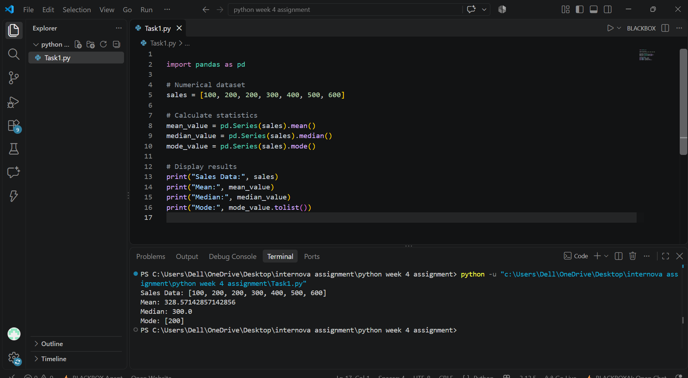
Task 1 — Python code and terminal output.
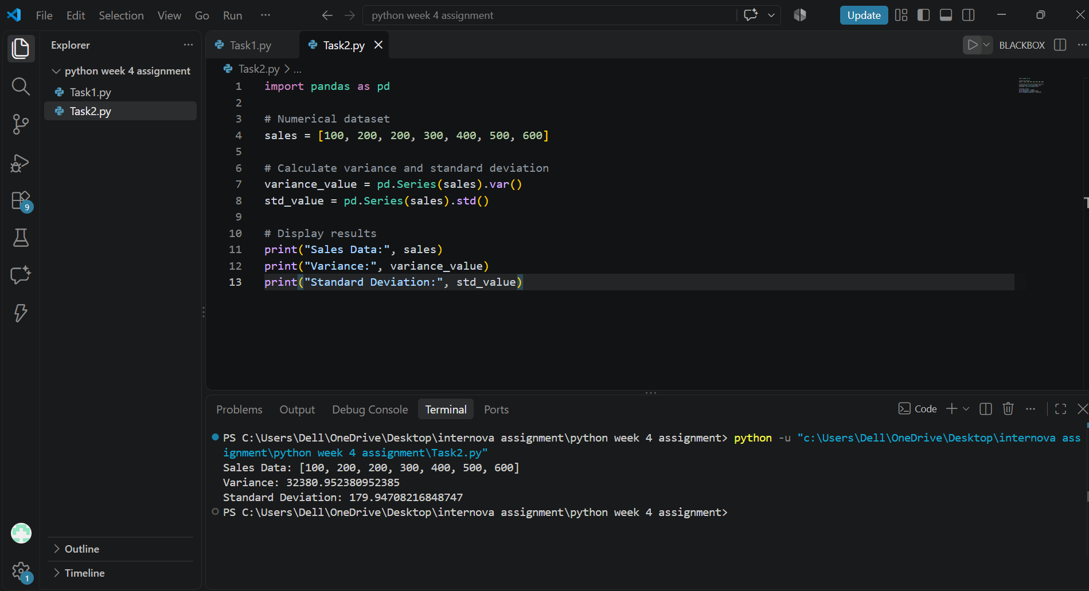
Task 1/2 — working code screenshot retained from the assignment workflow.

4. Task 2 — Variance and Standard Deviation
Objective: measure how widely sales amounts are spread around their average.
Measure | Result
Variance of sales | 79,080.0130
Standard deviation of sales | 281.2117

Interpretation: the standard deviation indicates that individual sales amounts vary meaningfully around the mean. Variance is expressed in squared units, while standard deviation is in the same units as Amount.
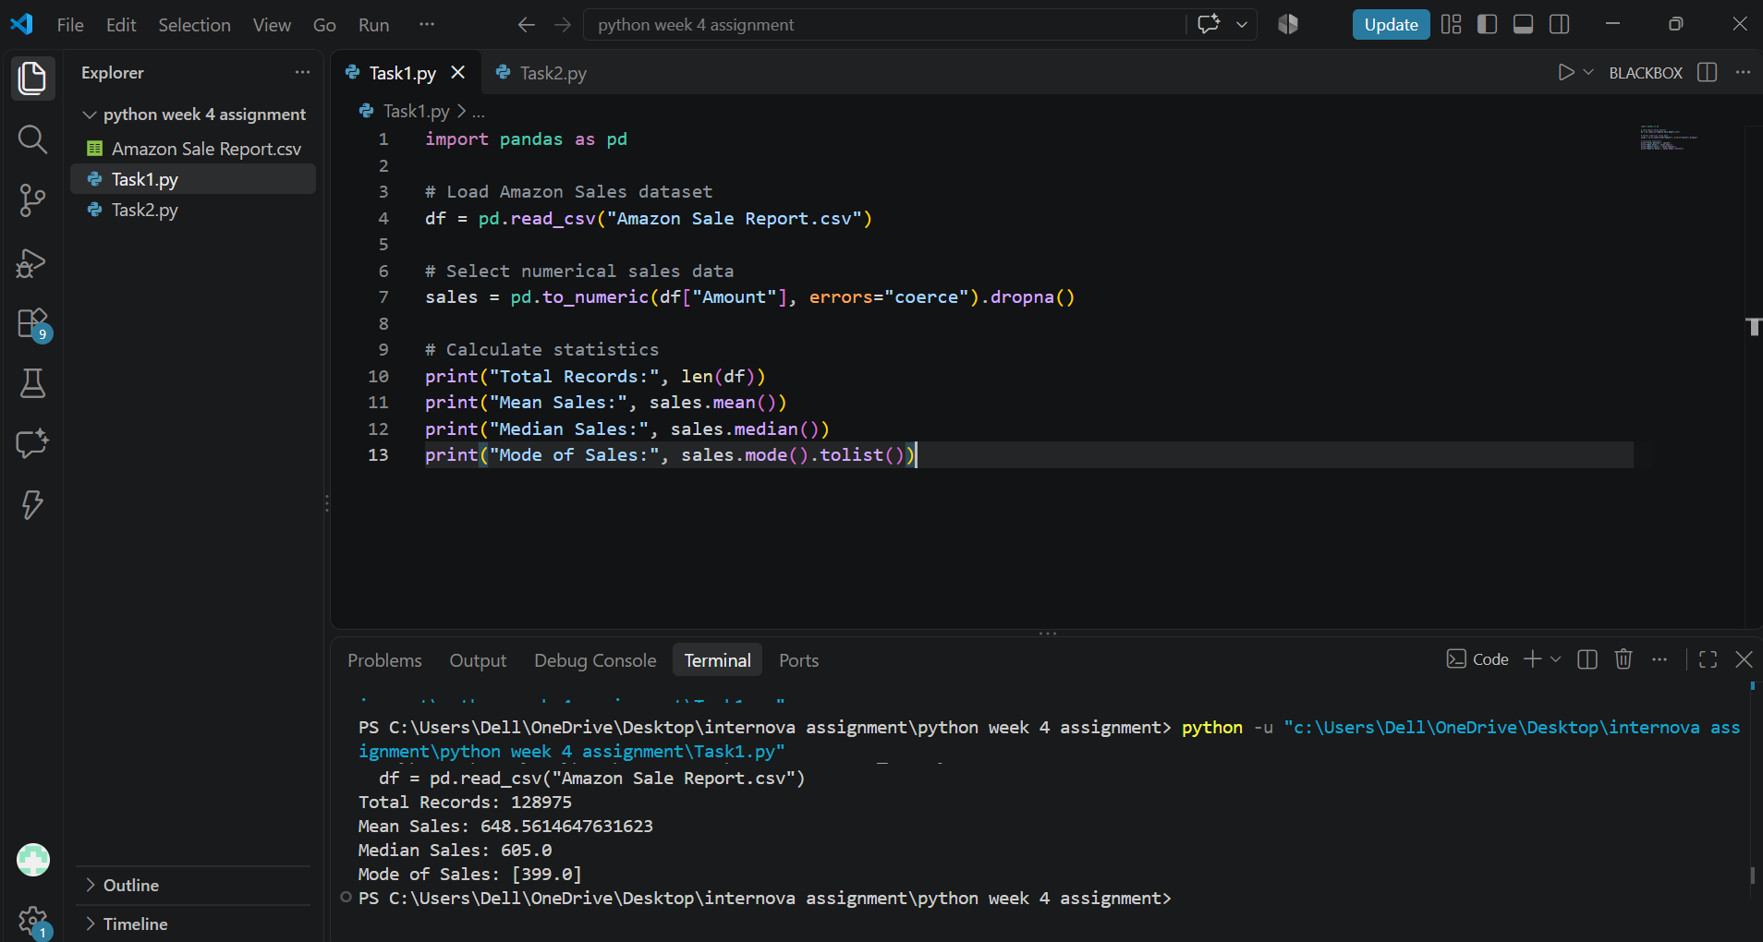
Task 2 — Python analysis screenshot.
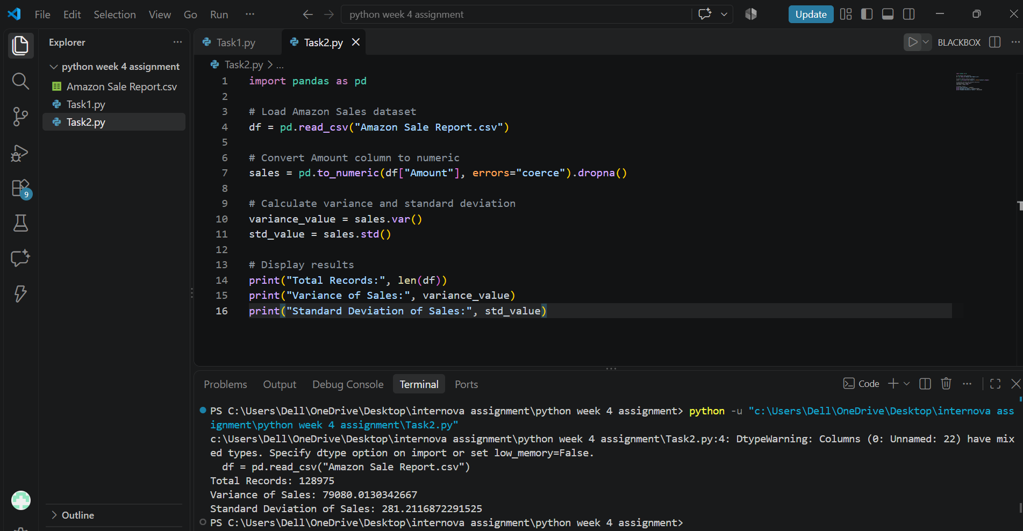
Task 2 — code/output workflow screenshot.

5. Task 3 — Correlation and Probability
Objective: calculate the linear relationship between Qty and Amount and estimate the probability that Amount exceeds 1,000.
Metric | Result
Correlation between Qty and Amount | 0.0669
Valid records used for probability | 121,180
Records with Amount > 1,000 | 13,332
Estimated probability | 0.1100 (about 11.00%)

Interpretation: the correlation is weakly positive and close to zero, so quantity alone does not strongly explain order amount through a linear relationship. Approximately 11% of the valid records used in this calculation have an Amount greater than 1,000.
Task 3 — code screenshot from the statistical analysis workflow.
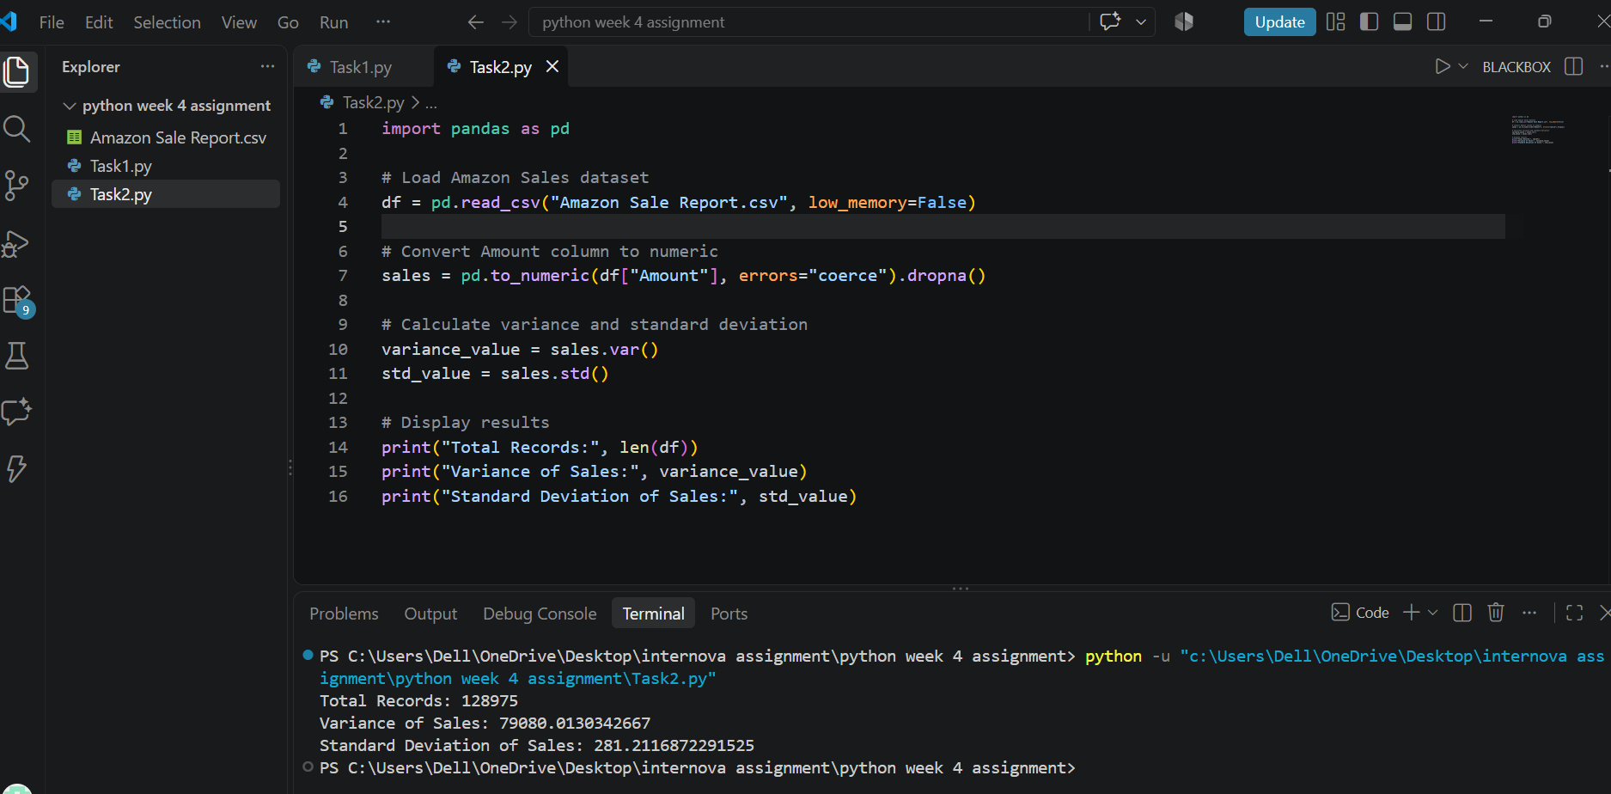
Task 3 — analysis output screenshot.

6. Task 4 — Outlier Detection using IQR
Objective: identify unusually high or low Amount values using the Interquartile Range method.
Statistic | Result
First quartile (Q1) | 449.00
Third quartile (Q3) | 788.00
IQR (Q3 − Q1) | 339.00
Lower bound | -59.50
Upper bound | 1,296.50
Number of detected outliers | 3,600

The IQR method flags values below Q1 − 1.5 × IQR or above Q3 + 1.5 × IQR. The detected values should be investigated, not automatically deleted: some may be legitimate high-value orders.
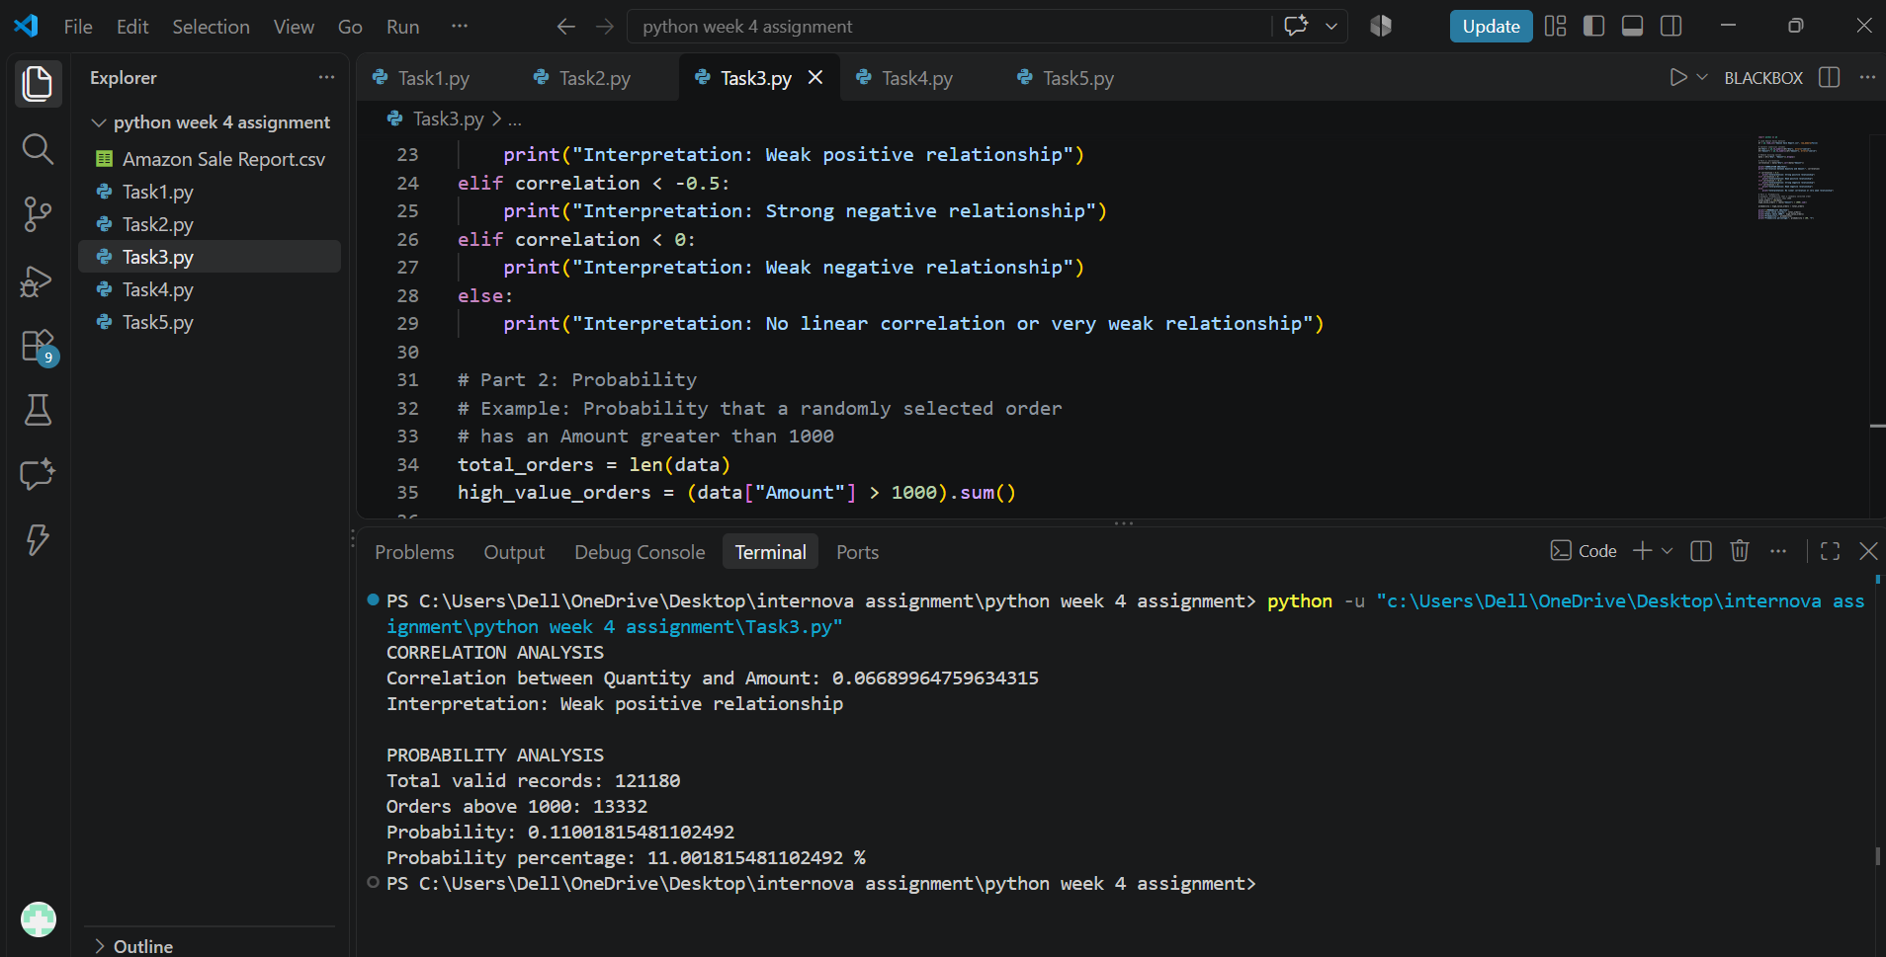
Task 4 — outlier analysis screenshot.
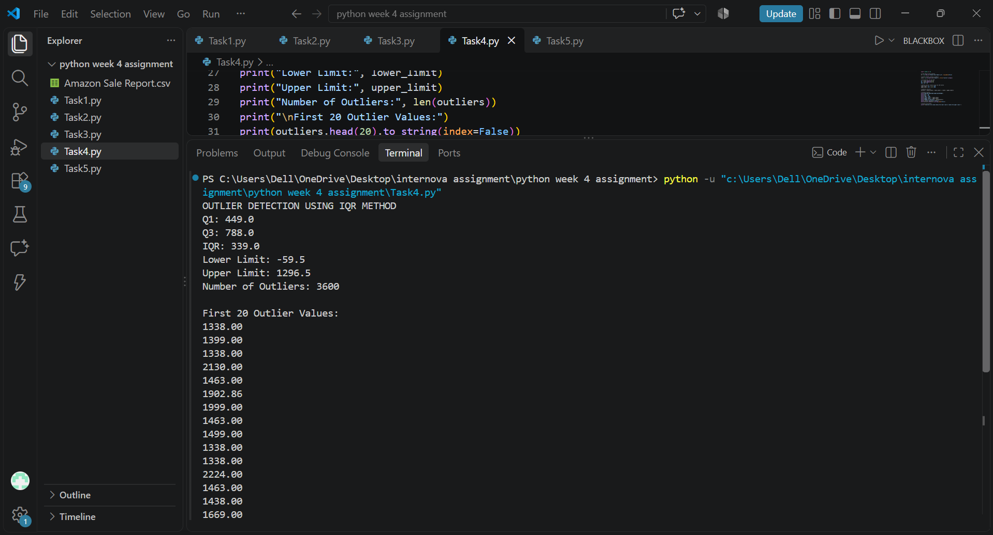
Task 4 — terminal output / outlier results.

7. Task 5 — Data Visualization with Matplotlib
Objective: use Matplotlib to communicate different aspects of the sales dataset through multiple chart types.
- Line chart: monthly sales trend.
- Bar chart: top product categories.
- Pie chart: sales share of the leading categories.
- Histogram: distribution of order amounts.
- Scatter plot: quantity compared with order amount.
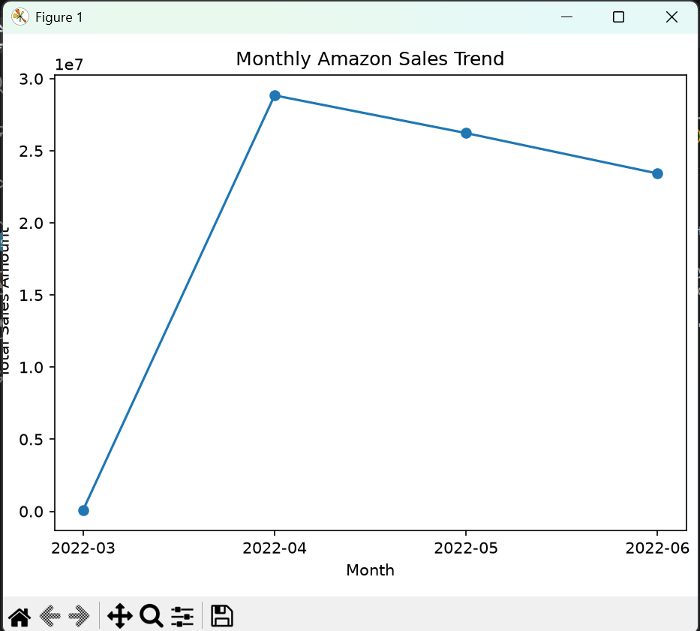
Figure 5.1 — Monthly Amazon sales trend.
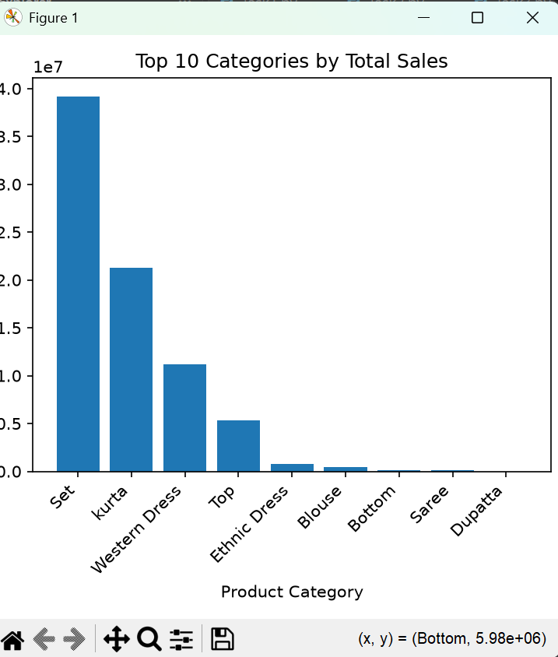
Figure 5.2 — Top categories by sales.
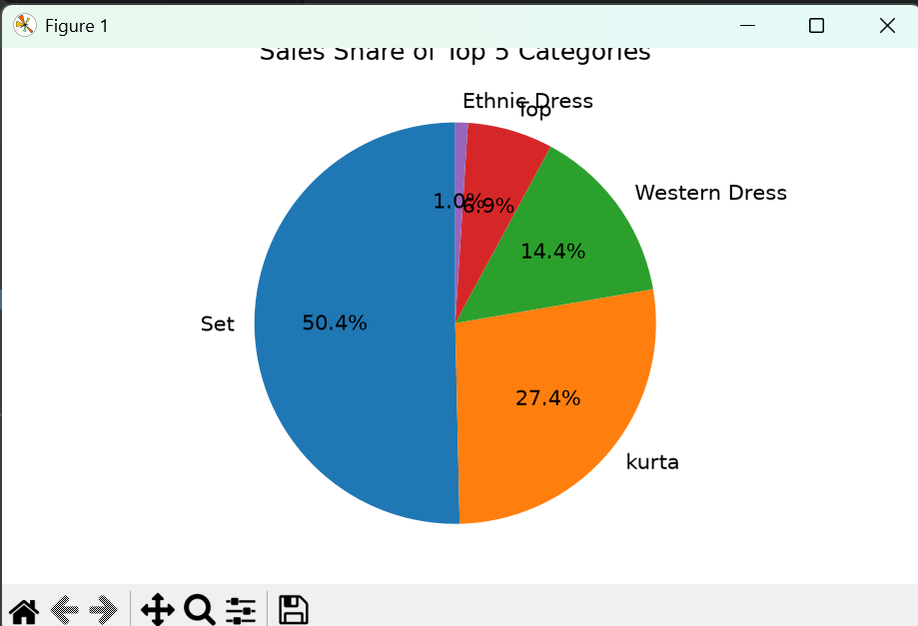
Figure 5.3 — Sales share across leading categories.
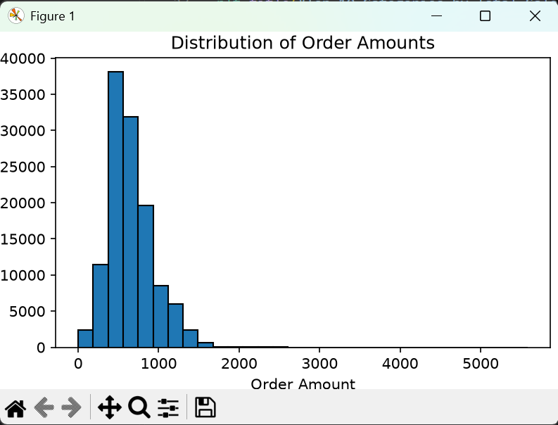
Figure 5.4 — Distribution of order amounts.
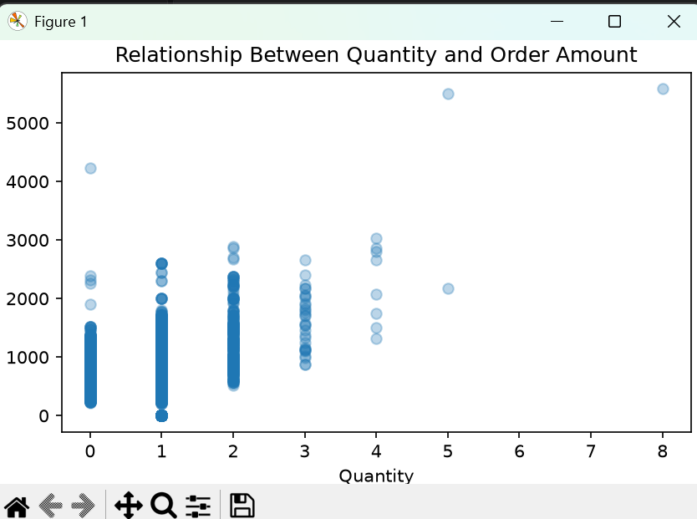
Figure 5.5 — Quantity versus order amount.

8. Task 6 — Data Visualization with Seaborn
Objective: use Seaborn to produce statistical charts that help compare categories and inspect numerical relationships.
- Count plot: number of records/orders by product category.
- Box plot: distribution of Amount across product categories.
- Heatmap: correlation between Amount and Qty.
- Pair plot: pairwise distributions and relationships between selected numeric variables.
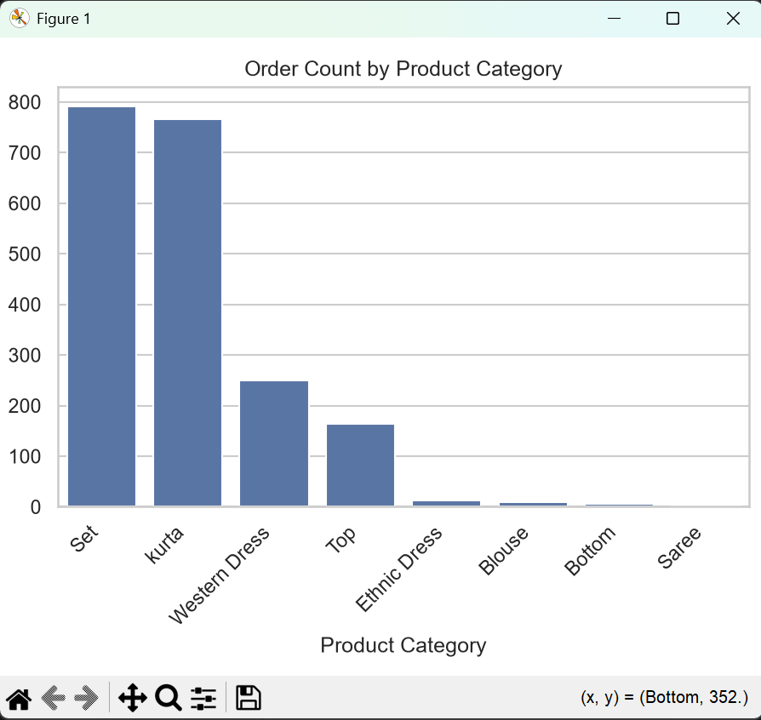
Figure 6.1 — Category count plot.
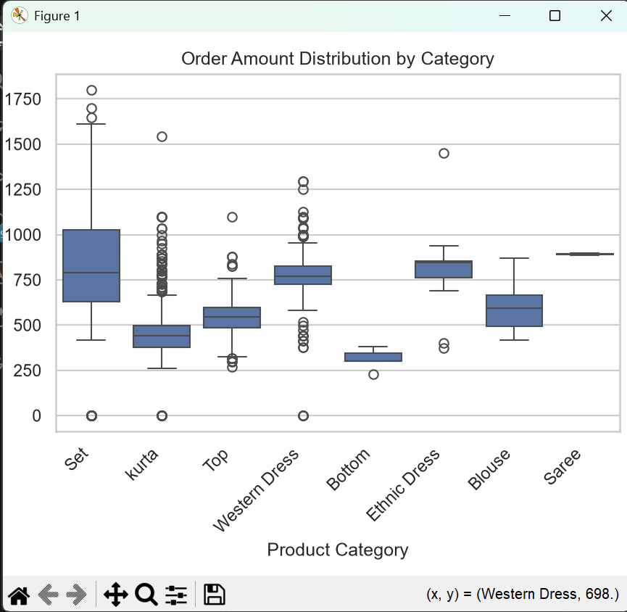
Figure 6.2 — Order amount distribution by category.
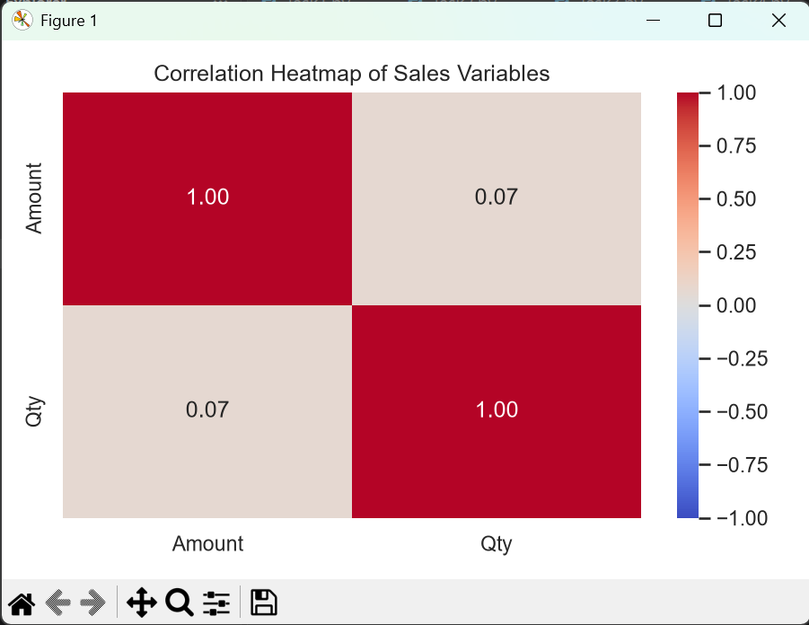
Figure 6.3 — Correlation heatmap.
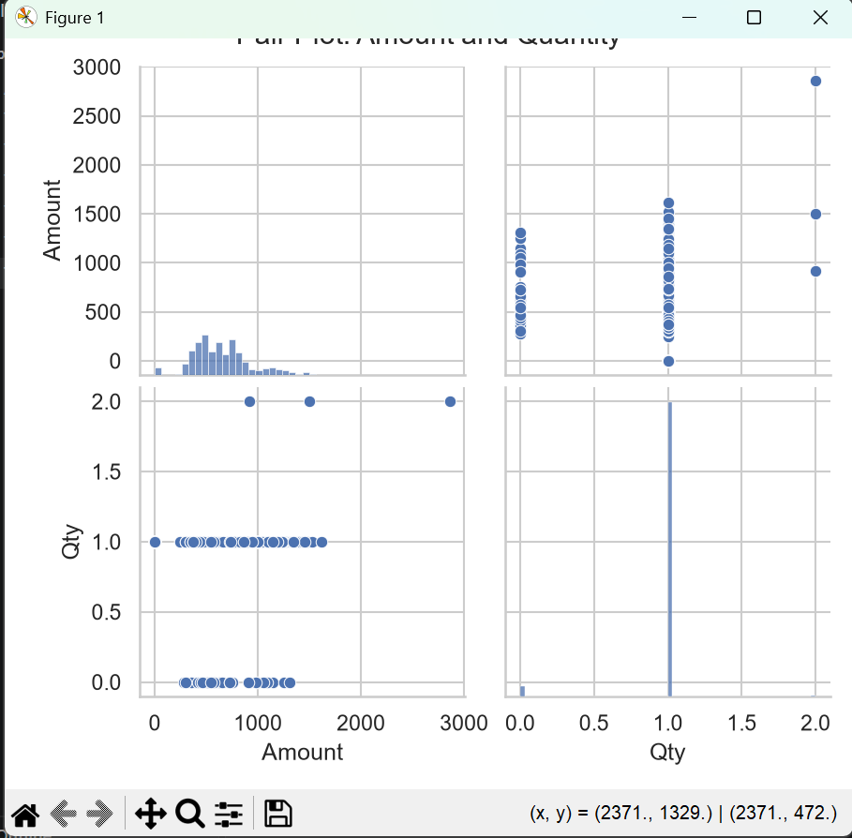
Figure 6.4 — Pair plot of selected variables.

9. Task 7 — Data Inspection and Cleaning
Objective: inspect the raw data, standardize text fields, convert numerical/date columns and save a cleaned dataset for later tasks.
Cleaning check | Observed result
Original shape | 128,975 rows × 24 columns
Missing values across columns | 210,495 missing cells in total
Exact duplicate rows found | 0
Rows after cleaning | 121,180 rows × 24 columns
Rows excluded due to unusable Amount/Qty | 7,795
Cleaned output file | Amazon_Sales_Cleaned.csv

The cleaning workflow strips extra spaces from text fields, converts Amount and Qty to numeric values, parses dates, removes exact duplicates if present, and excludes rows without usable Amount or Qty values. Some fields such as promotion IDs and fulfilment details remain missing because they are optional/incomplete in the source data.
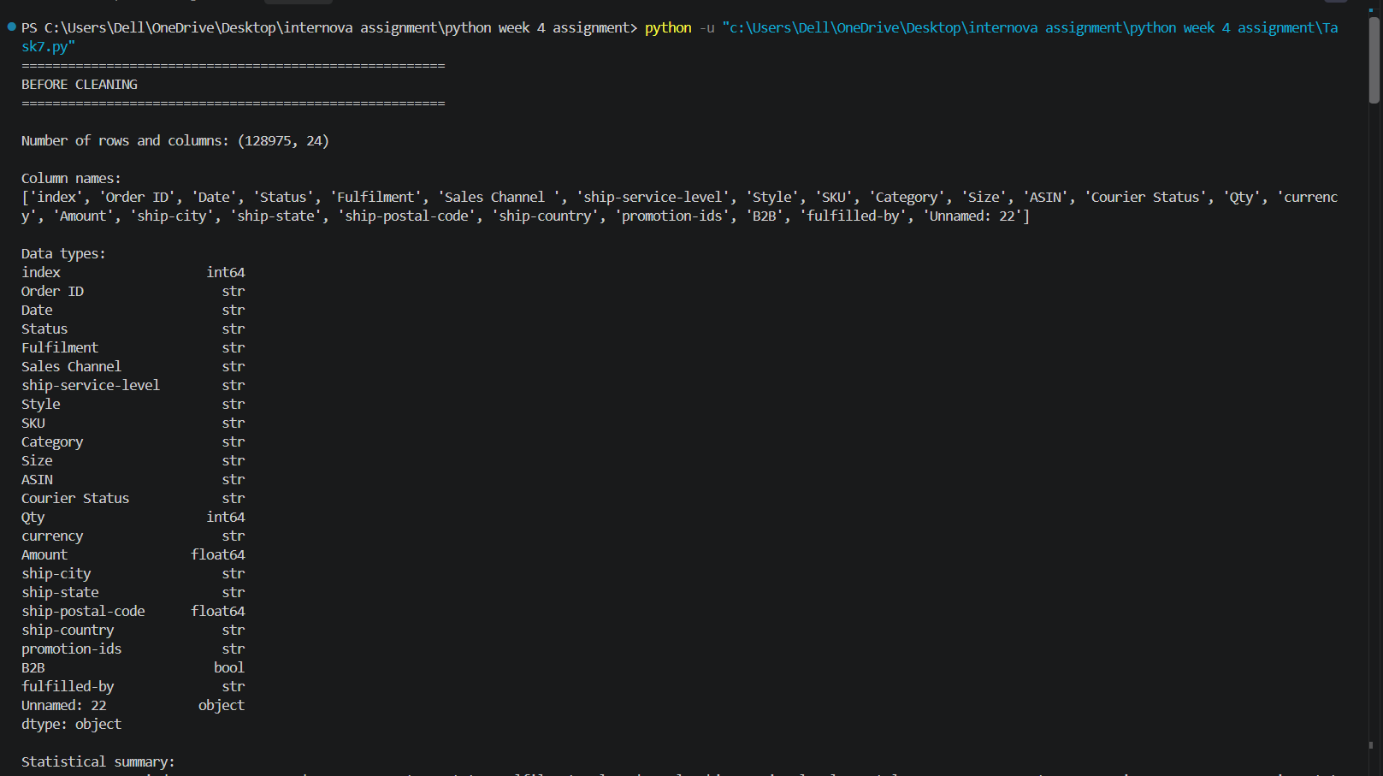
Task 7 — dataset inspection output.
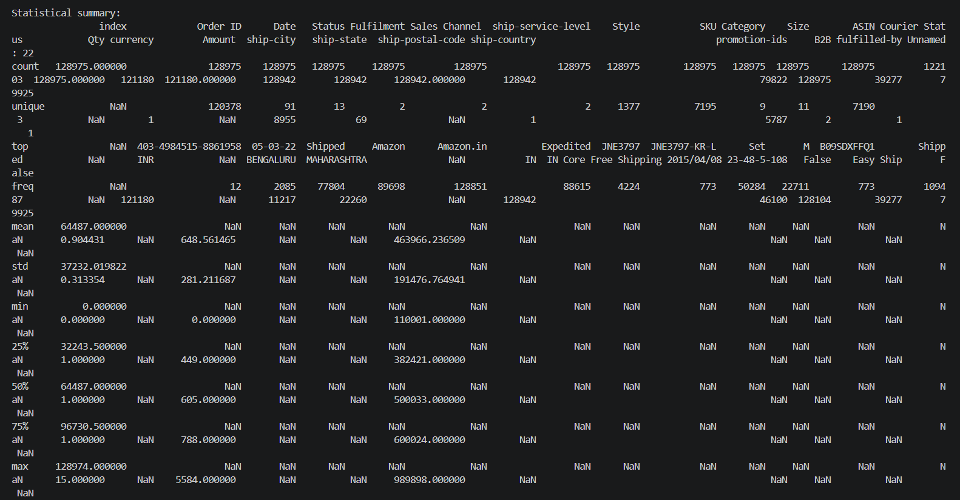
Task 7 — missing-value inspection screenshot.
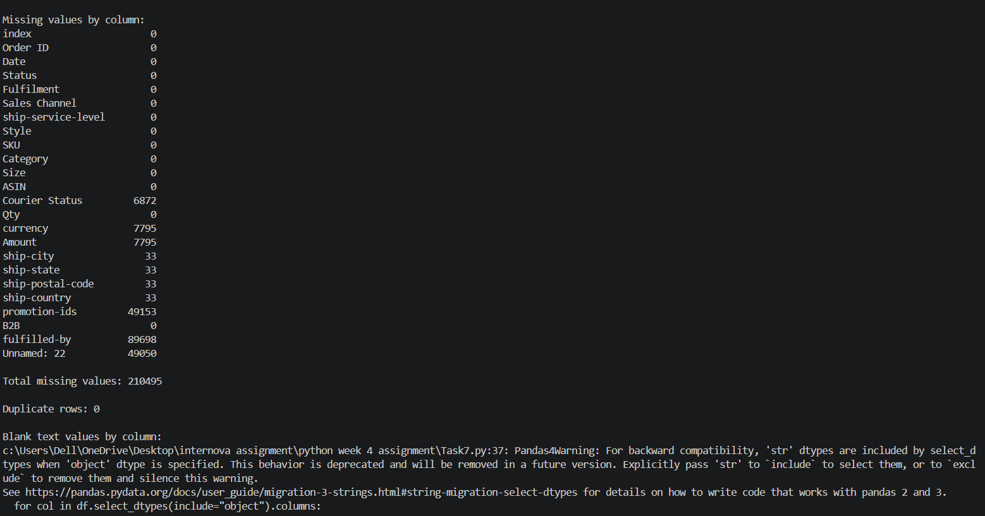
Task 7 — cleaning output screenshot.
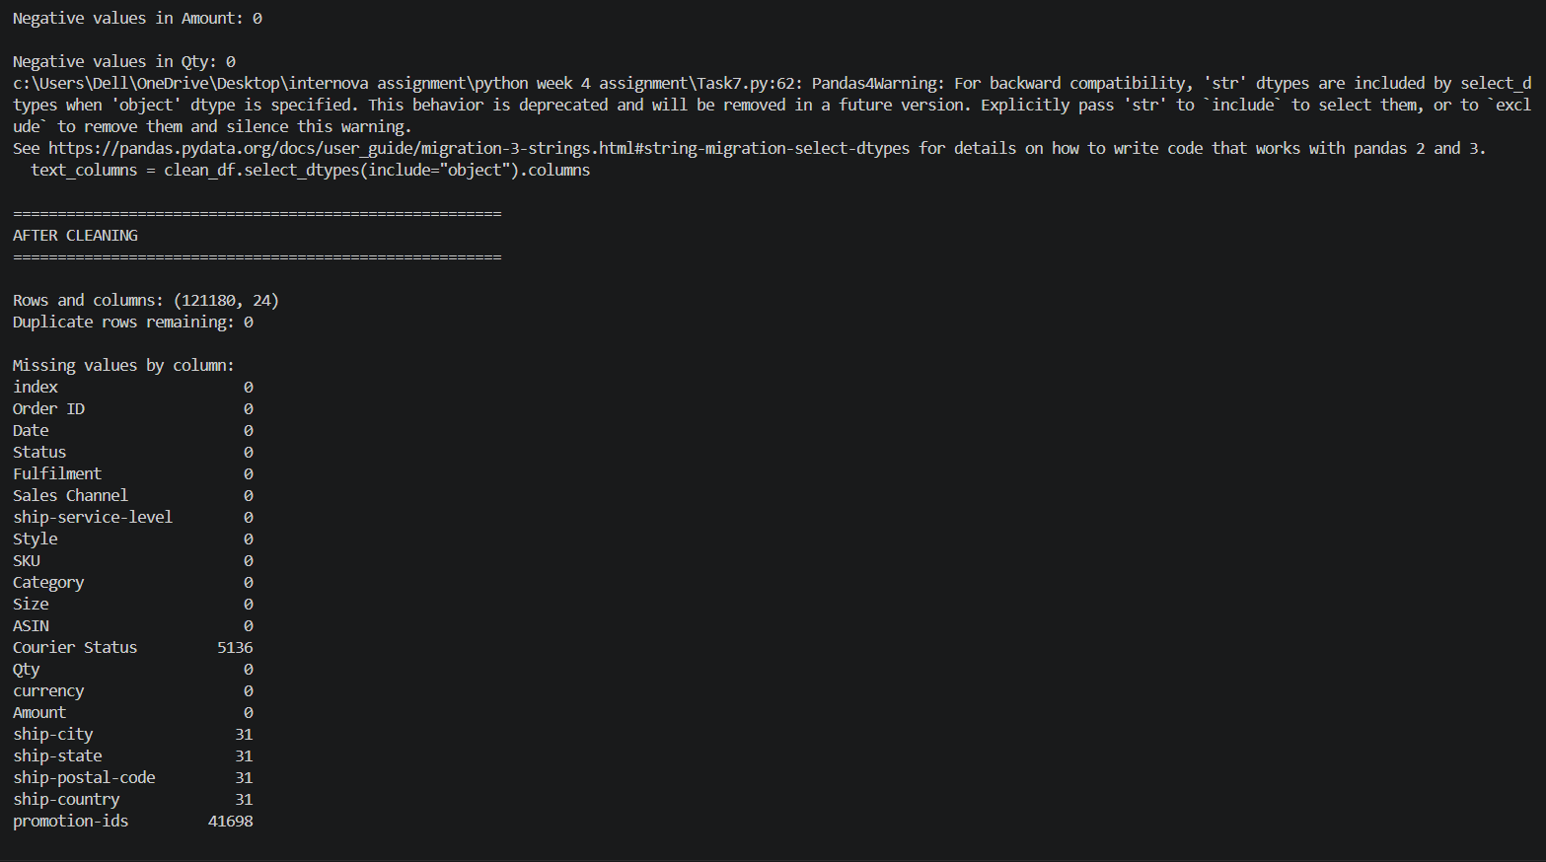
Task 7 — cleaned data/output screenshot.
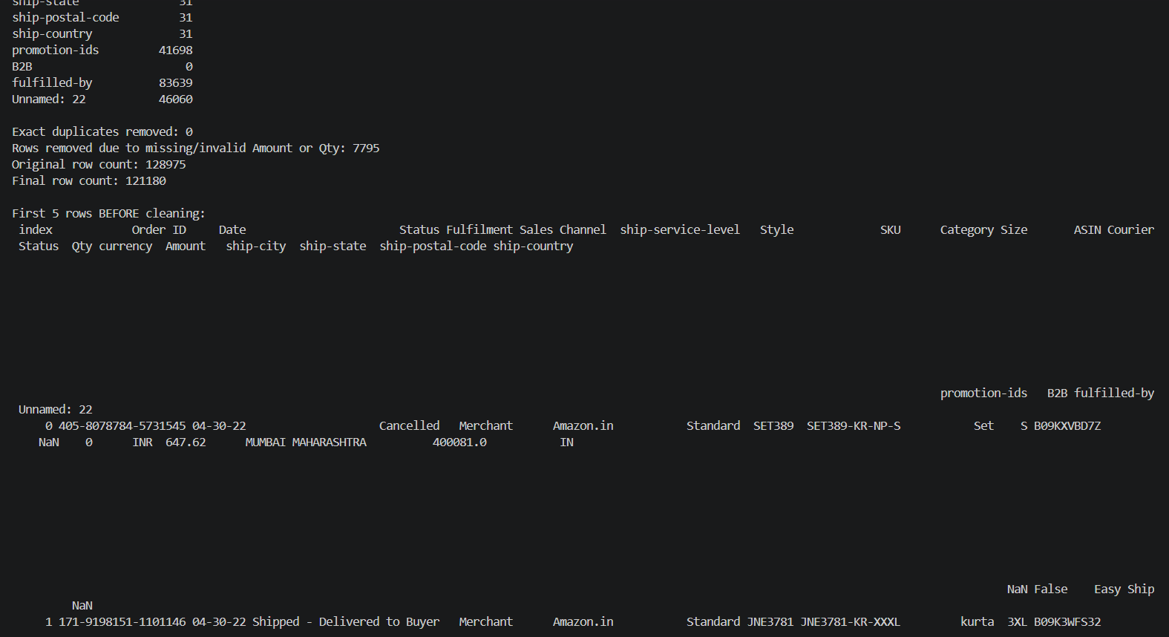
Task 7 — validation output screenshot.
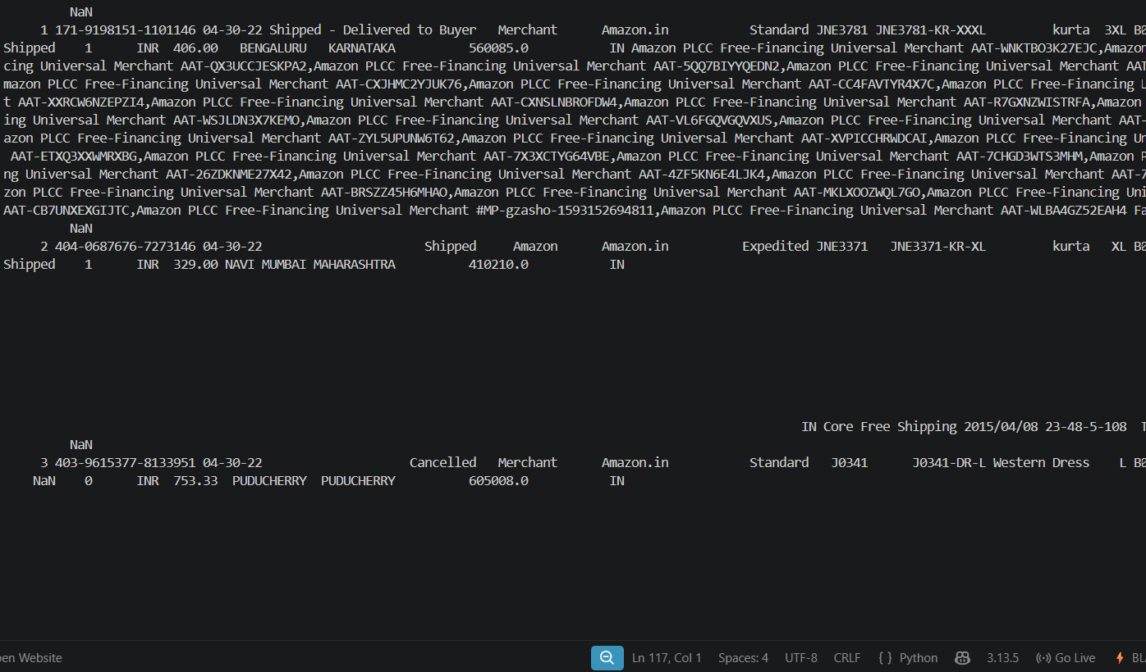
Task 7 — terminal results after cleaning.
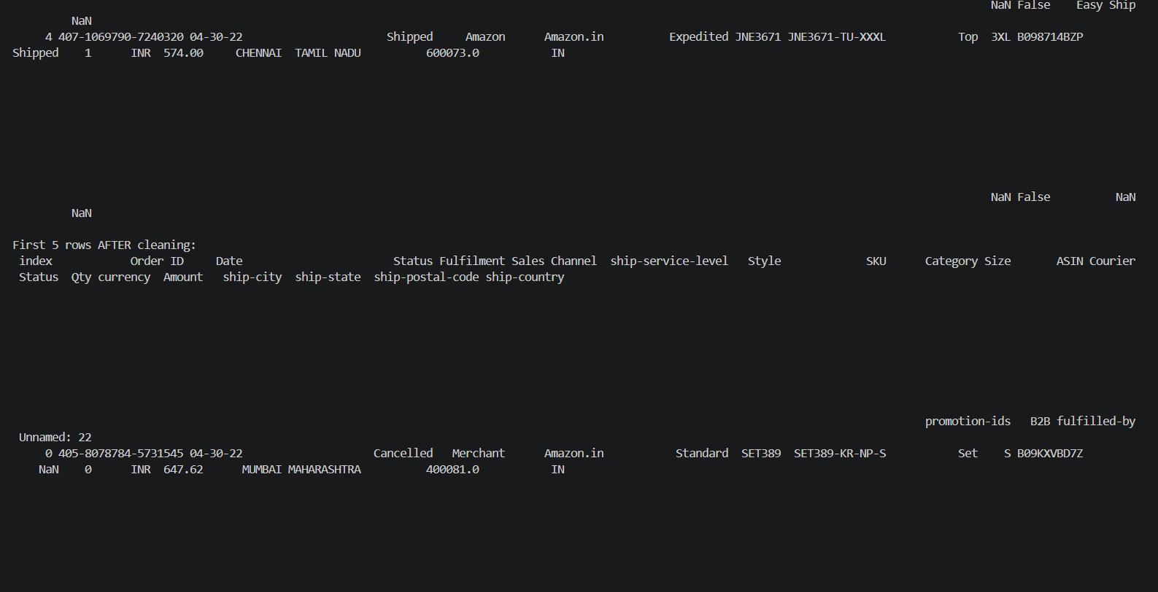
Task 7 — final cleaning confirmation.

Task 7 — corrected cleaning code screenshot.

10. Task 8 — Correlation Analysis and Insights
Objective: analyse relationships, category sales and monthly patterns, and derive at least three evidence-based insights.
Finding | Result
Dataset used | 121,180 rows × 24 columns
Correlation between Amount and Qty | 0.0669 — weak positive relationship
Highest sales category | Set
Total sales amount for Set | INR 39,204,124.03
Highest monthly total | April 2022 — INR 28,838,708.32
Lowest monthly total | March 2022 — INR 101,683.85

Key insights
- Amount and Qty have a weak positive linear relationship (correlation = 0.0669).
- Set is the highest-selling category by total Amount in the analysed dataset.
- April 2022 has the highest recorded monthly total; March has the lowest. March and June are partial periods, so comparisons require caution.
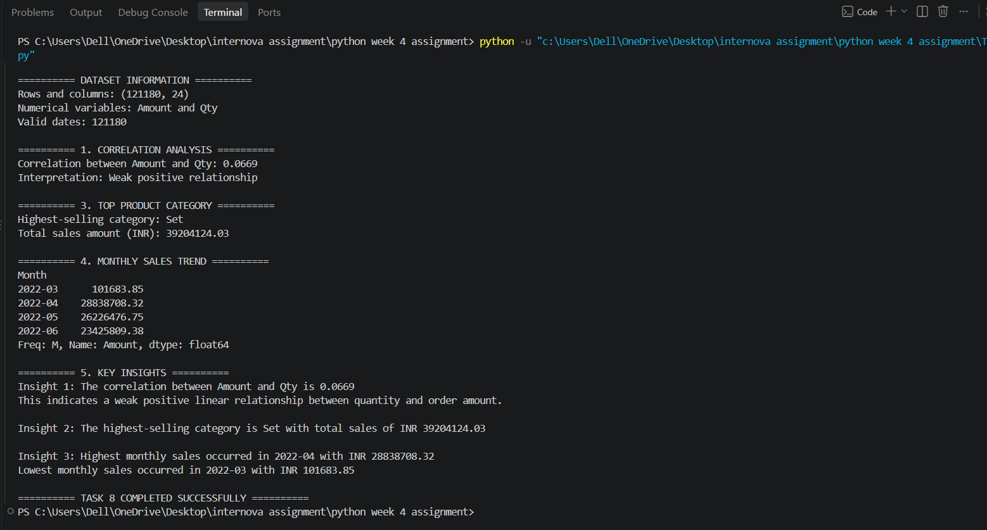
Task 8 — terminal output showing correlation, category sales, monthly totals and insights.
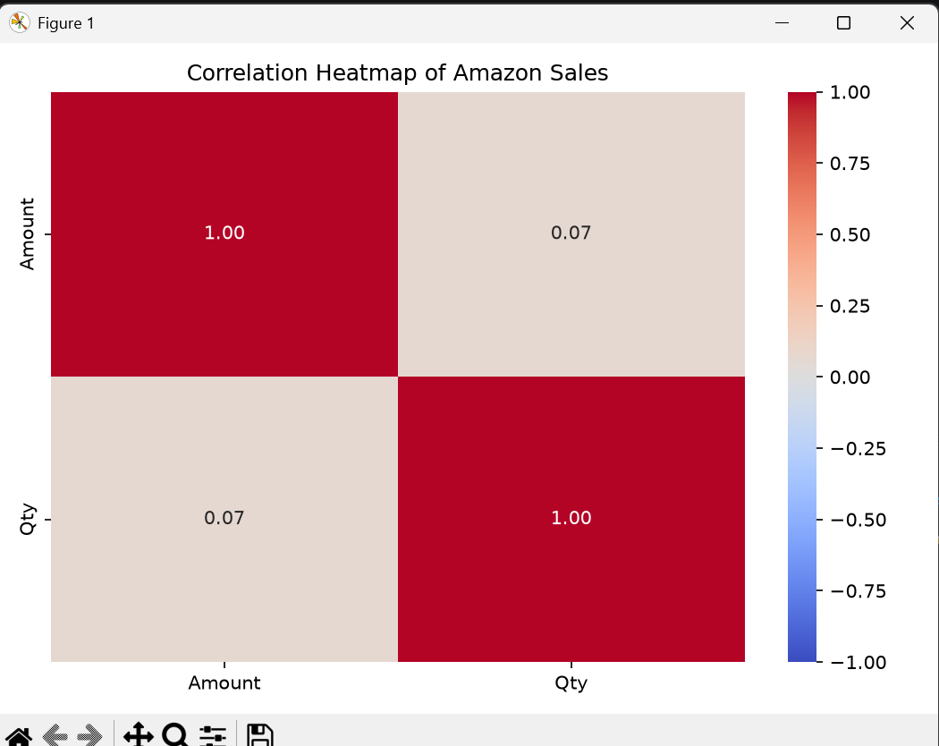
Figure 8.1 — correlation heatmap.
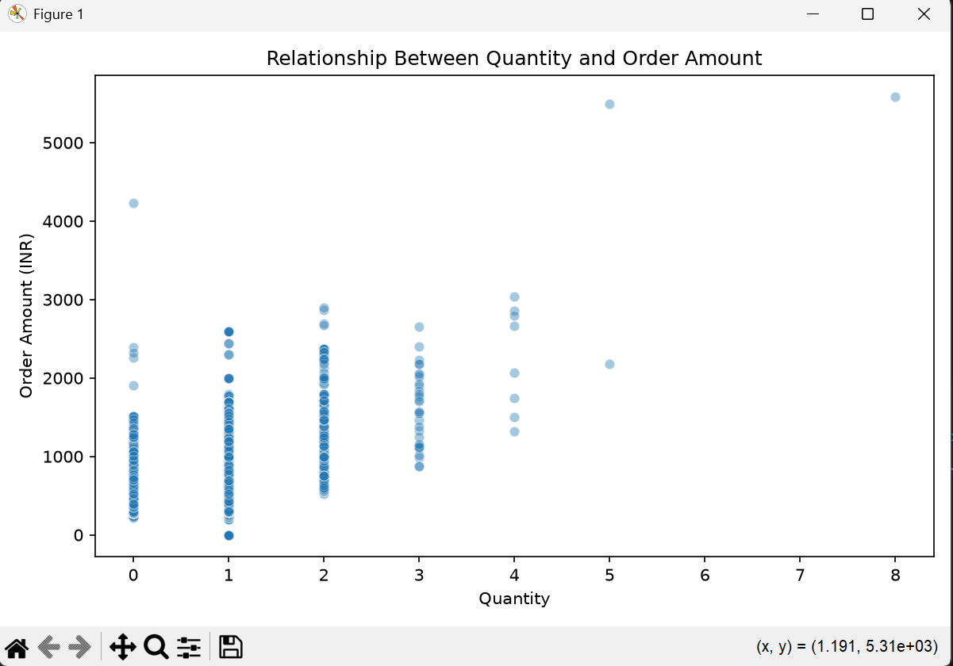
Figure 8.2 — quantity versus order amount.
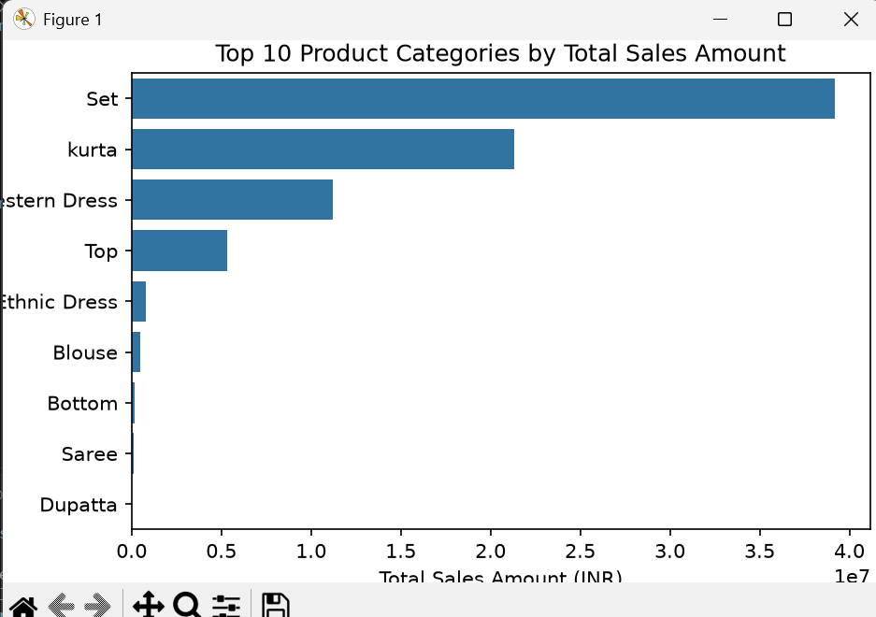
Figure 8.3 — top product categories by total sales.
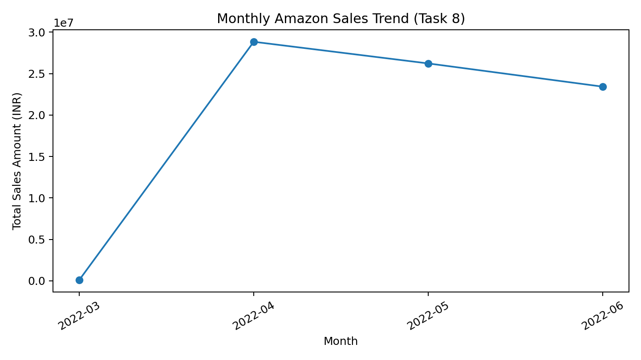
Figure 8.4 — monthly sales trend recreated from the reported Task 8 monthly totals.

11. Task 9 — Business Recommendations
Objective: translate the observed EDA results into practical business actions supported by the dataset.

Recommendation 1: Focus on top-selling categories
Finding: Set generated the highest total sales amount, INR 39,204,124.03 (approximately ₹3.92 crore). Recommendation: maintain adequate stock of popular products in this category, monitor inventory and use targeted promotions. Data support: category-wise sales aggregation ranked Set highest by total Amount.

Recommendation 2: Make quantity-based decisions carefully
Finding: the correlation between Qty and Amount is 0.0669. Recommendation: evaluate product prices, discounts, categories and order sizes before planning quantity-based offers. Data support: the weak correlation shows that quantity alone does not strongly explain order amount.

Recommendation 3: Monitor monthly sales
Finding: April 2022 had the highest recorded monthly total, while March 2022 had the lowest. Recommendation: review monthly trends and plan inventory and marketing around observed demand. Data support: monthly totals vary considerably. March and June are partial periods, so compare complete months where possible.
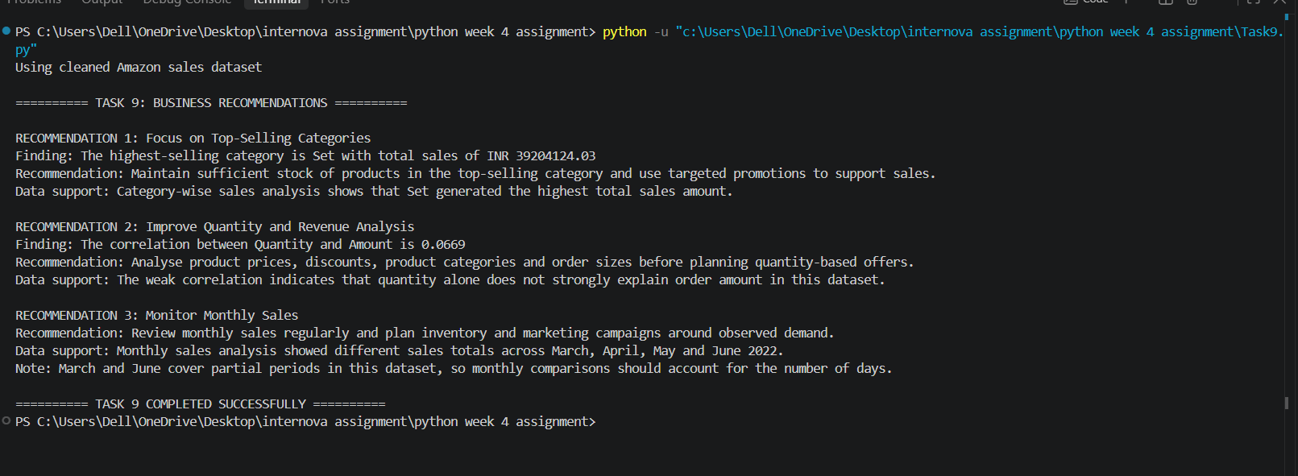
Task 9 — terminal output containing all three business recommendations.

12. Overall Conclusion
This assignment applied descriptive statistics, probability, correlation, IQR-based outlier detection, Matplotlib and Seaborn charts, data cleaning and business interpretation to an Amazon sales dataset. The cleaned working dataset contains 121,180 rows and 24 columns. The analysis found a weak positive correlation between Amount and Qty, identified Set as the leading category by total sales amount, and highlighted differences in monthly totals. These findings support recommendations to monitor leading categories, use broader factors when evaluating order revenue, and track sales trends over comparable time periods.
Limitations: the analysis is based on the available dataset and does not directly measure profit, costs, inventory availability, advertising spend or customer lifetime value. Recommendations should be validated with those additional business metrics before implementation.

