**A structured open dataset of government interventions in response to COVID-19 (MedRxiv)**

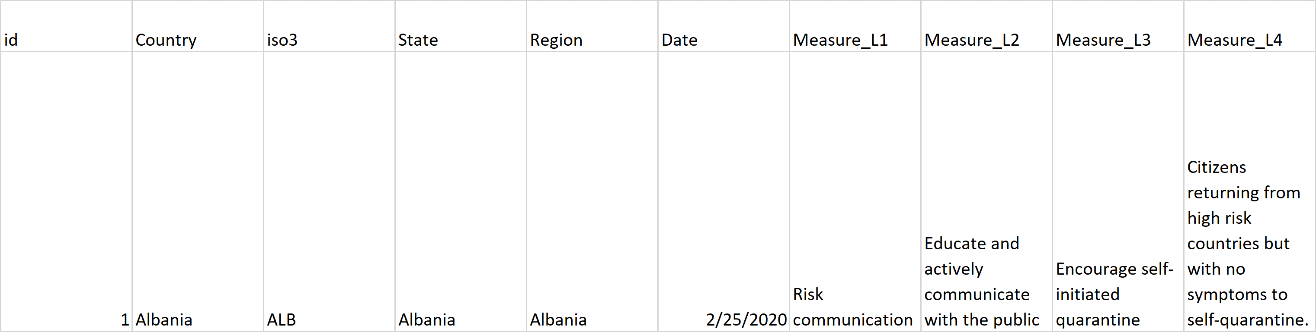

<https://github.com/amel-github/covid19-interventionmeasures>

<https://medrxiv.org/cgi/content/short/2020.05.04.20090498v1>

5237 Rows

**ACAPS**

# #COVID19 GOVERNMENT MEASURES DATASET



13042 Rows

<https://www.acaps.org/covid19-government-measures-dataset>

<https://www.acaps.org/sites/acaps/files/resources/files/acaps_covid19_government_measures_dataset.xlsx>

**Keystone Strategy**

# <https://www.keystonestrategy.com/coronavirus-covid19-intervention-dataset-model/>

# covid19-intervention-data

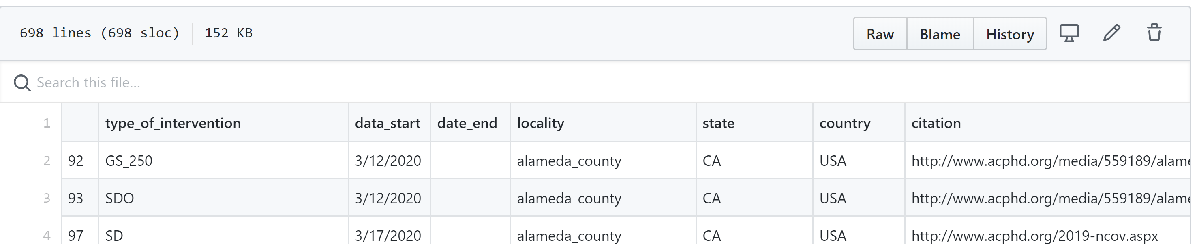

<https://github.com/Keystone-Strategy/covid19-intervention-data/>

**Imperial College**

### **[Data scenarios (Report 12)](https://www.imperial.ac.uk/media/imperial-college/medicine/mrc-gida/Global-unmitigated-mitigated-suppression-scenarios-26-03-2020.xlsx)**

[Data on global unmitigated, mitigated and suppression scenarios (26-03-2020) for "Report 12: The global impact of COVID-19 and strategies for mitigation and suppression"](https://www.imperial.ac.uk/media/imperial-college/medicine/mrc-gida/Global-unmitigated-mitigated-suppression-scenarios-26-03-2020.xlsx)

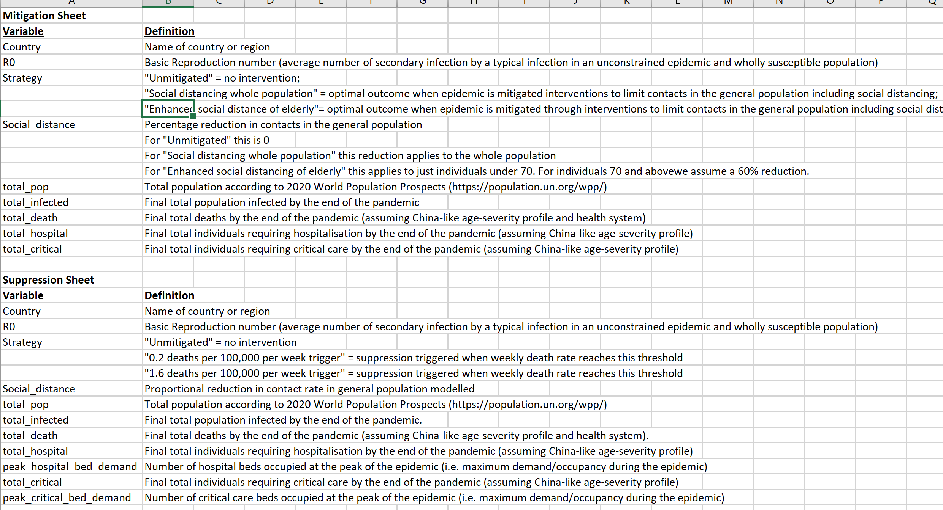

<https://www.imperial.ac.uk/media/imperial-college/medicine/mrc-gida/Global-unmitigated-mitigated-suppression-scenarios-26-03-2020.xlsx>

# covid19model

# Estimating the effects of non-pharmaceutical interventions on COVID-19 in Europe

Lots here, comprehensive and basis for their latest report. Code and data.

Code for modelling estimated deaths and infections for COVID-19 from ["Estimating the effects of non-pharmaceutical interventions on COVID-19 in Europe"](https://www.nature.com/articles/s41586-020-2405-7), Flaxman, Mishra, Gandy et al, Nature, 2020, the published version of our original [Report 13](https://www.imperial.ac.uk/mrc-global-infectious-disease-analysis/covid-19/report-13-europe-npi-impact/).

If you are looking for the individual based model used in Imperial's [Report 9, Ferguson, Laydon, Nedjati-Gilani et al](https://www.imperial.ac.uk/mrc-global-infectious-disease-analysis/covid-19/report-9-impact-of-npis-on-covid-19/), please look [here](https://github.com/mrc-ide/covid-sim).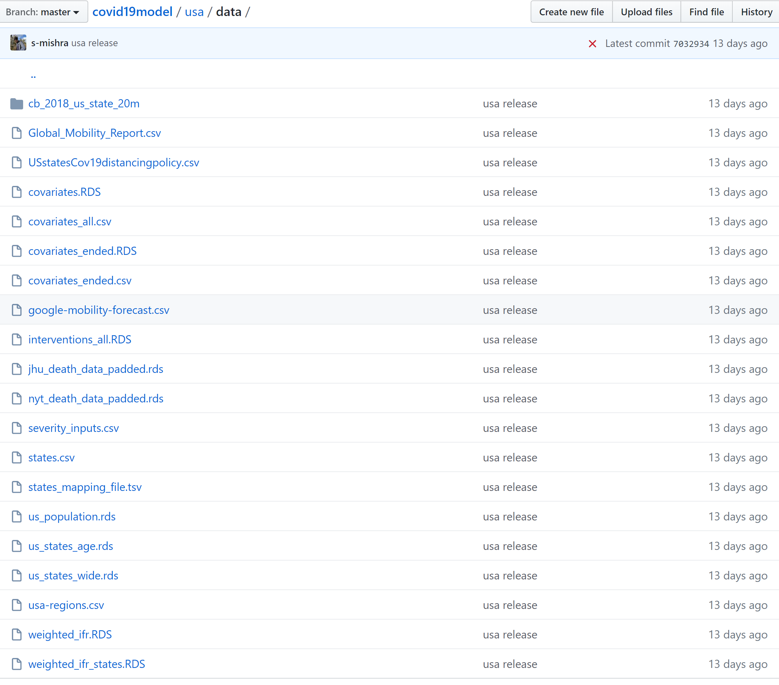

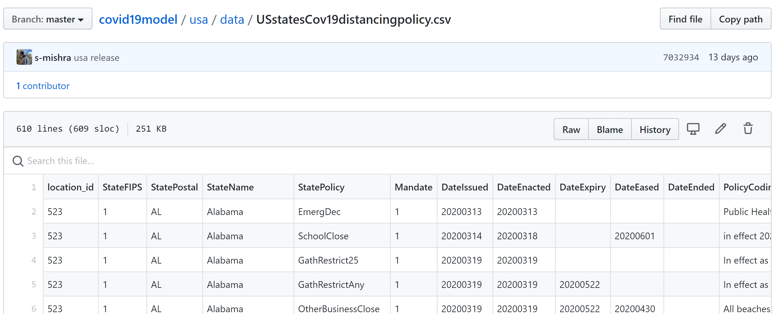

<https://github.com/ImperialCollegeLondon/covid19model>

**Oxford**

[**https://github.com/OxCGRT/covid-policy-tracker/blob/master/documentation/codebook.md**](https://github.com/OxCGRT/covid-policy-tracker/blob/master/documentation/codebook.md)

<https://github.com/OxCGRT/covid-policy-tracker>