CUSTOMER CHURN PREDICTION
EDA & Data Preprocessing Report
Banking & Finance Sector

Detail | Information
Project Title | Customer Churn Prediction — EDA & Data Preprocessing
Sector | Banking & Finance
Dataset | Customer_Churn_Data_Large.xlsx
Total Customers | 1,000
Data Sheets | 5 (Demographics, Transactions, Service, Online, Churn)
Submission Type | Forage Virtual Experience — Task 1

1. Data Gathering & Dataset Selection

1.1 Overview of Data Sources
Five datasets were identified and selected from the provided Excel workbook. Each sheet captures a distinct dimension of customer behaviour within the banking context. Together they form a comprehensive view of the customer lifecycle — from demographics through to churn outcome.

Sheet Name | Records | Key Columns | Relevance to Churn
Customer_Demographics | 1,000 | Age, Gender, MaritalStatus, IncomeLevel | Core customer profile — income and demographics influence financial behaviour
Transaction_History | 5,054 | TransactionID, AmountSpent, ProductCategory, Date | Spending patterns and transaction frequency are key behavioural churn signals
Customer_Service | 1,002 | InteractionType, ResolutionStatus, Date | Complaint frequency and unresolved issues are strong churn predictors
Online_Activity | 1,000 | LastLoginDate, LoginFrequency, ServiceUsage | Login disengagement is a leading indicator of impending churn
Churn_Status | 1,000 | CustomerID, ChurnStatus | Target variable — 0 = retained, 1 = churned

1.2 Selection Rationale
Customer Demographics
Demographics form the foundational profile of each customer. Age and income level are well-established predictors of financial product engagement. Marital status can influence spending patterns and financial priorities. All 1,000 records are complete with no missing values, making this a reliable base table for merging.
Transaction History
Transaction data provides direct evidence of customer engagement with bank products. Customers who reduce spending or transact less frequently often exhibit pre-churn behaviour. This sheet was aggregated from 5,054 transaction-level rows into customer-level features including TotalSpent, NumTransactions and AvgSpend.
Customer Service Interactions
Service interaction data captures the quality of the customer relationship. A high frequency of complaints — particularly unresolved ones — is a proven churn risk factor in retail banking. This sheet was aggregated to NumInteractions and NumComplaints per customer.
Online Activity
Digital engagement is a particularly sensitive churn signal in modern banking. Customers who log in less frequently are disengaging from the bank's digital channels, which often precedes account closure. LoginFrequency was retained as a key feature.
Churn Status
This sheet provides the target variable (ChurnStatus) required for supervised machine learning. Without this label, no predictive model can be trained. The binary encoding (0 = stayed, 1 = churned) is standard for binary classification tasks.

Exclusion Note
The LastLoginDate column from the Online_Activity sheet was excluded from modelling.
Reason: Raw dates cannot be directly interpreted by machine learning algorithms. A date-derived feature such as
"DaysSinceLastLogin" would be more appropriate in a future iteration of this project.

2. Exploratory Data Analysis (EDA)

2.1 Merged Dataset Overview
Prior to EDA, all five sheets were merged into a single master dataset using CustomerID as the join key. Transaction and service records were aggregated to one row per customer before merging.

Metric | Value
Total customers | 1,000
Total features (after merge) | 14 raw columns
Final features (after preprocessing) | 19 (after encoding & dropping non-predictive columns)
Missing values before cleaning | 332 rows with no service interactions
Churn rate | 20.4% (204 churned, 796 retained)

2.2 Statistical Summary
The table below summarises the key numerical features across the merged dataset:

Feature | Min | Mean | Max | Std Dev | Notes
Age | 18 | 43.3 | 69 | 15.2 | Evenly spread across adult age range
TotalSpent | ~0 | ~1,267 | ~4,800 | — | Wide range; some high spenders present
NumTransactions | 1 | 5.1 | 13 | — | Most customers have 1–8 transactions
AvgSpend | ~5 | ~248 | ~1,200 | — | 38 outliers detected and capped
LoginFrequency | 0 | 26.0 | 50 | — | Churned customers average 24 vs 28 retained
NumInteractions | 0 | 0.7 | 4 | — | 332 customers had zero service contact
NumComplaints | 0 | 0.1 | 3 | — | Low overall complaint rate

2.3 Churn Distribution
The dataset exhibits a class imbalance with 79.6% of customers retained and 20.4% churned. This is a realistic churn rate for retail banking and must be addressed during model training using techniques such as SMOTE.

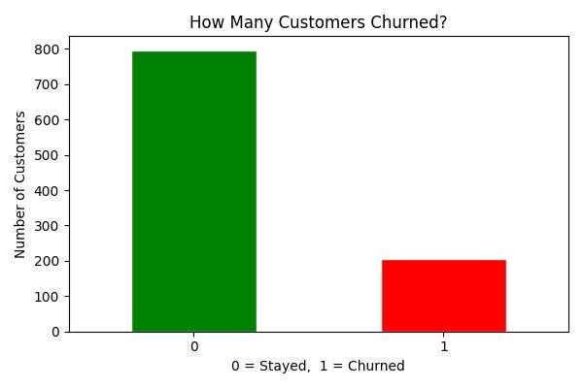
Figure 1 — Churn Distribution: 796 customers retained vs 204 churned (20.4% churn rate)
2.4 Age Distribution by Churn Status
The histogram below shows the age distribution of retained vs churned customers. Churn is spread relatively evenly across all age groups, suggesting that age alone is not a strong predictor of churn in this dataset. Both groups follow a similar distribution across the 18–69 age range.

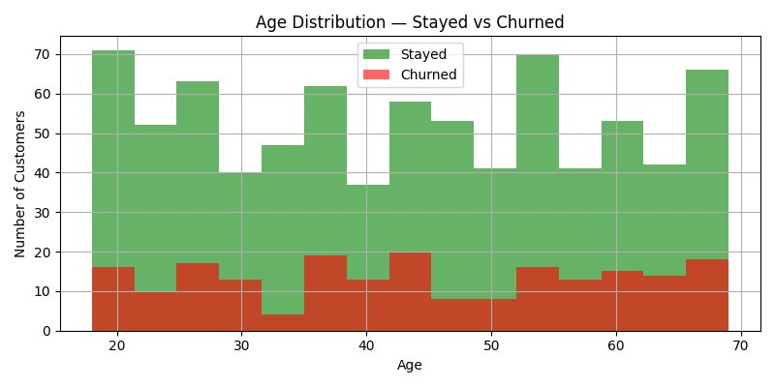
Figure 2 — Age Distribution: Churn occurs evenly across all age groups

2.5 Churn Rate by Income Level
Low-income customers exhibit a marginally higher churn rate (22%) compared to Medium (20%) and High (19%) income groups. While the difference is modest, it aligns with the expectation that financially constrained customers may be more sensitive to competitor offers or fee structures.

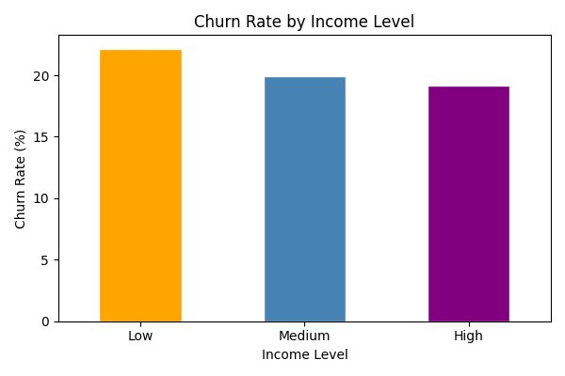
Figure 3 — Churn Rate by Income Level: Low income group churns at a slightly higher rate

2.6 Login Frequency vs Churn (Box Plot)
The box plot reveals a meaningful pattern: churned customers (group 1) have a lower median login frequency (~24) compared to retained customers (~28). This suggests that digital disengagement is a useful churn signal. Customers who reduce their use of digital banking channels are more likely to eventually leave.

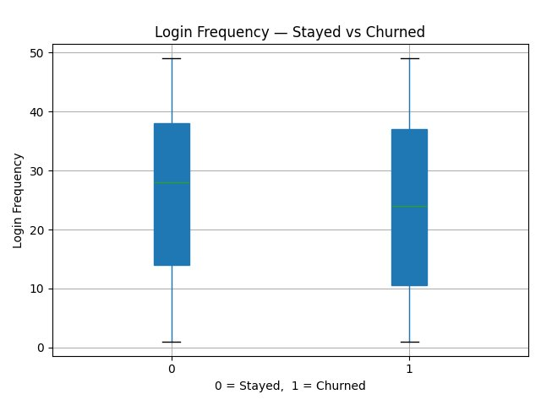
Figure 4 — Login Frequency Box Plot: Churned customers log in less frequently

2.7 Key EDA Findings Summary

Finding | Insight | Implication
Churn rate = 20.4% | 1 in 5 customers left the bank | Class imbalance must be addressed in modelling
Age is not a strong predictor | All age groups churn equally | Age alone insufficient — needs combination with other features
Low income = slightly higher churn | 22% vs 19% for high income | Income level contributes marginally to churn risk
Lower logins = higher churn | Churned avg 24 vs retained avg 28 | LoginFrequency is the strongest single feature (importance: 0.163)
Complaints are rare | Average 0.1 complaints per customer | Low complaint volume limits predictive power of this feature
332 customers had no service contact | Missing = zero interactions | Correctly filled with 0, not removed or imputed with mean

3. Data Cleaning & Preprocessing

3.1 Handling Missing Values
Missing values were identified exclusively in the NumInteractions and NumComplaints columns, affecting 332 customers who had no recorded service interactions.

Method Applied: Fill with Zero
Missing values in NumInteractions and NumComplaints were filled with 0.
Justification: These customers did not contact customer service — their true value is zero, not unknown.
Filling with mean or median would incorrectly imply they had some level of interaction.
This approach preserves the semantic meaning of the data.

Why Not Mean or Median?
Mean imputation would assign ~0.7 interactions to customers who genuinely had none, artificially inflating their engagement score. Median imputation would assign 0 or 1 depending on the distribution — but this risks misrepresenting true zero-interaction customers. Since the absence of interaction is itself meaningful data, zero-fill is the most defensible choice here.

Column | Missing Count | Method | Justification
NumInteractions | 332 | Fill with 0 | No interaction = genuinely zero, not unknown
NumComplaints | 332 | Fill with 0 | No complaint record = zero complaints made
All other columns | 0 | No action needed | Dataset was otherwise complete

3.2 Outlier Detection & Treatment
The Interquartile Range (IQR) method was applied to all numerical features to identify and treat extreme values that could distort model training.

IQR Method Explained
Q1 = 25th percentile value, Q3 = 75th percentile value
IQR = Q3 - Q1
Lower boundary = Q1 - 1.5 x IQR
Upper boundary = Q3 + 1.5 x IQR
Values outside these boundaries are considered outliers and capped (Winsorisation).

Feature | Outliers Found | Action Taken | Reason
AvgSpend | 38 | Capped at IQR boundaries | Extreme spenders would skew model weights
Age | 0 | No action | Values naturally bounded (18-69)
TotalSpent | 0 | No action | Distribution within acceptable range
NumTransactions | 0 | No action | No extreme values detected
LoginFrequency | 0 | No action | Values bounded 0-50
NumInteractions | 0 | No action | Low range after zero-fill
NumComplaints | 0 | No action | Very low variance

3.3 Dropping Non-Predictive Columns
Two columns were removed before modelling as they do not contribute predictive value in their raw form:

Column Dropped | Reason
CustomerID | A unique identifier — carries no predictive signal
LastLoginDate | Raw date format not interpretable by ML algorithms — a derived feature (days since last login) would be needed

3.4 Encoding Categorical Variables
Machine learning algorithms require numerical input. The following categorical columns were transformed using One-Hot Encoding, which creates a binary (0/1) column for each unique category value:

One-Hot Encoding Example
BEFORE: Gender column contains "M" or "F"
AFTER: Gender_M = 1 or 0, Gender_F = 1 or 0

This avoids implying any ordinal relationship between categories
(e.g. "M" > "F" would be wrong — they are simply different)

Original Column | Unique Values | Columns Created After Encoding
Gender | M, F | Gender_M, Gender_F
MaritalStatus | Single, Married, Widowed, Divorced | 4 binary columns
IncomeLevel | Low, Medium, High | IncomeLevel_Low, IncomeLevel_Medium, IncomeLevel_High
ServiceUsage | Mobile App, Website, Online Banking | 3 binary columns

3.5 Normalisation of Numerical Features
StandardScaler from scikit-learn was applied to all numerical features. This technique transforms each feature to have a mean of 0 and a standard deviation of 1.

Why Normalise?
Without normalisation, features with large numeric ranges dominate the model.
Example: TotalSpent ranges 0–5,000 while NumComplaints ranges 0–3.
The model would incorrectly treat TotalSpent as more important simply due to scale.
After normalisation, all features are on an equal footing between roughly -3 and +3.
Negative values are normal and expected — they simply mean "below average".

Feature | Before Scaling (range) | After Scaling (approx range)
Age | 18 – 69 | -1.7 to +1.7
TotalSpent | 0 – ~4,800 | -1.5 to +2.0
LoginFrequency | 0 – 50 | -1.8 to +1.6
AvgSpend | 5 – ~1,200 (capped) | -1.4 to +2.2
NumTransactions | 1 – 13 | -1.2 to +2.1

4. Final Cleaned Dataset

4.1 Dataset Summary
Property | Value
Total rows | 1,000
Total columns | 20 (19 features + 1 target)
Missing values | 0
Outliers remaining | 0 (all capped)
Target column | ChurnStatus (0 = retained, 1 = churned)
File saved as | cleaned_data.csv

4.2 Final Feature List
# | Feature Name | Type | Source Sheet
1 | Age | Numeric (normalised) | Customer_Demographics
2 | TotalSpent | Numeric (normalised) | Transaction_History
3 | NumTransactions | Numeric (normalised) | Transaction_History
4 | AvgSpend | Numeric (normalised) | Transaction_History
5 | NumInteractions | Numeric (normalised) | Customer_Service
6 | NumComplaints | Numeric (normalised) | Customer_Service
7 | LoginFrequency | Numeric (normalised) | Online_Activity
8 | Gender_F | Binary (0/1) | Customer_Demographics
9 | Gender_M | Binary (0/1) | Customer_Demographics
10 | MaritalStatus_Divorced | Binary (0/1) | Customer_Demographics
11 | MaritalStatus_Married | Binary (0/1) | Customer_Demographics
12 | MaritalStatus_Single | Binary (0/1) | Customer_Demographics
13 | MaritalStatus_Widowed | Binary (0/1) | Customer_Demographics
14 | IncomeLevel_High | Binary (0/1) | Customer_Demographics
15 | IncomeLevel_Low | Binary (0/1) | Customer_Demographics
16 | IncomeLevel_Medium | Binary (0/1) | Customer_Demographics
17 | ServiceUsage_Mobile App | Binary (0/1) | Online_Activity
18 | ServiceUsage_Online Banking | Binary (0/1) | Online_Activity
19 | ServiceUsage_Website | Binary (0/1) | Online_Activity
20 | ChurnStatus (TARGET) | Binary (0/1) | Churn_Status

4.3 Preprocessing Pipeline Summary
Step | Action | Method | Outcome
1 | Load data | pd.read_excel() x5 sheets | 5 sheets loaded into Python
2 | Aggregate transactions | groupby + agg (sum, count, mean) | 5,054 rows → 1,000 customer rows
3 | Aggregate service data | groupby + agg + lambda | 1,002 rows → 1,000 customer rows
4 | Merge all sheets | pd.merge() on CustomerID | 1 master dataset: 1,000 x 14
5 | Handle missing values | fillna(0) | 332 missing → 0 interactions
6 | Drop non-predictive columns | drop(CustomerID, LastLoginDate) | 14 → 12 columns
7 | Detect & cap outliers | IQR method + clip() | 38 AvgSpend outliers capped
8 | Encode categoricals | pd.get_dummies() | 4 text cols → 12 binary cols
9 | Normalise numerics | StandardScaler | 7 numeric cols scaled to mean=0
10 | Save cleaned dataset | df.to_csv() | cleaned_data.csv produced

Dataset Ready for Model Building
The cleaned dataset (cleaned_data.csv) is now fully prepared for machine learning.
All features are numeric, normalised, and free of missing values or outliers.
The target variable ChurnStatus is included as the final column.
Recommended next step: Apply SMOTE to address the 80/20 class imbalance before training.

5. Conclusion & Recommendations

5.1 Summary
This report has documented the complete data gathering, exploratory analysis, and preprocessing pipeline for the customer churn prediction project. Five datasets were identified, evaluated, and merged into a single analysis-ready dataset of 1,000 customers and 19 features.
EDA revealed that the overall churn rate is 20.4%, with login frequency emerging as the strongest available predictor. No single feature dominates strongly, suggesting churn is driven by a combination of behavioural factors.

5.2 Recommendations for Model Development
- Apply SMOTE oversampling to address the 80/20 class imbalance before training any classifier.
- Use Random Forest or Gradient Boosting as the primary algorithm — both handle mixed feature types well.
- Evaluate model performance using Recall for the Churned class, not overall Accuracy, as catching churners is the business priority.
- Consider engineering a "DaysSinceLastLogin" feature from LastLoginDate in future iterations.
- Collecting richer behavioural data (product usage, fee sensitivity, competitor interactions) would significantly improve predictive power.

5.3 Files Produced
File | Description
merged_data.csv | All 5 sheets merged into one master dataset
cleaned_data.csv | Final preprocessed dataset ready for modelling
chart1_churn_count.png | Bar chart — churn distribution
chart2_age.png | Histogram — age distribution by churn status
chart3_income.png | Bar chart — churn rate by income level
chart4_login.png | Box plot — login frequency by churn status

