Ticket Selling Application

Analysis and Design Document

Student: Nalbitoru Florin
Group: 30431

Table of Contents

1. Requirements Analysis 3
1.1 Assignment Specification 3
1.2 Functional Requirements 3
1.3 Non-functional Requirements 3
2. Use-Case Model 3
3. System Architectural Design 3
4. UML Sequence Diagrams 3
5. Class Design 3
6. Data Model 3
7. System Testing 3
8. Bibliography 3

1. Requirements Analysis

Assignment Specification

This document describes the requirements for a ticket selling system for the Untold festival. The system should have two types of users, a cashier and an administrator, and allow them to perform various operations related to cashiers' information, performances, and ticket sales. The system should be implemented using Java/C# Desktop, using a relational database to store the data. The system should use the Layers architectural pattern, with separate layers for the user interface, business logic, and data access.

Functional Requirements

The functional requirements for the system are:

Authentication: The system should require users to provide a username and password to access the system.
Cashier operations: Cashiers should be able to sell tickets, view sold tickets, cancel reservations, and edit reservations.
Administrator operations: Administrators should be able to perform CRUD operations on cashiers' information, performances, and export sold tickets for a certain show.
Performance information: The system should keep track of performance information, including genre, title, date and time of the show, and maximum number of tickets per show.
Ticket sales: The system should notify the cashier when the maximum number of tickets for a show has been exceeded.
Validations: The system should validate inputs to prevent invalid data from being entered.

Non-functional Requirements

The non-functional requirements for the system are:

Security: Passwords should be encrypted with a one-way encryption algorithm (base 64).
Performance: The system should be able to handle a large number of concurrent users and perform operations quickly.
Usability: The system should be easy to use and have a user-friendly interface.
Reliability: The system should be reliable and prevent data loss or corruption.
Testability: The system should be testable, with unit tests for key components.

2. Use-Case Model

The use-case model for the system includes the following use cases:
Login: Allows users to log in to the system.
Sell Ticket: Allows cashiers to sell tickets for a show.
View Sold Tickets: Allows cashiers to view sold tickets for a show.
Cancel Reservation: Allows cashiers to cancel a reservation.
Edit Reservation: Allows cashiers to edit a reservation.
Add Cashier: Allows administrators to add a new cashier.
View Cashier: Allows administrators to view information about a cashier.
Edit Cashier: Allows administrators to edit information about a cashier.
Delete Cashier: Allows administrators to delete a cashier.
Add Performance: Allows administrators to add a new performance.
View Performance: Allows administrators to view information about a performance.
Edit Performance: Allows administrators to edit information about a performance.
Delete Performance: Allows administrators to delete a performance.
Export Sold Tickets: Allows administrators to export sold tickets for a show.

3. System Architectural Design

3.1 Architectural Pattern Description
The system will use the Layers architectural pattern, with separate layers for the user interface, business logic, and data access. The user interface layer will include screens for the cashier and administrator, implemented using a GUI framework such as JavaFX or Windows Forms. The business logic layer will include services that implement the use cases and handle business rules and validations. The data access layer will include repositories that handle database operations using an ORM framework such as Hibernate or Entity Framework.

Diagrams

4. UML Sequence Diagrams

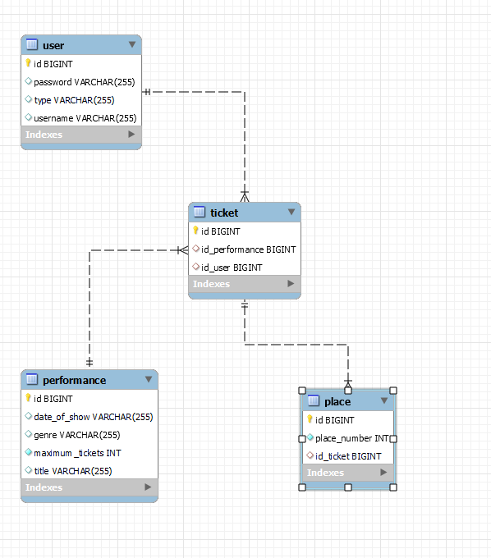

5. Class Design

5.1 Design Patterns Description
The class design for the system will include classes for each entity, such as Cashier, Performance, and Ticket, as well as classes for services, repositories, and other key components. The classes will be designed to support

5.2 UML Class Diagram

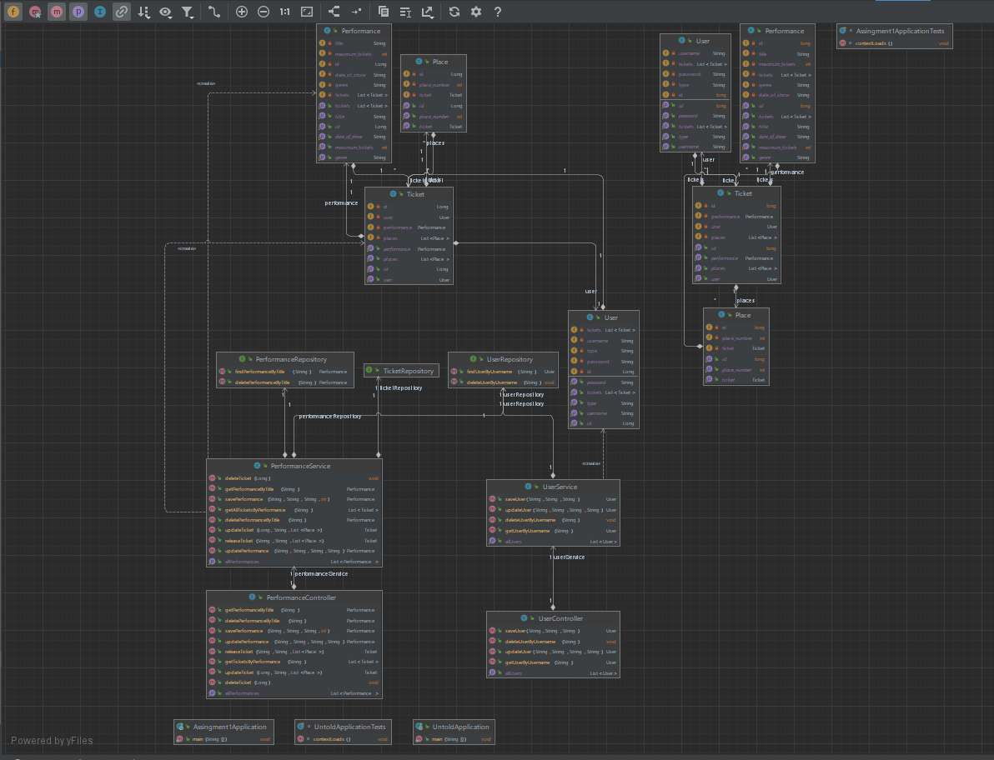

6. Data Model
For this ticket selling system application, we need to store data related to cashiers, performances, tickets, and reservations. The data model for this application will consist of several tables, including a Cashier table, a Performance table, a Ticket table, and a Reservation table.

The Cashier table will store information about each cashier, including their name, username, password, and contact information.

The Performance table will store information about each performance, including the title, date and time, genre, and maximum number of tickets available for each show.

The Ticket table will store information about each ticket sold, including the performance for which the ticket was sold, the number of places, and the total cost.

The Reservation table will store information about each reservation, including the performance for which the reservation was made, the number of places reserved, and the time the reservation was made.

These tables will be related to each other through foreign key constraints, ensuring data integrity and consistency.

7. System Testing
System testing is a critical part of the software development process, as it ensures that the application functions as intended, meets the requirements, and performs well in different scenarios.

For this ticket selling system application, we will perform different types of system testing to ensure its functionality and quality. These testing types include functional testing, performance testing, security testing, and usability testing.

Functional testing will ensure that the application meets all the functional requirements specified in the assignment, such as CRUD operations, ticket sales, reservations, and exports.

Performance testing will test the system's response time, scalability, and stability under different loads and user scenarios. This will help to identify potential bottlenecks and areas for optimization.

Security testing will ensure that the application's data is secure and that users can only access the features they are authorized to use. This will include testing password encryption and decryption, authentication and authorization mechanisms, and data validation.

Usability testing will test the application's user interface and user experience, making sure that it is intuitive, user-friendly, and meets users' needs and expectations.

By performing these different types of system testing, we can ensure that the ticket selling system application is reliable, efficient, secure, and user-friendly.

8. Bibliography

