BELGIUM CAMPUS iTVERSITY
IOT261 - INTERNET OF THINGS
TECHNICAL DESIGN REPORT
Human Detection Probe
for Post-Earthquake
Search and Rescue Operations

Prepared By | Naledi Reed
Date of Submission | 21 May 2026
Module | IOT261 - Internet of Things
Institution | Belgium Campus iTversity

1. Executive Summary
This technical design report presents the design, modelling, and control architecture of an embedded Human Detection Probe based on the Arduino Uno platform. The proposed system addresses the need for a compact electronic aid that can help search-and-rescue teams identify possible survivors trapped beneath debris following an earthquake.
The prototype uses a passive infrared (PIR) sensor to detect changes in infrared energy associated with human movement. When motion is detected, the Arduino activates both visual and acoustic warning outputs and updates a 16x2 LCD with the current system state. A pushbutton provides a manual diagnostic test function. The design was modelled virtually and its firmware logic was developed for the simulated microcontroller environment.

2. Background Knowledge & Problem Statement

2.1 The Engineering Problem
Earthquakes can cause buildings to collapse and leave survivors trapped below concrete, brick, and other structural debris. Search-and-rescue teams must work within a limited time window, often described as the “Golden Hours”, because the likelihood of survival decreases significantly after roughly 48 to 72 hours.
Traditional search methods such as canine teams and acoustic listening equipment can be valuable, but they may be difficult to position in narrow spaces and can require considerable time. A compact electronic probe therefore offers a practical way to extend sensing capability into gaps that rescuers cannot safely access directly.

2.2 Transducer Theory: Passive Infrared (PIR) Sensors
The sensing element selected for the prototype is the Parallax 555-28027 Passive Infrared (PIR) Sensor. Objects above absolute zero emit infrared radiation. The human body, with a typical core temperature of about 37°C, produces strong infrared emission in the approximate 9–10 micrometre wavelength region.
A PIR sensor is passive: it does not transmit energy into the environment. Instead, a pyroelectric sensing element positioned behind a segmented Fresnel lens responds to changes in infrared energy across its detection zones. When a warm body moves across these zones, the sensor electronics produce a digital HIGH output that can be read by the Arduino. This makes PIR sensing suitable for a low-cost rescue probe intended to identify movement through openings in debris.

3. System Requirements & Hardware Specifications
The hardware was selected to balance processing capability, clear user feedback, acoustic signalling, and simple construction within the simulated environment.
- Microcontroller Board (Arduino Uno R3): The central controller uses the ATmega328P microcontroller running at 16 MHz. It reads digital inputs from the PIR sensor and pushbutton and controls the display, LED, and buzzer outputs.
- Infrared Sensor (Parallax 555-28027 PIR): A 5 V motion-sensing device that provides a digital output when a change in infrared energy is detected.
- Alphanumeric Display (16x2 LCD, Parallel Interface): A two-line, 16-character LCD connected in 4-bit parallel mode. RS and EN use digital pins 7 and 8, while LCD data lines D4-D7 use Arduino pins 9-12. A 10 kΩ potentiometer controls display contrast through the V0 pin.
- Acoustic Transducer (Piezo Buzzer): Produces an audible warning tone when the controller enters an alert state.
- Visual Indicator (5 mm Red LED): Provides an immediate visual warning. A 220 Ω series resistor limits LED current.
- Control Input (Normally Open Pushbutton): Provides a manual test or diagnostic input to the system.
- Pull-Down Resistor (10 kΩ): Keeps the pushbutton input at a defined LOW level when the switch is open and prevents a floating input.
- Contrast Control (10 kΩ Potentiometer): Connected between +5 V and GND, with the wiper connected to the LCD V0 pin to adjust character visibility.

4. Software Implementation

4.1 System Control Firmware
The firmware below implements the control logic used by the simulated Arduino. It continuously reads the PIR and pushbutton inputs and maps the input state to the LCD, LED, and piezo buzzer outputs.
#include <LiquidCrystal.h>

const int PIR_PIN = 2;
const int LED_PIN = 3;
const int PIEZO_PIN = 4;
const int BUTTON_PIN = 5;

LiquidCrystal lcd(7, 8, 9, 10, 11, 12);

void setup() {
pinMode(PIR_PIN, INPUT);
pinMode(LED_PIN, OUTPUT);
pinMode(PIEZO_PIN, OUTPUT);
pinMode(BUTTON_PIN, INPUT);

lcd.begin(16, 2);
lcd.setCursor(0, 0);
lcd.print("System Ready");
delay(2000);
lcd.clear();
}

void loop() {
int motionDetected = digitalRead(PIR_PIN);
int buttonPressed = digitalRead(BUTTON_PIN);

if (motionDetected == HIGH) {
lcd.setCursor(0, 0); lcd.print("MOTION DETECTED!");
lcd.setCursor(0, 1); lcd.print("Status: ALERT ");
digitalWrite(LED_PIN, HIGH);
tone(PIEZO_PIN, 1000);
}
else if (buttonPressed == HIGH) {
lcd.setCursor(0, 0); lcd.print("Button Pressed ");
lcd.setCursor(0, 1); lcd.print("Status: TESTING ");
digitalWrite(LED_PIN, HIGH);
tone(PIEZO_PIN, 1500);
delay(200);
noTone(PIEZO_PIN);
digitalWrite(LED_PIN, LOW);
}
else {
lcd.setCursor(0, 0); lcd.print("Monitoring... ");
lcd.setCursor(0, 1); lcd.print("Status: CLEAR ");
digitalWrite(LED_PIN, LOW);
noTone(PIEZO_PIN);
}

delay(100);
}

4.2 Code Architecture Explanation
During setup(), the Arduino configures the PIR and pushbutton pins as inputs and the LED and piezo pins as outputs. The LCD is also initialised in 16x2 mode and briefly displays “System Ready”.
The loop() function then runs continuously. A HIGH signal on the PIR input (digital pin 2) takes priority and places the system in ALERT mode: the LCD displays a motion warning, the LED on pin 3 switches on, and a 1 kHz tone is generated on pin 4. If no motion is detected but the pushbutton on pin 5 is HIGH, the controller performs a short TESTING sequence using the LED and a 1.5 kHz tone. When both inputs are LOW, the system remains in CLEAR mode and continues monitoring.

5. Schematic and Visual Implementation

5.1 Tinkercad Simulation Layout
The virtual layout below shows the Arduino Uno connected to the PIR sensor, LED, piezo buzzer, pushbutton, 16x2 LCD, potentiometer, and supporting resistors on breadboards.
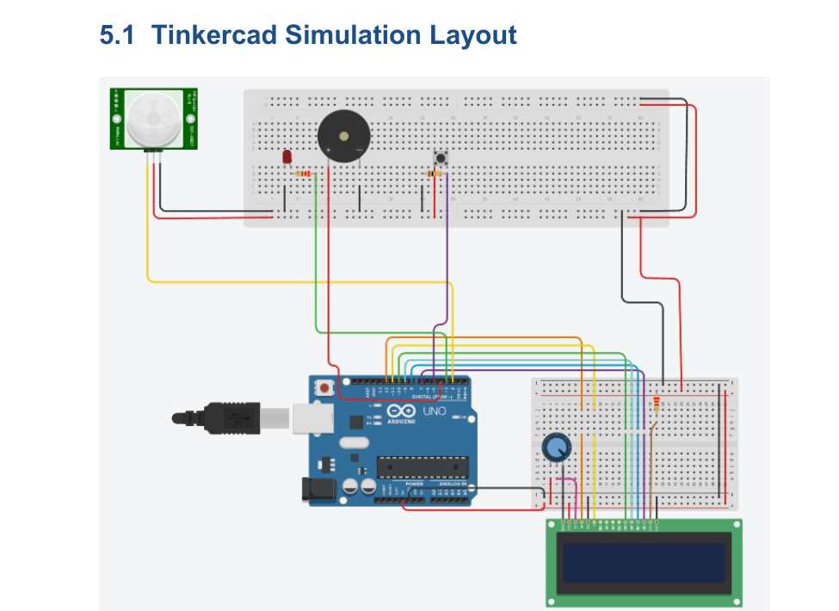
Figure 1. Tinkercad simulation layout of the Human Detection Probe.

5.2 Schematic Assembly and Wiring
- Microcontroller representation: Use an Arduino Uno R3 as the central controller and identify digital pins D2, D3, D4, D5, D7, D8, D9, D10, D11, and D12, together with the 5 V and GND connections.
- Power distribution: Connect the circuit to +5 V and GND rails from the Arduino.
- PIR sensor: Connect VCC to +5 V, GND to ground, and OUT to Arduino digital pin D2.
- Piezo buzzer: Connect the positive terminal to D4 and the negative terminal to GND.
- LED indicator: Connect D3 through a 220 Ω resistor to the LED anode, and connect the cathode to GND.
- Pushbutton: Connect one side of the pushbutton to +5 V and the other side to D5. Connect a 10 kΩ pull-down resistor from the D5 node to GND.
- LCD interface: Connect LCD VCC to +5 V and GND to ground. Wire RS to D7, EN to D8, and LCD D4-D7 to Arduino D9-D12. Connect the 10 kΩ potentiometer across +5 V and GND and connect its wiper to LCD V0 for contrast adjustment.
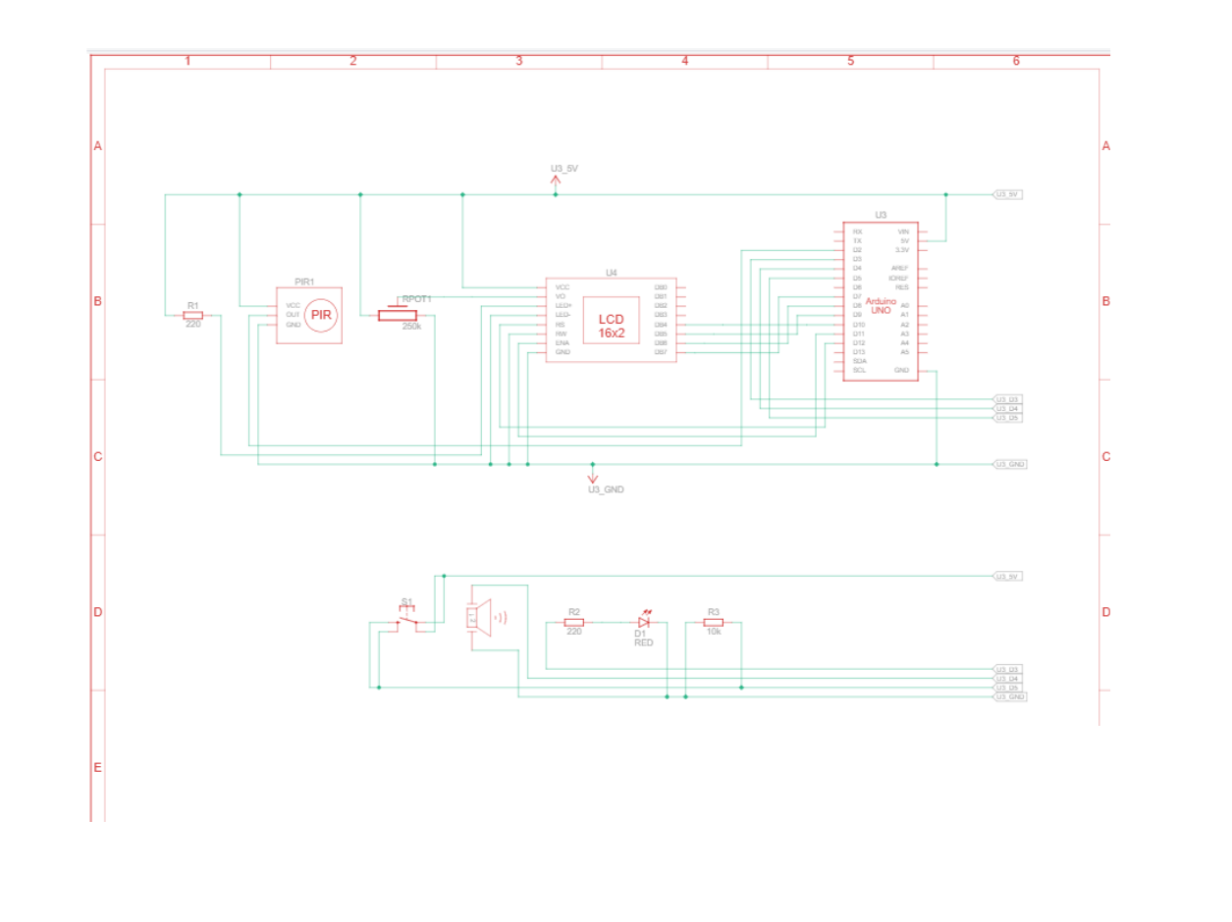
Figure 2. Circuit schematic for the Human Detection Probe.

6. Future Enhancements and Market Readiness
To move from a simulated prototype toward a field-ready rescue device, the following improvements could be considered:
- Wireless Telemetry and Mesh Networking: A LoRaWAN radio or ESP32-based wireless link could allow a deployed probe to transmit detection status to rescuers at a safer distance.
- Geographic Position Tagging (GPS): A low-power GPS module such as the Neo-6M could log the location associated with a detection event for use in rescue coordination and digital incident maps.
- Environmental Armour and Protective Housing: A rugged IP67-rated enclosure could protect the electronics from dust, water, and mechanical abrasion in disaster environments while keeping the PIR sensing area unobstructed.

7. Conclusion
The Human Detection Probe demonstrates how an Arduino-based embedded system can convert a PIR sensor input into clear operational feedback for a search-and-rescue scenario. The design combines motion sensing, a visual LED warning, an audible piezo alarm, an LCD status display, and a manual test input in a single prototype.
Within the simulated environment, the system logic provides three clear states - ALERT, TESTING, and CLEAR - and shows how low-cost embedded components can be integrated into a compact detection concept intended for post-earthquake rescue operations.

8. References
- Arduino. (2025). Arduino Uno hardware documentation and GPIO reference. https://www.arduino.cc
- Parallax Inc. (2020). Parallax 555-28027 Passive Infrared Sensor Technical Datasheet. Rocklin, CA.
- Belgium Campus iTversity. (2026). IOT261 Project Brief & Technical Report Structure Formatting Guide. Akasia, South Africa.

