Question 1
ERD:
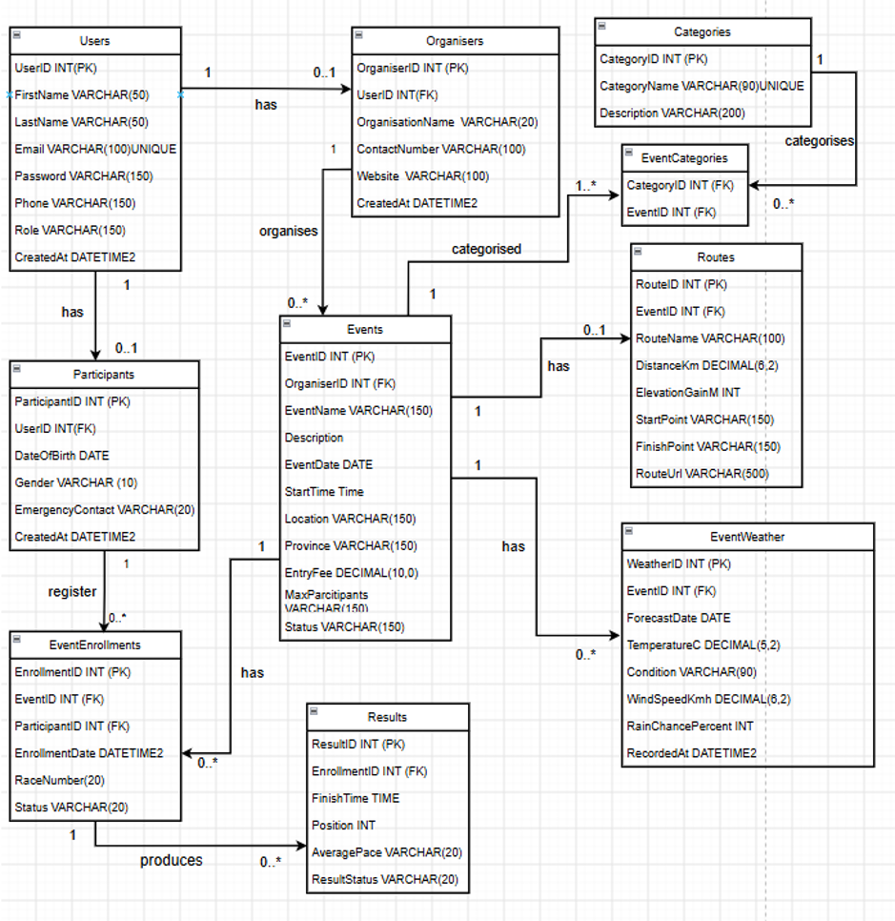

Business Rules:
-A User can have no more than one Organiser profile, and every Organiser profile must be linked to one User.
-A User can have no more than one Participant profile, and each Participant profile must be connected to one User.
-One Organiser can manage multiple Events, but every Event must be managed by exactly one Organiser.
-A Participant can sign up for multiple Events, and each Event can have multiple Participants.
-A Participant can only enrol once in the same Event.
-Each Event must be linked to at least one Category, while a Category can be used by multiple Events.
-The same Category cannot be linked to an Event more than once.
-An Event can have either no Route or one Route, and each Route must be linked to a single Event.
-An Event can contain multiple Weather records, with each Weather record belonging to one Event only.
-An Event can contain multiple EventEnrollment records, while each EventEnrollment is associated with one Event.
-Every EventEnrollment must be linked to one Participant.
-The total number of Participants registered for an Event must not exceed the specified MaxParticipants limit.
-Each Participant's RaceNumber must be unique for a particular Event.
-An EventEnrollment can have zero or one Result, while each Result must be associated with exactly one EventEnrollment.

Question 2

1. Event Organiser API Endpoints
HTTP Method | Route | Description | Role Required | Request Body | Expected Response
POST | /api/auth/register | Creates a new Event Organiser account. | Event Organiser | { name, email, password, role } | 201 Created – account created. 400 Bad Request – invalid details. 409 Conflict – email already exists.
POST | /api/auth/login | Authenticates an Event Organiser and provides an authentication token. | Event Organiser | { email, password } | 200 OK – login successful with token. 401 Unauthorized – invalid credentials.
GET | /api/users/me | Retrieves the logged-in organiser's profile information. | Event Organiser | None | 200 OK – organiser profile. 401 Unauthorized – authentication required.
PUT | /api/users/me | Updates the logged-in organiser's profile information. | Event Organiser | { name, email, phone, location } | 200 OK – profile updated. 400 Bad Request – invalid information.
GET | /api/categories | Retrieves all event categories available when creating an event. | Event Organiser | None | 200 OK – list of categories.
POST | /api/categories | Creates a new event category. | Event Organiser | { name, description } | 201 Created – category created. 400 Bad Request – invalid data.
PUT | /api/categories/{id} | Updates an existing event category. | Event Organiser | { name, description } | 200 OK – category updated. 404 Not Found – category does not exist.
DELETE | /api/categories/{id} | Deletes an event category that is no longer required. | Event Organiser | None | 204 No Content – category deleted. 404 Not Found – category does not exist.
GET | /api/events | Retrieves events managed by the organiser. | Event Organiser | None | 200 OK – list of organiser events.
GET | /api/events/{id} | Retrieves detailed information about a specific event. | Event Organiser | None | 200 OK – event details. 404 Not Found – event does not exist.
POST | /api/events | Creates and publishes a new running, walking or cycling event. | Event Organiser | { name, description, categoryId, date, startTime, location, distance, routeInfo } | 201 Created – event created. 400 Bad Request – invalid data.
PUT | /api/events/{id} | Updates information for an event managed by the organiser. | Event Organiser | { name, description, categoryId, date, startTime, location, distance, routeInfo } | 200 OK – event updated. 404 Not Found – event does not exist. 403 Forbidden – organiser does not own event.
DELETE | /api/events/{id} | Removes an event managed by the organiser. | Event Organiser | None | 204 No Content – event deleted. 404 Not Found – event does not exist.
GET | /api/events/{id}/enrolments | Retrieves all participants enrolled in a specific event. | Event Organiser | None | 200 OK – list of enrolled participants. 404 Not Found – event does not exist.
POST | /api/events/{id}/results | Records a participant's result after an event has been completed. | Event Organiser | { userId, finishTime, position, status } | 201 Created – result recorded. 400 Bad Request – invalid result. 404 Not Found – participant/event not found.
GET | /api/events/{id}/results | Retrieves the results for all participants in an event. | Event Organiser | None | 200 OK – event results. 404 Not Found – event does not exist.
PUT | /api/results/{id} | Corrects or updates a participant's result. | Event Organiser | { finishTime, position, status } | 200 OK – result updated. 404 Not Found – result does not exist.

2. Participant API Endpoints
HTTP Method | Route | Description | Role Required | Request Body | Expected Response
POST | /api/auth/register | Creates a new Participant account so the user can enrol in events and track performance. | Participant | { name, email, password, role } | 201 Created – account created. 400 Bad Request – invalid details. 409 Conflict – email already exists.
POST | /api/auth/login | Authenticates a Participant and provides an authentication token. | Participant | { email, password } | 200 OK – login successful with token. 401 Unauthorized – invalid credentials.
GET | /api/users/me | Retrieves the logged-in participant's profile information. | Participant | None | 200 OK – participant profile. 401 Unauthorized – authentication required.
PUT | /api/users/me | Updates the logged-in participant's profile information. | Participant | { name, email, phone, location } | 200 OK – profile updated. 400 Bad Request – invalid information.
GET | /api/categories | Retrieves available event categories such as running, walking and cycling. | Participant | None | 200 OK – list of categories.
GET | /api/events | Allows participants to browse upcoming events. | Participant | None | 200 OK – list of upcoming events.
GET | /api/events/{id} | Displays detailed information about a selected event. | Participant | None | 200 OK – event details. 404 Not Found – event does not exist.
POST | /api/events/{id}/enrolments | Registers the logged-in participant for a specific event. | Participant | { emergencyContact, selectedDistance } | 201 Created – enrolment created. 404 Not Found – event does not exist. 409 Conflict – already enrolled.
GET | /api/enrolments | Retrieves all events in which the logged-in participant is enrolled. | Participant | None | 200 OK – participant's enrolments.
DELETE | /api/enrolments/{id} | Allows a participant to cancel an event enrolment. | Participant | None | 200 OK – enrolment details. 404 Not Found – enrolment does not exist.
GET | /api/users/me/results | Retrieves the participant's complete personal performance history. | Participant | None | 200 OK – performance history. 401 Unauthorized – authentication required.
GET | /api/events/{id}/weather | Provides weather information for the event location to help the participant prepare for race day. | Participant | None | 200 OK – weather information.

