PROG6212_ST10446045
Naledi Paballo Tshelane

Table of Contents
Design choice 2
UML Diagram 3
GUI Layout 4
The Project Plan 6

Design choice
This prototype serves as the groundwork for a fully functional Contract Monthly Claim System. Its design prioritizes a balance between user-friendliness, ease of maintenance, and role-based access control. The architecture is built to be scalable, allowing for future enhancements such as back-end integration, authentication, and data validation.
The Contract Monthly Claim System was developed to provide a smooth and transparent process for lecturers and academic managers to submit and approve monthly claims. It features a role-based dashboard interface built with Windows Presentation Foundation (WPF) in .NET Core. A tabbed layout separates functionalities for different users, lecturers and managers enhancing both usability and user focus.
The Lecturer Dashboard enables users to submit new claims, upload supporting documents, and track the status of all their submissions, promoting transparency and accountability. The Manager Dashboard displays all pending claims and provides options to approve or reject them, allowing academic managers to handle claims efficiently.
This prototype functions solely as a non-operational front-end, offering a visual representation of the planned features. Interaction logic and data storage will be incorporated in future development stages.

UML Diagram
1:1
1:*
1:*
SupportingDocument
-DocumentID{PK}
-ClaimID{FK}
-FileName
-FileType
-UploadDate
Claim
-ClaimID{PK}
-LecturerID{FK}
-DateSubmitted
-HoursWorked
-ClaimAmount
-Status
-ApproverID{FK}
Approver
-ApproverID{PK}
-FullName
-Email
-Role

Lecturer
-LecturerID{PK}
-FullName
-Email
Department
-SubmitClaim()

GUI Layout
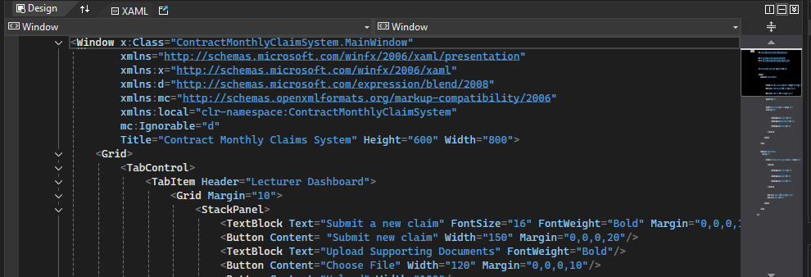
- Main Window (Navigation)
- Welcome screen or basic navigation (TabControl or Menu).
- Lecturer Dashboard
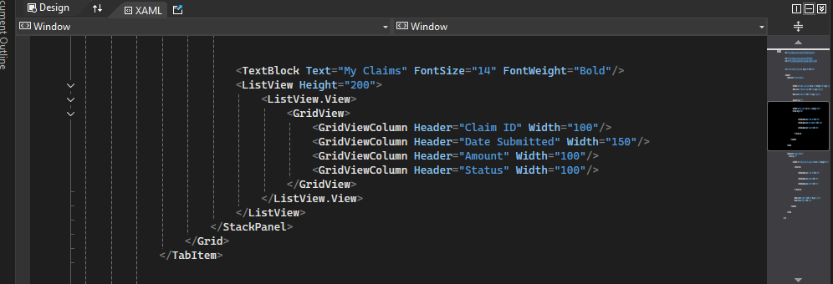
- “Submit New Claim” Button
- A claims list ( ListView) showing Claim ID, Date Submitted, Amount, and Status
- Upload supporting documents section with file upload and submit options
- Manager Dashboard (View only)
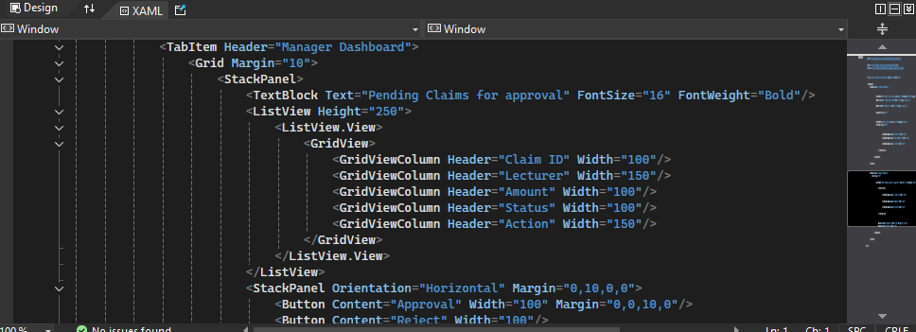
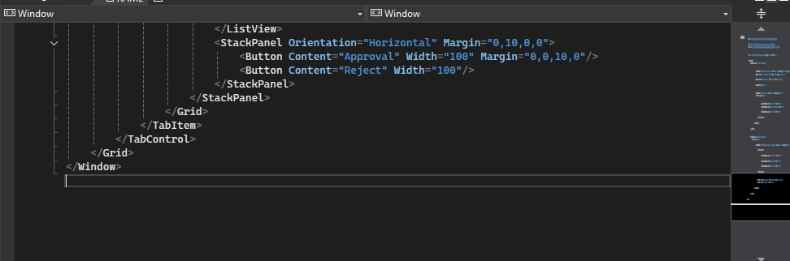
- List of pending claims with lecturer name, amount, status, and an action column
- Mock “Approve”/ “Reject” buttons
The layout was structured using StackPanel and Grid to maintain clarity and simplicity. WPF controls were selected due to their versatility for desktop applications.

Assumptions and Constraints
- All users are required to register and log in.
- Claims must be submitted on a monthly basis and must include appropriate documentation.
- Approval or rejection of claims is restricted to academic managers.
- Uploaded documents must be in either PDF or image format.
- The graphical user interface is currently a prototype and does not include back-end functionality.

The Project Plan
TaskID | Task Name | Date | Date | Duration | Dependencies | Notes
1 | Requirements Gathering | Week 1 | Week 1 | 5 days | None | Meet with stakeholders, define scope
2 | UI WireFrame Design | Week 1 | Week 2 | 7 days | Task 1 | Create mockups using sketch
3 | UI Approval and Feedback | Week 2 | Week 2 | 3 days | Task 2 | Incorporate feedback from stakeholders
4 | Front-end Development | Week 2 | Week 4 | 10 days | Task 3 | Start building actual interface
5 | Back-end Development | Week 3 | Week 5 | 10 days | Task 4 | Connect database, API’s, logic
6 | Integration and internal testing | Week 5 | Week 5 | 5 days | Task 4 and 5 | Ensure all components work together
7 | Bug Fixing and Improvements | Week 5 | Week 6 | 5 days | Task 6 | Fix issues found during testing
8 | Final Presentation | End if Week 6 | End of Week 6 | 2 days | Task 7 | Prepare project report or demo video

