#### SUMMER INTERNSHIP REPORT

on

#### RESOLVE NOW

A report submitted in partial fulfillment of requirement for the Award in Degree of

#### BACHELOR OF TECHNOLOGY

by

**Nali Kusuma (23005A0506)**

##### Under the guidance of

**Dr. R. Raja Sekhar M. Tech, Ph. D**

**Professor**

(Duration: 12th May 2025 to 12th July 2025)



#### DEPARTMENT OF COMPUTER SCIENCE AND ENGINEERING JAWAHARLAL NEHRU TECHNOLOGICAL UNIVERSITY ANANTAPUR COLLEGE OF ENGINEERING (AUTONOMOUS)

**ANANTHAPURAMU – 515002**

**2025**

**JAWAHARLAL NEHRU TECHNOLOGICAL UNIVERSITY ANANTAPUR COLLEGE OF ENGINEERING(Autonomous)**

#### ANANTHAPURAMU – 515002

**2025-2026**

#### DEPARTMENT OF COMPUTER SCIENCE AND ENGINEERING



**CERTIFICATE**

This is to certify that the internship entitled, “**Resolve now**”, is bonafide work of **Nali kusuma**, bearing admission number: **23005A0506**, submitted to the faculty of Computer Science and Engineering, in partial fulfillment of requirements for the award of the degree of BACHELOR OF TECHNOLOGY in COMPUTER SCIENCE AND ENGINEERING, JNTUA College of Engineering,

Ananthapuramu at smart bridge educational services Pvt. Ltd in collaboration with Andhra Pradesh state council of higher education(APSCHE).

### Signature of Mentor Signature of HOD

**Dr. R. Raja Sekhar M. Tech Ph. D Dr. K. F. Bharati M. Tech, Ph. D**

Professor Head of the Department(HOD) Dept of CSE Dept of CSE

#### DECLARATION

I hereby declare that the summer internship entitled “**Resolve now** ” is a bonafide work carried out by me and the results embodied in this internship report have not been reproduced or copied from any source. The work carried out and results embodied in this report have not been submitted to any other University or Institution for the award of any degree or diploma.

##### Name of the candidate Roll number Signature

Nali Kusuma 23005A0506

Place: Anantapur Date:

**INTERNSHIP COMPLETION CERTIFICATE**

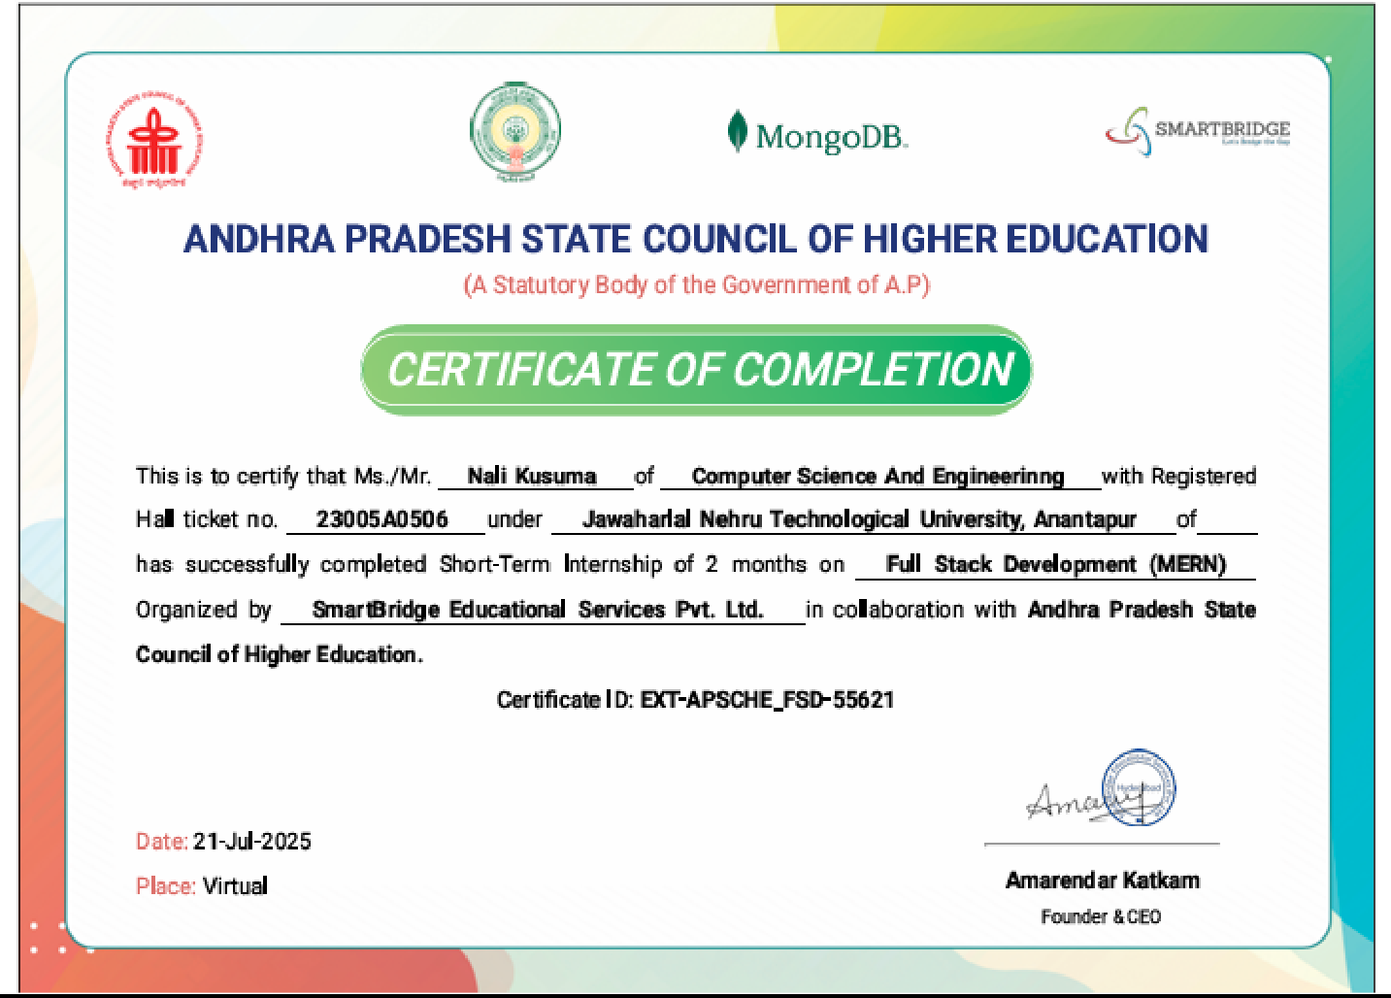

# ACKNOWLEDGEMENT

First we would like to thank **Educator Yatharath sharawat of smart bridge educational services Pvt. Ltd** for giving us this internship opportunity to do an internship within the organization. It is a great pleasure in expressing deep sense of gratitude and veneration to the internship.

We would like to thank our college, **JNTUA COLLEGE OF ENGINEERING ANATHAPURAMU** for giving us an opportunity to prepare this project as a part of our internship.

I would like to thank our guide **Dr.R.Raja sekhar M.tech,ph.D., Professor** for guiding us throughout the preparation of this internship and for correcting me wherever required.

We are very greatly indebted to **Dr. K. F. Bharati, M.Tech., Ph.D., Associate Professor,** Head of the Computer Science and Engineering Department. Advised, assistanced and patience are greatly appreciated for providing outstanding facilities for completion of internship.

We also expressing my sincere thanks to the **Prof. P. Chenna Reddy, M. Tech., Ph.D., Principal, JNTUA College of Engineering Ananthapuramu** for his encouragement and for providing the opportunity for the students to go and work in the field with the advent of internship after the completion of third year.

**With gratitude,**

N. KUSUMA (23005A0506)

# ABSTRACT

In the current era of technological advancement, organizations across various industries are rapidly transitioning towards digital solutions to improve their services and operations. Among the most in- demand skills in this evolving landscape is full-stack web development, where developers are proficient in managing both the front-end and back-end components of web applications. To gain practical exposure in this field and enhance my technical skills according to industry standards, I enrolled in the Full Stack Developer (MERN Stack) Internship Program organized by Smart bridge, in collaboration with NASSCOM and Future skills Prime, and approved by the Andhra Pradesh State Council of Higher Education (APSCHE). This internship was specifically designed to bridge the gap between academic learning and industry requirements by offering a structured blend of technical training and real-world project development.

The internship primarily focused on the MERN stack, one of the most popular and efficient technology stacks used in modern web application development. The MERN stack comprises four key technologies: MongoDB, a flexible and scalable NoSQL database for efficient data storage and retrieval; Express.js, a fast and lightweight web application framework for creating server-side APIs; React.js, a powerful JavaScript library used for building dynamic, component-based, and responsive user interfaces; and Node.js, a server-side runtime environment for executing JavaScript code. Together, these technologies create a full-stack development environment where both front- end and back-end processes are handled using JavaScript, offering high performance and faster development cycles.

During the initial phase of the internship, I received rigorous training that started from fundamental web development concepts such as HTML, CSS, and JavaScript, and advanced to more complex topics like component-based architecture with React, state management using React Hooks and Context API, API development using Express.js, and data operations with MongoDB. I also learned to create RESTful APIs, implement secure authentication mechanisms with JWT (JSON Web Tokens), and connect the front-end and back-end through proper API integrations. The program also focused on best coding practices, application architecture design, and modular code development, ensuring the creation of professional-quality applications.

In the project phase, I applied these skills to develop a real-time, full-stack web application called “Resolve now – Online Complaint Registration and Management System.” This project was aimed at solving common problems found in traditional complaint management by providing a centralized online platform for users to submit complaints, track their status, and communicate directly with agents. The system included features such as secure user login, complaint submission, real-time status updates, and administrative controls for complaint assignment and monitoring. Additionally, the internship introduced me to industry practices such as version control using Git and GitHub, collaborative coding workflows, and deployment techniques for hosting applications on the cloud. Overall, this internship greatly improved my full-stack development capabilities, enhanced my practical knowledge, and prepared me to confidently take on challenges in the software industry.

**TABLE OF CONTENTS**

|  |  |  |
| --- | --- | --- |
| **S.No** | **DESCRIPTION** | **Page** |
| **1.** | **Introduction** | **No.**  **1-3** |
|  | 1.1 Overview of the Organization | 2 |

* 1. Internship Objectives 2
  2. Overview of the Project 3

1. Background / Related Work 4-6
   1. Requirement Analysis 4-5
   2. Software Requirements 5-6
2. Algorithms / Frameworks Used 7-8
   1. Frontend Technologies 7
   2. Backend Technologies 8
3. Results 9-11
4. Weekly Report 12-18
5. Conclusions 19
6. References 20

## CHAPTER 1 INTRODUCTION

The internship served as a valuable platform to bridge the gap between academic learning and practical industry application. It provided an opportunity to gain first-hand experience in a professional work environment, thereby enhancing both technical proficiency and soft skills. The primary objective of the internship was to acquire practical exposure to real-time projects, comprehend organizational workflows, and strengthen analytical and problem-solving capabilities. Throughout the tenure, responsibilities included contributing to the design, development, and testing of project modules, collaborating effectively with team members, and adhering to industry best practices. This experience has significantly contributed to professional development and has laid a strong foundation for future endeavors in the field of software development.

### Over view of the organization

Smart Bridge Educational Services Pvt. Ltd., in collaboration with the Andhra Pradesh State Council of Higher Education (APSCHE), is a prominent educational technology and skill development organisation dedicated to empowering students through experiential learning. The organisation plays a vital role in bridging the gap between academic knowledge and industry requirements by offering innovative training programs, industry-driven projects, and structured internship opportunities.

Smart Bridge focuses on equipping learners with practical skills in emerging domains such as Artificial Intelligence, Machine Learning, Data Science, Cloud Computing, Internet of Things (IoT), and Full Stack Development. Its programs are designed to promote hands-on learning, critical thinking, and problem-solving capabilities, ensuring students are well-prepared for real-world challenges.

Through its collaboration with APSCHE, Smart Bridge extends its reach to a wide network of students across Andhra Pradesh, creating a platform for them to work on live industry projects under expert mentorship. This partnership also emphasizes building employability skills, fostering innovation, and preparing students to meet the evolving demands of the global workforce. The organisation is committed to nurturing talent and contributing to the creation of a skilled, job-ready generation.

### Internship objectives

* + - Gain practical exposure to real-world projects and industry practices.
    - Skill development in HTML, CSS, and JavaScript, MERN stack.
    - Enhance technical skills, problem-solving abilities, and hands-on experience.
    - Understand organisational workflows and professional standards.
    - Develop teamwork, communication, and collaboration skills.
    - Build a strong foundation for future career growth in software development.

### Over view of the project

The **"Resolve Now: Online Complaint Registration and Management System"** is a digital platform developed to simplify and improve the way complaints are registered, managed, and resolved. Traditional methods of grievance redressal often involve lengthy paperwork, delayed communication, and a lack of transparency, making the process frustrating for both complainants and authorities. Resolve Now addresses these challenges by offering a fast, accessible, and user-friendly online solution that can be used anytime, from anywhere.

The platform is built around two main modules:

1. **User Module** – This allows users to register complaints quickly by filling in the required details and, if needed, attaching supporting documents or images. Once submitted, the complaint can be tracked in real time, with users receiving status updates and notifications at each stage.
2. **Admin Module** – Designed for administrators or authorities, this section provides tools to view all incoming complaints, categorize them by type or urgency, assign them to relevant departments, and update their status. This ensures no complaint is left unresolved and that actions are taken in a timely manner.

Key features of Resolve Now include a simple interface for easy navigation, secure storage of data, instant alerts, and a well-structured complaint tracking system. The design focuses on making the process transparent so that users know exactly what stage their complaint is at and administrators can efficiently manage workloads.

By creating a direct and structured communication channel between the complainant and the authority, Resolve Now reduces delays, avoids miscommunication, and fosters accountability. Its flexible structure makes it suitable for multiple sectors — from educational institutions to corporate offices and public service departments. In all these settings, the platform helps save time, reduce paperwork, and ensure issues are handled with greater efficiency and fairness.

With its combination of accessibility, transparency, and ease of use, Resolve Now represents a modern approach to solving everyday problems and improving the quality of service delivery.

**************

### Chapter 2 Background /Related work

### Requirement Analysis

##### Front-End Requirements

**Objective:**

The front-end must provide an intuitive, responsive, and accessible interface for users to register complaints, track their status, and communicate with administrators.

##### Key Areas:

1. **User Interface (UI) Design**
   * **Tools/Frameworks:** React.js for building interactive UI components; HTML5, CSS3, and JavaScript for structure and styling.

##### Design Requirements:

* + - Clean and minimal layout for ease of navigation.
    - Mobile-friendly and responsive design.
    - Consistent color scheme and typography aligned with branding.

##### User Experience (UX)

* + **Usability:**
    - Easy-to-use complaint registration form.
    - Clear navigation menus for different sections (Home, Register Complaint, Track Status, Contact).

##### Accessibility:

* + - ARIA attributes for screen readers.
    - Keyboard navigation support.

##### Integration with Back-End

* + Dynamic fetching and display of complaint status.
  + Real-time chat interface for admin-user communication.
  + Form submissions connected to REST APIs.

##### Testing and Debugging

* + Manual testing for UI responsiveness and usability.
  + Browser compatibility checks across Chrome, Firefox, and Edge.
  + Use of Jest or React Testing Library for component testing.

##### Back-End Requirements Objective:

The back-end must manage complaint records, handle authentication, store user and admin

messages, and process data efficiently while ensuring security.

##### Key Areas:

1. **Server-Side Logic**
   * **Tools/Frameworks:** Node.js with Express.js for REST API development.
   * Handles CRUD operations for complaints, users, and admin data.
   * Implements role-based authentication (user/admin).

##### Database Management

* + **Database:** MySQL for structured complaint and user records.
  + Database schema includes tables for Users, Complaints, Messages, and Complaint Status.
  + Optimized queries for faster search and retrieval of complaint records.

##### API Integration

* + RESTful APIs for front-end data requests.
  + Secure endpoints with JWT authentication.
  + Real-time updates for chat using WebSockets or Socket.io.

##### Security & Error Handling

* + Password hashing (bcrypt) for secure storage.
  + Input validation and sanitization to prevent SQL Injection and XSS.
  + Centralized error handling for better debugging.

##### Testing & Deployment

* + Unit and integration testing using Mocha/Chai or Jest.
  + Deployment on a cloud service (e.g., AWS, Heroku, or Render).
  + Backup and recovery plan for database.

### Software requirements

The software requirements for **Resolve Now: Online Complaint Registration and Management System** define the necessary specifications to ensure smooth development, deployment, and operation of the application. These requirements are designed to provide a user-friendly interface, reliable functionality, and efficient performance for all stakeholders, including users, administrators, and system managers.

##### Purpose

The purpose of this document is to define the functional and non-functional requirements for the Resolve Now system. This online platform is designed to streamline complaint registration, tracking, and resolution between users and administrators. It ensures efficient communication, real-time updates, and organized management of grievance redressal.

##### Scope

Resolve Now will serve as a digital medium where users can register complaints, track their progress, and receive timely responses. Administrators will be able to manage complaints, update their statuses, and communicate with users through an integrated messaging system. The platform will:

* Reduce manual handling of complaints.
* Provide transparency in resolution timelines.
* Maintain a database for analytics and reporting.
* Enhance trust between users and service providers.

##### Functional Requirements

* **User Registration & Login**: Secure authentication for both users and administrators.
* **Complaint Registration**: Ability to submit complaints with necessary details and supporting attachments.
* **Complaint Tracking**: Users can view the current status and history of their submitted complaints.
* **Admin Dashboard**: Enables administrators to view, manage, and update complaint statuses.
* **Communication Module**: Allows two-way messaging between users and administrators for complaint clarification.
* **Search & Filter**: Enables users and admins to locate complaints quickly based on ID, category, or date.
* **Notification System**: Sends updates to users when complaint status changes.

##### Non-Functional Requirements

* **Performance**: The system should handle multiple complaint submissions and updates simultaneously without performance degradation.
* **Security**: All user data and communications must be encrypted and protected from unauthorized access.
* **Usability**: Interface must be simple, intuitive, and accessible across different devices and screen sizes.
* **Scalability**: The system should support future enhancements, such as integration with DigiLocker or other third-party services.
* **Availability**: The application should maintain high uptime with minimal service interruptions.\

##### Technical Requirements

* **Frontend**: React.js for building an interactive and responsive user interface.
* **Backend**: Node.js with Express.js for handling server-side logic.
* **Database**: MySQL or MongoDB for storing user and complaint data.
* **APIs**: RESTful APIs for communication between frontend and backend.

************

## CHAPTER – 3

### Algorithms/Frameworks Used

### Front end technologies

The **frontend** is the part of the application users interact with directly — the screens, forms, buttons, and messages they see. For ResolveNow, the frontend technologies help build a user- friendly, responsive, and interactive interface.

* **React.js:**

React is a popular JavaScript library used to build user interfaces with reusable components.

* + Enables fast and dynamic rendering of pages without full reloads.
  + Makes it easy to manage complex UI states like complaint lists and chat messages.
  + Strong community support and many available libraries.

##### Use in Resolve Now:

React helps build the complaint registration form, status tracking pages, and the real-time chat window for messaging between users and admins.

#### HTML5

The standard markup language used to structure the content on the web.

##### Use in Resolve Now:

Defines the structure of complaint forms, buttons, text inputs, and display areas.

#### CSS3

Style sheet language used to make the frontend visually appealing and responsive.

##### Use in Resolve Now:

Used for styling the layout, colors, fonts, and making the app look professional and mobile- friendly.

##### JavaScript (ES6+)

Programming language that adds interactivity and logic on the frontend.

##### Use in ResolveNow:

Handles form validation, dynamic content updates (like showing complaint status changes), and sending/receiving data from the backend using API calls.

##### React Router

A library to handle navigation between different pages or views in React apps.

##### Use in Resolve Now:

Allows smooth transitions between complaint submission page, status tracking page, and admin dashboard without reloading the browser.

### Backend technologies

The **backend** is the server side of the application that processes data, manages business logic, stores information, and communicates with the frontend.

##### Node.js

Node.js is a JavaScript runtime environment that lets you run JavaScript code on the server.

Lightweight and fast.

Uses event-driven, non-blocking I/O, which makes it great for handling multiple requests (like many users submitting complaints or chatting simultaneously).

Allows using JavaScript on both frontend and backend, simplifying development.

##### Use in ResolveNow:

Handles incoming requests from users, such as complaint submissions, retrieving complaint data, or sending messages.

##### Express.js

Express is a minimal and flexible Node.js web application framework that provides tools to build APIs and web servers.

Simplifies routing (defining how the app responds to client requests).

Makes it easy to create RESTful APIs.

Middleware support for tasks like authentication, logging, etc.

##### Use in ResolveNow:

Routes API requests from the frontend (e.g., /submit-complaint, /get-status) to the appropriate backend logic.

##### MongoDB

A NoSQL document database that stores data in JSON-like flexible documents.

Flexible schema allows storing complaint data that may vary in structure.

Scales well for many users and large amounts of data.

Easy to integrate with Node.js using libraries like Mongoose.

##### Use in ResolveNow:

Stores user profiles, complaint details, chat messages, and status updates.

##### Mongoose

An Object Data Modeling (ODM) library for MongoDB and Node.js.

Provides a schema-based solution to model application data.

Simplifies querying and validation.

##### Use in ResolveNow:

Defines data models like Complaint, User, and Message and handles database operations.

##### JSON Web Tokens (JWT)

A compact, URL-safe token format used for secure user authentication.

Allows stateless authentication.

Securely passes user identity between frontend and backend.

##### Use in ResolveNow:

Manages user login sessions, ensuring only authorized users can access or update complaints.

##### Thunder Client

Thunder Client is a lightweight REST API client extension for Visual Studio Code.

Allows developers to easily test backend API endpoints directly from VS Code.

Simplifies sending HTTP requests (GET, POST, PUT, DELETE) without leaving the code editor.

Helps verify that the backend APIs (e.g., complaint submission, fetching status, messaging) are working correctly.

##### Use in ResolveNow:

Used during backend development and testing to quickly check if APIs respond as expected before integrating with frontend.

## CHAPTER 4 RESULTS

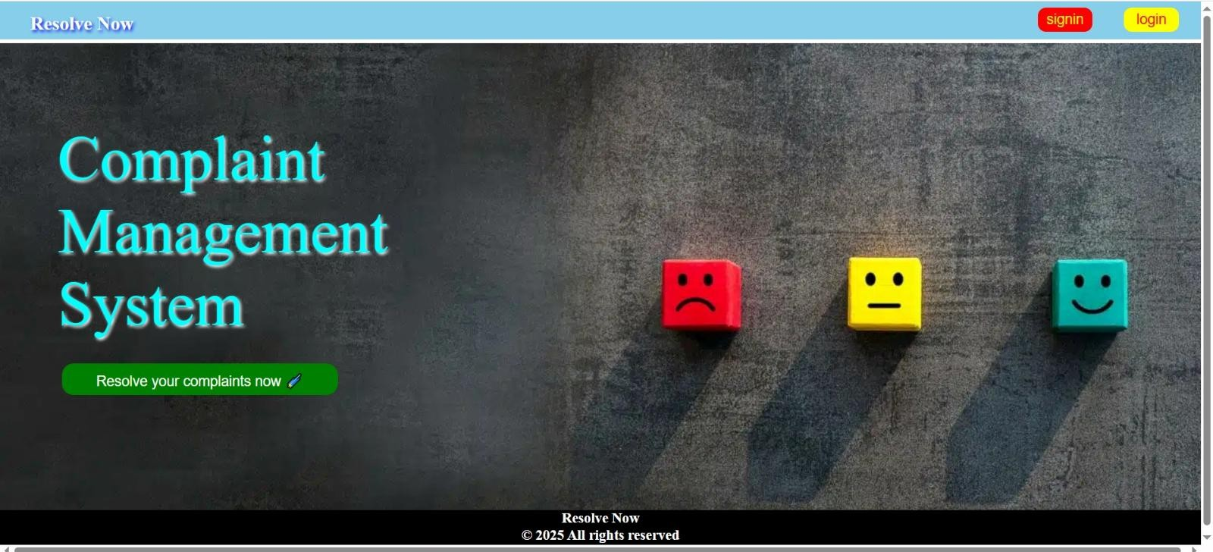

Fig 4.1 landing page

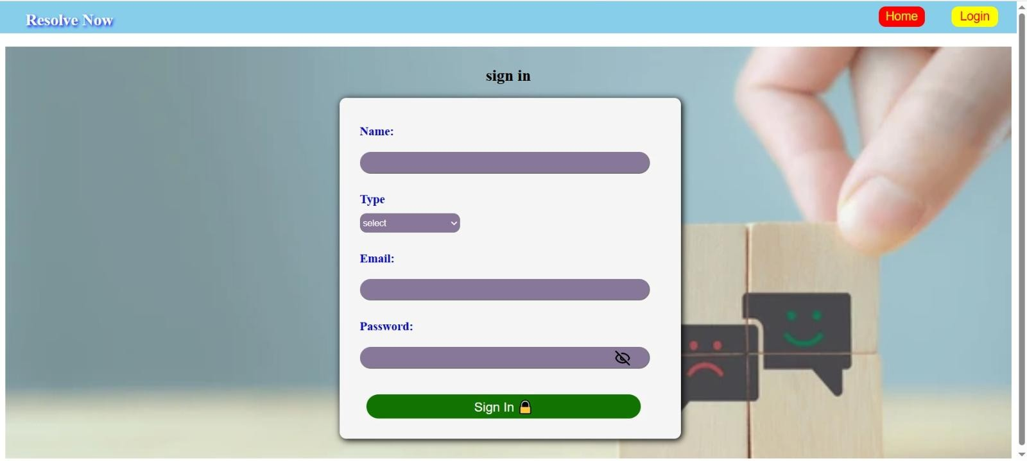

Fig 4.2 user authentication page

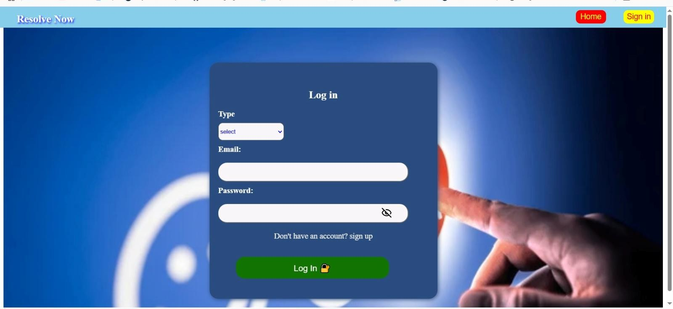

Fig 4.3 user & admin authentication page

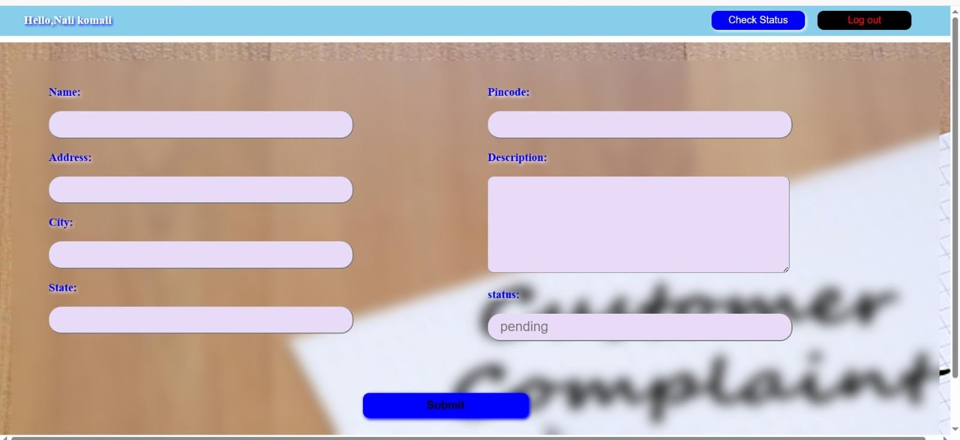

Fig 4.4 complaint registration page

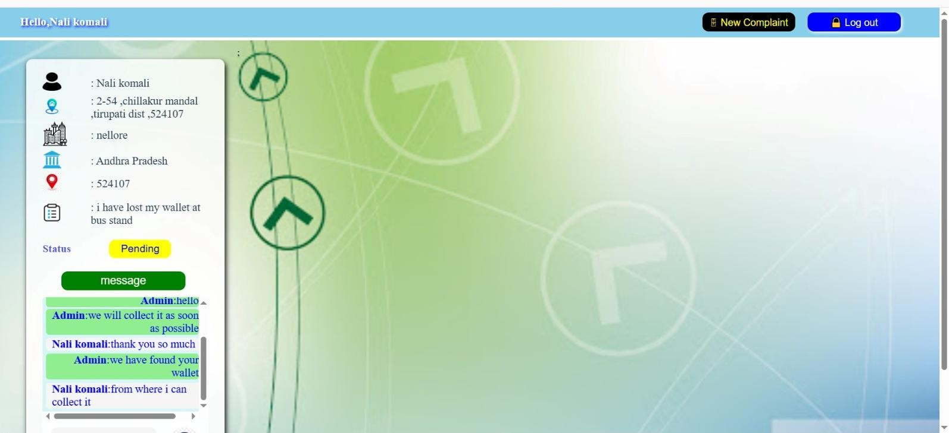

Fig 4.2 user status tracking page

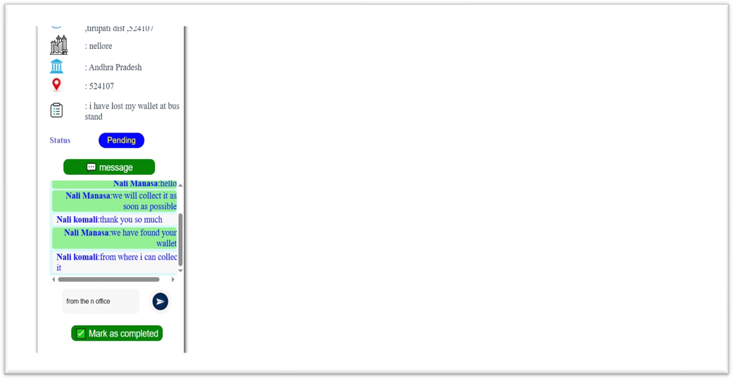

Fig 4.2 admin complaint management page

## CHAPTER 5 WEEKLY REPORT



weekly report of summer internship

on

Full stack development (MERN stack)

**Name:** Nali Kusuma **Admission no:** 23005A0506

**First Week** (19/05/2025 –23/05/2025)

|  |  |  |
| --- | --- | --- |
| **Date** | **Topics covered** | **Description** |
| 19/05/2025 | Introduction to full stack development(MERN stack) | Learned about the importance of full stack development and various technologies like Mongo dB, Express.js, React.js, Node.js. and there applications. |
| 20/05/2025 | Introduction to HTML | Learned about the basics of html includes( boiler-plate of HTML5 , heading tags, paragraph tag, image tag, hr tag and there attributes. |
| 21/05/2025 | Continuation of HTML | Learned about unordered and ordered list, table, form tags and introduction to cascading style sheet(CSS) |
| 22/05/2025 | Introduction to CSS | Learned about the css attributes and properties, types of css selectors(id and class selectors) types of css (Internal,external,inline)  With examples |
| 23/05/2025 | Advanced CSS and introduction to JS | Learned about box model(margin and padding), Flex box and its properties . discussed about importance of javascript and performed basic  operations . |

Signature of the Mentor(DR. R. Raja sekhar)

 

weekly report of summer internship on Full stack development (MERN stack)

**Name:** Nali Kusuma **Admission no:** 23005A0506

**Second Week** (26/05/2025 –30/05/2025)

|  |  |  |
| --- | --- | --- |
| **Date** | **Topics covered** | **Description** |
| 26/05/2025 | Introduction to javascript and it’s basics | Learned about the importance of javascript and types of datatypes(primitive and non-primitive) and arrays and it’s operation (push,  shift, pop, unshift) |
| 27/05/2025 | Functions, objects | Learned about the representations of functions and objects with examples . |
| 28/05/2025 | Call backs and control statements | Learned about the function and there representations(anonymous, arrow function)and call back functions and control statements |
| 29/05/2025 | Introduction to ES6(ECMAscr  ipt) | Learned about es6 and its importance in javascript, new features of es6 like let and const  , Strict equal operator , destructuring. |
| 30/05/2025 | Continuation of  ES6(Advanced javascript) | Learned about higher order function (map, forEach), spread and rest operator with examples. |

Signature of the Mentor(DR. R. Raja sekhar)

 

weekly report of summer internship on Full stack development (MERN stack)

**Name:** Nali Kusuma **Admission no:** 23005A0506

**Third Week** (02/06/2025 –06/06/2025)

|  |  |  |
| --- | --- | --- |
| **Date** | **Topics covered** | **Description** |
| 02/06/2025 | Introduction to react | Learned about the importance of react and installation of node js and npm (node package manager) |
| 03/06/2025 | Building first react app | Created first react app using vite native and description about content inside react app and their importance |
| 04/06/2025 | Props and components | Learned about props and rendering react app using props and components |
| 05/06/2025 | Asynchronou s programming in js | Learned about asynchronous programming with promises and suitable examples and continuation with await and async |
| 06/06/2025 | Continuation of promises | Learned about promises in react and connected with api and handle issues with suitable examples |

Signature of the Mentor(DR. R. Raja sekhar)

 

weekly report of summer internship on Full stack development (MERN stack)

**Name:** Nali Kusuma **Admission no:** 23005A0506

**fourth Week** (09/06/2025 –13/06/2025)

|  |  |  |
| --- | --- | --- |
| **Date** | **Topics covered** | **Description** |
| 09/06/20  25 | Hooks and API | Learned about the hooks in react and worked on the functions in hooks with suitable examples |
| 10/06/20  25 | Introduction to NodeJs | Learned about the node js and performed basic operations. Tried to create a server using node js and performed similar operations |
| 11/06/20  25 | Introduction to expressjs | Learned about introduction to expressjs and differences in accessing server using node js and expressjs |
| 12/06/20  25 | Creating api and connecting to database using  express | Learned about user defined api and made access through server and connected to mongodb database and performed crud operations |
| 13/06/20  25 | Connecting both frontend and backend | Learned about connecting a backend with front end and making a complete full stack app using all the knowledge that we have gained. This wrap up the training period in internship and  moving forward to project development. |

Signature of the Mentor(DR. R. Raja sekhar

 

weekly report of summer internship on Full stack development (MERN stack)

**Name:** Nali Kusuma **Admission no:** 23005A0506

**fifth Week** (20/06/2025 –24/06/2025)

|  |  |  |
| --- | --- | --- |
| **Date** | **Topics covered** | **Description** |
| 20/06/2025 | Allocation of project | After completion of the training phase, the internship project was officially allocated. The selected project is titled **“Resolve Now – Online Complaint Registration and Management System”**, aimed at providing a digital  platform for users to submit and track complaints. |
| 21/06/2025 | Analysis of project idea | Understood the idea of the project. Identified how the system will work, who the users are (user, agent, admin), and how each role will use the system. |
| 22/06/2025 | Identification of User requirements | Listed out the important features of the project such as **user registration**, **login**, **complaint submission**, **status tracking**, and **chat with agents**. |
| 23/06/2025 | Setting Up Environment and Tools | Performing installation and configuration of all resources(node, react, express, mongodb) and performing crud operations. |
| 24/06/2025 | Backend Server and API Setup | Created a backend server using **Express.js**. Developed APIs for user registration, login, and complaint submission. Tested APIs using **Thunder client** and connected them with **MongoDB** database. |

Signature of the Mentor(DR. R. Raja sekhar

16

|  |  |  |  |
| --- | --- | --- | --- |
| weekly report of summer internship on Full stack development (MERN stack)  **Name:** Nali Kusuma **Admission no:** 23005A0506  **Sixth Week** (27/06/2025 –01/07/2025) | | | |
|  | **Date** | **Topics covered** | **Description** |
| 27/06/2025 | React App Setup & Basic Pages | Created a basic React app using Vite. Learned how to create pages for registration and login. Added navigation using React Router. |
| 28/06/2025 | Designing User Registration & Login | Designed forms using HTML/CSS in React for user signup and login. Created simple frontend validations and started backend setup using Express.js and  MongoDB. |
| 29/06/2025 | Connecting Frontend to Backend | Learned how to send and receive data between React frontend and Express backend. Connected the user login and signup forms with the backend database. |
| 30/06/2025 | Storing Data in MongoDB | Successfully stored user data in MongoDB database. Tested user creation and login functionality using Postman and browser. |
| 01/07/2025 | Complaint Form Design | Created a complaint form where users can write their issues. Added fields for complaint type, description, and contact details. |
| Signature of the Mentor(DR. R. Raja sekhar)  17 | | | |

 

weekly report of summer internship on Full stack development (MERN stack)

**Name:** Nali Kusuma **Admission no:** 23005A0506

**Seventh Week** (05/07/2025 –10/07/2025)

|  |  |  |
| --- | --- | --- |
| **Date** | **Topics covered** | **Description** |
| 05/07/2025 | Complaint Management Backend | Created MongoDB schema for complaints. Implemented backend API endpoints for complaint submission and retrieval. Tested endpoints using Thunder Client. |
| 06/07/2025 | Admin panel setup | Designed admin dashboard in React to display complaints in a card/table layout. Added admin authentication. |
| 07/07/2025 | Message feature | Built two-way messaging between admin and user. Linked messages to complaint ID in MongoDB. Styled chat interface for clear  distinction between sender and receiver. |
| 08/07/2025 | Status update | Added functionality for admin to update complaint status (Pending, In Progress, Resolved). Displayed status in real-time on user dashboard. |
| 09/07/2025 | Module integration | Connected all modules: registration/login, complaint form, admin panel, messaging, and status updates. Fixed API integration bugs. |
| 10/07/2025 | Depolyment | Deployed backend on Render and frontend on Netlify. Configured environment variables for database and API URLs. |

Signature of the Mentor(DR. R. Raja sekhar)

## CHAPTER 6 CONCLUSION

The internship has been a highly valuable and enriching experience, providing me with practical exposure to real-world software development processes. Through this project, I was able to apply my theoretical knowledge of full stack development to build a complete, functional application from scratch. I enhanced my skills in React, Express.js, MongoDB, and API integration while also gaining hands-on experience in debugging, deployment, and documentation.

Working under the guidance of my mentor, I learned the importance of systematic planning, time management, and problem-solving in delivering a project within deadlines. This internship not only strengthened my technical expertise but also improved my communication, teamwork, and adaptability skills.

Overall, this journey has been instrumental in shaping my professional growth and preparing me for future challenges in the software development field. I am grateful for the opportunity, guidance, and support provided throughout this internship, which has made this experience both productive and memorable.

*************

## CHAPTER 7 REFERENCES

Resolve now video link: https://drive.google.com/file/d/13_4Fitepf2IlUsbPo1TaUw8JXfLrFYWX/view?usp=sharing