|  |
| --- |
|  |

|  |
| --- |
| **DATA ANALYSIS WITH SPREEDSHHETS** |
| DATACAMP |
|  |
|  |
| **Milka-PC** |
| **12/31/2018** |
|  |

**Function composition - SQRT**

In this exercise, you're going to use the output of one function as input to another function. *Google Sheets* will first evaluate the innermost function, and use the result as an argument for the outer function. Combining functions like this is called **function composition**.

For example, you can use the SQRT function (explained below) in a ROUND function as such: =ROUND(SQRT(5.0625)). First, SQRT(5.0625) will be evaluated to 2.25 and used as an input in ROUND. The final output will be the result of =ROUND(2.25), which is 2. The following illustration can clarify:

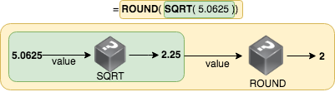

In this exercise, you'll use the following function in combination with the ROUND function:

* [**SQRT(value)**](https://support.google.com/docs/answer/3093577): the square root of a value

**INSTRUCTIONS**

* In C2:C13, fill in the SQRT of the values in B. You can start with C2 and copy the values downward.
* In D2:D13, fill in the rounded values of C.
* Note that you needed **2 columns** to find the rounded square root. In E2:E13, fill in the rounded square root of the values in B, by using function composition. This way you only use **1 column**. The values should be the same as in D2:D12.

**HINT**

* The value in C2 should be =SQRT(B2). Copy the value downward by selecting C2, finding the "+"-sign in the lower right corner and dragging it downward.
* The value in D2 should be =ROUND(C2). Copy the value downward.
* The value in E2 should use both SQRT and ROUND: =ROUND(SQRT(...)). Fill in the dots yourself

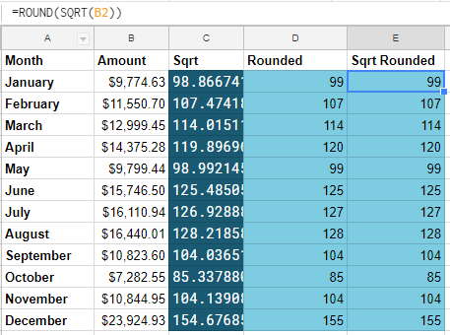

**Even more arguments - RANK**

In this exercise, you're going to use the RANK function again. This time, use the third argument, is_ascending, to get the rank of the value where the data list is considered in an ascending order.

Here's some information on RANK as a refresher:

* [**RANK(value, data, [is_ascending])**](https://support.google.com/docs/answer/3094098): when is_ascending is 1, the rank is considered in an ascending order of the data. It defaults to 0, meaning the rank will be considered in a descending list of data.

An example: if A1:A3 holds 3, 1, 2 then =RANK(A2,A1:A3,1) evaluates to 1, since 1 is the lowest number.

You're going to use an ascending rank to find the worst months in terms of revenue.

**INSTRUCTIONS**

**INSTRUCTIONS**

* In C2, fill in the rank of B2 in B2:B13, considered in an ascending order. Don't forget to use an absolute reference, like in the previous exercise.
* Copy the value of C2 until C13.
* Fill in D2:D13, checking whether the rank in column C is smaller than or equal to 2, to find the worst 2 months. You can use the comparison operator: ... <= ... (fill in the dots).

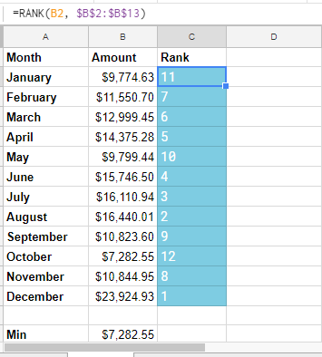

**Even more arguments - RANK**

In this exercise, you're going to use the RANK function again. This time, use the third argument, is_ascending, to get the rank of the value where the data list is considered in an ascending order.

Here's some information on RANK as a refresher:

* [**RANK(value, data, [is_ascending])**](https://support.google.com/docs/answer/3094098): when is_ascending is 1, the rank is considered in an ascending order of the data. It defaults to 0, meaning the rank will be considered in a descending list of data.

An example: if A1:A3 holds 3, 1, 2 then =RANK(A2,A1:A3,1) evaluates to 1, since 1 is the lowest number.

You're going to use an ascending rank to find the worst months in terms of revenue.

**INSTRUCTIONS**

**INSTRUCTIONS**

* In C2, fill in the rank of B2 in B2:B13, considered in an ascending order. Don't forget to use an absolute reference, like in the previous exercise.
* Copy the value of C2 until C13.
* Fill in D2:D13, checking whether the rank in column C is smaller than or equal to 2, to find the worst 2 months. You can use the comparison operator: ... <= ... (fill in the dots).

**Show Answer**

**HINT**

* For instruction one, fill in =RANK(B2, $B$2:$B$13, 1) in C2. This will evaluate to the rank of B2 in B2:B13, considered in an ascending order.
* Because you used an absolute reference in instruction one, you can copy the value of C2 until C13.
* In D2, fill in = C2 <= 2 and copy this value until D13.

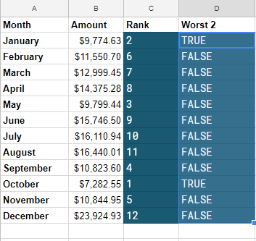

# String manipulation - LEFT, RIGHT

In the previous exercises, you saw some functions to handle numeric data. Let's look at some functions that are used to work with plain text, also called a [**string**](https://support.google.com/docs/answer/7570448). The functions in this exercise can be used to manipulate strings.

Have a look at the following functions:

* [**LEFT(string, [number_of_characters])**](https://support.google.com/docs/answer/3094079): selects the leftmost part of a string. The number of characters selected is defined in the optional argument number_of_characters, and defaults to 1.
* [**RIGHT(string, [number_of_characters])**](https://support.google.com/docs/answer/3094087): selects the rightmost part of a string. The number of characters selected is defined in the optional argument number_of_characters, and defaults to 1.

The data you'll work with is the 10 most lucrative movies in the [**domestic box office data of 2017**](http://www.boxofficemojo.com/yearly/chart/?yr=2017).

##### INSTRUCTIONS

##### INSTRUCTIONS

* You need to be able to identify each movie using a maximum of 4 characters, so you create a new column: movie id. In E2:E11, try to take the last 4 characters of the movies in A. Use RIGHT here. Does the result make a lot of sense?
* In F2:F11, try to take the first 4 characters of the movies in A. Use LEFT here. This seems to make a bit more sense.

**HINT**

* In E2, you should have =RIGHT(A2, 4), and copy it to E11. The second argument is the number of characters you want to take from the right.
* In F2, you should have something like =LEFT(A2, 4), and copy it to F11. The second argument is the number of characters you want to take from the left.

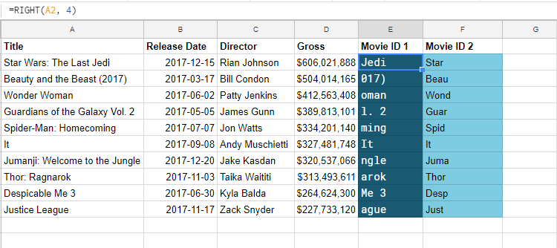

**String information - LEN, SEARCH**

In this exercise, you'll learn some functions that are used to gather some information about strings.

You'll be using the following two new functions:

* [**LEN(text)**](https://support.google.com/docs/answer/3094081): evaluates to the number of characters of text. E.g. =LEN("Cell") would evaluate to 4.
* [**SEARCH(search_for, text_to_search)**](https://support.google.com/docs/answer/3094154): searches for search_for in text_to_search:
  + search_for: the string to look for
  + text_to_search: the string to look in

SEARCH evaluates to a number, the location in the string where search_for appears, with 1 being the first character. E.g. =SEARCH("e", "test test") would evaluate to 2, because the first "e" appears as the second character.

**INSTRUCTIONS**

**INSTRUCTIONS**

You are going to combine LEN and SEARCH to retrieve the surnames of the directors.

* In E2:E11, find the number of characters in the directors' names using LEN.
* In F2:F11, find the position of the space in the directors' names using SEARCH.
* In G2:G11, find the number of characters in the directors' surnames by subtracting the values in F from the values in E.
* In H2:H11, retrieve the directors' surnames using RIGHT and the number of characters in G.

**Show Answer**

**HINT**

* First, in E2 fill in =LEN(C2), copy the value until E11.
* In F2, fill in =SEARCH(" ", C2) to look for the space in C2. Copy the value to F11.
* In G2, calculate the difference between E2 and F2. Copy the value to G2.
* Finally, retrieve the surname of the director by using their name in C, the values in G and the function RIGHT.

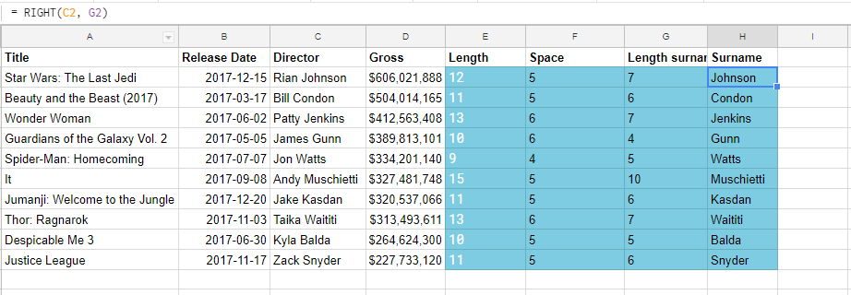

**Combining strings - CONCATENATE**

In the last exercise on string functions, you'll see how to combine strings using the CONCATENATE function:

* [**CONCATENATE(string1, [string2, ...])**](https://support.google.com/docs/answer/3094123): combines one or more strings into a single string. E.g. =CONCATENATE("foo", " ", "bar")evaluates to foo bar.

**INSTRUCTIONS**

In E, you can see a formula that selects the Last name of the director's name in C.

* In F2:F11, fill in the first character of the first name of the directors. For example, F2 should contain R. Use LEFT to achieve this.
* In G2:G11, the values should evaluate to the surname and the first character of the first name, with some punctuation. For example G2 should evaluate to Johnson R.. Use CONCATENATE to achieve this.

**Show Answer**

**HINT**

* F2 should contain something like =LEFT(C2). This value can be copied downwards to F11.
* In G2, you should use CONCATENATE as follows: =CONCATENATE(E2, " ", F2, "."). This value can be copied downwards to G11.

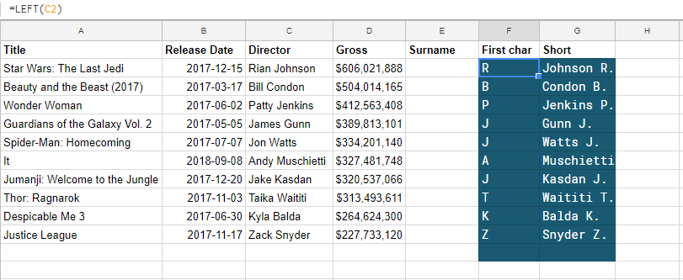

**Date functions - WEEKDAY**

Some functions are used to get specific information or do operations on dates. One example of such a function is WEEKDAY:

* [**WEEKDAY(date, [type])**](https://support.google.com/docs/answer/3092985): evaluates to the day of the week of a date. type is 1, 2 or 3.
  + type = 1: Sunday is day 1 and Saturday is day 7 (default)
  + type = 2: Monday is day 1 and Sunday is day 7
  + type = 3: Monday is day 0 and Sunday is day 6

**INSTRUCTIONS**

* From E2:E11, figure out the weekday of the release date in B2:B11. For the weekday, use the correct type so that Monday would evaluate to 0.
* The values in F2:F11 should be TRUE when the value in column E is a Wednesday, FALSEotherwise. Use the comparison operator: = ... = ..., try to fill in the dots.
* The values in G2:G11 should be TRUE when the value in column E is a Friday, FALSE otherwise.

**Show Answer**

**HINT**

* Use WEEKDAY with the second argument set to 3 in B2:B11. The date will evaluate to a number between 0 and 6 (inclusive), where 0 is Monday.
* In F2:F11, check whether the weekday in Eevaluated to 2.
* In G2:G11, check whether the weekday in Eevaluated to 4.

