- Create a new repository in github.

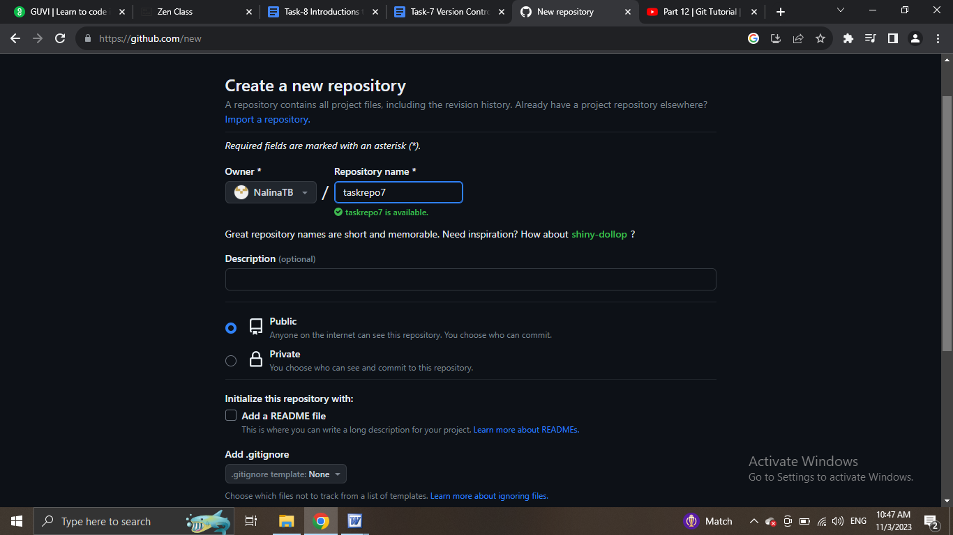

- Use the init command to create a git repository in that directory

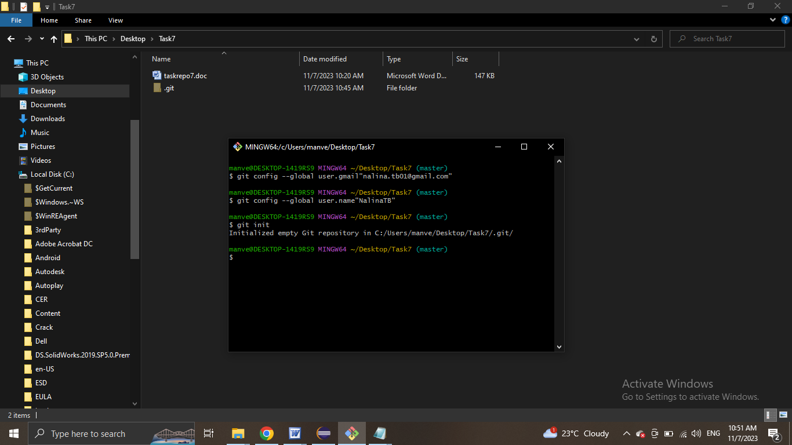

- Observe that there is now .git directory

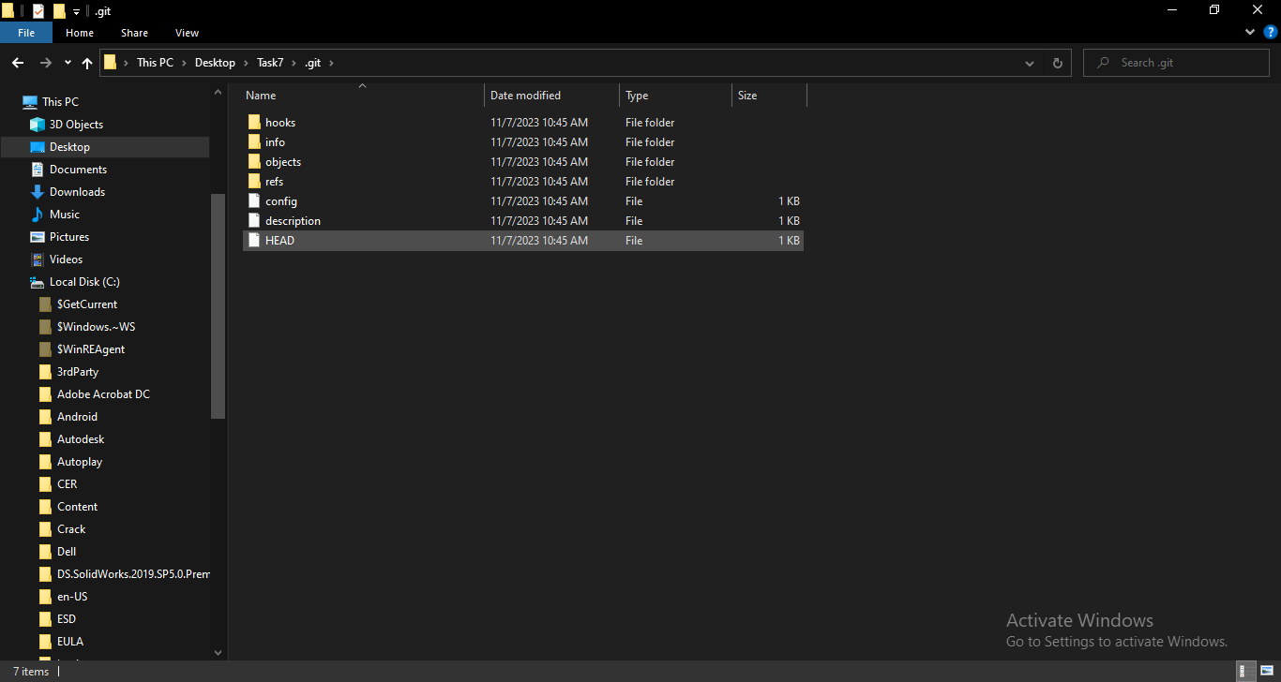

- Create a README file.

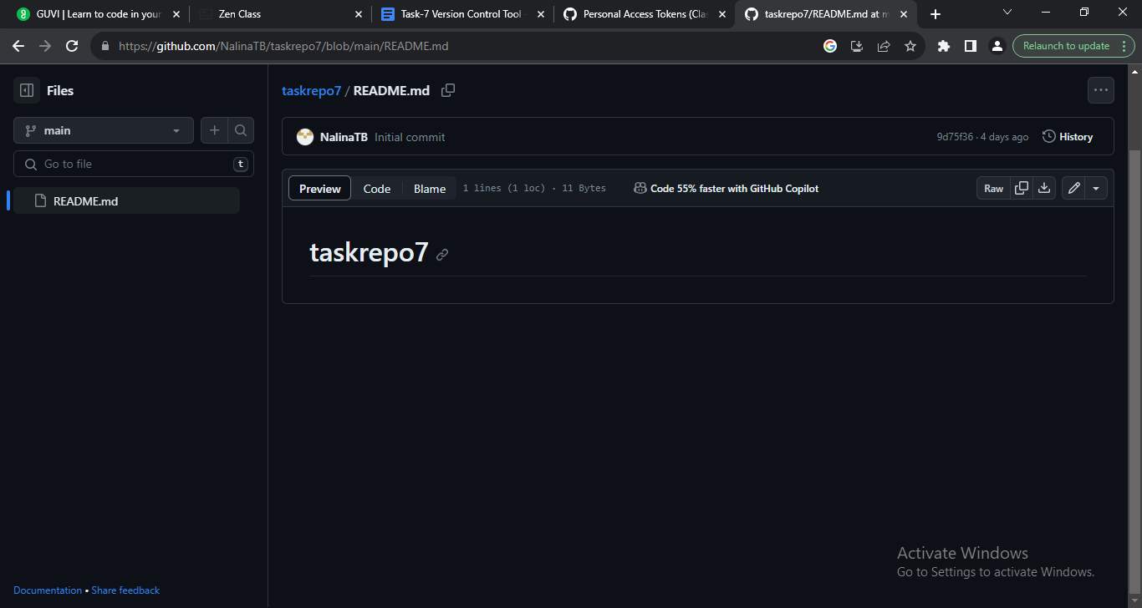

- Use the add command to add the new file to the staging are. Again, look at the output of the status command.

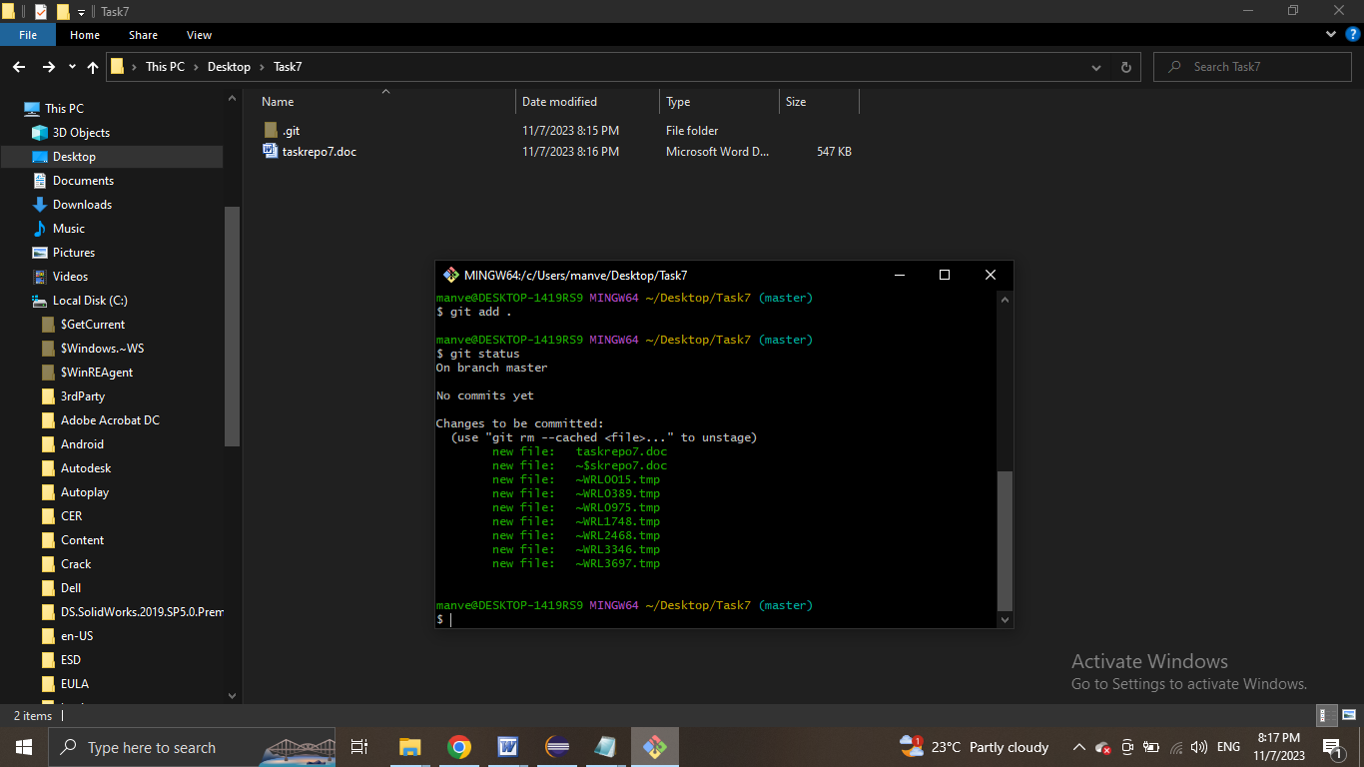

- Now use the commit command to commit the contents of the staging area.

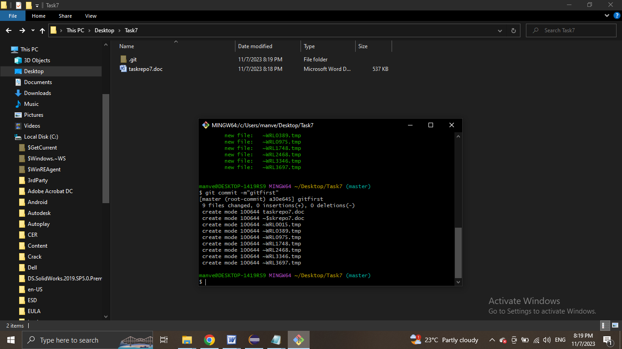

- use the commit command to commit the contents of the staging area.

- create erc directory and add a couple of files to it.

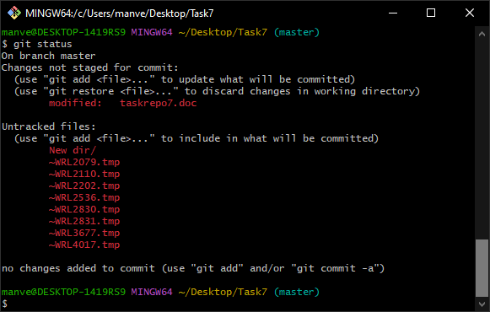

- Use the add command, but name the directory, not the individual files. Use the status command. See how both have been staged. Commit them.

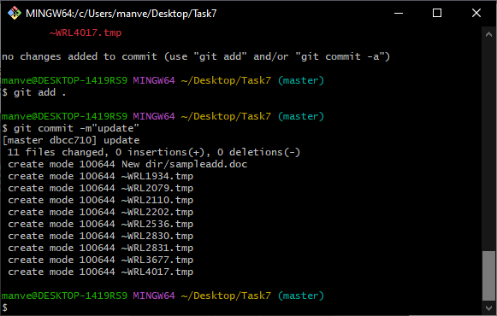

- Make a change to one of the files. Use the diff command to view the details of the change.

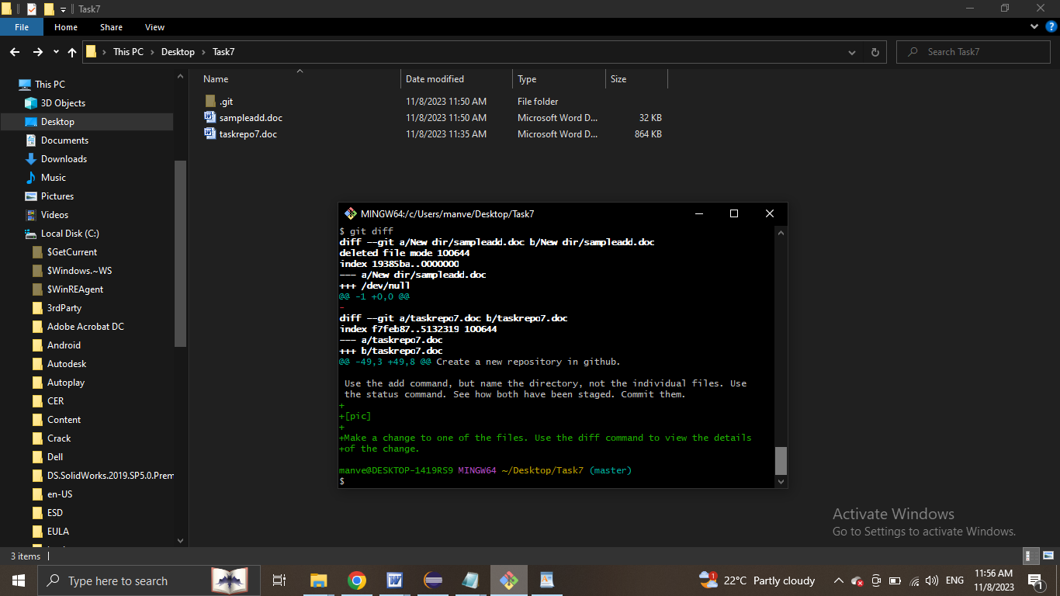

- Next add the changed file, add notice how it moves to the staging area in the status output.

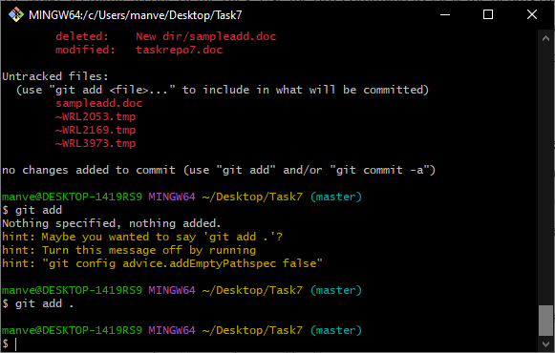

12. both staged and unstaged

