**6. Spring Boot**

1. What is an API?

**API stands for Application Programming Interface. In basic terms, APIs are a set of functions and procedures that allow for the creation of applications. They access the data and features of other applications, services, or operating systems.**

1. What are http methods?

Followings are the mostly used http methods.

**GET -** The GET method is used to retrieve information from the given server using a given URI. Requests using GET should only retrieve data and should have no other effect on the data.

**POST -** A POST request is used to send data to the server, for example, customer information, file upload, etc. using HTML forms.

**PUT -** Replaces all current representations of the target resource with the uploaded content.

**DELETE -** Removes all current representations of the target resource given by a URI.

1. Create a spring boot application

**Completed**

1. Create a new controller class

**Completed**

1. Add a new end-point to return and string

**Completed**

1. Test the endpoint with postman

**Completed**

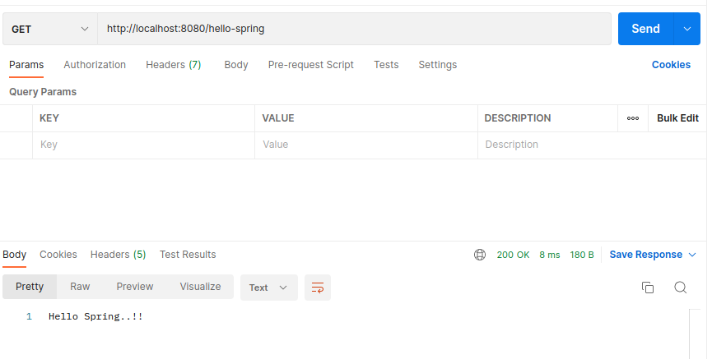

1. Create a Student class (attributes: id, name, date of birth, average)
2. Create a new controller class for students
3. Create a new service class for students
4. Add an endpoint to get list of students
5. Add an endpoint to get a student with id
6. Add new endpoint to create a student
7. Run mongodb as a docker container
8. Insert student received to endpoint created in step 12 to database
9. Extend step 10 and 11 to query data from database
10. Add an endpoint to delete a student with id.
11. Delete the student with id from database
12. What are http status codes

**Status codes are embedded in the HTTP header of a page to tell the browser the result of its request.**

1. Briefly explain the meaning of following status codes

200, 201, 301, 400, 401, 403, 404, 405, 500, 501, 502, 503, 504

|  |  |
| --- | --- |
| Status code |  |
| 200 | The request succeeded. |
| 201 | The request succeeded, and a new resource was created as a result. |
| 301 | The URL of the requested resource has been changed permanently. The new URL is given in the response. |
| 400 | The server cannot or will not process the request due to something that is perceived to be a client error. |
| 401 | Unauthorized. That is, the client must authenticate itself to get the requested response. |
| 403 | The client does not have access rights to the content; that is, it is unauthorized, so the server is refusing to give the requested resource. Compared to 401 client’s identity is known by the server. |
| 404 | The server cannot find the requested resource. |
| 405 | The request method is known by the server but is not supported by the target resource. |
| 500 | Internal server error : The server has encountered a situation it does not know how to handle. |
| 501 | Not implemented: The request method is not supported by the server and cannot be handled. |
| 502 | Bad gateway: This error response means that the server, while working as a gateway to get a response needed to handle the request, got an invalid response. |
| 503 | Service unavailable: The server is not ready to handle the request. |
| 504 | Gateway timeout: This error response is given when the server is acting as a gateway and cannot get a response in time. |

1. Using docker-compose run spring boot application and mongodb
2. Create new branch “spring-boot-app-v1” and push the project you created
3. Add your codes and answer sheet to a directory named “spring-boot-basic-training-v1” and push it to your training github repository
4. Create a pull request to main branch and assign it to your trainer