**5. Docker Basics**

1. List few benefits of docker

* **Scalability - many containers can be placed in a single host**
* **Running your service on hardware that is much cheaper than standard servers**
* **Fast deployment, ease of creating new instances, and faster migrations.**
* **Easy to move and maintain applications**
* **Better security, less access needed to work with the code running inside containers, and fewer software dependencies**
* **Flexible resource sharing**

1. Install docker
2. Check docker version and copy the output



1. Create a new java project with maven

**Completed**

1. Create a main class and print “Hello docker example”

**Completed**

1. Create a jar file for the project (inside target directory)

**Completed**

1. Run the generated jar file inside target directory with command line

**Completed**

1. Display the output



1. Create a docker image for the java project. What is the command you used?

**Docker build -t dockerdemo:v1 .**

1. List all the docker images and show output

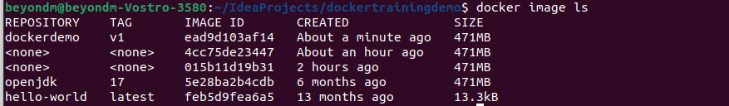

1. Run the created docker image. What is the command you used?

docker run <image name or id>

1. List all the docker images and show output

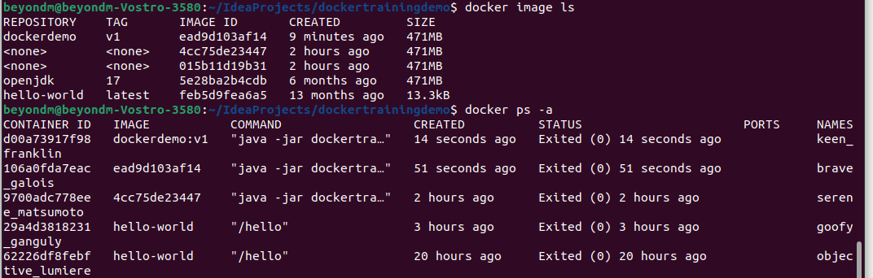

1. Stop the docker container?
2. List all the docker containers and show output

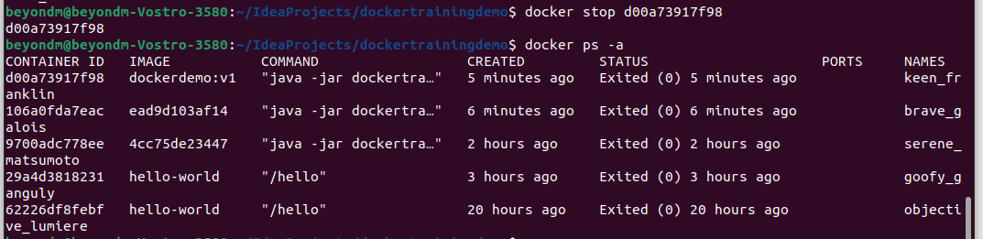

1. Remove the docker image. What is the command you used?

**Docker image rm –force <image name or id>**

1. List all the docker images and show output
2. What is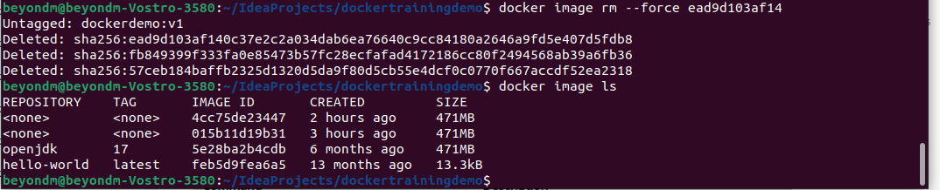 docker hub?

**Docker Hub is a cloud-based repository in which Docker users and partners create, test, store and distribute container images.**

1. Pull hello-world image from docker hub
2. Run hello-world image and show output

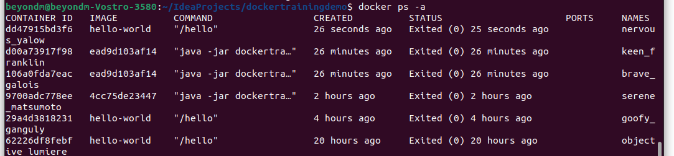

1. Pull and run mongodb as docker container
2. Open mongo shell
3. List mongodb databases

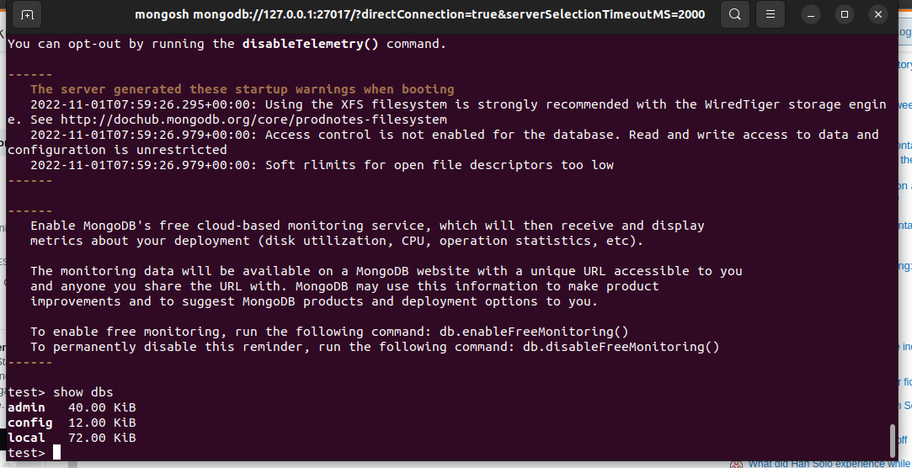

1. Add your codes and answer sheet to a directory named “docker-basic-training” and push it to your training github repository