Application Deployment
(Deploy the given react application to a production ready state)

Application:

Clone the below mentioned repo and deploy the application(Run the application in port 80 [HTTP])

Repo URL: https://github.com/sriram-R-krishnan/devops-build

Clone the above repository use vs code.click clone repository .mention repo name.

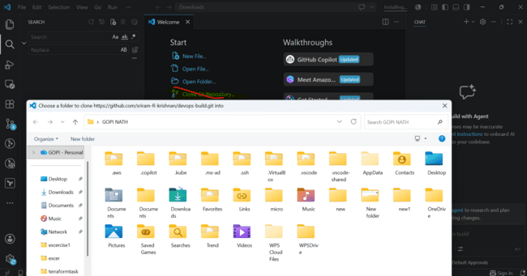

Create a new folder in downloads

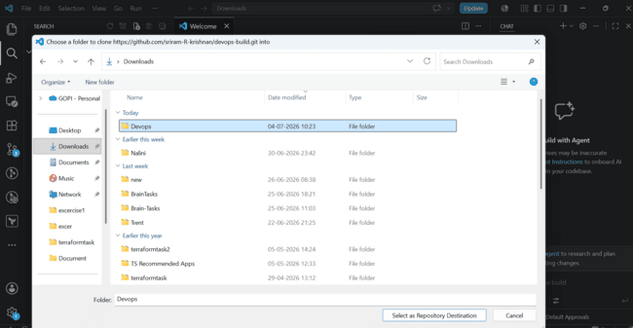
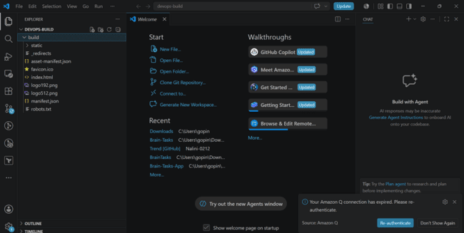

Docker:
- Dockerize the application by creating a Dockerfile
- Create a docker-compose file to use the above image

Create Dockerfiles and Docker compose files

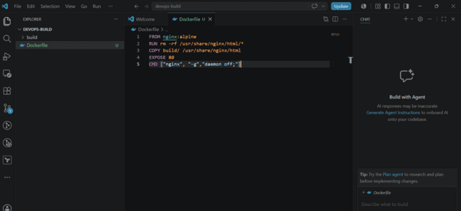
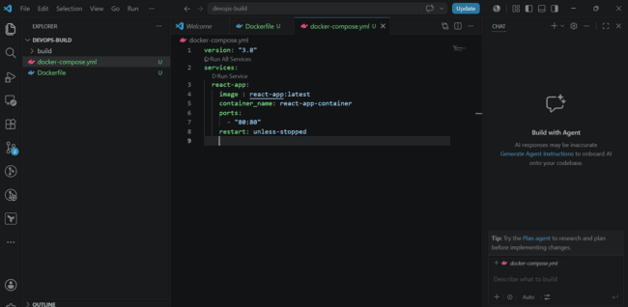

Bash Scripting:
write 2 scripts
- build.sh - for building the docker images
- deploy.sh - for deploying the image to server

Create folder named scripts create two files

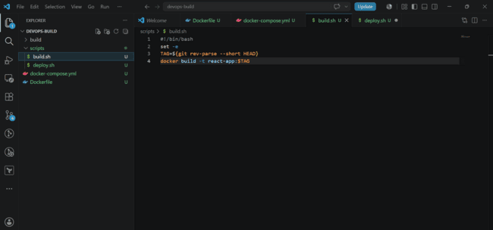
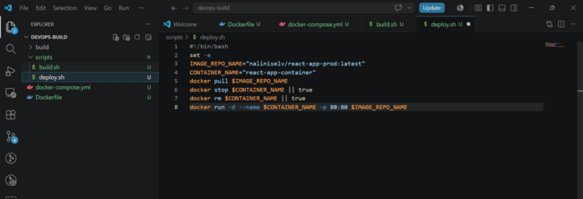

Version Control:
- push to GitHub to dev branch (use dockerignore and gitignore files)
- Note: Use only CLI for related git commands

Add two files use dockerignore and gitignore files so that certain files are excluded from Docker image and from Git commits.

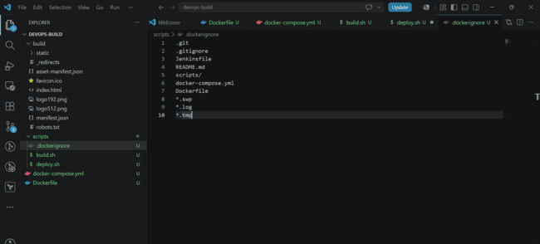
DockerHub:
- Create 2 repos "dev" and "prod" to push images
"prod" repo must be private and "dev" repo can be public

PROD - Private repo
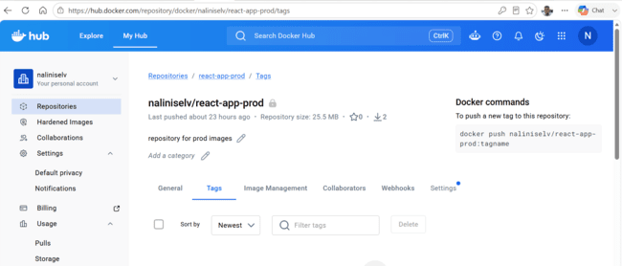

DEV- Public repo

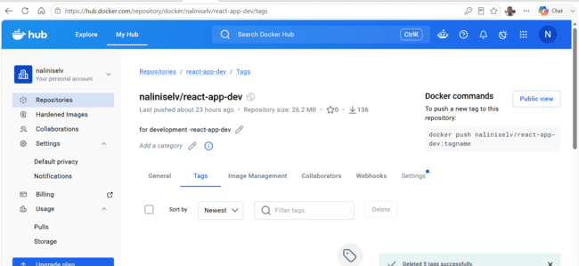

Jenkins:

Write jenkins file first

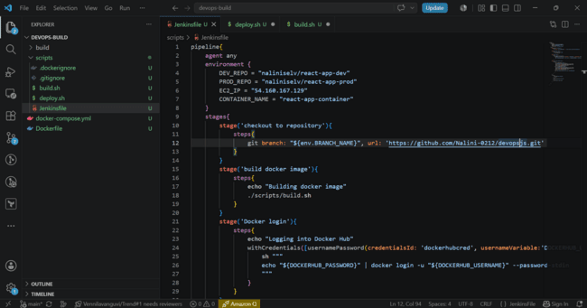
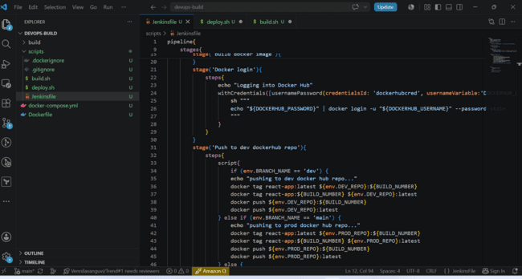
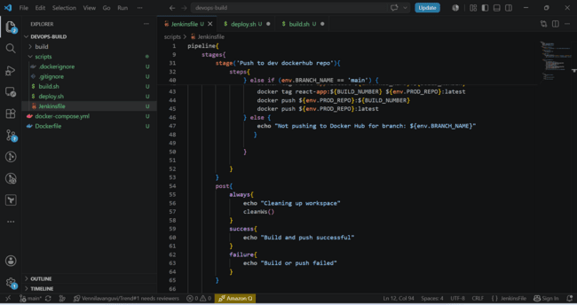
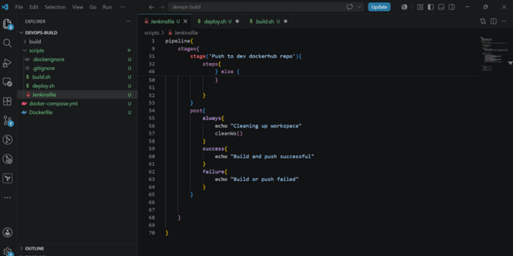

Now push to Git CLI

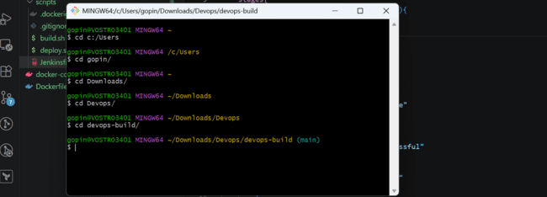
Remove origin now as it is set to cloned repo

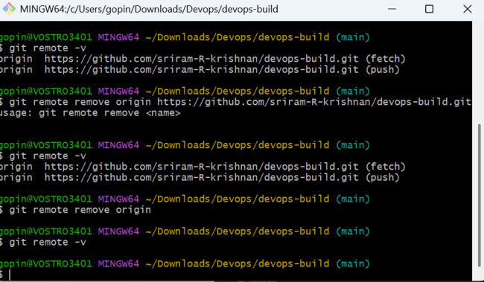

Create a new repo with name devopsjs
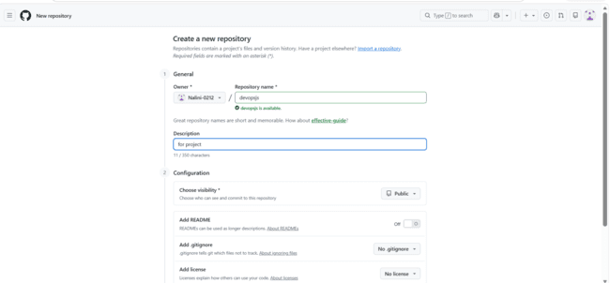
Create below structure

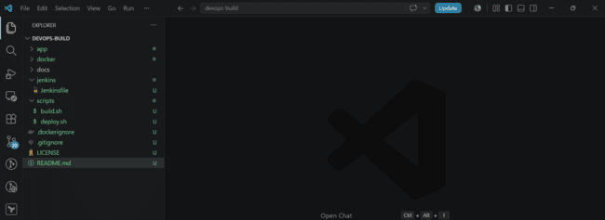
Use GIT CLI command to push to new repo

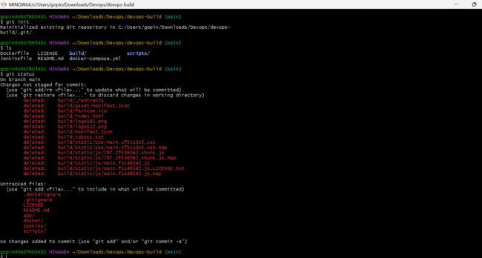
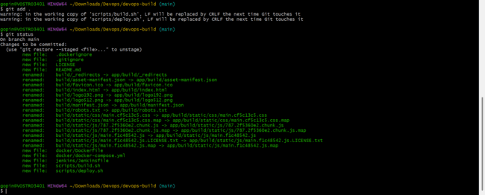
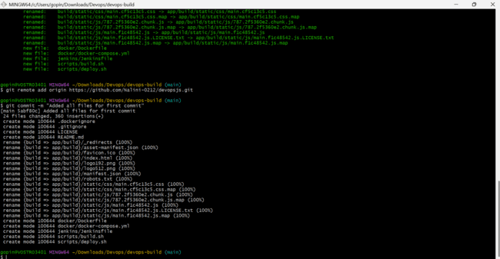
Now checkout to dev branch and push to dev branch in github repo

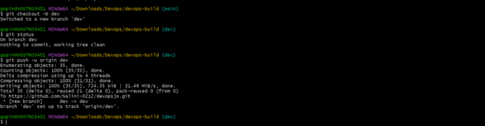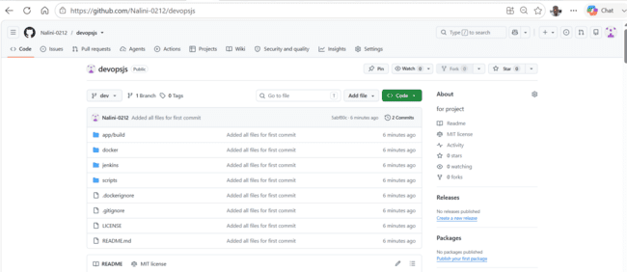

Now create ec2 server and install docker ,docker compose to check if docker file is working and docker compose is able to run containers.

Create EC2 server
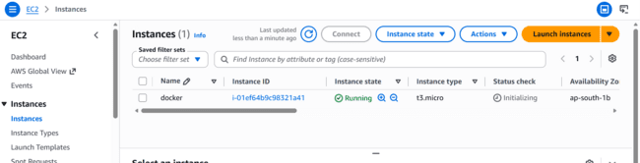
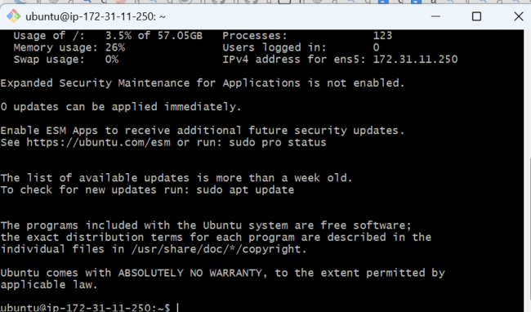
Install docker from documentation
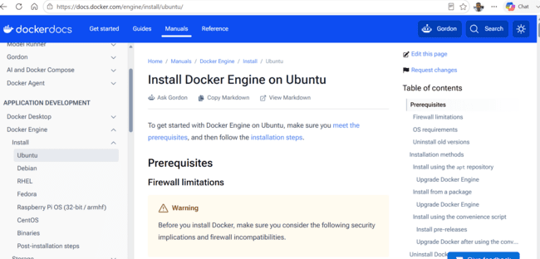
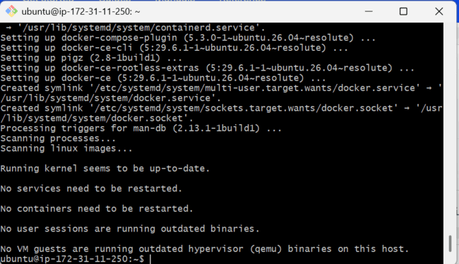

Add ubuntu user to docker group and logout and login again

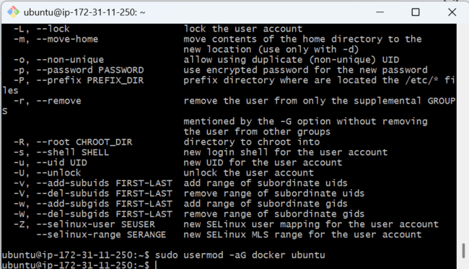
Now after logout and login now ubuntu is added to docker group

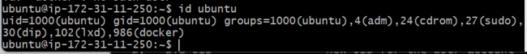

Clone the repo dev branch

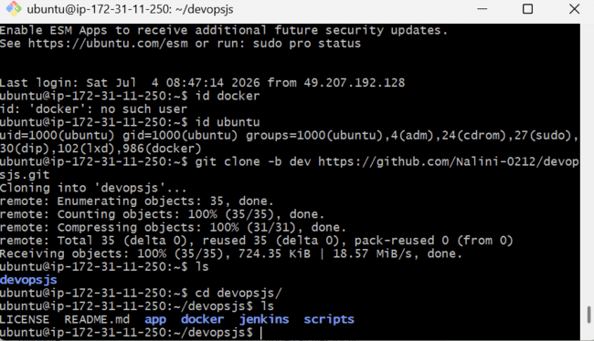

Now build docker image and try to run it fails as we changed structure

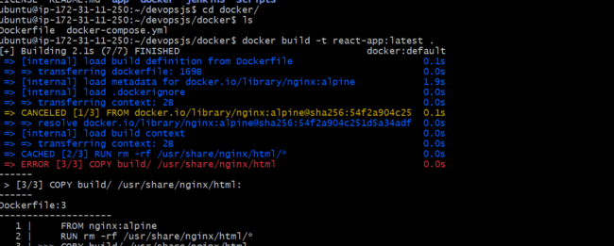

Try to modify dockerfile path to copy build folder
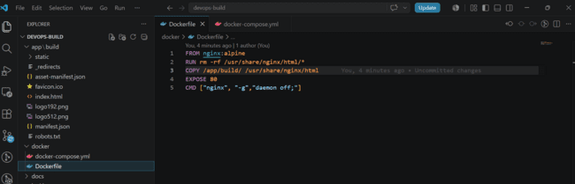

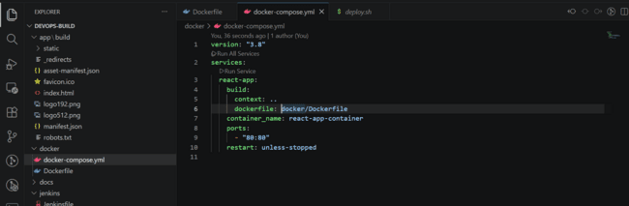

Try stage, to commit and push to github repo.

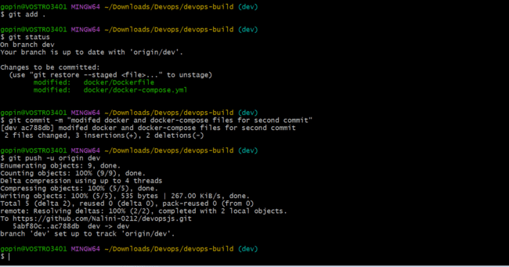

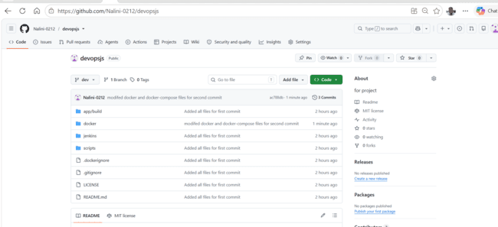

Now try to clone and start building image

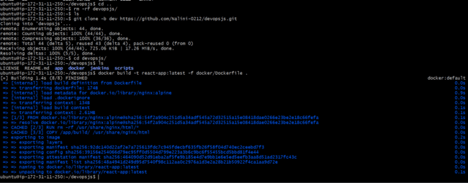

Try to run the container using docker run command and run docker inspect and docker logs to see logs and inspect container
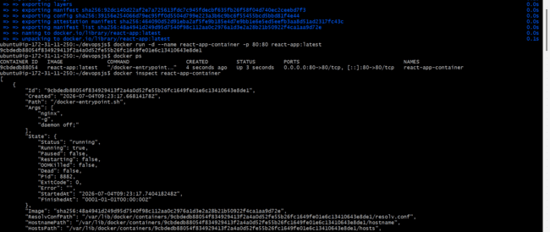

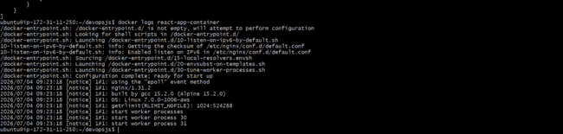

Try to access applications with port server ip:80 eg: 52.66.235.46:80 . open port 80 from ec2 security group source 0.0.0.0/0 as we need to access from internet.

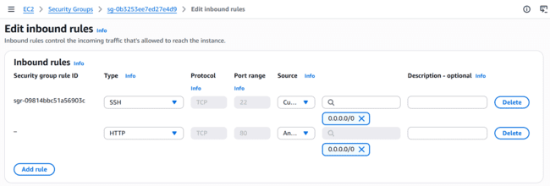

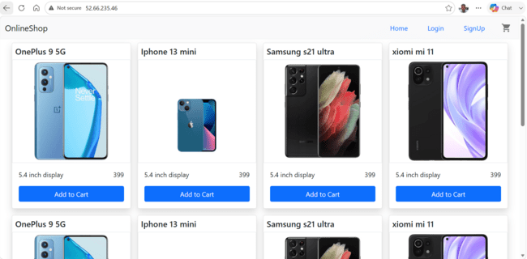

Try to remove container using below commands and try to start container with compose

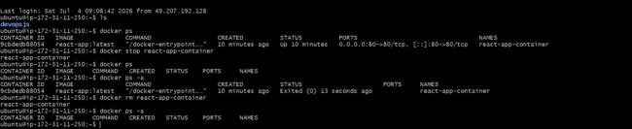
Start container using docker compose up

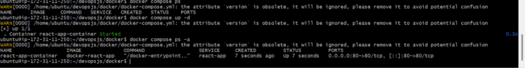
Try to access container

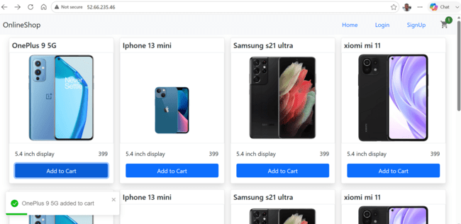

Remove container using below commands

As we need to dockerize application using same image build by docker file build .modify compose file already we have image build by docker build command react-app:latest.

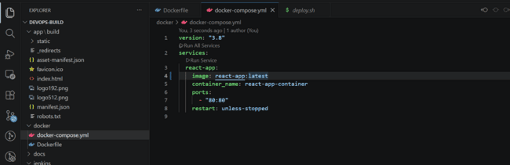

Push to github

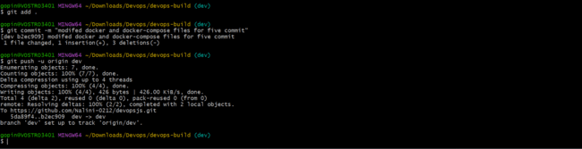

Try to remove old files and clone code from github

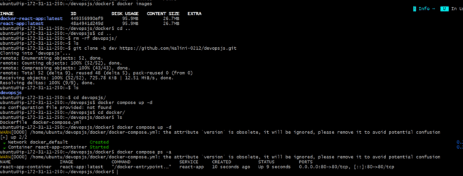

Try to access now with same port 80

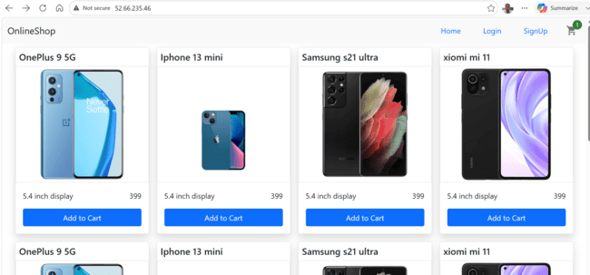

Remove containers now and remove images.

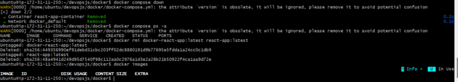

Jenkins

- Install and configure Jenkins build step as per needs to build,push and deploy the application.
- connect Jenkins to the GitHub repo with auto build trigger from both dev and master branch.
- If code pushed to dev branch , docker image must build and pushed to dev repo in docker hub.
- If dev merged to master , then docker image must be pushed to prod repo in docker hub

Refer the documentation

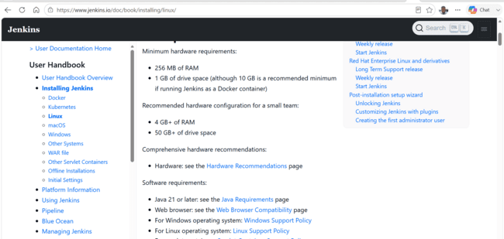

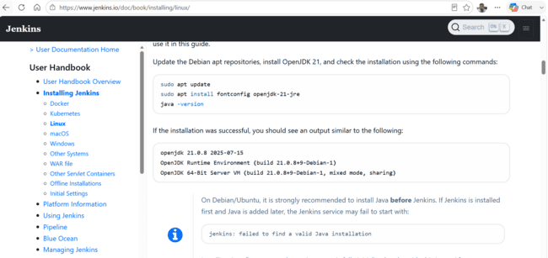
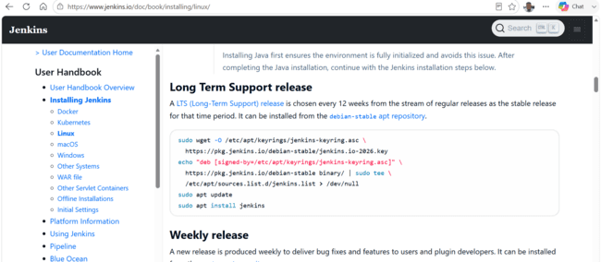

I have stopped and started again ec2-server so public ip has changed

Install java and then jenkins
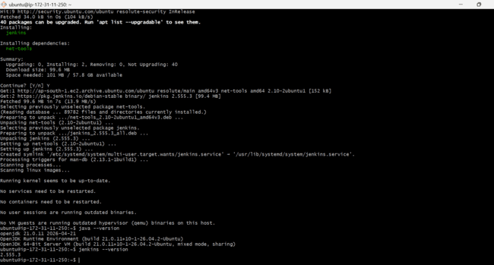

Both java and jenkins installed now

As we need to execute docker commands we need to add jenkins user to docker group and logout and login again. Now jenkins user is added to docker group.

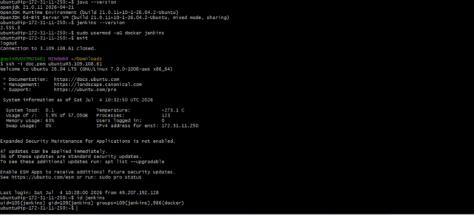

Try to login to jenkins with port 8080

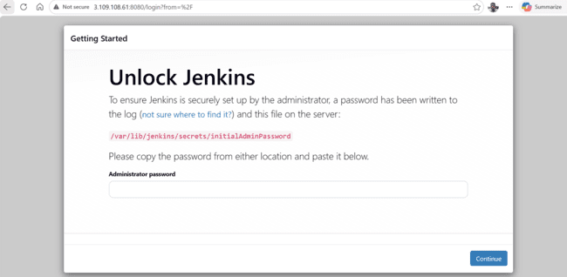
Try to type sudo cat path above one to get the password

Install suggested plugins.

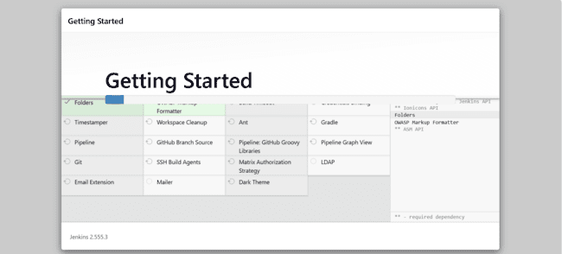

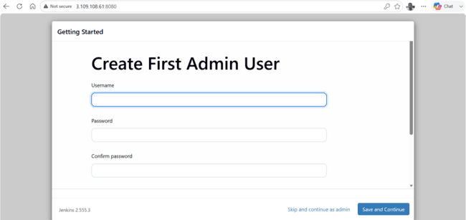

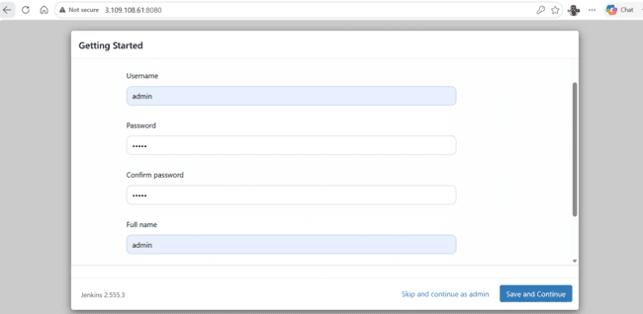

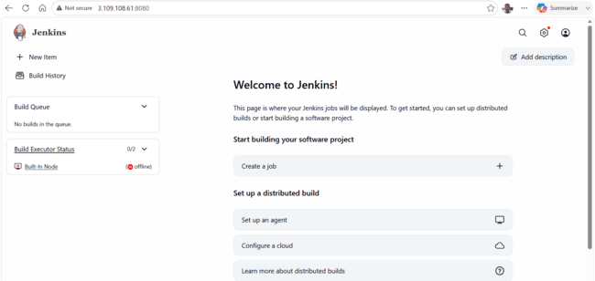

Now create multi branch pipeline

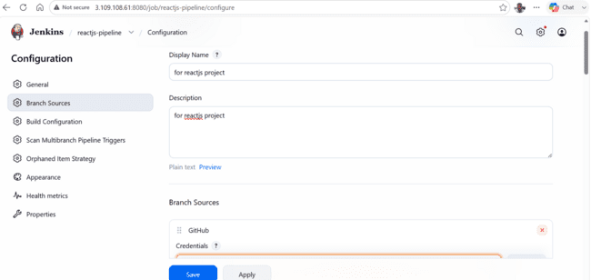

Create credentials

For github go to setting , developer setting , classic tokens

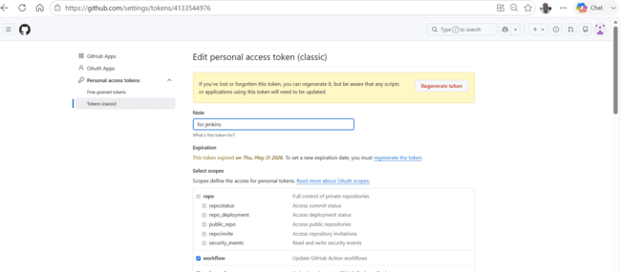

Regenerate tokens

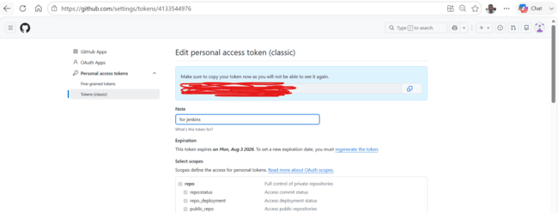

Add to jenkins

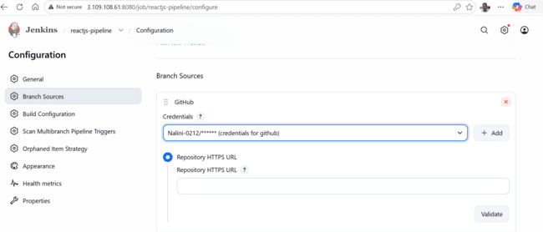

Now create other credentials in credential section dockerhub credentials and also

Select username with password

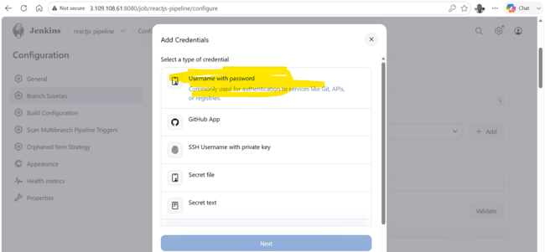

Go to dockerhub account setting -> personal access tokens and generate tokens

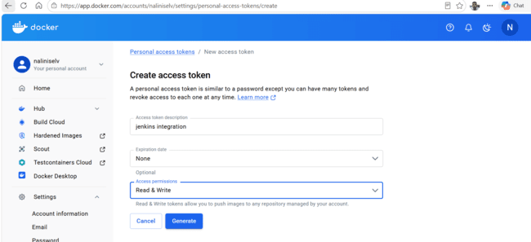

Click generate
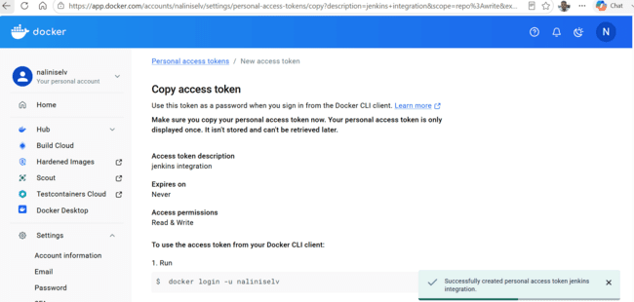

And copy token and username: naliniselv and paste in credentials section of jenkins

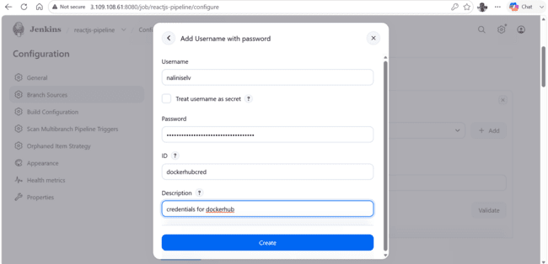

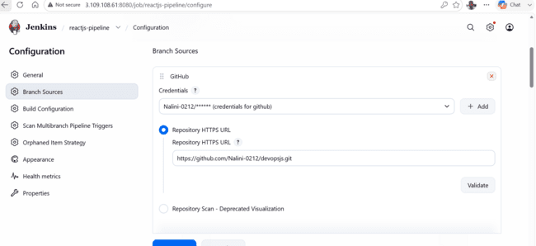

Repo url paste

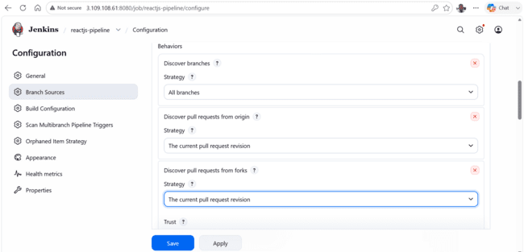

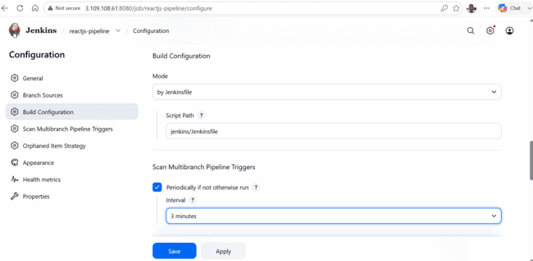

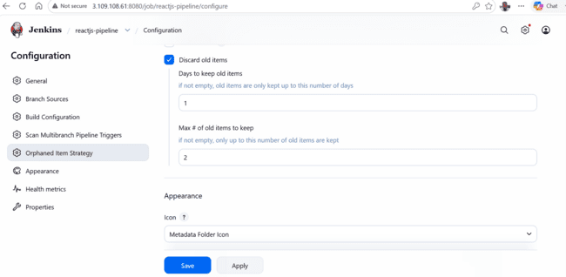

Now click on ok . install some plugins rebuilder, pipeline stage view

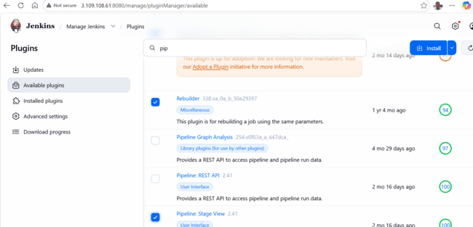

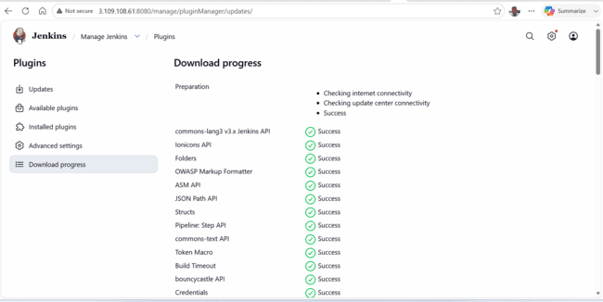

Need to trigger webhook for auto trigger

Go to repo setting in github ->webhook

http://public-ip:8080/github-webhook/

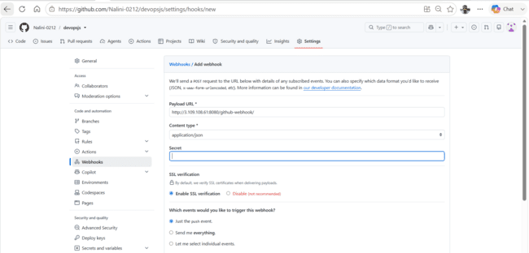

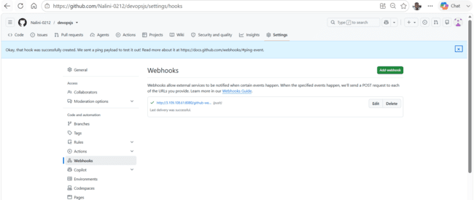

As we have started jenkins in t3.micro . go to manage jenkins->nodes ->configure monitor
The Free Temp Space monitor is also set to:
- Free Space Threshold: 1 GiB
- Free Space Warning Threshold: 2 GiB
/tmp filesystem is only 455 MB, so it can never satisfy a 1 GiB minimum. That's why Jenkins keeps reporting the node as unhealthy.

Change these values
For both Free Disk Space and Free Temp Space, change the thresholds to below your /tmp size.

100 MiB and 200 MiB and checked option. Don't mark agents temporarily offline.

Failed to read if we build as we have docker file in docker/ folder

Modify build.sh and deploy.sh

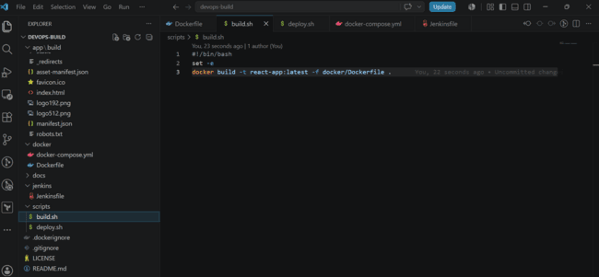

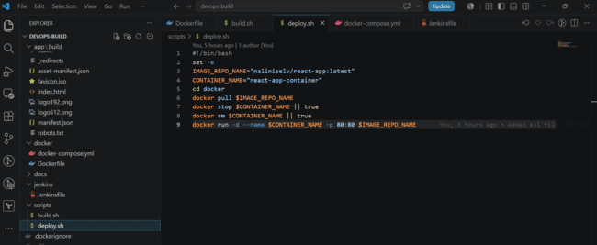
Push to github

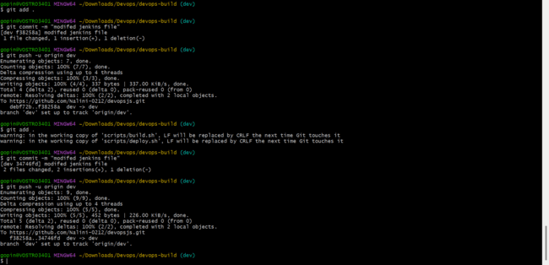
Automatically triggers pipeline as we have set webhook
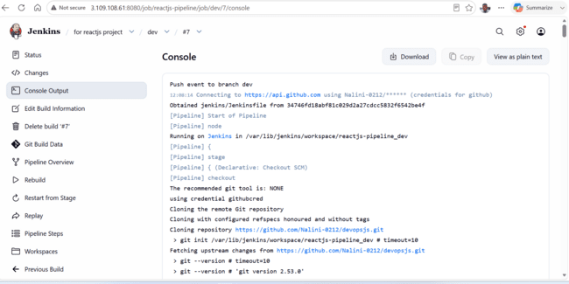

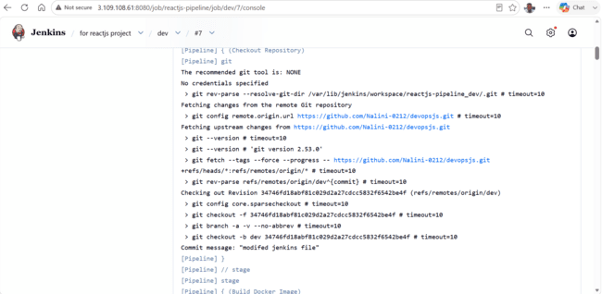

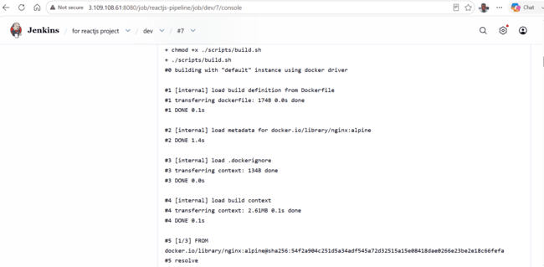

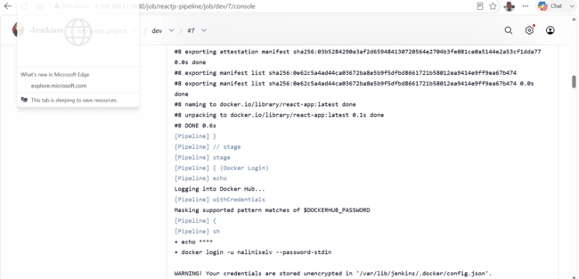
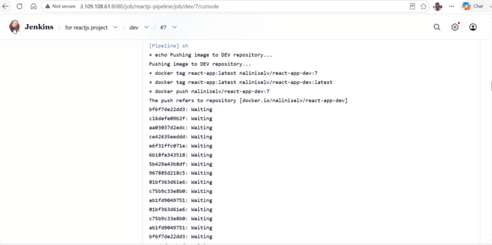
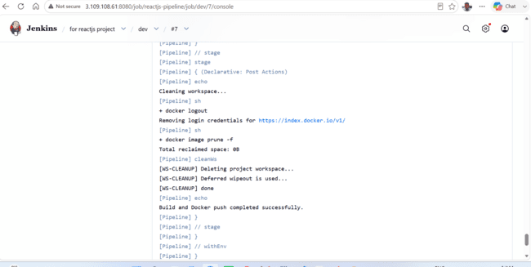


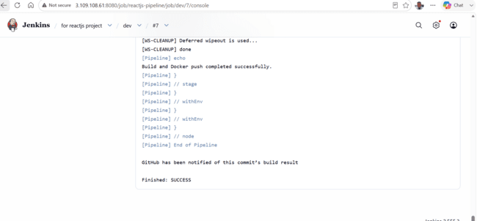

Now check if build image is pushed to docker hub public repo

We see two images pushed latest and with build number.

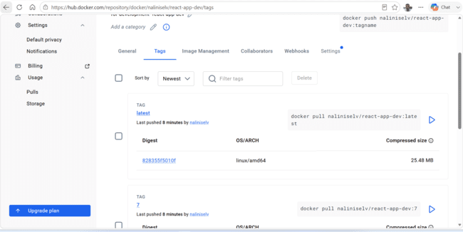

Private repo has no images now

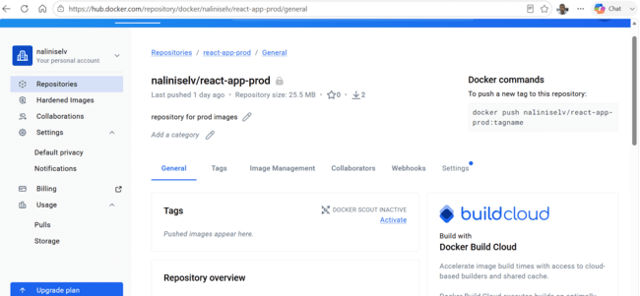

Try to test dev image that is pushed to docker hub
As i see build images locally modified jenkins as below

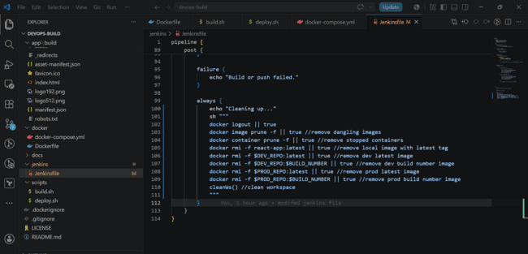

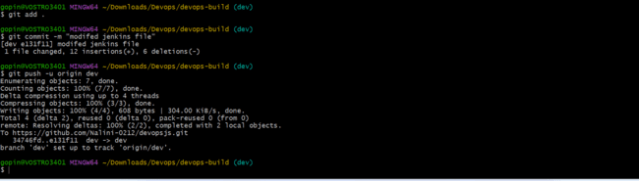
Auto trigger happened

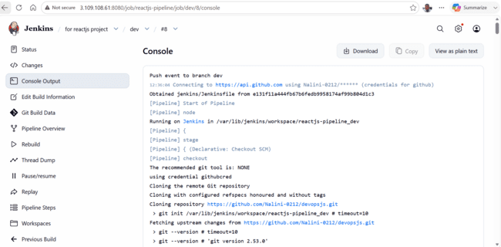
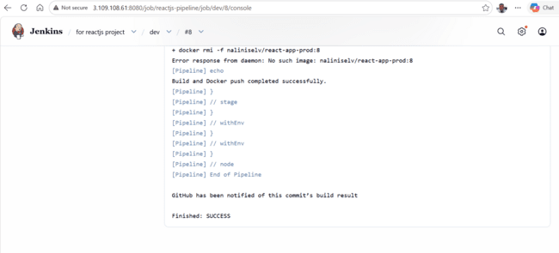
We see two images one with latest tag and build number.
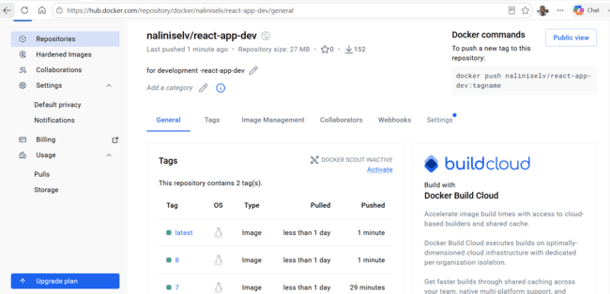

Now we don’t see any images locally

Try to test dev image
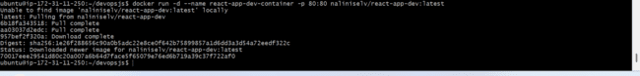

Now try to open URL with publicip:80

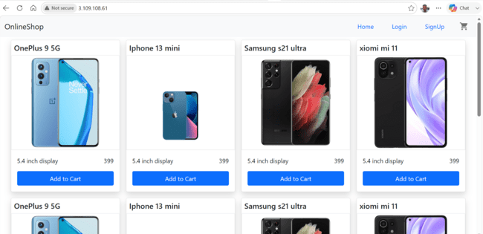

Try to deploy image using script
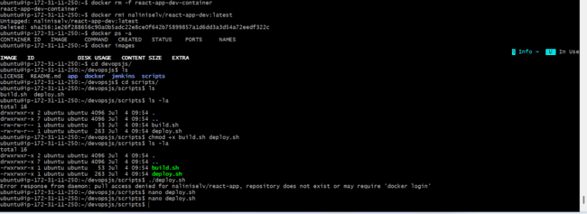
Change deploy.sh
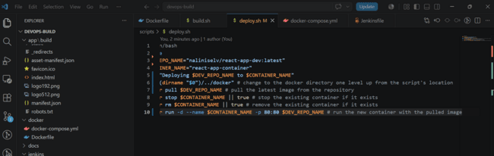
Try to push to git hub and deploy image
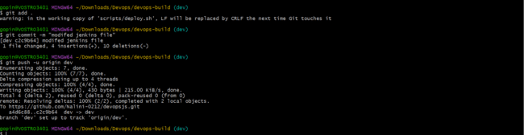

Stop old container and clone recent repo

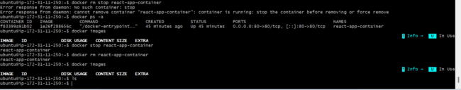

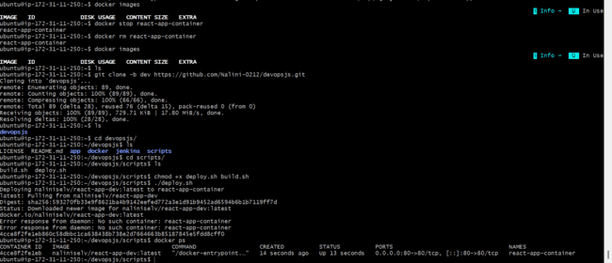
Try to browse url with 80 IP (dev image)
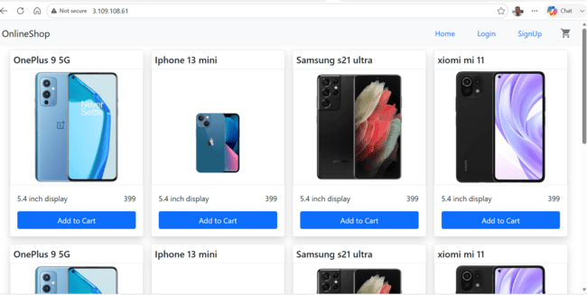

Now it is working with dev image try to modify pipeline to push prod image to prod private repo and deploy automatically.

Now modify jenkins file to push image to prod repo in docker hub image if dev is merged to main branch in github. and build automatically and also modify the deploy.sh to deploy image from (Private pod rep) to EC2 server automatically on any push to github.

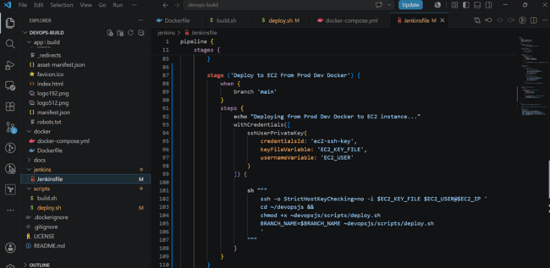

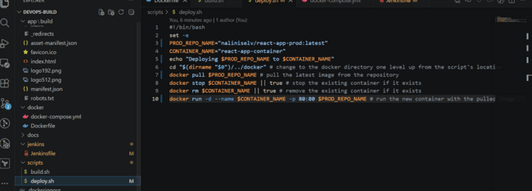

Now push to github

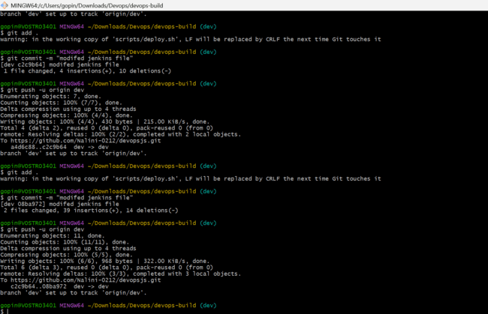

Lanch t2.micro instance and deploy the create application.- created t3.micro as it is only available in free tier
Configure SG as below:
- whoever has ip address can access the application.
- login to server can should be made only from your ip
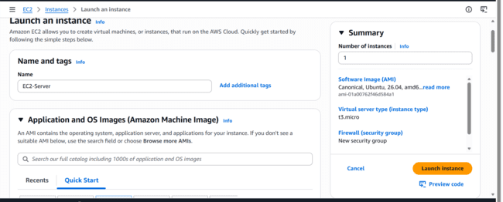

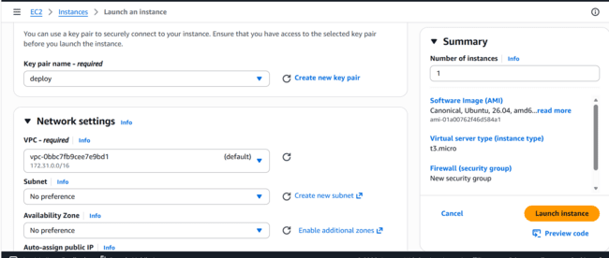
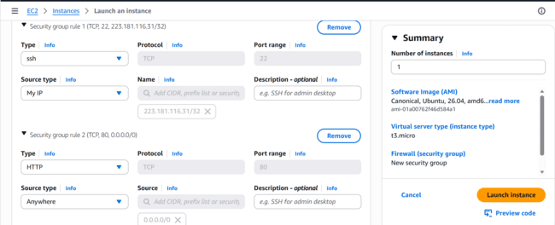
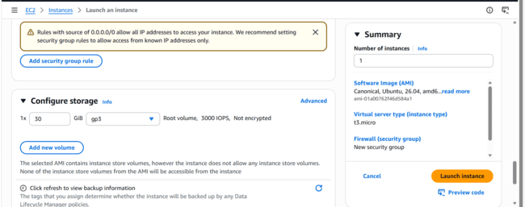

Launch instance
Change public-ip address of ec2-server in VSCODE and try to stage and commit to github.

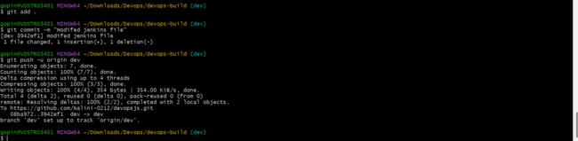

Try to start jenkins server now as i have stopped before.Public ip changes
Ssh to ec2-server deployment server also
In jenkins server create ssh key pair by going to jenkins user
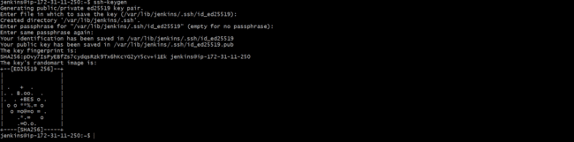

Id_ed25519.pub is public key -> copy from jenkins server to ec2-server (deployment server)
And paste in authorized key under .ssh folder in deployment servers ubuntu home directory
Jenkins server:
Ec2-server:
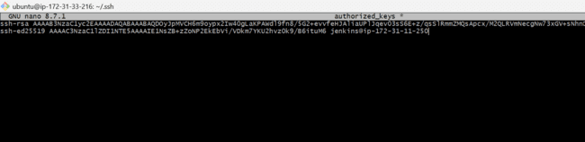
Now press ctrl-o and ctrl-x to exist the nano editor

Now go to jenkins and add private pem file generated now Id_ed25519 in jenkins server .
Copy to credentials section

Go to jenkins

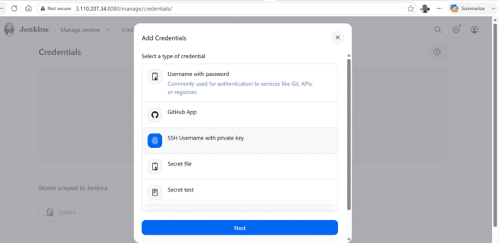
Select SSH username with private key

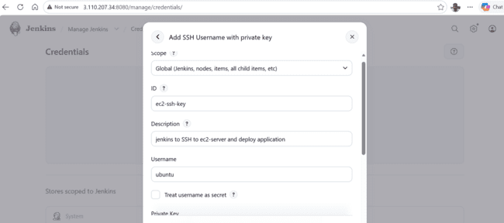
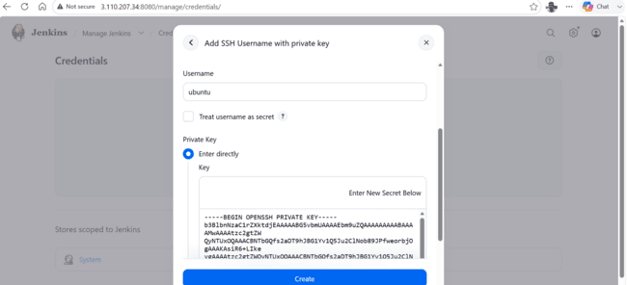

Click on create . Now try to raise pull request in github as we have tested applications in dev.
Created main branch manually or it may already exist . try to update anything in dev branch it will have more commits than main branch
Added …

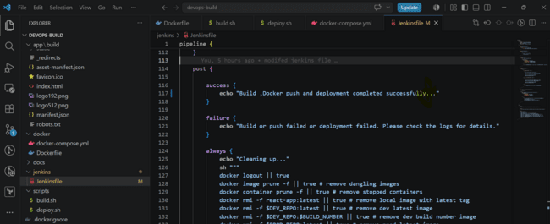
Try to stage now and commit and push to dev branch

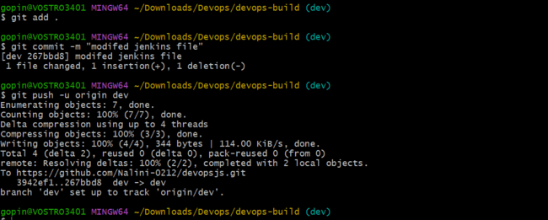
Main branch is one commit behind dev branch

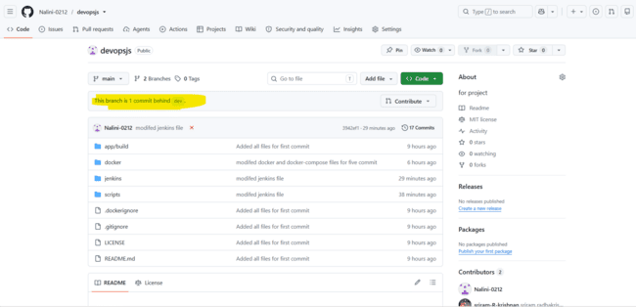

Raise pull request to merge branch also change security group to allow ssh from jenkins server ip

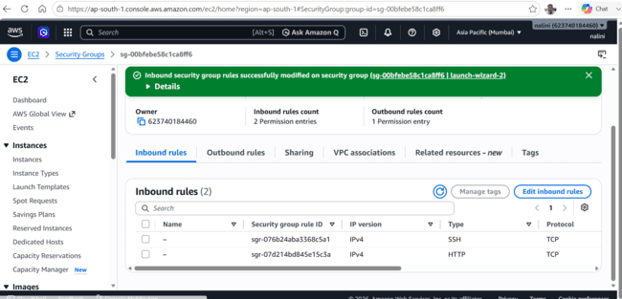

Made another commit and raised pull request

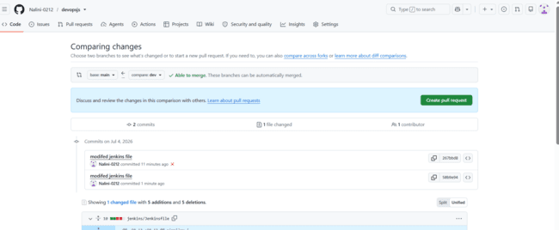
Click on create pull request
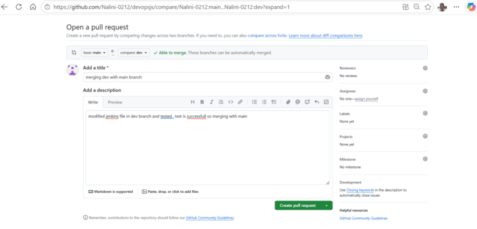
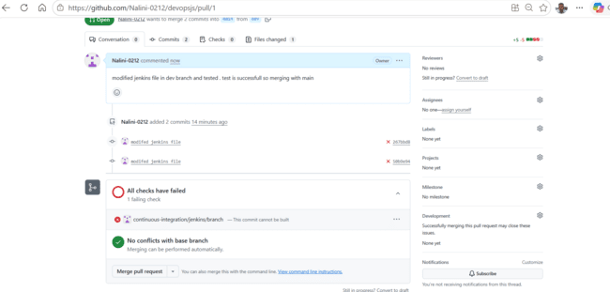

Click on merge pull request by reviewing with others
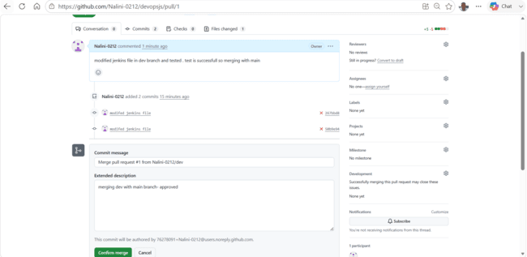
Click on confirm merge
And close pull request
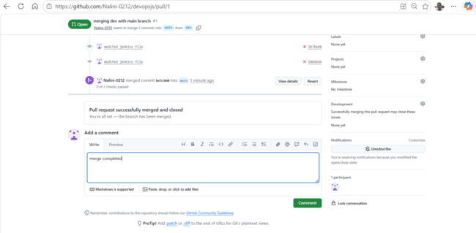

As pipeline is failing try to modify as below as i missed / after cd~/devopsjs

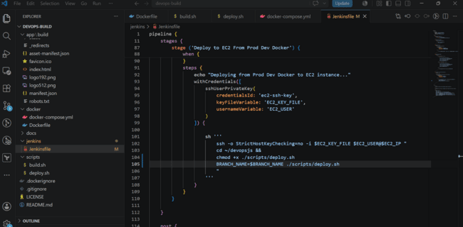

Now it has triggered 2 times

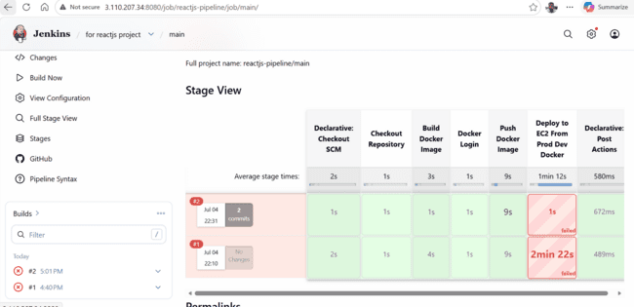
Now we will merge dev with main by raising pull request
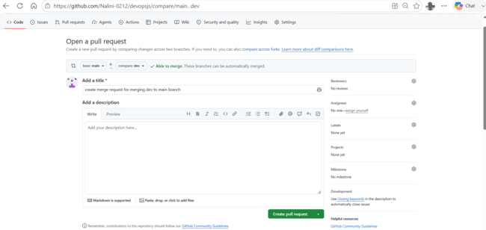
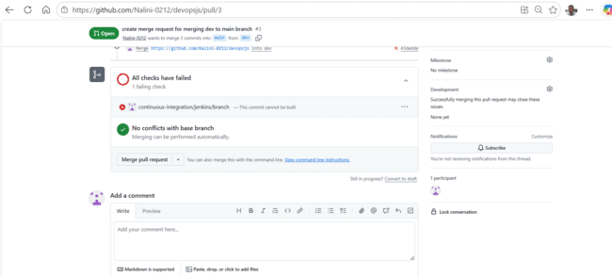

We see it got triggered automatically but it failed as it was not able to find the repo in EC2 server

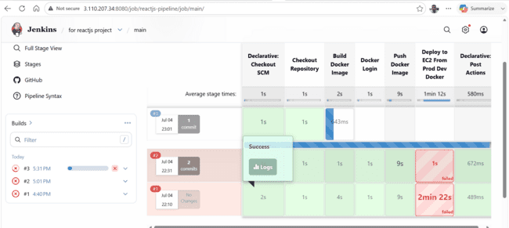
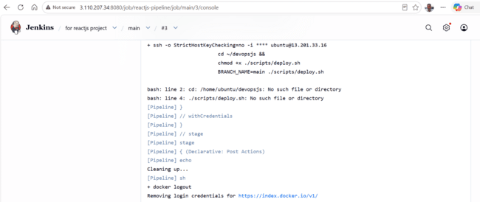
I modified jenkins file to clone repo if it doesnot exist

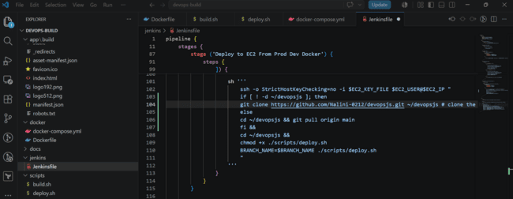

Try to stage and commit to dev branch

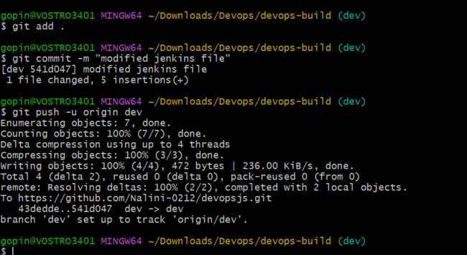

Raise pull request for merging
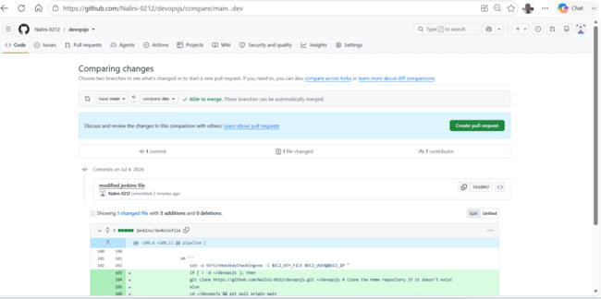
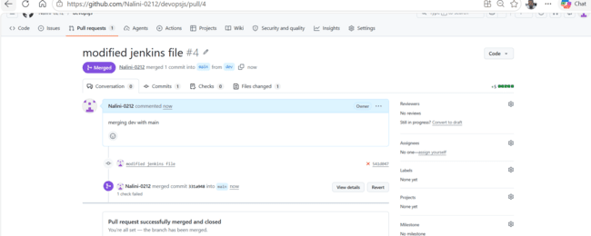
Merged to main

Now automatic trigger should happen
Again it failed
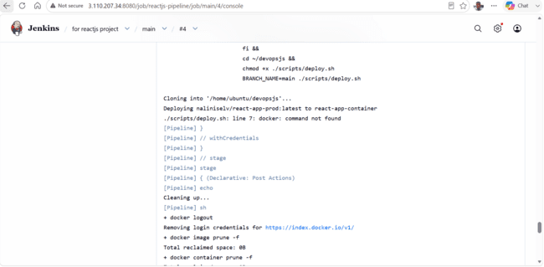

Due to docker not found . Install docker on ec2-server and ubuntu user to docker group

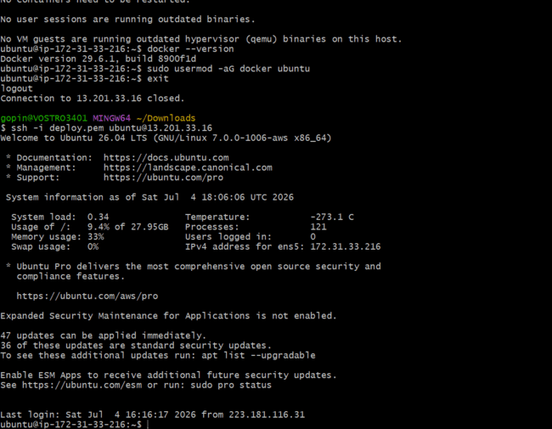
Exist and login again
We modified jenkins file as we see error while pushing dev branch code

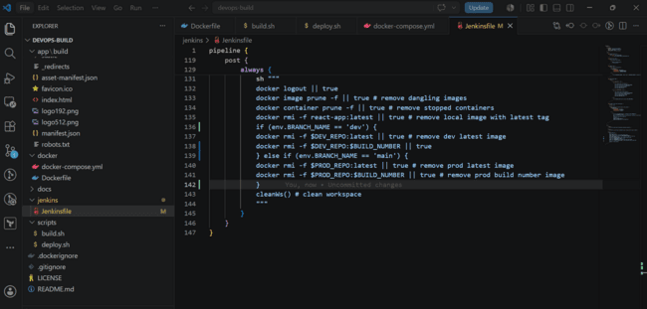
Try to push to dev branch and raise pull request
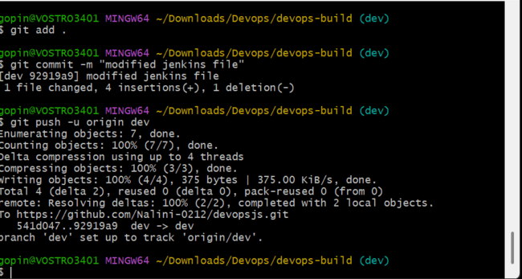
Raise pull request
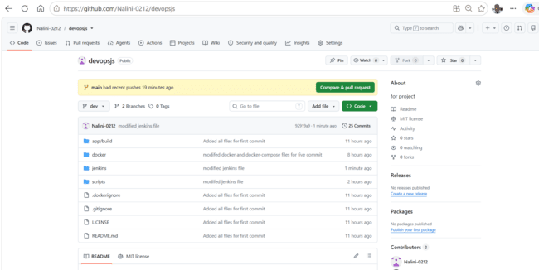
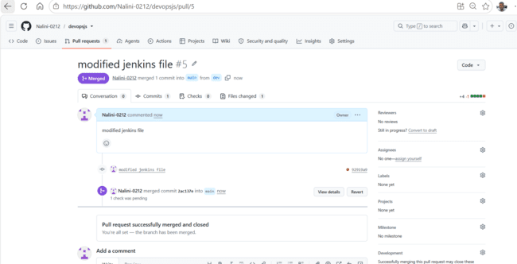
As we pushed to dev branch first it triggered auto

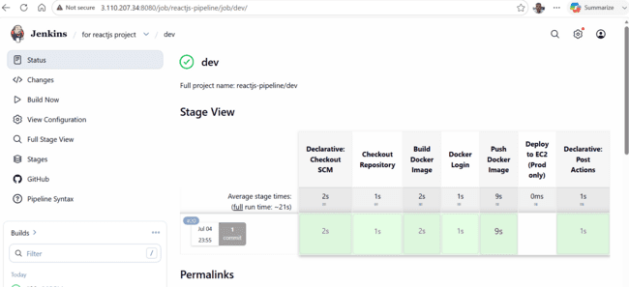
And pushed to dev repo with 20 and latest version
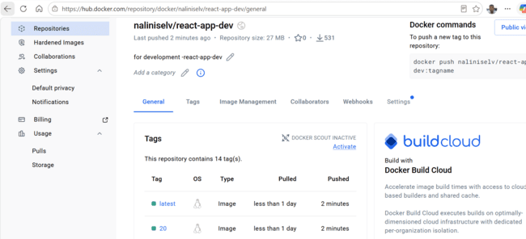

We merged dev to main branch

Now automatically it should build push to private repo and then deploy to ec2 server
It is failing due to pull access is denied i tried to modify the jenkins file
Modify jenkins file and push to dev branch and raise pull request

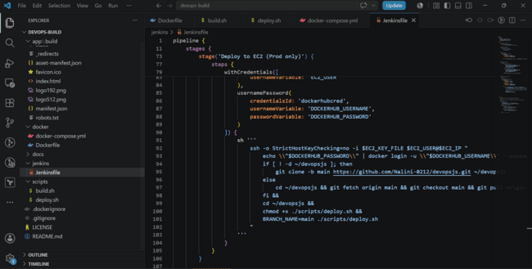

I see dev(when pushed via GIT CLI command) and main branch got triggered(pull request merged)

I see it is successful
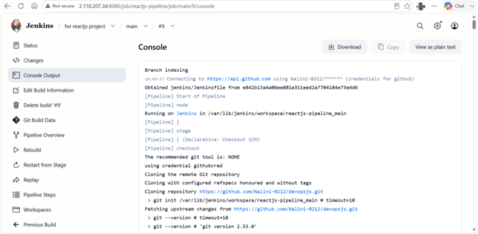
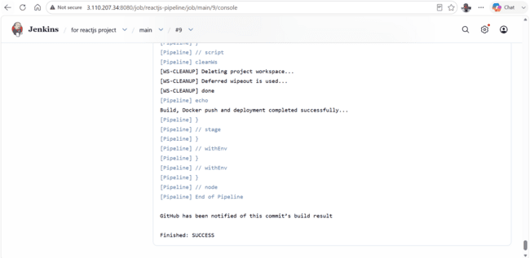
Now we see image also got pushed to docker hub private repo
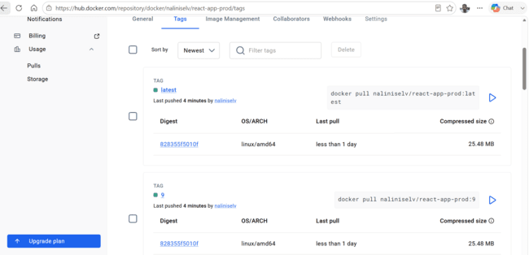
And try to access application now from ec2-s-server IP:80

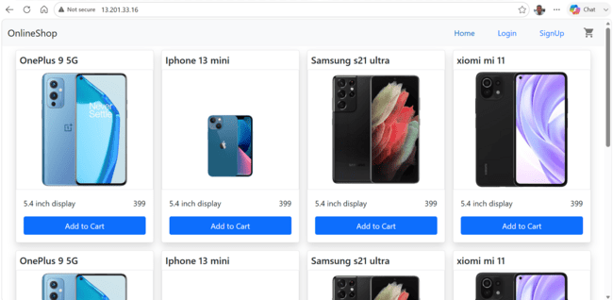

Below is jenkins file for automated one(build,push and deploy) to another ec2 -server

Jenkins and ec2-server is different but our instructions says ssh allowed from only my ip.

Below is jenkins file if ssh is allowed from other jenkins SG or other Ip also
pipeline {
agent any

environment {
DEV_REPO = "naliniselv/react-app-dev"
PROD_REPO = "naliniselv/react-app-prod"
EC2_IP = "13.201.33.16"
CONTAINER_NAME = "react-app-container"
}

stages {

stage('Checkout Repository') {
steps {
git branch: "${env.BRANCH_NAME}",
url: 'https://github.com/Nalini-0212/devopsjs.git'
}
}

stage('Build Docker Image') {
steps {
echo "Building Docker image..."
sh '''
chmod +x ./scripts/build.sh
./scripts/build.sh
'''
}
}

stage('Docker Login') {
steps {
echo "Logging into Docker Hub..."
withCredentials([
usernamePassword(
credentialsId: 'dockerhubcred',
usernameVariable: 'DOCKERHUB_USERNAME',
passwordVariable: 'DOCKERHUB_PASSWORD'
)
]) {
sh '''
echo "$DOCKERHUB_PASSWORD" | docker login -u "$DOCKERHUB_USERNAME" --password-stdin
'''
}
}
}

stage('Push Docker Image') {
steps {
script {
if (env.BRANCH_NAME == 'dev') {
sh '''
echo "Pushing image to DEV repository..."
docker tag react-app:latest $DEV_REPO:$BUILD_NUMBER
docker tag react-app:latest $DEV_REPO:latest
docker push $DEV_REPO:$BUILD_NUMBER
docker push $DEV_REPO:latest
'''
} else if (env.BRANCH_NAME == 'main') {
sh '''
echo "Pushing image to PROD repository..."
docker tag react-app:latest $PROD_REPO:$BUILD_NUMBER
docker tag react-app:latest $PROD_REPO:latest
docker push $PROD_REPO:$BUILD_NUMBER
docker push $PROD_REPO:latest
'''
} else {
echo "Skipping Docker push for branch: ${env.BRANCH_NAME}"
}
}
}
}

stage('Deploy to EC2 (Prod only)') {
when {
branch 'main'
}
steps {
echo "Deploying PROD build to EC2..."
withCredentials([
sshUserPrivateKey(
credentialsId: 'ec2-ssh-key',
keyFileVariable: 'EC2_KEY_FILE',
usernameVariable: 'EC2_USER'
),
usernamePassword(
credentialsId: 'dockerhubcred',
usernameVariable: 'DOCKERHUB_USERNAME',
passwordVariable: 'DOCKERHUB_PASSWORD'
)
]) {
sh '''
ssh -o StrictHostKeyChecking=no -i $EC2_KEY_FILE $EC2_USER@$EC2_IP "
echo \\"$DOCKERHUB_PASSWORD\\" | docker login -u \\"$DOCKERHUB_USERNAME\\" --password-stdin &&
if [ ! -d ~/devopsjs ]; then
git clone -b main https://github.com/Nalini-0212/devopsjs.git ~/devopsjs
else
cd ~/devopsjs && git fetch origin main && git checkout main && git pull origin main
fi &&
cd ~/devopsjs &&
chmod +x ./scripts/deploy.sh &&
BRANCH_NAME=main ./scripts/deploy.sh
"
'''
}
}
}

}

post {
success {
echo "Build, Docker push and deployment completed successfully..."
}
failure {
echo "Build or push failed or deployment failed. Please check the logs for details."
}
always {
echo "Cleaning up..."
sh """
docker logout || true
docker image prune -f || true # remove dangling images
docker container prune -f || true # remove stopped containers
docker rmi -f react-app:latest || true
"""
script {
if (env.BRANCH_NAME == 'dev') {
sh """
docker rmi -f $DEV_REPO:latest || true
docker rmi -f $DEV_REPO:$BUILD_NUMBER || true
"""
} else if (env.BRANCH_NAME == 'main') {
sh """
docker rmi -f $PROD_REPO:latest || true
docker rmi -f $PROD_REPO:$BUILD_NUMBER || true
"""
}
}
cleanWs() // clean workspace
}
}
}

As the statement says

AWS:
Lanch t2.micro instance and deploy the create application.
Configure SG as below:
- whoever has ip address can access the application.
- login to server can should be made only from your ip

Try to create another machine and perform deployment

Try to create ec2 server .created t3.micro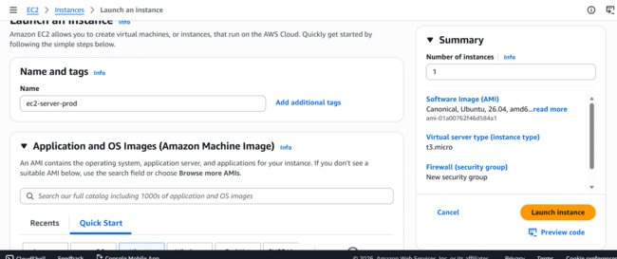
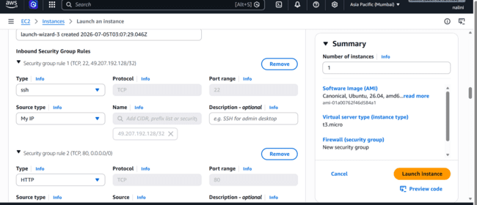

Open SSH from only my ip and HTTP from any source.

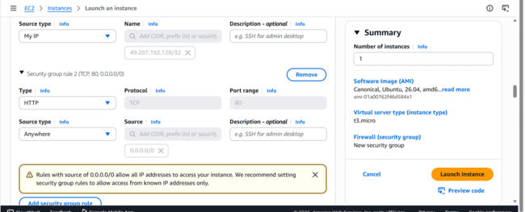
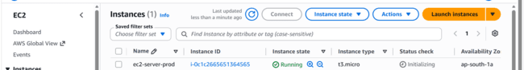

Try to login to server
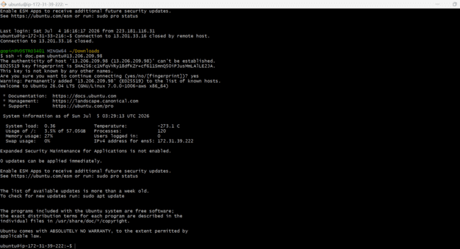
Install docker now and logout and login again

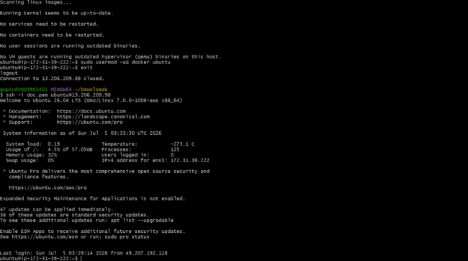
Login to docker hub using docker login command

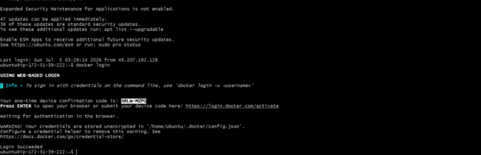
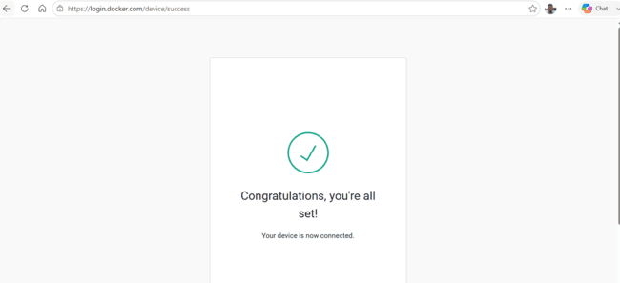
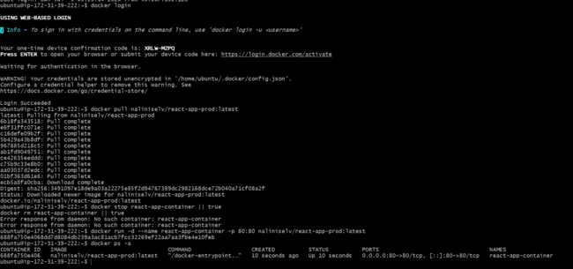
Pull the image from docker hub latest prod image stop container if already exist & run now. Try to browse url
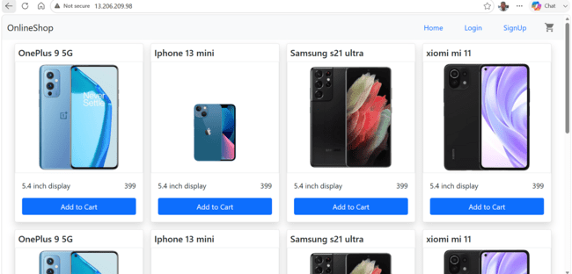now we have run manually image which was pushed automatically to prod repo in dockerhub.

As per instructions understood jenkins and ec2-server-deploy (SG allows only ssh from my IP & accessible from anywhere )so we consider are separate servers so we need to manually deploy.

We can also consider jenkins and ec2-server-deploy installed in same machine

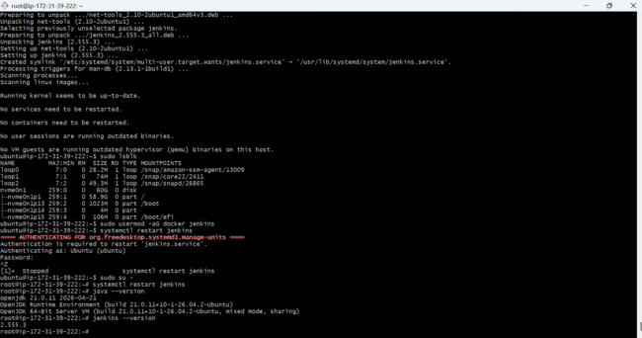

Now add 8080 to security group of server
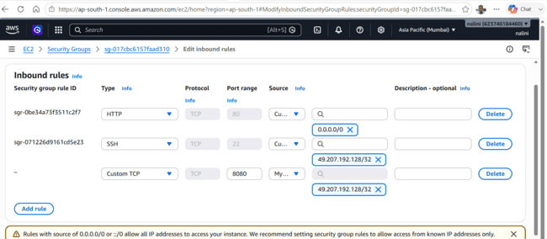

As per instructions the app is public, but only you can log in to the server. Jenkins cannot deploy unless it runs from your IP. Otherwise, deployment is manual.

Manual already deployed automatic deployment lets see

Now modify jenkins file

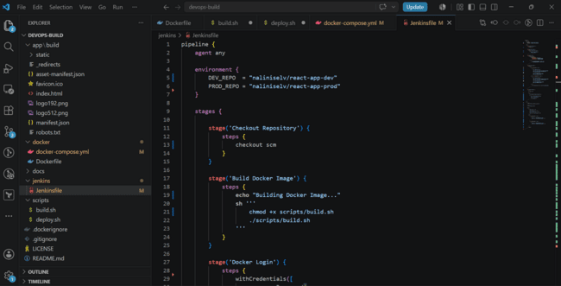
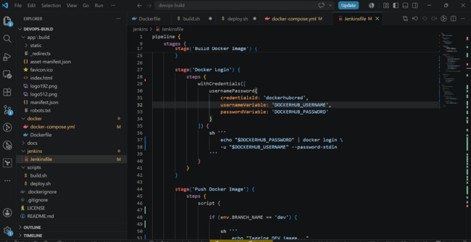
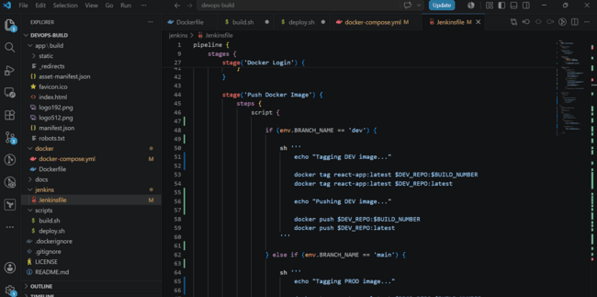
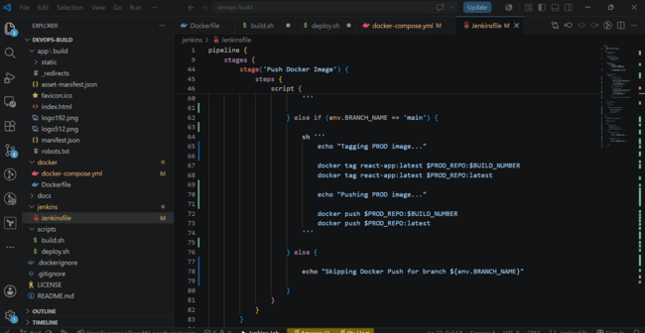
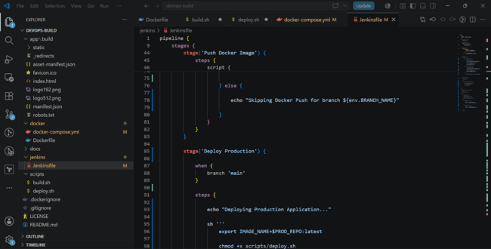
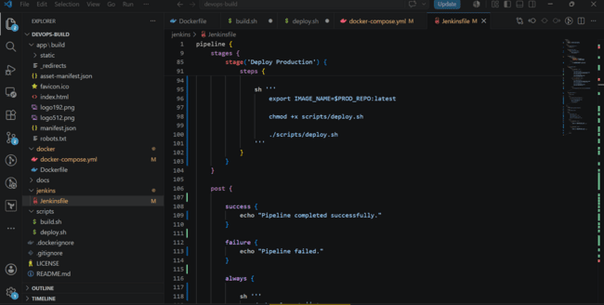
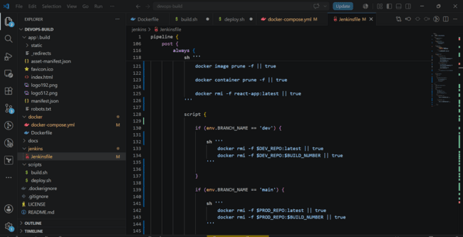
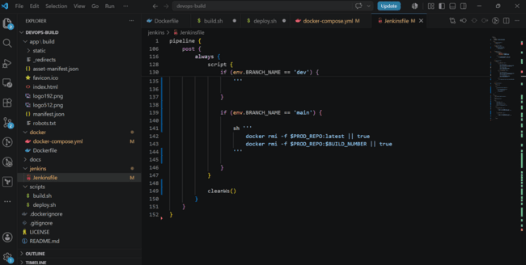
Modify build.sh and deploy.sh
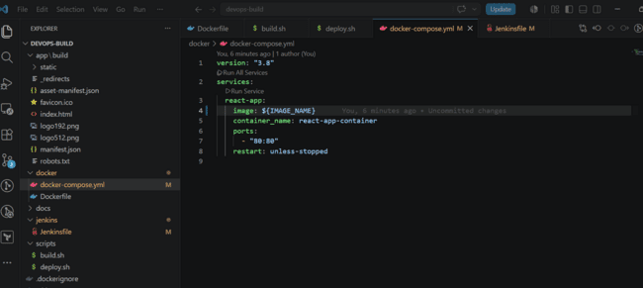

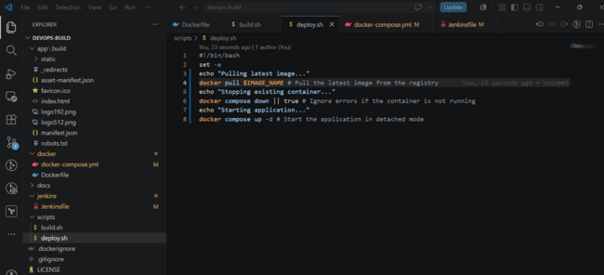
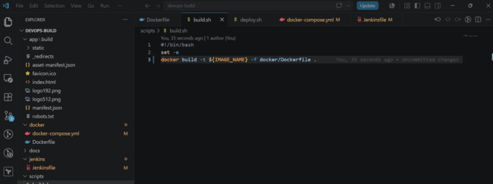
Try to push to github

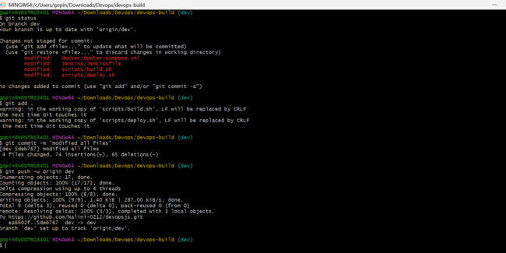


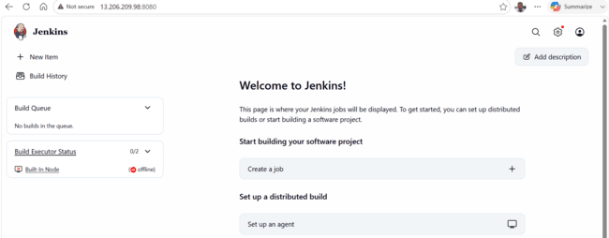
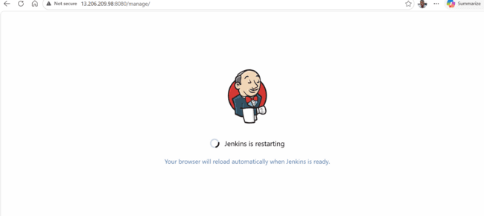

Update webhook
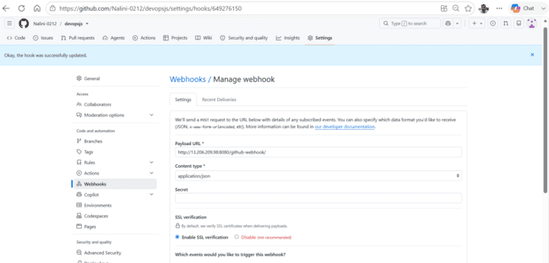
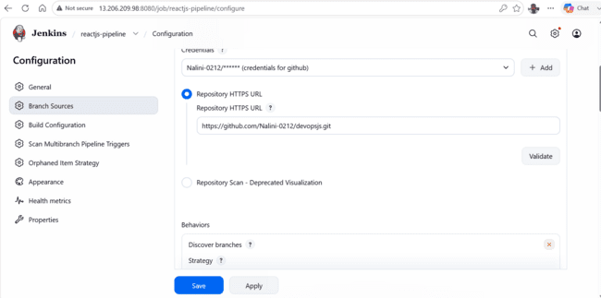
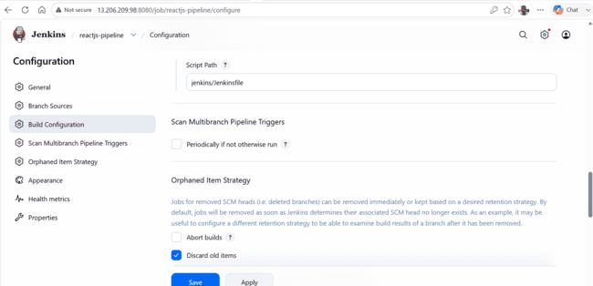

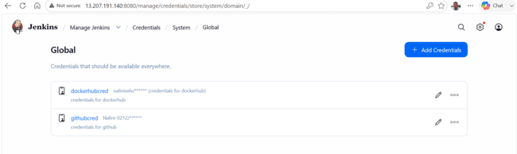

Pipeline failed

Modify file and push again

pipeline {
agent any

environment {
DEV_REPO = "naliniselv/react-app-dev"
PROD_REPO = "naliniselv/react-app-prod"
}

stages {

stage('Checkout Repository') {
steps {
checkout scm
}
}

stage('Docker Login') {
steps {
withCredentials([
usernamePassword(
credentialsId: 'dockerhubcred',
usernameVariable: 'DOCKERHUB_USERNAME',
passwordVariable: 'DOCKERHUB_PASSWORD'
)
]) {
sh '''
echo "$DOCKERHUB_PASSWORD" | docker login \
-u "$DOCKERHUB_USERNAME" --password-stdin
'''
}
}
}

stage('Build Docker Image') {
steps {
script {

if (env.BRANCH_NAME == "dev") {
env.IMAGE_NAME = "${DEV_REPO}:latest"
} else if (env.BRANCH_NAME == "main") {
env.IMAGE_NAME = "${PROD_REPO}:latest"
} else {
error "Unsupported branch: ${env.BRANCH_NAME}"
}

sh """
chmod +x scripts/build.sh
IMAGE_NAME=${env.IMAGE_NAME} ./scripts/build.sh
"""
}
}
}

stage('Push Docker Image') {

when {
anyOf {
branch 'dev'
branch 'main'
}
}

steps {

script {

if (env.BRANCH_NAME == "dev") {

sh """
echo "Tagging DEV Image..."

docker tag ${DEV_REPO}:latest ${DEV_REPO}:${BUILD_NUMBER}

echo "Pushing DEV Images..."

docker push ${DEV_REPO}:latest
docker push ${DEV_REPO}:${BUILD_NUMBER}
"""

}

if (env.BRANCH_NAME == "main") {

sh """
echo "Tagging PROD Image..."

docker tag ${PROD_REPO}:latest ${PROD_REPO}:${BUILD_NUMBER}

echo "Pushing PROD Images..."

docker push ${PROD_REPO}:latest
docker push ${PROD_REPO}:${BUILD_NUMBER}
"""

}

}

}

}

stage('Deploy Production') {

when {
branch 'main'
}

steps {

sh """
chmod +x scripts/deploy.sh
IMAGE_NAME=${PROD_REPO}:latest ./scripts/deploy.sh
"""

}

}

}

post {

success {
echo "Pipeline completed successfully."
}

failure {
echo "Pipeline failed."
}

always {

sh '''
docker logout || true

docker image prune -af || true

docker container prune -f || true

docker volume prune -f || true
'''

script {

if (env.BRANCH_NAME == "dev") {

sh """
docker rmi -f ${DEV_REPO}:latest || true
docker rmi -f ${DEV_REPO}:${BUILD_NUMBER} || true
"""

}

if (env.BRANCH_NAME == "main") {

sh """
docker rmi -f ${PROD_REPO}:latest || true
docker rmi -f ${PROD_REPO}:${BUILD_NUMBER} || true
"""

}

}

cleanWs()

}

}

}

Dev has passed now . We can manually deploy it like before

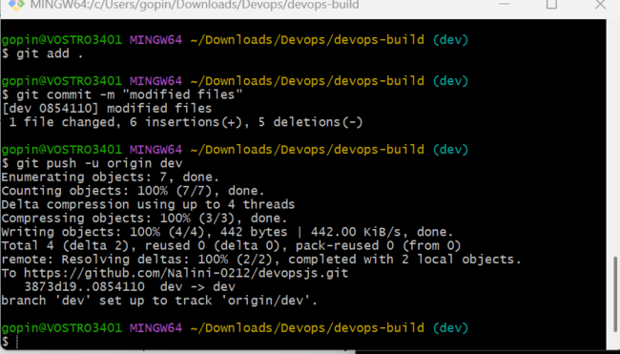
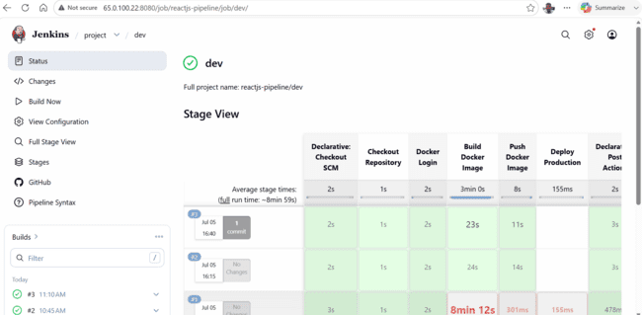
3 and latest got pushed
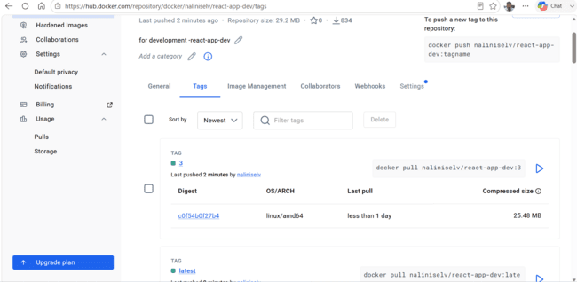
Raise the pull request
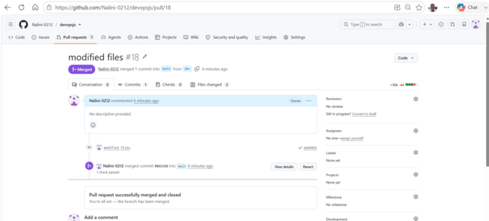

DEV It was triggered by push event

Now main branch job is triggered
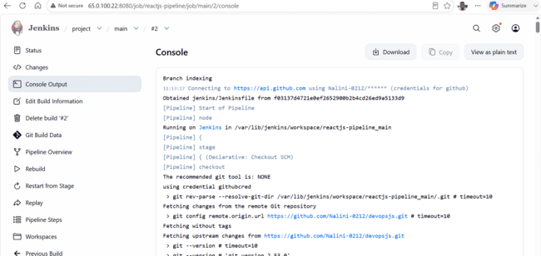
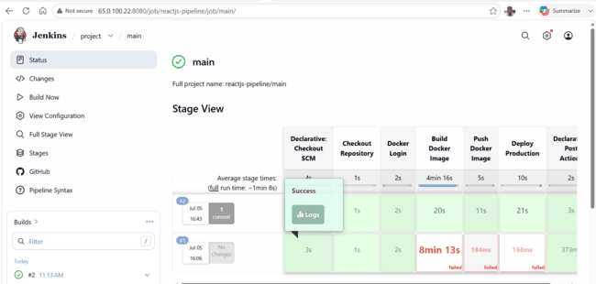
Now try to browse URL
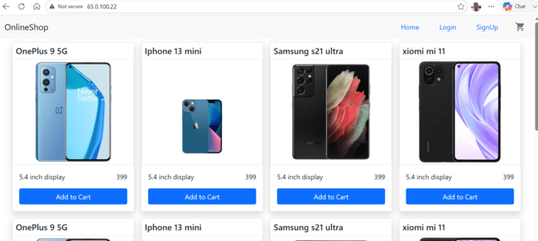
Able to access with same ip as jenkins with port 80
Monitoring:

Setup a monitoring system to check the health status of application (open source).
sending notification only if the application goes down is highly appreciable.

As here we need to monitor health status of application we use promethus and blackbox exporter which will do end point monitoring.
Create ec2 server with SG that allows 3 ports 9090-promethus , 9093- alert manager and 9115 - blackbox exporter

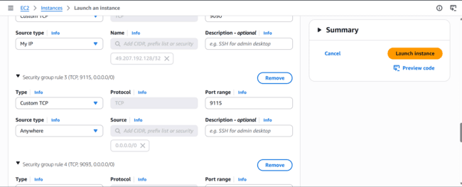
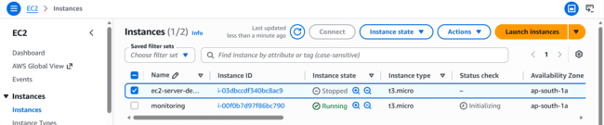
Install prometheus , blackbox and alert manager i=using documentation
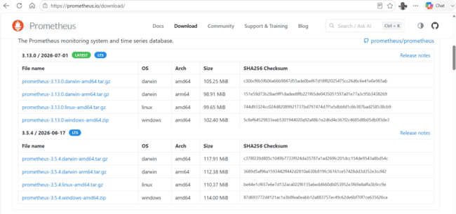
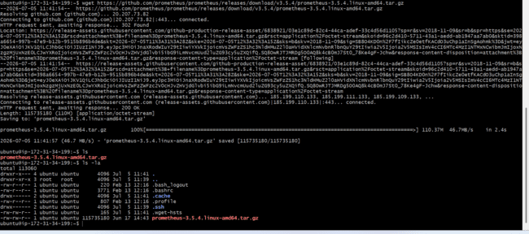
Extract it
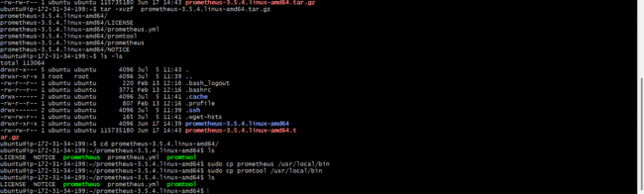
Copy binaries to /usr/local/bin

Prometheus doesn’t scrape application directly
Prometheus use blackbox exporter which checks application status eg : use HTTP check and returns metrics such as probe_success , probe_duration_seconds. Prometheus stores those metrics and evaluate alert rules .we specify these thing in prometheus.yml configuration file.

Prometheus provide url which blackbox exporter use to probe application servers
Modify prometheus.yml as below
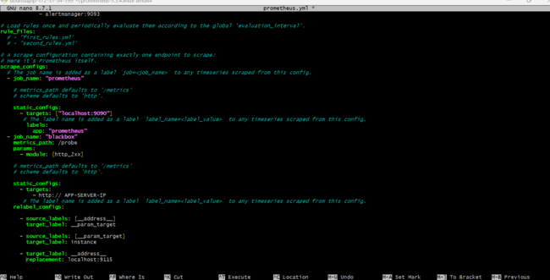

SAVE and exist

Install blackbox exporter and extract and copy binaries to /usr/local/bin

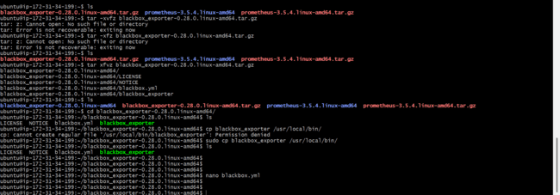

Alert manager install and extract it

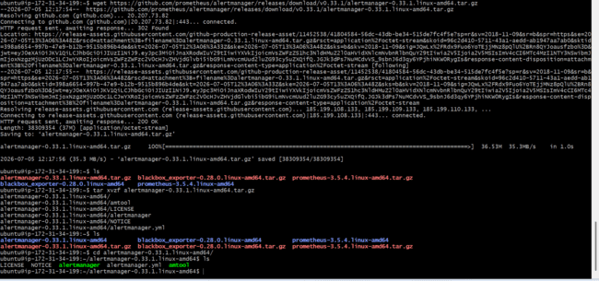
Create systemd service for alert manager
Open /etc/systemd/system/alertmanager.service
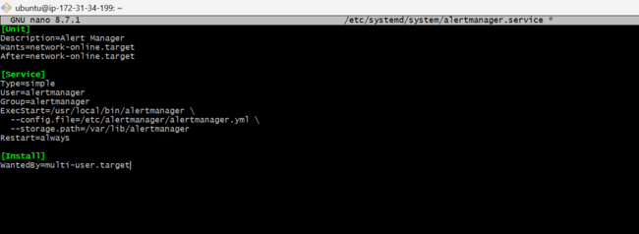

Reload daemons
Configure prometheus to use alert manager go to prometheus.yml file
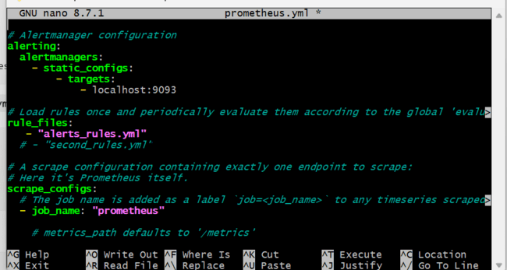

Then create alerts_rules.yml
When alerts should be triggered
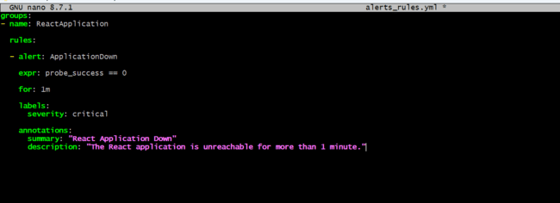
Save and exist
Copy alertmanager.yml file to execstart directory
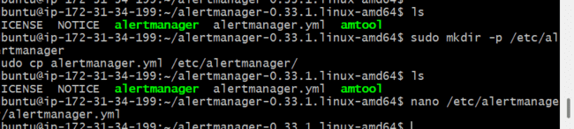
And also modify file as below
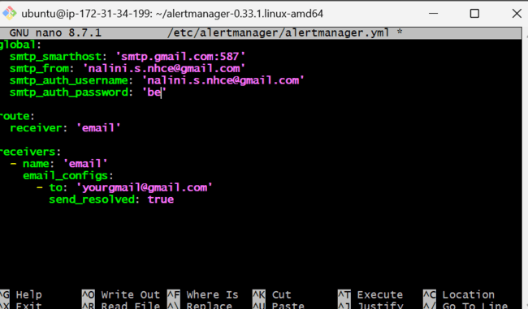

Instead of be add app password generated from gmail (security app password enable 2 factor authentication)

Now start blackbox then alert manager and last prometheus
Black box exporter started successfully on port 9115
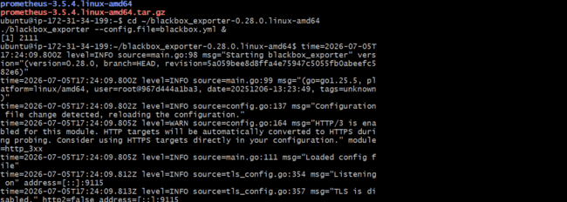

Alert manager start it

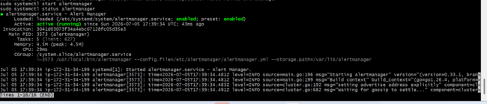
Go to prometheus.yml and change ip address to below
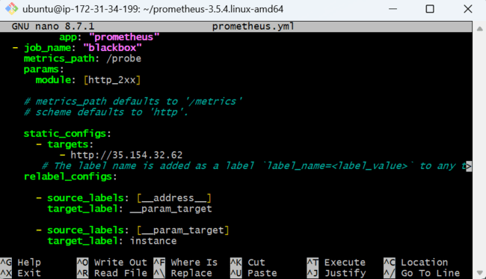

And start prometheus
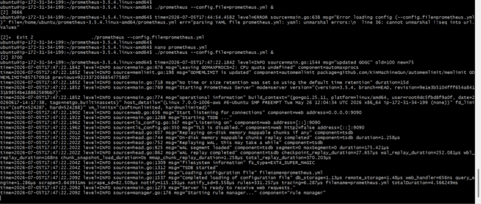

Prometheus started properly now
Now do verification check all 3 ports and alert manager service which we configured is running or not

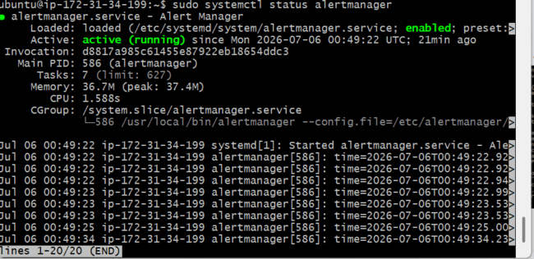
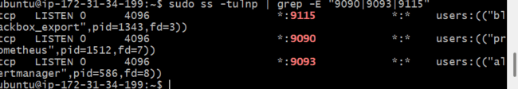
All 3 ports are listening
Verify prometheus is healthy

Open http://server-ip:9090

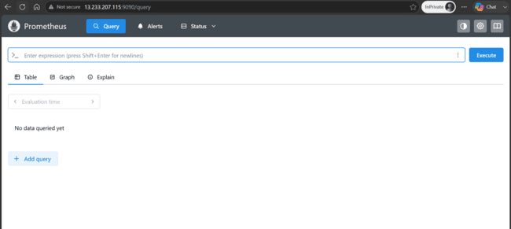

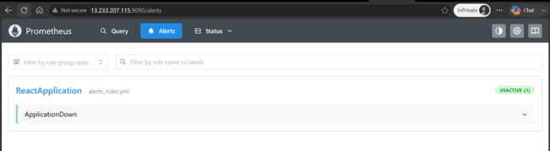
The above one is alert rule which we specified in prometheus.yml . it is loaded properly
Below is prometheus targets.

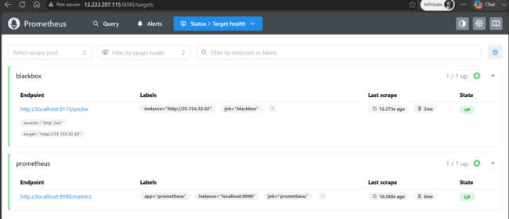
Verify blackbox exporter

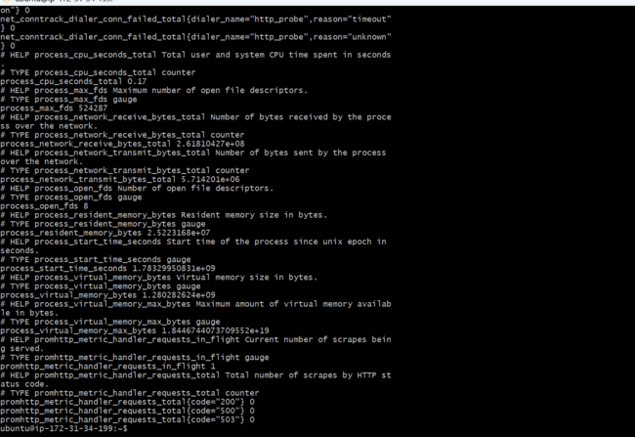
Perform test on actual probe (send http request to application)
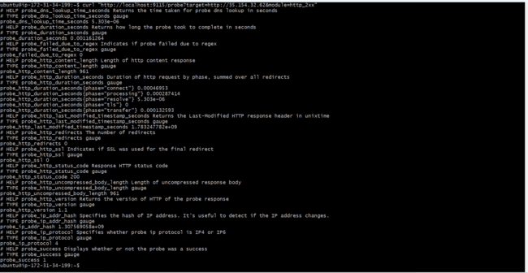
We see probe_success 1 then application is reachable
Verify alert manager
Open alert manager on port 9093
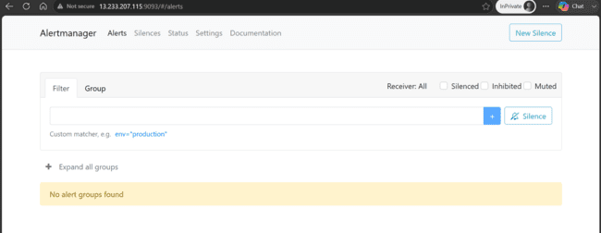

On application server stop container
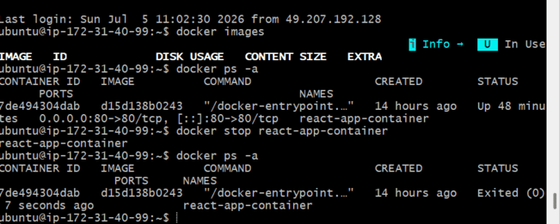
Then check prometheus
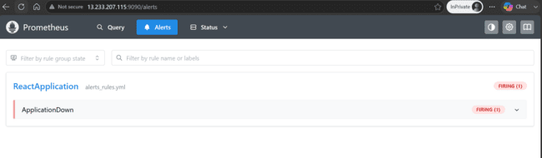
Open alert manager
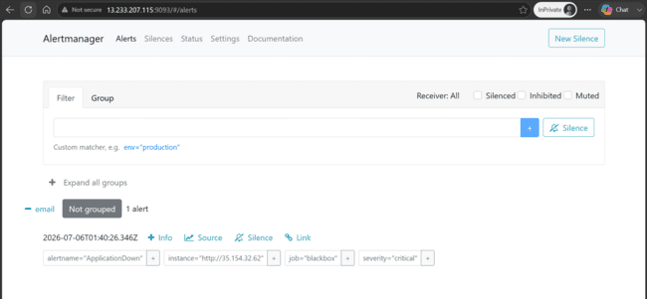
We receive notification
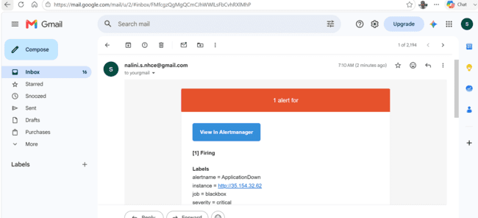

Start application again
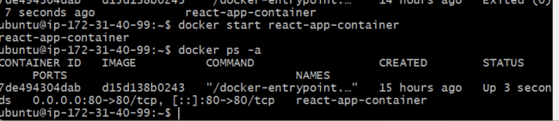
After starting application
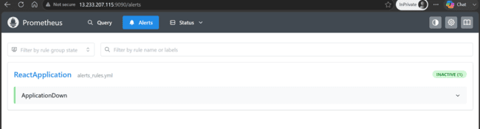
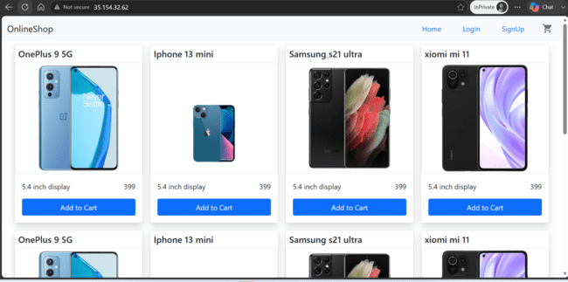
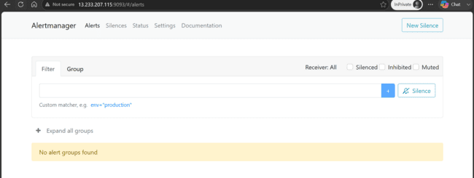
We received resolution mail
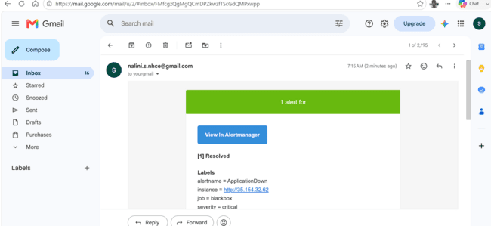

Reload systemd
Create the Systemd

