# Project Report

|  |  |
| --- | --- |
| **Team Id** | PNT2022TMID03443 |
| **Project Title** | AI-powered Nutrition Analyzer for Fitness Enthusiasts |

## INTRODUCTION

* 1. Project Overview
  2. Purpose

## LITERATURE SURVEY

* 1. Existing problem
  2. References
  3. Problem Statement Definition

## IDEATION & PROPOSED SOLUTION

* 1. Empathy Map Canvas
  2. Ideation & Brainstorming
  3. Proposed Solution
  4. Problem Solution fit

## REQUIREMENT ANALYSIS

1. Functional requirement
2. Non-Functional requirements

## PROJECT DESIGN

* + 1. Data Flow Diagrams
    2. Solution & Technical Architecture
    3. User Stories

## PROJECT PLANNING & SCHEDULING

* + 1. Sprint Planning & Estimation
    2. Sprint Delivery Schedule
    3. Reports from JIRA

## CODING & SOLUTIONING

* + 1. Feature 1
    2. Feature 2

## TESTING

* + 1. Test Cases
    2. User Acceptance Testing

## RESULTS

* + 1. Performance Metrics **10.ADVANTAGES & DISADVANTAGES 11.CONCLUSION**

**12.FUTURE SCOPE 13. APPENDIX** Source Code

GitHub & Project Demo Link

## INTRODUCTION

The most crucial factor in living a healthy life is eating a balanced, healthy diet. It supports healthy outcomes, aging, normal growth, and the growth of a sense of well-being. Additionally, it lowers the chance of developing cardiac and heart disorders and aids in maintaining a healthy body weight. Age, way of life, culture, gender, and a host of other factors all affect a balanced diet. Therefore, there is a need for nutritionists that can analyze each and every person based on their unique culinary culture and way of life. Artificial intelligence fills a requirement in the current, developing society for identity and nutrition studies. When a huge amount of data is required for structuring and integrating the metabolomics, AI algorithms will help forecast the complicated non-linear relationships in fitness related data sets. Every person needs to be aware of how many calories they are consuming in their fruits because society as a whole is becoming more diet concerned. It encourages better digestion and helps you feel full on less food. One can become more aware of their food choices by making a few minor adjustments to their eating routine. This analyser will give users an assistant that will advise them on what to eat, how much to consume, and all of the fruit’s calories and nutrients. Additionally, it aids in lowering birth weight, malnutrition, and other issues.

## PROJECT OVERVIEW

The idea is to ensure that the food has an optimal requirement of vitamins and minerals wherein the examination of nutrition in food helps in understanding about the fat proportion, carbohydrates dilution, proteins, fiber, sugar, etc. And thereafter the appropriate presence of nutritional value assists in fulfilling the compliance regulations matched by the national and international bodies. Food nutritional analysis is a compulsory requirement for food products manufacturing industries as it’s a necessary complaint for the products to get launched. Thus have the scanning of the food product’s nutritional value and be rest assured.

## PURPOSE

The purpose of nutritional assessment, however, is to define a patient's nutritional status, to define clinically relevant malnutrition and to monitor changes in nutritional status.

## LITERATURE SURVEY

**EXISTING PROBLEM**

A Study of Calorie Estimation in Pictures of Food by Jun Zhou, Dane Bell, Sabrina Nusrat, Melanie Hingle, Mihai Surdeanu, Stephen Kobourov findings offer fresh knowledge on the method for estimating calories from food photographs, which may be

used to improve analysis and software development. As a function of respondent characteristics and food features, their study aims to assess the accuracy of crowdsourced annotations of calorie content in food photographs as well as to identify and quantify sources of bias and noise. They distributed a custom-made webpage that conducts an online test and encouraged adult social media users to offer calorie estimates for 20 food photos (for which actual calorie data were known). The pictures were chosen to show different meal varieties and energy densities. Participants might have disclosed their height, weight, and gender. The identical data was also annotated by five nutrition specialists to serve as a basis for comparison. Using linear mixed effects models with participant and image index as random variables, they investigated estimated accuracy on the basis of competence, demographic information, and meal quality. They also looked at the benefit of combining estimates from different sources. [1] An analysis of calorie estimation accuracy by Hannah Mixon and Matthew E. Davis is obesity monitoring and controlling by understanding the risk factors of every individual. Understanding risk factors is crucial to comprehend the role that individual differences in cognitive abilities play in the nutritional decision-making process, from the assessment of calories to the influence of any cognitive biases or miscalculations that may occur. In the current study, researchers looked into how dietary aspects like limited eating and cognitive factors like cognitive reflection and numeracy affect biases and miscalculations about calories. Additionally, it primarily focuses on packaged goods and calculates risk and calories for them. [2] Popular Nutrition-Related Mobile Apps: A Feature Assessment by Rodrigo Zenun Franco, Rosalind Fallaize, Julie A Lovegrove, Faustina Hwang is a model proposed in 2016, is to examine and contrast the approaches and technologies used by the most widely used nutrition apps for dietary assessment and user feedback. 13 apps in total were deemed popular enough to be included in the analysis. Nine applications included a food diary function for prospectively documenting food intake. There were barcode scanners and text search capabilities for food selection. Selection of the portion size was only textual (ie, without images or icons). All nine of these apps have the ability to gather data on physical activity (PA) through wearable integrations, self-report, or GPS tracking. Their work mainly concentrated on achieving a healthy energy balance between dietary intake and PA. None of these nine applications provided elements specifically linked to meal plans and coaching for motivation. The remaining four of the 13 apps, however, concentrated on these prospects without including food diaries. Another cutting-edge feature of one app, Fat Secret, allowed users to communicate with medical experts, and S Health offered a nutrient balance score. [3] Artificial Intelligence Applications in Nutrition and Dietetics is a model that provides the advantages and disadvantages. Both dieticians and clients should track dietary assessments of individuals when assessing nutritional status. Artificial intelligence applications are becoming more prevalent in the fields of dietetics and nutrition, according to observations. For instance, the food consumption logs, which are assessed by photographing the meals ingested, are helpful in determining the nutritional status.

These smartphone-shot images demonstrate how useful and adaptable the application is.

The dietician can follow the suggested diet plan using these apps, and the clients can take responsibility for their own diet adaption. In order to lower the danger in this approach, hospitalized patients' usual food consumption must be closely monitored. [4]

## REFERENCES

1. A Study of Calorie Estimation in Pictures of Food by Jun Zhou, Dane Bell, Sabrina Nusrat,

Melanie Hingle, Mihai Surdeanu, Stephen Kobourov

1. An analysis of calorie estimation accuracy by Hannah Mixon and Matthew E. Davis
2. Popular Nutrition-Related Mobile Apps: A Feature Assessment by Rodrigo Zenun Franco, Rosalind Fallaize, Julie A Lovegrove, Faustina Hwang
3. Artificial Intelligence Applications in Nutrition and Dietetics is a model provides the advantages and disadvantages

## PROBLEM STATEMENT

The main aim of the project is to building a model which is used for classifying the fruit depends on the different characteristics like colour, shape, texture etc. Here the user can capture the

images of different fruits and then the image will be sent the trained model. The model analyses the image and detect the nutrition based on the fruits like (Sugar, Fibre, Protein, Calories, etc. To

accomplish this, we have to complete all the activities and tasks listed below

* + Data Collection.
    - Collect the dataset or Create the dataset
  + Data Preprocessing.
  + Import the ImageDataGenerator library
  + Configure ImageDataGenerator class
  + ApplyImageDataGenerator functionality to Train Set and Test Set
  + Model Building

Import the model building Libraries

* + - Initializing the model
    - Adding Input Layer
    - Adding Hidden Layer
    - Adding Output Layer
    - Configure the Learning Process
    - Training and testing the model
    - Save the Model ●

Application Building

* + - * Create an HTML file
    - Build Python Code

## IDEATION & PROPOSED SOLUTION

**EMPATHY MAP CANVAS**

An empathy map is a simple, easy-to-digest visual that captures knowledge about a user’s behaviors and attitudes. It is a useful tool to help teams better understand their users.

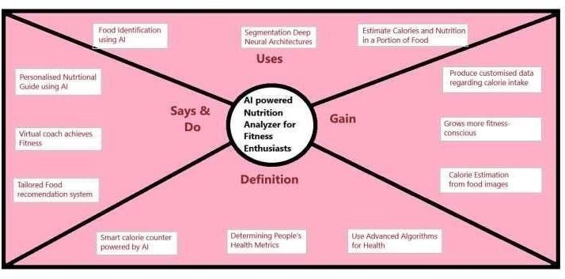Creating an effective solution requires understanding the true problem and the person who

is experiencing it. The exercise of creating the map helps participants consider things from the user’s perspective along with his or her goals and challenges.

**IDEATION & BRAINSTORMING**

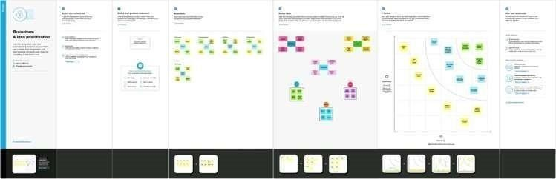

# PROPOSED SOLUTION

|  |  |  |
| --- | --- | --- |
| **S.No.** | **Parameter** | **Description** |
| 1. | Problem Statement (Problem solved) | A nutrition analyser with AI powered fruit classifier based on the features to provide nutritional values likefiber, vitamins, minerals etc to Fitness Ethusiasts. |
| 2. | Idea / Solution description | Creating web interface application to monitor and track health condition and helping the people to improve their health condition. |
| 3. | Novelty / Uniqueness | Artificial Intelligence offers unparalleled opportunities of progress and applications in nutrition. There remain gaps to address to potentialize this emerging field |
| 4. | Social Impact / Customer Satisfaction | The relationship between an individual’s social, psychological, and cultural environment and his or her  nutritional status is one of both cause and effect. With use of this application one can keep track of how much nutrients they can balance intheir diet. |

|  |  |  |
| --- | --- | --- |
| 5. | Business Model (Revenue Model) | Offering monthly or yearly subscription for premium features. Monetizing data from the application. |
| 6. | Scalability of the Solution | For now the nutrition analyser is limited to mostly fruits only, which can be scaled to other foods, Implementing in mobile app. |

## PROBLEM SOLUTION FIT

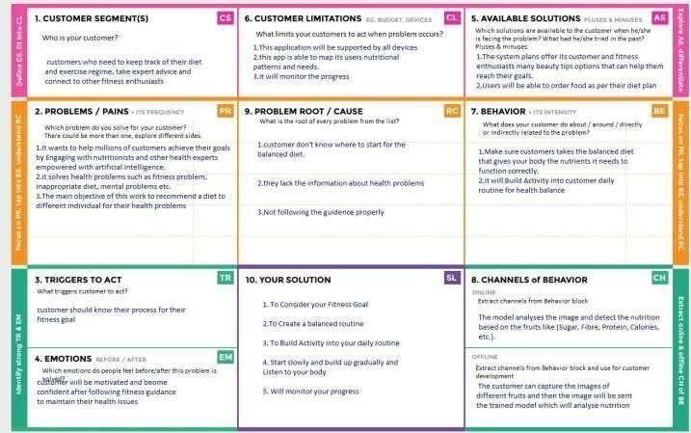

1. **REQUIREMENT ANALYSIS**

## FUNCTIONAL REQUIREMENTS

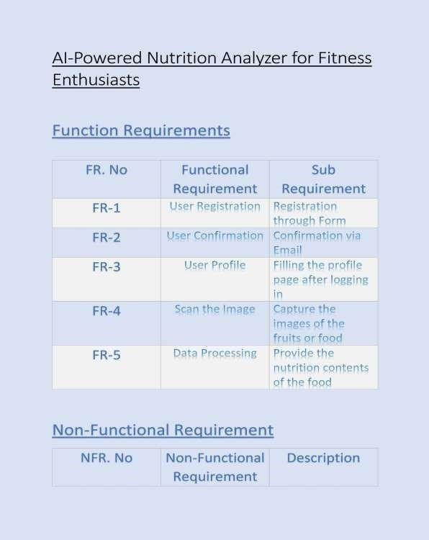

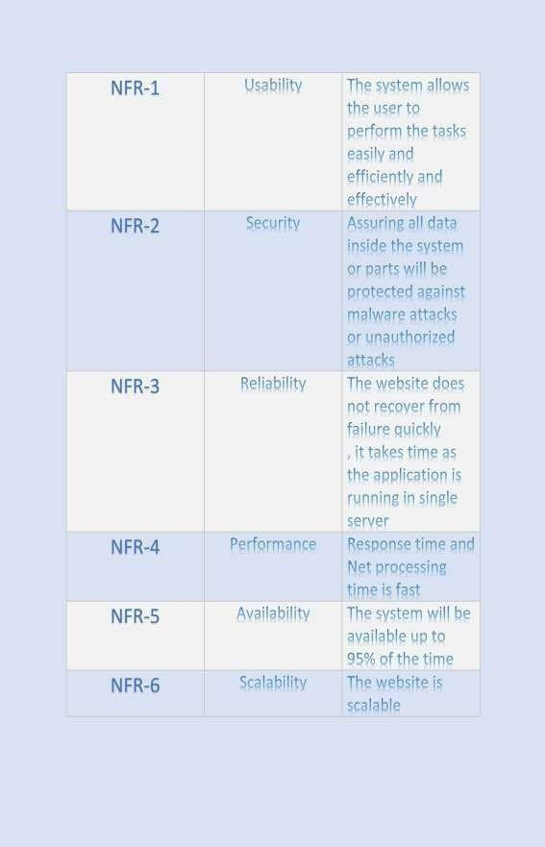

1. 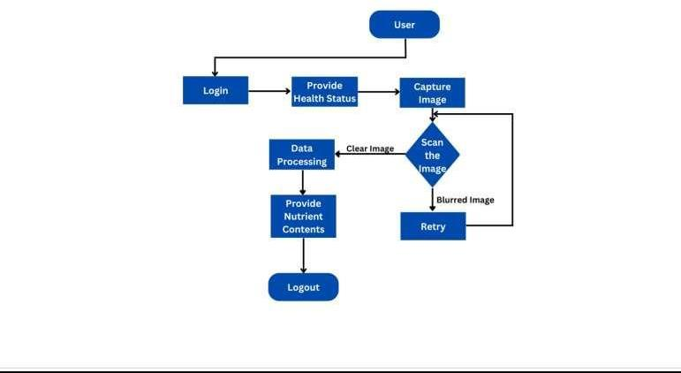**PROJECT DESIGN** **DATA FLOW DIAGRAMS**

## SOLUTION & TECHNICAL ARCHITECTURE

**USER STORIES**

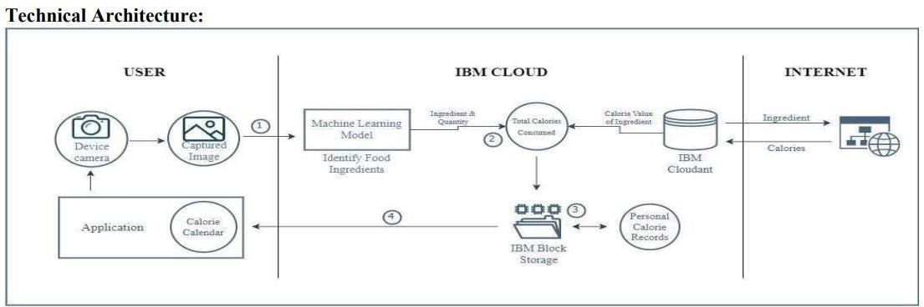

|  |  |  |  |  |  |  |
| --- | --- | --- | --- | --- | --- | --- |
| **USER TYPE** | **FUNCTIONAL REQUIREMENT S** | **USER STORY NUMBE**  **R** | **USER STORY**  **/TASK** | **ACCEPTANC ECRITERIA** | **PRIORITY** | **RELEASE** |
| Customer | Registration | USN-1 | As a user, I | I can access my | High | Sprint-1 |
| can register | account / |
| for the application byentering my Name, Age, Gender, E-mail, password, and  confirming  my password. | dashboard |
|  |  | USN-2 | As a user, I | I can receive | High | Sprint-1 |
| will receive a | confirmation |
| confirmation | email & click |
| email once Ihave registered for the application. | confirm. |
|  | Profile Updating | USN-3 | As a user, I | I can update | High | Sprint-1 |
| have to enter | these |
| my height, | information on |
| weight and daily activity  details | Dashboard. |

|  |  |  |  |  |  |  |
| --- | --- | --- | --- | --- | --- | --- |
|  | Login | USN-4 | As a user, I can login to the application by entering Email and password. | I can access my account/ dashboard. | High | Sprint-1 |
|  | Dashboard | USN-5 | As a user, I can login to the application by entering Email and password. | I can get the nutritional value of that particular meal. | High | Sprint-2 |
|  |  | USN-6 | As a user, I can track my daily calorie intake. | I can access my account/ Dashboard | Medium | Sprint-2 |
| Applic ation | Maintain Application | USN-7 | Maintaining details for users. | I can access the database. | High | Sprint-3 |

## PROJECT PLANNING & SCHEDULING SPRINT PLANNING & ESTIMATION

|  |  |  |  |  |  |  |
| --- | --- | --- | --- | --- | --- | --- |
| **SPRINT** | **FUNCTIONAL REQUIREMENT** | **USER STORY N0** | **USER STORY/TASK** | **STORY POINTS** | **PRIORITY** | **TEAM MEMBERS** |

|  |  |  |  |  |  |  |
| --- | --- | --- | --- | --- | --- | --- |
| 1 | Data Collection | USN-1 | Dataset - Collecting images of  food items apples ,  banana, orange, pineapple, watermelon for  analysis | 5 | High | Monica jk Sneha sv |
| 1 | Image Processing | USN-2 | Image data augmentation - Increasing the amount of data by generating new data points from existing data | 4 | Medium | Monisree v Sneha m |
| 2 | Image Processing | USN-3 | Image Data  Generator Class - Used for getting the input of the original data | 4 | Medium | Monica jk Sneha sv |
| 1 | Image Processing | USN-4 | Applying image data generator functionality to train set and test set | 4 | Medium | Monisree v Sneha m |
| 2 | Model Phasing | USN-5 | Defining the model architecture - Building the model using deep learning  approach and adding CNN  layers | 4 | Medium | Monica jk Sneha sv |
|  |  |  |  |  |  |  |
| 2 | Model phasing | USN-6 | Training , saving, testing and predicting the model | 5 | High | Monisree v Sneha m |
| 2 | Recognise fruit type | USN-7 | Data base creation for the input classes | 4 | High | Monica jk Sneha sv |

|  |  |  |  |  |  |  |
| --- | --- | --- | --- | --- | --- | --- |
| 2 | Development Phase | USN-8 | User database creation  - It contains  the details of users | 2 | Medium | Monisree v Sneha m |
| 2 | Development Phase | USN-9 | Home page creation - It shows options of the application | 2 | Low | Monica jk Sneha sv |
| 2 | Development Phase | USN-10 | Login and registration page creation - User can register and login through gmail with Id and password | 2 | low | Monisree v Sneha m |
| 3 | Development Phase | USN-11 | Dashboard creation – Dashboard contains the information of user profile and features of the application | 2 | low | Monica jk Sneha sv |
| 3 | Development Phase | USN-12 | User Input Page Creation - It is for the user to feed the input images | 4 | Medium | Monisree v Sneha m |
| 3 |  | USN-13 | Analysis and prediction page creation - It shows the prediction of given user input | 4 | Medium | Monica jk Sneha sv |

|  |  |  |  |  |  |  |
| --- | --- | --- | --- | --- | --- | --- |
| 3 | Application Phase | USN-14 | Creation of about us, feedback and rating page – It shows application history and feedback page to users | 4 | Medium | Monisree v Sneha m |
| 3 | Application Phase | USN-15 | Building the python code and importing the flask module into the  Project | 6 | High | Monica jk Sneha sv |
| 4 | Application Phase | USN-16 | Create the Flask application and loading the model | 5 | High | Monisree v Sneha m |

|  |  |  |  |  |  |  |
| --- | --- | --- | --- | --- | --- | --- |
| 4 | Application Phase | USN-17 | API integration - Connecting front end and back end and perform routing and run the application | 5 | High | Monica jk Sneha sv |
| 4 | Deployment phase | USN-18 | Cloud deployment – Deployment of application by using IBM cloud | 4 | High | Monisree v Sneha m |
| 4 | Testing Phase | USN-19 | Functional testing – Checking usability and accessibility | 3 | Medium | Monica jk Sneha sv |
| 4 |  | USN-20 | Non Functional testing – Checking scalability and performance of the application | 3 | Medium | Monisree v Sneha m |

**SPRINT DELIVERY SCHEDULE**

|  |  |  |  |  |  |  |
| --- | --- | --- | --- | --- | --- | --- |
| **SPRINT** | **TOTAL STORY POINTS** | **DURATION** | **SPRINT START DATE** | **SPRINT END DATE** | **STORY POINTS COMPLETED** | **SPRINT RELEASE DATE** |
| 1 | 20 | 6 Days | 24 Oct  2022 | 29 Oct 2022 | 17 | 29 Oct 2022 |
| 2 | 20 | 6 Days | 31 Oct  2022 | 05 Nov 2022 | 20 | 5 Nov 2022 |
| 3 | 20 | 6 Days | 07 Nov  2022 | 12 Nov 2022 | 20 | 12 Nov 2022 |
| 4 | 20 | 6 Days | 14 Nov  2022 | 19 Nov 2022 | 20 | 19 Nov 2022 |

## 6.3 REPORTS FROM JIRA

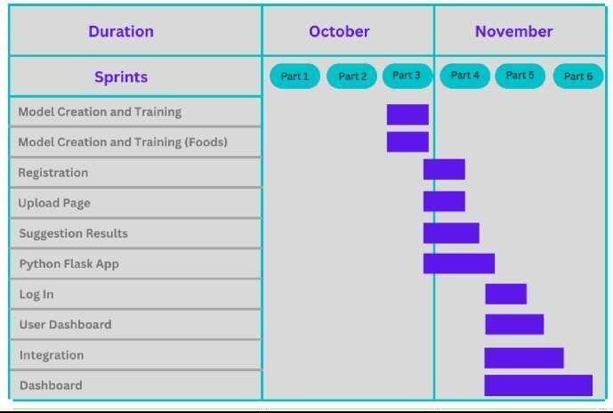

1. **CODING & SOLUTIONING**

## FEATURE 1

Home.html

## Feature 2

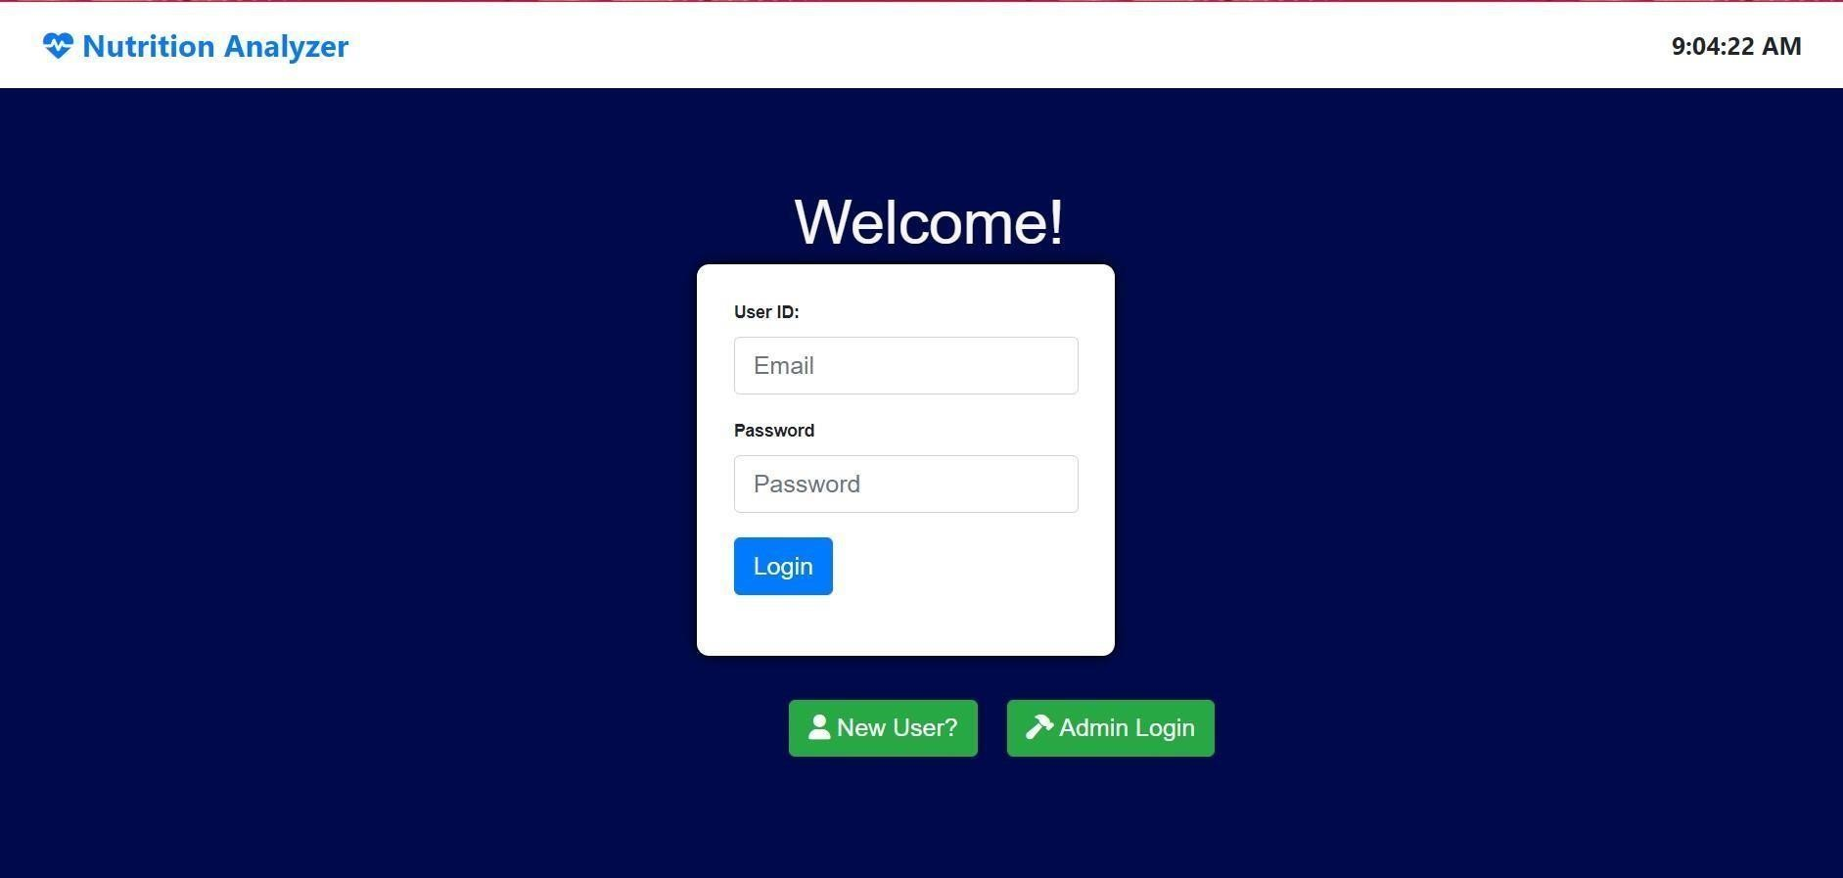**Index.html**

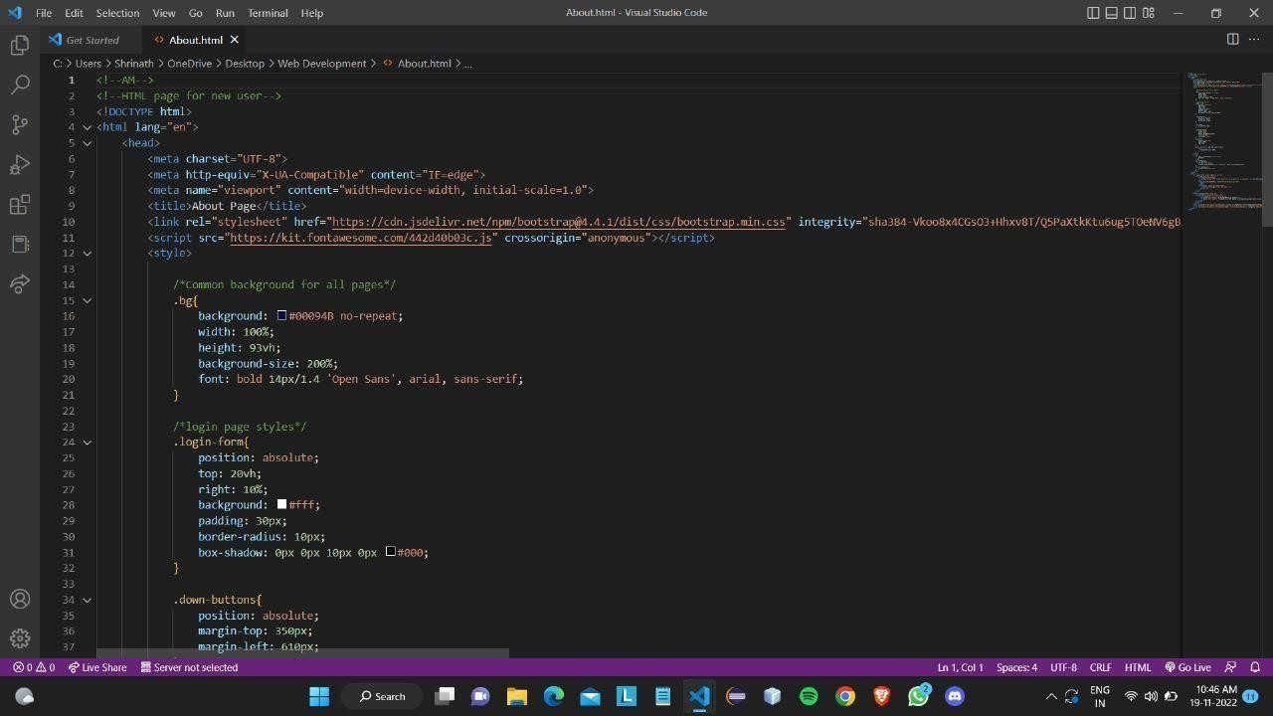

## App.py

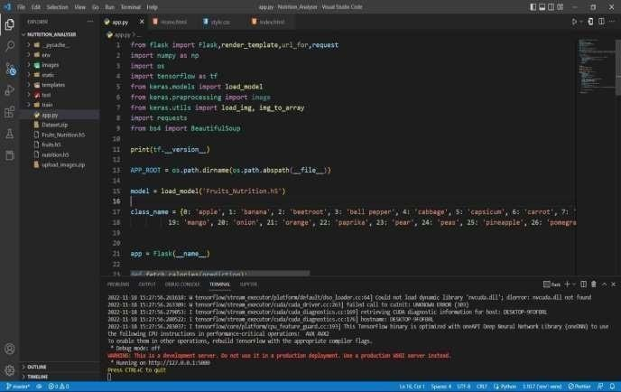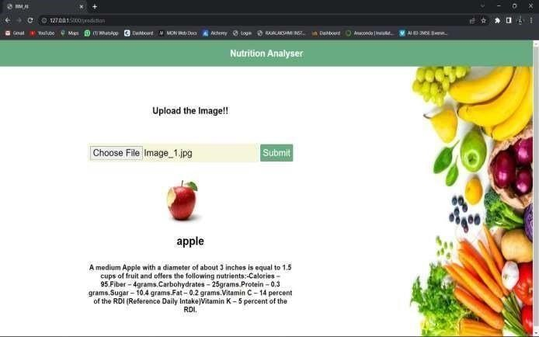

**Data Collection**

Download the dataset using the above given link # Unzipping the dataset

!unzip '/content/Dataset.zip' inflating: Dataset/TRAIN_SET/PINEAPPLE/33_100.jpg inflating: Dataset/TRAIN_SET/PINEAPPLE/34_100.jpg inflating: Dataset/TRAIN_SET/PINEAPPLE/35_100.jpg inflating: Dataset/TRAIN_SET/PINEAPPLE/36_100.jpg inflating: Dataset/TRAIN_SET/PINEAPPLE/37_100.jpg inflating: Dataset/TRAIN_SET/PINEAPPLE/38_100.jpg inflating: Dataset/TRAIN_SET/PINEAPPLE/39_100.jpg inflating: Dataset/TRAIN_SET/PINEAPPLE/40_100.jpg inflating: Dataset/TRAIN_SET/PINEAPPLE/41_100.jpg inflating: Dataset/TRAIN_SET/PINEAPPLE/42_100.jpg inflating: Dataset/TRAIN_SET/PINEAPPLE/43_100.jpg inflating: Dataset/TRAIN_SET/PINEAPPLE/44_100.jpg inflating: Dataset/TRAIN_SET/PINEAPPLE/45_100.jpg inflating: Dataset/TRAIN_SET/PINEAPPLE/46_100.jpg inflating: Dataset/TRAIN_SET/PINEAPPLE/47_100.jpg inflating: Dataset/TRAIN_SET/PINEAPPLE/48_100.jpg inflating: Dataset/TRAIN_SET/PINEAPPLE/49_100.jpg inflating: Dataset/TRAIN_SET/PINEAPPLE/4_100.jpg

## Image ProProcessing

Importing the ImageDataGenerator Library import numpy as np import tensorflow as tf from tensorflow.keras.models import Sequential

from tensorflow.keras import layers from tensorflow.keras.layers import Dense,Flatten from tensorflow.keras.layers import

Conv2D,MaxPooling2D,Dropout from keras.preprocessing.image import ImageDataGenerator

**Config ImageDataGenerator Class** train_datagen = ImageDataGenerator(rescale = 1./255,shear_range=0.2, zoom_range=0.2, horizontal_flip= True) test_datagen

= ImageDataGenerator(rescale = 1./255)

**Applying Image DataGenerator Functionality To Trainset And Testset** #Applying Image DataGenerator Functionality To Trainset And Testset x_train = train_datagen.flow_from_directory(r'/content/drive/MyDrive/DataSet-

IBM/TRAIN_SET', target_size=(64, 64),batch_size=5,color_mode='rgb',class_mode='sparse')

#Applying Image DataGenerator Functionality To Testset x_test = test_datagen.flow_from_directory( r'/content/drive/MyDrive/DataSet- IBM/TEST_SET', target_size=(64, 64),batch_size=5,color_mode='rgb',class_mode='sparse')

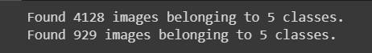

## Image PreProcessing

**Model Creation**

Importing libraries import numpy as np import tensorflow as tf from tensorflow.keras.models import Sequential from tensorflow.keras import layers from tensorflow.keras.layers import Dense,Flatten from tensorflow.keras.layers import

Conv2D,MaxPooling2D,Dropout from keras.preprocessing.image import ImageDataGenerator

## Initializing the Model model

= Sequential()

## Adding CNN Layers

classifier = Sequential()

# First convolution layer and pooling classifier.add(Conv2D(32, (3, 3), input_shape=(64, 64, 3), activation='relu')) classifier.add(MaxPooling2D(pool_size=(2, 2))) # Second convolution layer and pooling classifier.add(Conv2D(32, (3, 3), activation='relu'))

# input_shape is going to be the pooled feature maps from the previous convolution layer classifier.add(MaxPooling2D(pool_size=(2, 2)))

# Flattening the layers classifier.add(Flatten())

**Adding Dense Layers** classifier.add(Dense(units=128, activation='relu')) classifier.add(Dense(units=5, activation='softmax'))

classifier.summary()

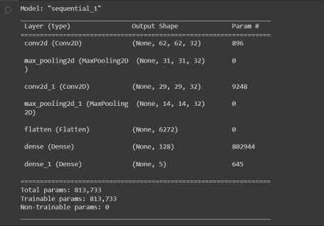

## Configure the Learning Process

# Compiling the CNN

# categorical_crossentropy for more than 2 classifier.compile(optimizer='adam', loss='sparse_categorical_crossentropy', metrics=['accuracy'])

**Train The Model** classifier.fit_generator(generator=x_train,steps_per_epoch = len(x_train),epochs=20, validation_data=x_test,validation_steps = len(x_test))

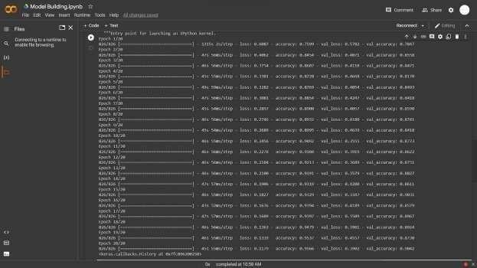

## Save the Model

classifier.save('ainutrition.h5')

## TESTING

* 1. **TEST CASES & USER ACCEPTANCE TESTING Test the Model**

#Predict the results from tensorflow.keras.models import load_model from keras.preprocessing import image from keras_preprocessing.image import load_img model = load_model("ainutrition.h5")

from tensorflow.keras.utils import img_to_array #loading of the image

img = load_img(r'/content/drive/MyDrive/DataSet- IBM/TEST_SET/ORANGE/n07749192_1251.jpg', grayscale=False, target_size= (64,64)) #image to array x = img_to_array(img)

#changing the shape x = np.expand_dims(x,axis = 0) predict_x=model.predict(x) classes_x=np.argmax(predict_x,axis=-

1) classes_x

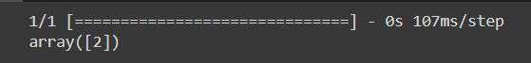

index=['APPLES', 'BANANA',

'ORANGE','PINEAPPLE','WATERMELON'] result=str(index[classes_x[0]]) result



print(result) if result == 'APPLES': print("One serving, or one medium apple, provides about 95 calories, 0 gram fat, 1 gram

protein, 25 grams carbohydrate, 19 grams sugar (naturally occurring), and 3 grams fiber.") elif

result == 'BANANA':

print("One serving, or one medium ripe banana, provides about 110 calories, 0 gram fat, 1 gram protein, 28 grams carbohydrate, 15 grams sugar (naturally occurring), 3 grams fiber, and 450 mg potassium.") elif result == 'ORANGE':

print("60 calories, No fat or sodium, 3 grams of fiber, 12 grams of sugar, 1 gram of protein, 14 micrograms of vitamin A, 70 milligrams of vitamin C, 6% of your daily recommended amount of calcium.") elif result == 'PINEAPPLE':

print("Calories: 83, Fat: 1.7 grams, Protein: 1 gram, Carbs: 21.6 grams, Fiber: 2.3 grams, Vitamin C: 88% of the Daily Value (DV), Manganese: 109% of the DV, Vitamin B6: 11% of the DV.") elif result == 'WATERMELON':

print("Calories: 46, Carbs: 11.5 grams, Fiber: 0.6 grams, Sugar: 9.4 grams, Protein: 0.9 grams, Fat: 0.2 grams, Vitamin A: 5% of the Daily Value (DV), Vitamin C: 14% of the DV.")



## Model Building

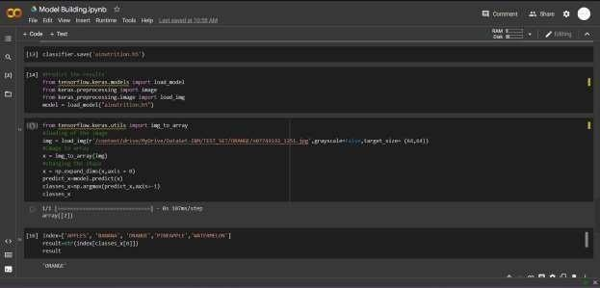

**Webpage**

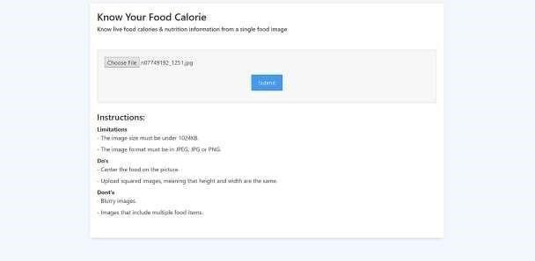

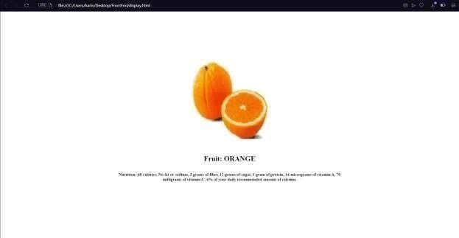

## RESULTS

* 1. **PERFORMANCE METRICS**

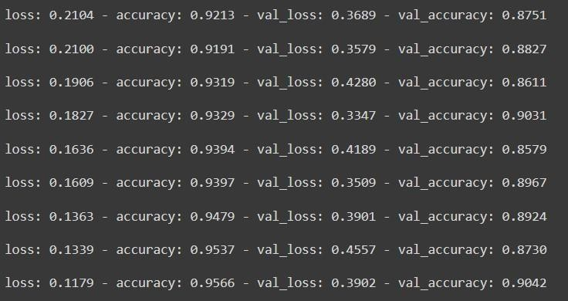

## ADVANTAGES & DISADVANTAGES

**Advantages :**

* Easily detect and Estimate the food nutrition
* Most Accurate
* Flexible Model which can give maximized outcome
* No Specific Requirements needed to implement the model

## Disadvantages :

* Training model is a time consuming process.
* Change in uploading image size or format will throw error

## CONCLUSION

Thus we have constructed a model that can identify the fruit variety and it can analyze its nutrition by advanced AI techniques and CNN Algorithm, then the Prediction model is checked. Then the entire model is deployed to the IBM Cloud account that we have created with the studies we have done.

## FUTURE SCOPE

* It can be developed as a Web or Android Application.
* In future Alternate Advanced technologies can be Implemented.
* The Identification and tracking system can be implemented if possible

## APPENDIX Source Code:

**Github** [:https://github.com/IBM-EPBL/IBM-Project-7744-1658897339](https://github.com/IBM-EPBL/IBM-Project-22580-1659854181)

**Demo**:https://youtu.be/x3XgODk4unM