**Final Assignment – Converter techniques (cohort 2025-04)**

**Submitted By: Lokesh Nalla**

**Exercise 1: Basic Concepts in 3-Phase Thyristor converters (Thy3_Concepts.plecs)**

**Simulation Model:**



The subsystem of “Vd1 and Vd1_avg” is as below and the same model for other two subsystems: “Vd2 and Vd2_avg, Vd and Vd_avg”.



The subsystem of “Va and Ia” is as below. Based on FFT, the fundamental component of ‘ia’ is calculated and the same is plotted along with measured ‘va’ and ‘ia’.





**Waveforms:**

**Case 1:** Firing angle of 45 degrees







1. Average of Vd1 is 184.052 Volts.
2. Average of Vd2 is 184.051 Volts.
3. Average of Vd is 368.103 Volts.

The average of Vd based on theoretical concept is

Vd_theory = = Volts.

Therefore, the measured output voltage closely matches with the theoretical output voltage.

1. The measured displacement angle (The phase angle of fundamental current of ia with respect to va) is -0.820638 radians or 47.019 degrees. The measured displacement power factor is 0.68175 lag.

Theoretical Displacement Power Factor (DPF) calculation:

Power Factor (PF) = DPF * Distortion Factor (DF).

Where DF =

PF =

DPF = PF/DF = 0.6513/0.955 =0.68198 lag

Therefore the measured DPF is same as with the calculated one.

**Case 2:** Firing angle of 90 degrees

 



1. Average of Vd1 is -6.83141 Volts.
2. Average of Vd2 is -6.83366 Volts.
3. Average of Vd is -13.6679 Volts.

The average of Vd based on theoretical concept is

Vd_theory = = Volts.

Therefore, the measured output voltage closely matches with the theoretical output voltage.

1. The measured displacement angle (The phase angle of fundamental current of ia with respect to va) is 4.6874 radians or 268.568 (or 91.432) degrees. The measured displacement power factor is 0.025 lead.

Theoretical Displacement Power Factor (DPF) calculation:

Power Factor (PF) = DPF * Distortion Factor (DF).

Where DF =

PF =

DPF = PF/DF = -0.024/0.955 = -0.025 lag or 0.025 lead

Therefore the measured DPF is same as with the calculated one.

**Case 3:** Firing angle of 135 degrees

 



1. Average of Vd1 is -197.693 Volts.
2. Average of Vd2 is -197.693 Volts.
3. Average of Vd is -395.382 Volts.

The average of Vd based on theoretical concept is

Vd_theory = = Volts.

Therefore, the measured output voltage closely matches with the theoretical output voltage.

1. The measured displacement angle (The phase angle of fundamental current of ia with respect to va) is 3.8914 radians or 222.96 (or 137.04) degrees. The measured displacement power factor is 0.731822 lead.

Theoretical Displacement Power Factor (DPF) calculation:

Power Factor (PF) = DPF * Distortion Factor (DF).

Where DF =

PF =

DPF = PF/DF = -0.69918/0.955 = -0.732125 lag or 0.732125 lead

Therefore the measured DPF is same as with the calculated one.

**Exercise 2: 3-Phase Thyristor Rectifier Bridge (Thyrect3.plecs)**

**Simulation Model:**



The subsystem of “Id and Id_avg” is as below.



The subsystem of “FFT_Ia” is as below.



The subsystem of “Ia_Ia1_rms” is as below.



**Waveforms:**

**P1:**

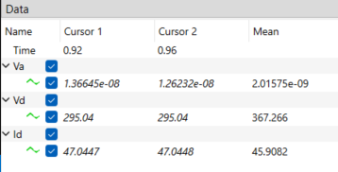 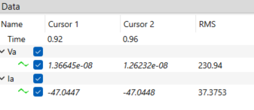 

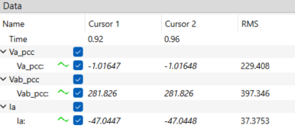



**P2:**

Commutation interval from the given equation is:

 



Id_avg value is 45.9082 A. The commutation interval from the plot is noted as u = 0.236412 ms.

There is a considerable difference in u between the calculated and measured ones. This is because of difference in Id magnitude considered. In the measurement plot, commutation period is measured till id reaches 40.873 A whereas in the given equation id is considered as 45.9082.

If we consider Id = 40.873 in the given equation, we get

**P3:**



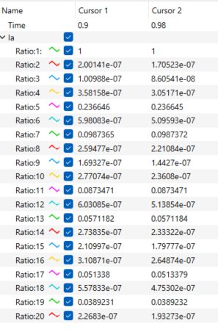



The significant harmonic components are 5, 7, 11, 13, 17 and 19.

**P4:**



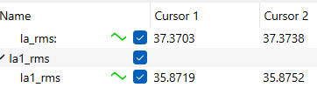

Power Factor (PF) = DPF * Distortion Factor (DF).

Where DF =

PF =

The values of are obtained from figures of P1.

DPF = PF/DF = /0.96 = 0.67828 lag.

**P5:**

1. **Line-notch depth 𝜌(%)**

It is the ratio of peak-peak deviation from the actual voltage signal to the peak of actual voltage.

 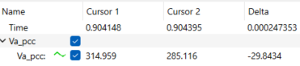

Peak to peak deviation is 29.8434 V and the peak of actual voltage is 325.32 V. So, Line notch depth =

1. **Line-notch area**

 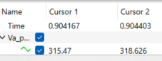



Line-notch area = Area of rectangle

=

**P6:**

The average value of Vd from the figures of P1 is 367.266 V.

The given equation for average of Vd is

Substituting (from P1 figures), we get .

The calculated value matches close to the measured value.

**Exercise 3: Three-Phase, PWM Inverter (PWINV3.plecs)**

**Simulation Model:**



The subsystem of “FFT_VAn” is as below. The similar model is used in “FFT_IA” subsystem except the input which is IA instead of VAn.



The subsystem of “VAnh” is as below. The similar model is used in “IAh” subsystem except the input which is IA instead of VAn.





The subsystem of “FFT_Id_avg” is as below.



**Waveforms:**

**P1:**

 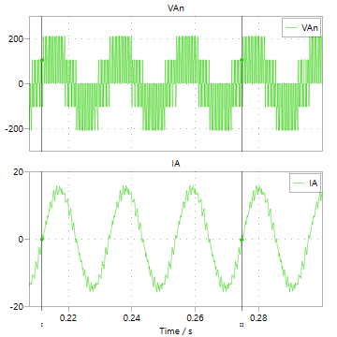

****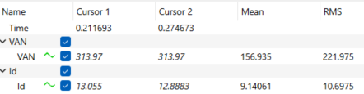

**P2:**

***

The measured fundamental voltage is same as the calculated i.e., 105.39 V.

**P3:**

P4:

The measured fundamental current is same as the calculated i.e., 10 A.

**P5:**

 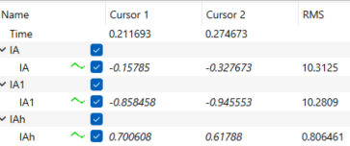

**P6:**

 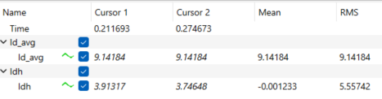

The average value is 9.14184 A and the ripple value is 5.55742 A.

**P7:**

The mid-point of the DC input voltage is assumed as its reference point N.

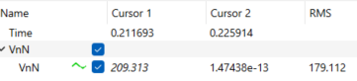

VnN is nothing but common mode voltage of the converter.



**Exercise 4: Three-Phase, Square-Wave Inverter (SQINV3.plecs)**

**Simulation Model:**



The subsystem of “FFT_VAn” is as below. The similar model is used in “FFT_IA” subsystem except the input which is IA instead of VAn.



The subsystem of “VAnh” is as below. The similar model is used in “IAh” subsystem except the input which is IA instead of VAn.





The subsystem of “FFT_Id_avg” is as below.



**Fundamental frequency considered in all the applicable PLECS elements is**

**Waveforms:**

**P1:**

 

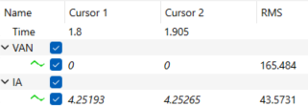

***

**P2:**

The measured fundamental voltage is same as the calculated i.e., 1→ V.

**P3:**

 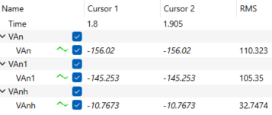

P4:

 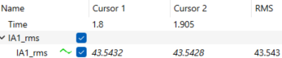

The measured fundamental current is not same as the calculated i.e., 10 A. This is due to mismatch in the common mode voltages (CMVs) as we used different PWM schemes. The fundamental RMS CMV in this example is 123.345 V which is less compared to in the previous example (179.059 V). These values could be noted from the figure of P7.

**P5:**

**P6:**

The average value is 22.0366 A and the ripple value is 23.6315 A.

**P7:**

The mid-point of the DC input voltage is assumed as its reference point N.

VnN is nothing but common mode voltage of the converter.



**Exercise 5: Three-Phase, PWM Inverter with a Three-Phase Rectifier Input (PWMInv3_Rect.plecs)**

**Simulation Model:**



**Waveforms:**

**P1:**

**P2:**

From the above figures, the RMS values of currents ()are 25.582 A, 23.5983 A, and 34.6055 A respectively.

**P3:**



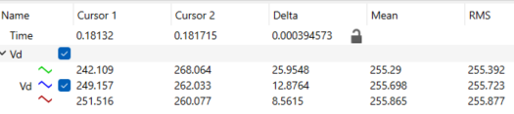

The RMS and Average values of DC-link voltage are same for all capacitance values but the peak-peak voltage is inversely proportional to the capacitance value.

**P4:**



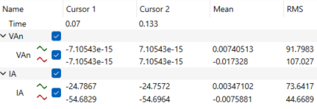

As the filter inductance increases, the current quality is improved.

**Exercise 6: 3-Phase, Switch-Mode Interconnection for a Bi-directional-Power-Flow (3Ph_Conn.plecs)**

**Simulation Model:**



The subsystem of “FFT_Vconv_a1” is as below.





The subsystem of “FFT_Isah” is as below.





**Waveforms:**

**P1:**

***

**P2:**

 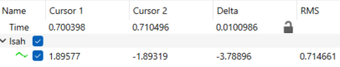

So peak-peak ripple current is 3.78896 A.

**P3:**

 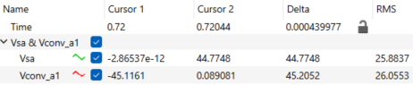

Vconv1 lags Vs by a time of 0.439977 ms and its equivalent angle in degrees is 7.919586.

**P4:**

**P5:**

a.

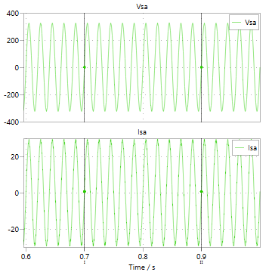

No change in fundamental RMS source current value with increase in filter inductance.

b.

 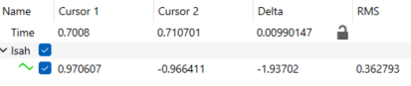

The peak-peak ripple current is 1.93702 A which is almost half of the peakpeak ripple current with 5 mH filter inductance. The increased inductance helps in reducing the ripple in source currents.

c.



Vconv1 lags Vs by a time of 0.85807 ms and its equivalent angle in degrees is 14.44526 which is almost double that of with 5 mH filter inductance.

d.

 