Word Tracker: An Interactive Book System

***Abstract* -This project aims to provide an innovative online platform for students enrolled at CBIT (Chaitanya Bharathi Institute of Technology). The platform offers access to a comprehensive collection of academic books spanning across various departments. One of the distinguishing features of this platform is its integrated exploration tool designed to enhance the reading experience. When encountering unfamiliar terms or concepts while perusing the texts, students can simply highlight the word or phrase. In doing so, a contextual tab dynamically appears, furnishing a concise yet informative explanation of the selected term or concept. This feature serves to alleviate comprehension barriers, facilitating a smoother learning process for students.**

**Furthermore, the integration of the exploration tool elevates the platform's utility by providing immediate assistance to students encountering unfamiliar terminology or complex concepts within the texts. For instance, if a student encounters a technical jargon or a specialized term while studying, they can simply ctrl+ right click on the term to summon a succinct yet comprehensive explanation. This feature not only aids in comprehension but also fosters a deeper understanding of the subject matter by providing contextual clarity.**

***Keywords - Online Book Store, Interactive Book, meaning, words, genres***

# Introduction

In the digital age, reading has evolved with the advent of online platforms that offer portability and interactive features. However, encountering unfamiliar words can disrupt the reading flow. This project addresses this issue by developing a web-based application that allows users to read books and get instant definitions for words they click on.

The platform is designed using HTML, CSS, and JavaScript, for a responsive interface. The backend, built with Node.js, manages data and API interactions, while a dictionary API provides real-time word definitions. The user interface is intuitive, featuring a clean reading environment and unobtrusive pop-ups for definitions.

This project enhances the digital reading experience by integrating vocabulary support, promoting continuous learning, and making literature more accessible and enjoyable. This paper details the design, development, and implementation of the application, highlighting technical solutions and its impact on readers.

# Related Work

# The evolution of digital reading platforms and tools has significantly influenced our project. Notable contributions include:

E-Readers and Digital Libraries:

Platforms like Amazon Kindle and Google Books offer vast collections of digital texts but often lack immediate word comprehension tools, which our project aims to provide.

Interactive Reading Applications:

Apps such as Instapaper and Pocket allow for article saving and annotation but do not offer instant word definitions, a gap our project addresses with double-click functionality.

Dictionary Integration in Reading Apps:

E-readers like Kindle and Apple Books feature built-in dictionaries that require pressing on words. Our project enhances this by offering real-time definitions via an open-source dictionary API with double-click ease.

Educational and Language Learning Tools:

Apps like Duolingo and Memorize use interactive methods to teach vocabulary. Although focused on language learning, their success in vocabulary enhancement informs our approach within a reading context.

Open-Source Dictionary APIs:

APIs such as Dictionary API provide extensive word data, enabling our project to deliver accurate and immediate definitions, enhancing the reading experience without leaving the platform.

Contextual Learning in Digital Texts:

Research supports that learning words in context is more effective. Our project incorporates instant definitions within the text, aiding better comprehension and retention.

# iii.​ Requirements

The platform offers access to a comprehensive collection of academic books spanning across various departments. One of the distinguishing features of this platform is its integrated exploration tool designed to enhance the reading experience. When encountering unfamiliar terms or concepts while perusing the texts, students can simply highlight the word or phrase. In doing so, a contextual tab dynamically appears, furnishing a concise yet informative explanation of the selected term or concept. This feature serves to alleviate comprehension barriers, facilitating a smoother learning process for students.

The online book store caters specifically to the academic needs of CBIT students, housing an extensive repository of textbooks covering diverse subjects ranging from engineering to humanities. With the convenience of digital access, students can easily navigate through their required course materials at any time and from anywhere. This digital platform not only mitigates the logistical challenges associated with physical textbooks but also offers an interactive reading experience.

Furthermore, the integration of the exploration tool elevates the platform's utility by providing immediate assistance to students encountering unfamiliar terminology or complex concepts within the texts. For instance, if a student encounters a technical jargon or a specialized term while studying, they can simply double-click on the term to summon a succinct yet comprehensive explanation. This feature not only aids in comprehension but also fosters a deeper understanding of the subject matter by providing clarity.

There were two more categories namely the functional part (ones which were necessary features) and the non-functional requirements (which were not explicit but were necessary for the Interactive Book to function properly)

### Functional Requirements

* 1. *Inputs:*
* Book Searching.
* Book genres.
* Contact store.
* Open A Book.
* Information of word.

### Processes

* Searching the results for user’s book request.
* Providing different genres
* Opening book in a pdf format.
* Analyzing the word and displaying the meaning.

### Outputs

* If the searched book was found then display its result.
* Display close related results if the search query matched many books.
* Displaying the information of word

### Non-Functional Requirements

To ensure the successful development and deployment of the proposed web-based application for digital reading with instant word definition retrieval, the following requirements must be carefully considered and addressed:

1. User Interface:

Clean and Intuitive Design: The user interface should be visually appealing and easy to navigate, with clear delineation between different sections such as book selection, reading interface, and word definition display.

Reading Environment: Provide a distraction-free environment for reading books comfortably, with options to customize text size, font, and background color for user preference.

Definition Display: Implement a non-intrusive method for displaying word definitions upon double-clicking, such as pop-up windows or tooltips that appear adjacent to the selected word without obstructing the reading experience.

2. Functional Features:

Book Selection: Allow users to browse and select books from a diverse collection spanning different genres, with options for sorting and filtering to facilitate discovery.

Reading Controls: Include intuitive controls for page navigation, bookmarking, highlighting, and annotating text, enhancing the user's ability to interact with the content.

Word Detection: Implement double-click functionality to detect words for which definitions are requested, ensuring accuracy and responsiveness in identifying user interactions.

Real-Time Definition Retrieval: Integrate with a reliable and comprehensive dictionary API to fetch word definitions in real-time, displaying them instantly within the reading interface with minimal latency.

The website uses the conventional system of user-ids and passwords for authentications. We have taken the following measures to ensure the integrity and security of the information

3. Performance:

Responsiveness: Ensure the application responds promptly to user interactions, with smooth transitions between pages and swift loading times for book content and definition retrieval.

Fast Loading Times: Optimize the loading times of book content and definition data by minimizing unnecessary network requests and leveraging caching mechanisms to enhance performance.

Scalability: Design the application architecture to accommodate potential increases in user traffic and book catalog size, with scalable infrastructure and efficient resource management to support growth.

4. Security and Privacy:

Data Encryption: Implement encryption protocols to secure user data transmission and storage, safeguarding sensitive information such as login credentials and reading history.

Privacy Policy: Clearly articulate the application's privacy policy, outlining how user data is collected, stored, and utilized, and obtaining explicit consent from users for data processing activities to comply with relevant regulations and protect user privacy.

5. Compatibility and Accessibility:

Cross-Browser Compatibility: Ensure the application functions consistently across major web browsers (e.g., Chrome, Firefox, Safari) and devices, with thorough testing and compatibility checks to address any browser-specific issues.

Accessibility Features: Incorporate accessibility features such as keyboard navigation, screen reader compatibility, and text-to-speech functionality to accommodate users with disabilities and ensure an inclusive reading experience for all users.

6. Integration:

Dictionary API Integration: Successfully integrate with a reputable and up-to-date dictionary API that offers comprehensive word definitions and supports frequent updates to maintain accuracy and relevance.

Backend Development: Develop a robust backend system to handle user authentication, book management, and API interactions, with secure endpoints and efficient data processing to support the application's functionality.

Deployment: Deploy the application on a reliable and scalable hosting platform (e.g., AWS, Heroku) with adequate resources and infrastructure to accommodate user demand and ensure high availability and performance.

7. Testing and Quality Assurance:

Unit Testing: Conduct rigorous testing of individual components and modules using automated testing frameworks to validate functionality and identify any defects or regressions.

# IV. Prototype

In order to develop the interactive book, the following considerations were taken into account. The inputs, the processes computed on those inputs and the outputs.

Following steps were carried out to gather the requirements for the Interactive Book.

* Reading related research papers.
* Evaluating current interactive book options such ashttps://medium.com/life-learning/2a1841f1335d.
* Weekly meetings were carried out to judge the changing requirements.
* Any change of requirements was based on response from the supervisors, those being the teachers/instructors for the course.
* After repeated meetings, a list of requirements was decided which are described later in this section.

### Product at Work

A new user first able to see the book store name and different genres like fiction, horror, novels, education etc.



*Figure1. Home page*



*Figure 2: Horror books page*

*The users can choose their desired genres. So that respective genre books page will display.*

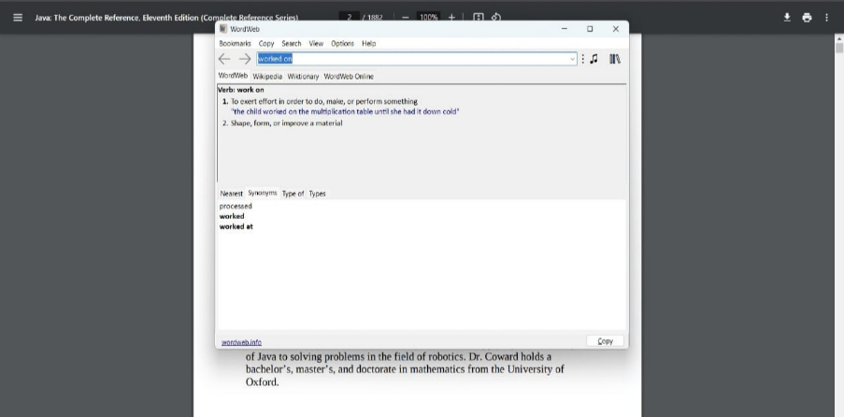

*Figure 3. Searching Screen*

*Once a word is highlighted it will give the information of that word like meaning, synonyms etc.*

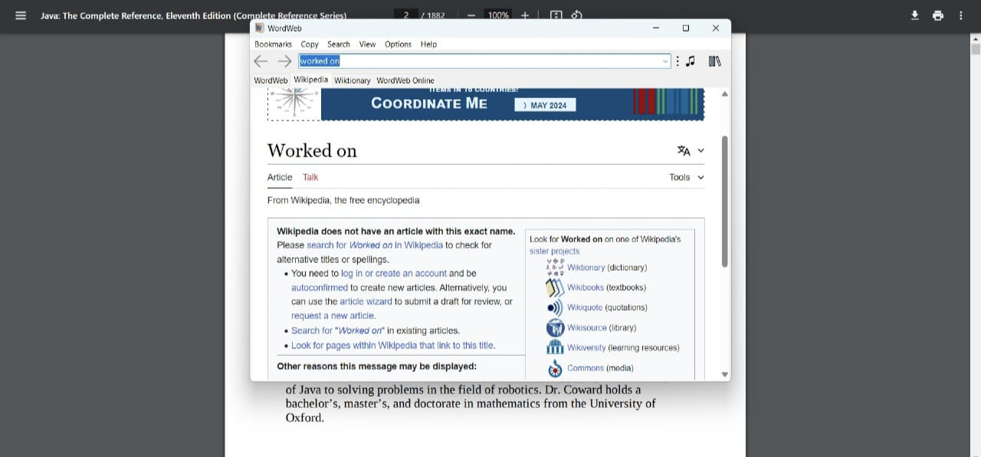

*Figure 4. Directing to a Wikipedia*

# V. Computing Components

There were two main aspects of the system.

i. Programming

ii. Connecting to extension

*i. Programming:* The main components that were used to make the project monitoring systems programming and processing unit were primarily HTML, CSS and JavaScript. The reason behind usage of these was its generality with the current web-based applications.

* *Justification:* These are currently the De facto tools used for making web-based applications. Also, JS is open source and is platform independent since the code runs on the server’s side and not the client’s side.JS also enjoys a wide community and numerous online forums which help to resolve problems if they were encountered on the way.
* *Restrictions:* The object-oriented programming support in JS is somewhat loose. While on the code- organization level the syntax of JS can be a mess sometimes. Some community responses are late and more complex questions tend to remain unanswered.

*ii. Connecting to Extension*: Through connecting this extension to the web page it will take highlighted word as input and display the information of that word

### Architecture

Word Tracker is a web-based application which has been designed to provide the users the facility of reading or searching the books online, thus its architecture deploys all the modules of the application on the single platform. The system consists two main views, one if of user and the other is of administrator. Both of the views are well defined in the architecture and their functions are highlighted in the diagram shown below. Apart from the views stated, a data base system has been accomplished with the application which keeps track of the flow of data on the website. The architecture is designed in such a way that both user and administrator have to first register themselves on the website before availing the facilities provided by the Word Tracker.

* Web Interface

An online web-based application is designed, so that the user can access the application easily.

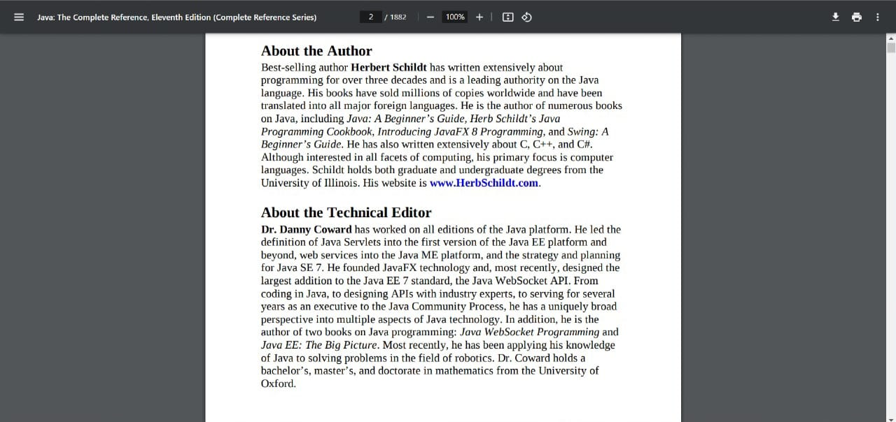

*Figure 5. Architecture*

# VI. WORD TRACKER IN USE

In the "Project in Use" phase, users engage with the web-based application for digital reading with instant word definition retrieval, interacting with its features to explore, read, and comprehend books. Upon registering and logging into the application, users are introduced to its functionalities, which may include selecting preferences or customizing the reading environment. They navigate through a diverse collection of books, exploring various genres and authors through browsing and searching capabilities. Once a book is selected, users delve into the reading interface, which offers intuitive controls for page navigation, text customization, and bookmarking. A notable feature is the ability to retrieve word definitions instantly by ctrl+ right-clicking on words within the text, enhancing vocabulary comprehension and facilitating uninterrupted reading. Users interact with the application by highlighting text, adding annotations, and sharing excerpts, contributing to their engagement with the content. Feedback mechanisms allow users to provide input on their experiences, enabling the application to continuously evolve and improve. Through metrics and user testimonials, it becomes apparent that the application positively impacts users' reading habits, vocabulary enhancement, and overall satisfaction with the digital reading experience. Looking ahead, the application's roadmap includes plans for feature enhancements and updates based on user feedback and evolving requirements, ensuring its continued relevance and effectiveness in the digital reading landscape.



*Figure 6. Contact page*

# VII. Limitations

Following are the imitations of the Word Tracker application that can be kept in consideration while using the Word Tracker application.

* Dependency on External APIs: The application relies on external dictionary APIs for word definition retrieval. Any downtime or changes in the API's availability or functionality could affect the application's performance and user experience.
* Limited Dictionary Coverage: The accuracy and comprehensiveness of word definitions are contingent on the quality and coverage of the dictionary API used. Users may encounter words or specialized terminology that are not adequately covered by the API, leading to incomplete or inaccurate definitions.
* Internet Connectivity Requirement: The application requires an internet connection to fetch word definitions in real-time from the dictionary API. Offline access to word definitions is not supported, limiting usability in environments with limited or no internet connectivity.

VIII. Future Enhancements

In the future, the web-based application for digital reading with instant word definition retrieval has promising avenues for enhancement. These improvements aim to enrich the user experience, expand functionality, and foster continued engagement. Potential enhancements include features such as personalized learning recommendations based on user habits, interactive reading tools like quizzes and flashcards, and social reading features for community interaction. Additionally, offline access capabilities, multi-language support, and augmented reality integration could broaden accessibility and appeal to a diverse audience. Accessibility enhancements and integration with educational platforms would further support inclusive learning environments, while data analytics could offer valuable insights into user behavior and preferences. Overall, these enhancements position the application as a comprehensive digital reading platform that promotes continuous learning and engagement for users worldwide.

# IX. Conclusion

In brief, the web-based application for digital reading with instant word definition retrieval offers a user-friendly platform for enhancing vocabulary comprehension while reading digital books. Its seamless integration of word definition functionality provides users with a convenient way to deepen their understanding of the text. Future enhancements promise to further enrich the reading experience, offering personalized learning recommendations, interactive tools, and social features. Overall, the application promotes accessibility, engagement, and continuous learning for users worldwide.

# References

[1] National Reading Panel. (2000). Report of the National Reading Panel:

Retrieved from  <https://www1.nichd.nih.gov/publications/pubs/nrp/Documents/report.pdf>

[2] Reading Rockets. (n.d.). Vocabulary. Retrieved from

<https://www.readingrockets.org/teaching/reading101-course/modules/vocabulary/>

[3] Vocabulary.com. (n.d.). Learn Words-English Dictionary. Retrieved from

<https://www.vocabulary.com/>

[4] Scholastic. (n.d.). Vocabulary and Spelling. Retrieved from

https://www.scholastic.com/teachers/teaching-tools/expert-articles/vocabulary-spelling.html