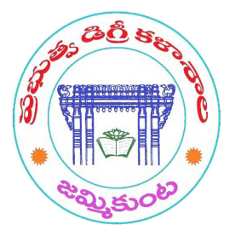\

**GOVERNMENT DEGREE COLLEGE**

**CERTIFICATE OF PARTICIPATION**

This is to certificate is presented to _____________________

for participating in the “Micro-soft Excel“ Training in Feb 2022. Given this March of 2022.

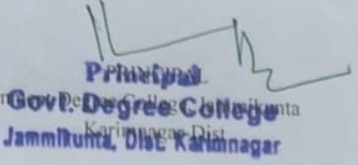

**Jammikunta, Dist: Karimnagar.**