Industrial Internship Report on
"Smart Factory Industrial Asset Management Dashboard"
Prepared by
Nalla Sumang
Java Full Stack Internship


Executive Summary
This report provides details of the Industrial Internship provided by upskill Campus and The IoT Academy in collaboration with Industrial Partner UniConverge Technologies Pvt Ltd (UCT).
This internship was focused on a project/problem statement provided by UCT. We had to finish the project including the report in 6 weeks’ time.
My project was a Full-Stack Industrial Asset Management Dashboard, built using Java, Spring Boot, and React.js, that allows factory supervisors to monitor machine status, uptime, and maintenance activity in real time. It was developed as part of the Java Full Stack Internship domain.
This internship gave me a very good opportunity to get exposure to Industrial problems and design/implement solution for that. It was an overall great experience to have this internship.

TABLE OF CONTENTS
1 Preface 4
2 Introduction 6
2.1 About UniConverge Technologies Pvt Ltd 6
2.2 About upskill Campus 10
2.3 The IoT Academy 12
2.4 Objectives of this Internship program 12
2.5 Reference 12
2.6 Glossary 12
3 Problem Statement 13
4 Existing and Proposed solution 14
5 Proposed Design/ Model 15
5.1 High Level Diagram 15
5.2 Low Level Diagram 15
5.3 Interfaces 16
6 Performance Test 17
6.1 Test Plan/ Test Cases 17
6.2 Test Procedure 17
6.3 Performance Outcome 18
7 My learnings 19
8 Future work scope 20

Preface
Over the course of this internship, I worked on designing and developing a Smart Factory Industrial Asset Management Dashboard using the Java full stack (Spring Boot for the backend and React.js for the frontend), progressing from requirement understanding and architecture design through implementation, testing, and final documentation.
Internships like this play a crucial role in career development, as they help bridge the gap between academic learning and industry-relevant, hands-on technical experience, and give students real exposure to how software is actually built and evaluated in a professional setting.
My project focused on building a web-based dashboard that allows factory supervisors to monitor machine status, uptime, and maintenance activity in real time, replacing the manual, paper-based tracking methods that are still common on many factory floors.
I am grateful to upskill Campus (USC) and UniConverge Technologies (UCT) for providing this opportunity to work on an industry-oriented problem statement under proper guidance and mentorship.
The program was structured across weekly milestones covering onboarding, requirement analysis, system design, development, performance testing, and final report submission, as illustrated below.
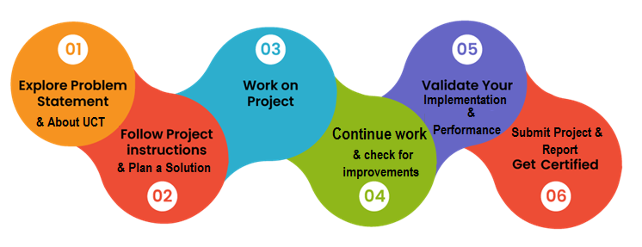
Through this internship, I gained practical experience in full-stack development using Java and Spring Boot for the backend and React.js for the frontend, along with exposure to REST API design, database integration using JPA/Hibernate, and performance testing. Overall, it was a valuable, hands-on learning experience.
I would like to thank the entire team at upskill Campus and UniConverge Technologies for organizing this internship, along with my mentors and faculty at MRITS, for their continuous guidance and support throughout this internship.
To my juniors and peers, I would encourage you to make the most of this internship by building a project you genuinely understand end-to-end, since that will help you far more in the long run than simply meeting the submission checklist.

Introduction

About UniConverge Technologies Pvt Ltd
A company established in 2013 and working in Digital Transformation domain and providing Industrial solutions with prime focus on sustainability and RoI.
For developing its products and solutions it is leveraging various Cutting Edge Technologies e.g. Internet of Things (IoT), Cyber Security, Cloud computing (AWS, Azure), Machine Learning, Communication Technologies (4G/5G/LoRaWAN), Java Full Stack, Python, Front end etc.
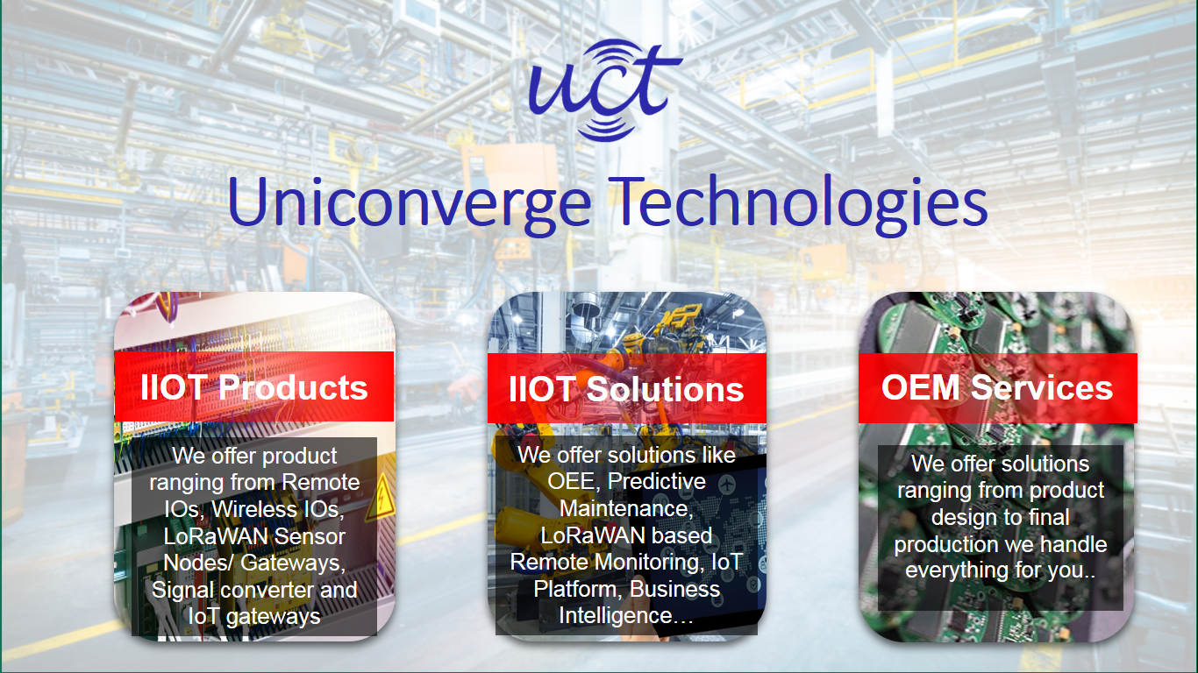
- UCT IoT Platform ()
UCT Insight is an IOT platform designed for quick deployment of IOT applications on the same time providing valuable “insight” for your process/business. It has been built in Java for backend and ReactJS for Front end. It has support for MySQL and various NoSql Databases.
- It enables device connectivity via industry standard IoT protocols - MQTT, CoAP, HTTP, Modbus TCP, OPC UA
- It supports both cloud and on-premises deployments.
It has features to
• Build Your own dashboard
• Analytics and Reporting
• Alert and Notification
• Integration with third party application(Power BI, SAP, ERP)
• Rule Engine

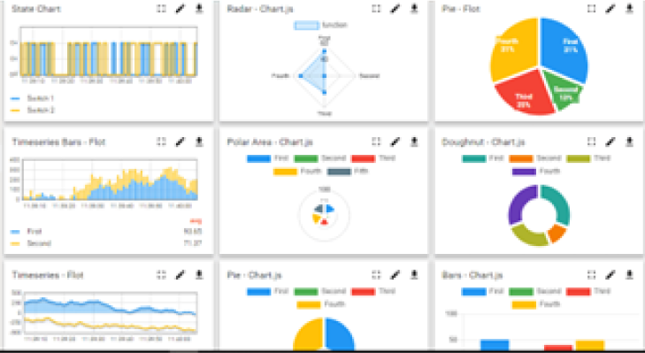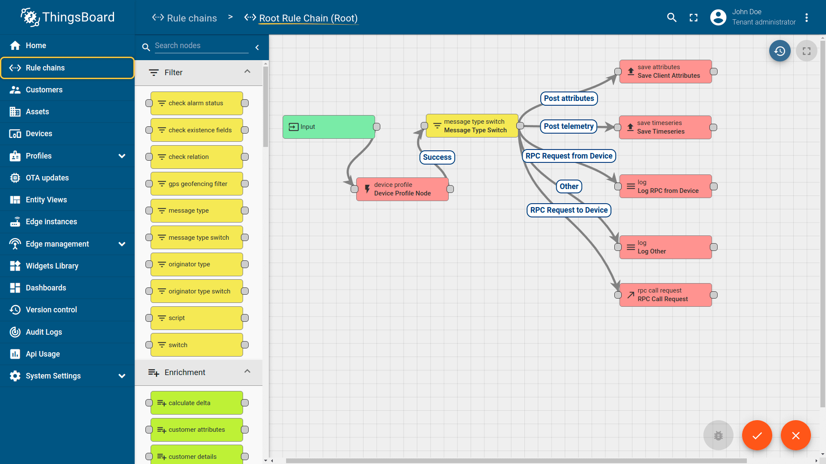

- Smart Factory Platform ()
Factory watch is a platform for smart factory needs.
It provides Users/ Factory
- with a scalable solution for their Production and asset monitoring
- OEE and predictive maintenance solution scaling up to digital twin for your assets.
- to unleash the true potential of the data that their machines are generating and helps to identify the KPIs and also improve them.
- A modular architecture that allows users to choose the service that they want to start and then can scale to more complex solutions as per their demands.
Its unique SaaS model helps users to save time, cost and money.
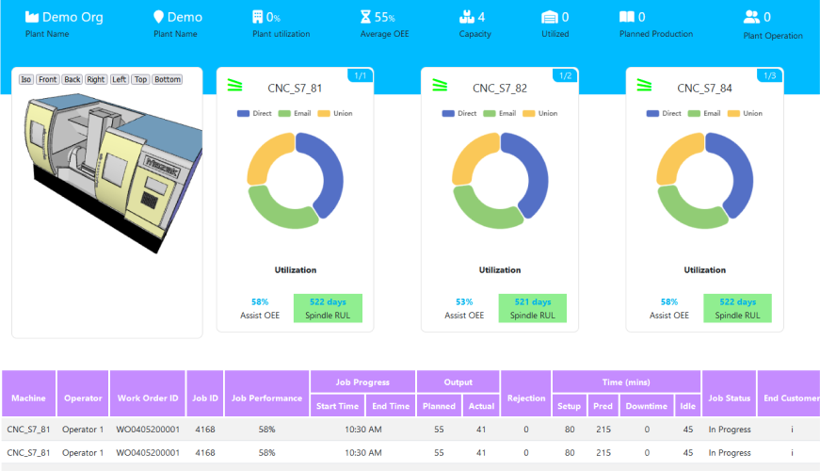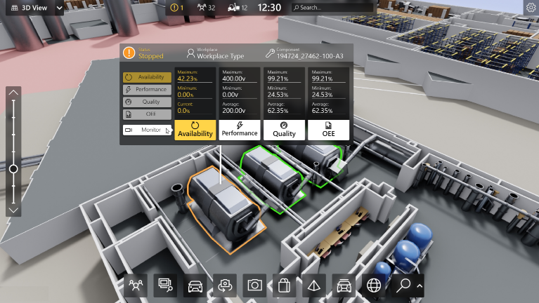

- 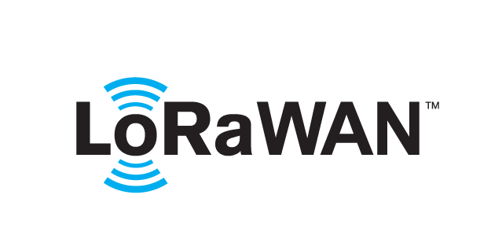 based Solution
UCT is one of the early adopters of LoRAWAN technology and providing solution in Agritech, Smart cities, Industrial Monitoring, Smart Street Light, Smart Water/ Gas/ Electricity metering solutions etc.
- Predictive Maintenance
UCT is providing Industrial Machine health monitoring and Predictive maintenance solution leveraging Embedded system, Industrial IoT and Machine Learning Technologies by finding Remaining useful life time of various Machines used in production process.
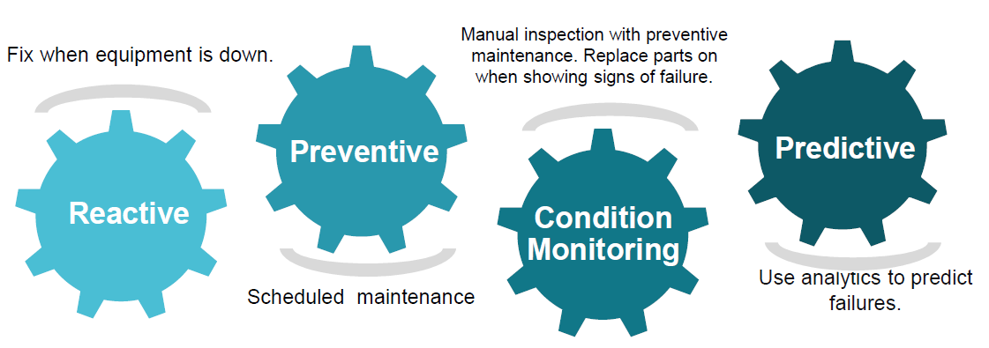

About upskill Campus (USC)
upskill Campus along with The IoT Academy and in association with Uniconverge technologies has facilitated the smooth execution of the complete internship process.
USC is a career development platform that delivers personalized executive coaching in a more affordable, scalable and measurable way.



Seeing need of upskilling in self paced manner along-with additional support services e.g. Internship, projects, interaction with Industry experts, Career growth Services
https://www.upskillcampus.com/
upSkill Campus aiming to upskill 1 million learners in next 5 year

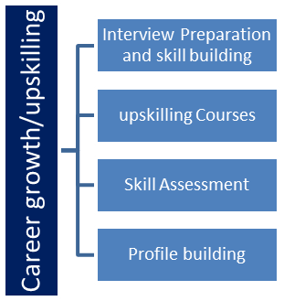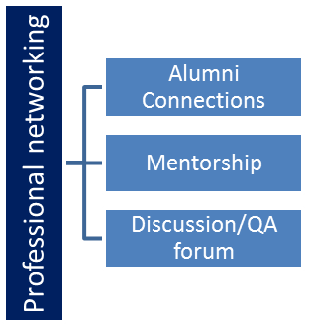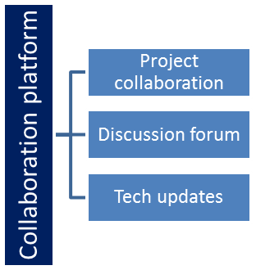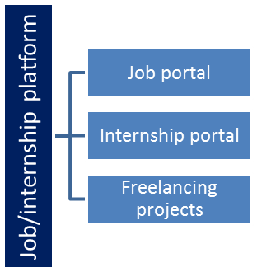

The IoT Academy
The IoT academy is EdTech Division of UCT that is running long executive certification programs in collaboration with EICT Academy, IITK, IITR and IITG in multiple domains.

Objectives of this Internship program
The objective for this internship program was to
☛ get practical experience of working in the industry.
☛ to solve real world problems.
☛ to have improved job prospects.
☛ to have Improved understanding of our field and its applications.
☛ to have Personal growth like better communication and problem solving.

Reference
[1] Spring Boot Reference Documentation – https://docs.spring.io/spring-boot/documentation.html
[2] React.js Official Documentation – https://react.dev
[3] Spring Data JPA Reference Documentation – https://docs.spring.io/spring-data/jpa/reference/

Glossary
Terms | Acronym
REST | Representational State Transfer
JPA | Java Persistence API
CRUD | Create, Read, Update, Delete
JSON | JavaScript Object Notation
CORS | Cross-Origin Resource Sharing

Problem Statement
In the assigned problem statement
Factory floors currently suffer from a lack of real-time visibility into machinery status. Supervisors rely on manual logbooks or static spreadsheets to track whether machines are running, stopped, or under maintenance. This delay in information sharing leads to extended downtime, inefficient maintenance scheduling, and a lack of accurate machine utilization metrics.

Existing and Proposed solution

Existing solutions largely rely on manual data entry or expensive, difficult-to-scale legacy ERP systems, which are often not well suited for small and mid-sized factory setups and provide limited real-time visibility.
The proposed solution is a lightweight, modern full-stack web application built with a Java Spring Boot REST API backend and a React.js frontend, enabling real-time CRUD operations for machine status through a simple, browser-based dashboard.
This solution enables immediate digital tracking of machine uptime and status changes, accessible from any web browser on the factory network, without the overhead and cost of legacy ERP systems.

Code submission (Github link)
https://github.com/NallaSumang/upskillcampus/blob/main/backend/src/main/java/com/uct/smartfactory/controller/AssetController.java

Report submission (Github link) :
https://github.com/NallaSumang/upskillcampus/blob/main/SmartFactoryIndustrialAssetManagementDashboard_NallaSumang_USC_UCT.pdf

Proposed Design/ Model

The system follows a three-tier architecture consisting of a React.js frontend, a Spring Boot REST API backend, and an H2 in-memory database. User actions on the dashboard trigger Axios calls to the backend, which processes the request through a service layer and persists or retrieves data via Spring Data JPA, before returning a JSON response that updates the UI in real time.

High Level Diagram
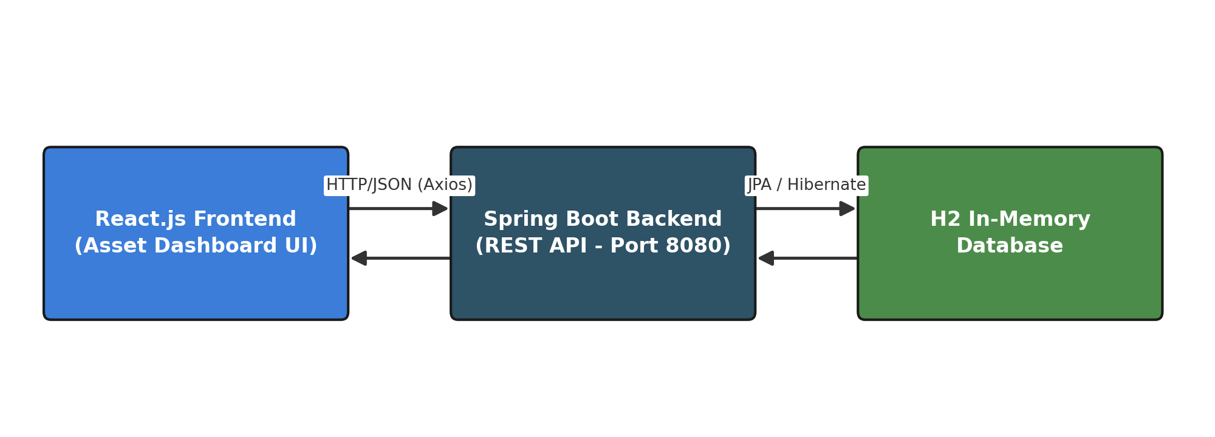

Figure 1: HIGH LEVEL DIAGRAM OF THE SYSTEM

Low Level Diagram
The diagram below shows how the Asset entity flows between the REST controller, service layer, repository, and the H2 database table.
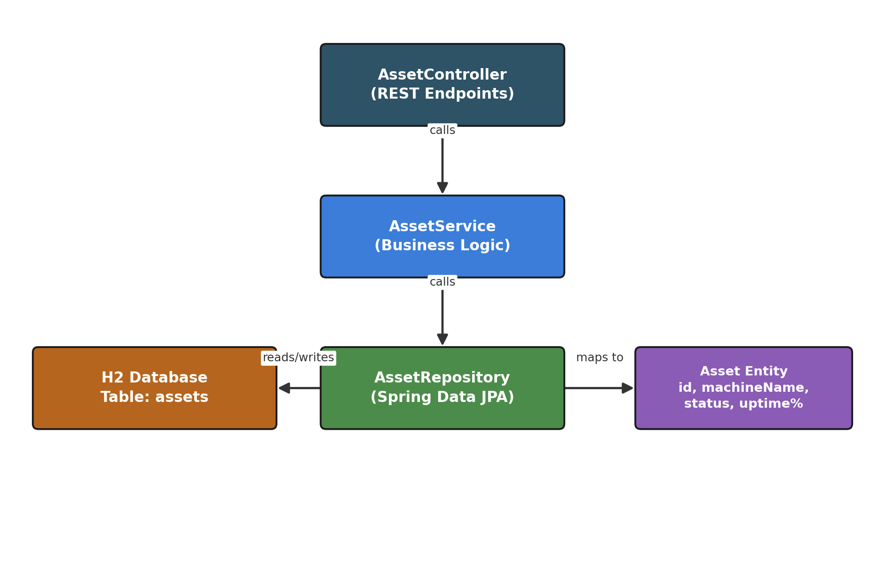

Interfaces
The frontend communicates with the backend via asynchronous HTTP/REST calls using JSON payloads through Axios. Cross-Origin Resource Sharing (CORS) is configured on the Spring Boot application to allow requests from the React development server. The backend exposes GET /api/assets to fetch all machine records and PUT /api/assets/{id}/status to update a machine's status, with all data validated and persisted through the AssetRepository (Spring Data JPA) layer.

Performance Test

Performance testing is what distinguishes this work from a purely academic exercise and demonstrates its viability for real industrial use.
The primary constraint for a real-time monitoring dashboard is API response latency, since the UI must render machine statuses without noticeable delay.
This constraint was addressed by keeping the backend logic lightweight, using an in-memory H2 database for fast reads/writes, and exposing a minimal, well-indexed REST API so that each request completes quickly.
A JUnit performance test (AssetControllerPerformanceTest.java) using Spring MockMvc was used to simulate repeated GET /api/assets requests and measure response times against a 200ms threshold.
The key constraints considered for this project were API response latency, database read/write speed, and memory overhead of the Spring Boot application under repeated requests.
If the system were to scale to hundreds of concurrent factory sensors, the H2 in-memory database would become a bottleneck; a recommended next step would be migrating to a persistent, indexed database such as PostgreSQL and introducing connection pooling.

Test Plan/ Test Cases
The test plan covered both functional correctness of the REST API and non-functional performance under repeated requests, since the dashboard depends on fast, reliable data for real-time monitoring.
TC1: GET /api/assets returns the complete list of machine records with correct id, machineName, status, and uptime% fields.
TC2: PUT /api/assets/{id}/status updates the specified machine's status and the change is correctly persisted in the H2 database.
TC3: Average response time for GET /api/assets stays below a 200ms threshold across repeated calls, as measured by AssetControllerPerformanceTest.java.

Test Procedure
Functional test cases (TC1, TC2) were implemented as JUnit 5 tests in AssetControllerTest.java, using Spring Boot Test and MockMvc to call the REST endpoints and assert on the returned status codes and JSON response bodies.
The performance test case (TC3) was implemented in AssetControllerPerformanceTest.java, which issues repeated GET /api/assets requests through MockMvc, records the response time for each call in milliseconds, and asserts that the average stays under the 200ms threshold.
All tests were executed using mvn test, and the console/build report was reviewed to confirm that every test case passed before the code was pushed to the GitHub repository.

Performance Outcome
All functional test cases (TC1, TC2) passed, confirming that the API correctly returns and updates machine records.
The performance test (TC3) showed that GET /api/assets consistently responded well within the 200ms threshold, which confirms the backend is fast enough for a real-time monitoring dashboard at the current, single-user testing scale.
No noticeable memory or performance degradation was observed across repeated test runs, though this was validated only in a lightweight, in-memory H2 setup and not yet under concurrent multi-user or hundreds-of-sensors load, which is captured as a recommendation in the Future Work section.

My learnings

This internship gave me hands-on experience across the full Java web development stack – from designing REST APIs in Spring Boot and modeling data with JPA/Hibernate, to building a responsive React.js frontend and writing performance tests. It strengthened my understanding of how frontend, backend, and database layers work together in a real application, and gave me confidence to take on larger full-stack projects in my career ahead.

Future work scope

Due to time limitations, authentication and security were not implemented in this version. Future iterations could include Spring Security with JWT-based authentication for role-based access control (separating Admin and Operator views), migration from the H2 in-memory database to a persistent PostgreSQL database, and integration with real IoT sensors for live telemetry instead of simulated status updates.

