Session 1

Introduction

Java is one of the world’s most important and widely used computer languages. It is also a powerful, general-purpose programming language suitable for a wide variety of purposes. In 1991 Java was conceived by James Gosling, Patrick Naughton, Chris Warth, Ed Frank, and Mike Sheridan at Sun Microsystems, Inc. Initially language was called as “Oak,” and renamed as “Java” in 1995. It is an Object Oriented Programming language.

Java Architecture

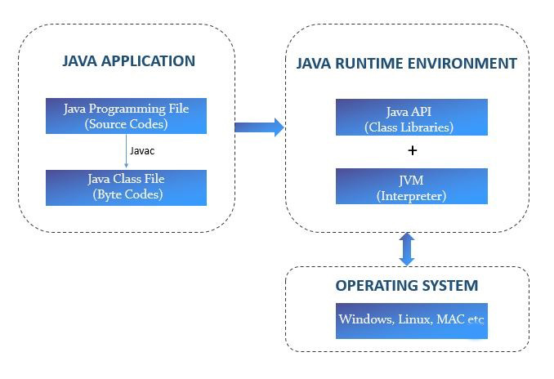

JVM Architecture

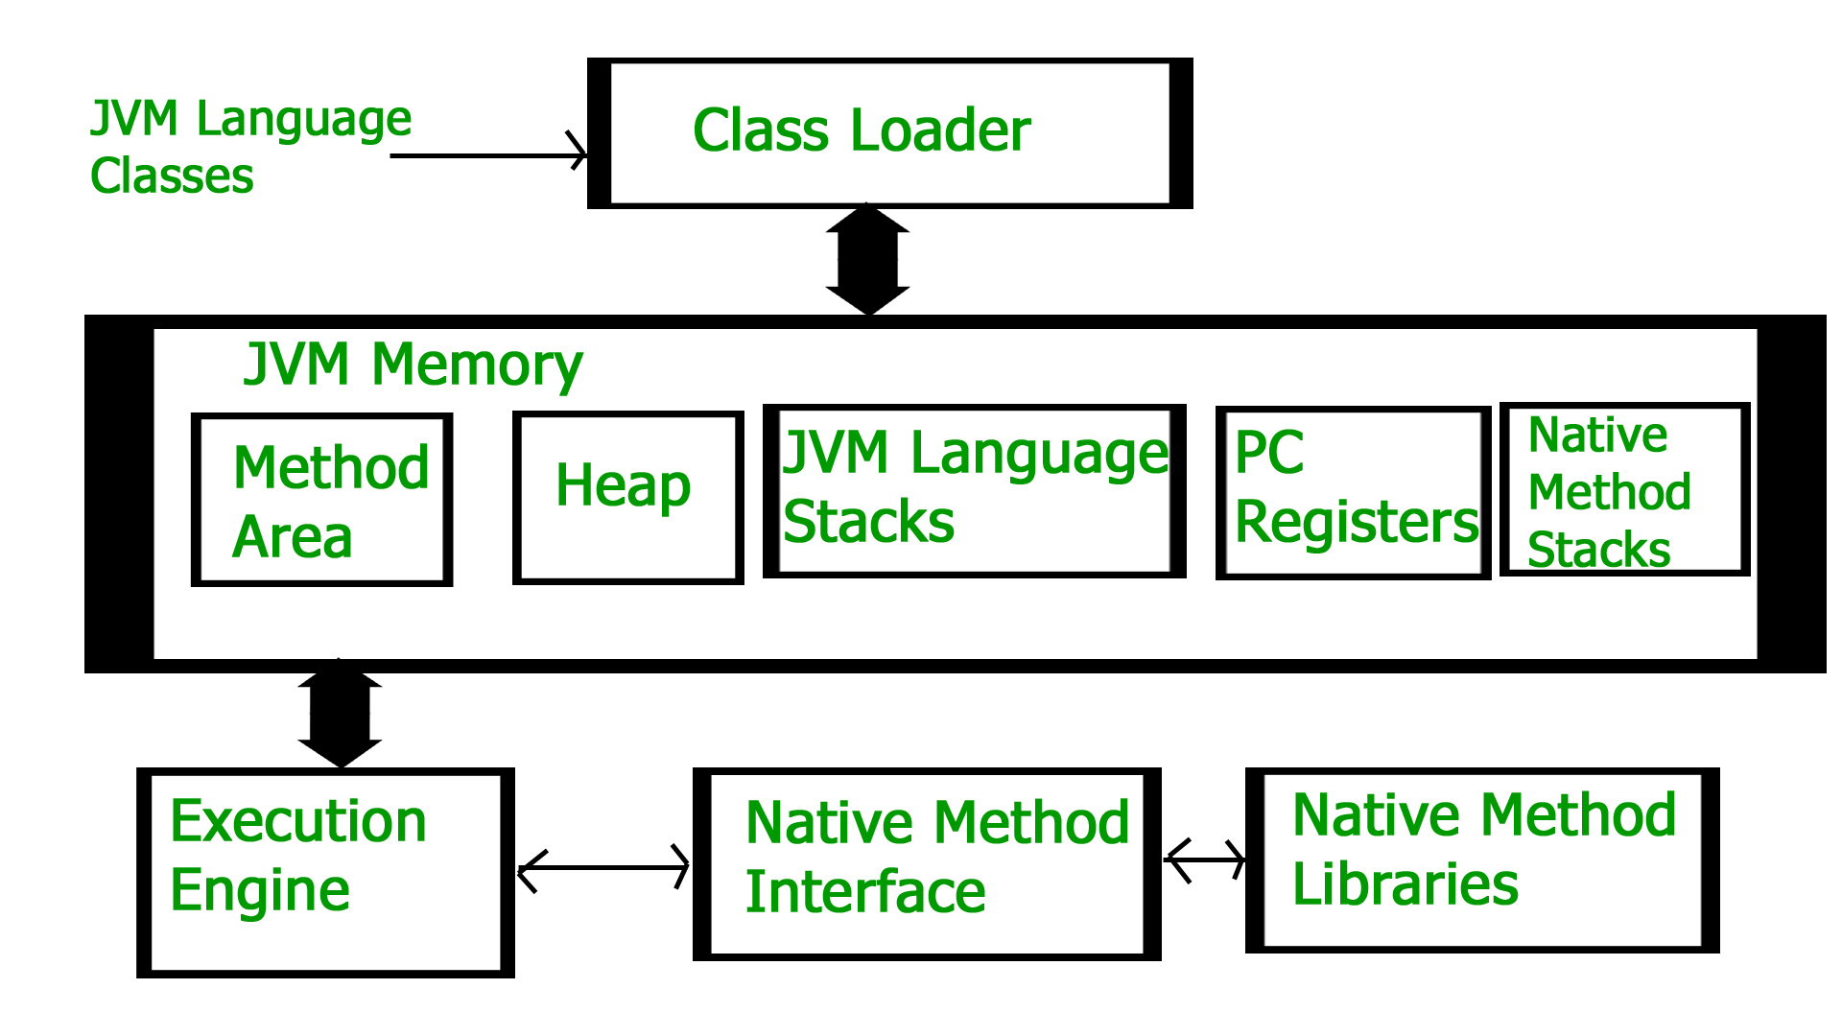

Class Loader Subsystem

It is mainly responsible for three activities.

- Loading
- Linking
- Initialization

Loading: The Class loader reads the “.class” file, generate the corresponding binary data and save it in the method area. For each “.class” file, JVM stores the following information in the method area.
- The fully qualified name of the loaded class and its immediate parent class.
- Whether the “.class” file is related to Class or Interface or Enum.
- Modifier, Variables and Method information etc.

After loading the “.class” file, JVM creates an object of type Class to represent this file in the heap memory. Please note that this object is of type Class predefined in java.lang package. These Class object can be used by the programmer for getting class level information like the name of the class, parent name, methods and variable information etc.

Linking: Performs verification, preparation, and (optionally) resolution.

Verification: It ensures the correctness of the .class file i.e. it checks whether this file is properly formatted and generated by a valid compiler or not. If verification fails, we get run-time exception java.lang.VerifyError. This activity is done by the component ByteCodeVerifier. Once this activity is completed then the class file is ready for compilation.

Preparation: JVM allocates memory for class variables and initializing the memory to default values.

Resolution: It is the process of replacing symbolic references from the type with direct references. It is done by searching into the method area to locate the referenced entity.

Initialization: In this phase, all static variables are assigned with their values defined in the code and static block(if any). This is executed from top to bottom in a class and from parent to child in the class hierarchy.

In general, there are three class loaders :

Bootstrap class loader: Every JVM implementation must have a bootstrap class loader, capable of loading trusted classes. It loads core java API classes present in the “JAVA_HOME/jre/lib” directory. This path is popularly known as the bootstrap path. It is implemented in native languages like C, C++.

Extension class loader: It is a child of the bootstrap class loader. It loads the classes present in the extensions directories “JAVA_HOME/jre/lib/ext”(Extension path) or any other directory specified by the java.ext.dirs system property. It is implemented in java by the sun.misc.Launcher$ExtClassLoader class.

System/Application class loader: It is a child of the extension class loader. It is responsible to load classes from the application classpath. It internally uses Environment Variable which mapped to java.class.path. It is also implemented in Java by the sun.misc.Launcher$AppClassLoader class.

JVM Memory

Method area: In the method area, all class level information like class name, immediate parent class name, methods and variables information etc. are stored, including static variables. There is only one method area per JVM, and it is a shared resource.

Heap area: Information of all objects is stored in the heap area. There is also one Heap Area per JVM. It is also a shared resource.

Stack area: For every thread, JVM creates one run-time stack which is stored here. Every block of this stack is called activation record/stack frame which stores methods calls. All local variables of that method are stored in their corresponding frame. After a thread terminates, its run-time stack will be destroyed by JVM. It is not a shared resource.

PC Registers: Store address of current execution instruction of a thread. Obviously, each thread has separate PC Registers.

Native method stacks: For every thread, a separate native stack is created. It stores native method information.

Execution Engine

Execution engine executes the “.class” (bytecode). It reads the byte-code line by line, uses data and information present in various memory area and executes instructions. It can be classified into three parts:

Interpreter: It interprets the bytecode line by line and then executes. The disadvantage here is that when one method is called multiple times, every time interpretation is required.

Just-In-Time Compiler(JIT): It is used to increase the efficiency of an interpreter. It compiles the entire bytecode and changes it to native code so whenever the interpreter sees repeated method calls, JIT provides direct native code for that part so re-interpretation is not required, thus efficiency is improved.

Garbage Collector: It destroys un-referenced objects.

Java Native Interface (JNI) :

It is an interface that interacts with the Native Method Libraries and provides the native libraries(C, C++) required for the execution. It enables JVM to call C/C++ libraries and to be called by C/C++ libraries which may be specific to hardware.

Native Method Libraries :

It is a collection of the Native Libraries(C, C++) which are required by the Execution Engine.

Features of Java

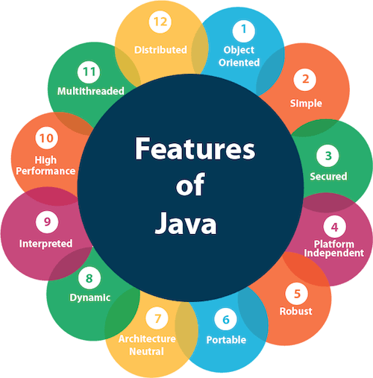

Simple:

Java was designed to be easy for the professional programmer to learn and use effectively. Assuming that you have some programming experience, you will not find Java hard to master. If you already understand the basic concepts of object-oriented programming, learning Java will be even easier.

Object-Oriented:

Java was not designed to be source code compatible with any other language. This allowed the Java team the freedom to design with a blank slate. One outcome of this was a clean, usable, pragmatic approach to objects. Java manages to strike a balance between the purist’s “everything is an object” paradigm and the pragmatist’s “stay out of my way” model. The object model in Java is simple and easy to extend, while primitive types, such as integers, are kept as high-performance non objects.

Robust:

To better understand how Java is robust, consider two of the main reasons for program failure: memory management mistakes and mishandled exceptional conditions (that is, run-time errors). Java virtually eliminates these problems by managing memory allocation and deallocation for you. (In fact, deallocation is completely automatic, because Java provides garbage collection for unused objects.) Java helps in this area by providing object-oriented exception handling. In a well-written Java program, all run-time errors can—and should—be managed by your program.

Multithreaded:

Java was designed to meet the real-world requirement of creating interactive, networked programs. To accomplish this, Java supports multithreaded programming, which allows you to write programs that do many things simultaneously.

Architecture-Neutral:

A central issue for the Java designers was that of code longevity and portability. At the time of Java’s creation, one of the main problems facing programmers was that no guarantee existed that if you wrote a program today, it would run tomorrow—even on the same machine. Operating system upgrades, processor upgrades, and changes in core system resources can all combine to make a program malfunction. The Java designers made several hard decisions in the Java language and the Java Virtual Machine in an attempt to alter this situation. Their goal was “write once; run anywhere, any time, forever.” To a great extent, this goal was accomplished.

Interpreted and High Performance:

Java enables the creation of cross-platform programs by compiling into an intermediate representation called Java bytecode. This code can be executed on any system that implements the Java Virtual Machine. Most previous attempts at cross-platform solutions have done so at the expense of performance.

Distributed:

Java is designed for the distributed environment of the Internet because it handles TCP/IP protocols. In fact, accessing a resource using a URL is not much different from accessing a file. Java also supports Remote Method Invocation (RMI). This feature enables a program to invoke methods across a network.

Dynamic:

Java programs carry with them substantial amounts of run-time type information that is used to verify and resolve accesses to objects at run time. This makes it possible to dynamically link code in a safe and expedient manner. This is crucial to the robustness of the Java environment, in which small fragments of bytecode may be dynamically updated on a running system.

The Evolution of Java

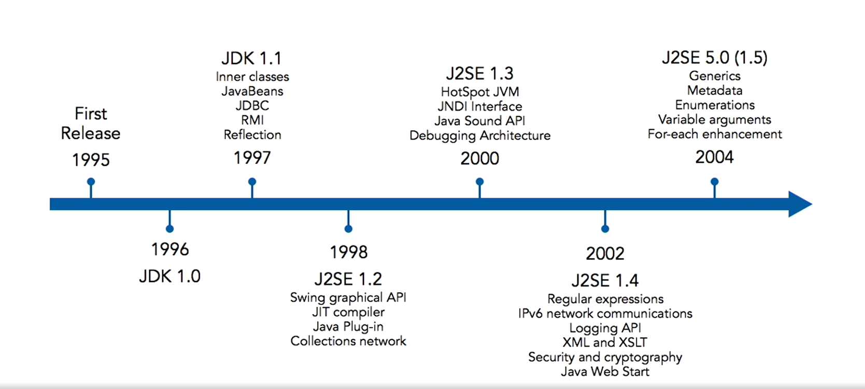
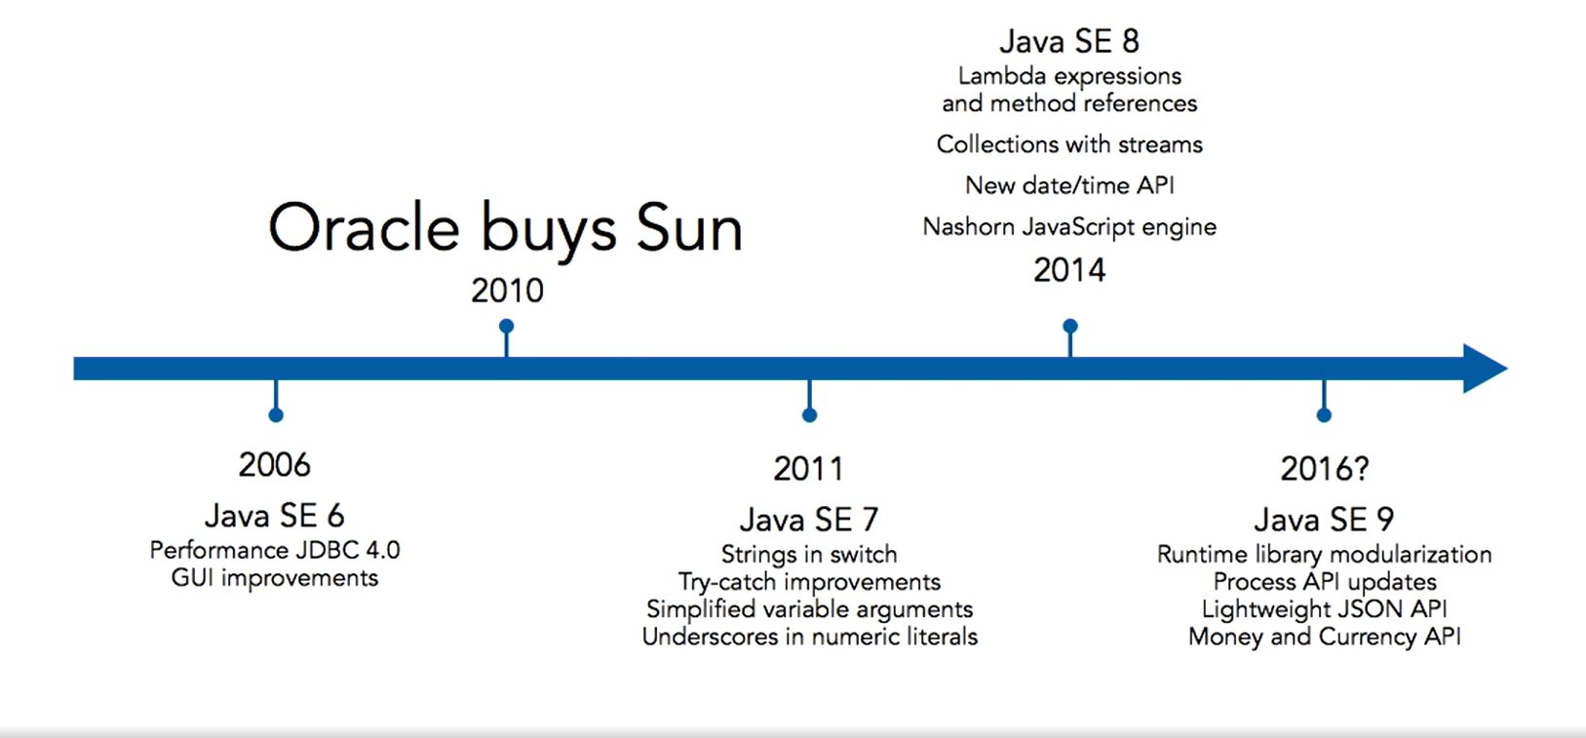

Two Paradigms:

All computer programs consist of two elements: code and data. Furthermore, a program can be conceptually organized around its code or around its data. There are the two paradigms;

Process-oriented model
Object-oriented programming

Object-Oriented Programming:

Object-oriented programming (OOP) is at the core of Java. OOP is so integral to Java that it is best to understand its basic principles before you begin writing even simple Java programs. All object-oriented programming languages provide mechanisms that help you implement the object-oriented model.

OOPs Concept:

- Abstraction
- Encapsulation
- Inheritance
- Polymorphism

Abstraction:

An essential element of object-oriented programming is abstraction. Humans manage complexity through abstraction. For example, people do not think of a car as a set of tens of thousands of individual parts. They think of it as a well defined object with its own unique behavior. This abstraction allows people to use a car to drive to the grocery store without being overwhelmed by the complexity of the individual parts. They can ignore the details of how the engine, transmission, and braking systems work. Instead, they are free to utilize the object as a whole.

Hierarchical abstractions of complex systems can also be applied to computer programs. The data from a traditional process-oriented program can be transformed by abstraction into its component objects. A sequence of process steps can become a collection of messages between these objects. Thus, each of these objects describes its own unique behavior.

Real-time Example



Encapsulation:

Encapsulation is the mechanism that binds together code and the data it manipulates, and keeps both safe from outside interference and misuse. One way to think about encapsulation is as a protective wrapper that prevents the code and data from being arbitrarily accessed by other code defined outside the wrapper. Access to the code and data inside the wrapper is tightly controlled through a well-defined interface.

To relate this to the real world, consider the automatic transmission on an automobile. It encapsulates hundreds of bits of information about your engine, such as how much you are accelerating, the pitch of the surface you are on, and the position of the shift lever. You, as the user, have only one method of affecting this complex encapsulation: by moving the gear-shift lever. You can’t affect the transmission by using the turn signal or wind shield wipers, for example. Thus, the gear-shift lever is a well-defined (indeed, unique) interface to the transmission.

In Java, the basis of encapsulation is the class. A class defines the structure and behaviour (data and code) that will be shared by a set of objects. Each object of a given class contains the structure and behaviour defined by the class. For this reason, objects are sometimes referred to as instances of a class. Thus, a class is a logical construct; an object has physical reality.

When you create a class, you will specify the code and data that constitute that class. Collectively, these elements are called members of the class. Specifically, the data defined by the class are referred to as member variables or instance variables. The code that operates on that data is referred to as member methods or just methods.
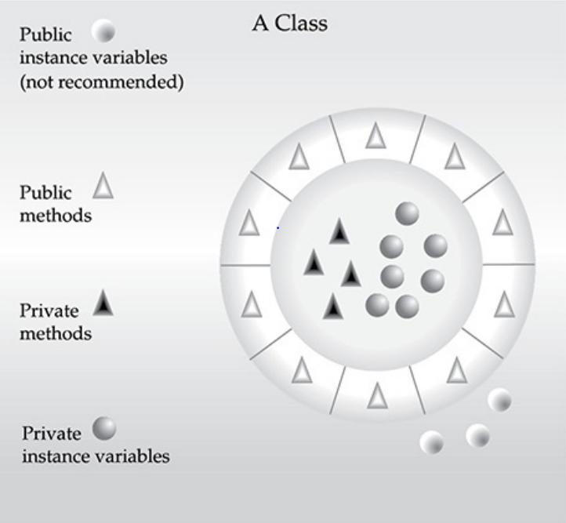

Inheritance:

Inheritance is the process by which one object acquires the properties of another object.

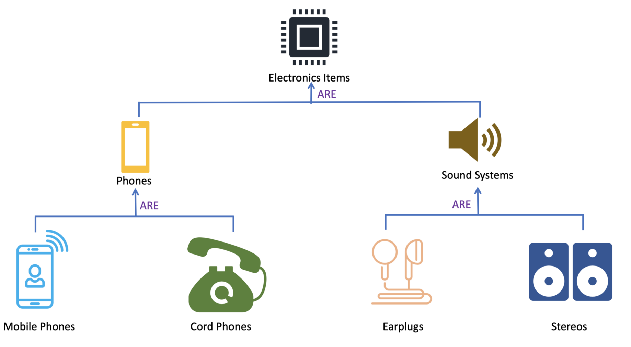

Types of inheritance:

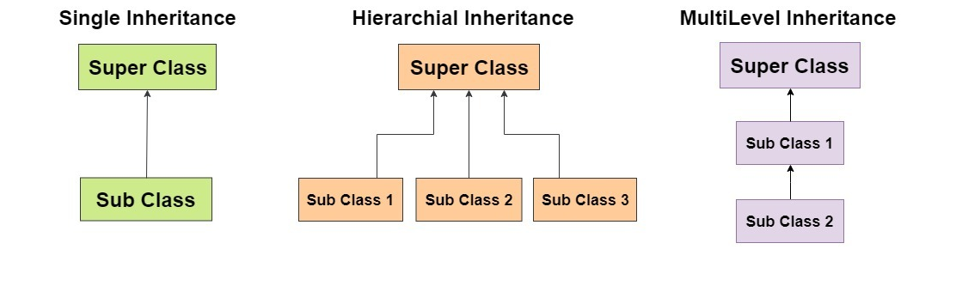
Polymorphism:

Polymorphism (from Greek, meaning “many forms”) is a feature that allows one interface to be used for a general class of actions.

Consider a stack (which is a last-in, first-out list). You might have a program that requires three types of stacks. One stack is used for integer values, one for floating-point values, and one for characters. The algorithm that implements each stack is the same, even though the data being stored differs. In a non–object-oriented language, you would be required to create three different sets of stack routines, with each set using different names. However, because of polymorphism, in Java you can specify a general set of stack routines that all share the same names.

More generally, the concept of polymorphism is often expressed by the phrase “one interface, multiple methods.” This means that it is possible to design a generic interface to a group of related activities. This helps reduce complexity by allowing the same interface to be used to specify a general class of action.

A First Simple Program

/*
This is a simple Java program
File name: Example.java
*/
class Example{
// program begin with a call to main()
public static void main(String args[]){
System.out.println(“This is a simple Java program”);
}
}

Compiling the Program

To compile the Example program, execute the compiler, javac, specifying the name of the source file on the command line, as shown here:

C:\> javac Example.java

The javac compiler creates a file called Example.class that contains the bytecode version of the program.

To actually run the program, you must use the Java application launcher called java. To do so, pass the class name Example as a command-line argument, as shown here:

C:\>java Example

When the program is run, the following output is displayed:

Output: This is a simple Java program.

Identifiers:

Identifiers are used to name things, such as classes, variables, and methods. An identifier may be any descriptive sequence of uppercase and lowercase letters, numbers, or the underscore and dollar-sign characters.

Literals:

A constant value in Java is created by using a literal representation of it.

Keywords:

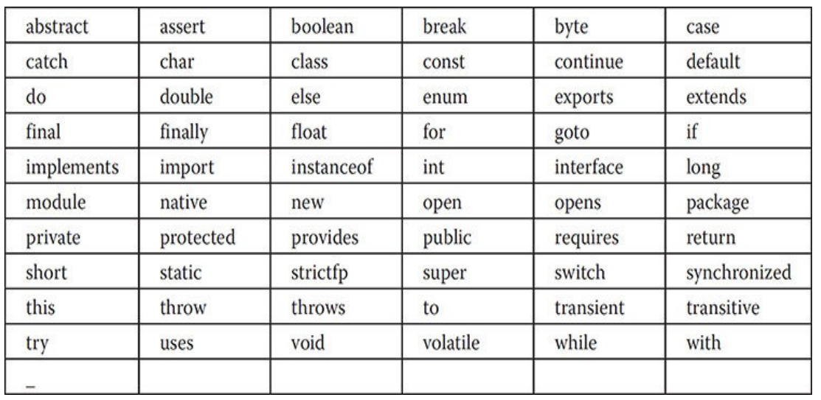
Data type:

Eight primitive types: byte, short, int, long, char, float, double, Boolean

These can be put in four groups:

Integers - includes byte, short, int, and long.
Floating-point numbers - includes float and double.
Characters - includes char.
Boolean - includes boolean.

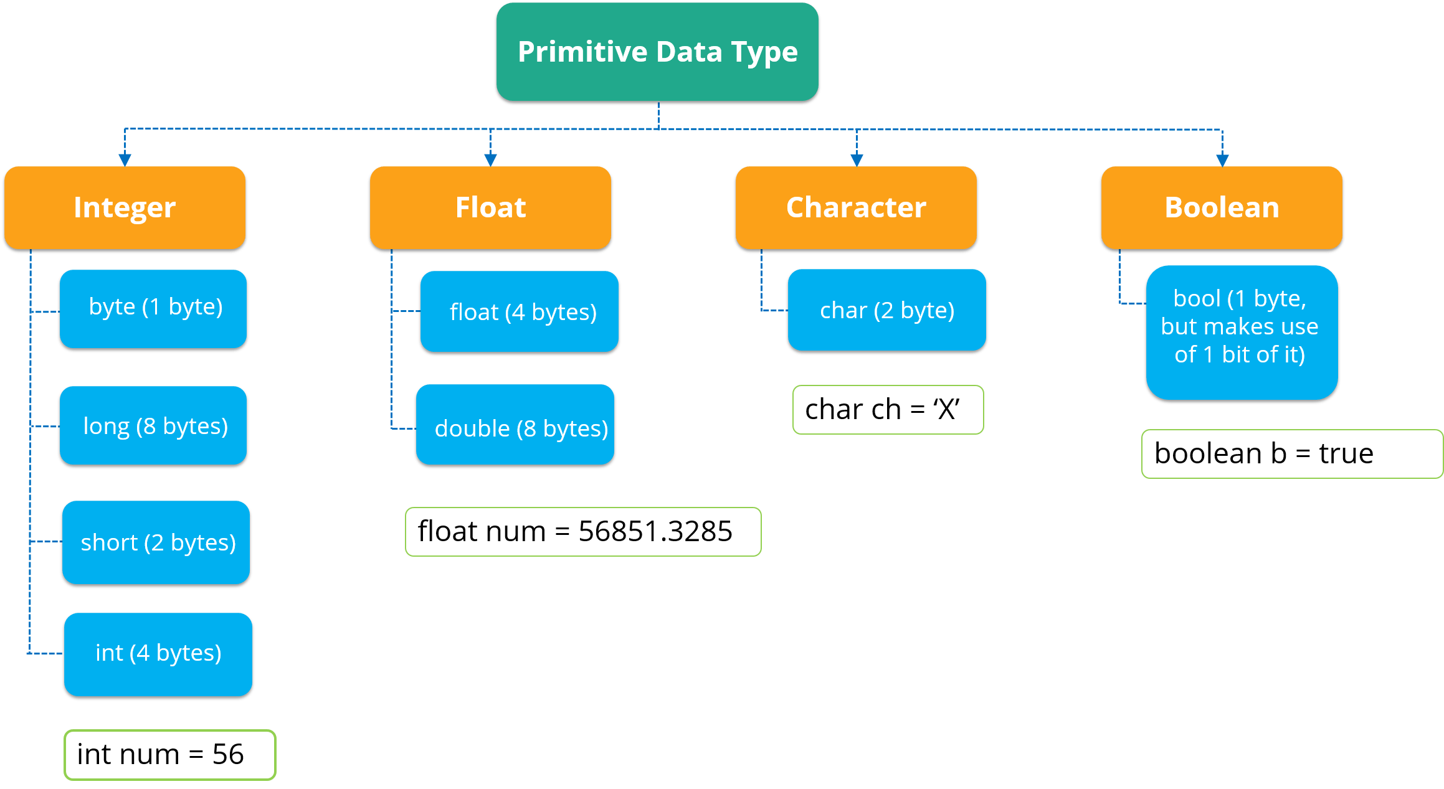

Non-primitive data types
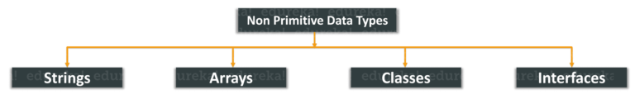
Variables:

The variable is the basic unit of storage in a Java program. A variable is defined by the combination of an identifier, a type, and an optional initializer. In addition, all variables have a scope, which defines their visibility, and a lifetime.

Declaring a Variable:

In Java, all variables must be declared before they can be used. The basic form of a variable declaration is shown here:

Syntax:

data-type identifier [ = value ][, identifier [= value ] …];

The Scope and Lifetime of Variables:

Java allows variables to be declared within any block. A block is begun with an opening curly brace and ended by a closing curly brace. It defines a scope. Thus, each time you start a new block, you are creating a new scope.

In Java, the two major scopes are those defined by a class and those defined by a method.

Type Conversion and Casting:

When one type of data is assigned to another type of variable, an automatic type conversion will take place if the following two conditions are met:

• The two types are compatible.
• The destination type is larger than the source type.

To create a conversion between two incompatible types, you must use a cast.
A cast is simply an explicit type conversion. It has this general form:

Syntax:

(target-data-type) value

Example:

int inumber;
byte bnumber;

bnumber = (byte)inumber;

Arrays:

An array is a group of like-typed variables that are referred to by a common name. Arrays of any type can be created and may have one or more dimensions. A specific element in an array is accessed by its index.

One-Dimensional Arrays:

A one-dimensional array is, essentially, a list of like-typed variables. To create an array, you first must create an array variable of the desired type.

The general form of a one-dimensional array declaration is

Syntax:

data-type var-name[];

Eg:

int month_days[];

Obtaining an array is a two-step process. First, you must declare a variable of the desired array type. Second, you must allocate the memory that will hold the array, using new, and assign it to the array variable. Thus, in Java all arrays are dynamically allocated.

Syntax:

data-type var-name = new array-type[size];

Eg:

int month_days = new int[12];

Multidimensional Arrays:

In Java, multidimensional arrays are implemented as arrays of arrays. To declare a multidimensional array variable, specify each additional index using another set of square brackets.

Syntax:

data-type var-name = new array-type[row-size][col-size];

For example, the following declares a two-dimensional array variable called twoD:

int twoD[][] = new int[4][5];

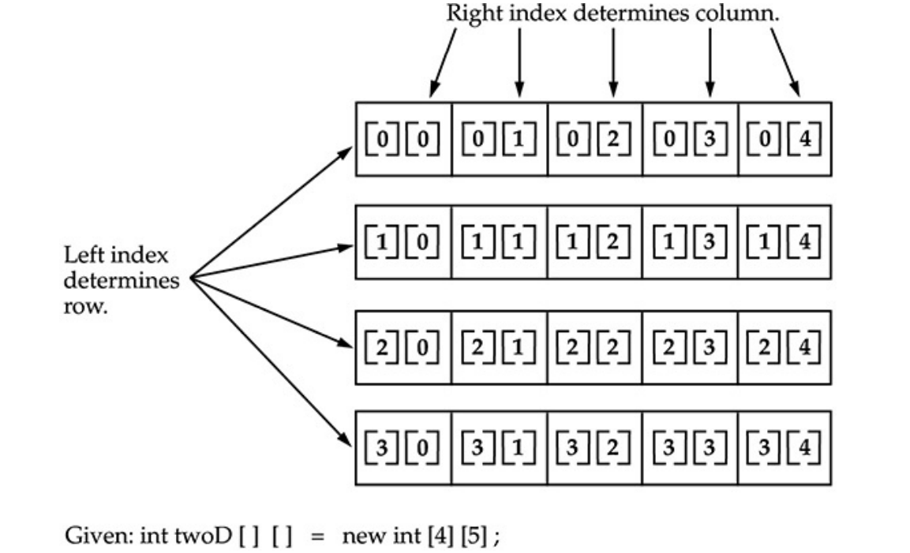
Introducing Type Inference with Local Variables

Beginning with JDK 10, an exciting new feature called local variable type inference was added to the Java language. To begin, let’s review two important aspects of variables. First, all variables in Java must be declared prior to their use. Second, a variable can be initialized with a value when it is declared.

To use local variable type inference, the variable must be declared with var as the type name and it must include an initializer. For example, in the past you would declare a local double variable called avg that is initialized with the value 10.0, as shown here:

double avg = 10.0;

Using type inference, this declaration can now also be written like this:

var avg = 10.0;

Note:

Only one variable can be declared at a time; a variable cannot use null as an initializer; and the variable being declared cannot be used by the initializer expression.

Strings:

The String type is used to declare string variables. You can also declare arrays of strings. A quoted string constant can be assigned to a String variable. A variable of type String can be assigned to another variable of type String. For example, consider the following fragment:

String str = "this is a test";
System.out.println(str);

Here, str is an object of type String. It is assigned the string "this is a test". This string is displayed by the println( ) statement.

Operators:

Java provides a rich operator environment. Most of its operators can be divided into the following four groups:

- Arithmetic
- Bitwise
- Relational
- Logical

Arithmetic Operators:

Arithmetic operators are used in mathematical expressions in the same way that they are used in algebra. The following table lists the arithmetic operators:

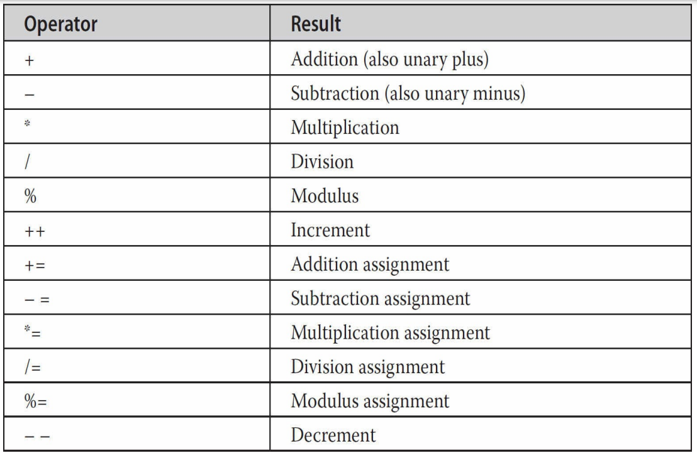

Arithmetic Compound Assignment Operators:

Java provides special operators that can be used to combine an arithmetic operation with an assignment.

As you probably know, statements like the following are quite common in programming:

a = a + 4;

In Java, you can rewrite this statement as shown here:

a += 4;

This version uses the += compound assignment operator.

Increment and Decrement

The ++ and the – – are Java’s increment and decrement operators. The increment operator increases its operand by one. The decrement operator decreases its operand by one.

For example, this statement:

x = x + 1; is equivalent to x++;

Similarly, this statement: x = x - 1; is equivalent to x--;

These operators are unique in that they can appear both in postfix form and prefix form. In the foregoing examples, there is no difference between the prefix and postfix forms.

In the prefix form, the operand is incremented or decremented before the value is obtained for use in the expression.

x = 42;
y = ++x;

In the above case, y is set to 43 as you would expect, because the increment occurs before x is assigned to y.

In postfix form, the previous value is obtained for use in the expression, and then the operand is modified.

x = 42;
y = x++;

the value of x is obtained before the increment operator is executed, so the value of y is 42. Of course, in both cases x is set to 43.

The Bitwise Operators

Java defines several bitwise operators that can be applied to the integer types: long, int, short, char, and byte. These operators act upon the individual bits of their operands.

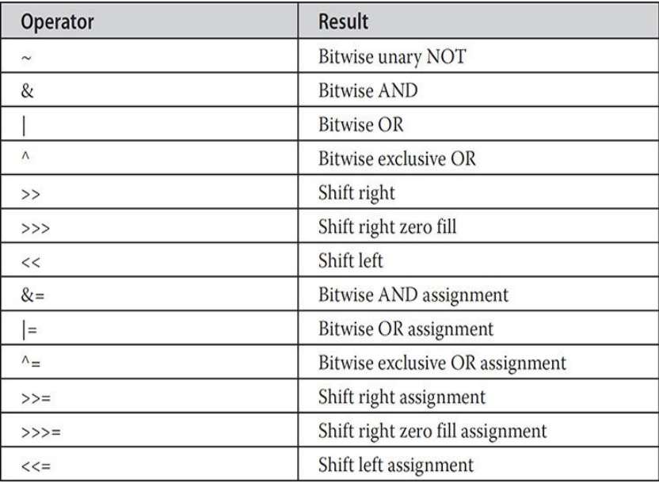

Bitwise Logical Operators

The bitwise logical operators are &, |, ^, and ~. The following table shows the outcome of each operation.

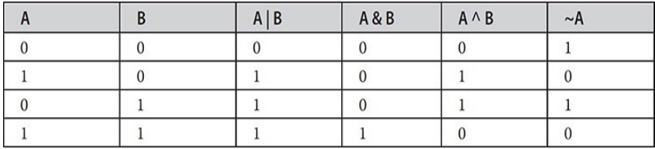

Relational Operators:

The relational operators determine the relationship that one operand has to the other. Specifically, they determine equality and ordering. The relational operators are shown here:

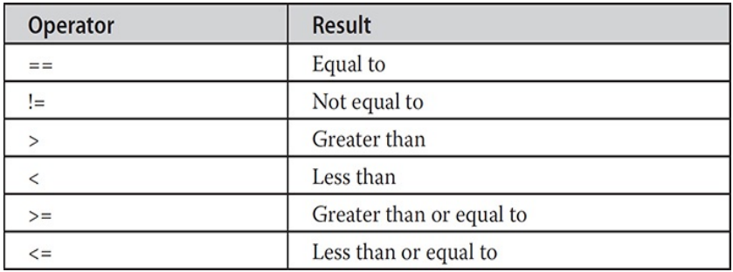

Ternary Operator:

Java includes a special ternary (three-way) operator that can replace certain types of if-then-else statements. This operator is the ?. It can seem somewhat confusing at first, but the ? can be used very effectively once mastered. The ? has this general form:

expression1 ? expression2 : expression3

Control Statements:

Java’s program control statements can be put into the following categories:

Selection statements allow your program to choose different paths of execution based upon the outcome of an expression or the state of a variable.

Iteration statements enable program execution to repeat one or more statements (that is, iteration statements form loops).

Jump statements allow your program to execute in a nonlinear fashion.

Selection Statements:

These statements allow you to control the flow of your program’s execution based upon conditions known only during run time.

if -> The if statement is Java’s conditional branch statement. It can be used to route program execution through two different paths. Here is the general form of the if statement:

Syntax:

if (condition){
statement1;
}
else {
statement2;
}

Flowchart:

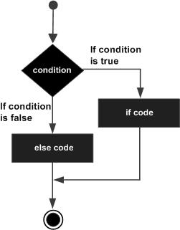

The if-else-if Ladder -> It looks like this:

if(condition)
statement;
else if(condition)
statement;
.
.
.
else
statement;

Nested ifs:

if(condition){
if(condition)
statement;
else
statement;
}
else{
statement;
}

switch

The switch statement is Java’s multiway branch statement. It provides an easy way to dispatch execution to different parts of your code based on the value of an expression. As such, it often provides a better alternative than a large series of if-else-if statements. Here is the general form of a switch statement:

switch (expression) {
case value1:
// statement sequence
break;
case value2:
// statement sequence
break;
.
.
.
case valueN :
// statement sequence
break;
default:
// default statement sequence
}

Flowchart

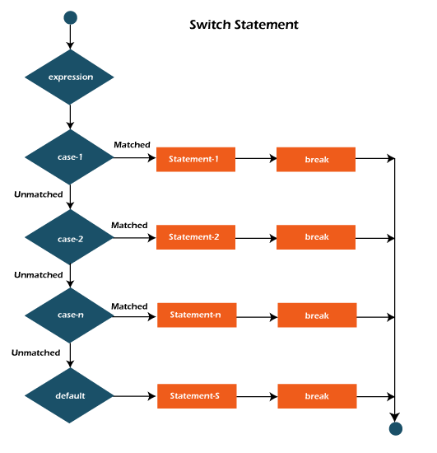

Note: Prior to JDK 7, expression must resolve to type byte, short, int, char, or an enumeration. Beginning with JDK 7, expression can also be of type String

Iteration Statements

Java’s iteration statements are for, while, and do-while.

while

The while loop is Java’s most fundamental loop statement. It repeats a statement or block while its controlling expression is true. Here is its general form:

while(condition) {
// body of loop
}

do-while

The do-while loop always executes its body at least once, because its conditional expression is at the bottom of the loop. Its general form is

do {
// body of loop
} while (condition);

for

There are two forms of the for loop. The first is the traditional form that has been in use since the original version of Java. The second is the newer “foreach” form, added by JDK 5.

Here is the general form of the traditional for statement:

for(initialization;condition;iteration){
//statement;
}

The For-Each Version of the for Loop

In Java, the for-each style of for is also referred to as the enhanced for loop. The general form of the for-each version of the for is shown here:

for(type itr-var : collection) {
statement-block
}

Jump Statements

Java supports three jump statements: break, continue, and return. These statements transfer control to another part of your program.

Example:

/*
Write a program to find the given number is armstrong
*/

public class Armstrong {
public static void main(String[] args) {
// declaring the variable
int number, temp, remainder, result, length;
// initialzing the value
number = 1634;
result = 0;
length = 0;
temp = number;
// loop for identifying the
for(int counter=0;temp!=0;counter++) {
temp /=10;
length++;
}
// checking the given number is armstrong
temp = number;
while(temp!=0) {

remainder = temp % 10;
int power = 1;
for(int counter=length;counter>0;counter--)
power = power * remainder;
result += power;
temp /= 10;
}
if(number==result)
System.out.println(number+" is an armstrong");
else
System.out.println(number+" not an armstrong");

}

}

