Session 2
Introducing Classes

The class is at the core of Java. It is the logical construct upon which the entire Java language is built because it defines the shape and nature of an object.

Perhaps the most important thing to understand about a class is that it defines a new data type. Once defined, this new type can be used to create objects of that type. Thus, a class is a template for an object, and an object is an instance of a class.

A class is declared by use of the class keyword. A simplified general form of a class definition is shown here;

Syntax:

class classname{
access-specifier data-type instance-variable1;
access-specifier data-type instance-variable2;
:
:
access-specifier data-type instance-variablen;

access-specifier return-type method-name1([parameter-list]){
//method definition
}
access-specifier return-type method-name2([parameter-list]){
//method definition
}
:
:
access-specifier return-type method-namen([parameter-list]){
//method definition
}
}

The data, or variables, defined within a class are called instance variables. The code is contained within methods. Collectively, the methods and variables defined within a class are called members of the class.

Variables defined within a class are called instance variables because each instance of the class (that is, each object of the class) contains its own copy of these variables. Thus, the data for one object is separate and unique from the data for another.

Naming Convention

- It should start with the uppercase letter.
- It should be a noun such as Button, System, Thread, etc.
- The name should not contain any white spaces.
- The name should not start with digits
- The name sould not contain the special characters like @,#,%,^,&,*,(,),-,+.
- Keywords(reserved) words cannot by used as name

Example:

/*
Defining a class to manipulate employee data
*/
class Employee{
//instance variable declaration
String employeeId;
String employeeName;
String emailid;
//method declaration
void setEmployeeId(String employeeId){
this.employeeId = employeeId;
}
String getEmployeeId(){
return employeeId;
}
void setEmployeeName(String employeeName){
this.employeeName = employeeName;
}
String getEmployeeName(){
return employeeName;
}
void setEmailId(String emailid){
this.emailid = emailid;
}
String getEmailid (){
return emailid;
}
}

Declaring Objects

Obtaining objects of a class is a two-step process. First, you must declare a variable of the class type. This variable does not define an object. Instead, it is simply a variable that can refer to an object. Second, you must acquire an actual, physical copy of the object and assign it to that variable. You can do this using the new operator. The new operator dynamically allocates (that is, allocates at run time) memory for an object and returns a reference to it. This reference is, essentially, the address in memory of the object allocated by new. This reference is then stored in the variable. Thus, in Java, all class objects must be dynamically allocated.

Syntax:

classname objectname;

(or)

classname objectname = new-operator constructorname();

Example:

Statement Effect
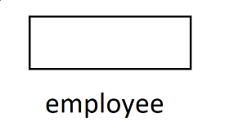
Employee employee; //declare reference to object
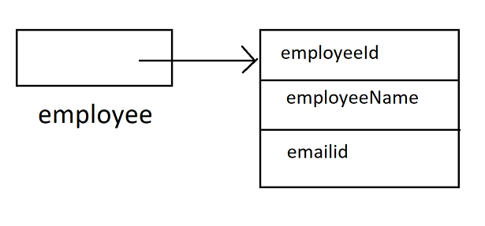
Employee employee = new Employee(); //allocate a Employee object

Introducing Methods

Classes usually consist of two things: instance variables and methods. The topic of methods is a large one because Java gives them so much power and flexibility.

This is the general form of a method:

data-type name(parameter-list) {
// body of method
}

Here, type specifies the type of data returned by the method. This can be any valid type, including class types that you create. If the method does not return a value, its return type must be void.

Methods that have a return type other than void return a value to the calling routine using the following form of the return statement:

return value;

Here, value is the value returned.

Adding a Method to the Class

We will use methods to access the instance variables defined by the class. Let’s begin by adding a method to the Box class. since the volume of a box is dependent upon the size of the box, it makes sense to have the Box class compute it. To do this, you must add a method to Box, as shown here:

// This program includes a method inside the class

class Box{
double width;
double height;
double depth;

// Display the volume
void volume(){
System.out.println(“Volume is ”);
System.out.println(width*height*depth);
}
}
class BoxMain{
public static void main(String args[]){
Box mybox1 = new Box();
Box mybox2 = new Box();

// assign values to mybox1’s instance variables
mybox1.width = 3;
mybox1.height = 6;
mybox1.depth = 9;

// display volume of first box
mybox1.volume();

// assign values to mybox2’s instance variables
mybox2.width = 10;
mybox2.height = 20;
mybox2.depth = 15;

// display volume of second box
mybox2.volume();
}
}

Output:

Volume is 162.0
Volume is 3000.0

Returning a Value

// This program includes a method inside the class

class Box{
double width;
double height;
double depth;

// compute and return the volume
double volume(){
return width*height*depth;
}
}
class BoxMain{
public static void main(String args[]){
Box mybox1 = new Box();
Box mybox2 = new Box();

// assign values to mybox1’s instance variables
mybox1.width = 3;
mybox1.height = 6;
mybox1.depth = 9;

// get volume of first box
System.out.println(“Volume is ”+mybox1.volume());

// assign values to mybox2’s instance variables
mybox2.width = 10;
mybox2.height = 20;
mybox2.depth = 15;

// get volume of second box
System.out.println(“Volume is ”+mybox2.volume());
}
}

Output:

Volume is 162.0
Volume is 3000.0

Adding a Method That Takes Parameters

// This program includes a method inside the class

class Box{
double width;
double height;
double depth;

// compute and return the volume
double volume(){
return width*height*depth;
}

// set dimensions of box
void setDimension(double width, double height, double depth){
this.width = width;
this.height = height;
thid.depth = depth;
}
}
class BoxMain{
public static void main(String args[]){
Box mybox1 = new Box();
Box mybox2 = new Box();

// initialize each box
mybox1.setDimension(3,6,9);
mybox2.setDimension(10,20,15);

// get volume of first box
System.out.println(“Volume is ”+mybox1.volume());

// get volume of second box
System.out.println(“Volume is ”+mybox2.volume());
}
}

Output:

Volume is 162.0
Volume is 3000.0

The this Keywords

Sometimes a method will need to refer to the object that invoked it. To allow this, Java defines the this keyword. this can be used inside any method to refer to the current object. That is, this is always a reference to the object on which the method was invoked.

Constructors

It can be tedious to initialize all of the variables in a class each time an instance is created. Even when you add convenience methods like setDimension( ), it would be simpler and more concise to have all of the setup done at the time the object is first created. Because the requirement for initialization is so common, Java allows objects to initialize themselves when they are created. This automatic initialization is performed through the use of a constructor.

A constructor initializes an object immediately upon creation. It has the same name as the class in which it resides and is syntactically similar to a method. Once defined, the constructor is automatically called when the object is created, before the new operator completes.

It look a little strange because they have no return type, not even void. This is because the implicit return type of a constructor is the class type itself. It is the constructor’s job to initialize the internal state of an object so that the code creating an instance will have a fully initialized, usable object immediately.

You can rework the Box example so that the dimensions of a box are automatically initialized when an object is constructed. To do so, replace setDimension( ) with a constructor.

// This program includes a method inside the class
class Box{
double width;
double height;
double depth;

// constructor for Box
Box(){
System.out.println(“Constructor initializing dimension”);
this.width = 10;
this.height = 20;
thid.depth = 15;
}

// compute and return the volume
double volume(){
return width*height*depth;
}
}
class BoxMain{
public static void main(String args[]){
Box mybox1 = new Box();
Box mybox2 = new Box();

// get volume of first box
System.out.println(“Volume is ”+mybox1.volume());

// get volume of second box
System.out.println(“Volume is ”+mybox2.volume());
}
}

Output:

Constructor initializing dimension
Constructor initializing dimension
Volume is 3000.0
Volume is 3000.0

Parameterized Constructors

While the Box( ) constructor in the preceding example does initialize a Box object, it is not very useful—all boxes have the same dimensions.

What is needed is a way to construct Box objects of various dimensions. The easy solution is to add parameters to the constructor.

// This program includes a method inside the class

class Box{
double width;
double height;
double depth;

// constructor for Box with parameter
Box(double width, double height, double depth){
this.width = width;
this.height = height;
thid.depth = depth;
}

// compute and return the volume
double volume(){
return width*height*depth;
}
}
class BoxMain{
public static void main(String args[]){
Box mybox1 = new Box(10,20,15);
Box mybox2 = new Box(3,6,9);

// get volume of first box
System.out.println(“Volume is ”+mybox1.volume());

// get volume of second box
System.out.println(“Volume is ”+mybox2.volume());
}
}

Output:

Volume is 3000.0
Volume is 162.0

Instance Variable Hiding

It is illegal in Java to declare two local variables with the same name inside the same or enclosing scopes. When a local variable has the same name as an instance variable, the local variable hides the instance variable.

A word of caution: The use of this in such a context can sometimes be confusing, and some programmers are careful not to use local variables and formal parameter names that hide instance variables. Of course, other programmers believe the contrary—that it is a good convention to use the same names for clarity, and use this to overcome the instance variable hiding. It is a matter of taste which approach you adopt.

Garbage Collection:

Since objects are dynamically allocated by using the new operator, you might be wondering how such objects are destroyed and their memory released for later reallocation. In some languages, such as traditional C++, dynamically allocated objects must be manually released by use of a delete operator. Java takes a different approach; it handles deallocation for you automatically. The technique that accomplishes this is called garbage collection.

Overloading Methods

In Java, it is possible to define two or more methods within the same class that share the same name, as long as their parameter declarations are different. When this is the case, the methods are said to be overloaded, and the process is referred to as method overloading. Method overloading is one of the ways that Java supports polymorphism.

When an overloaded method is invoked, Java uses the type and/or number of arguments as its guide to determine which version of the overloaded method to actually call. Thus, overloaded methods must differ in the type and/or number of their parameters.

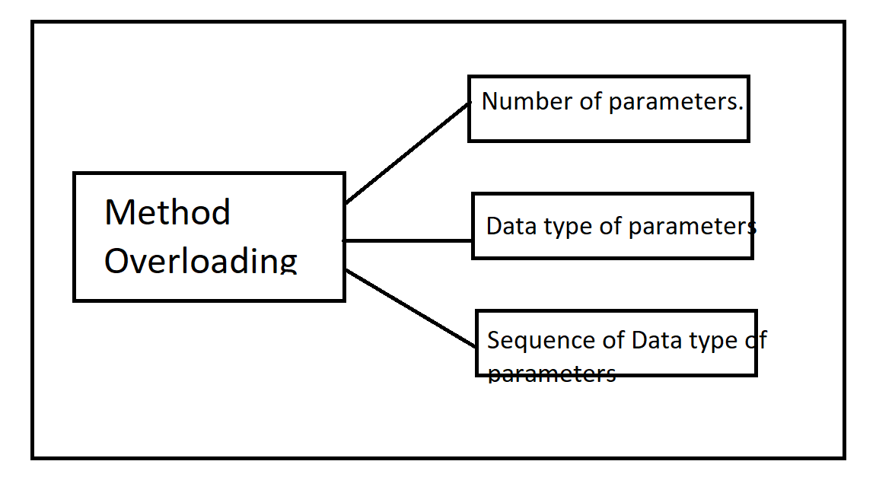

Here is a simple example that illustrates method overloading:

// This program includes method overloading inside the class

class Shape{

void area(int length){
System.out.println(“Area of Square:”+length*length);
}
void area(int length, int breath){
System.out.println(“Area of Rectangle:”+length*breath);
}
void area(int length, float breath){
System.out.println(“Area of Triangle:”+0.5*length*breath);
}
}
class ShapeMain{
public static void main(String args[]){
Shape shape = new Shape();
// display the area of square
shape.area(10);
// display the area of rectangle
shape.area(10,20);
// display the area of triangle
shape.area(10,8.0f);
}
}

Note: If two methods have same name, same parameters and have different return type, then this is not a valid method overloading.

Overloading Constructors

In addition to overloading normal methods, you can also overload constructor methods. In fact, for most real-world classes that you create, overloaded constructors will be the norm, not the exception.

// This program includes a method inside the class

class Box{
double width;
double height;
double depth;

//constructor for Box with-out parameter
Box(){
this.width = 0.0;
this.height = 0.0;
this.depth = 0.0;
}

// constructor for Box with parameter
Box(double width, double height, double depth){
this.width = width;
this.height = height;
thid.depth = depth;
}

// compute and return the volume
double volume(){
return width*height*depth;
}
}
class BoxMain{
public static void main(String args[]){
Box mybox1 = new Box(10,20,15);
Box mybox2 = new Box(3,6,9);

// get volume of first box
System.out.println(“Volume is ”+mybox1.volume());

// get volume of second box
System.out.println(“Volume is ”+mybox2.volume());
}
}

Output:

Volume is 3000.0
Volume is 162.0

Using Objects as Parameters

So far, we have only been using simple types as parameters to methods. However, it is both correct and common to pass objects to methods. For example, consider the following short program:

// Objects may be passed to methods
class Test{
int number1;
int number2;

Test(int number1, int number2){
this.number1 = number1;
this.number2 = number2;
}

// return true if testobj is equal to the invoking object
boolean equalTo(Test testobj){
if(testobj.number1 == this.number1 && testobj.number2 == this.number2)
return true;
else
return false;
}
}

class TestMain{
public static void main(String args[]){
Test testobj1 = new Test(100, 22);
Test testobj2 = new Test(100, 22);
Test testobj3 = new Test(-1,-1);

System.out.println(“Is testobj1 and testobj2 equal?”+testobj1.equalTo(testobj2));
System.out.println(“Is testobj1 and testobj3 equal?”+testobj1.equalTo(testobj3));
}
}

Output:

Is testobj1 and testobj2 equal? true
Is testobj1 and testobj3 equal? false

A Closer Look at Argument Passing

There are two ways that a computer language can pass an argument to a subroutine.

Call-by-value

This approach copies the value of an argument into the formal parameter of the subroutine. Therefore, changes made to the parameter of the subroutine have no effect on the argument.

// Primitive type are passed by value
class Test{

void calculate(int number1, int number2){
number1 *= 2;
number2 /= 2;
}
}
class CallByValueTestMain{
public static void main(String args[]){
int number1 = 15, number2 = 30;
Test testobj = new Test();

System.out.println(“Value of number1 and number2 before call:”+number1+” “+number2);
testobj.calculate(number1,number2);
System.out.println(“Value of number1 and number2 after call:”+number1+” “+number2);
}
}

Output:

Value of number1 and number2 before call: 15 30
Value of number1 and number2 after call: 15 30

Call-by-reference

In this approach, a reference to an argument (not the value of the argument) is passed to the parameter. Inside the subroutine, this reference is used to access the actual argument specified in the call. This means that changes made to the parameter will affect the argument used to call the subroutine.

// Object type are passed by reference
class Test{

int number1;
int number2;

Test(int number1, int number2){
this.number1 = number1;
this.number2 = number2;
}

void calculate(Test testobj){
number1 *= 2;
number2 /= 2;
}
}
class CallByReferenceTestMain{
public static void main(String args[]){
Test testobj = new Test(15,30);

System.out.println(“Value of number1 and number2 before call:”+testobj.number1+” “+testobj.number2);
testobj.calculate(testobj);
System.out.println(“Value of number1 and number2 after call:”+testobj.number1+” “+testobj.number2);
}
}

Output:

Value of number1 and number2 before call: 15 30
Value of number1 and number2 after call: 30 15

Returning Objects

A method can return any type of data, including class types that you create.

Recursion

Java supports recursion. Recursion is the process of defining something in terms of itself. As it relates to Java programming, recursion is the attribute that allows a method to call itself. A method that calls itself is said to be recursive.

The classic example of recursion is the computation of the factorial of a number.

// A simple example of recursion
class Factorial{
int fact(int number){
int result;
if(n==1)
return 1;
result = fact(number-1)*n;
return result;
}
}
class Recursion{
public static void main(String args[]){

Factorial fact = new Factorial();
System.out.println("Factorial of 5:"+fact.fact(5))
}
}

Output:

Factorial of 5:120

Introducing Access Control

As you know, encapsulation links data with the code that manipulates it.
However, encapsulation provides another important attribute: access control.
Through encapsulation, you can control what parts of a program can access the
members of a class. By controlling access, you can prevent misuse.

Modifier

Two types of modifiers
Access modifiers
Non-access modifiers

Access Modifers
private
protected
public

Non-access modifiers
Non-access modifiers provide information about the characteristics of a class, method, or variable to the JVM. Seven types of Non-Access modifiers are present in Java. They are –

- static
- final
- abstract
- synchronized
- volatile
- transient
- native

static

The static keyword means that the entity to which it is applied is available outside any particular instance of the class. That means the static methods or the attributes are a part of the class and not an object. The memory is allocated to such an attribute or method at the time of class loading. The use of a static modifier makes the program more efficient by saving memory. A static field exists across all the class instances, and without creating an object of the class, they can be called.

final

The final keyword indicates that the specific class cannot be extended or a method cannot be overridden.

abstract

abstract keyword is used to declare a class as partially implemented means an object cannot be created directly from that class. Any subclass needs to be either implement all the methods of the abstract class, or it should also need to be an abstract class. The abstract keyword cannot be used with static, final, or private keywords because they prevent overriding, and we need to override methods in the case of an abstract class.

synchronized

synchronized keyword prevents a block of code from executing by multiple threads at once. It is very important for some critical operations.

volatile

The volatile keyword is used to make the class thread-safe. That means if a variable is declared as volatile, then that can be modified by multiple threads at the same time without any issues. The volatile keyword is only applicable to a variable. A volatile keyword reduces the chance of memory inconsistency. The value of a volatile variable is always read from the main memory and not from the local thread cache, and it helps to improve thread performance.

transient

The transient keyword may be applied to member variables of a class to indicate that the member variable should not be serialized when the containing class instance is serialized. Serialization is the ​process of converting an object into a byte stream. When we do not want to serialize the value of a variable, then we declare it as transient.

native

The native keyword may be applied to a method to indicate that the method is implemented in a language other than Java. Using this java application can call code written in C, C++, or assembler language. A shared code library or DLL is required in this case.

