Session 5

Relationship in Java

A relationship in Java means different relations between two or more classes. we have two types of relationship:

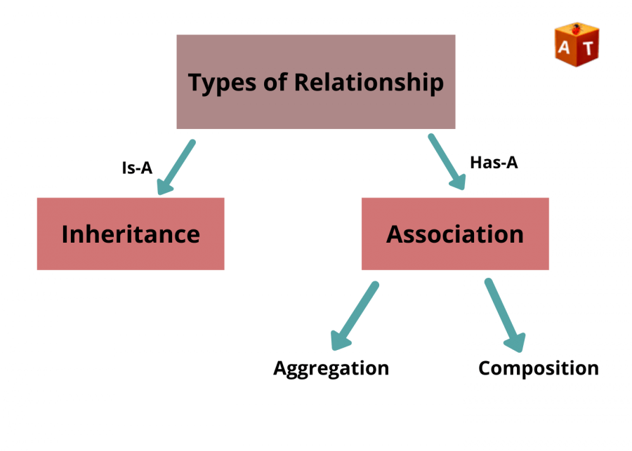

Is-A relationship: Whenever one class inherits another class, it is called an IS-A relationship. It is wholly related to Inheritance. For example – a kiwi is a fruit; a Manager is an Employee

- Can simply be achieved by using extends Keyword.
- Additionally used for code re-usability in Java and to avoid code redundancy.
- Unidirectional
- Tightly coupled, which means changing one entity will affect another entity

Has-A relationship: Whenever an instance of one class is used in another class, it is called HAS-A relationship.

Association is the relation between two separate classes which establishes through their Objects. Composition and Aggregation are the two forms of association. In Java, a Has-A relationship is otherwise called composition. It is additionally utilized for code reusability in Java. In Java, a Has-A relationship essentially implies that an example of one class has a reference to an occasion of another class or another occurrence of a similar class. For instance, a vehicle has a motor, a canine has a tail, etc.

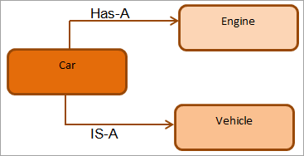

The Collections Framework

The java.util package also contains one of Java’s most powerful subsystems: the Collections Framework. The Java Collections Framework standardizes the way in which groups of objects are handled by your programs. Collections were not part of the original Java release, but were added by J2SE 1.2. Prior to the Collections Framework, Java provided ad hoc classes such as Dictionary, Vector, Stack, and Properties to store and manipulate groups of objects. Although these classes were quite useful, they lacked a central, unifying theme. This early, ad hoc approach was not designed to be easily extended or adapted. Collections were an answer to these (and other) problems.

The Collections Framework was designed to meet several goals. First, the framework had to be high-performance. The implemntations for the fundamental collections (dynamic arrays, linked lists, trees, and hash tables) are highly efficient. Second, the framework had to allow different types of collections to work in a similar manner and with a high degree of interoperability. Third, extending and/or adapting a collection had to be easy.

Algorithms are another important part of the collection mechanism. Algorithms operate on collections and are defined as static methods within the Collections class. Another item closely associated with the Collections Framework is the Iterator interface. An iterator offers a general-purpose, standardized way of accessing the elements within a collection, one at a time. Thus, an iterator provides a means of enumerating the contents of a collection. Because each collection provides an iterator, the elements of any collection class can be accessed through the methods defined by Iterator.

JDK 8 also added iterator interfaces designed for use with primitive types, such as PrimitiveIterator and PrimitiveIterator.OfDouble. In addition to collections, the framework defines several map interfaces and classes. Maps store key/value pairs. Although maps are part of the Collections Framework, they are not “collections” in the strict use of the term.

The Collection Interfaces

The Collections Framework defines several core interfaces. In addition to the collection interfaces, collections also use the Comparator, RandomAccess, Iterator, ListIterator, and Spliterator interfaces.
Comparator defines how two objects are compared; Iterator, ListIterator, and Spliterator enumerate the objects within a collection. By implementing RandomAccess, a list indicates that it supports efficient, random access to its elements.

Interface | Description
Collection | Enables you to work with groups of objects; it is at the top of the collection hierarchy.
List | Extends Collection to handle sequences (list of objects)
Set | Extends Collection to handle set, which must contains unique elements
SortedSet | Extends Set to handle sorted set.
NavigableSet | Extends SortedSet to handle retrieval of elements based on closest-match searches.
Queue | Extends Collection to handle special types of lists in which elements are removed only from the head.
Deque | Extends Queue to handle a double-ended queue.

The Collection interface is the foundation upon which the Collections Framework is built because it must be implemented by any class that defines a collection. Collection is a generic interface that has this declaration: interface Collection Here, E specifies the type of objects that the collection will hold. Collection extends the Iterable interface. This means that all collections can be cycled through by use of the for-each style for loop.

Collection declares the core methods that all collections will have.

Methods | Description
add(Object) | Used to add an object to the collection.
addAll(Collection c) | Adds all the elements in the given collection to this collection.
clear() | Removes all of the elements from this collection.
contains(Object o) | Returns true if the collection contains the specified element.
containsAll(Collection c) | Returns true if the collection contains all of the elements in the given collection.
equals(Object o) | Compares the specified object with this collection for equality.
hashCode() | Return the hash code value for this collection.
isEmpty() | Returns true if this collection contains no elements.
iterator() | Returns an iterator over the elements in this collection.
max() | Return the maximum value present in the collection.
parallelStream() | Returns a parallel Stream with this collection as its source.
remove(Object o) | Remove the given object from the collection. If there are duplicate values, then this method removes the first occurrence of the object.
removeAll(Collection c) | Remove all the objects mentioned in the given collection from the collection.
removeIf(Predicate filter) | Remove all the elements of this collection that satisfy the given predicate.
retainAll(Collection c) | Retain only the elements in this collection that are contained in the specified collection.
size() | Return the number of elements in the collection.
spliterator() | Create a Spliterator over the elements in this collection.
stream() | Return a sequential Stream with this collection as its source.
toArray() | Return an array containing all of the elements in this collection.

The List Interfaces

The List interface extends Collection and declares the behavior of a collection that stores a sequence of elements. Elements can be inserted or accessed by their position in the list, using a zero-based index. A list may contain duplicate elements. List is a generic interface that has this declaration:

interface List<E>

Here, E specifies the type of objects that the list will hold.

Methods of List

The List interface includes all the methods of the Collection interface. Its because Collection is a super interface of List.

Some of the commonly used methods of the Collection interface that's also available in the List interface are:

Methods | Description
add(int index, element) | Add an element at a particular index in the list. When a single parameter is passed, it simply adds the element at the end of the list.
addAll(int index, Collection collection) | Add all the elements in the given collection to the list. When a single parameter is passed, it adds all the elements of the given collection at the end of the list.
remove(int index) | Removes an element from the specified index. It shifts subsequent elements(if any) to left and decreases their indexes by 1.
remove(element) | Remove the first occurrence of the given element in the list.
get(int index) | Returns elements at the specified index.
set(int index, element) | Replaces elements at a given index with the new element. This function returns the element which was just replaced by a new element.
indexOf(element) | Returns the first occurrence of the given element or -1 if the element is not present in the list.
lastIndexOf(element) | Returns the last occurrence of the given element or -1 if the element is not present in the list.
sort(Comparator comp) | Sort the elements of the list on the basis of the given comparator.

Java ArrayList

In Java, we use the ArrayList class to implement the functionality of resizable-arrays.

It implements the List interface of the collections framework.

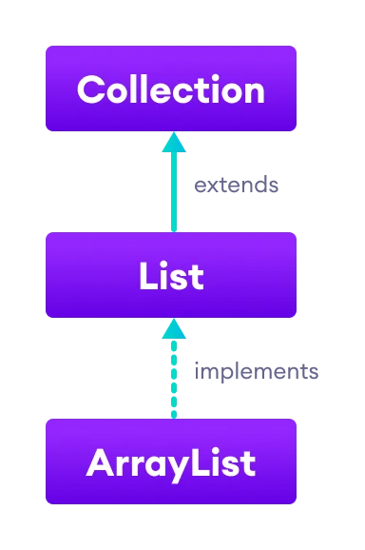

Java ArrayList Vs Array

In Java, we need to declare the size of an array before we can use it. Once the size of an array is declared, it's hard to change it.

To handle this issue, we can use the ArrayList class. It allows us to create resizable arrays.

Unlike arrays, arraylists can automatically adjust their capacity when we add or remove elements from them. Hence, arraylists are also known as dynamic arrays.

Java Vector

The Vector class is an implementation of the List interface that allows us to create resizable-arrays similar to the ArrayList class.

Java Vector vs. ArrayList

In Java, both ArrayList and Vector implements the List interface and provides the same functionalities. However, there exist some differences between them.

The Vector class synchronizes each individual operation. This means whenever we want to perform some operation on vectors, the Vector class automatically applies a lock to that operation.

It is because when one thread is accessing a vector, and at the same time another thread tries to access it, an exception called ConcurrentModificationException is generated. Hence, this continuous use of lock for each operation makes vectors less efficient.

However, in array lists, methods are not synchronized. Instead, it uses the Collections.synchronizedList() method that synchronizes the list as a whole.

Note: It is recommended to use ArrayList in place of Vector because vectors less efficient.

Java Stack Class

The Java collections framework has a class named Stack that provides the functionality of the stack data structure.

The Stack class extends the Vector class.

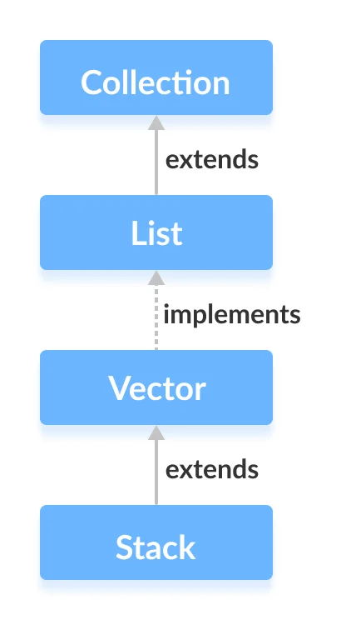

Stack Implementation

In stack, elements are stored and accessed in Last In First Out manner. That is, elements are added to the top of the stack and removed from the top of the stack.
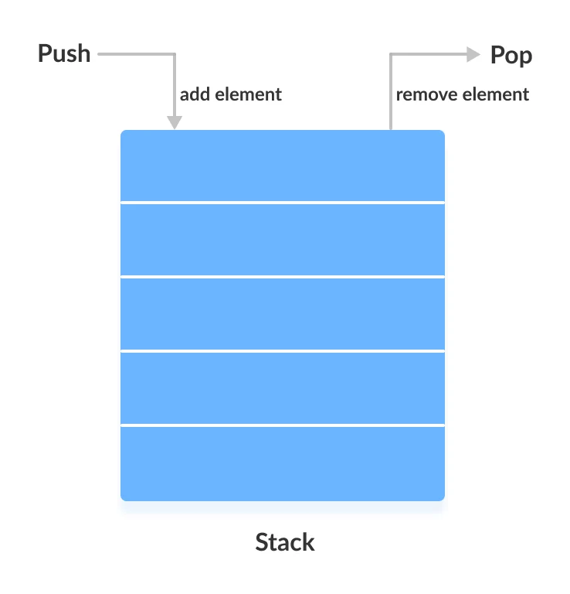

Methods | Description
push() | To add an element to the top of the stack
pop() | To remove an element from the top of the stack
peep() | method returns an object from the top of the stack
search() | To search an element in the stack. It returns the position of the element from the top of the stack.
empty() | To check whether a stack is empty or not.

Java LinkedList

The LinkedList class of the Java collections framework provides the functionality of the linked list data structure (doubly linkedlist).

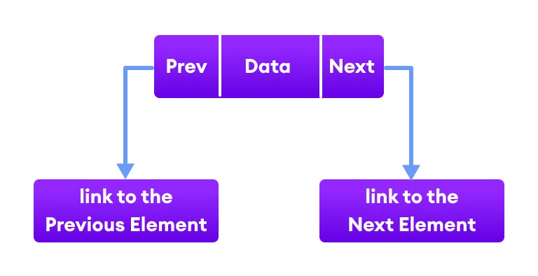

Each element in a linked list is known as a node. It consists of 3 fields:

Prev - stores an address of the previous element in the list. It is null for the first element
Next - stores an address of the next element in the list. It is null for the last element
Data - stores the actual data

Working of a Java LinkedList

Elements in linked lists are not stored in sequence. Instead, they are scattered and connected through links (Prev and Next).

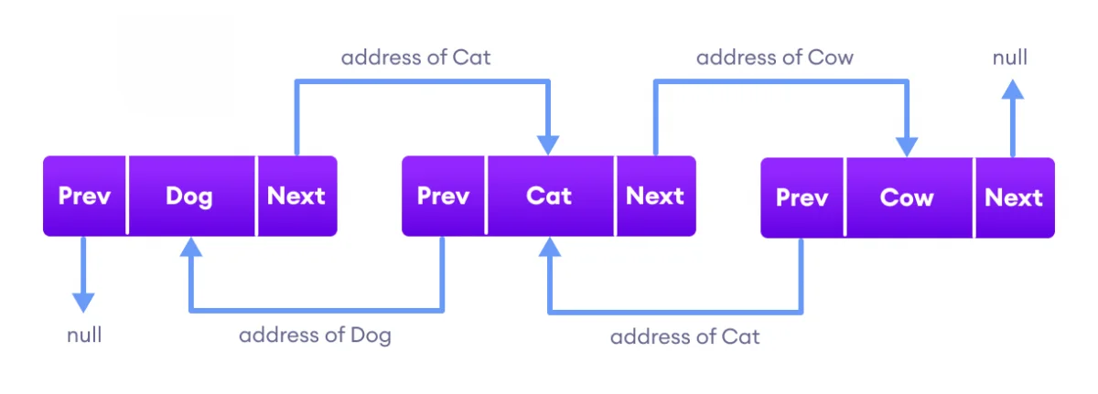
Here we have 3 elements in a linked list.

Dog - it is the first element that holds null as previous address and the address of Cat as the next address
Cat - it is the second element that holds an address of Dog as the previous address and the address of Cow as the next address
Cow - it is the last element that holds the address of Cat as the previous address and null as the next element

The Set Interface

The Set interface defines a set. It extends Collection and specifies the behavior of a collection that does not allow duplicate elements. Therefore, the add( ) method returns false if an attempt is made to add duplicate elements to a set. With two exceptions, it does not specify any additional methods of its own. Set is a generic interface that has this declaration:

interface Set<E>

Here, E specifies the type of objects that the set will hold.

In order to use functionalities of the Set interface, we can use these classes

HashSet
LinkedHashSet
EnumSet
TreeSet

Interfaces that extend Set

SortedSet
NavigableSet

Java SortedSet Interface

The SortedSet interface of the Java Collections framework is used to store elements with some order in a set.

It extends the Set interface.

Class that implements SortedSet

In order to use the functionalities of the SortedSet interface, we need to use the TreeSet class that implements it.

Methods of SortedSet

The SortedSet interface includes all the methods of the Set interface. It's because Set is a super interface of SortedSet.

Besides methods included in the Set interface, the SortedSet interface also includes these methods:

Methods | Description
comparator() | returns a comparator that can be used to order elements in the set
first() | returns the first element of the set
last() | returns the last element of the set
headSet(element) | returns all the elements of the set before the specified element
tailSet(element) | returns all the elements of the set after the specified element including the specified element
subSet(element1, element2) | returns all the elements between the element1 and element2 including element1

Java NavigableSet Interface

The NavigableSet interface of the Java Collections framework provides the features to navigate among the set elements.

It is considered as a type of SortedSet.

Class that implements NavigableSet

In order to use the functionalities of the NavigableSet interface, we need to use the TreeSet class that implements NavigableSet.

Methods for Navigation

The NavigableSet provides various methods that can be used to navigate over its elements.

Methods | Description
descendingSet() | reverses the order of elements in a set
descendingIterator() | returns an iterator that can be used to iterate over a set in reverse order
ceiling() | returns the lowest element among those elements that are greater than or equal to the specified element
floor() | returns the greatest element among those elements that are less than or equal to the specified element
higher() | returns the lowest element among those elements that are greater than the specified element
lower() | returns the greatest element among those elements that are less than the specified element
pollFirst() | returns and removes the first element from the set
pollLast() | returns and removes the last element from the set

Java HashSet Class

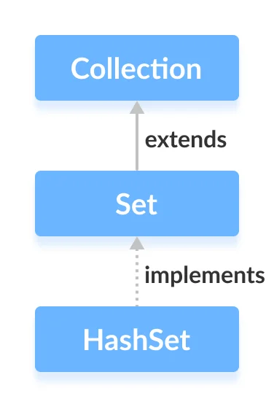
The HashSet class of the Java Collections framework provides the functionalities of the hash table data structure.

It implements the Set interface.

Why HashSet?

In Java, HashSet is commonly used if we have to access elements randomly. It is because elements in a hash table are accessed using hash codes.

The hashcode of an element is a unique identity that helps to identify the element in a hash table.

HashSet cannot contain duplicate elements. Hence, each hash set element has a unique hashcode.

Note: HashSet is not synchronized. That is if multiple threads access the hash set at the same time and one of the threads modifies the hash set. Then it must be externally synchronized.

Java LinkedHashSet
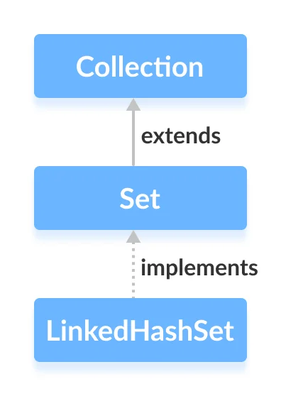
The LinkedHashSet class of the Java collections framework provides functionalities of both the hashtable and the linked list data structure. It implements the Set interface.

Elements of LinkedHashSet are stored in hash tables similar to HashSet.

However, linked hash sets maintain a doubly-linked list internally for all of its elements. The linked list defines the order in which elements are inserted in hash tables.

LinkedHashSet Vs. HashSet

Both LinkedHashSet and HashSet implements the Set interface. However, there exist some differences between them.

LinkedHashSet maintains a linked list internally. Due to this, it maintains the insertion order of its elements.

The LinkedHashSet class requires more storage than HashSet. This is because LinkedHashSet maintains linked lists internally.

The performance of LinkedHashSet is slower than HashSet. It is because of linked lists present in
LinkedHashSet.
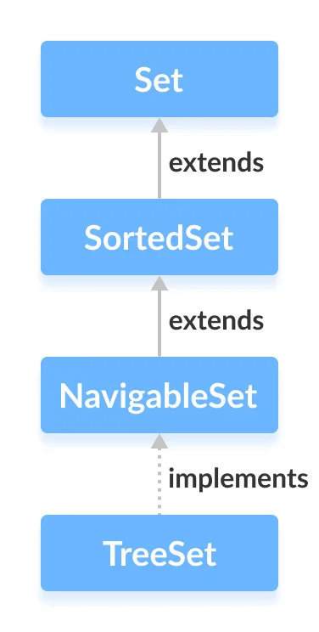
Java TreeSet

The TreeSet class of the Java collections framework provides the functionality of a tree data structure.

It extends the NavigableSet interface.

The elements in TreeSet are sorted naturally (ascending order). However, we can customize the sorting of elements by using the Comparator interface.

TreeSet Vs. HashSet

Both the TreeSet as well as the HashSet implements the Set interface. However, there exist some differences between them.

Unlike HashSet, elements in TreeSet are stored in some order. It is because TreeSet implements the SortedSet interface as well.

TreeSet provides some methods for easy navigation. For example, first(), last(), headSet(), tailSet(), etc. It is because TreeSet also implements the NavigableSet interface.

HashSet is faster than the TreeSet for basic operations like add, remove, contains and size.

TreeSet Comparator

Tree set elements are sorted naturally. However, we can also customize the ordering of elements.

Java Deque Interface

The Deque interface of the Java collections framework provides the functionality of a double-ended queue. It extends the Queue interface.

Working of Deque

In a regular queue, elements are added from the rear and removed from the front. However, in a deque, we can insert and remove elements from both front and rear.

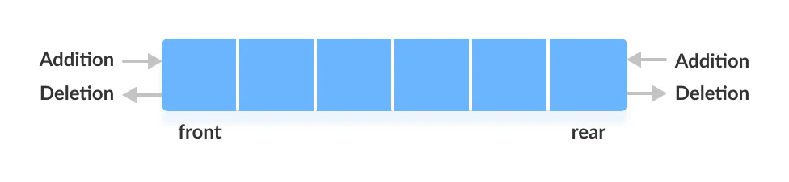

Classes that implement Deque

In order to use the functionalities of the Deque interface, we need to use classes that implement it:

ArrayDeque

Method | Description
add(element) | add an element at the tail of the queue. If the Deque is capacity restricted and no space is left for insertion, it returns an IllegalStateException. The function returns true on successful insertion.
addFirst(element) | add an element at the head of the queue. If the Deque is capacity restricted and no space is left for insertion, it returns an IllegalStateException. The function returns true on successful insertion.
addLast(element) | add an element at the tail of the queue. If the Deque is capacity restricted and no space is left for insertion, it returns an IllegalStateException. The function returns true on successful insertion.
contains() | check whether the queue contains the given object or not.
descendingIterator() | returns an iterator for the deque. The elements will be returned in order from last(tail) to first(head).
element() | retrieve, but not remove, the head of the queue represented by this deque.
getFirst() | retrieve, but not remove, the first element of this deque.
getLast() | retrieve, but not remove, the last element of this deque.
iterator() | returns an iterator for the deque. The elements will be returned in order from first (head) to last (tail).
offer(element) | add an element at the tail of the queue. This method is preferable to add() method since this method does not throws an exception when the capacity of the container is full since it returns false.
offerFirst(element) | add an element at the head of the queue. This method is preferable to addFirst() method since this method does not throws an exception when the capacity of the container is full since it returns false.
offerLast(element) | add an element at the tail of the queue. This method is preferable to add() method since this method does not throws an exception when the capacity of the container is full since it returns false.
peek() | retrieve the element at the head of the deque but doesn’t remove the element from the deque. This method returns null if the deque is empty.
peekFirst() | retrieve the element at the head of the deque but doesn’t remove the element from the deque. This method returns null if the deque is empty.
peekLast() | retrieve the element at the tail of the deque but doesn’t remove the element from the deque. This method returns null if the deque is empty.
poll() | retrieve and remove the element at the head of the deque. This method returns null if the deque is empty.
pollFirst() | retrieve and remove the element at the head of the deque. This method returns null if the deque is empty.
pollLast() | retrieve and remove the element at the tail of the deque. This method returns null if the deque is empty.
pop() | remove an element from the head and return it.
push(element) | add an element at the head of the queue.
removeFirst() | remove an element from the head of the queue.
removeLast() | remove an element from the tail of the queue.
size() | find and return the size of the deque.

LinkedList Vs. ArrayList

Both the Java ArrayList and LinkedList implements the List interface of the Collections framework. However, there exists some difference between them.

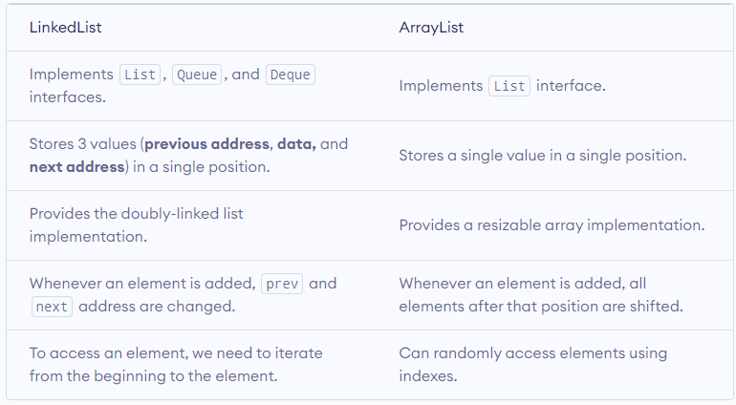

Java ArrayDeque

In Java, we can use the ArrayDeque class to implement queue and deque data structures using arrays.

Interfaces implemented by ArrayDeque

The ArrayDeque class implements these two interfaces:

Java Queue Interface
Java Deque Interface

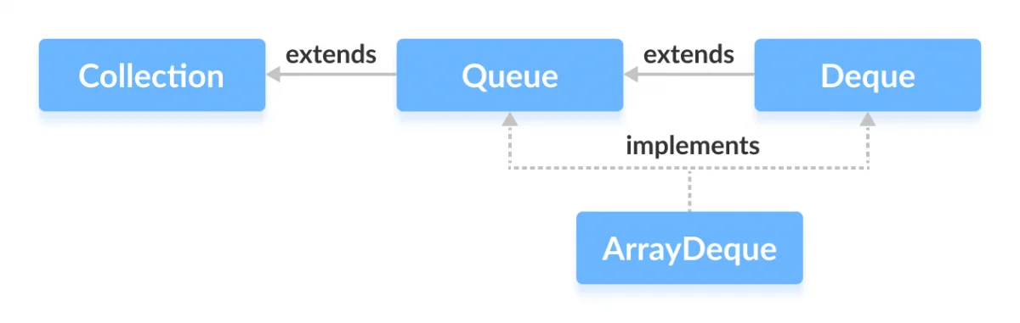
ArrayDeque Vs. LinkedList Class

Both ArrayDeque and Java LinkedList implements the Deque interface. However, there exist some differences between them.

LinkedList supports null elements, whereas ArrayDeque doesn't.

Each node in a linked list includes links to other nodes. That's why LinkedList requires more storage than ArrayDeque.

If you are implementing the queue or the deque data structure, an ArrayDeque is likely to faster than a LinkedList.

Use ArrayDeque Instead of Stack

The Stack class provides the direct implementation of the stack data structure. However, it is recommended not to use it. Instead, use the ArrayDeque class (implements the Deque interface) to implement the stack data structure in Java.

Java Map Interface

The Map interface of the Java collections framework provides the functionality of the map data structure.

Working of Map

In Java, elements of Map are stored in key/value pairs. Keys are unique values associated with individual Values.

A map cannot contain duplicate keys. And, each key is associated with a single value.

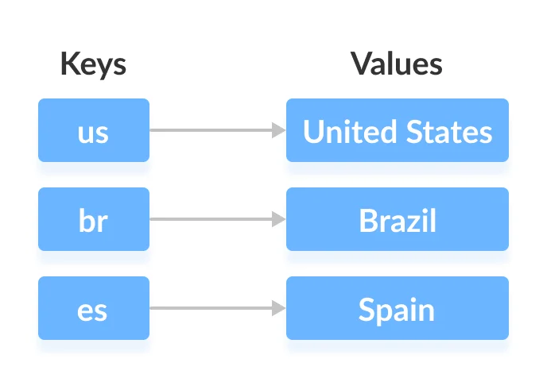

We can access and modify values using the keys associated with them.

In the above diagram, we have values: United States, Brazil, and Spain. And we have corresponding keys: us, br, and es.

Now, we can access those values using their corresponding keys.

Note: The Map interface maintains 3 different sets:

the set of keys
the set of values
the set of key/value associations (mapping).
Hence we can access keys, values, and associations individually.

Classes that implement Map

Since Map is an interface, we cannot create objects from it.

In order to use functionalities of the Map interface, we can use these classes:

HashMap
EnumMap
LinkedHashMap
WeakHashMap
TreeMap

These classes are defined in the collections framework and implement the Map interface.

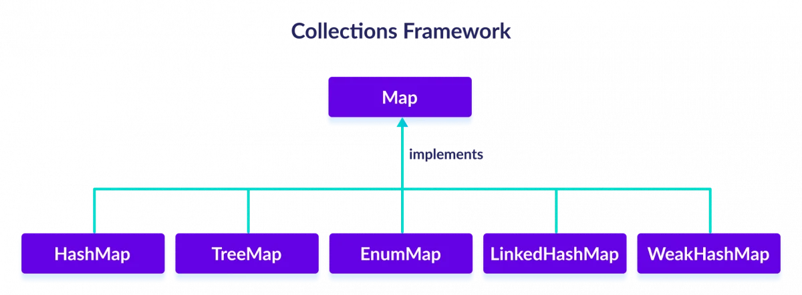

Interfaces that extend Map

The Map interface is also extended by these subinterfaces:

SortedMap
NavigableMap
ConcurrentMap

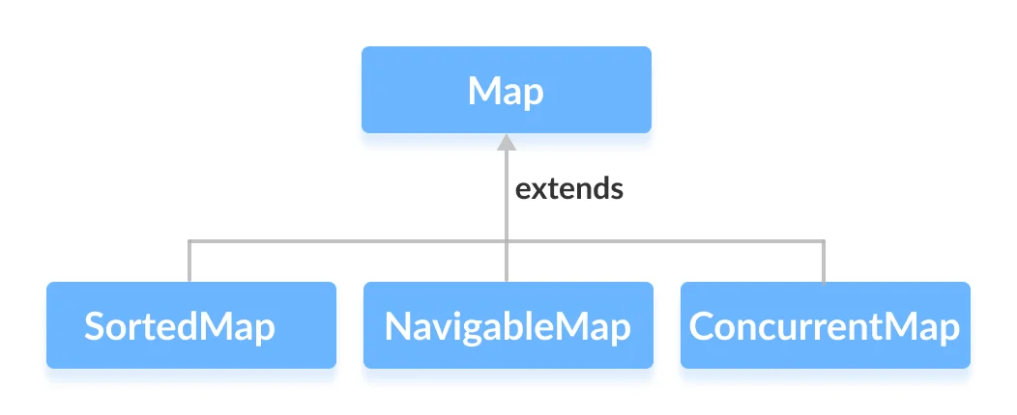
Methods of Map

The Map interface includes all the methods of the Collection interface. It is because Collection is a super interface of Map.

Besides methods available in the Collection interface, the Map interface also includes the following methods:

Method | Description
put(K, V) | Inserts the association of a key K and a value V into the map. If the key is already present, the new value replaces the old value.
putAll() | Inserts all the entries from the specified map to this map.
putIfAbsent(K, V) | Inserts the association if the key K is not already associated with the value V.
get(K) | Returns the value associated with the specified key K. If the key is not found, it returns null.
getOrDefault(K, defaultValue) | Returns the value associated with the specified key K. If the key is not found, it returns the defaultValue.
containsKey(K) | Checks if the specified key K is present in the map or not.
containsValue(V) | Checks if the specified value V is present in the map or not.
replace(K, V) | Replace the value of the key K with the new specified value V.
replace(K, oldValue, newValue) | Replaces the value of the key K with the new value newValue only if the key K is associated with the value oldValue.
remove(K) | Removes the entry from the map represented by the key K.
remove(K, V) | Removes the entry from the map that has key K associated with value V.
keySet() | Returns a set of all the keys present in a map.
values() | Returns a set of all the values present in a map.
entrySet() | Returns a set of all the key/value mapping present in a map.
clear() | removes all mappings from the HashMap
compute() | computes a new value for the specified key
computeIfAbsent() | computes value if a mapping for the key is not present
computeIfPresent() | computes a value for mapping if the key is present
merge() | merges the specified mapping to the HashMap
size() | returns the number of items in HashMap
isEmpty() | checks if the Hashmap is empty

Java SortedMap Interface

The SortedMap interface of the Java collections framework provides sorting of keys stored in a map.

It extends the Map interface.

Class that implements SortedMap

Since SortedMap is an interface, we cannot create objects from it.

In order to use the functionalities of the SortedMap interface, we need to use the class TreeMap that implements it.

Methods of SortedMap

The SortedMap interface includes all the methods of the Map interface. It is because Map is a super interface of SortedMap.

Besides all those methods, here are the methods specific to the SortedMap interface.

Method | Description
comparator() | returns a comparator that can be used to order keys in a map
firstKey() | returns the first key of the sorted map
lastKey() | returns the last key of the sorted map
headMap(key) | returns all the entries of a map whose keys are less than the specified key
tailMap(key) | returns all the entries of a map whose keys are greater than or equal to the specified key
subMap(key1, key2) | returns all the entries of a map whose keys lies in between key1 and key2 including key1

Java NavigableMap Interface

The NavigableMap interface of the Java collections framework provides the features to navigate among the map entries.

It is considered as a type of SortedMap.
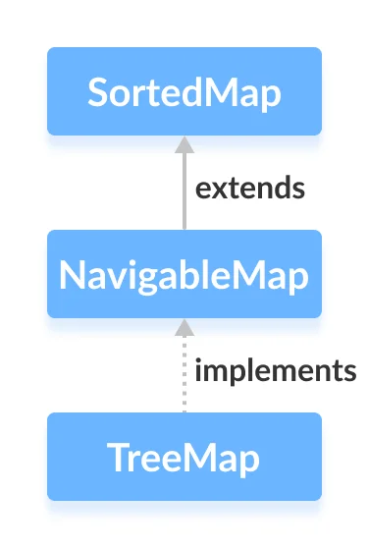

Class that implements NavigableMap

Since NavigableMap is an interface, we cannot create objects from it.

In order to use the functionalities of the NavigableMap interface, we need to use the TreeMap class that implements NavigableMap.

Methods of NavigableMap

The NavigableMap is considered as a type of SortedMap. It is because NavigableMap extends the SortedMap interface.

Hence, all SortedMap methods are also available in NavigableMap.

However, some of the methods of SortedMap (headMap(), tailMap(), and subMap() ) are defined differently in NavigableMap.

Method | Description
ceilingEntry(K key) | Returns a key-value mapping associated with the least key greater than or equal to the given key, or null if there is no such key.
ceilingKey(K key) | Returns the least key greater than or equal to the given key, or null if there is no such key.
descendingKeySet() | Returns a reverse order NavigableSet view of the keys contained in this map.
descendingMap() | Returns a reverse order view of the mappings contained in this map.
firstEntry() | Returns a key-value mapping associated with the least key in this map, or null if the map is empty.
floorEntry(K key) | Returns a key-value mapping associated with the greatest key less than or equal to the given key, or null if there is no such key.
floorKey(K key) | Returns the greatest key less than or equal to the given key, or null if there is no such key.
headMap(K toKey) | Returns a view of the portion of this map whose keys are strictly less than toKey.
headMap(K toKey, boolean inclusive) | Returns a view of the portion of this map whose keys are less than (or equal to, if inclusive is true) toKey.
higherEntry(K key) | Returns a key-value mapping associated with the least key strictly greater than the given key, or null if there is no such key.
higherKey(K key) | Returns the least key strictly greater than the given key, or null if there is no such key.
lastEntry() | Returns a key-value mapping associated with the greatest key in this map, or null if the map is empty.
lowerEntry(K key) | Returns a key-value mapping associated with the greatest key strictly less than the given key, or null if there is no such key.
lowerKey(K key) | Returns the greatest key strictly less than the given key, or null if there is no such key.
navigableKeySet() | Returns a NavigableSet view of the keys contained in this map.
pollFirstEntry() | Removes and returns a key-value mapping associated with the least key in this map, or null if the map is empty.
pollLastEntry() | Removes and returns a key-value mapping associated with the greatest key in this map, or null if the map is empty.
subMap(K fromKey, boolean  fromInclusive, K toKey, boolean toInclusive) | Returns a view of the portion of this map whose keys range from fromKey to toKey.
subMap(K fromKey, K toKey) | Returns a view of the portion of this map whose keys range from fromKey, inclusive, to toKey, exclusive.
tailMap(K fromKey) | Returns a view of the portion of this map whose keys are greater than or equal to fromKey.
tailMap(K fromKey, boolean inclusive) | Returns a view of the portion of this map whose keys are greater than (or equal to, if inclusive is true) fromKey.

Java HashMap

The HashMap class of the Java collections framework provides the functionality of the hash table data structure.

It stores elements in key/value pairs. Here, keys are unique identifiers used to associate each value on a map.

The HashMap class implements the Map interface.

Iterate through a HashMap

To iterate through each entry of the hashmap, we can use Java for-each loop. We can iterate through keys only, vales only, and key/value mapping. For example,

import java.util.HashMap;
import java.util.Map.Entry;

class Main {
public static void main(String[] args) {

// create a HashMap
HashMap<Integer, String> languages = new HashMap<>();
languages.put(1, "Java");
languages.put(2, "Python");
languages.put(3, "JavaScript");
System.out.println("HashMap: " + languages);

// iterate through keys only
System.out.print("Keys: ");
for (Integer key : languages.keySet()) {
System.out.print(key);
System.out.print(", ");
}

// iterate through values only
System.out.print("\nValues: ");
for (String value : languages.values()) {
System.out.print(value);
System.out.print(", ");
}

// iterate through key/value entries
System.out.print("\nEntries: ");
for (Entry<Integer, String> entry : languages.entrySet()) {
System.out.print(entry);
System.out.print(", ");
}
}
}

Java LinkedHashMap

The LinkedHashMap class of the Java collections framework provides the hash table and linked list implementation of the Map interface.

The LinkedHashMap interface extends the HashMap class to store its entries in a hash table. It internally maintains a doubly-linked list among all of its entries to order its entries.

LinkedHashMap Vs. HashMap

Both the LinkedHashMap and the HashMap implements the Map interface. However, there exist some differences between them.

LinkedHashMap maintains a doubly-linked list internally. Due to this, it maintains the insertion order of its elements.

The LinkedHashMap class requires more storage than HashMap. This is because LinkedHashMap maintains linked lists internally.

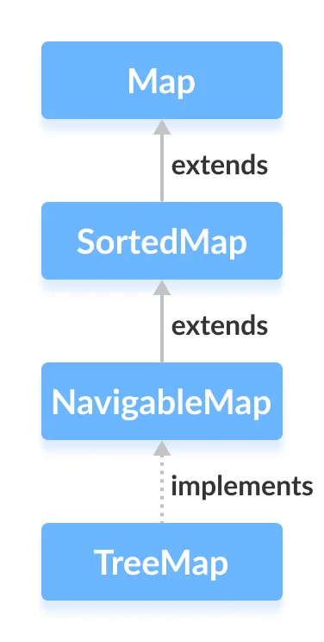
The performance of LinkedHashMap is slower than HashMap.

Java TreeMap

The TreeMap class of the Java collections framework provides the tree data structure implementation.

It implements the NavigableMap interface.

TreeMap Comparator

Treemap elements are sorted naturally (in ascending order). However, we can also customize the ordering of keys.

Java ConcurrentMap Interface

The ConcurrentMap interface of the Java collections framework provides a thread-safe map. That is, multiple threads can access the map at once without affecting the consistency of entries in a map.

ConcurrentMap is known as a synchronized map.

It extends the Map interface.

Class that implements ConcurrentMap

Since ConcurrentMap is an interface, we cannot create objects from it.

In order to use the functionalities of the ConcurrentMap interface, we need to use the class ConcurrentHashMap that implements it.

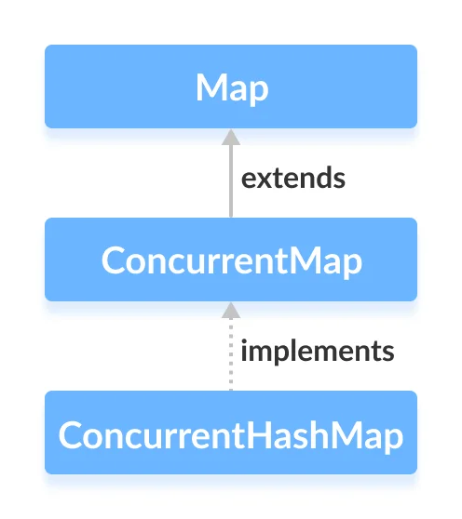
Java ConcurrentHashMap

The ConcurrentHashMap class of the Java collections framework provides a thread-safe map. That is, multiple threads can access the map at once without affecting the consistency of entries in a map.

It implements the ConcurrentMap interface.

Methods of ConcurrentHashMap

The ConcurrentHashMap class provides methods that allow us to perform various operations on the map.

Insert Elements to ConcurrentHashMap

put() - inserts the specified key/value mapping to the map
putAll() - inserts all the entries from specified map to this map
putIfAbsent() - inserts the specified key/value mapping to the map if the specified key is not present in the map
Access ConcurrentHashMap Elements

1. Using entrySet(), keySet() and values()

entrySet() - returns a set of all the key/value mapping of the map
keySet() - returns a set of all the keys of the map
values() - returns a set of all the values of the map

2. Using get() and getOrDefault()

get() - Returns the value associated with the specified key. Returns null if the key is not found.
getOrDefault() - Returns the value associated with the specified key. Returns the specified default value if the key is not found.

Remove ConcurrentHashMap Elements

remove(key) - returns and removes the entry associated with the specified key from the map
remove(key, value) - removes the entry from the map only if the specified key mapped to the specified value and return a boolean value

Bulk ConcurrentHashMap Operations

The ConcurrentHashMap class provides different bulk operations that can be applied safely to concurrent maps.

1. forEach() Method

The forEach() method iterates over our entries and executes the specified function.

It includes two parameters.

parallelismThreshold - It specifies that after how many elements operations in a map are executed in parallel.
transformer - This will transform the data before the data is passed to the specified function.

Variation of forEach() Method

forEachEntry() - executes the specified function for each entry
forEachKey() - executes the specified function for each key
forEachValue() - executes the specified function for each value

2. search() Method

The search() method searches the map based on the specified function and returns the matched entry.

Here, the specified function determines what entry is to be searched.

It also includes an optional parameter parallelThreshold. The parallel threshold specifies that after how many elements in the map the operation is executed in parallel.

Variants of search() Method

searchEntries() - search function is applied to key/value mappings
searchKeys() - search function is only applied to the keys
searchValues() - search function is only applied to the values

3. reduce() Method
The reduce() method accumulates (gather together) each entry in a map. This can be used when we need all the entries to perform a common task, like adding all the values of a map.

It includes two parameters.

parallelismThreshold - It specifies that after how many elements, operations in a map are executed in parallel.
transformer - This will transform the data before the data is passed to the specified function.

Variants of reduce() Method

reduceEntries() - returns the result of gathering all the entries using the specified reducer function
reduceKeys() - returns the result of gathering all the keys using the specified reducer function
reduceValues() - returns the result of gathering all the values using the specified reducer function

Why ConcurrentHashMap?

The ConcurrentHashMap class allows multiple threads to access its entries concurrently. By default, the concurrent hashmap is divided into 16 segments. This is the reason why 16 threads are allowed to concurrently modify the map at the same time. However, any number of threads can access the map at a time. The putIfAbsent() method will not override the entry in the map if the specified key already exists. It provides its own synchronization.

ConcurrentHashMap vs HashMap

Here are some of the differences between ConcurrentHashMap and HashMap,

ConcurrentHashMap is a thread-safe collection. That is, multiple threads can access and modify it at the same time.

ConcurrentHashMap provides methods for bulk operations like forEach(), search() and reduce().

Hashtable

Hashtable was part of the original java.util and is a concrete implementation of a Dictionary. However, with the advent of collections, Hashtable was reengineered to also implement the Map interface. Thus, Hashtable is integrated into the Collections Framework. It is similar to HashMap, but is synchronized. Like HashMap, Hashtable stores key/value pairs in a hash table. However, neither keys nor values can be null. When using a Hashtable, you specify an object that is used as a key, and the value that you want linked to that key. The key is then hashed, and the resulting hash code is used as the index at which the value is stored within the table. Hashtable was made generic by JDK 5. It is declared like this:

class Hashtable Here, K specifies the type of keys, and V specifies the type of values. A hash table can only store keys that override the hashCode( ) and equals( ) methods that are defined by Object. The hashCode( ) method must compute and return the hash code for the object. Of course, equals( ) compares two objects.

Properties

Properties is a subclass of Hashtable. It is used to maintain lists of values in which the key is a String and the value is also a String. The Properties class is used by some other Java classes. For example, it is the type of object returned by System.getProperties( ) when obtaining environmental values.

Demo

/* Let us see how to manipulate collection of object using collection framework
* Use Stream API methods,
*/

Entity Class:

public class Product {

private String productId;
private String productDescription;
private int quantityOnHand;
private float unitiPrice;
private LocalDate manufacturedDate;
private LocalDate expiryDate;
// define constructor, getter, setter, hashcode(), equals() and toString()
}

public class OrderProduct {
private String orderId;
private List<Product> productList; // Order has list of product
// define constructor, getter, setter, hashcode(), equals() and toString()
}

Exception

public class OrderManagementException extends Exception{

private String errorMessage;
private LocalDateTime errorOccuredTime;
public OrderManagementException(String errorMessage, LocalDateTime errorOccuredTime) {
super();
this.errorMessage = errorMessage;
this.errorOccuredTime = errorOccuredTime;
}
public String getErrorMessage() {
return errorMessage;
}
public LocalDateTime getErrorOccuredTime() {
return errorOccuredTime;
}
}

DAO

public interface OrderProductDao {

public String addOrder(OrderProduct orderproduct) throws OrderManagementException;
public List<Product> findAllProductByOrderId(String orderId) throws OrderManagementException;
public String deleteOrderedProduct(String orderid,Product product) throws OrderManagementException;
public String updateProductQuantity(String orderid, Product product) throws OrderManagementException;

}

public class OrderProductDaoImpl implements OrderProductDao{

private Map<String, List<Product>> ordermapproduct = new HashMap<>();

@Override
public String addOrder(OrderProduct orderproduct) throws OrderManagementException {
if(!ordermapproduct.containsKey(orderproduct.getOrderId())) {
ordermapproduct.put(orderproduct.getOrderId(), orderproduct.getProductList());
return orderproduct.getOrderId()+" placed";
}
else {
throw new OrderManagementException("Sorry unable to place your order.", LocalDateTime.now());
}
}

@Override
public List<Product> findAllProductByOrderId(String orderId) throws OrderManagementException {
if(!ordermapproduct.isEmpty()) {
List<Product> products = ordermapproduct.get(orderId.toUpperCase());
if(products.isEmpty())
throw new OrderManagementException("Unable to process the request. Please check!", LocalDateTime.now());
else
return products;
}
else {
throw new OrderManagementException("Cart is empty", LocalDateTime.now());
}
}

@Override
public String deleteOrderedProduct(String orderid, Product product) throws OrderManagementException {
if(!ordermapproduct.isEmpty()) {
List<Product> products = ordermapproduct.get(orderid);
Product deleteproduct = products.stream()
.filter(prod -> prod.getProductId().equalsIgnoreCase(product.getProductId()))
.findAny()
.orElse(null);
if(deleteproduct!=null)
products.remove(deleteproduct);
else
throw new OrderManagementException("Sorry product not found in cart!", LocalDateTime.now());
return product.getProductDescription()+" removed!";
}
else {
throw new OrderManagementException("Cart is empty", LocalDateTime.now());
}
}

@Override
public String updateProductQuantity(String orderid, Product product) throws OrderManagementException {
if(!ordermapproduct.isEmpty()) {
List<Product> products = ordermapproduct.get(orderid.toUpperCase());
Product updateproduct = products.stream()
.filter(prod -> prod.getProductId().equalsIgnoreCase(product.getProductId()))
.findAny()
.orElse(null);
if(updateproduct!=null)
updateproduct.setQuantityOnHand(product.getQuantityOnHand());
else
throw new OrderManagementException("Sorry product not found in cart!", LocalDateTime.now());
return product.getProductId()+" updated!";
}
else {
throw new OrderManagementException("Cart is empty", LocalDateTime.now());
}
}
}

Service

public interface OrderProductService {

public String addOrder(OrderProduct orderproduct);
public List<Product> findAllProductByOrderId(String orderId);
public String deleteOrderedProduct(String orderid,Product product);
public String updateProductQuantity(String orderid, Product product);

}

public class OrderProductServiceImpl implements OrderProductService{

private OrderProductDao orderproductdao = new OrderProductDaoImpl();

@Override
public String addOrder(OrderProduct orderproduct) {
try {
return orderproductdao.addOrder(orderproduct);
} catch (OrderManagementException e) {
System.err.println(e.getErrorOccuredTime()+" Error Message:"+e.getErrorMessage());
return "unable to addorder";
}
}

@Override
public List<Product> findAllProductByOrderId(String orderId) {
try {
return orderproductdao.findAllProductByOrderId(orderId);
} catch (OrderManagementException e) {
System.err.println(e.getErrorOccuredTime()+" Error Message:"+e.getErrorMessage());
return null;
}
}

@Override
public String deleteOrderedProduct(String orderid, Product product) {
try {
return orderproductdao.deleteOrderedProduct(orderid, product);
} catch (OrderManagementException e) {
System.err.println(e.getErrorOccuredTime()+" Error Message:"+e.getErrorMessage());
return "unable to delete";
}
}

@Override
public String updateProductQuantity(String orderid, Product product) {
try {
return orderproductdao.updateProductQuantity(orderid, product);
} catch (OrderManagementException e) {
System.err.println(e.getErrorOccuredTime()+" Error Message:"+e.getErrorMessage());
return "unable to update";
}
}

}

Main

public class OrderProductApp {

public static void main(String[] args) {

String choice;
char repeat='n';

List<Product> products = new ArrayList<Product>();
products.add(new Product("P001","Monitor",100,15000.0f,LocalDate.of(2021, 12, 6),LocalDate.of(2026, 12, 6)));
products.add(new Product("P002","Lays",50,15.0f,LocalDate.of(2021, 12, 6),LocalDate.of(2022, 1, 6)));
products.add(new Product("P003","Maagi",60,20.0f,LocalDate.of(2021, 12, 6),LocalDate.of(2026, 12, 6)));

OrderProduct orderproduct = new OrderProduct("OR001", products);

OrderProductService orderproductservice = new OrderProductServiceImpl();
do {
System.out.println("Enter your choice:");
System.out.println("1. Add order");
System.out.println("2. Update the product quantity");
System.out.println("3. Delete a product");
System.out.println("4. Reterive all product");
System.out.println("5. Exit");
Scanner input = new Scanner(System.in);
choice = input.next();
switch(choice) {
case "add":
System.out.println(orderproductservice.addOrder(orderproduct));;
break;
case "update":
String orderid,productid;
int quantity;
Product product;
System.out.println("Enter the orderid to update quantity:");
orderid = input.next();
System.out.println("Enter the productid and quantity");
productid=input.next();
quantity = input.nextInt();
product = new Product(productid,"",quantity,0.0f,null,null);
System.out.println(orderproductservice.updateProductQuantity(orderid, product));;
break;
case "search":
String deleteorderid,dproductid;
Product deleteproduct;
System.out.println("Enter the orderid to search:");
deleteorderid = input.next();
System.out.println("Enter the product id to be deleted:");
dproductid = input.next();
deleteproduct = new Product(dproductid,"",0,0.0f,null,null);
System.out.println(orderproductservice.deleteOrderedProduct(deleteorderid, deleteproduct));
break;
case "reterive":
String sorderid;
System.out.println("Enter the orderid:");
sorderid = input.next();
orderproductservice.findAllProductByOrderId(sorderid)
.stream()
.forEach(prod->System.out.println(prod));
break;
case "exit":
System.out.println("Thank you! Visit again");
System.exit(0);
default:
System.out.println("Please select a valid choice");
}
System.out.println("Do you want to repeat?");
repeat = input.next().charAt(0);
}while(repeat=='y');
System.out.println("Thank you!");
}

}

