Session 6

Introduction to File Input and Output

Program often need to communicate with the outside world. The means of communication are input (such as a keyboard) and output (such as the computer screen). Programs can also communicate through stored data, such as files.

I/O Streams

A stream is a communication channel that a program has with the outside world. It is used to transfer data items in succession.

An Input/Output (I/O) Stream represents an input source or an output destination. A stream can represent many different kinds of sources and destinations, including disk files, devices, other programs, and memory arrays.

Streams support many different kinds of data, including simple bytes, primitive data types, localized characters, and objects. Some streams simply pass on data; others manipulate and transform the data in useful ways.

No matter how they work internally, all streams present the same simple model to programs that use them: A stream is a sequence of data.

Reading information into a program.

A program uses an input stream to read data from a source, one item at a time:

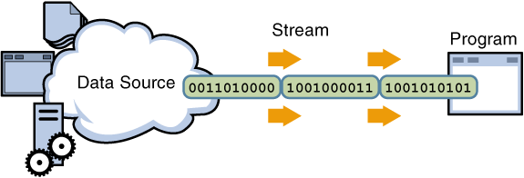

Writing information from a program.
A program uses an output stream to write data to a destination, one item at time:

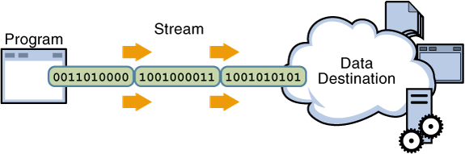

The data source and data destination pictured above can be anything that holds, generates, or consumes data. Obviously this includes disk files, but a source or destination can also another program, a peripheral device, a network socket, or an array.

The Java IO API

The java.io package contains many classes that your programs can use to read and write data. Most of the classes implement sequential access streams. The sequential access streams can be divided into two groups: those that read and write bytes and those that read and write Unicode characters. Each sequential access stream has a speciality, such as reading from or writing to a file, filtering data as its read or written, or serializing an object.

Types of Streams

Byte Streams: Byte streams perform input and output of 8-bit bytes. They read and write data one byte at a time. Using byte streams is the lowest level of I/0, so if you are reading or writing character data the best approach is to use character streams. Other stream types are built on top of byte streams.

Character Streams: All character stream classes are descended from Reader and Writer.We are going to use the Reader and Writer classes that perform file I/0, FileReader and FileWriter. We will look at two examples of writing programs using character streams, one that reads and writes one character at a time and one that reads and writes one line at a time.

Streams

1) Java programs perform I/O through streams
2) A stream is an abstraction that either produces or consumes information.
3) It is linked to a physical device by the Java I/O system
4) This means that an input stream can abstract many different kinds of input: from a disk file,
a keyboard, or a network socket. Likewise, an output stream may refer to the console, a disk
file, or a network connection.

Byte Streams and Character Streams

Java defines two types of streams: byte and character.

Byte streams provide a convenient means for handling input and output of bytes. Byte streams are used, for example, when reading or writing binary data.

Character streams provide a convenient means for handling input and output of characters. They use Unicode and, therefore, can be internationalized.

The Byte Stream Classes

Byte streams are defined by using two class hierarchies. At the top are two abstract classes InputStream and OutputStream.

InputStream and OutputStream define several key methods that the other stream classes implement. Two of the most important are read( ) and write( ) which, respectively, read and write bytes of data

The Character Stream Classes

Character streams are defined by using two class hierarchies. At the top are two abstract classes, Reader and Writer

Two of the most important methods are read( ) and write( ), which read
and write characters of data, respectively.

Reading Console Input

public class ReadingConsoleInputDemo {

public static void main(String[] args) throws IOException {
// TODO Auto-generated method stub
String name;
BufferedReader br = new BufferedReader(new InputStreamReader(System.in));
System.out.println("enter ur name");
//reading string input
name = br.readLine();
System.out.println("enter a character");
//reading character input
int ch = br.read();
System.out.println((char)ch);
//int result =Integer.parseInt(name)+1;
System.out.println("Welcome "+name);
}

}

Writing Console Output

print() and println() -> PrintStream class
it also implements the low-level method write()

void write(int byteval)

PrintWriter Class

PrintWriter is one of the character-based classes.

PrintWriter(OutputStream outputStream, boolean flushOnNewline)

print() and println()

Reading and Writing Files

Two of the most often-used stream classes are FileInputStream and FileOutputStream

Constructor;

FileInputStream(String fileName) throws FileNotFoundException
FileOutputStream(String fileName) throws FileNotFoundException

when you done with the file you have to call close();

void close() throws IOException

To read from a file you can use;

int read() throws IOException

To write to a file, you can use the write()

void write(int byteval) throws IOException

ByteArrayInputStream

An implementation of an input stream that uses a byte array as the source

ByteArrayInputStream(byte array[ ])
ByteArrayInputStream(byte array[ ], int start, int numBytes)

public class ByteArrayInputStreamDemo {

public static void main(String[] args) {
// TODO Auto-generated method stub
String input = "byte array input";
byte []arraybyte = input.getBytes();
int ch;
ByteArrayInputStream obj = new ByteArrayInputStream(arraybyte);
while((ch = obj.read())!=-1)
{
System.out.print((char)ch);
}
}

}

BufferedInputStream/BufferedOutputStream

public class BufferedInputStreamDemo {

public static void main(String[] args) throws IOException {
// TODO Auto-generated method stub
/*BufferedInputStream(InputStream inputStream)
BufferedInputStream(InputStream inputStream, int bufSize)*/
int ch;
BufferedInputStream obj = new BufferedInputStream
(new FileInputStream("inputFile"));
BufferedOutputStream outobj = new BufferedOutputStream
(new FileOutputStream("outfile",true));
while((ch=obj.read())!=-1)
{
outobj.write(ch);
}
obj.close();
outobj.close();

}

}

DataOutputStream and DataInputStream

It enable you to write or read primitive data to or from a stream.

They implement the DataOutput and DataInput interfaces, respectively.

These interfaces define methods that convert primitive values to or from a sequence of bytes. These streams make it easy to store binary data, such as integers or floating-point values, in a file.

DataOutputStream extends FilterOutputStream, which extends OutputStream.DataOutputStream defines the following constructor:

DataOutputStream(OutputStream outputStream)

DataOutput defines methods that convert values of a primitive type into a byte sequence and then writes it to the underlying stream.

final void writeDouble(double value) throws IOException
final void writeBoolean(boolean value) throws IOException
final void writeInt(int value) throws IOException

DataInputStream is the complement of DataOuputStream. It extends FilterInputStream, which extends InputStream, and it implements the DataInput interface. Here is its only constructor:

DataInputStream(InputStream inputStream)

double readDouble( ) throws IOException
boolean readBoolean( ) throws IOException
int readInt( ) throws IOException

public class DataIODemo {
public static void main(String args[])
throws IOException {
FileOutputStream fout = new FileOutputStream("Test.dat");
DataOutputStream out = new DataOutputStream(fout);
out.writeDouble(98.6);
out.writeInt(1000);
out.writeBoolean(true);
out.close();
FileInputStream fin = new FileInputStream("Test.dat");
DataInputStream in = new DataInputStream(fin);
double d = in.readDouble();
int i = in.readInt();
boolean b = in.readBoolean();
System.out.println("Here are the values: " +
d + " " + i + " " + b);
in.close();
}
}

The Character Streams

ByteStream cannot work directly with Unicode characters.So it is necessary to include I/O support for characters.

Reader and Writer abstract classes.

Reader

It is an abstract class that defines Java’s model of streaming character input.
It implements the Closeable and Readable interfaces.

Writer

Writer is an abstract class that defines streaming character output.
It implements the Closeable,Flushable, and Appendable interfaces

FileReader

FileReader class creates a Reader that you can use to read the contents of a file. Its two most commonly used constructors are

FileReader(String filePath)
FileReader(File fileObj)

public class FileReaderDemo {
public static void main(String args[]) throws IOException {
FileReader fr = new FileReader("FileReaderDemo.java");
BufferedReader br = new BufferedReader(fr);
String str;
while((str = br.readLine()) != null) {
System.out.println(s);
}
fr.close();
}
}

FileWriter

FileWriter creates a Writer that you can use to write to a file. Its most commonly used constructors are

FileWriter(String filePath)
FileWriter(String filePath, boolean append)
FileWriter(File fileObj)
FileWriter(File fileObj, boolean append)

public class FileWriterDemo
{
public static void main(String arg[])
{
String str = "good morining! have a nice day";
char []buffer = new char[str.length()];
str.getChars(0,str.length(),buffer,0);
FileWriter fwobj = new FileWriter("fileoutput");
fwobj.write(buffer);
fwobj.close();
}
}

Serialization

Serialization is the process of writing the state of an object to a byte stream.

This is useful when you want to save the state of your program to a persistent storage area, such as a file.

At a later time, you may restore these objects by using the process of deserialization.

It is also needed to implement Remote Method Invocation (RMI) which allows a Java object on one machine to invoke a method of a Java object on a different machine.

An object may be supplied as an argument to that remote method. The sending machine serializes the object and transmits it. The receiving machine deserializes it.

Serializable

Only an object that implements the Serializable interface can be saved and restored by the serialization facilities.

It defines no members, simply used to indicate that a class may be serialized.

class is serializable, all of its subclasses are also serializable.

Transient variable and static variables are not saved by the serialization facilities

Externalizable

The Externalizable interface defines these two methods:

void readExternal(ObjectInput inStream) throws IOException, ClassNotFoundException
void writeExternal(ObjectOutput outStream) throws IOException

ObjectOutput

ObjectOutput interface extends the DataOutput interface and supports object serialization.

writeObject() is called to serialize an object.

ObjectOutputStream

ObjectOutputStream class extends the OutputStream class and implements the ObjectOutput interface.It is responsible for writing objects to a stream.

ObjectOutputStream(OutputStream outStream) throws IOException

ObjectInput

ObjectInput interface extends the DataInput interface and supports object serialization.

readObject() method is called to deserialize an object

ObjectInputStream

ObjectInputStream class extends the InputStream class and implements the ObjectInput interface.
It is responsible for reading objects from a stream. A constructor of this class is

ObjectInputStream(InputStream inStream) throws IOException

eg:

class MyClass implements Serializable {
String s;
int i;
double d;
public MyClass(String s, int i, double d) {
this.s = s;
this.i = i;
this.d = d;
}
public String toString() {
return "s=" + s + "; i=" + i + "; d=" + d;
}
}

public class SerializationDemo {
public static void main(String args[]) {
// Object serialization
try {
MyClass object1 = new MyClass("Hello", -7, 2.7e10);
System.out.println("object1: " + object1);
FileOutputStream fos = new FileOutputStream("serial");
ObjectOutputStream oos = new ObjectOutputStream(fos);
oos.writeObject(object1);
oos.flush();
oos.close();
}
catch(IOException e) {
System.out.println("Exception during serialization: " + e);
System.exit(0);
}
// Object deserialization
try {
MyClass object2;
FileInputStream fis = new FileInputStream("serial");
ObjectInputStream ois = new ObjectInputStream(fis);
object2 = (MyClass)ois.readObject();
ois.close();
System.out.println("object2: " + object2);
}
catch(Exception e) {
System.out.println("Exception during deserialization: " + e);
System.exit(0);
}
}
}

Logger

Java Logging API was introduced in 1.4 and you can use java logging API to log application messages.

Logging levels, Logging Handlers, Formatters, Filters, Log Manager and logging configurations.

Java Logger

java.util.logging.Logger is the class used to log application messages in java logging API.

We can create java Logger as
Logger logger = Logger.getLogger(classname.class.getName());

(or)

Logger logger = Logger.getLogger(classname.class.getName());
LogManager.getLogManager().readConfiguration(new FileInputStream("logging.properties"));

Java Logging Levels

java.util.logging.Level defines the different levels of java logging.

SEVERE
WARNING
INFO
CONFIG
FINE
FINER
FINEST

We can set the logger level using following code:
logger.setLevel(Level.FINE);

The logs will be generated for all the levels equal to or greater than the logger level. For example if logger level is set to INFO, logs will be generated for INFO, WARNING and SEVERE logging messages.

Java Logging Handlers

There are two default handlers provided by Java Logging API.

ConsoleHandler: This handler writes all the logging messages to console

FileHandler: This handler writes all the logging messages to file in the XML format.

Java Logging Formatters

used to format the log messages. There are two available formatters in java logging API.

SimpleFormatter: This formatter generates text messages with basic information. ConsoleHandler uses this formatter class to print log messages to console.

XMLFormatter: This formatter generates XML message for the log, FileHandler uses XMLFormatter as a default formatter.

JDBC

1. What is JDBC?

Java Database Connectivity or JDBC API provides industry-standard and database-independent connectivity between the Java applications and relational database servers (relational databases, spreadsheets, and flat files).

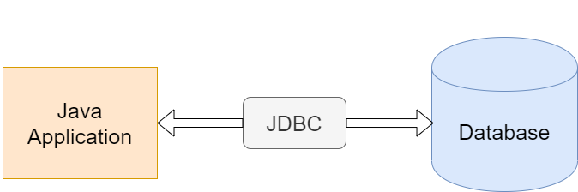

To keep it simple, JDBC allows a Java application to connect to a relational database. The major databases are supported such as Oracle, Microsoft SQL Server, DB2 and many others.

2. JDBC Flow

JDBC helps you to write Java applications that manage these three programming activities:

Connect to a data source, like a database
Send queries and update statements to the database
Retrieve and process the results received from the database in answer to your query

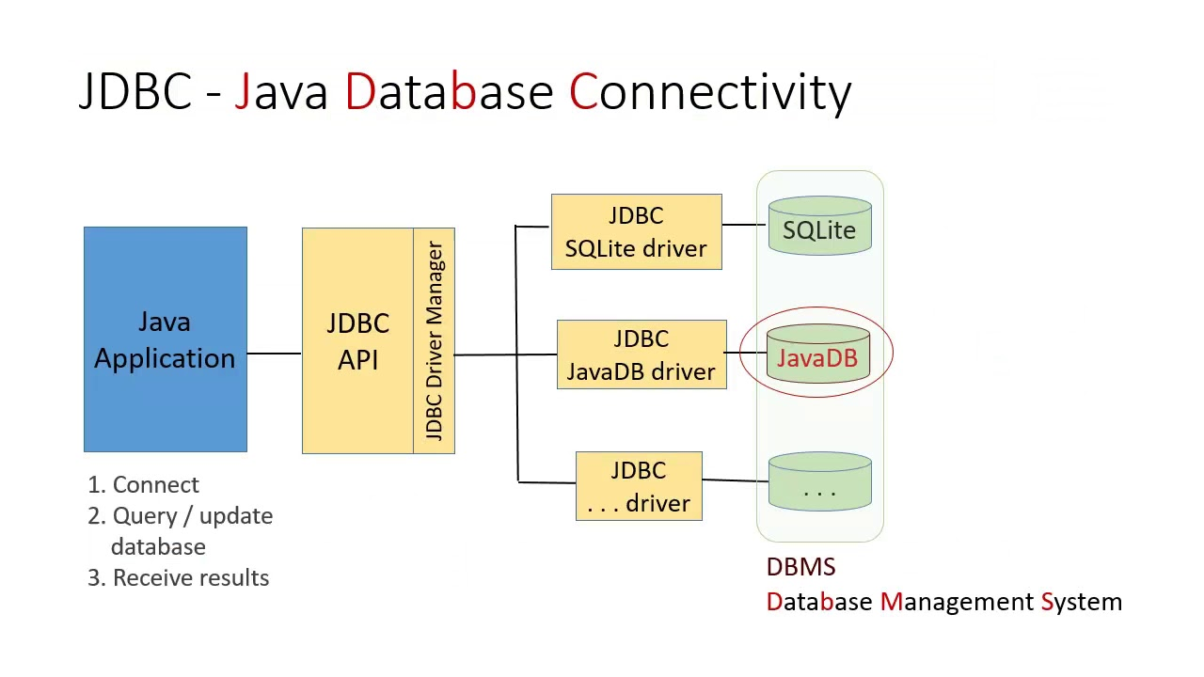
3. JDBC API

The JDBC API is comprised of two packages:
java.sql
javax.sql

JDBC API consists of two parts – the first part is the JDBC API to be used by the application programmers. The second part is the low-level API to connect to a database server(JDBC Driver).
The first part of JDBC API is part of standard java packages in java.sql package. We use java.sql package API for accessing and processing data stored in a data source (usually a relational database) using the Java programming language.

For the second part is the JDBC driver(there are four different types of JDBC drivers) A JDBC driver is a set of Java classes that implement the JDBC interfaces, targeting a specific database. The JDBC interfaces come with standard Java, but the implementation of these interfaces is specific to the database you need to connect to. Such an implementation is called a JDBC driver.

Key Classes and Interfaces

JDBC Connection Interface
JDBC Statement Interface
JDBC PreparedStatement Interface
JDBC CallableStatement Interface
JDBC ResultSet Interface with Examples
JDBC ResultSetMetaData Interface
JDBC DatabaseMetaData Interface
JDBC DriverManager Class

4. JDBC Driver Types

To use the JDBC API with a particular database management system(MySQL, Oracle, etc), we need a JDBC technology-based driver to mediate between JDBC technology and the database. Depending on various factors, a driver might be written purely in the Java programming language or in a mixture of the Java programming language and Java Native Interface (JNI) native methods.

Install a JDBC driver from the vendor of your database. A JDBC driver is a set of Java classes that implement the JDBC interfaces, targeting a specific database. The JDBC interfaces come with standard Java, but the implementation of these interfaces is specific to the database you need to connect to. Such an implementation is called a JDBC driver.

There are 4 different types of JDBC drivers:
Type 1: JDBC-ODBC bridge driver
Type 2: Java + Native code driver
Type 3: All Java + Middleware translation driver
Type 4: All Java driver.

If you are using Java DB ( Apache Derby database), it already comes with a JDBC driver. If you are using MySQL, install the latest version of Connector/J.

Type 1: JDBC-ODBC bridge driver

Drivers that implement the JDBC API as a mapping to another data access API, such as ODBC (Open Database Connectivity). Drivers of this type are generally dependent on a native library, which limits their portability.

Note: The JDBC-ODBC Bridge should be considered a transitional solution. It is not supported by Oracle. Consider using this only if your DBMS does not offer a Java-only JDBC driver.

Type 2: Java + Native code driver

Drivers that are written partly in the Java programming language and partly in native code. These drivers use a native client library specific to the data source to which they connect. Again, because of the native code, their portability is limited. Oracle's OCI (Oracle Call Interface) client-side driver is an example of a Type 2 driver.

Type 3: All Java + Middleware translation driver

Type 3: Drivers that use a pure Java client and communicate with a middleware server using a database-independent protocol. The middleware server then communicates the client's requests to the data source.

Type 4: All Java driver

Type 4: Drivers that are pure Java and implement the network protocol for a specific data source. The client connects directly to the data source.
MySQL Connector/J is a Type 4 driver.

How to install a JDBC driver?

Installing a JDBC driver generally consists of copying the driver to your computer, then add the location of it to your classpath. In addition, many JDBC drivers other than Type 4 drivers require you to install a client-side API. No other special configuration is usually needed.

5. Fundamental Steps in JDBC

The fundamental steps involved in the process of connecting to a database and executing a query consist of the following:
Import JDBC packages
Load and register the JDBC driver // This step is not required in Java 6 and in JDBC 4.0
Open a connection to the database.
Create a statement object to perform a query.
Execute the statement object and return a query resultset.
Process the resultset.
Close the resultset and statement objects. // This step is not required because we use a try-with-resource statement to auto-close the resources
Close the connection. // This step is not required because we use a try-with-resource statement to auto-close the resources

Demo

/* Create a Maven project to load the data from Employee.xls to Database
* Use Sonarqube to do analysis
* Use loggers and properties file to maintain db info
*/

Entity Class

public class Employee {

private String empId;
private String empName;
private String address;
private String designation;
private float salary;
//define constructor, getter, setter, hashcode(), equals() and toString()
}

Util Class

public class DBConnection {

private String server,host,portno,databasename,url,username,password;
private Logger log = Logger.getLogger(DBConnection.class.getName());

public Connection getConnection() throws IOException, SQLException
{
//connection object
Connection con = null;

try(FileReader fr = new FileReader("d:"+File.separator+"EmployeeLoad"+File.separator+"db.properties");) {
//opening a file for read

//object creation for property
Properties prop = new Properties();
//loading data from property file
prop.load(fr);
//server://host:portno/databasename
this.server = prop.getProperty("jdbc_server");
this.host = prop.getProperty("jdbc_host");
this.portno = prop.getProperty("jdbc_portno");
this.databasename = prop.getProperty("jdbc_databasename");
this.url = this.server+"://"+this.host+":"+this.portno+"/"+this.databasename;
this.username = prop.getProperty("jdbc_username");
this.password = prop.getProperty("jdbc_password");

//System.out.println(url+" "+username);
con = DriverManager.getConnection(url, username, password);
} catch (SQLException e) {
log.severe(e.getMessage());
} catch (FileNotFoundException e) {
log.severe(e.getMessage());
} catch (IOException e) {
log.severe(e.getMessage());
}
log.info("Database connnection obtained");
return con;

}
}

Exception

public class EmployeeException extends Exception{

private final String errorMessage;
private final LocalDateTime errorOccured;
public EmployeeException(String errorMessage, LocalDateTime errorOccured) {
super();
this.errorMessage = errorMessage;
this.errorOccured = errorOccured;
}
public String getErrorMessage() {
return errorMessage;
}
public LocalDateTime getErrorOccured() {
return errorOccured;
}

}

DAO

public interface EmployeeDao {

public void readDataFromExcel(File file) throws IOException, SQLException, EmployeeException;
public void loadDataIntoDatabase(Employee employee) throws IOException, SQLException, EmployeeException;

}

public class EmployeeDaoImpl implements EmployeeDao{

public void readDataFromExcel(File file) throws IOException, SQLException, EmployeeException {
FileInputStream fis = new FileInputStream(file);
HSSFWorkbook workbook = new HSSFWorkbook(fis);
Sheet sheet = workbook.getSheet("Employee");
Iterator<Row> rows = sheet.iterator();
rows.next();
while(rows.hasNext()) {

Row row = rows.next();
Iterator<Cell> cells = row.cellIterator();
while(cells.hasNext())
{
Cell cell = cells.next();
String empid = cell.getStringCellValue();

cell = cells.next();
String empname = cell.getStringCellValue();

cell = cells.next();
String address = cell.getStringCellValue();

cell = cells.next();
String designation = cell.getStringCellValue();

cell = cells.next();
String sal = cell.getStringCellValue();
float salary = Float.parseFloat(sal);

loadDataIntoDatabase(new Employee(empid,empname,address,designation,salary));
}

}

}

public void loadDataIntoDatabase(Employee employee) throws SQLException, EmployeeException, IOException {
DBConnection dbconnect = new DBConnection();
Connection con = dbconnect.getConnection();
if(con!=null) {

try(PreparedStatement pstmt = con.prepareStatement("insert into employee values(?,?,?,?,?)")){
pstmt.setString(1, employee.getEmpId());
pstmt.setString(2, employee.getEmpName());
pstmt.setString(3, employee.getAddress());
pstmt.setString(4, employee.getDesignation());
if(employee.getSalary()>0)
pstmt.setFloat(5, employee.getSalary());
else
throw new EmployeeException("Invalid salary data found! Please check the employee file.", LocalDateTime.now());
pstmt.execute();
}
}
else {
throw new SQLException("Unable to connect with database");
}

}

}

Service

public interface EmployeeService {

public boolean readFromExcel(File file);

}

public class EmployeeServiceImpl implements EmployeeService{

private EmployeeDao employeeDAO = new EmployeeDaoImpl();
private Logger log = Logger.getLogger(EmployeeServiceImpl.class.getName());

public boolean readFromExcel(File file) {
try {
employeeDAO.readDataFromExcel(file);
log.info("Employee detail loaded into database.");
return true;
} catch (IOException e) {
log.severe(e.getMessage());
return false;
} catch (SQLException e) {
log.severe(e.getMessage());
return false;
} catch (EmployeeException e) {
log.severe(e.getErrorOccured()+" Error Message:"+e.getErrorMessage());
return false;
}
}

}

App.java

public class App
{
public static void main( String[] args )
{
EmployeeService empservice = new EmployeeServiceImpl();
File file;
try {
file = new File("d:"+File.separator+"EmployeeLoad"+File.separator+"Employee.xls");
empservice.readFromExcel(file);
}
catch(Exception e) {
System.err.println(e.getMessage());
}

}
}

