**Linux**

Linux is an open source O/S and called as light weight O/S

1. **ls** – command is used to list the files and directories inside a folder.

Notes for ls: ls means list

1. **pwd** – command is used to display the **exact directory path** where you're currently working. This is known as the **working directory** or **current directory**

Notes: Pwd means Print working directory.

1. **hostnamectl**- This command shows the hostname, operating system, kernel version, architecture, and other system information.

Notes: hostnamectl means • **hostname** refers to the system's name.

• ctl is short for **control.**

1. **touch file**.txt – command is used for create a new file.

Notes: The touch command is used to **create an empty file** or **update the timestamps** of an existing file without changing its content

Here JFI: **Timestamps** are the record of the time when a file was created, last modified, or last accessed. They help track the file's history by showing when these actions occurred.

1. **vi file.txt** - command is used to **edit a file** in the terminal on Linux and Unix-like systems.

**Notes: vi** stands for **Visual Editor**. It is one of the oldest and most widely used text editors in Unix-based systems.

It has two main modes:

**1. i -- Insert Mode**

**2. esc -- Command mode**

• From **Command Mode** to **Insert Mode** by pressing **i** (to start typing).

• From **Insert Mode** back to **Command Mode** by pressing **Esc**.

1. **:wq** - command is used to **save** and **exit** from the vi editor.

Notes: • w stands for "write," which saves the file.

• q stands for "quit," which closes the editor.

When you're done editing in vi, you can type**: wq** and press **Enter** to save and exit.

1. **:q!** – command in vi is used to **quit** the editor without saving any changes.

Notes**:** If you use: q**!** means **force quit** the editor and **discard all changes** you've made.

1. Slash( **/** )

**/** - in vi editor The slash / is used for searching. If I use / and then type the word I want to search, it will be highlighted.  
  
For example, the following four lines are written in Notepad:

**Below screenshot FYR**: 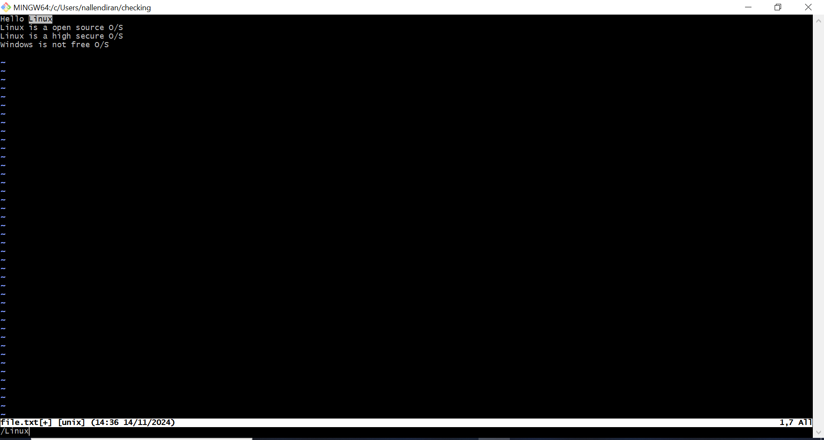

Notes: f I use /linux, the word 'Linux' in the first line will be highlighted.

FYI: The above screenshot FYR.

1. The? symbol is used for **searching backward**. If I use? and then type the word I want to search, it will search for that word **above** the current position and highlight it.

**For example:**

If I use? linux, it will search for 'linux' from the bottom to the top and highlight the first occurrence it finds above the current position.  
Below screenshot FYR:

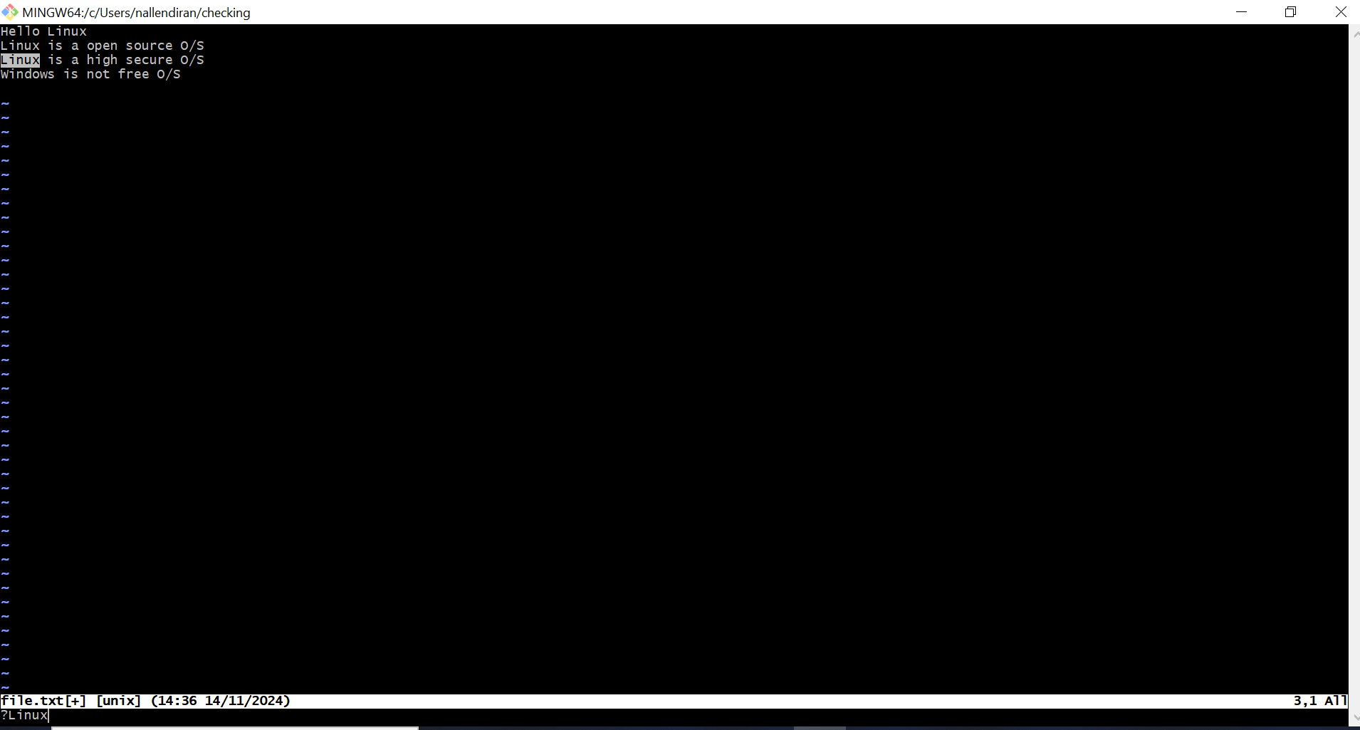

This way, (Question mark symbol)? searches in reverse, looking upwards through the document.

For our simple understanding:

• Using /linux will search for "linux" from top to bottom.

• Using ?linux will search for "linux" from bottom to top.

1. : set hlsearch – The: set **hlsearch** command is used to highlight all occurrences of a word in the document. For example, if I search for the word **'linux'**, all the word of **'linux'** in the file will be highlighted. If **'linux'** appears **three times in the file**, all three word will be highlighted...