BUSINESS REQUIREMENTS DOCUMENT
Inbox Triage Agent
An autonomous email classification and drafting assistant
Prepared by: Tanav Nalluri Reddy
Status: Draft
Last updated: September 2026
Version: 1.0

1. Purpose
Most professionals spend a significant share of the workday re-reading and manually triaging routine email — scheduling requests, simple confirmations, FYI threads — that doesn't need original human judgment. Existing tools (filters, labels, rules) sort by sender or keyword, not by actual content and intent, so the manual triage burden persists regardless of how well an inbox is organized.
This project builds an autonomous agent that reads unread email, classifies it by urgency and type, drafts context-aware replies for routine categories, and surfaces only genuinely ambiguous messages for human review — reducing the manual triage workload without removing human judgment from anything that requires it.

2. Background and Motivation
Industry research consistently shows email consumes a large share of the professional workweek. McKinsey Global Institute has found that roughly 28% of the average knowledge worker's week goes to reading and answering email. Separately, Microsoft's 2024 Work Trend Index found that Copilot-assisted workers spent about 11 fewer minutes per day on email processing — evidence that AI-assisted handling produces real, if modest, time savings on this specific task.
These figures motivate the project but are not used as a substitute for a measured result. This project's own before/after timing study (Section 8) is the basis for any efficiency claim in the final deliverable.

3. Objectives
- Reduce time spent on manual email triage for routine message categories
- Preserve human judgment and final approval for anything ambiguous or consequential
- Produce a working, demoable portfolio project with an honest, defensible efficiency metric
- Maintain a clean, narratively legible git history that documents real engineering decisions

4. Scope

4.1 In Scope
- Reading unread email via the Gmail API
- Classifying each email by urgency (today / this week / no response needed) and type (scheduling, informational, request, spam/newsletter, ambiguous)
- Drafting replies for clearly routine categories, using sender history/tone as context
- Surfacing ambiguous emails in a daily digest with a one-line reason for ambiguity
- Creating Gmail drafts (not sending) once core logic is verified

4.2 Out of Scope
- Auto-sending any email without human review
- Full inbox reorganization, labeling, or archival features
- Multi-account or team/shared-inbox support
- Training a dedicated ML classifier (Claude handles classification reasoning directly for this MVP)

5. Functional Requirements
ID | Requirement | Priority
FR1 | System shall authenticate to Gmail using OAuth2, starting with readonly scope | High
FR2 | System shall fetch unread emails, handling pagination for inboxes with >50 unread | High
FR3 | System shall classify each email by urgency and type in a single batched call per run | High
FR4 | System shall flag emails as ambiguous when classification confidence is low, with a stated reason | High
FR5 | System shall generate a draft reply for at least one routine category (scheduling) using sender history as context | Medium
FR6 | System shall produce a daily digest listing only ambiguous emails and their reasons | Medium
FR7 | System shall create Gmail drafts via the gmail.compose scope once drafting logic is verified — never gmail.send | High
FR8 | System shall log classification and draft outcomes to local storage for later review | Low

6. Non-Functional Requirements
Category | Requirement
Privacy | All email content stays local except for calls to the Claude API for classification/drafting; no third-party storage beyond that
Safety | No email is ever sent without explicit human action
Cost | Should run at negligible cost (low API token usage per run) for personal-scale inbox volume
Maintainability | Repository pattern for storage access to avoid duplicated query logic across modules

7. System Architecture
The system is composed of six cooperating modules: Gmail ingestion, batched classification, sender-context lookup, draft generation, ambiguous-email digesting, and local storage — each with a single responsibility so logic doesn't get duplicated as the project grows.
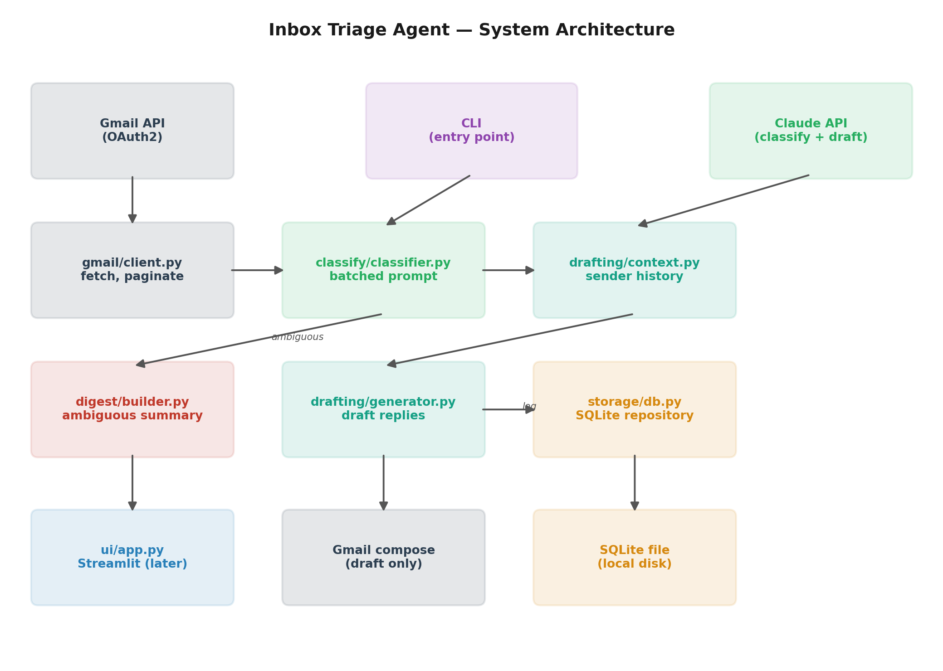

8. Process Flow
End to end, each run moves through six stages: fetch unread mail, classify it in a single batched call, branch on whether it's routine or ambiguous, then either draft a reply or log a digest entry — with a human always reviewing before anything is sent.
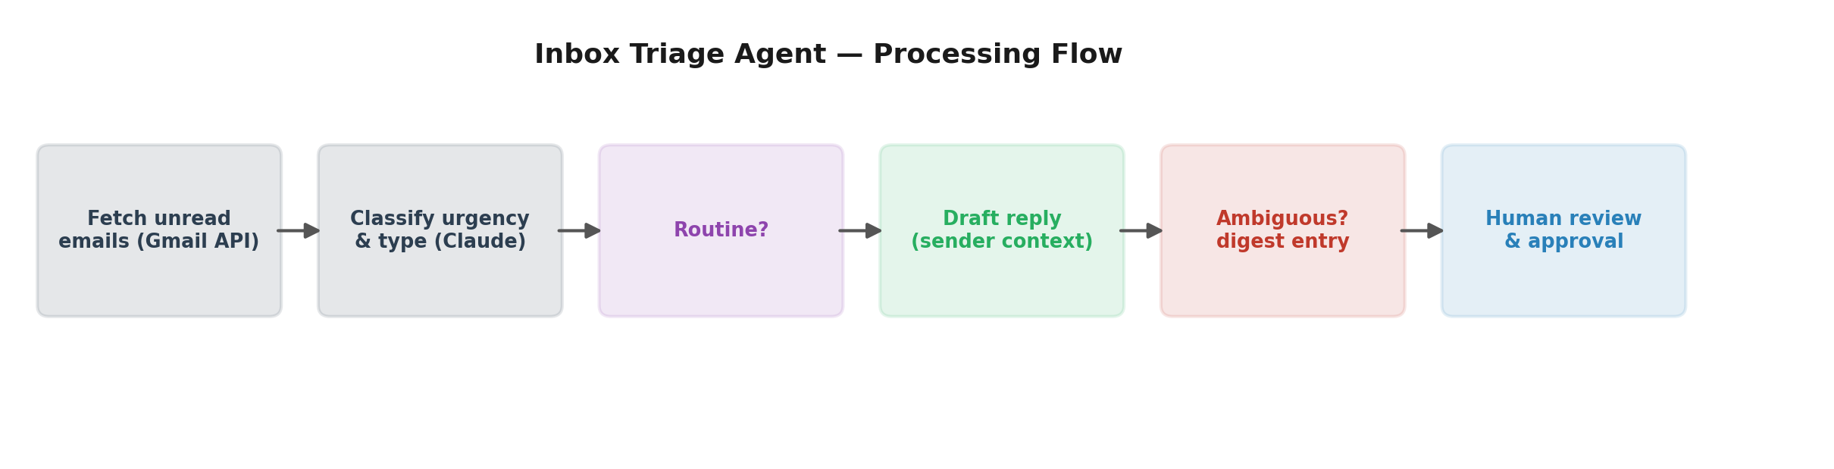

9. Success Metrics
Efficiency claims will be based on a self-run, documented timing study — not general industry statistics:
- Build and dogfood the MVP for 1–2 weeks to reach a stable state
- Select a fixed snapshot of unread emails (target: 30) as a test batch
- Time manual triage of that batch by hand (read, decide, draft/skip)
- Time the same batch processed through the agent, including human review of drafts
- Report percentage time reduction with the batch size and methodology documented alongside the number
Industry statistics (McKinsey, Microsoft) are used only as contextual motivation in project documentation, never as a stand-in for this measured result.

10. Technical Approach
Layer | Choice
Language | Python
Agent reasoning | Claude API / Claude Code
Email access | Gmail API (OAuth2), readonly → compose
Storage | SQLite
CLI | Typer/argparse (MVP), Streamlit (polish phase)
Dependency management | uv
Testing | pytest, fixed snapshot fixture for the timing study

11. Build Stages
Stage | Focus
1. Ingestion | Auth, fetch, pagination
2. Classification | Batched prompt, urgency/type/ambiguity
3. Digest | Ambiguous-email summary
4. Drafting | Sender-history context, single-category draft generation
5. Draft creation | Gmail compose integration
6. Measurement | Dogfooding period, timed comparison study
7. Polish | UI, settings panel, README with results and framing context

12. Risks and Open Questions
Risk | Mitigation
Classification accuracy on edge cases | Explicit ambiguity threshold rather than forcing a hard category on short/vague emails
OAuth scope creep | Start readonly, add compose only once core logic is verified; send scope never requested
Metric validity | Single 30-email study documented as a small sample, not presented as statistically robust
Sender-history “learning” feature | Deferred as a stretch goal given its complexity relative to MVP timeline
Classification non-determinism at the confidence threshold | Tightened classification prompt (explicit scoring rubric) and switched confidence to discrete bands (high/medium/low) instead of a continuous 0-1 score, which reduced but did not eliminate the effect: baseline was 6/50 emails affected (1 threshold flip + 5 confidence drifts) on a 2-call identical-input trial; after the change, 0/50 on one 2-call trial and 2/50 (1 flip + 1 diff) on a stricter 3-call trial. All figures are n=50, single batch, not a large-scale validation -- same small-sample caveat as the Section 9 timing study. Stage 6 measurement design should still classify once and freeze results rather than assume run-to-run determinism.
Scheduling classification catching marketing RSVP invites | Found during stage 4 verification: every "scheduling" match across a 400-email sample (3/3) was a retail marketing event invite (Nordstrom "YOU'RE INVITED", RSVP NOW, DATE/TIME/LOCATION fields), not a person expecting a reply -- drafting "I'll RSVP now, see you then" to a store CRM blast is wrong output. Classify only sees subject/sender/snippet, not the full body, and the actual "advertising message from Nordstrom" footer sits past the ~100-char snippet cutoff -- confirmed the model never saw it. Rubric tightened to require a real individual expecting a reply, using signals actually visible in subject/sender/snippet (brand-like sender domain, ad-copy tone/structure, mass-invite framing) rather than assuming full-body access. Re-run on the same 400-email sample: 0/400 false positives (down from 3/3), and 0 scheduling emails found at all -- this inbox segment currently has none, real or false-positive. The two known Stage 3 ambiguous cases (security-alert and login-notification emails) still classified sensibly after the fix. n=400, single batch/single re-run, not a large-scale validation -- same small-sample caveat as Section 9. No genuine person-to-person scheduling email existed anywhere in the account (searched Sent, .ics attachments, calendar-invite subjects) to close the loop with real data -- only marketing RSVPs and already-booked Calendly confirmations. One genuine test email was sent from a real external account (tfr5372@psu.edu) to produce one authentic data point: classified correctly as scheduling, and the generated draft picked one of the sender's two actually-offered time options ("Wednesday afternoon or Thursday morning") and greeted them by the name in their own signature -- both grounded in the real body, not invented. This single end-to-end verification is enough to unblock stage 5; it is not a claim that every scheduling variant (group invites, reschedules, multi-party threads, etc.) has been tested. Broader real-world coverage is expected to accumulate naturally during stage 6's dogfooding period rather than being purpose-built here.

